Ansible

Assignment 1
In a datacenter we have 100 nodes,
• Install Ansible on workstation so that it can serve as the control node.
• On the control node, create an inventory file & customize Ansible Configuration file.
This Control node should consist of the 2 managed Nodes. Setup a Ansible Architecture of one control node with of Ansible Engine & 2 Nodes with Python Installed into it.
• Execute the following Tasks using Ad hoc command:
- Transferring file to many servers/machines
- Creating new directory and give appropriate permissions
- Deleting whole directory and files
- Install wget on all managed nodes using Yum
- Install Latest version of http on managed Nodes
- Display Memory usage of managed Nodes
- Display Disk usage of managed Nodes
- Create user foo & give password
- Filter Ansible distribution version from your localhost
- Create new File & give permissions.
- Create group named Global
- Copy file /etc/hostname to /tmp Folder
- Start the http service
- Check the uptime
- Check Connectivity of manged nodes using Ping.

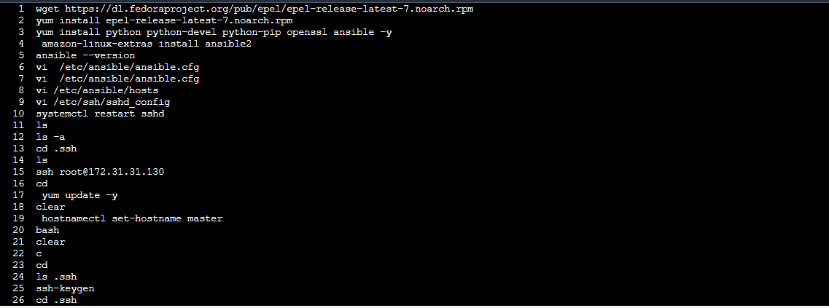
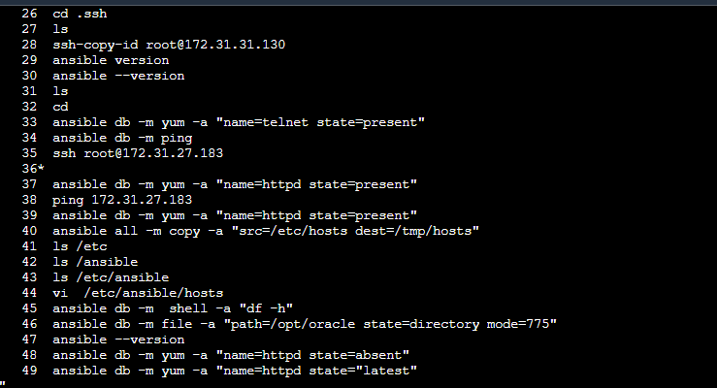
History of master machine
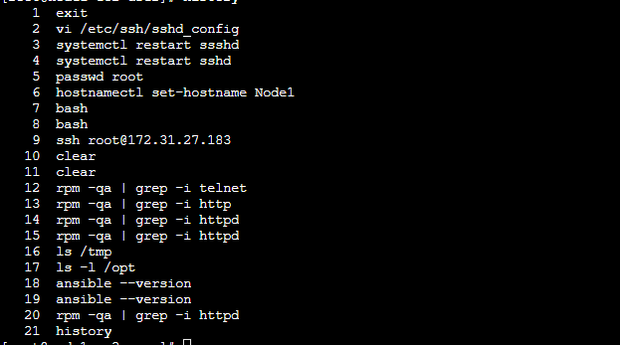
History of node1

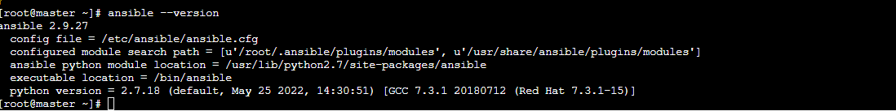
Ansible version

