1. **INTRODUCTION**
   1. *overview*
      * *Description of the project*

Project Description:

* 1. Keerthi Sweets a Manufacturer and Trader of Sweets, relies on Zoho Books to manage their inventory, handle purchase orders, and generate invoices for their customers. They can track stock levels, manage supplier payments, and generate financial reports. Zoho Books helps them streamline their wholesale operations and optimize inventory management. Keerthi Sweets is a renowned manufacturer and trader of delectable sweets, catering to both wholesale and retail customers. With a rich heritage spanning several decades, Keerthi Sweets has earned a reputation for its commitment to quality, authenticity, and customer satisfaction. Specializing in a wide variety of traditional and innovative sweets, they combine traditional recipes with modern techniques to create flavors that tantalize taste buds. Keerthi Sweets is a Private Limited company also registered under GST in Tamil Nadu. Keerthi sweets is a Manufacturer and trader of various sweets in wholesale and retail, it has a wide range of customers (B2B & B2C) all over the state and it procures raw material from various suppliers in the state. It operates at a Gross Profit margin of 50%.
  2. **PURPOSE**

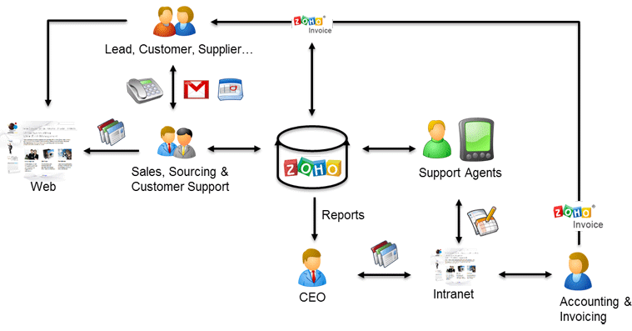

1. **Problem definition & design Thinking**
   1. *Empathy map*

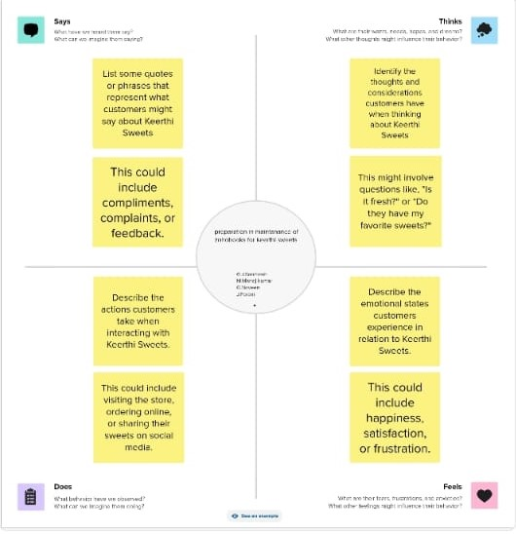

.

* 1. *Ideation & Brainstorming map*

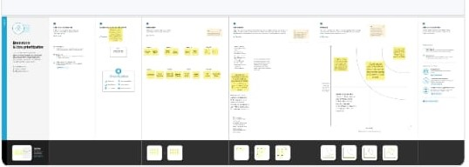

1. **Result Profit&loss**

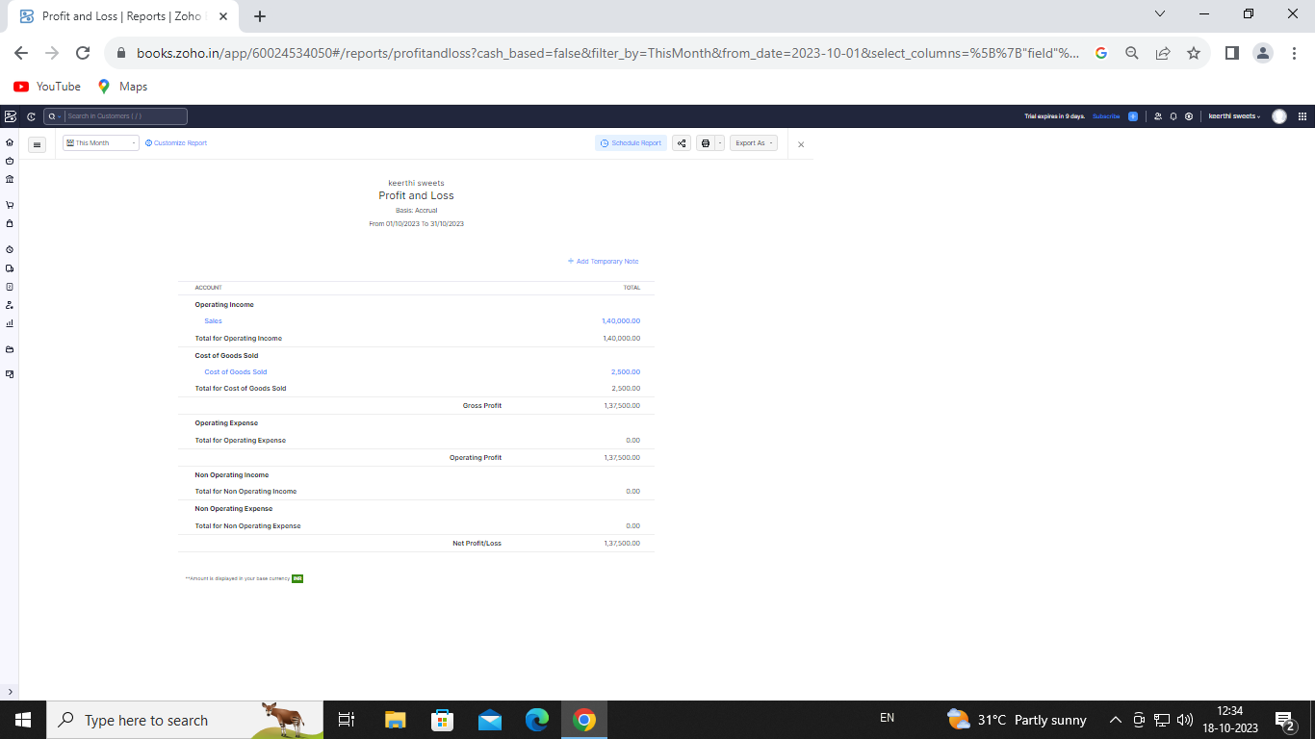

Balance sheet:

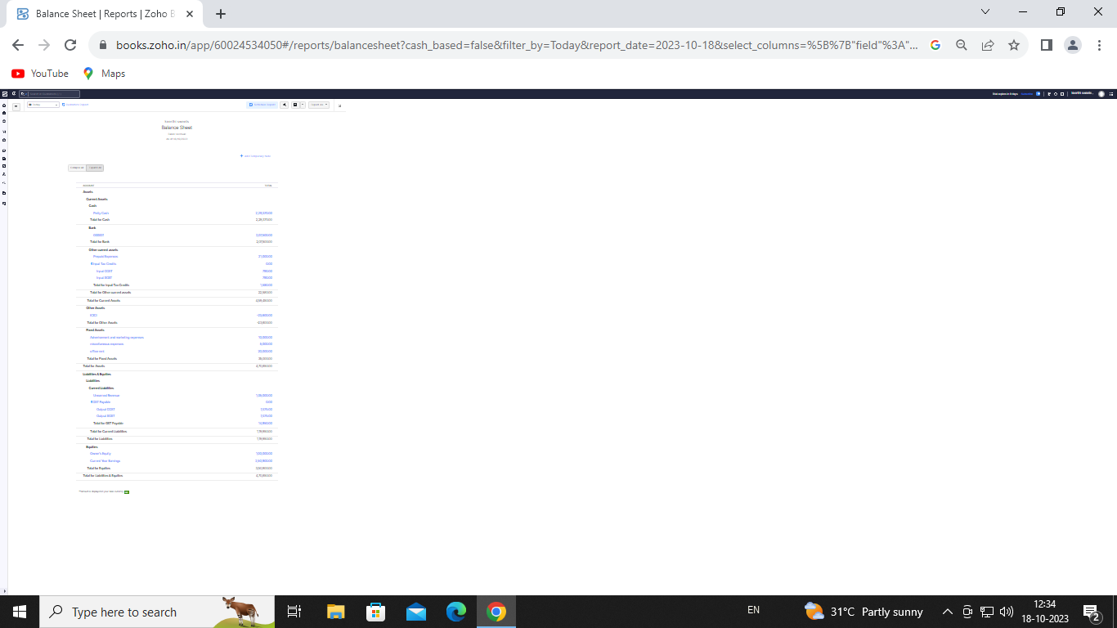

Purchase order:

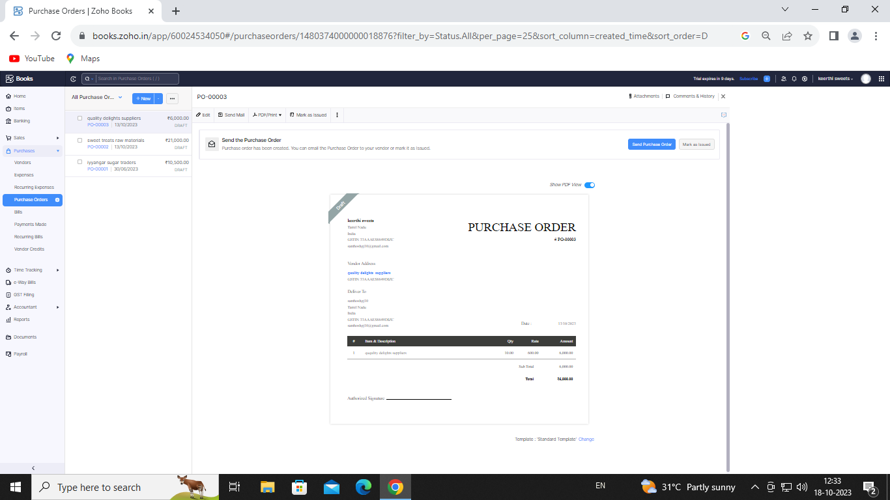

ADVANTAGES OF KEEERTHI SWEETS:

Sweets Could Help You Live Longer.

Chocolate Is Like Magic.

Sugar Can Help You Focus.

Sweets Bring Back Joy.

Chewing Gum Has Health Benefits, Too.

DISADVANTAGES OF HEALTHHUB MEDICAL CLINIC:

Recent studies show people consuming the highest level of added sugars also recorded the biggest spike in levels of unhealthy cholesterol, and the lowest levels of healthy cholesterol levels.

A diet high in sugar, and fructose, a common sugar-like food additive, triggers your liver to store fat, which can lead to non-alcoholic fatty liver disease – a condition rarely seen prior to 1980.

Fructose acts negatively on the leptin hormones that tell your brain when you have eaten enough. A high fructose diet can you leave you feeling hungry even when you’re overeating.

1. *APPLICATIONS:*

***KEERTHI SWEETS***

**Conclusion:**

**Nearly four years she opened Sweet Conclusion, the retail part of her business has not been as successful as she had hoped.**

1. **FUTURE SCOPE:**

**The potential opportunities and prospects in a particular field, industry, or career. It's essential to consider because it helps individuals make informed decisions about their education, career, and personal development.**

1. **APPENDIX:**

[**https://github.com/santhoshgjsanthosh/keerthi-sweets-NM2023TMId23240**](https://github.com/santhoshgjsanthosh/keerthi-sweets-NM2023TMId23240)

|  |
| --- |
|  |
| <!DOCTYPE html> |
|  | <html lang="en" data-color-mode="auto" data-light-theme="light" data-dark-theme="dark" data-a11y-animated-images="system" data-a11y-link-underlines="false"> |
|  |  |
|  | <style> |
|  | /* for each iteration, uncomment the CSS variable */ |
|  |  |
|  | /* light themes */ |
|  | [data-color-mode="light"][data-light-theme*="light"], |
|  | [data-color-mode="auto"][data-light-theme*="light"] { |
|  | /* iteration 1 */ |
|  | --border-color-iteration-1: #C8CCD0; |
|  | /* iteration 2 */ |
|  | --border-color-iteration-2: #BABFC5; |
|  | /* iteration 3 */ |
|  | --border-color-iteration-3: #A6ADB4; |
|  | /* iteration final */ |
|  | --border-color-iteration-4: #868F99; |
|  |  |
|  | /* the first value is the final step, which falls back to previous iterations */ |
|  | --control-borderColor-rest: var(--border-color-iteration-4, var(--border-color-iteration-3, var(--border-color-iteration-2, var(--border-color-iteration-1)))) !important; |
|  | } |
|  |  |
|  | /* dark themes */ |
|  | [data-color-mode="dark"][data-dark-theme*="dark"], |
|  | [data-color-mode="auto"][data-light-theme*="dark"] { |
|  | /* iteration 1 */ |
|  | --border-color-iteration-1: #363940; |
|  | /* iteration 2 */ |
|  | --border-color-iteration-2: #3F434B; |
|  | /* iteration 3 */ |
|  | --border-color-iteration-3: #4B5159; |
|  | /* iteration final */ |
|  | --border-color-iteration-4: #666E79; |
|  |  |
|  | /* the first value is the final step, which falls back to previous iterations */ |
|  | --control-borderColor-rest: var(--border-color-iteration-4, var(--border-color-iteration-3, var(--border-color-iteration-2, var(--border-color-iteration-1)))) !important; |
|  | } |
|  |  |
|  | [data-color-mode="dark"][data-dark-theme="dark_dimmed"], |
|  | [data-color-mode="dark"][data-dark-theme="light_high_contrast"], |
|  | [data-color-mode="dark"][data-dark-theme="dark_high_contrast"], |
|  | [data-color-mode="light"][data-light-theme="dark_dimmed"], |
|  | [data-color-mode="light"][data-light-theme="light_high_contrast"], |
|  | [data-color-mode="light"][data-light-theme="dark_high_contrast"] { |
|  | /* skip these themes, use the fallback */ |
|  | --control-borderColor-rest: initial !important; |
|  | } |
|  |  |
|  | @media (prefers-color-scheme: dark) { |
|  | /* dark colors in dark mode */ |
|  | [data-color-mode="auto"][data-dark-theme*="dark"] { |
|  | /* iteration 1 */ |
|  | --border-color-iteration-1: #363940; |
|  | /* iteration 2 */ |
|  | --border-color-iteration-2: #3F434B; |
|  | /* iteration 3 */ |
|  | --border-color-iteration-3: #4B5159; |
|  | /* iteration final */ |
|  | --border-color-iteration-4: #666E79; |
|  |  |
|  | /* the first value is the final step, which falls back to previous iterations */ |
|  | --control-borderColor-rest: var(--border-color-iteration-4, var(--border-color-iteration-3, var(--border-color-iteration-2, var(--border-color-iteration-1)))) !important; |
|  | } |
|  |  |
|  | /* light colors in dark mode */ |
|  | [data-color-mode="auto"][data-dark-theme*="light"] { |
|  | /* iteration 1 */ |
|  | --border-color-iteration-1: #C8CCD0; |
|  | /* iteration 2 */ |
|  | --border-color-iteration-2: #BABFC5; |
|  | /* iteration 3 */ |
|  | --border-color-iteration-3: #A6ADB4; |
|  | /* iteration final */ |
|  | --border-color-iteration-4: #868F99; |
|  |  |
|  | /* the first value is the final step, which falls back to previous iterations */ |
|  | --control-borderColor-rest: var(--border-color-iteration-4, var(--border-color-iteration-3, var(--border-color-iteration-2, var(--border-color-iteration-1)))) !important; |
|  | } |
|  |  |