EXPERIMENT 8: - Create a simple cloud web application for student counselling system using any Cloud Service Provider to demonstrate SaaS with the fields of student name, age, address, phone, subjects studied, Year of passing, percentage of marks, domain interest, etc.

Step 1: - Go to ZOHO.com

Step 2: - Create and account and log into the account

Step 3: - Create an application

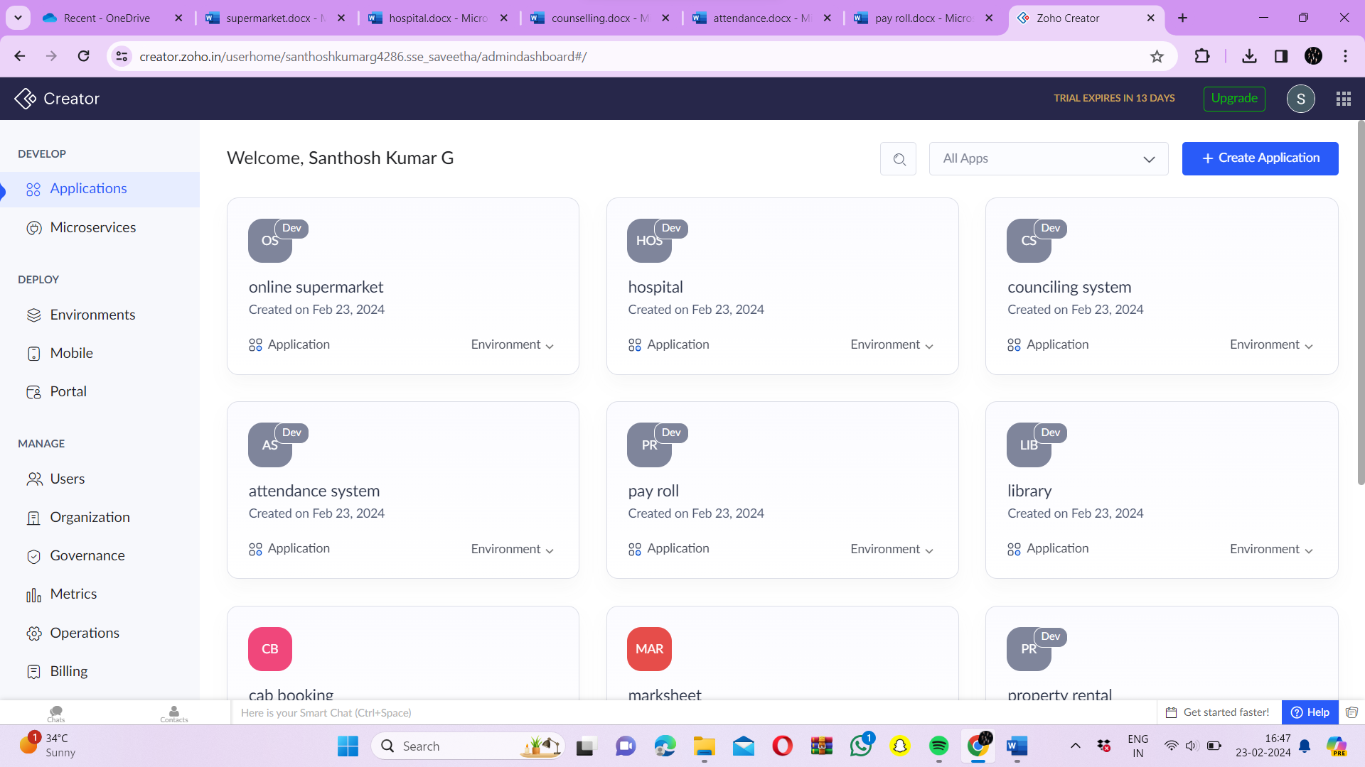

Step 4: - Create login form

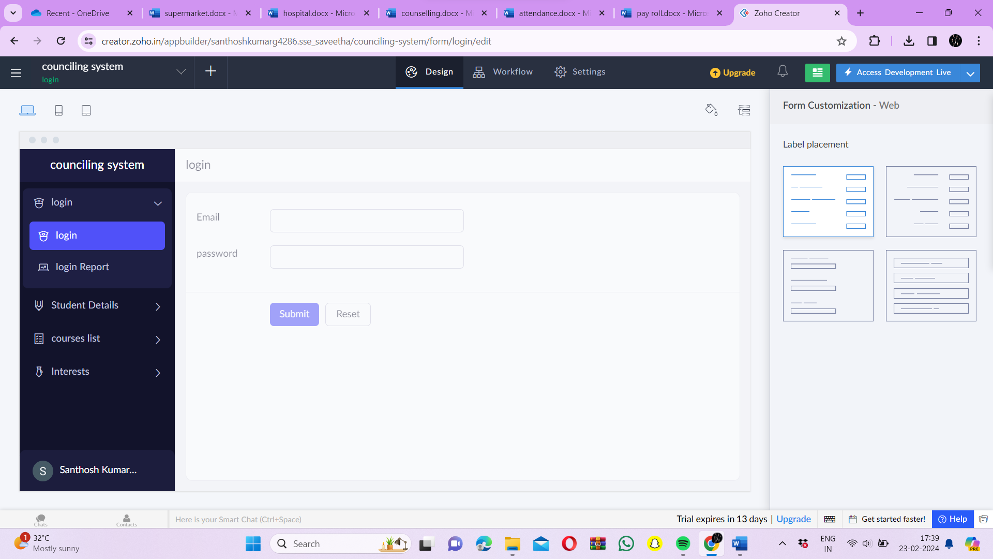

Step 5: - Create a form for student details

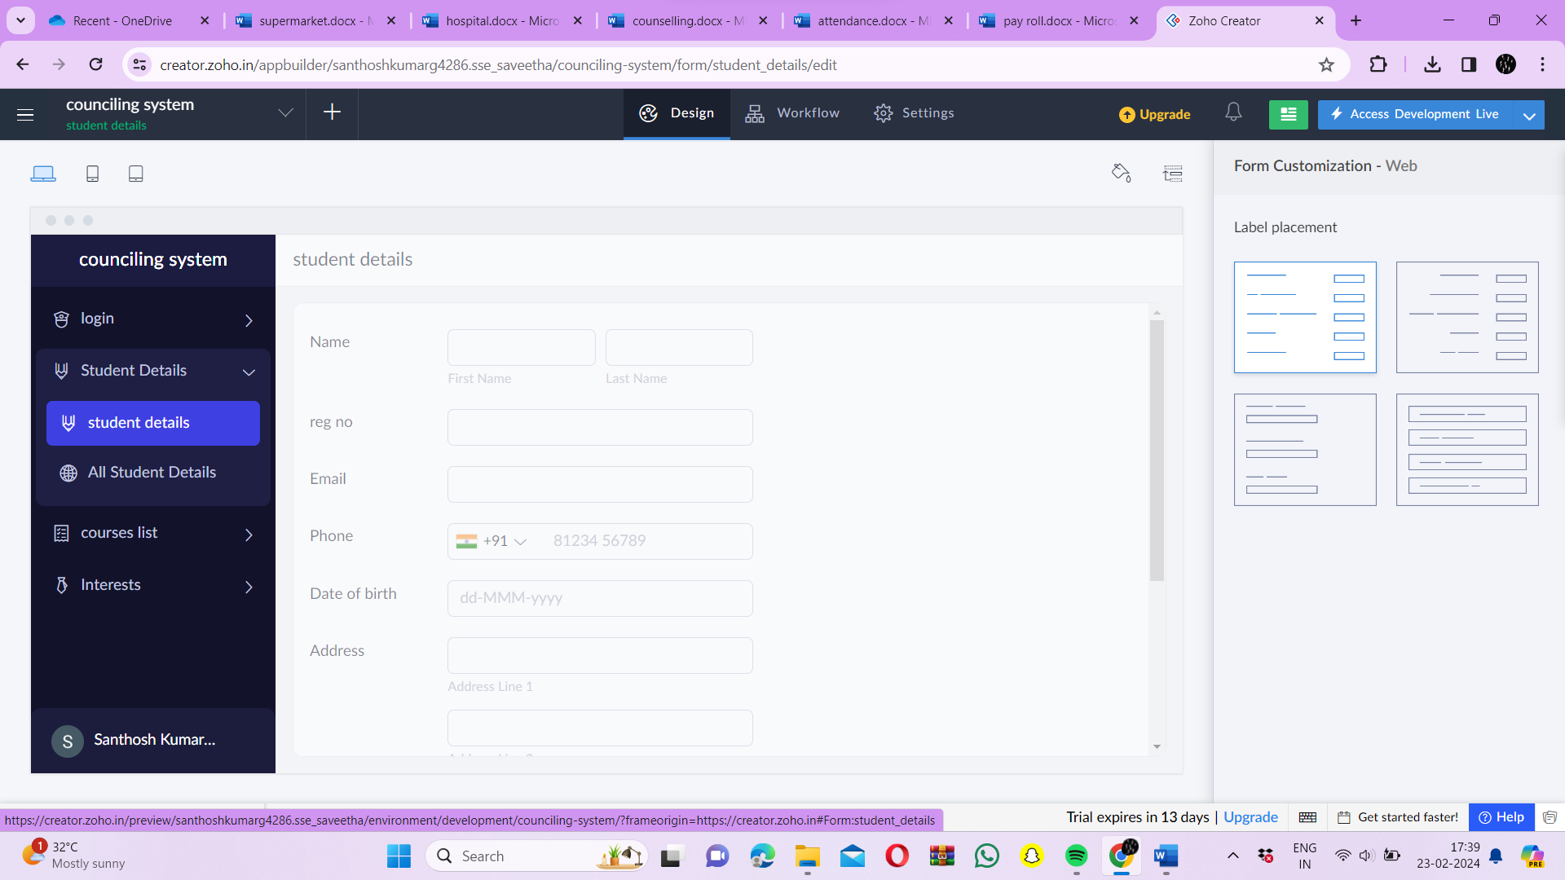

Step 6: - Create a form for courses list

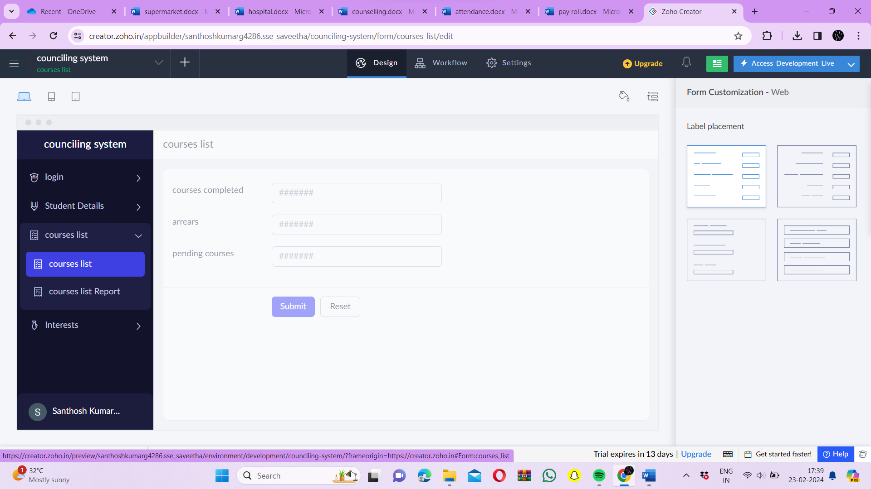

Step 7: - Create a form for student interests

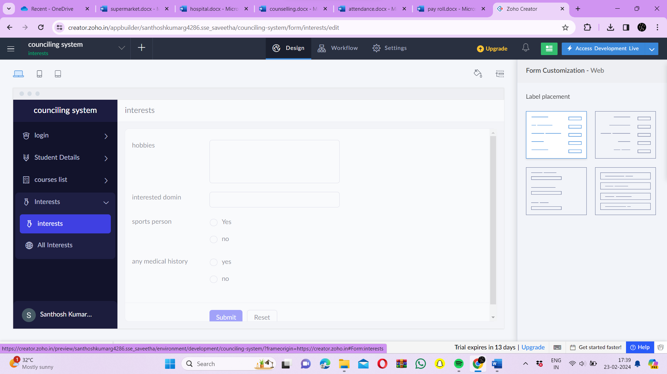

Step 8: - Click on the Access development live to view the output

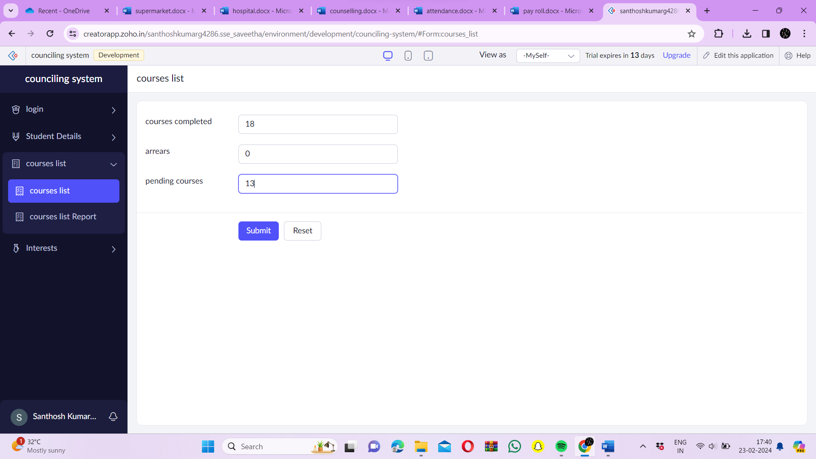

Step 9: - Click on the report to see the saved data’s

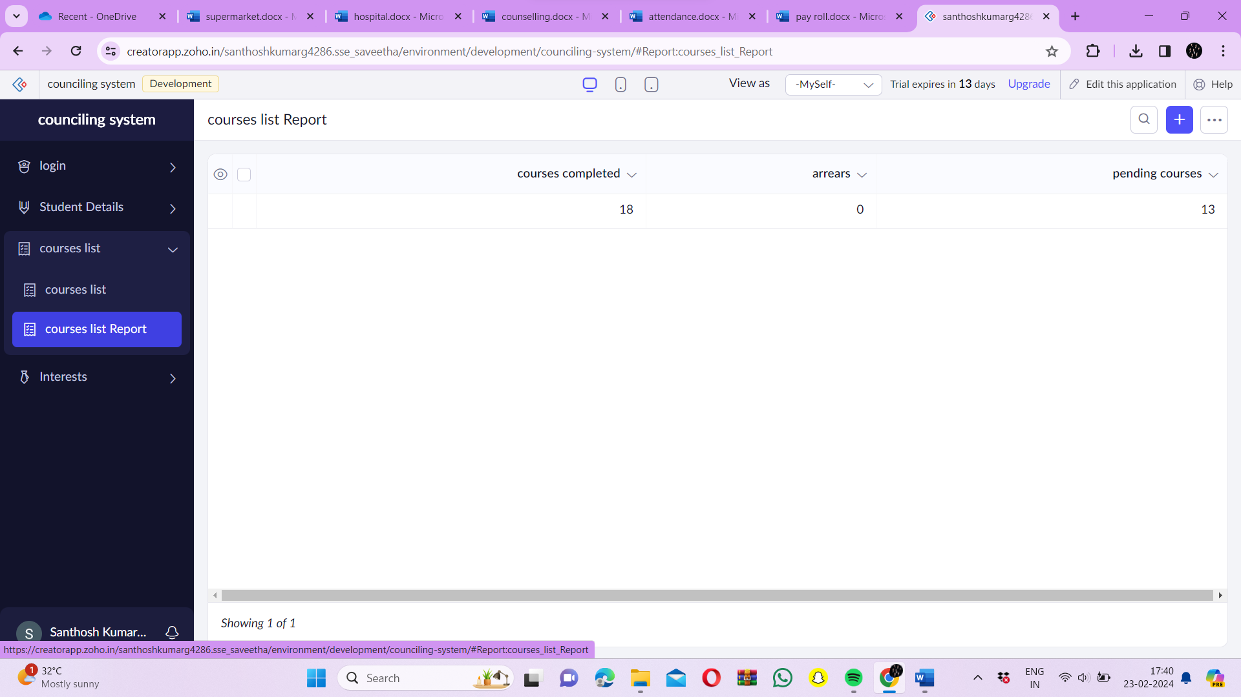

Step 10: - Click on the mobile icon to see the output in mobile format

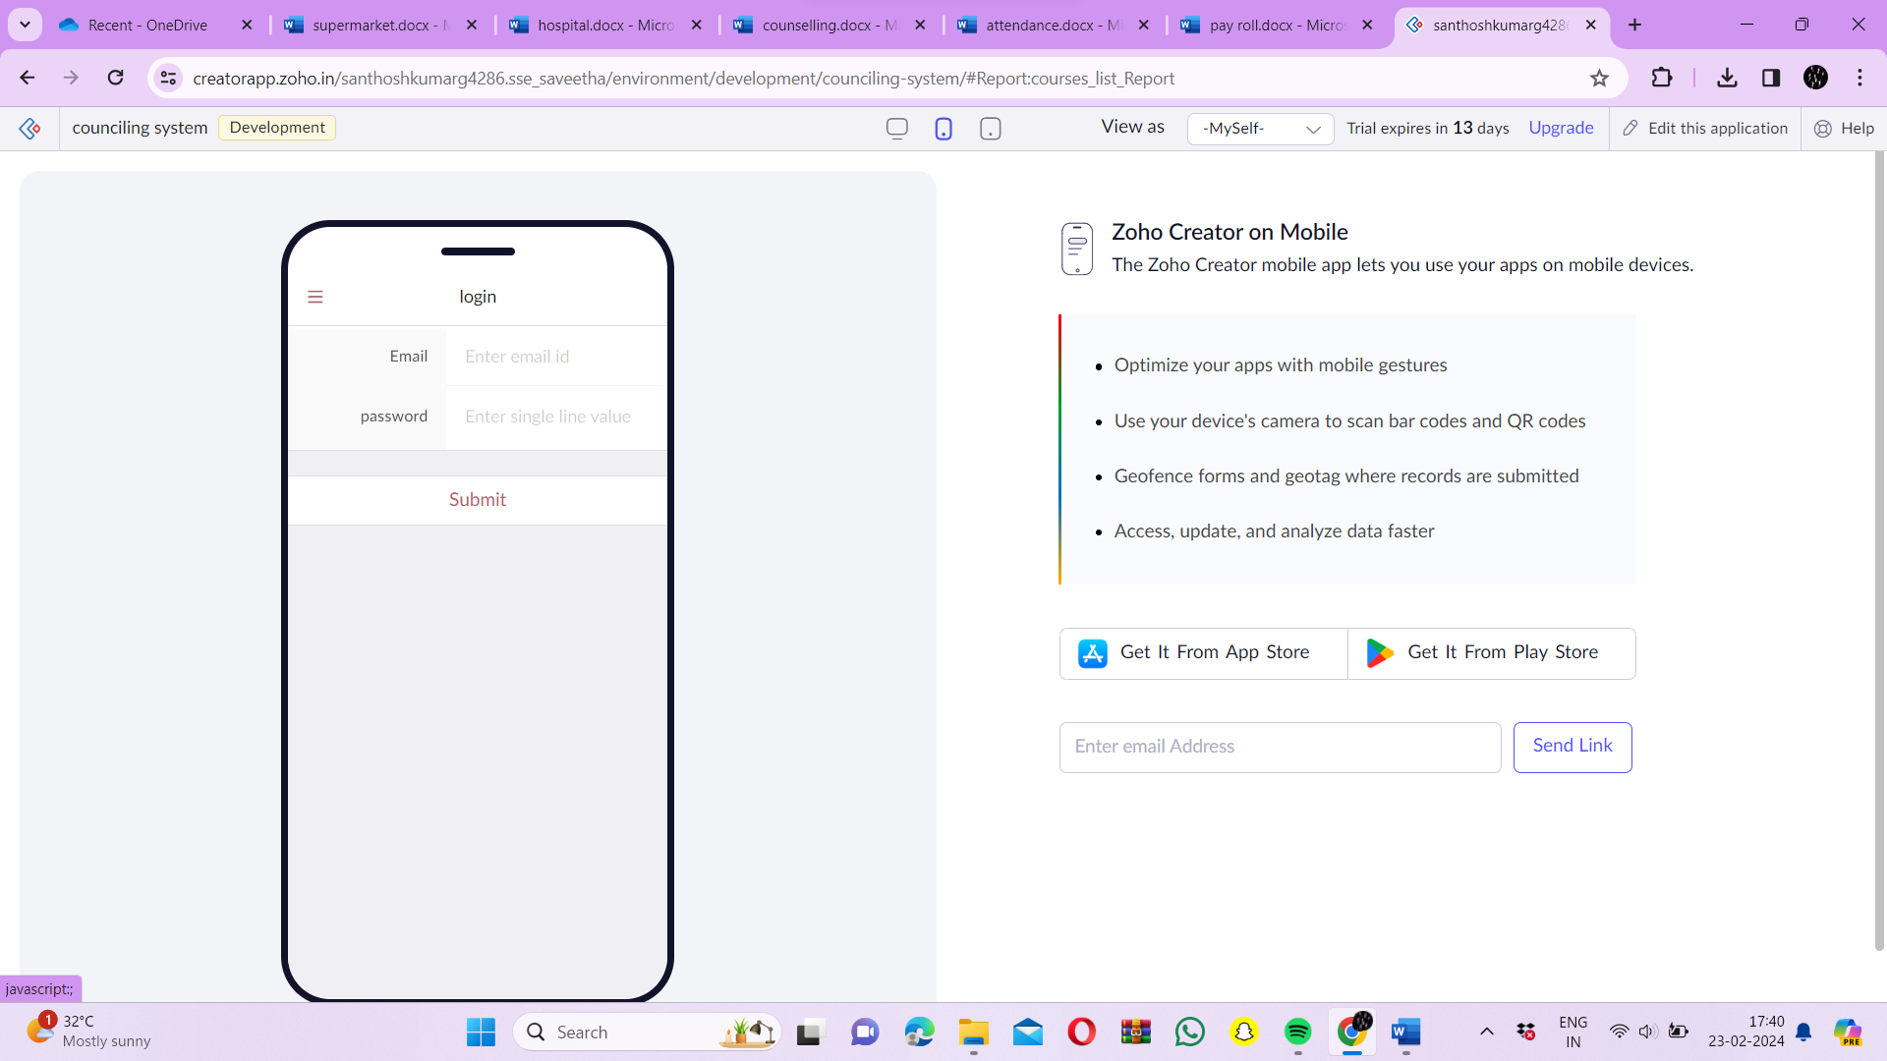

Step 11: - Click on the tablet icon to see the output in tablet format

