2 mark
1. How can architecture design be represented?
Using UML diagrams (component, deployment diagrams)
Using block diagrams / layered architecture diagrams
Using data flow diagrams (DFD)
Using architectural styles (client-server, MVC)

2. Aspects for evaluating modular design quality
Cohesion – module should perform a single task
Coupling – low interdependence between modules
Understandability
Maintainability

3. Horizontal vs Vertical Partitioning
Horizontal Partitioning: Divides system into layers (UI, business logic, data)
Vertical Partitioning: Divides system by features/functions (end-to-end modules)

4. Golden rules in UI design
Place user in control
Reduce user memory load
Maintain consistency
5.Identify the type of coupling in the following, Part of the program handles lookup for customers. When a customer is not found, a component adds a customer by directly modifying the contents of the data structure containing customer data.

Type of coupling (given case)
Content Coupling
One module directly modifies another module’s internal data

6. Reducing user memory load
Use menus and icons instead of commands
Provide defaults and auto-fill
Use consistent design
Provide help and hints

7. Steps for debugging & objectives of testing
Debugging steps:
Identify error
Locate source
Fix error
Retest
Objective of testing:
To find defects
To ensure software meets requirements

8. Testing principles
Testing shows presence of defects, not absence
Early testing is important
Pareto principle (80/20 rule)
Testing should be systematic

9. Verification vs Validation (test case usage)
Yes, both use test cases
Verification → checks correctness of process
Validation → checks correctness of product

10. Why highly coupled modules are hard to test?
Changes in one module affect others
Difficult to isolate module for testing

11. Project scheduling effect on integration testing
Poor scheduling may delay integration
Leads to late defect detection
Increases project risk

12. Who performs validation testing?
Software user / client
Because they verify if system meets real-world requirements

13. Is unit testing always possible?
No
Example:
GUI systems → hard to isolate units
Embedded systems → hardware dependency

14. Does exhaustive testing guarantee correctness?
No
Impossible for large systems
Cannot ensure 100% error-free software

15. More serious errors: client vs server?
Server-side errors
Because they affect entire system and multiple users

16. Load testing vs Stress testing
Load Testing: Tests system under expected load
Stress Testing: Tests beyond limits to check breaking point

17. Objective of security testing & who performs it
Objective: Identify vulnerabilities and threats
Performed by: Security testers / ethical hackers

18. Internal vs External testing views
Internal (White-box): Tests internal code structure
External (Black-box): Tests functionality without code knowledge

19. Estimating project time
Using LOC / Function Points
Using COCOMO model
Based on past project data

20. Quality control tools
Pareto chart
Cause-effect diagram
Control charts
Check sheets

21. Elements of SCM system
Version control
Change management
Configuration identification
Status accounting

22. Checklist for configuration audit
All changes approved?
Documents updated?
Version consistency maintained?
Tests completed?

23. Specificity & Completeness
Total requirements = 24 + 14 = 38
Specificity: Clearly defined requirements
Completeness: All requirements included (38 total → complete if none missing)

24. Process vs Project metrics
Process metrics: Improve development process
Project metrics: Track project progress (cost, time)

25. Why keep some metrics private?
To avoid misuse and pressure on developers
Private metrics:
Individual productivity
Error rate per developer
Code complexity per person
Public metrics:
Project cost
Schedule
Defect count

26. Impact of LOC & FP in cost estimation
LOC: Language dependent
FP: Language independent, more accurate
Both help estimate effort and cost

27. Cloud service models
IaaS: Infrastructure (servers, storage)
PaaS: Development platform
SaaS: Ready-to-use software

28. SPM vs SCM
SPM (Software Project Management): Planning, scheduling, cost
SCM (Software Configuration Management): Version & change control

29. Tools for quality control
Six Sigma tools
Statistical tools
Quality dashboards

30. DevOps testing tools
Selenium (UI testing)
JUnit (unit testing)
Jenkins (CI/CD testing)

31. Gantt chart concept
Bar chart showing tasks vs time
Helps track schedule and progress

32. Role of automation in DevOps
Speeds up build, test, deployment
Reduces manual errors
Enables continuous integration
PART-B/C

15 Marks Answer
MVC Architecture – Explanation, Challenges & Limitations

1. Introduction
MVC (Model–View–Controller) is an architectural pattern that separates an application into three main components.
It helps in achieving separation of concerns, modularity, and easy maintenance.

2. Components of MVC Architecture
Model
Represents data and business logic
Manages database operations
Performs validation and processing
Notifies the view when data changes
Independent of user interface

View
Represents user interface (UI)
Displays data from the model
Responsible for presentation only
Does not contain business logic
Can have multiple views for same model

Controller
Acts as intermediary between Model and View
Handles user input (clicks, requests)
Updates model based on input
Selects appropriate view for response
Controls application flow

3. Working of MVC Architecture
User interacts with the View
View sends input to the Controller
Controller processes request
Controller updates the Model
Model changes are reflected in the View
View displays updated output to user

4. Advantages of MVC
Clear separation of concerns
Improves code reusability
Easy to maintain and modify
Supports parallel development (different teams)
Multiple views can be created for same data
Simplifies testing of individual components
Scalable for large applications

5. Challenges in Implementing MVC
Difficult for beginners to understand
Requires proper planning and design
Increased number of components
Coordination between components is complex
Not suitable for very small applications
Learning curve for developers
Managing dependencies can be tricky

6. Limitations of MVC
Controller may become too complex (fat controller problem)
Debugging becomes difficult due to separation
Performance overhead in some cases
Tight coupling may still exist in poor design
Increased development time initially
Not ideal for simple applications
Handling large-scale applications can be challenging

7. Conclusion
MVC is widely used in modern software development due to its ability to improve modularity and maintainability.
However, it introduces complexity and design challenges, so it must be applied carefully.
Architectural Styles in System Design

1. Introduction
An architectural style defines how system components are organized and how they interact.
It helps in achieving scalability, maintainability, reusability, and performance in software systems.

2. Types of Architectural Styles

1. Layered Architecture (N-Tier)
System is divided into layers such as presentation, business, and data layer
Each layer performs a specific responsibility
Communication happens between adjacent layers
Advantages:
Easy to understand and design
Supports modular development
Enhances maintainability
Easy to test individual layers
Disadvantages:
Performance overhead due to multiple layers
Changes in one layer may affect others
Not suitable for real-time systems

2. Client–Server Architecture
System divided into clients (requesters) and servers (service providers)
Clients send requests, server processes and responds
Common in web and network applications
Advantages:
Centralized control and data management
Easy security implementation
Scalable by adding more clients
Disadvantages:
Server can become a bottleneck
Failure of server affects entire system
Network dependency

3. Pipe and Filter Architecture
Data flows through a sequence of components called filters
Each filter transforms input and passes output to next
Common in data processing systems
Advantages:
High reusability of filters
Easy to maintain and extend
Supports parallel processing
Disadvantages:
Not suitable for interactive systems
Data transformation overhead
Difficult error handling

4. Repository Architecture
Uses a central data repository shared by multiple components
Components interact through shared data
Advantages:
Data consistency and integrity
Easy data sharing among components
Simplifies integration
Disadvantages:
Single point of failure
Performance bottleneck
Tight dependency on data structure

5. Model–View–Controller (MVC)
Separates system into Model (data), View (UI), Controller (logic)
Improves separation of concerns
Advantages:
Supports multiple views
Easy to modify UI without affecting logic
Improves maintainability
Disadvantages:
Increased complexity
Requires proper design planning
Hard to manage large applications

6. Microservices Architecture
Application is divided into small independent services
Each service handles a specific functionality
Services communicate via APIs
Advantages:
Highly scalable
Independent deployment
Fault isolation
Disadvantages:
Complex communication
Difficult debugging
Requires DevOps support

7. Event-Driven Architecture
Components communicate through events
When an event occurs, other components respond
Advantages:
Loose coupling
Scalable and flexible
Suitable for real-time systems
Disadvantages:
Hard to debug
Event management complexity
Requires careful design
3. Conclusion
Different architectural styles are chosen based on system needs.
A good architecture improves performance, scalability, and maintainability, but choosing the wrong style can increase complexity.

13 Marks Answer
Design Patterns in Software Development (with Examples)

1. Introduction
Design patterns are reusable solutions to common problems in software design.
They provide best practices to improve code reusability, maintainability, and flexibility.

2. Types of Design Patterns
Design patterns are mainly classified into:
Creational Patterns
Structural Patterns
Behavioral Patterns

3. Creational Design Patterns
Focus on object creation mechanisms
1. Singleton Pattern
Ensures only one instance of a class exists
Provides a global access point
Example:
Database connection manager (only one connection object)

2. Factory Pattern
Creates objects without specifying exact class
Uses a common interface
Example:
Creating different types of users (Admin, Customer)

3. Builder Pattern
Constructs complex objects step by step
Separates construction from representation
Example:
Building a complex object like a car configuration

4. Prototype Pattern
Creates new objects by copying existing objects
Example:
Cloning an existing object instead of creating from scratch

4. Structural Design Patterns
Focus on class and object composition
1. Adapter Pattern
Converts one interface into another
Allows incompatible classes to work together
Example:
Mobile charger adapter converting voltage

2. Decorator Pattern
Adds new functionality without modifying existing code
Example:
Adding features to a coffee (milk, sugar)

3. Facade Pattern
Provides a simple interface to a complex system
Example:
One interface to operate multiple subsystems (home theater)

4. Composite Pattern
Treats individual objects and groups uniformly
Example:
File system (files and folders)

5. Behavioral Design Patterns
Focus on communication between objects
1. Observer Pattern
One object notifies multiple dependents
Example:
Notification system (subscribers get updates)

2. Strategy Pattern
Defines a family of algorithms and makes them interchangeable
Example:
Different payment methods (UPI, card, cash)

3. Command Pattern
Encapsulates a request as an object
Example:
Remote control buttons (each button is a command)

4. State Pattern
Object changes behavior based on its state
Example:
Traffic light system

6. Advantages of Design Patterns
Reusable solutions
Improves code readability
Reduces development time
Enhances flexibility
Promotes best practices

7. Conclusion
Design patterns play a vital role in building efficient and maintainable software systems.
Selecting the appropriate pattern improves software quality and scalability.

13 Marks Answer
White Box Testing vs Black Box Testing (with Banking Application Example)

1. Introduction
Software testing ensures that the system works correctly and meets requirements.
Two important approaches are White Box Testing and Black Box Testing.

2. White Box Testing
Also called structural / glass box testing
Tester has knowledge of internal code and logic
Focuses on code structure, paths, loops, conditions
Usually performed by developers
Key Points:
Tests internal working of program
Uses techniques like path testing, loop testing
Ensures all statements are executed
Helps in optimizing code

3. Black Box Testing
Also called functional testing
Tester has no knowledge of internal code
Focuses on input and output behavior
Performed by testers or users
Key Points:
Tests functionality against requirements
Uses test cases based on specifications
Detects missing functions and interface errors
Validates system behavior

4. Comparison (White Box vs Black Box)
Aspect | White Box Testing | Black Box Testing
Knowledge of code | Required | Not required
Focus | Internal logic | External behavior
Performed by | Developers | Testers / Users
Testing level | Unit testing | System / Acceptance testing
Techniques | Path, loop testing | Equivalence partitioning, boundary value
Objective | Code correctness | Requirement validation

5. Banking Application Example
Scenario: Online Banking System (Money Transfer)

White Box Testing Example
Check if balance deduction logic is correct
Verify if conditions (sufficient balance or not)
Test all execution paths (success, failure cases)
Ensure loops and conditions work correctly
Example:
If balance ≥ amount → allow transfer
Else → show error

Black Box Testing Example
Enter valid account details → expect successful transfer
Enter wrong account number → expect error message
Transfer amount greater than balance → expect failure
Check UI messages and outputs
Focus is on input-output behavior, not code

6. Advantages
White Box Testing
Improves code quality
Detects hidden errors
Ensures full code coverage
Black Box Testing
Tests from user perspective
No need for programming knowledge
Validates functional requirements

7. Conclusion
Both white box and black box testing are essential.
White box ensures internal correctness, while black box ensures functional accuracy.
Together, they provide complete testing coverage.
Consider the pseudo code for simple program below,
Program simple subtraction
Input(x,y)
Output(x)
Output(y)
If x>y then DO
x-y=z
13
K3
Else y-x=z
End If
Output(z)
Output “End Program”
Perform basis path testing and generate test cases.
13 Marks Answer
Basis Path Testing & Test Case Generation

1. Given Pseudo Code (Understanding)
Program performs subtraction:
If x > y → z = x − y
Else → z = y − x
Then prints result

2. Flow Analysis (Control Flow)
There is one decision point:
Condition: x > y
So, there are two possible paths:
True path → x > y
False path → x ≤ y

3. Cyclomatic Complexity (V(G))
Formula:
V(G) = Number of decision nodes + 1
Decision nodes = 1
V(G) = 1 + 1 = 2
So, 2 independent paths exist

4. Independent Paths
Path 1: Start → Input → Condition TRUE → z = x − y → Output
Path 2: Start → Input → Condition FALSE → z = y − x → Output

5. Test Case Design
Test Case 1 (True Condition: x > y)
Input: x = 10, y = 5
Expected Output:
z = 10 − 5 = 5
Output: 5

Test Case 2 (False Condition: x ≤ y)
Input: x = 3, y = 7
Expected Output:
z = 7 − 3 = 4
Output: 4

6. Test Case Table
Test Case | Input (x, y) | Condition | Expected Output (z)
TC1 | (10, 5) | x > y (True) | 5
TC2 | (3, 7) | x ≤ y (False) | 4

7. Conclusion
Cyclomatic complexity = 2
Number of test cases required = 2
All independent paths are covered → Complete basis path testing

13 Marks Answer
Various Testing Methods with Suitable Examples

1. Introduction
Software testing methods are techniques used to verify and validate software to ensure it meets requirements and is free from defects.
They help in improving quality, reliability, and performance.

2. Types of Testing Methods

1. Unit Testing
Testing individual components or modules
Performed by developers
Example:
Testing a function that calculates interest in a banking system
Key Points:
Focus on small units
Easy to detect errors early
Usually automated

2. Integration Testing
Testing interaction between modules
Ensures modules work together
Example:
Checking if login module correctly connects with database
Types:
Top-down
Bottom-up
Sandwich approach

3. System Testing
Testing the complete system as a whole
Verifies system requirements
Example:
Testing full banking application (login, transfer, logout)

4. Acceptance Testing
Testing performed by client/user
Confirms system meets user requirements
Example:
Bank staff testing software before deployment
Types:
Alpha testing
Beta testing

5. White Box Testing
Tests internal code structure
Requires programming knowledge
Example:
Checking all conditions in transaction logic

6. Black Box Testing
Tests functionality without code knowledge
Focus on inputs and outputs
Example:
Entering invalid password and checking error message

7. Grey Box Testing
Combination of white box and black box
Partial knowledge of internal system
Example:
Tester knows database structure but tests through UI

8. Performance Testing
Checks system speed and responsiveness
Example:
Testing how banking app performs with 1000 users

9. Load Testing
Tests system under expected load
Example:
Simulating 500 users accessing system simultaneously

10. Stress Testing
Tests system beyond limits
Example:
Simulating 10,000 users to check system crash

11. Security Testing
Identifies vulnerabilities and threats
Example:
Checking if unauthorized user can access account

3. Advantages of Testing Methods
Improves software quality
Detects defects early
Ensures reliability
Enhances user satisfaction
Reduces maintenance cost

4. Conclusion
Different testing methods are applied at different stages of development.
Using a combination of methods ensures complete and effective testing of software systems.

13 Marks Answer
Project Scheduling in Software Engineering

1. Introduction
Project Scheduling is the process of planning and organizing tasks, resources, and timelines for completing a software project within a specified time.
It ensures that the project is completed on time and within budget.

2. Objectives of Project Scheduling
To define start and end dates of activities
To allocate resources efficiently
To track project progress
To identify critical tasks
To avoid delays and cost overruns

3. Steps in Project Scheduling
1. Task Identification
Break the project into smaller tasks (Work Breakdown Structure - WBS)
Example: Design, coding, testing

2. Task Sequencing
Arrange tasks in logical order
Identify dependencies between tasks

3. Time Estimation
Estimate time required for each task
Use techniques like expert judgment, LOC, Function Points

4. Resource Allocation
Assign developers, tools, and materials to tasks
Ensure balanced workload

5. Schedule Development
Create timeline using tools like Gantt chart, PERT, CPM
Define milestones and deadlines

6. Monitoring and Control
Track progress regularly
Update schedule if required
Handle delays and risks

4. Techniques Used in Project Scheduling
Gantt Chart
Represents tasks as bars over time
Easy to understand and track progress

PERT (Program Evaluation Review Technique)
Uses probabilistic time estimates
Helps in uncertain projects

CPM (Critical Path Method)
Identifies longest path (critical path)
Determines minimum project completion time

5. Importance of Project Scheduling
Ensures timely completion
Improves resource utilization
Helps in risk management
Provides clear roadmap
Enhances coordination among team members

6. Challenges in Project Scheduling
Incorrect time estimation
Resource constraints
Changing requirements
Unexpected risks
Dependency issues

7. Conclusion
Project scheduling is essential for successful software development.
A well-planned schedule improves efficiency, coordination, and timely delivery of the project.
15 Marks Answer
Customer vs End User – Real-Life Examples

1. Introduction
In software engineering:
Customer → Person/organization that purchases or commissions the software
End User → Person who actually uses the software
Sometimes both are the same, but in many cases they are different.

2. Cases Where Customer and End User are SAME

Case 1: Personal Mobile Application
Example: A student downloads a note-taking app
Customer = User (same person)
Explanation:
The person who buys/downloads the app also uses it
No third party involved

Case 2: Freelance Software Purchase
Example: A small shop owner buys billing software
Customer = Shop owner
End User = Shop owner
Explanation:
Owner purchases and directly uses the software

Case 3: Individual Subscription Software
Example: Subscription to Microsoft Word
Customer = End User
The individual pays and uses the software

3. Cases Where Customer and End User are DIFFERENT

Case 1: Banking System
Customer = Bank organization
End Users = Bank employees and customers
Explanation:
Bank purchases/develops software
Employees and users operate it

Case 2: Hospital Management System
Customer = Hospital management
End Users = Doctors, nurses, staff
Explanation:
Management funds system
Staff uses it for daily operations

Case 3: Educational Institution Software
Customer = College/University
End Users = Students and faculty
Explanation:
Institution buys system
Students and teachers use it

4. Key Differences
Aspect | Customer | End User
Role | Purchases software | Uses software
Focus | Cost, requirements | Usability, functionality
Involvement | Requirement definition | System usage
Example | Company, organization | Employees, students

5. Importance of Distinction
Helps in gathering correct requirements
Ensures both business needs and usability are satisfied
Avoids miscommunication during development
Improves overall software success

6. Conclusion
Customer and end user may be the same or different depending on the application.
Understanding both perspectives is essential for developing effective and user-friendly software systems.
5 Marks Answer
Modes of COCOMO Model

1. Introduction
In the COCOMO (Constructive Cost Model), projects are classified into different modes based on complexity, size, and development environment.
These modes help in estimating effort and development time accurately.

2. Modes of COCOMO

1. Organic Mode
Suitable for small and simple projects
Developed by a small team with good experience
Requirements are well understood and stable
Minimal constraints
Examples:
Student projects
Simple business applications
Characteristics:
Low complexity
Flexible environment
Faster development

2. Semi-Detached Mode
Suitable for medium-sized projects
Team has mixed experience levels
Requirements are moderately complex
Examples:
Database systems
Compilers
Characteristics:
Moderate complexity
Partial constraints
Balanced team experience

3. Embedded Mode
Suitable for large and complex systems
Developed under strict constraints (hardware, software, regulations)
Requires high reliability
Examples:
Real-time systems
Embedded systems (medical, defense)
Characteristics:
High complexity
Strict rules and standards
Requires expert developers

3. Conclusion
COCOMO modes help classify projects based on complexity, which improves the accuracy of cost and effort estimation.
5 + 8 Marks Answer
COCOMO Model & Numerical Problem

PART A (5 Marks)
COCOMO Model (Constructive Cost Model)
COCOMO is a software cost estimation model developed by Barry Boehm to estimate:
Effort (Person-Months)
Development Time
Project Cost

Types of COCOMO Models
Basic COCOMO – Based only on LOC
Intermediate COCOMO – Includes cost drivers
Detailed COCOMO – Includes phase-wise estimation

Modes of COCOMO
Organic Mode → Small, simple projects
Semi-Detached Mode → Medium complexity
Embedded Mode → Complex, real-time systems

Basic COCOMO Formula (Organic Mode)
Effort (E) = 2.4 × (KLOC)^1.05
Development Time (T) = 2.5 × (E)^0.38

Advantages
Simple and easy to use
Provides quick estimation
Useful in early project planning

Limitations
Depends on accurate LOC estimation
Does not consider all real-world factors
Less accurate for modern agile projects

PART B (8 Marks)
Explain in detail the COCOMO model for software cost estimation. A project is expected to have 30,000 LOC. Estimate: Effort (in person-months) Development time (in months) Cost, assuming ₹60,000 per person-month, using the Basic COCOMO model (Organic mode).

Step 1: Calculate Effort (E)

E=a×(KLOC)b =2.4×(30)1.05

E =2.4×(30)1.05

E=2.4×34.98≈83.95 person-months

Step 2: Calculate Development Time (D)

D=c×(E)d=2.5×(83.95)0.38

D=2.5×5.57≈13.93 months

D=2.5×5.57≈13.93 months

Step 3: Calculate Cost

Total Cost=83.95 PM×₹60,000

=₹50,37,000
Conclusion
COCOMO helps in estimating effort, time, and cost effectively.
In this case, the project requires ~85 PM effort, ~13.5 months duration, and ~₹51 lakh cost.
15 Marks Answer
DevOps Architecture & Role of CI/CD

1. Introduction
DevOps is a set of practices that integrates development (Dev) and operations (Ops) to improve collaboration, speed, and quality of software delivery.
It focuses on automation, continuous processes, and rapid delivery.

2. DevOps Architecture
DevOps architecture is a combination of tools, processes, and practices that support continuous software development and deployment.

3. Key Components of DevOps Architecture
1. Version Control
Stores and manages source code
Enables team collaboration and tracking changes
Example: Git

2. Continuous Integration (CI)
Developers frequently integrate code into a shared repository
Automated builds and testing are performed
Helps detect errors early

3. Continuous Testing
Automated testing at every stage
Ensures code quality and reliability
Includes unit, integration, and system testing

4. Continuous Delivery (CD)
Ensures software is always ready for deployment
Code is automatically prepared for release

5. Continuous Deployment
Automatically deploys code to production without manual intervention
Faster delivery to users

6. Configuration Management
Maintains consistency across environments
Tools manage system configurations automatically

7. Monitoring and Logging
Tracks system performance and errors
Helps in quick issue detection and resolution

4. DevOps Lifecycle Phases
Plan → Requirement analysis
Develop → Coding
Build → Compile and package
Test → Automated testing
Release → Prepare for deployment
Deploy → Deliver to production
Operate → Maintain system
Monitor → Track performance

5. Role of Continuous Integration (CI)
Integrates code changes frequently
Detects bugs early through automated testing
Reduces integration issues
Improves code quality
Enables faster development cycles

6. Role of Continuous Delivery (CD)
Ensures code is always in deployable state
Automates release process
Reduces manual errors
Enables faster and reliable delivery
Improves customer satisfaction

7. Advantages of DevOps with CI/CD
Faster software delivery
Improved collaboration
Higher quality software
Reduced risk of failure
Quick feedback and bug fixing

8. Challenges of DevOps
Requires cultural change
Tool integration complexity
Need for skilled professionals
Initial setup cost

9. Conclusion
DevOps architecture, supported by CI/CD, enables organizations to deliver software quickly, reliably, and efficiently.
It is essential for modern software development practices.
15 Marks Answer
Phases of Software Deployment Pipeline (with Diagram)

1. Introduction
A software deployment pipeline is an automated process that allows code to move from development to production efficiently.
It ensures continuous integration, testing, and delivery of software.

2. Phases of Software Deployment Pipeline

1. Source / Version Control Phase
Developers write code and store it in a repository
Version control systems track changes
Enables collaboration among team members
Example: Git repository

2. Build Phase
Source code is compiled and converted into executable form
Dependencies are resolved
Build tools generate artifacts
Output: Executable file or package

3. Continuous Integration Phase
Code changes are integrated frequently
Automated builds and tests are triggered
Detects errors early

4. Testing Phase
Various tests are performed:
Unit testing
Integration testing
System testing
Ensures software quality

5. Release Phase
Code is prepared for deployment
Versioning and packaging are done
Approval may be required

6. Deployment Phase
Application is deployed to production environment
Can be manual or automated
Types:
Blue-green deployment
Rolling deployment

7. Monitoring Phase
System performance is monitored
Logs and metrics are analyzed
Detects issues in real-time

8. Feedback Phase
User feedback is collected
Bugs and improvements identified
Used for next development cycle

3. Diagram of Deployment Pipeline
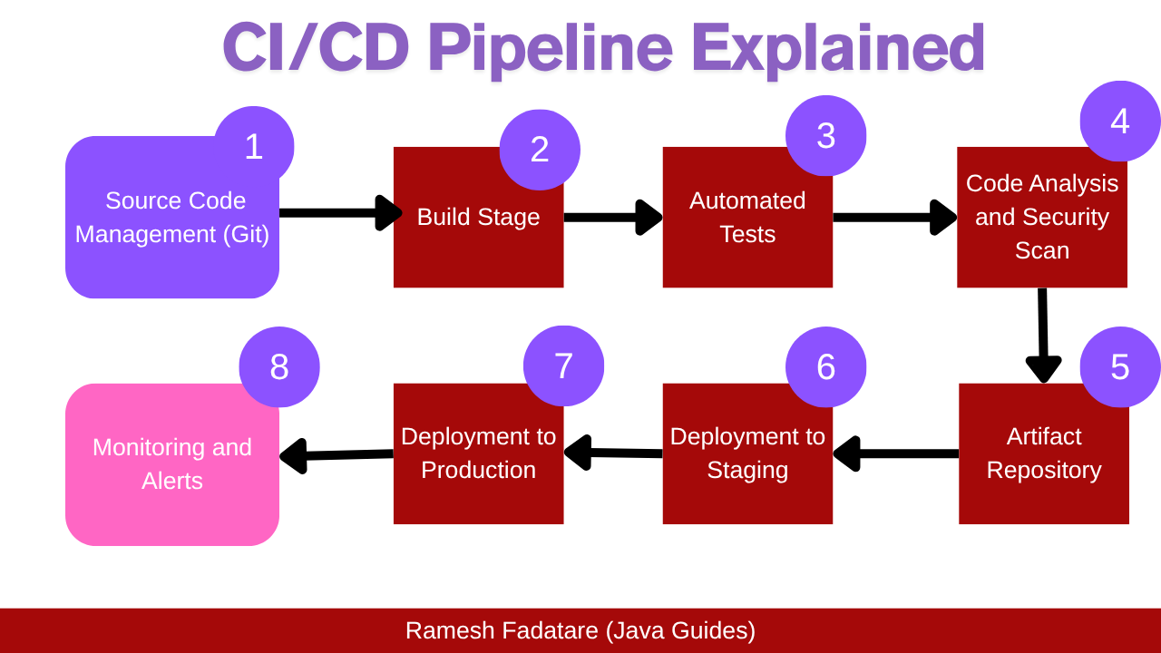

4. Advantages of Deployment Pipeline
Faster software delivery
Reduced manual errors
Improved software quality
Continuous feedback and improvement
Better collaboration

5. Conclusion
The deployment pipeline automates the process from development to production, ensuring efficient, reliable, and continuous software delivery.
1.Given the following components of a software system:

35 Inputs

20 Outputs

10 Inquiries

6 Files

4 Interfaces
Calculate the unadjusted function points assuming average
complexity. Estimate the effort in person-months assuming a
productivity of 12 FP/PM.

Function Point Analysis

Given the following components of a software system:

35 Inputs

20 Outputs

10 Inquiries

6 Files

4 Interfaces
Calculate the unadjusted function points assuming average
complexity. Estimate the effort in person-months assuming a
productivity of 12 FP/PM.
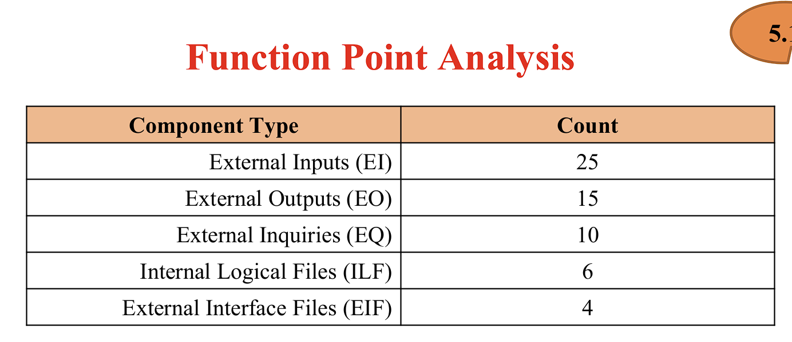

Use the Function Point Analysis method to estimate the unadjusted function
points, adjusted function points, and effort required for the given project.
Assume average complexity unless stated otherwise.
2.A legacy system has 940 modules. The latest release required that 90 of these modules be changed. In addition, 40 new modules were added and 12 old modules were removed. Compute the software maturity index for the system.
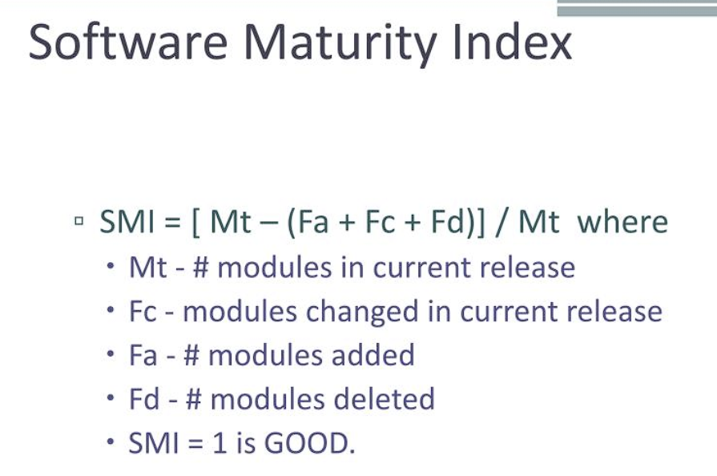
SMI=0.849≈0.85

Interpretation

Value close to 1 indicates higher software stability
and maturity

unadjusted function points

Given the following components of a software system:

35 Inputs

20 Outputs

10 Inquiries

6 Files

4 Interfaces

Calculate the unadjusted function points assuming average
complexity. Estimate the effort in person-months assuming a
productivity of 12 FP/PM.
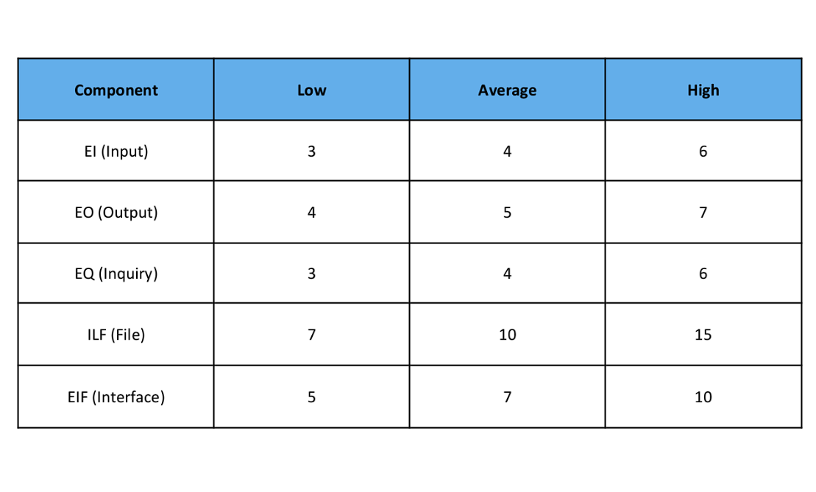

Step 1: Calculate Unadjusted Function Points (UFP)

UFP=(35×4)+(20×5)+(10×4)+(6×10)+(4×7)

UFP=368

Step 2: Estimate Effort

Effort = UPF / PRODUCTIVITY

=368/12

Effort = 31 persons/month

Software for system X has 24 individual functional
requirements and 14 nonfunctional requirements. What is
the specificity of the requirements and completeness?

Specificity

Specificity= Number of functional requirements

Total requirements​

= 24/(14+24) = 0.632

Completeness of Requirements

Completeness=Number of requirements specified​

Total expected requirements

Since all requirements are given and considered specified:

Completeness=1.0(𝑜𝑟100%)
3.A class X has 12 operations. cyclomatic complexity has been computed for all operations in the OO system, and the average value of module complexity is 4. For class X, the complexity for operations 1 to 12 is 5, 4, 3, 3, 6, 8, 2, 2, 5, 5, 4, 4, respectively. Compute the weighted methods per class.
WMC=∑Complexities of all methods

WMC=5+4+3+3+6+8+2+2+5+5+4+4

WMC=51

WMC

Higher WMC → Higher complexity → More effort
required for testing and maintenance

WMC = 51 indicates moderately high class complexity

WMC = sum of complexities (when individual
complexities are given)

If only average is given, then:

WMC=Number of methods×Average complexity

summary

DevOps combined with cloud operations results in faster
delivery, improved quality, cost efficiency, and
greater agility in software development and
deployment.

