TASK : Assign elastic ip address for ec2 instance

→Elastic IP = Static public IP provided by AWS

Step 1: Launch an EC2 Instance
Name: Eip-demo-ec2
Select AMI :Amazon Linux 2023 64-bit (x86) Select Free tier eligible
Instance Type: t2.micro
Key Pair: select or create the key pair
Network Settings:
- VPC: Default
- Subnet: Public subnet
- Auto-assign Public IP: Enable
Security Group :
- SSH – Port 22 – My IP
- HTTP – Port 80 – Anywhere

Click Launch Instance

Step 2: Assign elastic ip address for ec2 instance

Go to EC2 → Elastic IPs
Click Allocate Elastic IP
AWS creates a static public IP

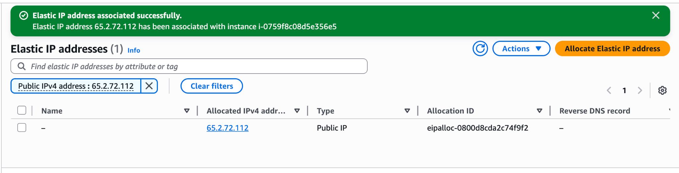

- Select the Elastic IP
- Click Actions → Associate Elastic IP
- Choose:
Resource type: Instance
Select your EC2 instance
Click Associate
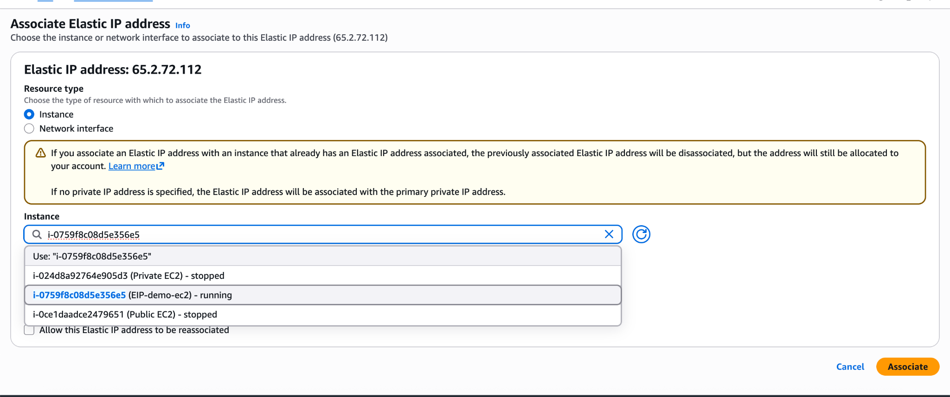
→ O/P: EC2 now uses Elastic IP for all internet traffic

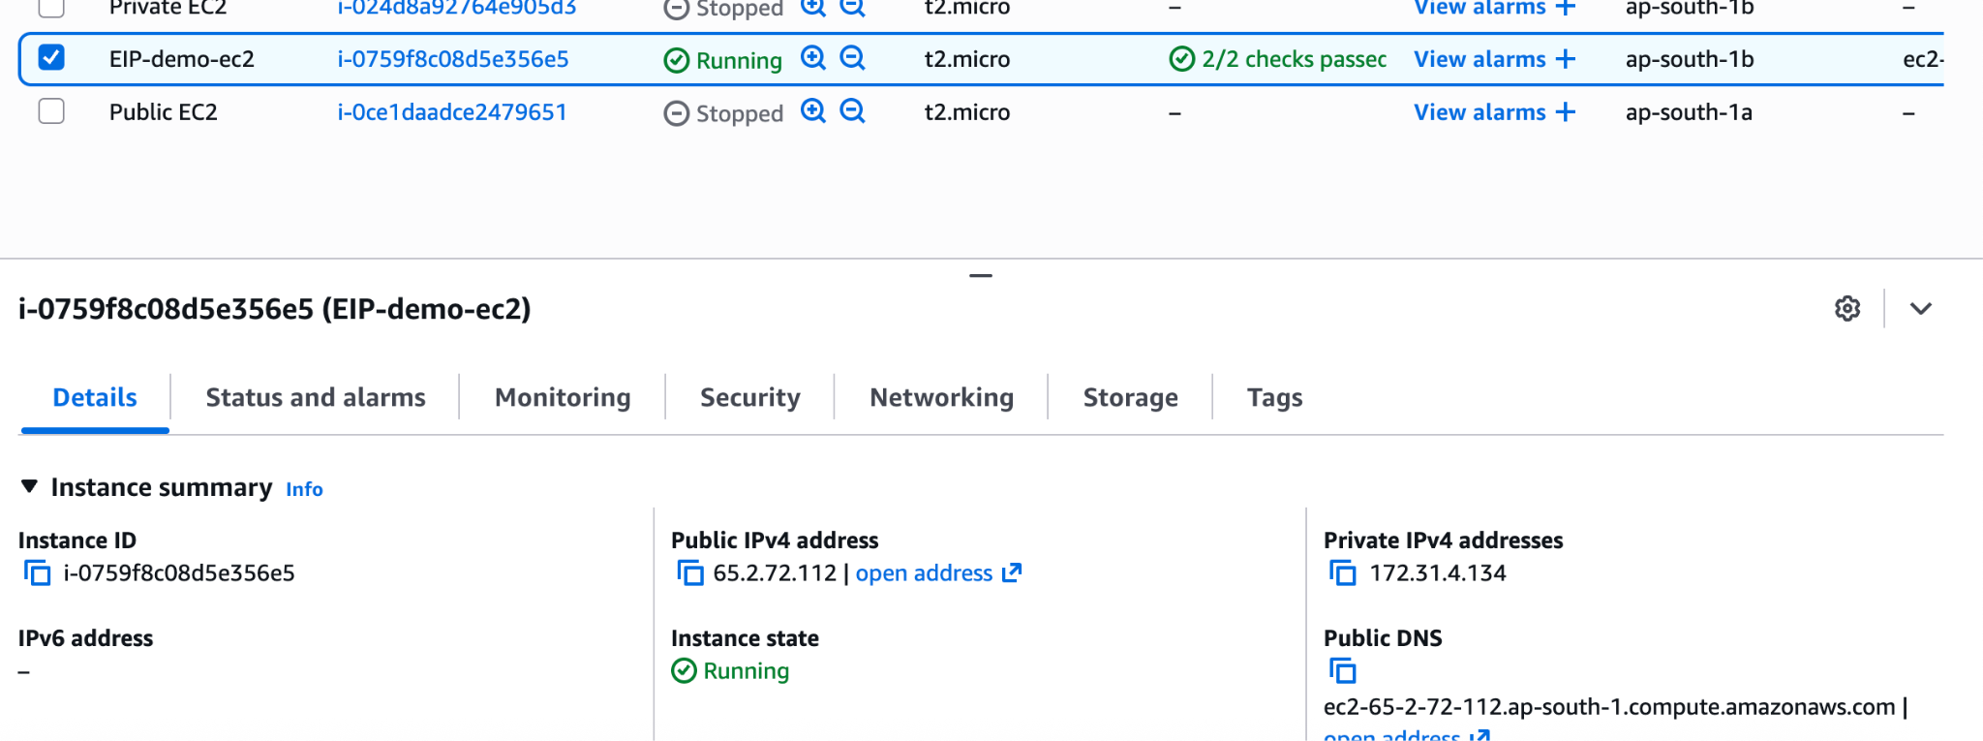

Advantage: if we stopped the instance also it having permanent IP address. If we are running any Jenkins server in that Instance at that time we need to use the static IP address and it should be the permanent IP address.

Step 3: If we dont want to use the elastic Ip address ( Deallocate Elastic IP for the EC2 instance)
Go to EC2 → Elastic IPs
Select the Elastic IP
Click Actions → Disassociate Elastic IP
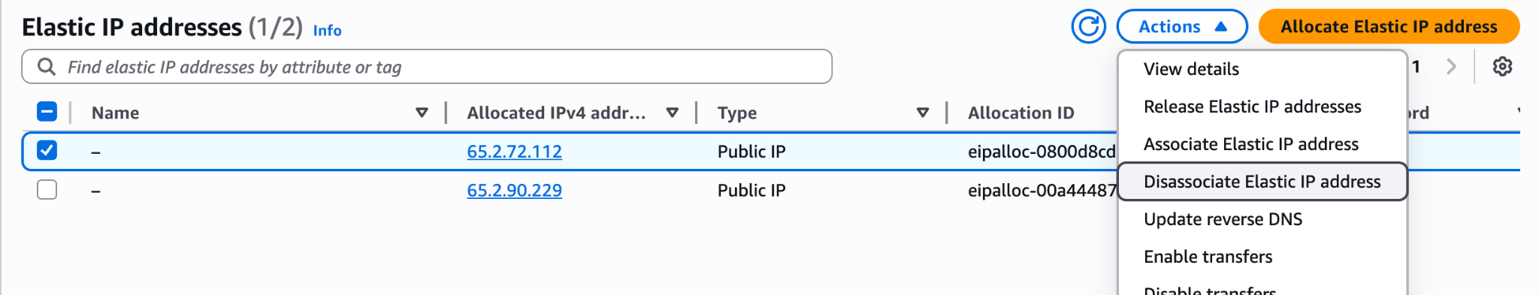
o/p: now the public Ip address will change . aws will automatically assign the ip address for the EC2 instance

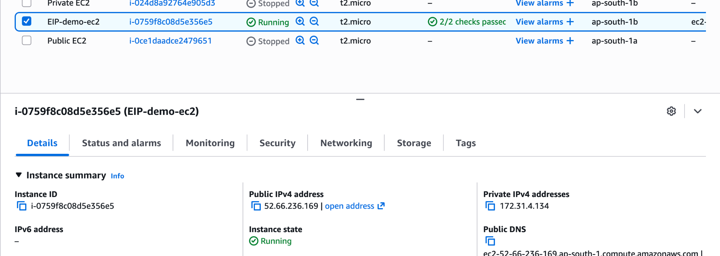

Step 4: If we want to delete the elastic Ip address permanently
Select the same Elastic IP
Click Actions → Release Elastic IP address
Confirm
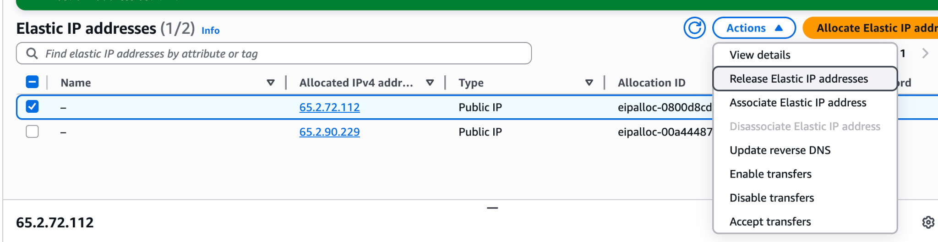

o/p:

