[Author name]



Report on FIFA 2018

Analysis (Power BI)

Contents

Prepare a rank ordered list of top 10 countries with most players. Which countries are producing the most numbers of footballers that plays at this level? 2

Plot the distribution of overall rating vs. age of players. Interpret what is the age after which a players stops improving? 2

Which type of offensive players tends to get paid the most: the striker, the right-winger, or the left-winger? Visualize through a scatter plot 3

Which club(s) have the maximum share of players from England? Which club(s) have the maximum share of players from Spain? Which club(s) have the maximum share of players from Germany? 3

Are the wages of a player influenced by the potential of a player? Check it out for players with age Between 16 to 28? 4

Do Strikers score higher on "Aggression" than defenders do? Group both the set of players (from an overall score of 80 to 85) and compare their average aggression levels. Which particular position has the highest aggression as a given (players with an overall score of 80 to 90)? 4

How based on the positional data, players are profiled for different roles/classes. Plot Aggression, Acceleration, Agility, Balance and Ball Control for strikers and Goal Keepers in a single line/Bar plot to understand the positional difference 5

Which clubs consists of the best future players? Consider only the players with Overall <86 and Potential >= 86, plot a graph to show which are the top 10 clubs with most number of best future players 5

How the best clubs in the world pay their players? Create a box plot of wages for FC Barcelona, Real Madrid, Paris Saint Germain, Manchester City, Liverpool, Juventus and Bayern Munich 6

# Prepare a rank ordered list of top 10 countries with most players. Which countries are producing the most numbers of footballers that plays at this level?

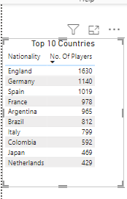

Most of the players are from England, Germany and Spain.

# Plot the distribution of overall rating vs. age of players. Interpret what is the age after which a players stops improving?

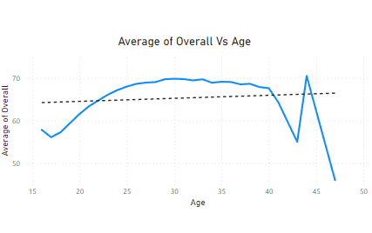

From Above Chart we can say that Players Overall Rating Started decreasing after age 40 but there are few exceptions where few players have a very good overall even at 43.

# Which type of offensive players tends to get paid the most: the striker, the right-winger, or the left-winger? Visualize through a scatter plot

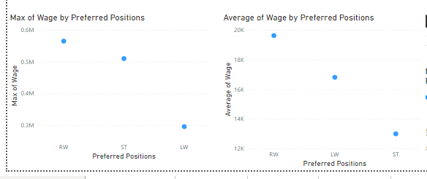

Right winger is paid the most and left winger is paid least in comparison to right, left winger and striker. But there is a crucial point that even though left winger is paid least compare to striker, average wage of left winger is high than the striker. Through which we can say that we have more number of left wingers than strikers.

Even though strikers have more wage but their average wage is least which we have to take a mark that what can be the reason behind this.

# Which club(s) have the maximum share of players from England? Which club(s) have the maximum share of players from Spain? Which club(s) have the maximum share of players from Germany?

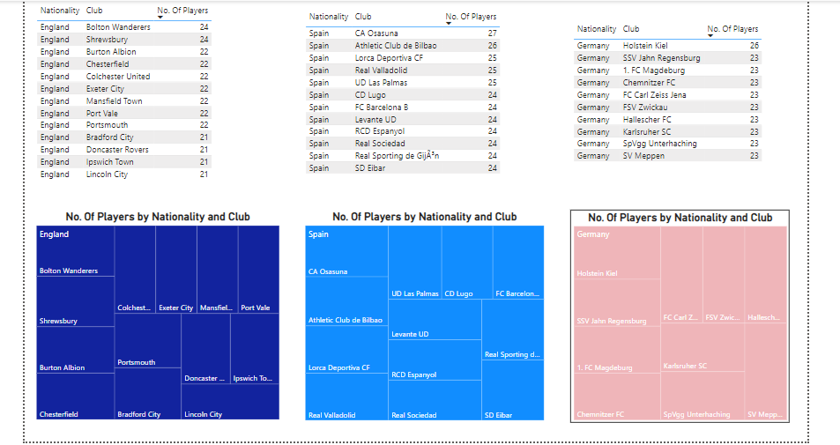

Above graphs have the information about the top clubs from England, Spain and Germany.

Even though England has more number of players, Athletic Club De Bilbao from Spain contributes more number of players in comparison with Germany and England.

# Are the wages of a player influenced by the potential of a player? Check it out for players with age Between 16 to 28?

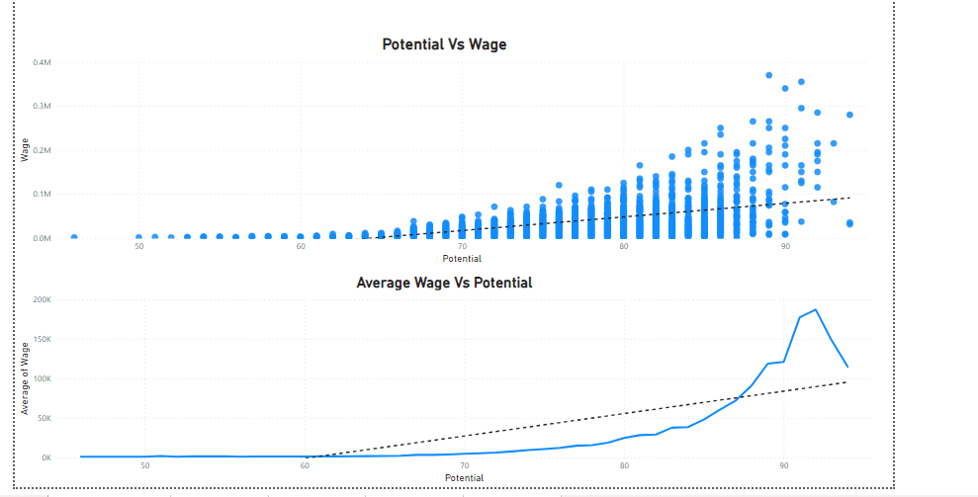

We can summarize that when potential is increasing wage is gradually decreasing.

The reason for this can be/ may be as the age increases, injuries and health issues may effect on number of matches they play which indirectly effecting their wage.

# Do Strikers score higher on "Aggression" than defenders do? Group both the set of players (from an overall score of 80 to 85) and compare their average aggression levels. Which particular position has the highest aggression as a given (players with an overall score of 80 to 90)?

# How based on the positional data, players are profiled for different roles/classes. Plot Aggression, Acceleration, Agility, Balance and Ball Control for strikers and Goal Keepers in a single line/Bar plot to understand the positional difference

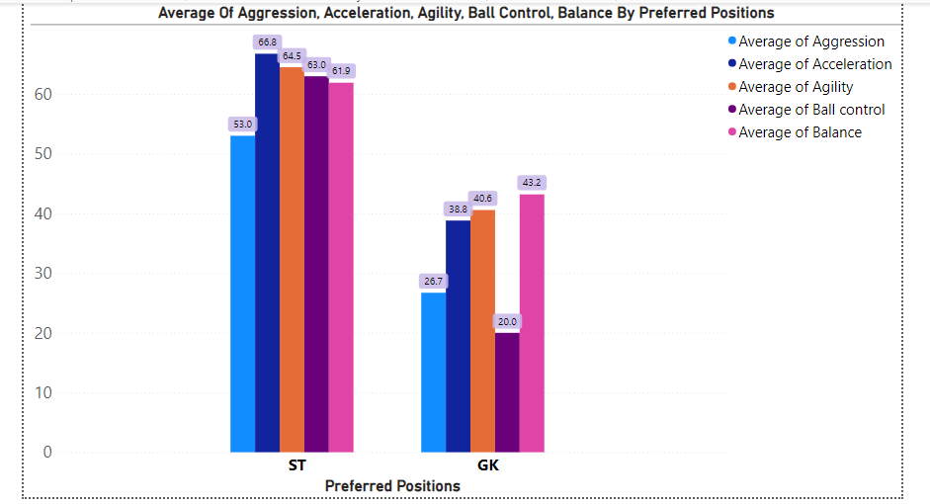

In comparison with striker and goal keeper, striker have high ability in all aspects like aggression, acceleration, agility, ball control and balance.

# Which clubs consists of the best future players? Consider only the players with Overall <86 and Potential >= 86, plot a graph to show which are the top 10 clubs with most number of best future players

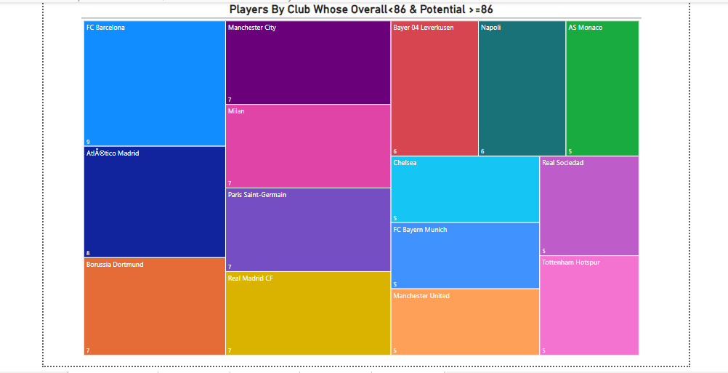

Below are the clubs that consists of best future players:

* FC Barcelona
* Atlactico Madrid
* Borussia Dortmund
* Manchester City
* Milan
* Paris Saint Germain
* Real Madrid CF
* Bayer 04 Leverkusen
* Napoli
* As Monaco

# How the best clubs in the world pay their players? Create a box plot of wages for FC Barcelona, Real Madrid, Paris Saint Germain, Manchester City, Liverpool, Juventus and Bayern Munich