**3.5 GSM**

SM is a mobile communication modem; it is stands for global system for mobile communication (GSM). The idea of GSM was developed at Bell Laboratories in 1970.  It is widely used mobile communication system in the world. GSM is an open and digital cellular technology used for transmitting mobile voice and data services operates at the 850MHz, 900MHz, 1800MHz and 1900MHz frequency bands.

GSM system was developed as a digital system using time division multiple access (TDMA) technique for communication purpose. A GSM digitizes and reduces the data, then sends it down through a channel with two different streams of client data, each in its own particular time slot. The digital system has an ability to carry 64 kbps to 120 Mbps of data rates.

[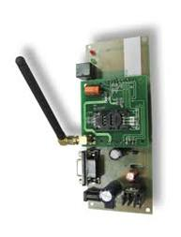](https://www.elprocus.com/wp-content/uploads/2013/07/GMS-Modem.jpg)GSM Modem

There are various cell sizes in a GSM system such as macro, micro, pico and umbrella cells. Each cell varies as per the implementation domain. There are five different cell sizes in a GSM network macro, micro, pico and umbrella cells. The coverage area of each cell varies according to the implementation environment.

**Time Division Multiple Access**

TDMA technique relies on assigning different time slots to each user on the same frequency. It can easily adapt to data transmission and voice communication and can carry 64kbps to 120Mbps of data rate.

**GSM Architecture**

A GSM network consists of the following components:

* **A Mobile Station:**  It is the mobile phone which consists of the transceiver, the display and the processor and is controlled by a SIM card operating over the network.
* **Base Station Subsystem:** It acts as an interface between the mobile station and the network subsystem. It consists of the Base Transceiver Station which contains the radio transceivers and handles the protocols for communication with mobiles. It also consists of the Base Station Controller which controls the Base Transceiver station and acts as a interface between the mobile station and mobile switching centre.
* **Network Subsystem:** It provides the basic network connection to the mobile stations. The basic part of the Network Subsystem is the Mobile Service Switching Centre which provides access to different networks like ISDN, PSTN etc. It also consists of the Home Location Register and the Visitor Location Register which provides the call routing and roaming capabilities of GSM. It also contains the Equipment Identity Register which maintains an account of all the mobile equipments wherein each mobile is identified by its own IMEI number. IMEI stands for International Mobile Equipment Identity.

**Features of GSM Module:**

* Improved spectrum efficiency
* International roaming
* Compatibility with integrated services digital network (ISDN)
* Support for new services.
* SIM phonebook management
* Fixed dialing number (FDN)
* Real time clock with alarm management
* High-quality speech
* Uses encryption to make phone calls more secure
* Short message service (SMS)

The security strategies standardized for the GSM system make it the most secure telecommunications standard currently accessible. Although the confidentiality of a call and secrecy of the GSM subscriber is just ensured on the radio channel, this is a major step in achieving end-to- end security.

**GSM Modem**

A GSM modem is a device which can be either a mobile phone or a modem device which can be used to make a computer or any other processor communicate over a network. A GSM modem requires a SIM card to be operated and operates over a network range subscribed by the network operator.  It can be connected to a computer through serial, USB or GSM connection.

A GSM modem can also be a standard GSM mobile phone with the appropriate cable and software driver to connect to a serial port or USB port on your computer. GSM modem is usually preferable to a GSM mobile phone. The GSM modem has wide range of applications in transaction terminals, supply chain management, security applications, weather stations and GPRS mode remote data logging.

**Working of GSM Module:**

From the below circuit, a GSM modem duly interfaced to the MC through the level shifter IC Max232. The SIM card mounted GSM modem upon receiving digit command by SMS from any cell phone send that data to the MC through serial communication. While the program is executed, the GSM modem receives command ‘STOP’ to develop an output at the MC, the contact point of which are used to disable the ignition switch. The command so sent by the user is based on an intimation received by him through the GSM modem ‘ALERT’ a programmed message only if the input is driven low. The complete operation is displayed over 16×2 LCD display.

[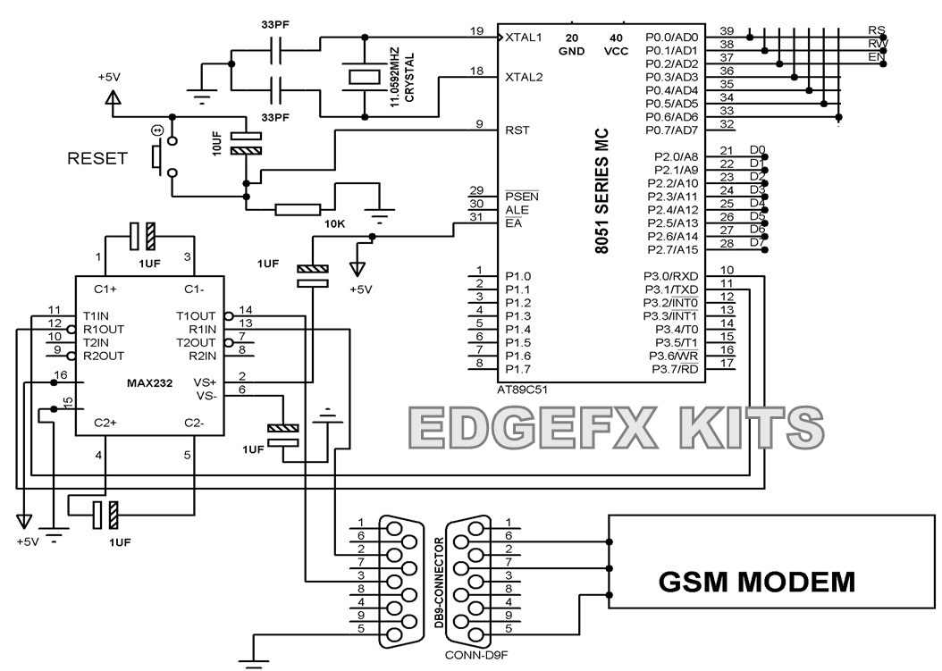](https://www.elprocus.com/wp-content/uploads/2013/07/GMS-Modem-Circuit.jpg)GMS Modem Circuit

**Intelligent GSM Device for Automation and Security**

In these days, the GSM mobile terminal has become one of the items that are constantly with us. Just like our wallet/purse, keys or watch, the GSM mobile terminal provides us a communication channel that enables us to communicate with the world. The requirement for a person to be reachable or to call anyone at any time is very appealing.

In this project, as the name says project is based on GSM network technology for transmission of SMS from sender to receiver. SMS sending and receiving is used for ubiquitous access of appliances and allowing breach control at home. The system proposes two sub-systems. Appliance control subsystem enables the user to control home appliances remotely and the security alert subsystem gives the automatic security monitoring.

The system is capable enough to instruct user via SMS from a specific cell number to change the condition of the home appliance according to the user’s needs and requirements. The second aspect is that of security alert which is achieved in a way that on the detection of intrusion, the system allows automatic generation of SMS thus alerting the user against security risk. GSM will allow communication anywhere, anytime, and with anyone. The functional architecture of GSM employing intelligent networking principles, and its ideology, which provides the development of GSM is the first step towards a true personal communication system that enough standardization to ensure compatibility.