# **MAX30100 - Heart Rate Oxygen Pulse Sensor**

### **Description of MAX30100**

MAX30100 is a multipurpose sensor used for multiple applications. It is a **heart rate monitoring** sensor along with a **pulse oximeter**. The sensor comprises two [Light Emitting Diodes](https://components101.com/tags/led), a photodetector, and a series of low noise signal processing devices to detect heart rate and to perform pulse oximetry.

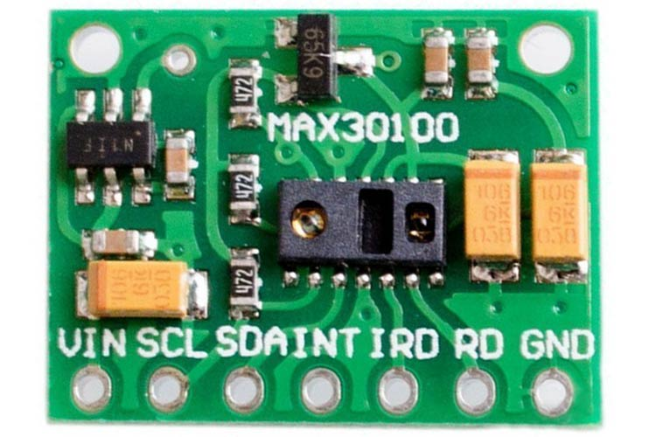

### **Features of MAX03100**

Here are some of the features and specifications of the MAX03100 Heart Rate Oxygen pulse sensor.

1. Operating Voltage - 1.8V to 3.3V
2. Input Current - 20mA
3. Integrated Ambient Light Cancellation
4. High Sample Rate Capability
5. Fast Data Output Capability

### **Pin Configuration of MAX30100 Oximeter Module**

Below is the pin configuration of the MAX30100 module. It is a 7 pin sensor module with an enabled I2C communication protocol to interact with the microcontroller.

|  |  |
| --- | --- |
| **Pin Type** | **Pin Function** |
| VIN | Voltage Input |
| SCL | I2C - Serial Clock |
| SDA | I2C - Serial Data |
| INT | Active low interrupt |
| IRD | IR LED Cathode and LED Driver Connection Point(Leave floating in the circuit) |
| RD | Red LED Cathode and LED Driver Connection Point(Leave floating in the circuit) |
| GND | Ground pin |

Note: There are two module versions of the MAX30100 sensor module. The one which we have showcased is the 7-pin version, whereas there is a 5-pin version as well which does not have IRQ and RD pin.

The 5-pin module is considered to be more accurate as the circuitry for the module is on the other side of the sensor.

### **Alternatives for MAX30100**

Pulse 3+, Proto Central AFE4490, ROHM BH1792GLC, FSH 7060

### **Equivalent for MAX30100**

MAX30102

**Note:**More technical information can be found in the **MAX30100 Datasheet** linked at the bottom of this page.

### **Working of the MAX30100 Oximeter**

**Working of an oximeter:**

The sensor consists of a pair of Light-emitting diode which emits monochromatic red light at a wavelength of 660nm and infrared light at a wavelength of 940 nm. These wavelengths are particularly chosen as at this wavelength oxygenated and deoxygenated hemoglobin have very different absorption properties. As shown in the graph below, it can be seen that there is a difference between HbO2(oxygenated Hb) and Hb(deoxygenated Hb) when subjected to these specific wavelengths.