AIRLINE RESERVATION SYSTEM

PROJECT DESCRIPTION
The Airline Reservation System is a database management project developed using MySQL to manage passenger details, flight information, bookings, and reservations. It stores and organizes airline-related data efficiently. SQL queries, joins, aggregate functions, and subqueries are used to retrieve and analyse data. The system helps maintain accurate records and simplifies reservation management. This project demonstrates practical knowledge of database design and SQL operations.

ER DIAGRAM

Table Schema:
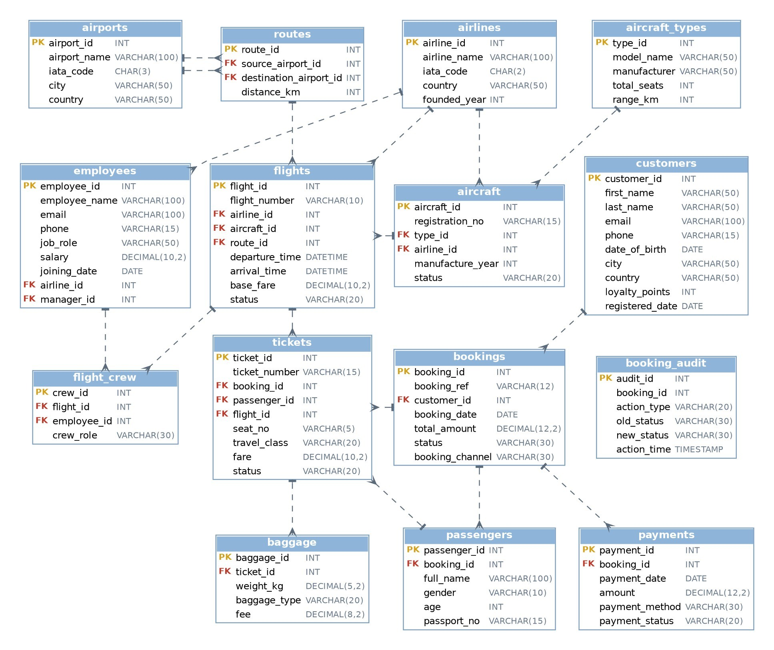

BASIC LEVEL
- Write a query to find all passengers whose age is above 65.
- Retrieve all flights scheduled for today.
- Find the total number of customers available in each city.
- Display all pilots working for Air India.
- Find the total number of flights handled by each pilot (captain).
- Retrieve customers who do not have any booking.
- Find all bookings where the total amount exceeds ₹50,000.
- Display the top 10 highest payment amounts.
- Find the total number of active aircraft for each airline.
- Retrieve all bookings with status = 'Cancelled'.
- Find the average passenger age grouped by gender.
- Retrieve pilots having more than 10 years of experience.
- Find the total number of baggage items checked in by each customer.
- Display all aircraft types with seat capacity below 200.
- Find all customers who booked more than once.
- Retrieve airlines having more than 20 employees.
- Find all payments that are still pending.
- Display the latest 20 booking records.
- Find the total airline revenue generated through payments.
- Retrieve the count of bookings month-wise.

INTERMEDIATE LEVEL
- Find the top 5 pilots who handled the highest number of completed flights.
- Retrieve customers who have booked tickets in multiple airlines.
- Find the airline generating the maximum revenue.
- Display customers who made more than 10 bookings.
- Find the most booked route in the airline system.
- Retrieve airlines whose average base fare is above the overall average fare.
- Retrieve the second highest spending customer.
- Find flights where most of the tickets are cancelled.
- Retrieve the average ticket fare generated by each airline.
- Find the top 10 cities generating maximum airline revenue.
- Display routes that are operated by more than 4 different airlines.
- Find customers who have bookings but never completed a journey. -- Retrieve all duplicate passenger records based on passport number.
- Find the percentage contribution of each airline to total revenue.
- Find the percentage contribution of each travel class to total revenue.
- Display airline performance rank using: Total flights, Revenue generated, Total passengers.

ADVANCED SQL (STORED PROCEDURE, TRIGGERS)
- 1.Write a query to identify suspicious payments where payment amount exceeds booking amount.
- Find customers who rebook the same route within 7 days.
- 3.Detect duplicate tickets for the same passenger (passport) on the same flight.
- Payment status automation: create a trigger on payments so that a booking becomes 'Confirmed' when it is fully paid, stays 'Pending' when it is only partly paid, and an overpayment is logged as suspicious in booking_audit.
- Duplicate ticket prevention: create a stored procedure that books a ticket (booking, passenger, ticket and payment) and stops with an error if the same passport already has an active ticket on that flight.
- Aircraft maintenance: create a stored procedure that changes an Active aircraft to 'Maintenance' and raises an error if the aircraft does not exist or is already under maintenance.

