PROJECT DOCUMENTATION

Auto Ticket Classification
using Flow Designer
ServiceNow Incident Management Automation

Team ID | SWTID-2026-1373
Team Size | 4
Team Leader | Santhoshi.P
Email | santhoshiprem67@gmail.com
Team Member | Preethika.S
Email | viswajipreethi@gmail.com
Team Member | Priyadharashini N
Email | ppriya14347@gmail.com
Team Member | Lalithavalli M
Email | lalithavalli6@gmail.com

Platform: ServiceNow • Workflow tool: Flow Designer

1. Introduction

1.1 Project Overview
Auto Ticket Classification using Flow Designer is a ServiceNow incident-management project that aims to make incoming incident records easier to organise by applying classification rules to information such as Category, Subcategory, and Short Description. Instead of relying entirely on a support agent to classify every ticket manually, a Flow Designer flow can evaluate the incident details and apply the configured classification or routing actions.

1.2 Problem Statement
Incident records may be created with incomplete or inconsistent classification. When category and subcategory values are selected manually, tickets can be misclassified, sent to the wrong support team, or take longer to process. A repeatable automated process can improve consistency and help support teams identify the type of issue more quickly.

1.3 Objectives
- Create and review incident records in ServiceNow.
- Use Flow Designer to build an automation flow for incident classification.
- Define classification conditions using incident fields such as Category, Subcategory, and Short Description.
- Apply appropriate classification values and, where configured, route the incident to the responsible assignment group.
- Test the flow with representative incident records and check the resulting field values.

1.4 Scope
The project focuses on incident-field classification and the Flow Designer configuration required to automate the process. Assignment-group routing can be included when the relevant rules and groups are configured. Advanced AI-based classification, external integrations, and production deployment are outside the demonstrated scope unless separately implemented.

2. Proposed Solution

2.1 Solution Overview
The proposed solution uses a Flow Designer flow that starts when an incident is created or updated. The flow checks selected incident fields against agreed rules and updates classification fields or assignment details when a rule matches. The exact conditions and actions should be adjusted to the organisation’s incident categories and support structure.

2.2 Proposed Process Flow
- A user or support agent creates an incident record.
- The flow is triggered by the configured incident event.
- The flow reads the incident fields, including Category, Subcategory, and Short Description.
- If/Else conditions evaluate the ticket details against the classification rules.
- The matching branch updates the appropriate classification fields and optionally the assignment group.
- The incident is saved and the agent reviews the result.

2.3 Example Classification Rules
Example condition | Suggested classification | Possible next action
Category = Hardware | Hardware incident | Route to hardware support if a group is configured
Category = Software | Software incident | Route to software support if a group is configured
Short Description contains “projector” | Audio/visual or projector issue | Use the organisation’s approved category and subcategory
Category or Subcategory is empty | Needs review | Leave for manual classification or set a review flag
These are illustrative rules, not confirmed values from the screenshots. Use the exact choices available in the target ServiceNow instance.

3. Tools and Components
- ServiceNow Incident Management – stores incident details and classification fields.
- Flow Designer / Workflow Studio – creates, tests, and manages the automation flow.
- Incident trigger – starts the flowwhen an incident is created or updated, depending on the selected configuration.
- Flow logic (If/Else) – checks classification conditions.
- Update Record or equivalent action – writes the chosen field values back to the incident.
- Assignment Group field – optionally routes incidents to the relevant team.

4. Implementation Procedure

4.1 Open Flow Designer
- Sign in to the ServiceNow instance with a role that allows flow creation.
- Open Workflow Studio / Flow Designer from the application navigator.
- Select New and choose Flow. Give the flow a clear name such as “Auto Ticket Classification”.
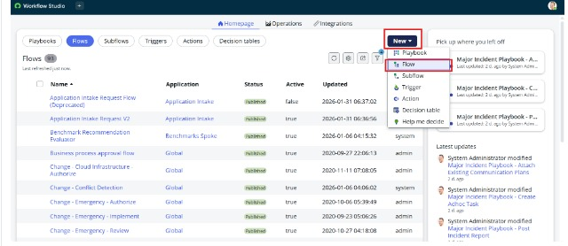
Figure 1. Workflow Studio menu showing the option to create a new Flow.

4.2 Review the Incident Fields
Open an incident record and identify the fields that will drive classification. The supplied screenshot shows an incident with Category set to Hardware, Subcategory set to Projector, and a Short Description describing a projector problem. This is an example of the field data that can be used as flow conditions.
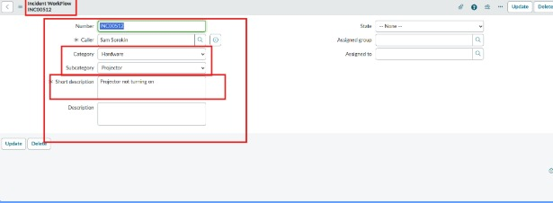
Figure 2. Example incident record with Category, Subcategory, and Short Description fields.

4.3 Configure the Flow Trigger and Conditions
- Choose an incident-based trigger that matches the required behaviour, such as when an incident is created or when an incident is created or updated.
- Add If/Else logic to test Category, Subcategory, or keywords in Short Description.
- For each branch, define the required classification result. Avoid repeatedly updating the record if the values already match.
- Add an Update Record action to set the approved fields. If routing is required, set Assignment Group only when a valid group mapping exists.
- Save and test the flow with sample incidents before activating it.

4.4 Review Application Navigation and Configuration
The supplied navigation screenshot shows search results for System Update Sets / Local Update Sets. Update sets may be useful for capturing configuration changes when the instance and permissions support that workflow, but this screenshot does not itself demonstrate ticket-classification logic.
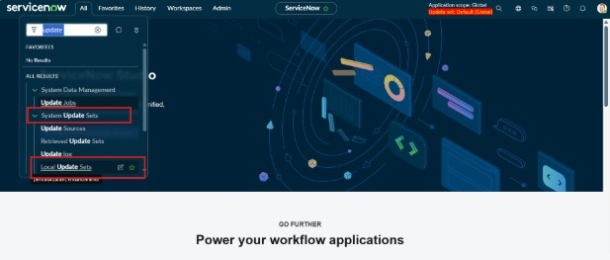
Figure 3. ServiceNow application navigator showing update-set search results.

4.5 Dictionary / Field Configuration Reference
The supplied screenshot shows a context menu with Configure Dictionary for an incident field. Dictionary configuration should only be changed when necessary and with appropriate permissions. For this project, the primary implementation should use the existing incident fields and choices unless a clear requirement calls for a schema change.
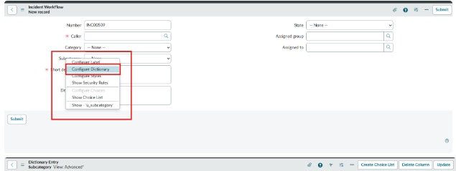
Figure 4. Incident field context menu showing Configure Dictionary.

5. Testing and Validation
Run these tests after the flow has been configured. The screenshots supplied establish the ServiceNow navigation, an example incident record, and the entry point for creating a flow; they do not show a completed classification flow or its execution results. Mark each test Pass only after performing it in the instance.
Test | Input / action | Expected result | Result
T1 | Create incident with Category = Hardware | Flow evaluates the record and applies the configured hardware rule | To be tested
T2 | Create incident with Category = Software | Software rule is applied correctly | To be tested
T3 | Create incident with missing classification values | Fallback or manual-review behaviour follows the design | To be tested
T4 | Use a Short Description with a configured keyword | The correct rule branch is selected | To be tested
T5 | Review the updated incident | Classification values and any assignment group are correct | To be tested
T6 | Update an existing incident | Flow does not create repeated updates or an unwanted loop | To be tested

6. Benefits
- Improves consistency in incident classification.
- Reduces repetitive manual field selection when rules match.
- Can help route incidents to the appropriate support group when group mappings are configured.
- Makes classification rules easier to review and maintain in one flow.
- Provides a foundation for future enhancements such as notifications and reporting.

7. Limitations and Future Enhancements

7.1 Limitations
- The supplied screenshots do not show a finished flow, its configured conditions, or a successful flow execution.
- Keyword-based rules may not understand ambiguous descriptions and should be tested against real examples.
- Automatic assignment depends on correct group names, permissions, and routing rules.

7.2 Future Enhancements
- Add more detailed category and subcategory mappings approved by the service desk.
- Add notifications when classification or assignment changes.
- Create reports to monitor misclassified or unassigned incidents.
- Use prediction or AI-based classification only if the instance has the required capability and governance approval.
- Add error handling and audit-friendly flow descriptions.

8. Conclusion
Auto Ticket Classification using Flow Designer proposes a practical way to standardise incident classification in ServiceNow. By evaluating incident fields and applying explicit rules, a flow can reduce repetitive manual work and support consistent handling. The supplied screenshots are included as configuration references; the flow rules and test outcomes must be completed and verified in the ServiceNow instance before claiming successful automation.

9. Team Details
Role | Name | Email
Team Leader | Santhoshi.P | santhoshiprem67@gmail.com
Team Member | Preethika.S | viswajipreethi@gmail.com
Team Member | Priyadharshini.N | ppriya14347@gmail.com
Team Member | Lalithavalli.M | lalithavalli6@gmail.com

Appendix A – Screenshot Inventory
Figure 1: Workflow Studio New menu. Figure 2: Incident record with classification fields. Figure 3: Application navigator showing update sets. Figure 4: Configure Dictionary context menu. The update-set screenshot was supplied twice; one copy is included to avoid duplicating the same evidence.

