**AIR QUALITY MONITORING**

**Air quality monitoring systems**

To provide a comprehensive overview of a project, including its objectives, IoT device setup, platform development, and code implementation, let's consider an example project: "Smart Air Quality Monitoring System." This project aims to develop an IoT-based system to monitor and manage indoor air quality in homes and offices. The system will use sensors to measure air quality parameters and provide real-time data through a web-based platform and a mobile app.

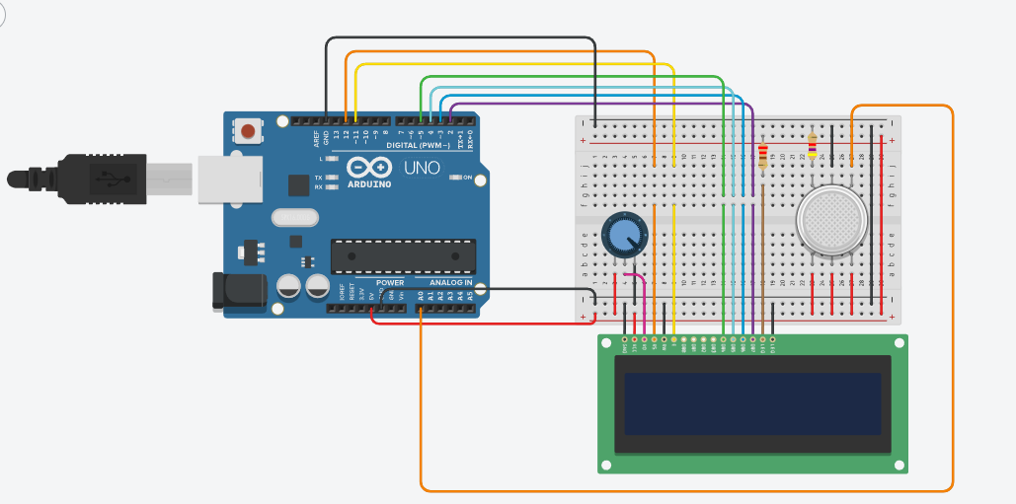

**Project Objectives:**

1.Develop a cost-effective and user-friendly smart air quality monitoring system.

2.Measure and monitor indoor air quality parameters, including temperature, humidity, CO2 levels, and particulate matter (PM2.5).

3.Provide real-time data visualization and alerts to users through a web platform and a mobile app.

4.Enable users to track historical air quality data and receive actionable recommendations for improving indoor air quality.

5.Promote awareness of air quality and its impact on health and well-being.

**IoT Device Setup**:

**Sensors:** Select and install appropriate sensors for measuring temperature, humidity, CO2 levels, and PM2.5. Connect these sensors to a microcontroller or IoT module (e.g., Arduino, Raspberry Pi, or dedicated IoT hardware).

**Data Transmission:** Use Wi-Fi or another suitable communication protocol to transmit data from the sensors to a cloud server. Ensure data security and encryption during transmission.

**Power Supply:** Provide a stable power source for the IoT devices, which can be battery-powered or connected to a continuous power supply.

Housing: Design protective enclosures for the sensors and IoT hardware to ensure their longevity and performance in indoor environments.

**Platform Development:**

**Cloud Backend:** Set up a cloud server to receive and store the data from the IoT devices. AWS, Azure, Google Cloud, or other cloud platforms can be used for this purpose.

**Database:** Create a database to store historical sensor data, user profiles, and device information.

**Web Platform:** Develop a web-based dashboard for users to access real-time air quality data, historical trends, and settings. Use technologies like HTML, CSS, and JavaScript for the front-end and backend frameworks like Node.js or Django.

**Mobile App:** Build a mobile application (iOS and Android) that syncs with the IoT devices and cloud server, providing users with on-the-go access to air quality information and notifications.

**User Authentication:** Implement user authentication and authorization mechanisms to protect user data and device control.

**Alert System:** Develop an alert system that can send push notifications, emails, or SMS messages to users when air quality parameters exceed defined thresholds.

**Data Visualization:** Create interactive charts and graphs to visualize air quality data, historical trends, and recommendations for improving indoor air quality.

**Machine Learning:** Implement machine learning algorithms to analyze air quality data and provide actionable recommendations for users to enhance indoor air quality.

**Schematics**

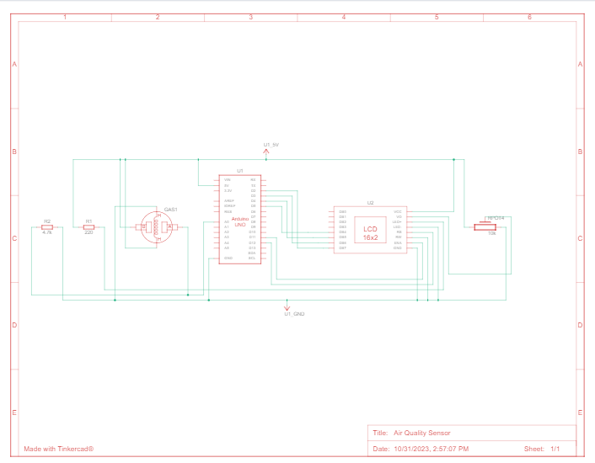

**IoT Device Setup:**

**Hardware Components:**

1.Sensors for temperature, humidity, CO2 levels, and PM2.5.

2.Microcontroller or IoT module (e.g., Arduino, Raspberry Pi).

3.Power supply (battery or continuous power source).

4.Sensor enclosures.

**Data-Sharing Platform:**

**Cloud Backend:**

1.Cloud server hosted on platforms like AWS, Azure, or Google Cloud.

2.Database to store sensor data, user profiles, and device information.

3.APIs for data communication between IoT devices and the server.

**Web Platform:**

1.User authentication and authorization system.

2.Real-time data visualization dashboard displaying air quality parameters.

3.Historical data trends and charts.

4.Device control settings.

5.An alert system for notifications.

**Mobile App:**

1.User login and registration.

2.Real-time data display.

3.Historical data access.

4.Push notification settings for alerts.

**Machine Learning Integration:**

Machine learning models would be integrated into the cloud backend to analyze air quality data and provide recommendations. This is not typically represented in a diagram but would involve code implementation within the server.

**Website:**

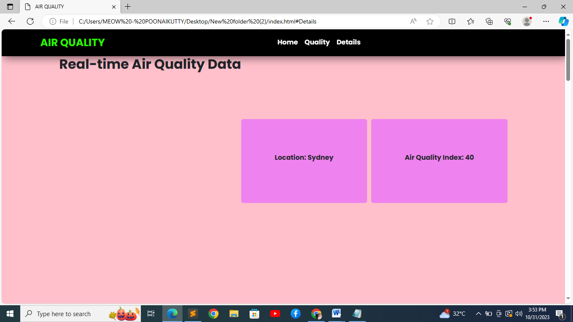

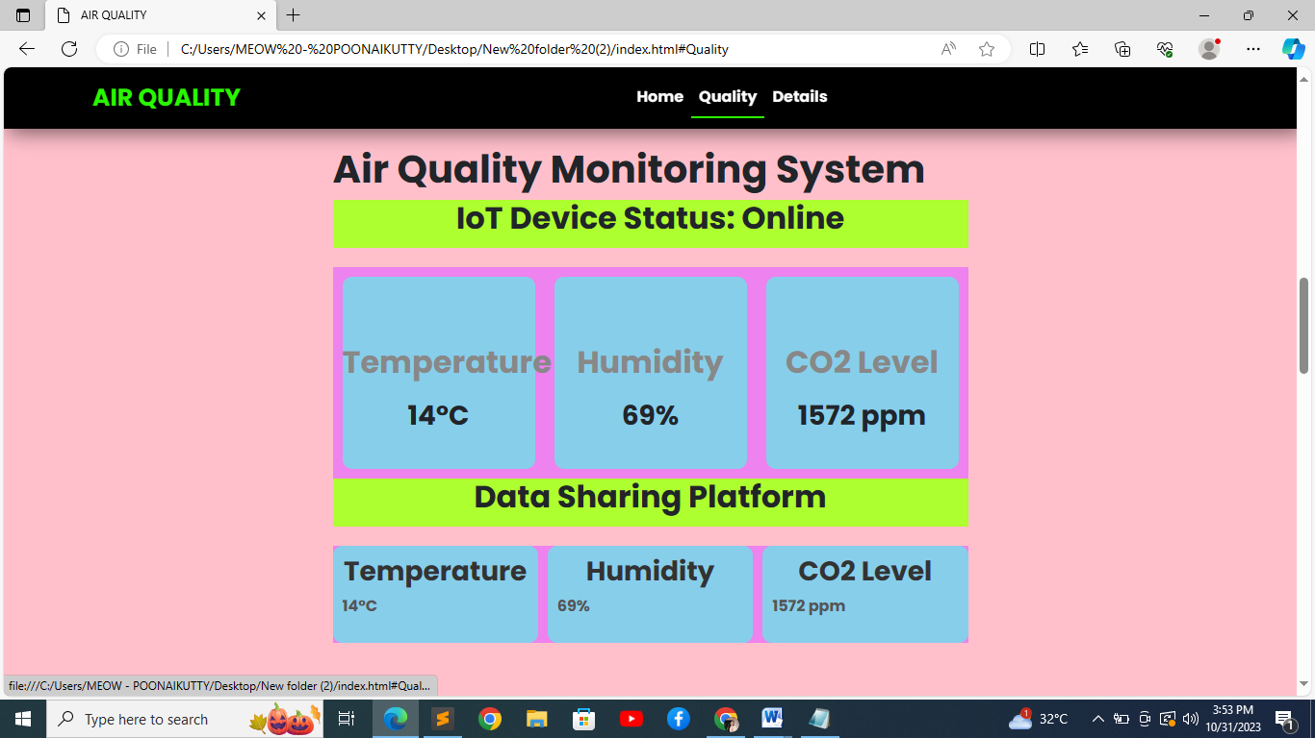

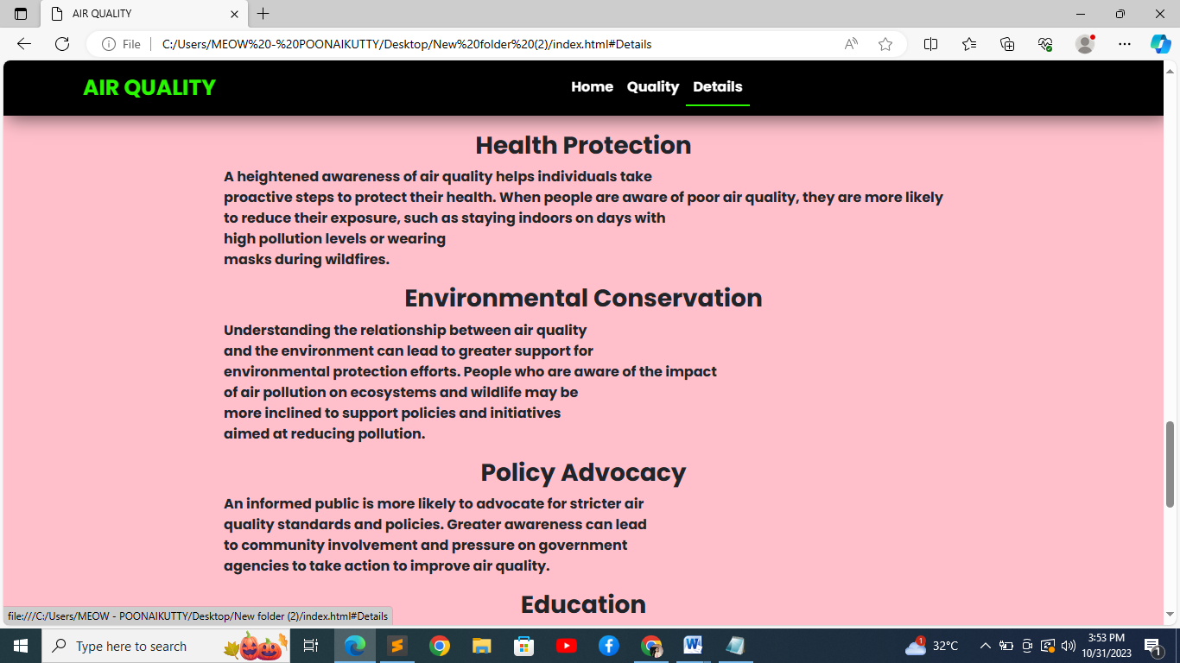

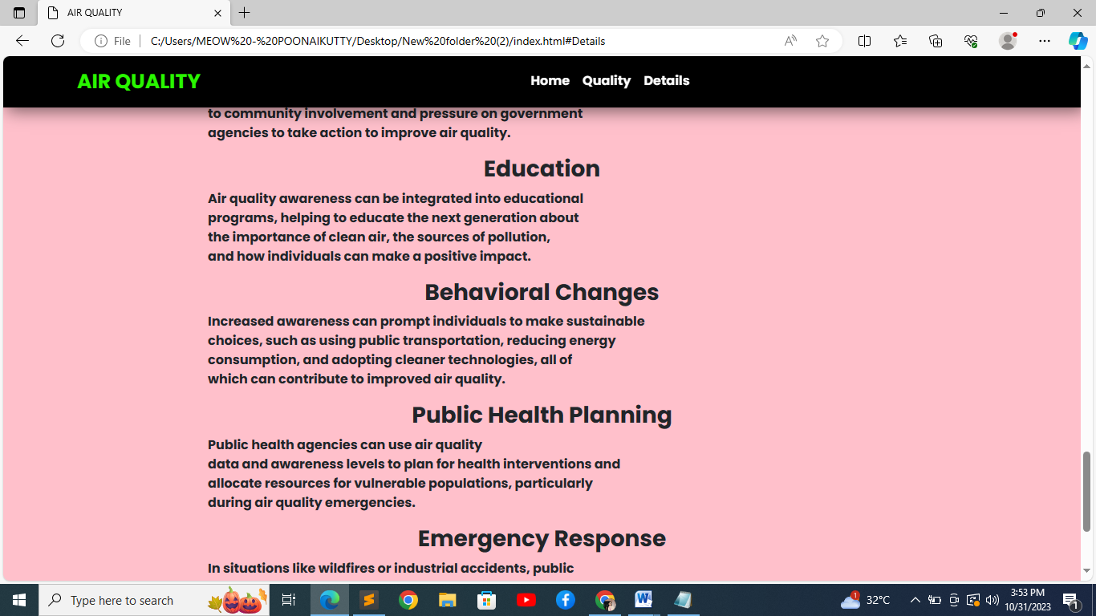

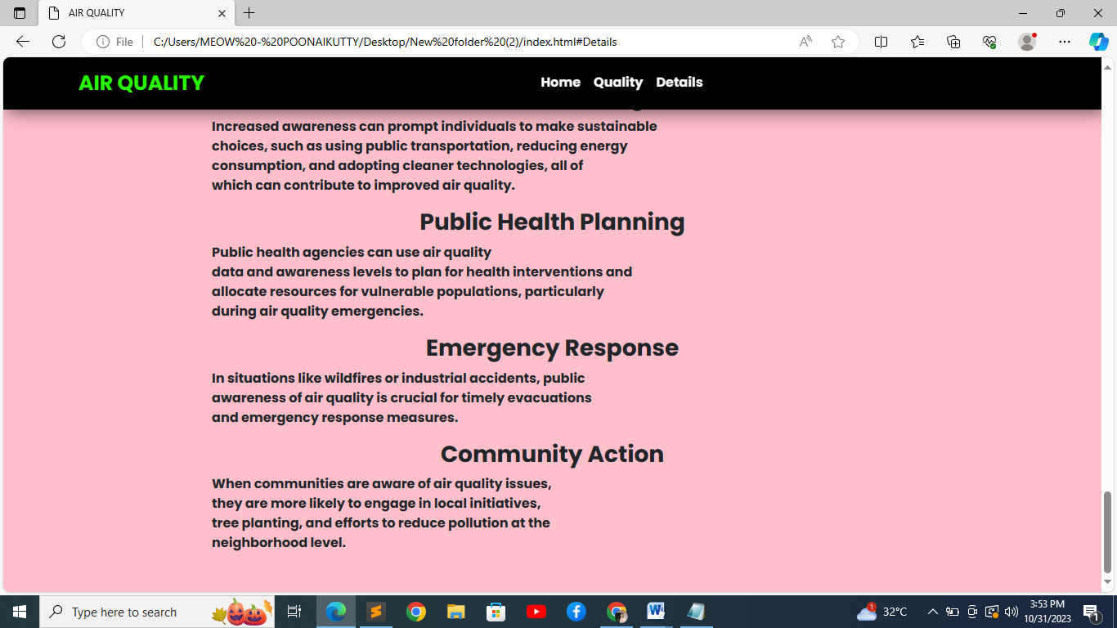

**//Html code**

<!DOCTYPE html>

<html>

<head>

<meta charset="utf-8">

<meta name="viewport" content="width=device-width, initial-scale=1">

<title>AIR QUALITY</title>

<link rel="stylesheet" type="text/css" href="style.css">

<link href="https://cdn.jsdelivr.net/npm/bootstrap@5.3.1/dist/css/bootstrap.min.css" rel="stylesheet">

<script src="java.js"></script>

</head>

<body style="background:url('C:\Users\MEOW - POONAIKUTTY\Desktop\New folder (2)')">

<!--navbar-->

<nav class="navbar navbar-expand-lg navbar-dark" id="navbar">

<div class="container-fluid">

<a class="navbar-brand" href="#">AIR QUALITY </a>

<button class="navbar-toggler" type="button"

data-bs-toggle="collapse"

data-bs-target="#navbarsupportedcontent"

aria-controls="navbarSupportedContent" aria-expanded="false"

aria-label="Toggle navigation">

<span class="navbar-toggler-icon"></span>

</button>

<div class="collapse navbar-collapse"

id="navbarSupportedContent">

<ul class="navbar-nav mx-auto">

<li class="nav-item">

<a class="nav-link" href="#Home">Home</a>

</li>

<li class="nav-item">

<a class="nav-link" href="#Quality"> Quality</a>

</li>

<li class="nav-item">

<a class="nav-link" href="#Details">Details</a>

</li>

</ul>

</div>

</div>

</nav>

<!----Home--->

<section id="Home">

<h2>Real-time Air Quality Data</h2>

<div id="dataContainer">

<div id="locationContainer"></div>

<div id="airQualityContainer"></div>

</div>

</section>

<!----Quality---->

<section id="Quality">

<div>

<h1>Air Quality Monitoring System</h1>

<div id="device-status">

<h2>IoT Device Status: Online</h2>

</div>

<div id="sensors">

<div class="sensor">

<h2>Temperature</h2>

<h3 id="temperature">0°C</h3>

</div>

<div class="sensor">

<h2>Humidity</h2>

<h3 id="humidity">0%</h3>

</div>

<div class="sensor">

<h2>CO2 Level</h2>

<h3 id="co2-level">0 ppm</h3>

</div>

</div>

<div id="data-platform">

<h2>Data Sharing Platform</h2>

</div>

<div id="data">

<div class="data-card">

<h3>Temperature</h3>

<p id="data-temperature">0°C</p>

</div>

<div class="data-card">

<h3>Humidity</h3>

<p id="data-humidity">0%</p>

</div>

<div class="data-card">

<h3>CO2 Level</h3>

<p id="data-co2-level">0 ppm</p>

</div>

</div>

</div>

</section>

<!---details--->

<section id="Details" >

<div>

<h3>Health Protection</h3>

<p>A heightened awareness of air quality helps individuals take <br>proactive steps to protect their health. When people are aware of poor air quality, they are more likely<br> to reduce their exposure, such as staying indoors on days with<br> high pollution levels or wearing<br> masks during wildfires.</p>

<h3>Environmental Conservation</h3>

<p>Understanding the relationship between air quality <br>and the environment can lead to greater support for<br> environmental protection efforts. People who are aware of the impact<br> of air pollution on ecosystems and wildlife may be<br> more inclined to support policies and initiatives <br>aimed at reducing pollution.</p>

<h3>Policy Advocacy</h3>

<p>An informed public is more likely to advocate for stricter air<br> quality standards and policies. Greater awareness can lead <br>to community involvement and pressure on government <br>agencies to take action to improve air quality.</p>

<h3>Education</h3>

<p>Air quality awareness can be integrated into educational <br>programs, helping to educate the next generation about<br> the importance of clean air, the sources of pollution,<br> and how individuals can make a positive impact.</p>

<h3>Behavioral Changes</h3>

<p> Increased awareness can prompt individuals to make sustainable <br>choices, such as using public transportation, reducing energy<br> consumption, and adopting cleaner technologies, all of <br>which can contribute to improved air quality.</p>

<h3>Public Health Planning</h3>

<p>Public health agencies can use air quality<br> data and awareness levels to plan for health interventions and <br>allocate resources for vulnerable populations, particularly<br> during air quality emergencies.</p>

<h3>Emergency Response</h3>

<p>In situations like wildfires or industrial accidents, public <br>awareness of air quality is crucial for timely evacuations <br>and emergency response measures.</p>

<h3>Community Action</h3>

<p>When communities are aware of air quality issues,<br> they are more likely to engage in local initiatives,<br> tree planting, and efforts to reduce pollution at the<br> neighborhood level.</p>

</div>

</section>

</body>

</html>

**//CSS Code**

@import url('https://fonts.googleapis.com/css2?family=Poppins:wght@700&display=swap');

*{

margin: 0;

padding: 0;

box-sizing: border-box;

font-family: 'Poppins', sans-serif;

}

#navbar{

position: sticky;

top: 0;

left: 0;

z-index: 100;

padding: .5rem 5rem;

box-shadow: 5px 5px 20px rgba(0, 0, 0,.5);

background:black;

}

.navbar .navbar-brand{

font-size: 25px;

font-weight: 800;

color:#29f700 !important;

}

#navbarSupportedContent a {

color:#fff;

border-bottom: 2px solid transparent;

}

#navbarSupportedContent a:hover{

border-bottom: 2px solid #29f700 ;

}

section{

height: 100vh;

display: flex;

justify-content: center;

}

#home{

font-family: Arial, sans-serif;

padding: 20px;

}

#home h1{

text-align: center;

position: sticky;

z-index: 100;

padding: .5rem 5rem;

box-shadow: 5px 5px 20px rgba(0, 0, 0,.5);

background:black;

color: white;

letter-spacing: 3px;

}

#dataContainer {

margin-top: 150px;

display: flex;

justify-content: center;

height: 200px;

}

#locationContainer {

text-align: center;

padding: 80px;

margin-right: 10px;

background-color: violet;

border-radius: 5px;

}

#airQualityContainer {

text-align: center;

padding: 80px;

background-color: violet;

border-radius: 5px;

}

section{

height: 100vh;

display: flex;

justify-content: center;

}

#navbar{

position: sticky;

top: 0;

left: 0;

z-index: 100;

padding: .5rem 5rem;

box-shadow: 5px 5px 20px rgba(0, 0, 0,.5);

background:black;

}

#Qualit h1 {

text-align: left;

position: sticky;

top: 0;

left: 0;

z-index: 100;

padding: .5rem 5rem;

box-sizing: border-box;

box-shadow: 5px 5px 20px rgba(0, 0, 0,.5);

background:black;

color: white;

letter-spacing: 3px;

}

h2{

text-align:center ;

color: skyblue;

box-sizing: border-box;

height: 50px;

}

#device-status {

margin-bottom: 20px;

background-color: greenyellow;

}

#sensors {

display: flex;

justify-content: center;

background-color: violet;

}

.sensor {

width: 200px;

height: 200px;

background-color: #f7f7f7;

border-radius: 10px;

text-align: center;

margin: 10px;

background-color:skyblue;

}

.sensor h2 {

margin-top: 70px;

color: #888;

}

#data-platform {

text-align: center;

margin-bottom: 20px;

background-color: greenyellow;

}

#data {

display: grid;

grid-template-columns: repeat(auto-fit, minmax(200px, 1fr));

grid-gap: 10px;

background-color: violet;

}

.data-card {

background-color: #f7f7f7;

border-radius: 10px;

padding: 10px;

color: #555;

background-color: skyblue;

}

.data-card h3 {

color: #333;

}

section{

height: 200vh;

display: flex;

justify-content: center;

background-color: pink;

}

h3{

text-align: center;

}

**//JS Code**

window.addEventListener('load', () => {

// Simulating real-time data

setInterval(() => {

const locationContainer = document.getElementById('locationContainer');

const airQualityContainer = document.getElementById('airQualityContainer');

// Generate random values for demonstration purposes

const city = generateRandomCity();

const airQualityIndex = generateRandomAirQualityIndex();

locationContainer.innerHTML = `<strong>Location:</strong> ${city}`;

airQualityContainer.innerHTML = `<strong>Air Quality Index:</strong> ${airQualityIndex}`;

}, 5000);

});

function generateRandomCity() {

const cities = ['New York', 'London', 'Tokyo', 'Paris', 'Sydney'];

const randomIndex = Math.floor(Math.random() * cities.length);

return cities[randomIndex];

}

function generateRandomAirQualityIndex() {

return Math.floor(Math.random() * 100);

}

// JavaScript code for real-time sensor data update

setInterval(() => {

// Simulating sensor data

let temperature = Math.floor(Math.random() * (35 - 10 + 1)) + 10;

let humidity = Math.floor(Math.random() * (80 - 30 + 1)) + 30;

let co2Level = Math.floor(Math.random() * (5000 - 1000 + 1)) + 1000;

// Update sensor data in the UI

document.getElementById("temperature").innerHTML = temperature + "°C";

document.getElementById("humidity").innerHTML = humidity + "%";

document.getElementById("co2-level").innerHTML = co2Level + " ppm";

// Update data platform values

document.getElementById("data-temperature").innerHTML = temperature + "°C";

document.getElementById("data-humidity").innerHTML = humidity + "%";

document.getElementById("data-co2-level").innerHTML = co2Level + " ppm";

}, 3000);

// JavaScript code for awareness button click event

document.getElementById("awareness-button").addEventListener("click", () => {

alert("Air pollution can lead to various health problems such as respiratory diseases and increased risk of heart attacks. Stay informed and take necessary precautions for your health.");

});