**IPL ANALYSIS**

1. **INTRODUCTION**
   1. **Background**

The Indian Premier League (IPL) is a professional Twenty20 cricket league in India contested during March or April and May of every year by eight teams representing eight different cities in India. The league was founded by the Board of Control for Cricket in India (BCCI) in 2008.IPL has an exclusive window in ICC Future Tours Programme.

The IPL is the most-attended cricket league in the world and in 2014 ranked sixth by average attendance among all sports leagues. In 2010, the IPL became the first sporting event in the world to be broadcast live on YouTube. The brand value of IPL in 2018 was US$6.3 billion, according to Duff & Phelps. According to BCCI, the 2015 IPL season contributed ?11.5 billion to the GDP of the Indian economy.

* 1. **Problem**

The team managements of all the teams participating in the league would be interested to see the player statistics in both bating and bowling department by comparing with different seasons. They would also be also eager to know the performance of the team when played under home conditions and away. Finally, the team will also be looking for impact from the toss which would help them in planning their strategy accordingly.

As a part of this analysis the some the major analysis problem the management are looking are as follows so that they can plan their strategy accordingly for coming season(s)

* Batsmen aggregates
* Bowler Aggregates
* Team wins in home city vs other cities
* Top 5 batsmen over seasons
* Percentage of total runs scored through boundaries for each batsman
* Performance of top bowlers over seasons
* Impact of toss on the match outcome
  1. **Interest**

The main audience for this problem would be team management & the team. The team management would be very keen to know the top batmen’s & bowlers who performed very well over a period so that it would be help them to bid them in the coming auction. Once the team is setup the entire team would also be very interested to know the impact of the toss at field and their performance when planned under home conditions and away.

1. **Data Source**

The data source for this project have been taken from Kaggle. The main source of data are the two csv files matches and deliveries respectively. The matches file contains the entire information about the matches played by every team over a different season. On the other hand, the delivery data sheet contains the complete information of the bowlers from all team with stats containing the number of overs they bowled, with number of runs they gave with number of wickets they picked up and finally there their respective economical rates from bowling end.

1. **Data Analysis**

As mentioned earlier the analysis is done for the various problem keeping the team management in mind, so that when these analyses are presented in the form of charts it would help them to plan to bid the rite player for the team in coming team along with setting up the best team every year they compete in the league. From the team part also, it will help them clearly understand their performance when played under home conditions and when played away from home conditions. It also helps them to decide what to choose after winning the toss after we present the analysis of the impact of toss in the respective fields.

1. **Batsmen Aggregate**

This table will show the aggregate of the batsmen’s comparing with earlier seasons of the league so that the team management could pick the rite players for their team. This include various information like the number of innings the batsmen played, number of four’s he has hit, number of sixes he has hit, the strike rate of the batsmen’s etc.

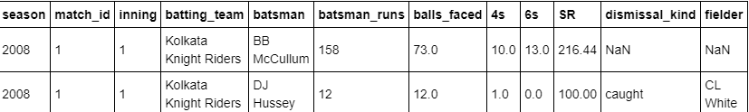

1. **Bowler Aggregate**

This table will show the bowling performance of the bowlers by comparing it with previous seasons so that team management will get an exact idea about their performance over a period of time. This table includes various information such as the seasons he has played, the number of overs he has bowled, the number of runs he has given with number of four’s and number of sixes. It also gives information about the number of wickets and their economical rates.

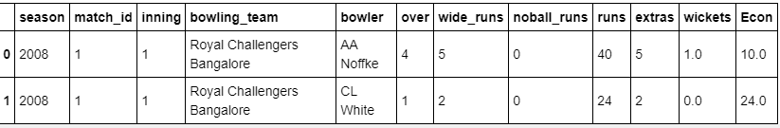

1. **Team wins in Home vs Away**

These below charts give the complete information about the team performance when they are played under home conditions and when they are played away from the home conditions. Its stats also gives information of the performance for over a period of time.

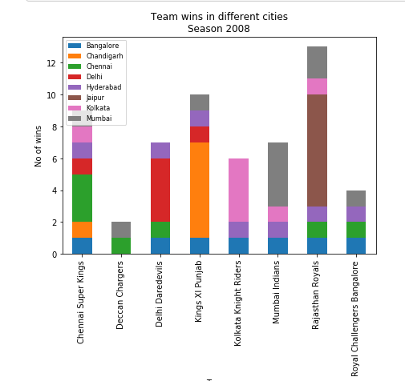

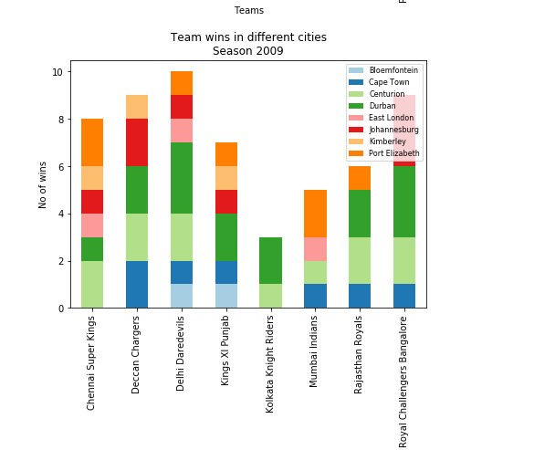

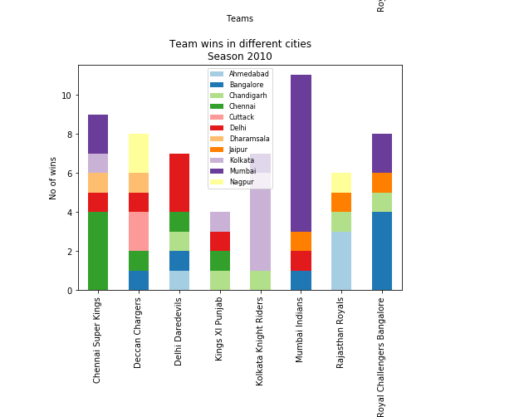

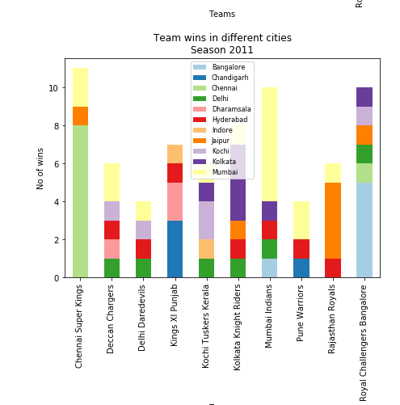

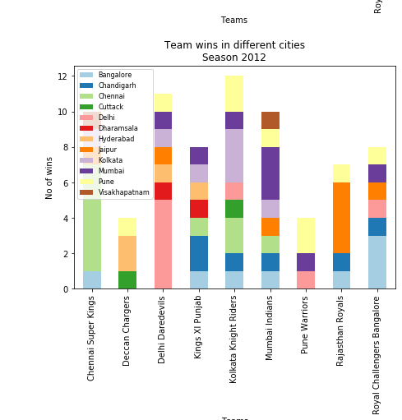

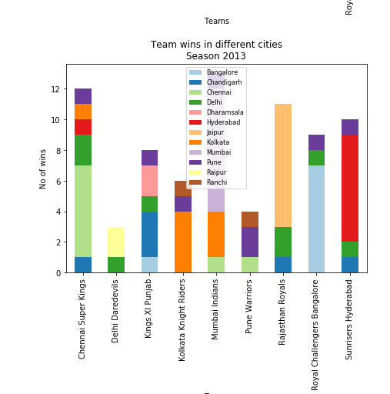

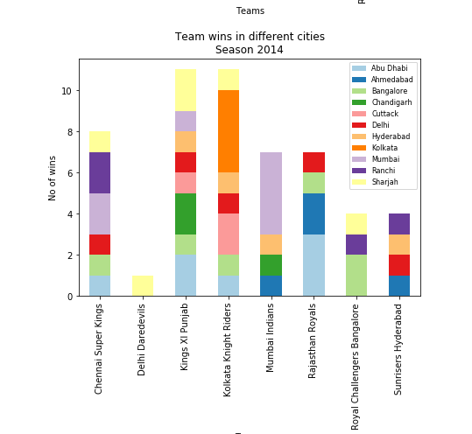

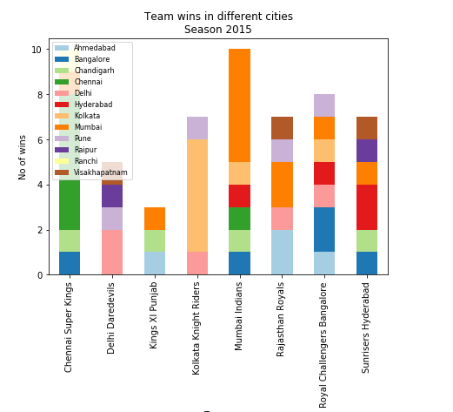

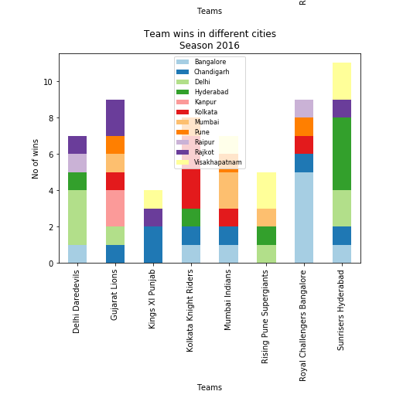

1. **Top 5 Batsmen over seasons**

This section will give complete information about the top 5 batsmen over the different seasons so that it would help the team management to select the rite batsmen for their team so that they would have strong batting line up.

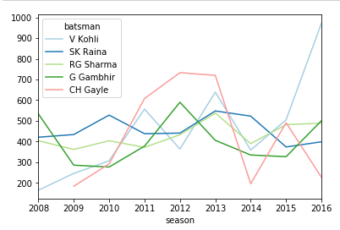

1. **Percentage of total runs scored through boundaries for each batsman**

This section will give information about the percentage of the total tuns scored through boundaries by each batsman.

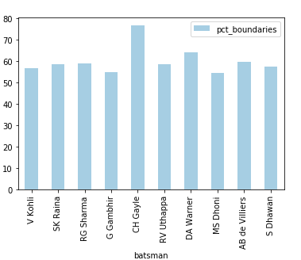

1. **Performance of top bowlers over seasons**

As told above this section will give complete information of the bowlers by comparing with different seasons. This will definitely help the team managements to pick the rite bowlers for the team which forms up their strong bowling line up.

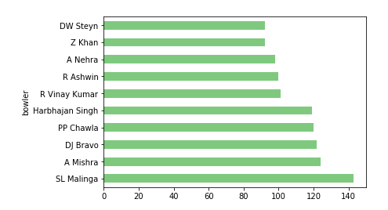

1. **Player of the Match**

This area will give information about the player who have got the “Player of Match” most number of times over the seasons.

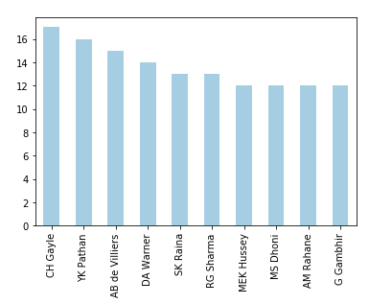

1. **Impact of the Toss outcome**

This seems to be one of the very important factor for the team. Based on this analysis the team can exactly decided to bat or bowl when they win toss. It will also helps to plan the strategy accordingly in case if they don’t win the toss as well.

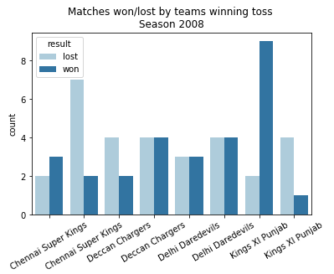

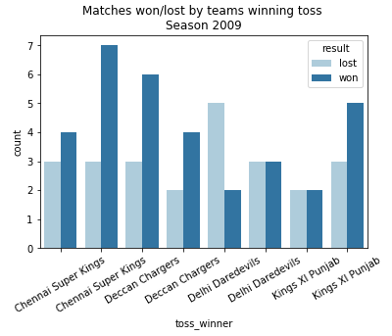

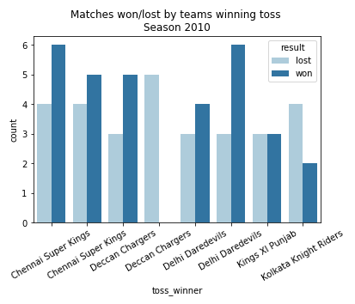

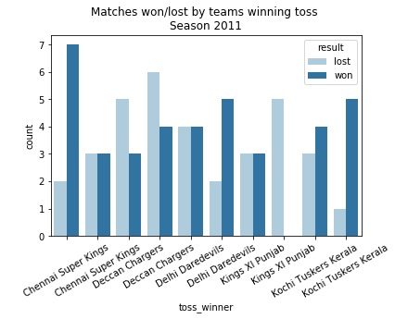

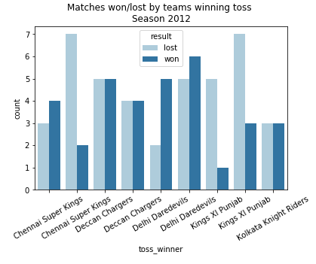

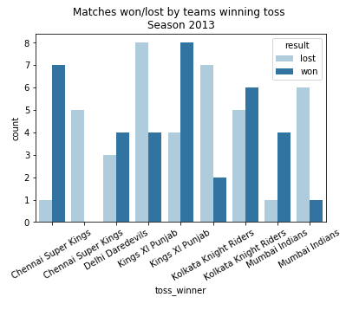

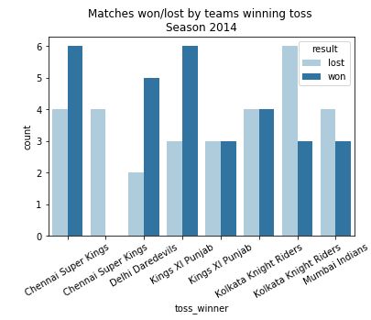

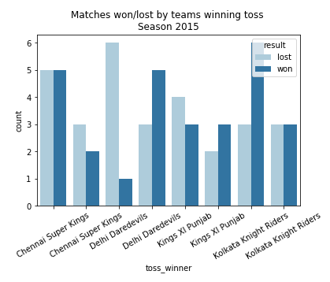

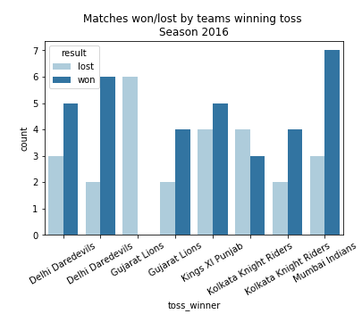

1. **Result**

After doing the above analysis we can say that when team management gets the information about these information’s presented in above section, it would help them to pick the rite team with combination of good batsmen and bowlers. It would also help the team to know their performance when played under home condition and when played under non-home conditions.

1. **Discussion**

For any more information on the ipl I would suggest visiting the <https://www.iplt20.com/> where users can get much more information in case if they need to analyses any more things

1. **Conclusion**

After collecting information about the IPL teams, bowlers, batsmen, team performance when played under home condition and when played under non-home conditions and analyzing thing and finally present them in form of charts I would like to conclude my project.