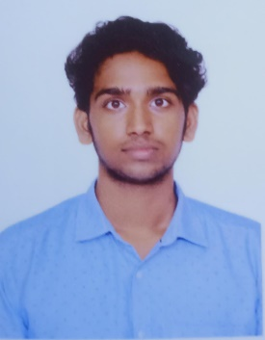SARATHKUMAR J

Male | 22 year | 950016659| Mail: [sarathjani31@gmail.com](mailto:sarathjani31@gmail.com)

GitHub: https://github.com/sarathprime/Projects

Address: Chennai District, Tamil Nadu

# OBJECTIVE

To obtain a position in which I can develop new skills and utilize existing in an environment that promotes

, Professional growth and also to contribute my creativity and hard work towards the success of your company

# ACADEMIC QUALIFICATIONS

* BE. Mechanical Engineer 2018 - 2022

Jeppiar Engineering College, Chennai

Secured 7.64 CGPA

* HSC 2017 - 2018

St Johns Matric Higher Secondary School, Chennai. Secured 71 Percentage.

* SSLC 2015 - 2016

St Johns Matric Higher Secondary School, Chennai. Secured 89 Percentage.

# INTERNSHIP/WORK EXPERIENCE

* + Junior Web Developer experience at Surya informatics solutions , Chennai.

# PROJECT

* Academic Project in Under Graduate: “**CONVERSION OF IC ENGINE TO EECTRIC GO-KART**”
  + Motive is to replacing IC engine to Induction motor in existing go-kart

For future innovative purpose.

* Mini Project: “**Material Prediction in Electronic Sector**” Language: Python

Technology: Machine Learning

* + Preprocessing the dataset and the main motive is to predict the necessary materials need for the requested material in order to prevent the silicon shortage

# TECHNICAL SKILLS

* + - Programming languages : Python, HTML, CSS, JS
    - Framework experience : Django
    - Application Packages : MS Office-Excel
    - Database : MySQL
    - **Operating system** : windows

# CERTIFICATIONS

* + - HTML, CSS, JS In Udemy
    - Python Full Course –UDEMY
    - MS OFFICE In ElearnMarkets

ACTIVITIES

* Interested & Good Knowledge in Adobe Photoshop, premiere
* Experience in video Editing in YouTube Channels
* Award as Volleyball Player of Events in school

DECLARATION

I hereby declare that the above furnished particulars are true to the best of my knowledge and Belief.

Yours’s sincerely

SARATHKUMAR J