# **Create a Spring Web Project using Maven**

# **Spring Core – Load Country from Spring Configuration XML**

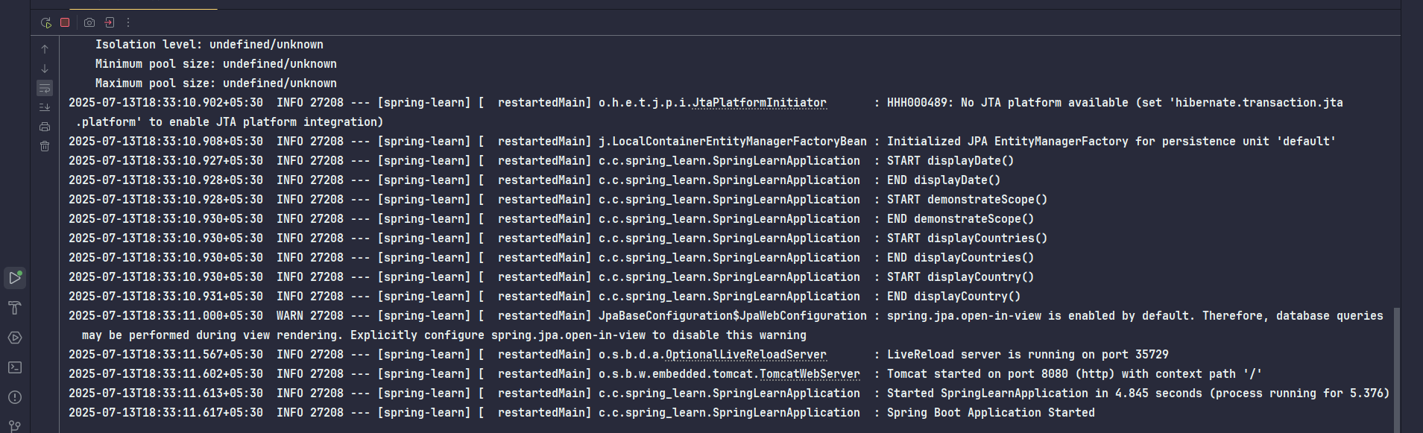

# **Hello World RESTful Web Service**

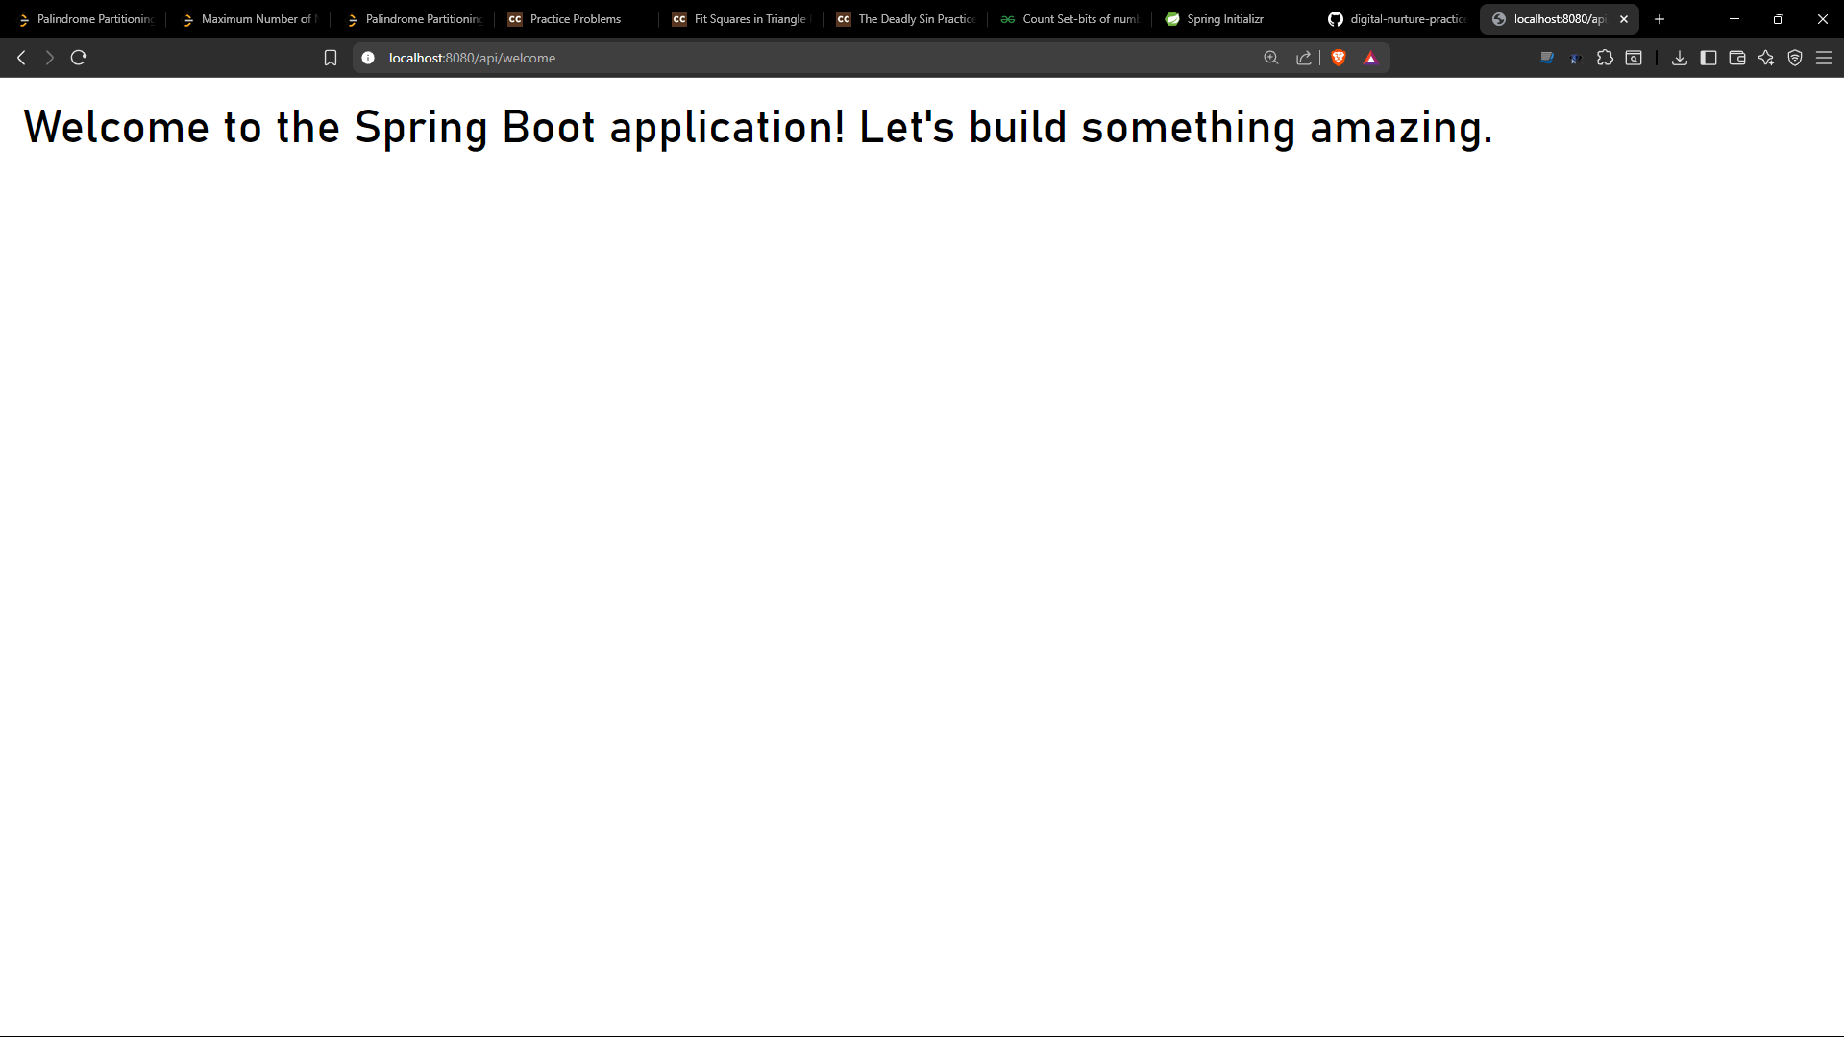

# **REST - Country Web Service**

