SMART SAFETY MONITORING SYSTEM FOR SEWAGE WORKERS

Contents

1.INTRODUCTION 5

2.EMBEDDED SYSTEM 6

2.1. Embedded System Classification 7

2.2. Embedded System Hardware 7

2.3. Embedded System Software 8

2.4. Embedded System Characteristics 9

2.5. Embedded System Applications 9

3.LITERATURE SURVEY 11

3.1. Survey - 1 11

3.2. Survey - 2 11

3.3. Survey - 3 12

3.4. Survey - 4 12

3.5. Survey – 5 13

3.6. Survey - 6 13

3.7. Survey - 7 13

3.8. Survey - 8 14

3.9. Survey - 9 14

3.10. Survey – 10 14

4. EXISTING SYSTEM 16

4.1. PROPOSED SYSTEM 16

5.HARDWARE REQUIREMENTS 18

5.1. POWER SUPPLY CIRCUIT 18

5.2. ARDUINO UNO 21

5.3. LIQUID CRYSTAL DISPLAY 25

5.4. VIBRATION MOTOR 26

5.5. GLOBAL SYSTEM FOR MOBILE COMMUNICATION (GSM): 27

5.5.1. GSM ARCHITECHURE: 29

5.5.2.GSM SPECIFICATIONS: 32

5.5.3. GSM ADDRESES ANDV IDENTIFICATIONS: 33

5.5.4. GSM OPERATIONS 35

5.5.5.GSM PROTOCOL STACK: 36

5.5.6.GSM USER SERVICE: 38

5.6. BUZZER 41

5.7. ULTRASONIC SENSOR: 42

5.8. PRESSURE SENSORS 44

5.9.GAS SENSOR (MQ6) 45

6. CONCLUSION 47

7. REFERENCE 47

**ABSTRACT**

In India sewage cleaning from manholes and drains are a difficult and risky job for anyone, but these people/workers are forced to do these jobs just to earn for their family. To develop such a device which would monitor the health of the person/worker entering the sewage and provide the health parameters in real time to the officials outside or the control room. The device presented will monitor the Blood pressure and Toxic gas sensor level is high, Buzzer will be ON at the same time Vibration motor is ON automatically. Water level indicator is used when drainage is full to find from ultrasonic sensor, SMS will be sent through GSM technology.

# 1.INTRODUCTION

A large number of sanitation workers die every year due to erratic and lack of facilities available, and harmful toxic gases released while cleaning the sewage. Manholes are not designed for someone to work in regularly, but workers may need to enter inside the manhole to complete their jobs such as cleaning, repair, inspection etc. A better knowledge related to hazards in the surroundings is necessary for the prevention of poisoning of gases. These gases have to be kept on track so that enormous rise in the normal level of effluents should be known and corrective measures can be taken. If the drainage system is not properly managed, then pure water gets contaminate with drainage water and infectious diseases may get spread.

# 2.EMBEDDED SYSTEM

An embedded system is one kind of a computer system mainly designed to perform several tasks like to access, process, store and also control the data in various electronics-based systems. [Embedded systems](https://www.elprocus.com/mini-embedded-systems-projects-ideas/) are a combination of hardware and software where software is usually known as firmware that is embedded into the hardware. One of its most important characteristics of these systems is, it gives the o/p within the time limits. Embedded systems support to make the work more perfect and convenient. So, we frequently use embedded systems in simple and complex devices too. The applications of embedded systems mainly involve in our real life for several devices like microwave, calculators, TV remote control, home security and neighborhood traffic control systems, etc.

An embedded system is integration of hardware and software, the software used in the embedded system is set of instructions which are termed as a program. The microprocessors or microcontrollers used in the hardware circuits of embedded systems are programmed to perform specific tasks by following the set of instructions. These programs are primarily written using any programming software like Proteus or Lab-view using any programming languages such as C or C++ or embedded C. Then, the program is dumped into the microprocessors or microcontrollers that are used in the [embedded system circuits](https://www.elprocus.com/real-time-applications-of-embedded-systems/).

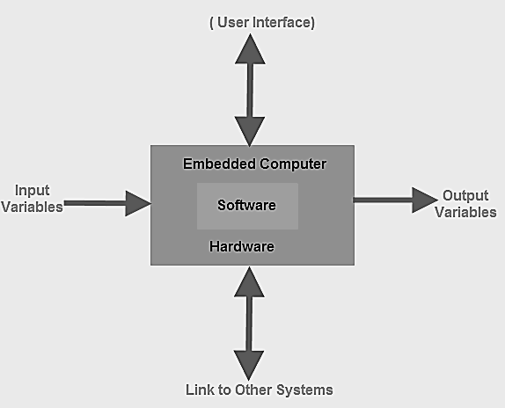

## 2.1. Embedded System Classification

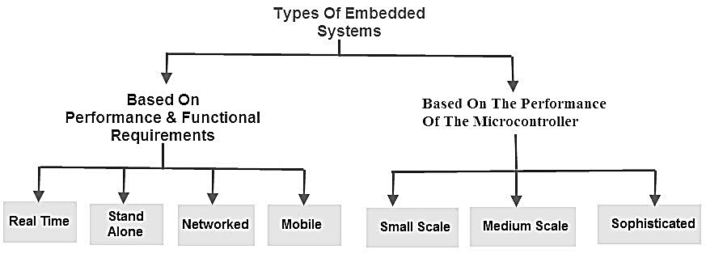

Embedded systems are primarily classified into different types based on complexity of hardware & software and microcontroller (8 or 16 or 32-bit). Thus, based on the performance of the microcontroller, embedded systems are classified into three types such as:

* Small scale embedded systems
* Medium scale embedded systems
* Sophisticated embedded systems

Further, based on performance and functional requirements of the system embedded system classified into four types such as:

* Real time embedded systems
* Standalone embedded systems.
* Networked embedded systems.
* Mobile embedded systems

## 2.2. Embedded System Hardware

An embedded system uses a hardware platform to perform the operation. Hardware of the embedded system is assembled with [a microprocessor/microcontroller](https://www.elprocus.com/microprocessor-and-microcontroller/). It has the elements such as input/output interfaces, memory, user interface and the display unit. Generally, an embedded system comprises of the following.

* [Power Supply](https://www.elprocus.com/switch-mode-power-supply-working/)
* Memory
* Processor
* Timers
* Output/Output circuits
* Serial communication ports
* SASC (System application specific circuits)

## 2.3. Embedded System Software

The[software of an embedded system is written](https://www.elprocus.com/embedded-system-programming-using-keil-c-language/) to execute a particular function. It is normally written in a high-level setup and then compiled down to offer code that can be stuck within a non-volatile memory in the hardware. An embedded system software is intended to keep in view of the following three limits.

* Convenience of system memory
* Convenience of processor’s speed
* When the embedded system runs constantly, there is a necessity to limit power dissipation for actions like run, stop and wake up.
* *RTOS (Real Time Operating System)*

A system which is essential to finish its task and send its service on time, then only it said to be [a real time operating system](https://www.elprocus.com/different-types-of-computer-operating-systems/). RTOS controls the application software and affords a device to allow the processor run. It is responsible for managing the different hardware resources of a personal computer and also host applications which run on the PC.

This operating system is specially designed to run various applications with an exact timing and a huge amount of consistency. Particularly, this can be significant in measurement & industrial automation systems where a delay of a program could cause a safety hazard.

***Memory and Processors***

The different kinds of processors used in an embedded system include Digital Signal Processor (DSP), microprocessor, [RISC processor](https://www.elprocus.com/what-is-risc-and-cisc-architecture-and-their-workings/), microcontroller, ASSP processor, ASIP processor, and ARM processor. The different types of memories of an embedded system are given in the below chart.

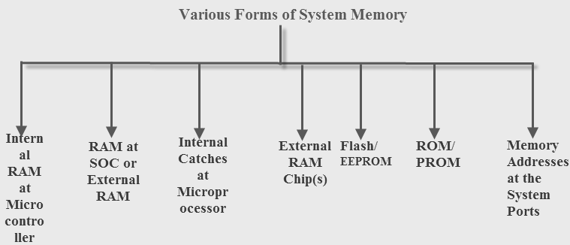

## 2.4. Embedded System Characteristics

Generally, an embedded system executes a particular operation and does the similar continually. For instance: A pager is constantly functioning as a pager.

All the computing systems have limitations on design metrics, but those can be especially tight. Design metric is a measure of an execution features like size, power, cost and also performance.

It must perform fast enough and consume less power to increase battery life.

Several embedded systems should constantly react to changes in the system and also calculate particular results in real time without any delay. For instance, a car cruise controller; it continuously displays and responds to speed & brake sensors. It must calculate acceleration/de-accelerations frequently in a limited time; a delayed computation can consequence in letdown to control the car.

It must be based on a microcontroller or microprocessor based.

It must require a memory, as its software generally inserts in ROM. It does not require any secondary memories in the PC.

It must need connected peripherals to attach input & output devices.

An Embedded system is inbuilt with hardware and software where the hardware is used for security and performance and Software is used for more flexibility and features.

## 2.5. Embedded System Applications

The applications of an embedded system basics include smart cards, computer networking, satellites, telecommunications, digital consumer electronics, missiles, etc.

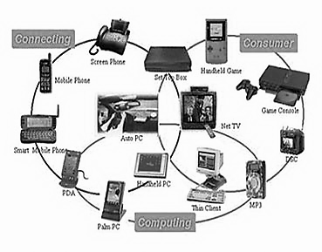

Embedded systems in automobiles include motor control, cruise control, body safety, engine safety, robotics in an assembly line, car multimedia, car entertainment, E-com access, mobiles etc.

Embedded systems in telecommunications include networking, mobile computing, and wireless communications, etc.

[Embedded systems in smart cards](https://www.elprocus.com/working-of-smart-card/) include banking, telephone and security systems.

Embedded Systems in satellites and missiles include defense, communication, and aerospace.

Embedded systems in computer networking & peripherals include image processing, networking systems, printers, network cards, monitors and displays.

Embedded Systems in digital consumer electronics include set-top boxes, DVDs, high-definition TVs and digital cameras.

# 3.LITERATURE SURVEY

## 3.1. Survey - 1

**TITLE**: Photoplethysmography-Based Heart Rate Monitoring in Physical Activities via Joint Sparse Spectrum Reconstruction

AUTHOR : Zhilin Zhang

YEAR : 2015

DESCRIPTIONA new method for heart rate monitoring using photo plethysmography (PPG) during physical activities is proposed. Methods: It jointly estimates spectra of PPG signals and simultaneous acceleration signals, utilizing the multiple measurement vector model in sparse signal recovery. Due to a common sparsity constraint on spectral coefficients, the method can easily identify and remove spectral peaks of motion artifact (MA) in PPG spectra. Thus, it does not need any extra signal processing modular to remove MA as in some other algorithms. Furthermore, seeking spectral peaks associated with heart rate is simplified. Results: Experimental results on 12 PPG datasets sampled at 25 Hz and recorded during subjects’ fast running showed that it had high performance.

## 3.2. Survey - 2

**TITLE**: A low power miniaturized monitoring system of six human physiological parameters based on wearable body sensor network

AUTHOR : Congcong Zhou, ChunlongTu

YEAR : 2015

DESCRIPTION: Health monitoring systems have drawn more and more attention, as people suffering from age-related diseases are increasing and the aging process is speeding up in many countries. And the cost of hospitalization and patient care continuously rises worldwide. Health monitoring system which works out of hospitals may assist residents and caregivers by providing non-invasive or invasive continuous health monitoring with minimum interaction of doctors and patients, and thus helps to reduce hospitalization and healthcare costs This work contributes in state of the art of wearable physiological parameters monitoring. Different physiological parameters were classified into subsystems based on the detection principles and system resources for power consumption management. Distributed and flat design methods were applied here to miniaturize the monitoring system. Algorithms were developed to monitor six vital physiological parameters, and reliable results were estimated by Fluke Prosim8 Vital Signs Simulators (produced by Fluke Corp. USA).

## 3.3. Survey - 3

**TITLE**: A Health-IoT Platform Based on the Integration of Intelligent Packaging, Unobtrusive Bio-Sensor and Intelligent Medicine Box

AUTHOR : Geng Yang, Li Xie, MattiMäntysalo

YEAR: 2013

DESCRIPTION:

In-home healthcare services based on the Internet-of-Things (IoT) have great business potential; however, a comprehensive platform is still missing. In this paper, an intelligent home-based platform, the iHome Health-IoT, is proposed and implemented. In particular, the platform involves 1) an open-platform-based intelligent medicine box (iMedBox) with enhanced connectivity and interchangeability for the integration of devices and services, 2) intelligent pharmaceutical packaging (iMedPack) with communication capability enabled by passive radio-frequency identification (RFID) and actuation capability enabled by functional materials, and 3) flexible and wearable bio-medical sensor device (Bio-Patch) enabled by the state-of-the-art inkjet printing technology and system-on-chip. The proposed platform seamlessly fuses IoT devices (e.g., wearable sensors, intelligent medicine packages, etc.) with in-home healthcare services (e.g., telemedicine) for an improved user experience and service efficiency.

## 3.4. Survey - 4

**TITLE**: Smart homes and home health monitoring technologies for older adults: A systematic review

AUTHOR : Lili Liu, IoanisNikolaidis

YEAR : 2016

DESCRIPTION: Around the world, populations are aging and there is a growing concern about ways that older adults can maintain their health and well-being while living in their homes. The aim of this paper was to conduct a systematic literature review to determine: the levels of technology readiness among older adults and, evidence for smart homes and home-based health-monitoring technologies that support aging in place for older adults who have complex needs. Results: We identified and analyzed 48 of 1863 relevant papers. Our analyses found that: technology-readiness level for smart homes and home health monitoring technologies is low; the highest level of evidence is 1b (i.e., one randomized controlled trial with a Pedro score ≥6); smart homes and home health monitoring technologies are used to monitor activities of daily living, cognitive decline and mental health, and heart conditions in older adults with complex needs; There is no evidence that smart homes and home health monitoring technologies help address disability prediction and health-related quality of life, or fall prevention; and there is conflicting evidence that smart homes and home health monitoring technologies help address chronic obstructive pulmonary disease.

## 3.5. Survey – 5

**TITLE**: Wearable Sensors in Health Monitoring Systems

AUTHOR : S.Sivasakthi, A.Rajeswari

YEAR : 2017

DESCRIPTION: Recent years have perceived an increase in the progress of wearable sensors for health monitoring systems. This increase has been due to several issues such as development in sensor technology as well as focused efforts on political and investor levels to promote projects which address the need for providing new methods for care given increasing challenges with an aging population. In this system is about study of how the data is treated and processed. This paper provides latest methods and algorithms used to analyze data from wearable sensors used for physiological monitoring of vital symbols in healthcare services. This paper outlines the data mining tasks that have been applied such as prediction, anomaly detection and decision making when considering in particular continuous time series measurements and detailed about the suitability of particular data mining and machine learning methods used to process the physiological data and provides an overview of the properties of the data sets used in experimental support. This paper includes datamining tasks for wearable sensors data mining approach and data sets and their properties and outlined the more common data mining tasks that have been applied.

## 3.6. Survey - 6

**TITLE**: A Review Paper on I2C Communication Protocol

AUTHOR: Vivek Kumar Pandey

YEAR:2018

DESCRIPTION: The I2C communication protocol is a well known and famous serial communication protocol developed by Philips Semiconductor (now NXP Semiconductor) in the 1980s (nearly 25 years ago) to exchange information specially between slow and fast devices. It consists of only two wires SDA and SCL and its ability to transmit data without loss makes it simpler and cheaper than other protocols. This paper is focused and aimed to present the valuable research work about I2C protocol by different researchers over the years.

## 3.7. Survey - 7

**TITLE**: A Wireless Monitoring System for Pulse-oximetry Sensors

AUTHOR: María J. Morón 1, Eduardo Casilari

YEAR: 2005

DESCRIPTION: This paper presents a wireless medical monitoring system. The system permits to receive and process in a single concentrator node (e.g. a laptop or a simple handheld device) the pulse-oximetry signals from one ore several monitored patients without using any wired infrastructure. The system, which is based on a piconet of Bluetooth sensors, can retransmit the medical signals by WLAN and GPRS. The paper describes the practical application scenarios in which this type of systems could be of great utility.

## 3.8. Survey - 8

**TITLE**: Migration of a SCADA system to IaaSclouds – a case study

AUTHOR: Philip Church1 , Harald Mueller

YEAR: 2017

DESCRIPTION: SCADA systems allow users to monitor and/or control physical devices, processes, and events remotely and in real-time. As these systems are critical to industrial processes, they are often run on highly reliable and dedicated hardware. Moving these SCADA systems to an Infrastructure as a Service (IaaS) cloud allows for: cheaper deployments, system redundancy support, and increased uptime. The goal of this work was to present the results of our experimental study of moving/migrating a selected SCADA system to a cloud environment and present major lessons learned. To this end, EclipseSCADA was deployed to the NeCTAR research cloud using the “lift and shift” approach. Performance metrics of a unique nature and large scale of experimentation were collected from the deployed EclipseSCADA system under different loads to examine the effects cloud resources and public networks have on SCADA behavior.

## 3.9. Survey - 9

**TITLE**: OPOGEE INSTRUMENT A OXYGEN SENSOR

AUTHOR: Bruce Bugbee

YEAR: 2015

DESCRIPTION: Oxygen (O2) is the second most abundant gas in the atmosphere and is essential to life on Earth. Oxygen availability determines the rate of many biological and chemical processes and is required for aerobic respiration. As described in this manual, it is the absolute amount of oxygen (measured as partial pressure in kilopascals) that nearly always determines oxygen availability, but we think of oxygen as a percent of the total number of molecules in the air (20.95 %). The best example of this is the oxygen on top of Mount Everest, which is 20.95 %, but most climbers need supplemental oxygen to get to the top.

## 3.10. Survey – 10

**TITLE**: Metagenomics for the study of viruses in urban sewage as a tool for public health surveillance

AUTHOR: X. Fernandez-Cassi a , N. Timoneda

YEAR: 2017

DESCRIPTION: The application of next-generation sequencing (NGS) techniques for the identification of viruses present in urban sewage has not been fully explored. This is partially due to a lack of reliable and sensitive protocols for studying viral diversity and to the highly complex analysis required for NGS data processing. One important step towards this goal is finding methods that can efficiently concentrate viruses from sewage samples. Here the application of a virus concentration method based on skimmed milk organic flocculation (SMF) using 10 L of sewage collected in different seasons enabled the detection of many viruses. However, some viruses, such as human adenoviruses, could not always be detected using meta genomics, even when quantitative PCR (qPCR) assessments were positive. A targeted metagenomic assay for adenoviruses was conducted and 59.41% of the obtained reads were assigned to murine adenoviruses. However, up to 20 different human adenoviruses (HAdV) were detected by this targeted assay being the most abundant HAdV-41 (29.24%) and HAdV-51 (1.63%).

# 4. EXISTING SYSTEM

Incorporates a varied network of low-cost and long-lasting components that enables municipal authorities to track the sewage environment and water levels at all times, in effect ensuring the sewage workers ’ safety and well-being. The Light sensors are an effective way of ensuring that the manhole is always sealed, and also to confirm that the system and all its components are intact and are not vulnerable to theft.

**DRAWBACKS**

* Nighttime renders these light sensors useless.
* No solutions are offered for this.

## 4.1. PROPOSED SYSTEM

The main component of this system is Arduino controller. The sensors like Gas, Blood pressure sensor and water level indicator are used for the proposed system. Water level indicator is used when drainage is full to find from ultrasonic sensor, SMS will be send through GSM technology. Blood pressure and Toxic gas sensor level is high; Buzzer will be ON at the same time Vibration motor is ON automatically. The received sensor details display on LCD at receiver with help of GSM.

**BLOCK DIAGRAM**

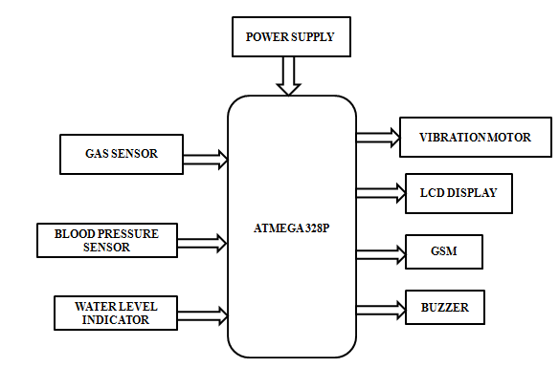

**FLOW CHART**

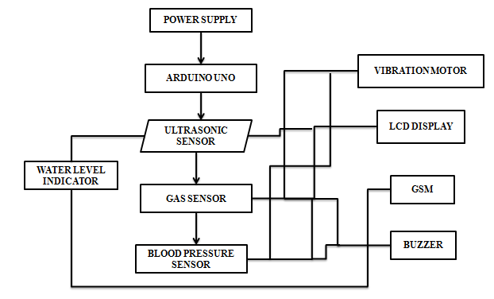

**CIRCUIT DIAGRAM**

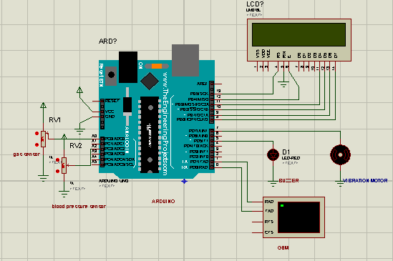

# 5.HARDWARE REQUIREMENTS

## 5.1. POWER SUPPLY CIRCUIT

Power supply is a reference to a source of electrical power. A device or system that supplies electrical or other types of energy to an output load or group of loads is called a power supply unit or PSU. The term is most applied to electrical energy supplies, less often to mechanical ones, and rarely to others.

Power supplies for electronic devices can be broadly divided into linear and switching power supplies. The linear supply is a relatively simple design that becomes increasingly bulky and heavy for high current devices; voltage regulation in a linear supply can result in low efficiency. A switched-mode supply of the same rating as a linear supply will be smaller, is usually more efficient, but will be more complex.

**Linear Power supply:**

An AC powered linear power supply usually uses a transformer to convert the voltage from the wall outlet (mains) to a different, usually a lower voltage. If it is used to produce DC, a rectifier is used. A capacitor is used to smooth the pulsating current from the rectifier. Some small periodic deviations from smooth direct current will remain, which is known as ripple. These pulsations occur at a frequency related to the AC power frequency (for example, a multiple of 50 or 60 Hz).

**Transformer:**



Transformers convert AC electricity from one voltage to another with little loss of power. Transformers work only with AC and this is one of the reasons why mains electricity is AC.

Step-up transformers increase voltage, step-down transformers reduce voltage. Most power supplies use a step-down transformer to reduce the dangerously high mains voltage (230V in UK) to a safer low voltage.

The input coil is called the primary and the output coil is called the secondary. There is no electrical connection between the two coils; instead they are linked by an alternating magnetic field created in the soft-iron core of the transformer. The two lines in the middle of the circuit symbol represent the core.

Transformers waste very little power so the power out is (almost) equal to the power in. Note that as voltage is stepped down current is stepped up.

The ratio of the number of turns on each coil, called the turn’s ratio, determines the ratio of the voltages. A step-down transformer has a large number of turns on its primary (input) coil which is connected to the high voltage mains supply, and a small number of turns on its secondary (output) coil to give a low output voltage.

**Bridge rectifier:**

A bridge rectifier can be made using four individual diodes, but it is also available in special packages containing the four diodes required. It is called a full-wave rectifier because it uses the entire AC wave (both positive and negative sections). 1.4V is used up in the bridge rectifier because each diode uses 0.7V when conducting and there are always two diodes conducting, as shown in the diagram below. Bridge rectifiers are rated by the maximum current they can pass and the maximum reverse voltage they can withstand (this must be at least three times the supply RMS voltage so the rectifier can withstand the peak voltages). Please see the DIODES page for more details, including pictures of bridge rectifiers.

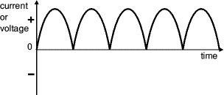

Bridge rectifier

Alternate pairs of diodes conduct, changing over the connections so the alternating directions of AC are converted to the one direction of DC.

Output: full wave varying DC: (using the entire AC wave):

**Smoothing:**

Smoothing is performed by a large value electrolytic capacitor connected across the DC supply to act as a reservoir, supplying current to the output when the varying DC voltage from the rectifier is falling. The diagram shows the unsmoothed varying DC (dotted line) and the smoothed DC (solid line). The capacitor charges quickly near the peak of the varying DC, and then discharges as it supplies current to the output.

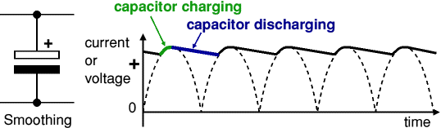

Note that smoothing significantly increases the average DC voltage to almost the peak value (1.4 × [**RMS**](http://www.kpsec.freeuk.com/acdc.htm#rms) value). For example, 6V RMS AC is rectified to full wave DC of about 4.6V RMS (1.4V is lost in the bridge rectifier), with smoothing this increase to almost the peak value giving 1.4 × 4.6 = 6.4V smooth DC.

Smoothing is not perfect due to the capacitor voltage falling a little as it discharges, giving a small ripple voltage. For many circuits, a ripple which is 10% of the supply voltage is satisfactory and the equation below gives the required value for the smoothing capacitor. A larger capacitor will give fewer ripples. The capacitor value must be doubled when smoothing half-wave DC.

Smoothing Capacitor for 10% ripple, C=5*10/vs.*f

C = smoothing capacitance in farads (F)

Io = output current from the supply in amps (A)

Vs = supply voltage in volts (V), this is the peak value of the unsmoothed DC

f    = frequency of the AC supply in hertz (Hz), 50Hz in the UK.

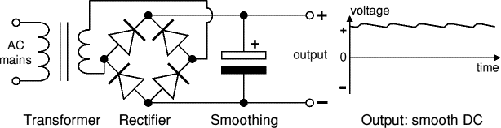

Fig: power supply circuit

The smooth DC output has a small ripple. It is suitable for most electronic circuits.

**Regulator:**

Voltage regulator ICs are available with fixed (typically 5, 12 and 15V) or variable output voltages. They are also rated by the maximum current they can pass. Negative voltage regulators are available, mainly for use in dual supplies. Most regulators include some automatic protection from excessive current ('overload protection') and overheating ('thermal protection').

The LM78XX series of three terminal regulators is available with several fixed output voltages making them useful in a wide range of applications. One of these is local on card regulation, eliminating the distribution problems associated with single point regulation. The voltages available allow these regulators to be used in logic systems, instrumentation, Hi-Fi, and other solid state electronic equipment. Although designed primarily as fixed voltage regulators these devices can be used with external components to obtain adjustable voltages and current.

Many of the fixed voltage regulator ICs has 3 leads and look like power transistors, such as the 7805 +5V 1A regulator shown on the right. They include a hole for attaching a [**heat sink**](http://www.kpsec.freeuk.com/components/heatsink.htm) if necessary.

**Positive regulator**

* input pin
* ground pin
* output pin

It regulates the positive voltage.

**Negative regulator**

* ground pin
* input pin
* output pin

It regulates the negative voltage.

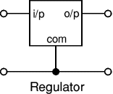

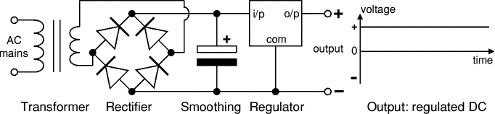

The regulated DC output is very smooth with no ripple. It is suitable for all electronic circuits.

## 5.2. ARDUINO UNO

The Arduino UNO is an open-source microcontroller board based on the [Microchip](https://en.wikipedia.org/wiki/Microchip_Technology) [ATmega328P](https://en.wikipedia.org/wiki/ATmega328P) microcontroller and developed by [Arduino.cc](https://en.wikipedia.org/wiki/Arduino). The board is equipped with sets of digital and analog input/output (I/O) pins that may be interfaced to various expansion boards (shields) and other circuits. The board has 14 Digital pins, 6 Analog pins, and programmable with the [Arduino IDE](https://en.wikipedia.org/wiki/Arduino#Software) (Integrated Development Environment) via a type B USB cable. It can be powered by a USB cable or by an external 9-volt battery, though it accepts voltages between 7 and 20 volts. It is also like the Arduino Nano and Leonardo. The hardware reference design is distributed under a [Creative Commons](https://en.wikipedia.org/wiki/Creative_Commons) Attribution Share-Alike 2.5 license and is available on the Arduino website. Layout and production files for some versions of the hardware are also available. “Uno” means one in Italian and was chosen to mark the release of Arduino Software (IDE) 1.0. The Uno board and version 1.0 of Arduino Software (IDE) were the reference versions of Arduino, now evolved to newer releases. The Uno board is the first in a series of USB Arduino boards, and the reference model for the Arduino platform. The Atmega328 on the Arduino Uno comes preprogrammed with a boot loader that allows uploading new code to it without the use of an external hardware programmer. It communicates using the original STK500 protocol. The Uno also differs from all preceding boards in that it does not use the FTDI USB-to-serial driver chip. Instead, it uses the Atmega16U2 (Atmega8U2 up to version R2) programmed as a USB-to-serial converter.

The Arduino project started at the [Interaction Design Institute Ivrea](https://en.wikipedia.org/wiki/Interaction_Design_Institute_Ivrea) (IDII) in [Ivrea](https://en.wikipedia.org/wiki/Ivrea), Italy. At that time, the students used a [BASIC Stamp](https://en.wikipedia.org/wiki/BASIC_Stamp) microcontroller at a cost of $100, a considerable expense for many students. In 2003 Hernando Barragán created the development platform [Wiring](https://en.wikipedia.org/wiki/Wiring_(development_platform)) as a Master’s thesis project at IDII, under the supervision of Massimo Banzi and Casey Reas, who are known for work on the [Processing](https://en.wikipedia.org/wiki/Processing_(programming_language)) language. The project goal was to create simple, low-cost tools for creating digital projects by non-engineers. The Wiring platform consisted of a [printed circuit board](https://en.wikipedia.org/wiki/Printed_circuit_board) (PCB) with an [Atmega](https://en.wikipedia.org/wiki/ATmega)168 microcontroller, an IDE based on Processing and library functions to easily program the microcontroller. In 2003, Massimo Banzi, with David Mellis, another IDII student, and David Cuartielles, added support for the cheaper Atmega8 microcontroller to Wiring. But instead of continuing the work on Wiring, they [forked](https://en.wikipedia.org/wiki/Fork_(software_development)) the project and renamed it Arduino. Early [arduino](https://en.wikipedia.org/wiki/Arduino" \o "Arduino) boards used the FTDI USB-to-serial driver chip and an [Atmega](https://en.wikipedia.org/wiki/ATmega)168. The Uno differed from all preceding boards by featuring the Atmega328P microcontroller and an Atmega16U2 (Atmega8U2 up to version R2) programmed as a USB-to-serial converter.

**SPECIFICATION**

[Microcontroller](https://en.wikipedia.org/wiki/Microcontroller): [Microchip](https://en.wikipedia.org/wiki/Microchip_Technology) [Atmega328P](https://en.wikipedia.org/wiki/ATmega328P)

Operating Voltage: 5 Volt

Input Voltage: 7 to 20 Volts

Digital I/O Pins: 14 (of which 6 provide PWM output)

Analog Input Pins: 6

DC Current per I/O Pin: 20 mA

DC Current for 3.3V Pin: 50 mA

[Flash Memory](https://en.wikipedia.org/wiki/Flash_Memory): 32 KB of which 0.5 KB used by [bootloader](https://en.wikipedia.org/wiki/Booting#BOOT-LOADER)

[SRAM](https://en.wikipedia.org/wiki/Static_random-access_memory): 2 KB

[EEPROM](https://en.wikipedia.org/wiki/EEPROM): 1 KB

Clock Speed: 16 MHz

Length: 68.6 mm

Width: 53.4 mm

Weight: 25 g

**COMMUNICATION**

The Arduino/Genuino Uno has a number of facilities for communicating with a computer, another Arduino/Genuino board, or other microcontrollers. The ATmega328 provides UART TTL (5V) serial communication, which is available on digital pins 0 (RX) and 1 (TX). An ATmega16U2 on the board channels this serial communication over USB and appears as a virtual com port to software on the computer. The 16U2 firmware uses the standard USB COM drivers, and no external driver is needed. However, on Windows, a .inf file is required. The Arduino Software (IDE) includes a serial monitor which allows simple textual data to be sent to and from the board. The RX and TX LEDs on the board will flash when data is being transmitted via the USB-to-serial chip and USB connection to the computer (but not for serial communication on pins 0 and 1). A SoftwareSerial library allows serial communication on any of the Uno's digital pins

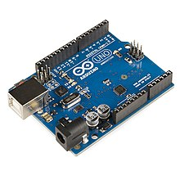

**PINS General Pin functions**

LED: There is a built-in LED driven by digital pin 13. When the pin is HIGH value, the LED is on, when the pin is LOW, it's off.

VIN: The input voltage to the Arduino/Genuino board when it's using an external power source (as opposed to 5 volts from the USB connection or other regulated power source). You can supply voltage through this pin, or, if supplying voltage via the power jack, access it through this pin.

5V: This pin outputs a regulated 5V from the regulator on the board. The board can be supplied with power either from the DC power jack (7 - 20V), the USB connector (5V), or the VIN pin of the board (7-20V). Supplying voltage via the 5V or 3.3V pins bypasses the regulator, and can damage the board.

3V3: A 3.3 volt supply generated by the on-board regulator. Maximum current draw is 50 mA.

GND: Ground pins.

IOREF: This pin on the Arduino/Genuino board provides the voltage reference with which the microcontroller operates. A properly configured shield can read the IOREF pin voltage and select the appropriate power source or enable voltage translators on the outputs to work with the 5V or 3.3V.

Reset: Typically used to add a reset button to shields which block the one on the board.

**Special Pin Functions**

Each of the 14 digital pins and 6 Analog pins on the Uno can be used as an input or output, using pinMode (), digitalWrite(), and digitalRead() functions. They operate at 5 volts. Each pin can provide or receive 20 mA as recommended operating condition and has an internal pull-up resistor (disconnected by default) of 20-50k ohm. A maximum of 40mA is the value that must not be exceeded on any I/O pin to avoid permanent damage to the microcontroller. The Uno has 6 analog inputs, labeled A0 through A5, each of which provide 10 bits of resolution (i.e. 1024 different values). By default they measure from ground to 5 volts, though is it possible to change the upper end of their range using the AREF pin and the analogReference() function.

In addition, some pins have specialized functions:

Serial / [UART](https://en.wikipedia.org/wiki/UART): pins 0 (RX) and 1 (TX). Used to receive (RX) and transmit (TX) TTL serial data. These pins are connected to the corresponding pins of the ATmega8U2 USB-to-TTL Serial chip.

External Interrupts: pins 2 and 3. These pins can be configured to trigger an interrupt on a low value, a rising or falling edge, or a change in value.

PWM (Pulse Width Modulation): 3, 5, 6, 9, 10, and 11 Can provide 8-bit PWM output with the analogWrite () function.

SPI (Serial Peripheral Interface): 10 (SS), 11 (MOSI), 12 (MISO), 13 (SCK). These pins support SPI communication using the SPI library.

TWI (Two Wire Interface) / [I²C](https://en.wikipedia.org/wiki/I%C2%B2C): A4 or SDA pin and A5 or SCL pin. Support TWI communication using the Wire library.

AREF (Analog REFerence): Reference voltage for the analog inputs

## 5.3. LIQUID CRYSTAL DISPLAY

A liquid crystal display (LCD) is a flat panel display, electronic visual display, or video display that uses the light modulating properties of liquid crystals. Liquid crystals do not emit light directly. LCDs are available to display arbitrary images (as in a general-purpose computer display) or fixed images which can be displayed or hidden, such as preset words, digits, and 7-segment displays as in a digital clock. They use the same basic technology, except that arbitrary images are made up of a large number of small pixels, while other displays have larger elements. An LCD is a small low cost display. It is easy to interface with a micro-controller because of an embedded controller (the black blob on the back of the board). This controller is standard across many displays (HD 44780) which means many micro-controllers (including the Arduino) have libraries that make displaying messages as easy as a single line of code.

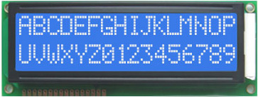

**LCD display unit**

LCDs are used in a wide range of applications including computer monitors, televisions, instrument panels, aircraft cockpit displays, and signage. They are common in consumer devices such as video players, gaming devices, clocks, watches, calculators, and telephones, and have replaced cathode ray tube (CRT) displays in most applications. They are available in a wider range of screen sizes than CRT and plasma displays, and since they do not use phosphors, they do not suffer image burn-in. LCDs are, however, susceptible to image persistence.

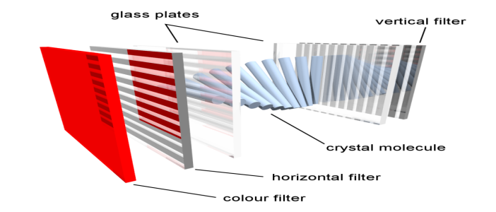

Internal working of LCD unit

|  |  |  |
| --- | --- | --- |
| Pin No | Function | Name |
| 1 | Ground (0V) | Ground |
| 2 | Supply voltage; 5V (4.7V – 5.3V) | Vcc |
| 3 | Contrast adjustment; through a variable resistor | VEE |
| 4 | Selects command register when low; and data register when high | Register Select |
| 5 | Low to write to the register; High to read from the register | Read/write |
| 6 | Sends data to data pins when a high to low pulse is given | Enable |
| 7 | 8-bit data pins | DB0 |
| 8 | DB1 |
| 9 | DB2 |
| 10 | DB3 |
| 11 | DB4 |
| 12 | DB5 |
| 13 | DB6 |
| 14 | DB7 |
| 15 | Backlight VCC (5V) | Led+ |
| 16 | Backlight Ground (0V) | Led- |

## 5.4. VIBRATION MOTOR

Vibration motor is a compact size coreless DC motor used to informs the users of receiving the signal by vibrating, no sound. Vibration motors are widely used in a variety of applications including cell phones, handsets, pagers, and so on. The main features of vibration motor is the magnet coreless DC motor are permanent, which means it will always have its magnetic properties (unlike an electromagnet, which only behaves like a magnet when an electric current runs through it); another main feature is the size of the motor itself is small, and thus light weight. Moreover, the noise and the power consumption that the motor produce while using are low. Based on those features, the performance of the motor is highly reliable. The vibration motors are configured in two basic varieties: coin (or flat) and cylinder (or bar). There are some components in both of their internal constructions.

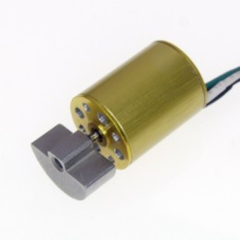

## 5.5. GLOBAL SYSTEM FOR MOBILE COMMUNICATION (GSM):

If you are in Europe or Asia and using a mobile phone, then most probably you are using GSM technology in your mobile phone.

GSM stands for Global System for Mobile Communication. It is a digital cellular technology used for transmitting mobile voice and data services.

The concept of GSM emerged from a cell-based mobile radio system at Bell Laboratories in the early 1970s.

GSM is the name of a standardization group established in 1982 to create a common European mobile telephone standard.

GSM is the most widely accepted standard in telecommunications and it is implemented globally.

GSM is a circuit-switched system that divides each 200 kHz channel into eight 25 kHz time-slots. GSM operates on the mobile communication bands 900 MHz and 1800 MHz in most parts of the world. In the US, GSM operates in the bands 850 MHz and 1900 MHz.

GSM owns a market share of more than 70 percent of the world's digital cellular subscribers.

GSM makes use of narrowband Time Division Multiple Access (TDMA) technique for transmitting signals.

GSM was developed using digital technology. It has an ability to carry 64 kbps to 120 Mbps of data rates.

Presently GSM supports more than one billion mobile subscribers in more than 210 countries throughout the world.

GSM provides basic to advanced voice and data services including roaming service. Roaming is the ability to use your GSM phone number in another GSM network.

GSM digitizes and compresses data, then sends it down through a channel with two other streams of user data, each in its own timeslot.

Listed below are the features of GSM that account for its popularity and wide acceptance.

Improved spectrum efficiency

International roaming

Low-cost mobile sets and base stations (BSs)

High-quality speech

Compatibility with Integrated Services Digital Network (ISDN) and other telephone company services

Support for new services

GSM SIM900 MODEM WITH RS232:

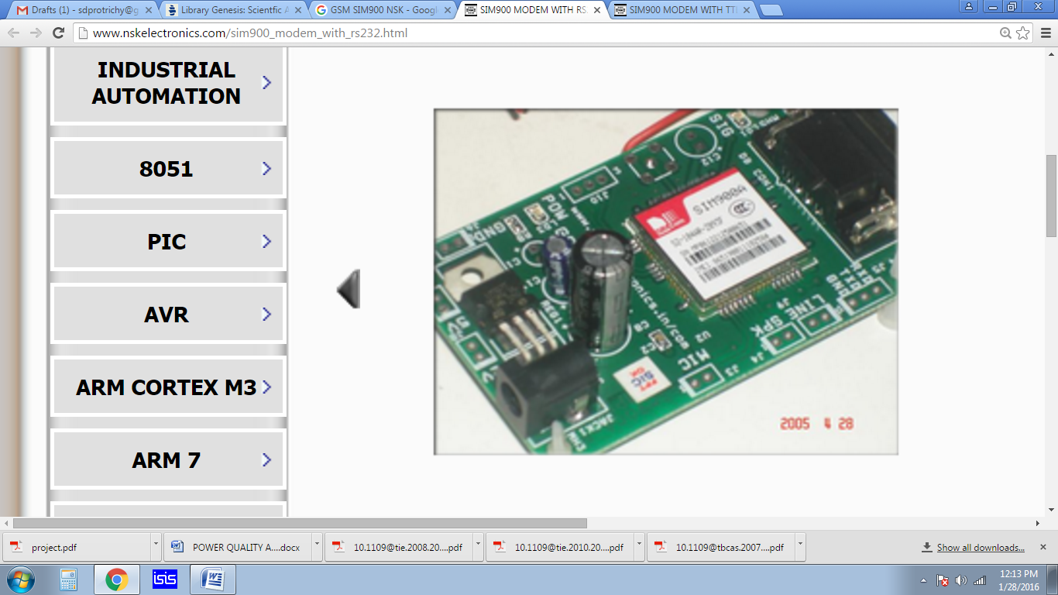

**DESCRIPTION:**   
 GSM/GPRS Modem-RS232 is built with Dual Band GSM/GPRS engine- SIM900A, works on frequencies 900/ 1800 MHz. The Modem is coming with RS232 interface, which allows you connect PC as well as microcontroller with RS232 Chip(MAX232). The baud rate is configurable from 9600-115200 through AT command. The GSM/GPRS Modem is having internal TCP/IP stack to enable you to connect with internet via GPRS. It is suitable for SMS, Voice as well as DATA transfer application in M2M interface.

The onboard Regulated Power supply allows you to connect wide range unregulated power supply . Using this modem, you can make audio calls, SMS, Read SMS, attend the incoming calls and internet ect through simple AT commands.  
  
**GSM/GPRS Modem Features:**

* High Quality Product (Not hobby grade)
* Dual-Band GSM/GPRS 900/ 1800 MHz
* RS232 interface for direct communication with computer or MCU kit
* Configurable baud rate
* Wire Amntenna ( SMA connector with GSM Antenna Optional )
* SIM Card holder.
* Built in Network Status LED
* Inbuilt Powerful TCP/IP protocol stack for internet data transfer over GPRS.
* Normal operation temperature: -20 °C to +55 °C
* Input Voltage: 12V DC

**GSM SIM900 MODEM WITH TTL:**

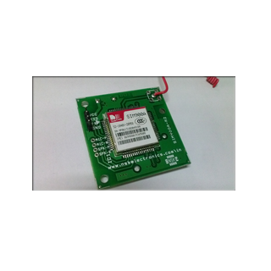  
**DESCRIPTION:**  
 GSM/GPRS TTL UART Modem is built with Dual Band GSM/GPRS engine- SIM900, works on frequencies 900/ 1800 MHz. The level The baud rate is configurable from 9600-115200 through AT command. The GSM/GPRS Modem is having internal TCP/IP stack to enable you to connect with internet via GPRS. It is suitable for SMS, Voice as well as DATA transfer application in M2M interface.

**GSM/GPRS Modem Features**

* High Quality Product
* Dual-Band GSM/GPRS 900/ 1800 MHz
* Configurable baud rate
* SIM Card holder.
* Built in Network Status LED
* Inbuilt Powerful TCP/IP protocol stack for internet data transfer over GPRS.
* Audio interface Connector
* Normal operation temperature: -20 °C to +55 °C
* Input Voltage: 3.6- 4.5 VDC

### 5.5.1. GSM ARCHITECHURE:

A GSM network comprises of many functional units. These functions and interfaces are explained in this chapter. The GSM network can be broadly divided into:

* [The Mobile Station (MS)](http://www.tutorialspoint.com/gsm/gsm_mobile_station.htm)
* [The Base Station Subsystem (BSS)](http://www.tutorialspoint.com/gsm/gsm_base_station_subsystem.htm)
* [The Network Switching Subsystem (NSS)](http://www.tutorialspoint.com/gsm/gsm_network_switching_subsystem.htm)
* [The Operation Support Subsystem (OSS)](http://www.tutorialspoint.com/gsm/gsm_operation_support_subsystem.htm)

Given below is a simple pictorial view of the GSM architecture.

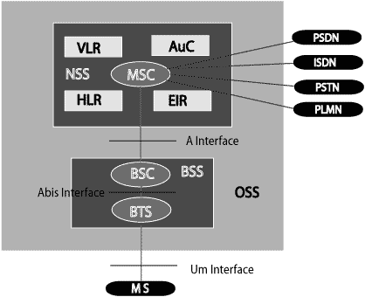

The additional components of the GSM architecture comprise of databases and messaging systems functions:

* Home Location Register (HLR)
* Visitor Location Register (VLR)
* Equipment Identity Register (EIR)
* Authentication Center (AuC)
* SMS Serving Center (SMS SC)
* Gateway MSC (GMSC)
* Chargeback Center (CBC)
* Transcoder and Adaptation Unit (TRAU)

The following diagram shows the GSM network along with the added elements:

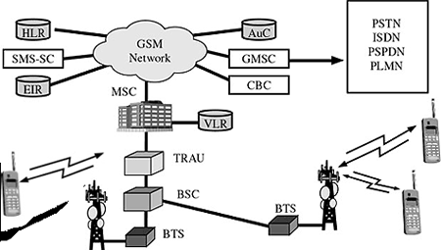

The MS and the BSS communicate across the Um interface. It is also known as the air interface or the radio link. The BSS communicates with the Network Service Switching (NSS) center across the A interface.

**GSM network areas:**

In a GSM network, the following areas are defined:

Cell : Cell is the basic service area; one BTS covers one cell. Each cell is given a Cell Global Identity (CGI), a number that uniquely identifies the cell.

Location Area : A group of cells form a Location Area (LA). This is the area that is paged when a subscriber gets an incoming call. Each LA is assigned a Location Area Identity (LAI). Each LA is served by one or more BSCs.

MSC/VLR Service Area : The area covered by one MSC is called the MSC/VLR service area.

PLMN : The area covered by one network operator is called the Public Land Mobile Network (PLMN). A PLMN can contain one or more MSCs.

The requirements for different Personal Communication Services (PCS) systems differ for each PCS network. Vital characteristics of the GSM specification are listed below:

**Modulation:**

Modulation is the process of transforming the input data into a suitable format for the transmission medium. The transmitted data is demodulated back to its original form at the receiving end. The GSM uses Gaussian Minimum Shift Keying (GMSK) modulation method.

**Access Methods:**

Radio spectrum being a limited resource that is consumed and divided among all the users, GSM devised a combination of TDMA/FDMA as the method to divide the bandwidth among the users. In this process, the FDMA part divides the frequency of the total 25 MHz bandwidth into 124 carrier frequencies of 200 kHz bandwidth.

Each BS is assigned with one or multiple frequencies, and each of this frequency is divided into eight timeslots using a TDMA scheme. Each of these slots are used for both transmission as well as reception of data. These slots are separated by time so that a mobile unit doesn’t transmit and receive data at the same time.

### 5.5.2.GSM SPECIFICATIONS:

**Transmission Rate:**

The total symbol rate for GSM at 1 bit per symbol in GMSK produces 270.833 K symbols/second. The gross transmission rate of a timeslot is 22.8 Kbps.

GSM is a digital system with an over-the-air bit rate of 270 kbps.

**Frequency Band:**

The uplink frequency range specified for GSM is 933 - 960 MHz (basic 900 MHz band only). The downlink frequency band 890 - 915 MHz (basic 900 MHz band only).

**Channel Spacing:**

Channel spacing indicates the spacing between adjacent carrier frequencies. For GSM, it is 200 kHz.

**Speech Coding:**

For speech coding or processing, GSM uses Linear Predictive Coding (LPC). This tool compresses the bit rate and gives an estimate of the speech parameters. When the audio signal passes through a filter, it mimics the vocal tract. Here, the speech is encoded at 13 kbps.

**Duplex Distance**

Duplex distance is the space between the uplink and downlink frequencies. The duplex distance for GSM is 80 MHz, where each channel has two frequencies that are 80 MHz apart.

**Misc**

Frame duration : 4.615 mS

Duplex Technique : Frequency Division Duplexing (FDD) access mode previously known as WCDMA.

Speech channels per RF channel : 8.

### 5.5.3. GSM ADDRESES ANDV IDENTIFICATIONS:

GSM treats the users and the equipment in different ways. Phone numbers, subscribers, and equipment identifiers are some of the known ones. There are many other identifiers that have been well-defined, which are required for the subscriber’s mobility management and for addressing the remaining network elements. Vital addresses and identifiers that are used in GSM are addressed below.

International Mobile Station Equipment Identity (IMEI):

The International Mobile Station Equipment Identity (IMEI) looks more like a serial number which distinctively identifies a mobile station internationally. This is allocated by the equipment manufacturer and registered by the network operator, who stores it in the Entrepreneurs-in-Residence (EIR). By means of IMEI, one recognizes obsolete, stolen, or non-functional equipment.

Following are the parts of IMEI:

Type Approval Code (TAC) : 6 decimal places, centrally assigned.

Final Assembly Code (FAC) : 6 decimal places, assigned by the manufacturer.

Serial Number (SNR) : 6 decimal places, assigned by the manufacturer.

Spare (SP) : 1 decimal place.

Thus, IMEI = TAC + FAC + SNR + SP. It uniquely characterizes a mobile station and gives clues about the manufacturer and the date of manufacturing.

International Mobile Subscriber Identity (IMSI)

Every registered user has an original International Mobile Subscriber Identity (IMSI) with a valid IMEI stored in their Subscriber Identity Module (SIM).

IMSI comprises of the following parts:

Mobile Country Code (MCC): 3 decimal places, internationally standardized.

Mobile Network Code (MNC): 2 decimal places, for unique identification of mobile network within the country.

Mobile Subscriber Identification Number (MSIN): Maximum 10 decimal places, identification number of the subscriber in the home mobile network.

Mobile Subscriber ISDN Number (MSISDN)

The authentic telephone number of a mobile station is the Mobile Subscriber ISDN Number (MSISDN). Based on the SIM, a mobile station can have many MSISDNs, as each subscriber is assigned with a separate MSISDN to their SIM respectively.

Listed below is the structure followed by MSISDN categories, as they are defined based on international ISDN number plan:

Country Code (CC): Up to 3 decimal places.

National Destination Code (NDC): Typically 2-3 decimal places.

Subscriber Number (SN): Maximum 10 decimal places.

Mobile Station Roaming Number (MSRN):

Mobile Station Roaming Number (MSRN) is an interim location dependent ISDN number, assigned to a mobile station by a regionally responsible Visitor Location Register (VLA). Using MSRN, the incoming calls are channeled to the MS.

The MSRN has the same structure as the MSISDN.

Country Code (CC): of the visited network.

National Destination Code (NDC): of the visited network.

Subscriber Number (SN): in the current mobile network.

Location Area Identity (LAI):

Within a PLMN, a Location Area identifies its own authentic Location Area Identity (LAI). The LAI hierarchy is based on international standard and structured in a unique format as mentioned below:

Country Code (CC) : 3 decimal places.

Mobile Network Code (MNC) : 2 decimal places.

Location Area Code (LAC) : maximum 5 decimal places or maximum twice 8 bits coded in hexadecimal (LAC < FFFF).

Temporary Mobile Subscriber Identity (TMSI):

Temporary Mobile Subscriber Identity (TMSI) can be assigned by the VLR, which is responsible for the current location of a subscriber. The TMSI needs to have only local significance in the area handled by the VLR. This is stored on the network side only in the VLR and is not passed to the Home Location Register (HLR).

Together with the current location area, the TMSI identifies a subscriber uniquely. It can contain up to 4 × 8 bits.

Local Mobile Subscriber Identity (LMSI):

Each mobile station can be assigned with a Local Mobile Subscriber Identity (LMSI), which is an original key, by the VLR. This key can be used as the auxiliary searching key for each mobile station within its region. It can also help accelerate the database access. An LMSI is assigned if the mobile station is registered with the VLR and sent to the HLR. LMSI comprises of four octets (4x8 bits).

**Cell Identifier (CI):**

Using a Cell Identifier (CI) (maximum 2 × 8) bits, the individual cells that are within an LA can be recognized. When the Global Cell Identity (LAI + CI) calls are combined, then it is uniquely defined.

5.5.4. GSM OPERATIONS:

Once a Mobile Station initiates a call, a series of events takes place. Analyzing these events can give an insight into the operation of the GSM system.

Mobile Phone to Public Switched Telephone Network (PSTN):

When a mobile subscriber makes a call to a PSTN telephone subscriber, the following sequence of events takes place:

The MSC/VLR receives the message of a call request.

The MSC/VLR checks if the mobile station is authorized to access the network. If so, the mobile station is activated. If the mobile station is not authorized, then the service will be denied.

MSC/VLR analyzes the number and initiates a call setup with the PSTN.

MSC/VLR asks the corresponding BSC to allocate a traffic channel (a radio channel and a time slot).

The BSC allocates the traffic channel and passes the information to the mobile station.

The called party answers the call and the conversation takes place.

The mobile station keeps on taking measurements of the radio channels in the present cell and the neighboring cells and passes the information to the BSC. The BSC decides if a handover is required. If so, a new traffic channel is allocated to the mobile station and the handover takes place. If handover is not required, the mobile station continues to transmit in the same frequency.

**PSTN to Mobile Phone:**

When a PSTN subscriber calls a mobile station, the following sequence of events takes place:

The Gateway MSC receives the call and queries the HLR for the information needed to route the call to the serving MSC/VLR.

The GMSC routes the call to the MSC/VLR.

The MSC checks the VLR for the location area of the MS.

The MSC contacts the MS via the BSC through a broadcast message, that is, through a paging request.

The MS responds to the page request.

The BSC allocates a traffic channel and sends a message to the MS to tune to the channel. The MS generates a ringing signal, and, after the subscriber answers, the speech connection is established.

Handover, if required, takes place, as discussed in the earlier case.

To transmit the speech over the radio channel in the stipulated time, the MS codes it at the rate of 13 Kbps. The BSC transcodes the speech to 64 Kbps and sends it over a land link or a radio link to the MSC. The MSC then forwards the speech data to the PSTN. In the reverse direction, the speech is received at 64 Kbps at the BSC and the BSC transcodes it to 13 Kbps for radio transmission.

GSM supports 9.6 Kbps data that can be channeled in one TDMA timeslot. To supply higher data rates, many enhancements were done to the GSM standards (GSM Phase 2 and GSM Phase 2+).

### 5.5.5.GSM PROTOCOL STACK:

GSM architecture is a layered model that is designed to allow communications between two different systems. The lower layers assure the services of the upper-layer protocols. Each layer passes suitable notifications to ensure the transmitted data has been formatted, transmitted, and received accurately.

The GMS protocol stacks diagram is shown below:

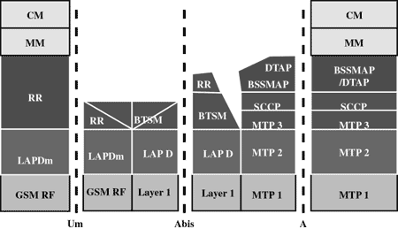

**MS Protocols:**

Based on the interface, the GSM signaling protocol is assembled into three general layers:

Layer 1 : The physical layer. It uses the channel structures over the air interface.

Layer 2 : The data-link layer. Across the Um interface, the data-link layer is a modified version of the Link access protocol for the D channel (LAP-D) protocol used in ISDN, called Link access protocol on the Dm channel (LAP-Dm). Across the A interface, the Message Transfer Part (MTP), Layer 2 of SS7 is used.

Layer 3 : GSM signalling protocol’s third layer is divided into three sublayers:

Radio Resource Management (RR),

Mobility Management (MM), and

Connection Management (CM).

**MS to BTS Protocols:**

The RR layer is the lower layer that manages a link, both radio and fixed, between the MS and the MSC. For this formation, the main components involved are the MS, BSS, and MSC. The responsibility of the RR layer is to manage the RR-session, the time when a mobile is in a dedicated mode, and the radio channels including the allocation of dedicated channels.

The MM layer is stacked above the RR layer. It handles the functions that arise from the mobility of the subscriber, as well as the authentication and security aspects. Location management is concerned with the procedures that enable the system to know the current location of a powered-on MS so that incoming call routing can be completed.

The CM layer is the topmost layer of the GSM protocol stack. This layer is responsible for Call Control, Supplementary Service Management, and Short Message Service Management. Each of these services are treated as individual layer within the CM layer. Other functions of the CC sublayer include call establishment, selection of the type of service (including alternating between services during a call), and call release.

**BSC Protocols:**

The BSC uses a different set of protocols after receiving the data from the BTS. The Abis interface is used between the BTS and BSC. At this level, the radio resources at the lower portion of Layer 3 are changed from the RR to the Base Transceiver Station Management (BTSM). The BTS management layer is a relay function at the BTS to the BSC.

The RR protocols are responsible for the allocation and reallocation of traffic channels between the MS and the BTS. These services include controlling the initial access to the system, paging for MT calls, the handover of calls between cell sites, power control, and call termination. The BSC still has some radio resource management in place for the frequency coordination, frequency allocation, and the management of the overall network layer for the Layer 2 interfaces.

To transit from the BSC to the MSC, the BSS mobile application part or the direct application part is used, and SS7 protocols is applied by the relay, so that the MTP 1-3 can be used as the prime architecture.

**MSC Protocols:**

At the MSC, starting from the BSC, the information is mapped across the A interface to the MTP Layers 1 through 3. Here, Base Station System Management Application Part (BSS MAP) is said to be the equivalent set of radio resources. The relay process is finished by the layers that are stacked on top of Layer 3 protocols, they are BSS MAP/DTAP, MM, and CM. This completes the relay process. To find and connect to the users across the network, MSCs interact using the control-signalling network. Location registers are included in the MSC databases to assist in the role of determining how and whether connections are to be made to roaming users.

Each GSM MS user is given a HLR that in turn comprises of the user’s location and subscribed services. VLR is a separate register that is used to track the location of a user. When the users move out of the HLR covered area, the VLR is notified by the MS to find the location of the user. The VLR in turn, with the help of the control network, signals the HLR of the MS’s new location. With the help of location information contained in the user’s HLR, the MT calls can be routed to the user.

### 5.5.6.GSM USER SERVICE:

GSM offers much more than just voice telephony. Contact your local GSM network operator to the specific services that you can avail.

* GSM offers three basic types of services:
* Telephony services or teleservices
* Data services or bearer services
* Supplementary services
* Teleservices:

The abilities of a Bearer Service are used by a Teleservice to transport data. These services are further transited in the following ways:

**Voice Calls:**

The most basic Teleservice supported by GSM is telephony. This includes full-rate speech at 13 kbps and emergency calls, where the nearest emergency-service provider is notified by dialing three digits.

**Videotext and Facsimile:**

Another group of teleservices includes Videotext access, Teletex transmission, Facsimile alternate speech and facsimile Group 3, Automatic facsimile Group, 3 etc.

**Short Text Messages:**

Short Messaging Service (SMS) service is a text messaging service that allows sending and receiving text messages on your GSM mobile phone. In addition to simple text messages, other text data including news, sports, financial, language, and location-based data can also be transmitted.

**Bearer Services:**

Data services or Bearer Services are used through a GSM phone. to receive and send data is the essential building block leading to widespread mobile Internet access and mobile data transfer. GSM currently has a data transfer rate of 9.6k. New developments that will push up data transfer rates for GSM users are HSCSD (high speed circuit switched data) and GPRS (general packet radio service) are now available.

**Supplementary Services:**

Supplementary services are additional services that are provided in addition to teleservices and bearer services. These services include caller identification, call forwarding, call waiting, multi-party conversations, and barring of outgoing (international) calls, among others. A brief description of supplementary services is given here:

**Conferencing:** It allows a mobile subscriber to establish a multiparty conversation, i.e., a simultaneous conversation between three or more subscribers to setup a conference call. This service is only applicable to normal telephony.

**Call Waiting:** This service notifies a mobile subscriber of an incoming call during a conversation. The subscriber can answer, reject, or ignore the incoming call.

**Call Hold:** This service allows a subscriber to put an incoming call on hold and resume after a while. The call hold service is applicable to normal telephony.

**Call Forwarding:** Call Forwarding is used to divert calls from the original recipient to another number. It is normally set up by the subscriber himself. It can be used by the subscriber to divert calls from the Mobile Station when the subscriber is not available, and so to ensure that calls are not lost.

**Call Barring:** Call Barring is useful to restrict certain types of outgoing calls such as ISD or stop incoming calls from undesired numbers. Call barring is a flexible service that enables the subscriber to conditionally bar calls.

**Number Identification:** There are following supplementary services related to number identification:

**Calling Line Identification Presentation:** This service displays the telephone number of the calling party on your screen.

Calling Line Identification Restriction: A person not wishing their number to be presented to others subscribes to this service.

Connected Line Identification Presentation: This service is provided to give the calling party the telephone number of the person to whom they are connected. This service is useful in situations such as forwarding's where the number connected is not the number dialed.

Connected Line Identification Restriction: There are times when the person called does not wish to have their number presented and so they would subscribe to this person. Normally, this overrides the presentation service.

Malicious Call Identification: The malicious call identification service was provided to combat the spread of obscene or annoying calls. The victim should subscribe to this service, and then they could cause known malicious calls to be identified in the GSM network, using a simple command.

Advice of Charge (AoC) : This service was designed to give the subscriber an indication of the cost of the services as they are used. Furthermore, those service providers who wish to offer rental services to subscribers without their own SIM can also utilize this service in a slightly different form. AoC for data calls is provided on the basis of time measurements.

Closed User Groups (CUGs) : This service is meant for groups of subscribers who wish to call only each other and no one else.

Unstructured supplementary services data (USSD) : This allows operator-defined individual services.

**GSM SECURITY AND ENCRYPTION**:

GSM is the most secured cellular telecommunications system available today. GSM has its security methods standardized. GSM maintains end-to-end security by retaining the confidentiality of calls and anonymity of the GSM subscriber.

Temporary identification numbers are assigned to the subscriber’s number to maintain the privacy of the user. The privacy of the communication is maintained by applying encryption algorithms and frequency hopping that can be enabled using digital systems and signalling.

This chapter gives an outline of the security measures implemented for GSM subscribers.

**Mobile Station Authentication**

The GSM network authenticates the identity of the subscriber through the use of a challenge-response mechanism. A 128-bit Random Number (RAND) is sent to the MS. The MS computes the 32-bit Signed Response (SRES) based on the encryption of the RAND with the authentication algorithm (A3) using the individual subscriber authentication key (Ki). Upon receiving the SRES from the subscriber, the GSM network repeats the calculation to verify the identity of the subscriber.

The individual subscriber authentication key (Ki) is never transmitted over the radio channel, as it is present in the subscriber’s SIM, as well as the AUC, HLR, and VLR databases. If the received SRES agrees with the calculated value, the MS has been successfully authenticated and may continue. If the values do not match, the connection is terminated and an authentication failure is indicated to the MS.

The calculation of the signed response is processed within the SIM. It provides enhanced security, as confidential subscriber information such as the IMSI or the individual subscriber authentication key (Ki) is never released from the SIM during the authentication process.

**Signaling and Data Confidentiality**

The SIM contains the ciphering key generating algorithm (A8) that is used to produce the 64-bit ciphering key (Kc). This key is computed by applying the same random number (RAND) used in the authentication process to ciphering key generating algorithm (A8) with the individual subscriber authentication key (Ki).

GSM provides an additional level of security by having a way to change the ciphering key, making the system more resistant to eavesdropping. The ciphering key may be changed at regular intervals as required. As in case of the authentication process, the computation of the ciphering key (Kc) takes place internally within the SIM. Therefore, sensitive information such as the individual subscriber authentication key (Ki) is never revealed by the SIM.

Encrypted voice and data communications between the MS and the network is accomplished by using the ciphering algorithm A5. Encrypted communication is initiated by a ciphering mode request command from the GSM network. Upon receipt of this command, the mobile station begins encryption and decryption of data using the ciphering algorithm (A5) and the ciphering key (Kc).

**Subscriber Identity Confidentiality**

To ensure subscriber identity confidentiality, the Temporary Mobile Subscriber Identity (TMSI) is used. Once the authentication and encryption procedures are done, the TMSI is sent to the mobile station. After the receipt, the mobile station responds. The TMSI is valid in the location area in which it was issued. For communications outside the location area, the Location Area Identification (LAI) is necessary in addition to the TMSI.

## 5.6. BUZZER

A buzzer or beeper is a signaling device, usually electronic, typically used in automobiles, household appliances such as a microwave oven, or game shows. It most commonly consists of a number of switches or sensors connected to a control unit that determines if and which button was pushed or a preset time has lapsed, and usually illuminates a light on the appropriate button or control panel, and sounds a warning in the form of a continuous or intermittent buzzing or beeping sound. Initially this device was based on an electromechanical system which was identical to an electric bell without the metal gong (which makes the ringing noise). Often these units were anchored to a wall or ceiling and used the ceiling or wall as a sounding board.

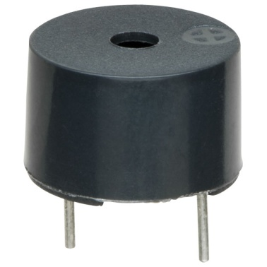

Another implementation with some AC-connected devices was to implement a circuit to make the AC current into a noise loud enough to drive a loudspeaker and hook this circuit up to a cheap 8-ohm speaker. Nowadays, it is more popular to use a ceramic-based piezoelectric sounder like a Sonalert which makes a high-pitched tone. Usually these were hooked up to "driver" circuits which varied the pitch of the sound or pulsed the sound on and off. In game shows it is also known as a "lockout system," because when one person signals ("buzzes in"), all others are locked out from signalling. Several game shows have large buzzer buttons which are identified as "plungers". The word "buzzer" comes from the rasping noise that buzzers made when they were electromechanical devices, operated from stepped-down AC line voltage at 50 or 60 cycles. Other sounds commonly used to indicate that a button has been pressed are a ring or a beep.

## 5.7. ULTRASONIC SENSOR:

Ultrasonic transducers are transducers that convert ultrasound waves to electrical signals or vice versa. Those that both transmit and receive may also be called ultrasound transceivers; many ultrasound sensors besides being sensors are indeed transceivers because they can both sense and transmit. These devices work on a principle similar to that of transducers used in radar and sonar systems, which evaluate attributes of a target by interpreting the echoes from radio or sound waves, respectively. Active ultrasonic sensors generate high-frequency sound waves and evaluate the echo which is received back by the sensor, measuring the time interval between sending the signal and receiving the echo to determine the distance to an object. Passive ultrasonic sensors are basically microphones that detect ultrasonic noise that is present under certain conditions, convert it to an electrical signal, and report it to a computer.

This technology can be used for measuring wind speed and direction (anemometer), tank or channel fluid level, and speed through air or water. For measuring speed or direction, a device uses multiple detectors and calculates the speed from the relative distances to particulates in the air or water. To measure tank or channel level, the sensor measures the distance to the surface of the fluid. Further applications include humidifiers, sonar, medical ultrasonography, burglar alarms, non-destructive testing and wireless charging. Systems typically use a transducer which generates sound waves in the ultrasonic range, above 18 kHz, by turning electrical energy into sound, then upon receiving the echo turn the sound waves into electrical energy which can be measured and displayed. The technology is limited by the shapes of surfaces and the density or consistency of the material. Foam, in particular, can distort surface level readings. This technology, as well, can detect approaching objects and track their positions.

**TRANSDUCER:**

An ultrasonic transducer is a device that converts AC into ultrasound, as well as the reverse, sound into AC. In ultrasonics, the term typically refers to piezoelectric transducers or capacitive transducers. Piezoelectric crystals change size and shape when a voltage is applied; AC voltage makes them oscillate at the same frequency and produce ultrasonic sound. Capacitive transducers use electrostatic fields between a conductive diaphragm and a backing plate. The beam pattern of a transducer can be determined by the active transducer area and shape, the ultrasound wavelength, and the sound velocity of the propagation medium. The diagrams show the sound fields of an unfocused and a focusing ultrasonic transducer in water, plainly at differing energy levels. Since piezoelectric materials generate a voltage when force is applied to them, they can also work as ultrasonic detectors. Some systems use separate transmitters and receivers, while others combine both functions into a single piezoelectric transceiver. Ultrasound transmitters can also use non-piezoelectric principles. such as magnetostriction. Materials with this property change size slightly when exposed to a magnetic field and make practical transducers. A capacitor ("condenser") microphone has a thin diaphragm that responds to ultrasound waves. Changes in the electric field between the diaphragm and a closely spaced backing plate convert sound signals to electric currents, which can be amplified.

**USES IN MEDICAL FIELD:**

Medical ultrasonic transducers (probes) come in a variety of different shapes and sizes for use in making cross-sectional images of various parts of the body. The transducer may be passed over the surface and in contact with the body or inserted into a body opening such as the rectum or vagina. Clinicians who perform ultrasound-guided procedures often use a probe positioning system to hold the ultrasonic transducer. Air detection sensors are used in various roles. Further explanation needed] Non-invasive air detection is for the most critical situations where the safety of a patient is mandatory. Many of the variables, which can affect performance of amplitude or continuous-wave-based sensing systems, are eliminated, or greatly reduced, thus yielding accurate and repeatable detection. One key principle in this technology is that the transmit signal consists of short bursts of ultrasonic energy. After each burst, the electronics looks for a return signal within a small window of time corresponding to the time it takes for the energy to pass through the vessel. Only signals received during this period will qualify for additional signal processing. This principle is similar to radar range gating.

**USES IN INDUSTRY:**

Ultrasonic sensors can detect movement of targets and measure the distance to them in many automated factories and process plants. Sensors can have an on or off digital output for detecting the movement of objects, or an analog output proportional to distance. They can sense the edge of material as part of a web guiding system. Ultrasonic sensors are widely used in cars as parking sensors to aid the driver in reversing into parking spaces. They are being tested for a few other automotive uses including ultrasonic people detection and assisting in autonomous UAV navigation. [citation needed] Because ultrasonic sensors use sound rather than light for detection, they work in applications where photoelectric sensors may not. Ultrasonics are a great solution for clear object detection, clear label detection and for liquid level measurement, applications that photoelectrics struggle with because of target translucence. As well, target color and/or reflectivity do not affect ultrasonic sensors, which can operate reliably in high-glare environments. Passive ultrasonic sensors may be used to detect high-pressure gas or liquid leaks, or other hazardous conditions that generate ultrasonic sound. In these devices, audio from the transducer (microphone) is converted down to human hearing range. High-power ultrasonic emitters are used in commercially available ultrasonic cleaning devices. An ultrasonic transducer is affixed to a stainless steel pan which is filled with a solvent (frequently water or isopropanol). An electrical square wave feeds the transducer, creating sound in the solvent strong enough to cause cavitation.

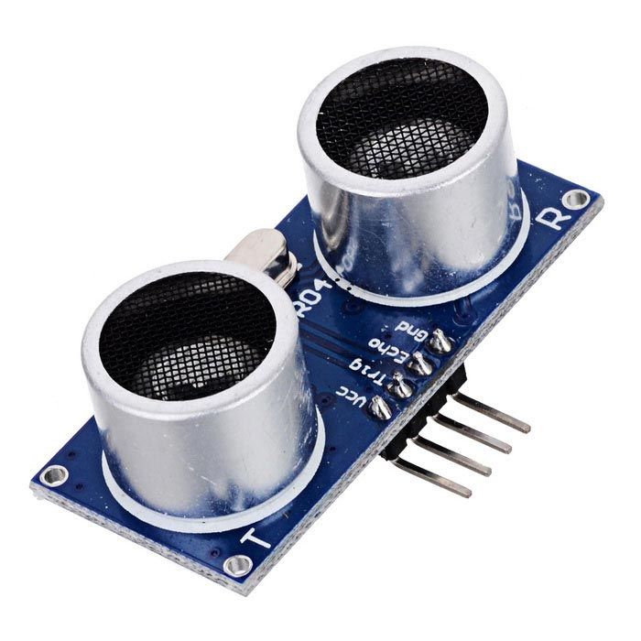

## 5.8. PRESSURE SENSORS

Together with temperature, pressure is one of the most important physical quantities in our environment. Pressure is a significant parameter in such varied disciplines as thermodynamics, aerodynamics, acoustics, fluid mechanics, soil mechanics and biophysics. As an example of important industrial applications of pressure measurement, we may consider power engineering. Hydroelectric, thermal, nuclear, wind and other plants generating mechanical, thermal or electrical energy require the constant monitoring and control of pressures:

overpressure could cause the deterioration of enclosures or drains and cause very significant damage. As a significant parameter, pressure enters into the control and operation of manufacturing units that are automated or operated by human operators. Pressure measurement is also used in robotics, either directly in controls or indirectly as a substitute for touch (artificial skin for example), for pattern recognition or for determining strength of grip. All these activities require instrument chains in which the first element is the pressure sensor, delivering data relating to the pressure of compressed air, gas, vapor, oil or other fluids, determining the correct operation of machines or systems. The variety of mentioned applications demands a great diversity of sensors. This diversity also derives from the fact that pressure covers a very wide range from ultra-high vacuums to ultra-high pressures. It can be expressed as an absolute value (compared to vacuum) or as a relative value (compared to atmospheric pressure); it pressure In what follows, we will consider the different physical characteristics necessary to understand pressure sensors: pressure as a physical quantity, and various sensor models with absolute, relative or differential pressure sensors. We will take a brief look at the physical properties of fluids.

Pressure as a physical quantity 1.2.1.1. Static pressure From a phenomenological point of view, pressure, p, as a macroscopic parameter is defined starting with element of force dF G , exerted perpendicularly on an element of surface dA G of the wall, by the fluid contained in the container

p = dF / dA

The element of force dF G caused by pressure p is perpendicular to the element of surface dA G .

For pressure p inside the fluid with free surface we may write: p = p0+ ρgh

Fluid physical properties In static fluids, the pressure force F is exerted on the surface originates only from the random kinetic energy of molecules. In dynamic fluids force F originates from the random and directed kinetic energy of the molecules. We generally distinguish between two main fluid families: gases and liquids. Liquids The total pressure is the sum of the static pressure, the pressure due to external forces and the dynamic pressure. This has the same value in all points for a fluid moving horizontally (incompressible, negligible viscosity, like liquids), following Bernoulli’s theorem: with: pt: total pressure ps: static pressure pd: dynamic pressure v: local velocity ρ: density Gases The pressure of a gas in a tank is the force exerted by gas on the walls of the tank per unit of area. When a tank contains a mixture of gases, we can define a partial pressure for each of them. The sum of the partial pressures is equal to the total pressure.

The equation of an ideal gas is: pV = nkBT p: pressure n: number of molecules T: temperature V: volume kB: Boltzmann consta

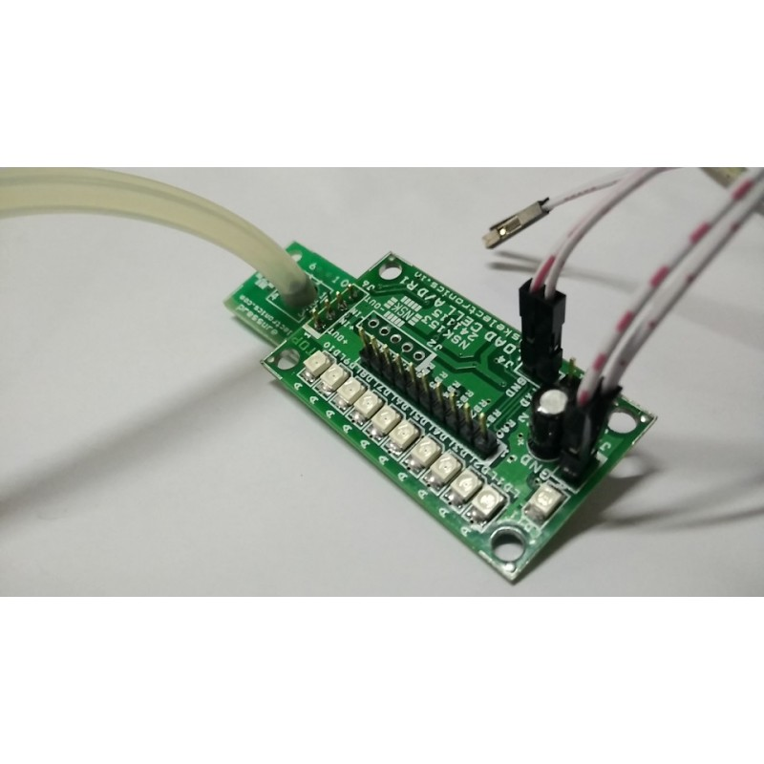

## 5.9.GAS SENSOR (MQ6)

A gas detector is a device that detects the presence of gases in an area, often as part of a safety system. This type of equipment is used to detect a gas leak and interface with a control system so a process can be automatically shut down. A gas detector can sound an alarm to operators in the area where the leak is occurring, giving them the opportunity to leave. This type of device is important because there are many gases that can be harmful to organic life, such as humans or animals. Gas detectors can be used to detect combustible, flammable and toxic gases, and oxygen depletion. This type of device is used widely in industry and can be found in locations, such as on oil rigs, to monitor manufacture processes and emerging technologies such as photovoltaic. They may be used in firefighting. Gas leak detection is the process of identifying potentially hazardous gas leaks by sensors. These sensors usually employ an audible alarm to alert people when a dangerous gas has been detected. Common sensors include infrared point sensors, ultrasonic sensors, electrochemical gas sensors, and semiconductor sensors. More recently, infrared imaging sensors have come into use. All of these sensors are used for a wide range of applications and can be found in industrial plants, refineries, waste-water treatment facilities, vehicles, and homes.

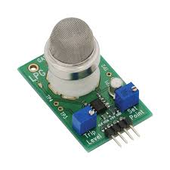

**FEATURES:**

* 5V DC or AC circuit
* Requires heater voltage
* Operation Temperature: -10 to 70 degrees C
* Heater consumption: less than 750mW
* CHARACTER CONFIGURATION:
* Good sensitivity to Combustible gas in wide range
* High sensitivity to LPG, Propane and Hydrogen
* Long life and low cost
* Simple drive circuit

**APPLICATION:**

* Domestic gas leakage detector
* Industrial Combustible gas detector
* Portable gas detector

# 6. CONCLUSION

This device is designed keeping in mind, the measurement of necessary parameters, which needs to be monitored for unhindered safety of the workers. The device finds major application in household sewage systems, municipal manholes and sewage, sewer, deep well, gutters and drains etc. However, the places where toxic gases or fumes are present should never be handled by human workers directly. The sewage system is an efficient and economical device, cost around 10,000INR compared to available safety equipment. In country like India, where sewage is mostly cleaned by humans, which makes this device useful around India.

# 7. REFERENCE

[1] Saad A., Ebrahim Y., and Abdel-Shakour A. (2003). “Respiratory Health Problems of Sewage Workers.” Environmental and Occupational Medicine Department, and Air Pollution Research Department National Research Center

[2] Hamid Raeisi Vanani1, Mohammad Shayannejad1, Ali Reza Soltani Toudeshki1, Mohammad Ali Arab1, Saeid Eslamian1, Vijay P. Singh2, Kaveh Ostad-Ali-Askari. (2018). ”Feasibility Study for Improving the Quality of Refined Sewage Due to the Advancement of Soil.” Water Engineering Department, Isfahan University of Technology, Isfahan, Iran. Department of Biological and Agricultural Engineering Zachry Department of Civil Engineering,Texas A and M University, 321 Scoates Hall, 2117 TAMU, College Station, Texas, U.S.A.

[3] Fioccola, G. B., Sommese, R., Tufano, I., Canonico, R., and Ventre, G. (2016).“Polluino: An efficient cloud based management of IoT devices for air quality monitoring.” 2016 IEEE 2nd International Forum on Research and Technologies for Society and Industry Leveraging a better tomorrow (RTSI), 1–6 (Sep.).

[4] Nitin Asthana, Ridhima Bahl. “IoT Device for Sewage Gas Monitoring and Alert System”.

[5] Liu, Z., Wang, Z., Chen, R., and Wu, X. (2008). “Intelligent residential security alarm and remote control system based on single chip computer.”2008 3rd IEEE Conference on Industrial Electronics and Applications, 159–161 (June).

[6] Keshamoni, K. and Hemanth, S. (2017). “Smart gas level monitoring, bookingamp;amp; gas leakage detector over iot.”2017 IEEE 7th International Advance Computing Conference (IACC), 330–332 (Jan).

[7] Haswani, Navin Deore, Pramod (2018). Web-based real time underground drainage or sewage monitoring system using Wireless Sensor Networks.

[8] B. Sumathy, G. Gowthaman, K. Hari Haran, G. Keerthee Rajan, A. Sweeto Jeison, 2018. Sewage Level Maintenance Using Iot. International Journal of Mechanical Engineering and Technology (IJMET).Volume:9,Issue:2,Pages:389-397.

[9] R. Girisrinivaas and V. Parthipan, ”Drainage overflow monitoring system using IoT (DOMS),” 2017 IEEE International Conference on Power, Control, Signals and Instrumentation Engineering (ICPCSI), Chennai, 2017, pp. 2133-2137.

[10]Yash Narale, Apurva Jogal, Himani Choudhary, S. P. Bhosale. Underground Drainage Monitoring System Using IoT, International Journal of Advance Research, Ideas and Innovations in Technology.

[11]Prof S. A. Shaikh1, Suvarna A. Sonawane2, ”Monitoring Smart City Application Using Raspberry PI based on IoT” International Journal of Innovative Science, Engineering Technology, Vol 5 Issue VIL, July 2017.

[12]Prof Muragesh SK1, Santhosha Rao2, “Automated Internet of Things For Underground Drainage and Manhole Monitoring Systems For Metropolitan Cities.” International Journal of Innovative Science, Engineering Technology, Vol. 2 Issue 4, June 2015.

[13]Lazarescu, M.T., ”Design of a WSN Platform for Long-Term Environmental Monitoring for IoT Applications,” Emerging and Selected Topics in Circuits And Systems, IEEE Journal on, vol.3, no.1, pp.45, 54, March 2013.

[14]S.D.T. Kelly, N.K. Suryadevara, S.C. Mukhopadhyay, ”Towards the Implementation of IoT for Environmental Condition Monitoring in Homes”, Sensors Journal IEEE, vol. 13, no. 10, pp. 3846-3853, Oct. 2013.

[15]I. Akyildiz, W. Su, Y. Sankarasubramanian, E. Cayirci, ”A Survey on Sensor Networks”, IEEE Communications Magazines, August 2002.

[16]Hamzeh Al Zabadi, Luc Ferrari, Irene Sari-Minodier, ´ Marie-Aude Kerautret, Aziz Tiberguent, Christophe Paris, Denis Zmirou-Navier, ”Integrated Exposure Assessment of Sewage Workers to Genotoxicants: an Urinary Biomarker Approach and Oxidative Stress Evaluation”, Environmental Health Journal, March 2011.

[17]Mayank Mrinal, Anubha Mandal, Anunay Gour, Lovleen Gupta, ”Evaluation of Green House Gases Emissions from Sewage Treatment Plants”, International Research Journal of Engineering and Technology (IRJET), May 2016.