ResearchPilot AI Agent
Autonomous Research Intelligence Hub

Intelligent Research Paper Discovery and Analysis System using Agentic AI

Project Description
With the exponential growth of academic research publications and the increasing complexity of staying current with scientific literature, researchers often struggle to efficiently discover, organize, and analyze relevant research papers. Traditional methods of paper management involve manual searching, tagging, and re-reading through extensive literature — a time-consuming process that limits research productivity. To address this challenge, ResearchPilot AI Agent was developed as an intelligent, agentic AI-powered research paper management platform. Built using React for the frontend, FastAPI for backend processing, ChromaDB as a local vector store, and Anthropic's Claude models for advanced natural language understanding, the platform enables researchers to seamlessly discover papers on arXiv, organize them into a tagged library, generate summaries in multiple styles, and interact with an AI agent that answers research questions grounded in the papers themselves.

Scenario 1: Efficient Research Paper Discovery and Organization
Researchers query arXiv through an intelligent, natural-language search interface, receiving curated results with full metadata (title, authors, publication date, abstract). Papers are saved into a personal library with a single click, then organized into collections, tagged freely, and tracked through an unread / reading / read status. The React frontend provides an intuitive browsing experience while the FastAPI backend handles search, persistence, and filtering seamlessly.

Scenario 2: AI-Powered Contextual Research Analysis
A retrieval-augmented chatbot, powered by Anthropic's Claude models, answers research-specific questions by retrieving relevant chunks from indexed papers through vector embeddings. Researchers can ask "What evaluation method does this paper use?" either against a single paper or across their entire indexed library. The AI synthesizes information across documents and cites the exact paper each fact came from, reducing manual reading time and preventing unsupported claims.

Scenario 3: Autonomous Research Assistance
Beyond search and chat, an agent module accepts free-form instructions such as "find recent papers on mixture-of-experts routing and summarize the most relevant one." The agent plans a short sequence of tool calls — search, save, summarize, or search the existing library — executes each one for real, and synthesizes a final answer. Every step is logged and shown to the researcher, so the agent's reasoning stays inspectable rather than a black box.

Architecture
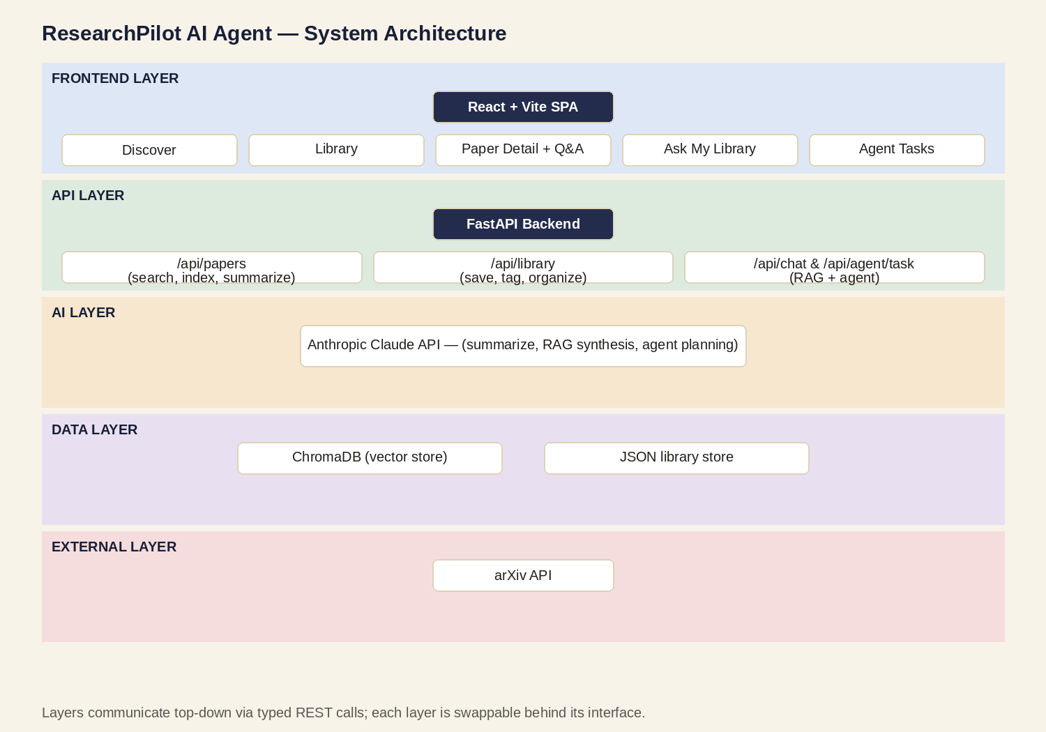
Figure 1: ResearchPilot AI Agent layered architecture

Pre-requisites
- FastAPI Framework Knowledge: https://fastapi.tiangolo.com/
- Anthropic API Familiarity: https://console.anthropic.com/
- HTML, CSS, and JavaScript Skills: https://www.w3schools.com/
- Python Programming Proficiency: https://docs.python.org/3/
- Version Control with Git: https://git-scm.com/doc
- Development Environment Setup: https://fastapi.tiangolo.com/tutorial/

Key Features
- Natural-language Paper Discovery across arXiv
- Smart Organization — collections, tags, and read status
- AI Summarization in four styles (concise, detailed, ELI5, critical)
- Contextual Q&A (RAG) — per-paper and library-wide, with citations
- Autonomous Research Agent — plans and executes multi-step tasks
- Local vector search with ChromaDB (no external vector-DB account required)

How It Works
Step 1: Researchers land on the Discover page and search arXiv using a natural-language query, optionally scoped to a category such as cs.AI or cs.CL.
Step 2: The FastAPI backend queries the arXiv API and returns curated results with title, authors, abstract, and links.
Step 3: Selected papers are saved into a personal library with one click, where they can be tagged, grouped into collections, and tracked by read status.
Step 4: A paper's abstract (and any researcher notes) is chunked and embedded into ChromaDB, making it queryable for contextual Q&A.
Step 5: Researchers ask questions of a single paper or their whole library; retrieved chunks are passed to Claude, which answers grounded only in that context and cites its sources.
Step 6: For open-ended requests, the research agent plans a short tool-call sequence, executes each tool for real, and synthesizes a final answer.
Step 7: Built with a React (Vite) frontend and an async FastAPI backend, the platform ensures fast responses, typed APIs, and a clear separation between UI, orchestration, and AI logic.

Prior Knowledge
You should have prior familiarity with the following topics to extend or rebuild this project:

Agentic AI and the Anthropic API
An agentic AI system plans, reasons, and executes multi-step tasks with limited human supervision. In this project, Claude models accessed through the Anthropic Messages API power three distinct roles: structured summarization, retrieval-grounded question answering, and short tool-call planning for the research agent.

FastAPI
Knowledge of building high-performance web backends using FastAPI, a modern async Python framework for RESTful APIs. FastAPI's typed request/response models, automatic documentation, and async support make it well suited to an AI-powered application that calls external services (arXiv, Anthropic) on the request path.

Frontend Development (React + Vite)
Familiarity with building responsive, interactive interfaces using React, component-based architecture, client-side routing, and calling a REST API from the browser. Building conversational chat UIs and filterable list views is particularly relevant here.

Vector Databases and Semantic Search
A basic understanding of vector embeddings, chunking, and similarity search — how a vector database like ChromaDB stores text as vectors and retrieves the most relevant chunks for a query based on conceptual similarity rather than keyword matching. This underlies both per-paper and library-wide contextual Q&A.

Project Workflow
Milestone 1: Requirements Specification and Project Setup
- Activity 1.1: Create requirements.txt file
- Activity 1.2: Install the required libraries
Milestone 2: Anthropic API Integration and Model Configuration
- Activity 2.1: Generate an Anthropic API key
- Activity 2.2: Configure API credentials
- Activity 2.3: Initialize the Anthropic client and settings
Milestone 3: Backend Development with FastAPI
- Activity 3.1: Build paper discovery endpoints
- Activity 3.2: Implement the vector store and indexing
- Activity 3.3: Build contextual Q&A and agent endpoints
Milestone 4: Frontend Development with React
- Activity 4.1: Build the Discover and Library pages
- Activity 4.2: Build the Paper Detail chat and Agent Tasks pages
Milestone 5: Research Agent Implementation
- Activity 5.1: Implement the plan → execute → synthesize agent loop
Milestone 6: Testing and Deployment
- Activity 6.1: Running the backend
- Activity 6.2: Running the frontend
- Activity 6.3: Configure CORS and environment variables

Project Structure
Create the ResearchPilot project folder with the following structure:
ResearchPilot/
├── backend/
│ ├── requirements.txt
│ ├── .env.example
│ └── app/
│ ├── main.py
│ ├── config.py
│ ├── models/schemas.py
│ ├── services/
│ │ ├── arxiv_client.py
│ │ ├── vector_store.py
│ │ ├── llm_client.py
│ │ ├── library_store.py
│ │ └── agent.py
│ └── routers/
│ ├── papers.py
│ ├── library.py
│ └── chat.py
└── frontend/
├── package.json
├── vite.config.js
└── src/
├── api/client.js
├── components/
└── pages/

Milestone 1: Requirements Specification and Project Setup
This milestone focused on defining the project's objectives and technical specifications, selecting the necessary frameworks and libraries, and setting up an isolated development environment.

Activity 1.1: Create requirements.txt file
Pinning dependency versions in requirements.txt ensures a reproducible backend environment.
fastapi==0.115.0
uvicorn[standard]==0.30.6
pydantic==2.9.2
pydantic-settings==2.5.2
httpx==0.27.2
chromadb==0.5.5
sentence-transformers==3.1.1
anthropic==0.34.2
arxiv==2.1.3
python-dotenv==1.0.1
tenacity==9.0.0

Activity 1.2: Install the required libraries
A virtual environment keeps project dependencies isolated and reproducible.
# Create virtual environment
python -m venv .venv
source .venv/bin/activate

# Install dependencies
cd backend
pip install -r requirements.txt

Milestone 2: Anthropic API Integration and Model Configuration
This milestone focused on integrating the Anthropic Messages API to power summarization, retrieval-grounded chat, and agent planning, with all model settings centralized in one configuration module.

Activity 2.1: Generate an Anthropic API key
- Visit https://console.anthropic.com/
- Open the API Keys section
- Create a new API key
- Store it securely as an environment variable, never in source control

Activity 2.2: Configure API credentials
Create a .env file in the backend directory, based on .env.example:
ANTHROPIC_API_KEY=sk-ant-your-key-here
LLM_MODEL=claude-sonnet-4-6
CHROMA_PERSIST_DIR=./chroma_data
EMBEDDING_MODEL_NAME=all-MiniLM-L6-v2

Activity 2.3: Initialize the Anthropic client and settings
config.py centralizes every tunable setting — model name, chunking, retrieval depth — behind pydantic-settings, so nothing is hard-coded and every value can be overridden per environment.
class Settings(BaseSettings):
model_config = SettingsConfigDict(env_file=".env", extra="ignore")

anthropic_api_key: str = ""
llm_model: str = "claude-sonnet-4-6"
llm_max_tokens: int = 1024
chunk_size_chars: int = 1200
top_k_chunks: int = 6
llm_client.py wraps every model call behind a single retrying helper:
@retry(stop=stop_after_attempt(3), wait=wait_exponential(multiplier=1, min=1, max=8))
def _complete(system: str, user: str, max_tokens: int | None = None) -> str:
response = _client.messages.create(
model=settings.llm_model,
max_tokens=max_tokens or settings.llm_max_tokens,
system=system,
messages=[{"role": "user", "content": user}],
)
return "".join(block.text for block in response.content if block.type == "text")

Milestone 3: Backend Development with FastAPI
This milestone focused on the core backend: discovery, indexing, retrieval, and the endpoints that tie them together behind a typed, documented REST API.

Activity 3.1: Build paper discovery endpoints
arxiv_client.py wraps the arXiv API and normalizes results into a shared Paper schema:
def search_papers(query: str, max_results=None, category=None) -> list[Paper]:
full_query = f"cat:{category} AND {query}" if category else query
search = arxiv.Search(
query=full_query,
max_results=max_results or settings.arxiv_max_results,
sort_by=arxiv.SortCriterion.Relevance,
)
return [_to_paper(r) for r in _client.results(search)]
papers.py exposes this as a REST endpoint:
@router.post("/search", response_model=SearchResponse)
def search_papers(req: SearchRequest):
results = arxiv_client.search_papers(req.query, max_results=req.max_results,
category=req.category)
return SearchResponse(query=req.query, results=results)

Activity 3.2: Implement the vector store and indexing
vector_store.py wraps ChromaDB with a local sentence-transformers embedder. Text is chunked with overlap, embedded, and upserted per paper, so retrieval can be scoped to one paper or the whole library:
def index_paper_text(paper_id: str, paper_title: str, full_text: str) -> int:
chunks = _chunk_text(full_text)
ids = [f"{paper_id}::chunk::{i}" for i in range(len(chunks))]
metadatas = [{"paper_id": paper_id, "paper_title": paper_title} for _ in chunks]
_collection.add(ids=ids, documents=chunks, metadatas=metadatas)
return len(chunks)

def query_similar_chunks(query: str, paper_id: str | None = None, top_k=None):
where = {"paper_id": paper_id} if paper_id else None
return _collection.query(query_texts=[query], n_results=top_k or
settings.top_k_chunks, where=where)

Activity 3.3: Build contextual Q&A and agent endpoints
chat.py retrieves relevant chunks and asks the LLM to answer grounded only in them:
@router.post("/chat", response_model=ChatResponse)
def chat(req: ChatRequest):
chunks = vector_store.query_similar_chunks(req.message, paper_id=req.paper_id)
answer = llm_client.answer_with_context(req.message, chunks,
[m.model_dump() for m in req.history])
citations = [Citation(paper_id=c["metadata"]["paper_id"],
paper_title=c["metadata"]["paper_title"],
chunk_preview=c["text"][:220]) for c in chunks]
return ChatResponse(answer=answer, citations=citations)

Milestone 4: Frontend Development with React
This milestone focused on a responsive React (Vite) single-page app: a Discover search page, a filterable Library, a Paper Detail view with summarization and per-paper chat, a library-wide chat page, and an Agent Tasks page — all sharing one thin fetch-based API client.

Activity 4.1: Build the Discover and Library pages
api/client.js centralizes every backend call so pages stay declarative:
export const api = {
searchPapers: (query, max_results = 10) =>
request("/papers/search", { method: "POST",
body: JSON.stringify({ query, max_results }) }),
addToLibrary: (paper, tags = [], collection = "Uncategorized") =>
request("/library", { method: "POST",
body: JSON.stringify({ paper, tags, collection }) }),
};

Activity 4.2: Build the Paper Detail chat and Agent Tasks pages
Each page keeps chat history in React state and calls the same /api/chat endpoint, scoped to a single paper_id or left null for a library-wide question:
const res = await api.chat(userMsg.content, paperId, messages);
setMessages(m => [...m, { role: "assistant", content: res.answer,
citations: res.citations }]);

Milestone 5: Research Agent Implementation
This milestone focused on the agent orchestrator: an LLM proposes a short plan of tool calls from a fixed toolset, each tool executes for real, and the LLM synthesizes a final answer from the combined outputs — keeping every step inspectable rather than hidden inside one opaque model call.

Activity 5.1: Implement the plan → execute → synthesize agent loop
def run_agent_task(instruction: str) -> tuple[list[AgentStep], str]:
plan = llm_client.plan_agent_steps(instruction, TOOLS)
steps, step_outputs = [], []
for raw_step in plan[:4]:
func = _TOOL_FUNCS.get(raw_step.get("tool"))
output, summary = func(raw_step.get("input", {}))
steps.append(AgentStep(tool=raw_step["tool"], input=raw_step["input"],
output_summary=summary))
step_outputs.append({"tool": raw_step["tool"], "output": output})
final_answer = llm_client.synthesize_agent_answer(instruction, step_outputs)
return steps, final_answer
Available tools: search_papers, add_to_library, summarize_paper, search_library.

Milestone 6: Testing and Deployment
This milestone focused on verifying the backend and frontend run together correctly, with secure, environment-driven configuration rather than hard-coded values.

Activity 6.1: Running the backend
cd backend
source .venv/bin/activate
uvicorn app.main:app --reload --port 8000

Activity 6.2: Running the frontend
cd frontend
npm install
npm run dev

Activity 6.3: Configure CORS and environment variables
main.py restricts cross-origin access to the known frontend origin(s):
app.add_middleware(
CORSMiddleware,
allow_origins=settings.cors_origins,
allow_credentials=True,
allow_methods=["*"],
allow_headers=["*"],
)

Interface Overview
The mockups below reflect the application's actual design system (typography, palette, and component layout) as implemented in the React frontend's stylesheet.

Discover page
The Discover page lets a researcher search arXiv with a natural-language query. Each result shows title, authors, publication year, and abstract, with one-click actions to open the paper or add it straight to the library. A small "marginalia" rail on each card previews its category tag.
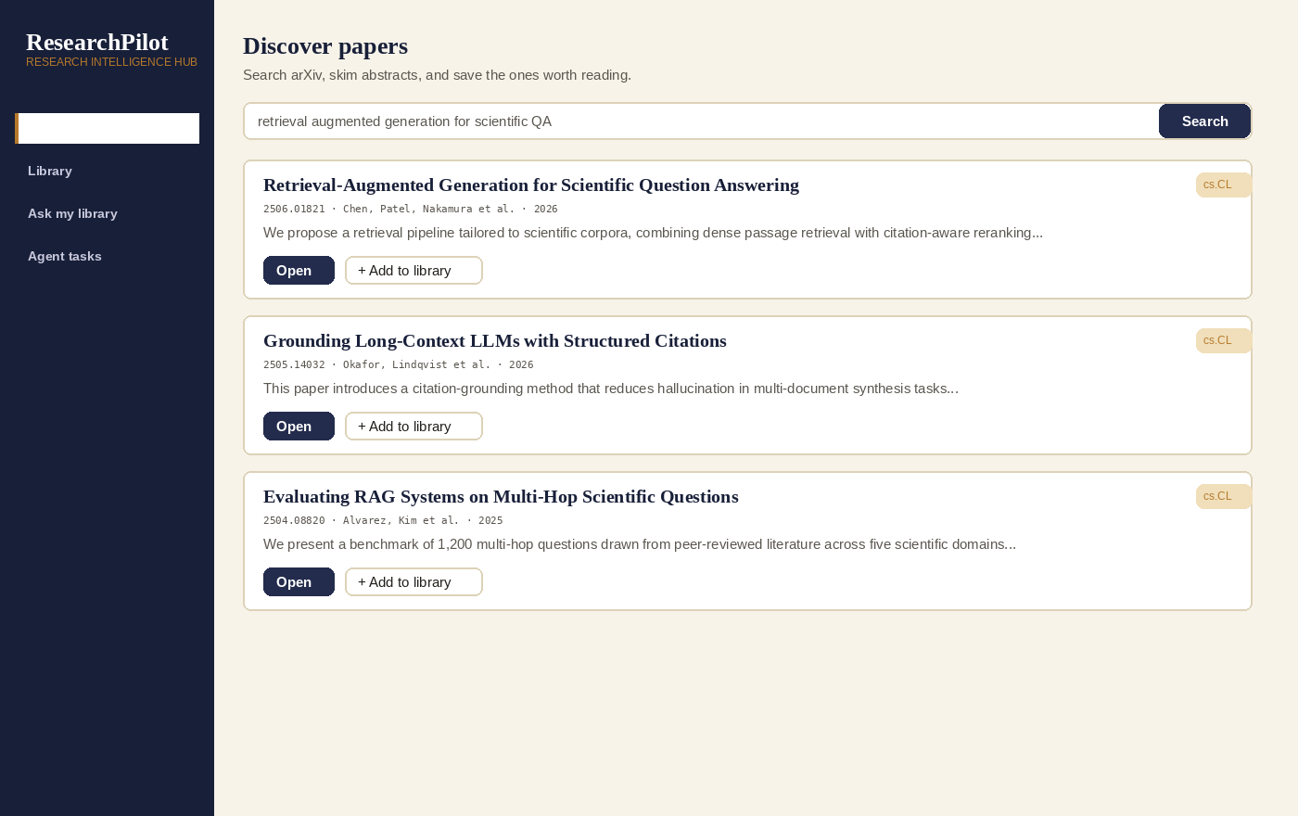
Figure 2: Discover page — natural-language arXiv search

Paper Detail — summaries and per-paper Q&A
Opening a paper shows its abstract alongside four summarization styles, plus a chat panel scoped to that single paper once it has been indexed. Answers are grounded in retrieved chunks and cite the exact passage they came from.
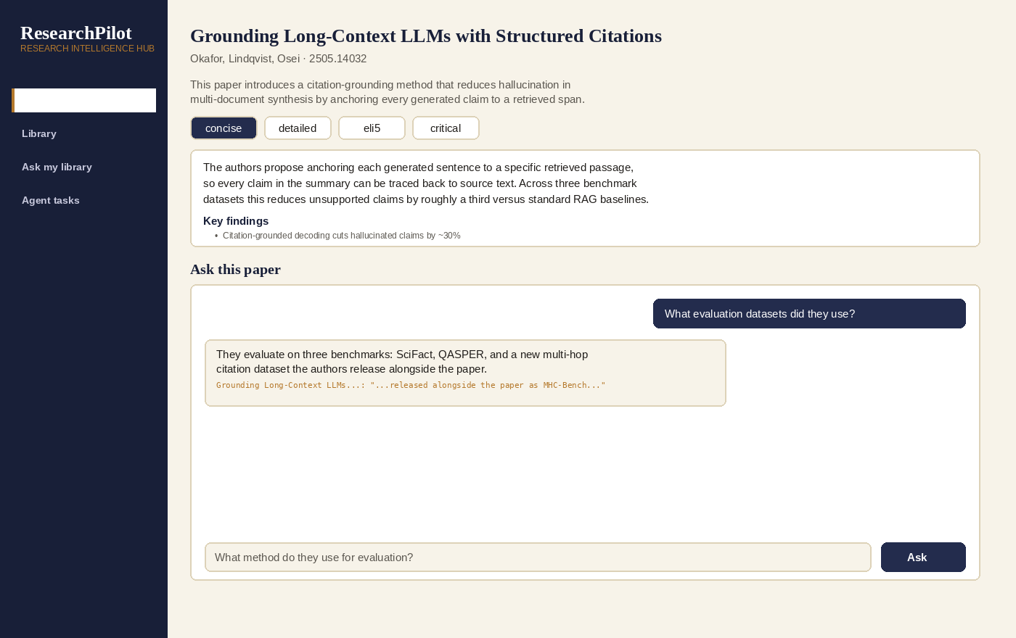
Figure 3: Paper Detail page — styled summaries and grounded Q&A

Agent Tasks page
A free-form instruction is broken into a short, visible plan of tool calls. Each step's tool name and result summary are listed before the agent's final, synthesized answer — keeping the process auditable.
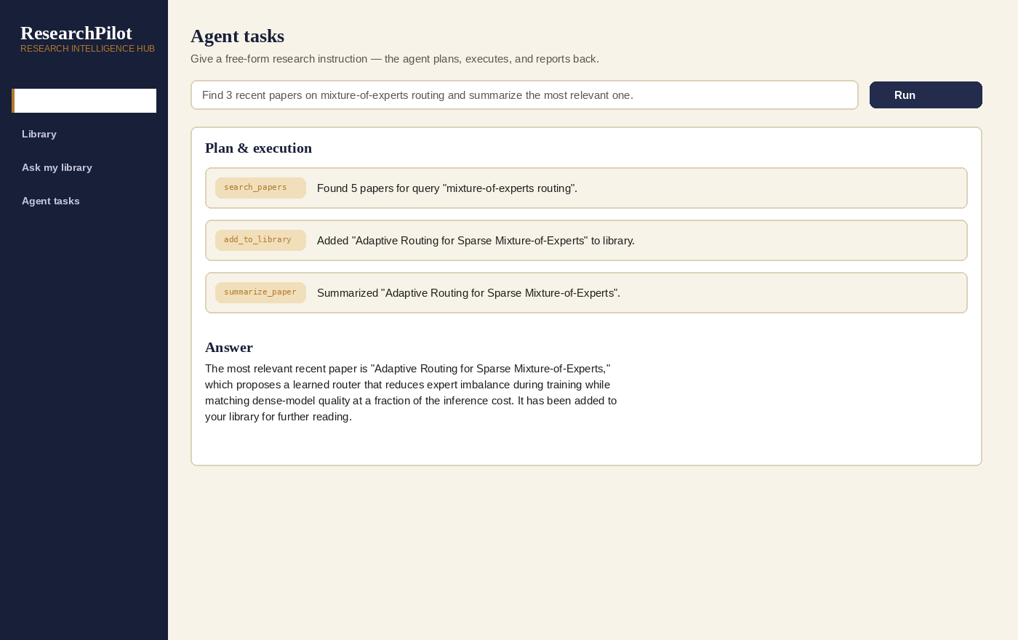
Figure 4: Agent Tasks page — inspectable plan → execute → synthesize loop

Conclusion
ResearchPilot AI Agent demonstrates how agentic AI can meaningfully reduce the manual overhead of academic research. By combining a React frontend, an async FastAPI backend, a local ChromaDB vector store, and Anthropic's Claude models, the platform delivers a working pipeline that discovers papers, organizes them into a structured library, summarizes them in multiple registers, and answers grounded questions with citations. Its agent module shows that "autonomous" does not have to mean opaque: every plan, tool call, and result is visible to the researcher. Key achievements include a genuine retrieval-augmented generation pipeline (not a keyword search dressed up as AI), a multi-step agent loop built from four real, callable tools, and a design and API surface built to be extended — full-text PDF ingestion, a hosted database, and streaming responses are the natural next steps.

