Client-Side App Rubric https://github.com/denisecase/pbl-lifeline-links
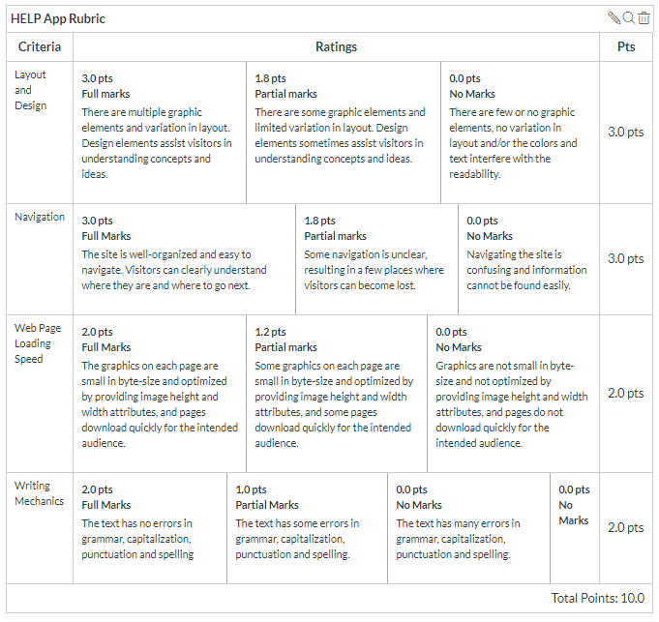
Team reviewed:
Link to the web site: https://gorantla96.github.io/group6/

Layout and Design
Score: 1.8pts
Comments: There were multiple graphic elements, it was a smooth design. There is a lot of negative space and the bottom button gives a 404 error, an image in the gallery is in question. Also the log needs to be bigger, I could hardly read it.

Navigation
Score: 2.5pts
Comments: The history button doesn’t work, the rest of it works and runs well.

Loading Speed:
Score: 2pts
Comments: Full points, all pages load well, some errors though with padding on different resolutions.

Writing Mechanics:
Score: 2 pts
Comments: Everything seems to be in order, no eye catching grammar errors.

General remarks:
Overall a decent website/app, needs some cleaning on for the laptop resolutions. Needs a bigger logo, less negative space, maybe some tabs to store the abundance of information on the home-screen.

Review performed by:

Group 6

Date and time performed:
December 5th, 2019

