Click Event Report

Click at (863, 266)
Timestamp: 2024-10-13T13-53-30-202Z
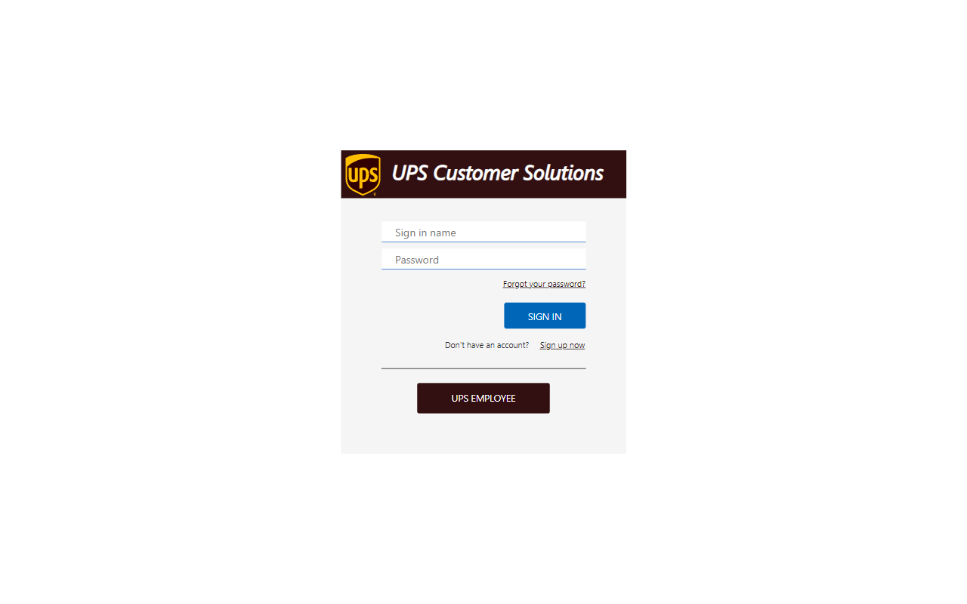

Click at (689, 299)
Timestamp: 2024-10-13T13-53-31-424Z
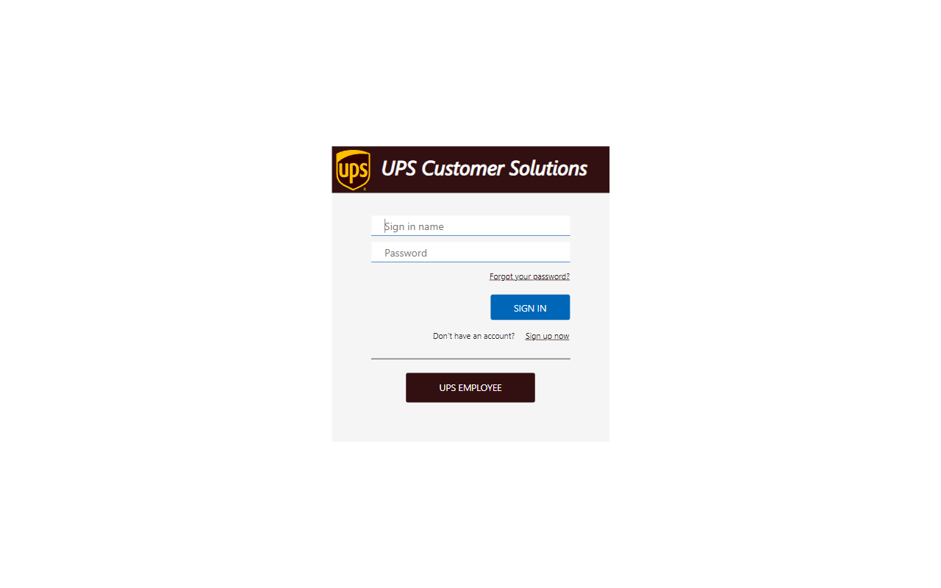

Click at (673, 347)
Timestamp: 2024-10-13T13-53-32-098Z
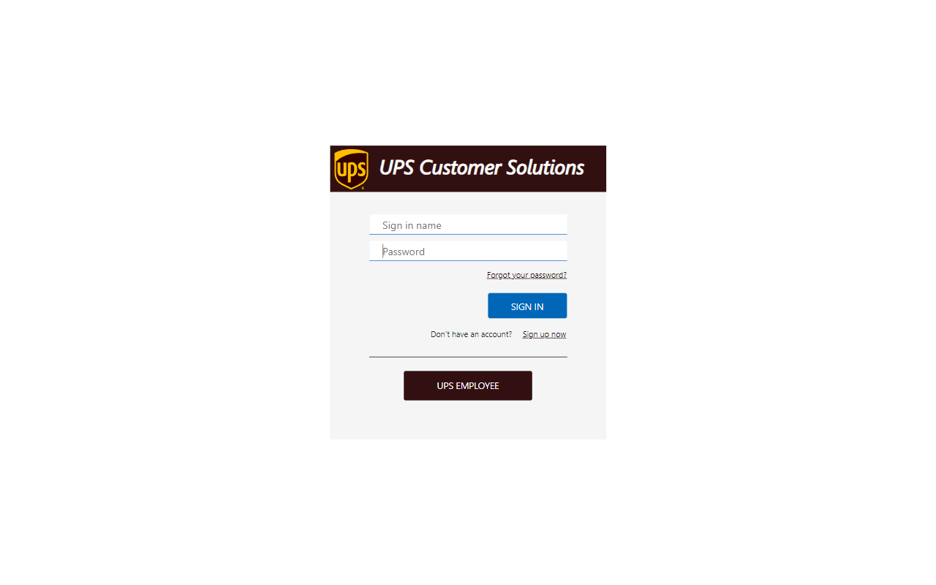

Click at (747, 457)
Timestamp: 2024-10-13T13-53-33-338Z
