50 Tricky Java MCQ: Looping & Loop Control
Beginner Level - 15 Concept Questions + 35 Coding Questions
Topics: For, While, Do-While, For-Each, Break, Continue, Nested Loops & Common Errors

Q1 [CONCEPT]: For Loop - What Executes First
Question: In a for loop for(int i=0; i<10; i++), what happens first?
A | The condition i<10 is checked
B | The variable i is initialized to 0
C | The i++ is executed
D | The loop body runs

Correct Answer: | B
Explanation: | In a for loop, the initialization (int i=0) happens FIRST, then condition check, then body, then increment.

Q2 [CONCEPT]: While Loop - When Loop Stops
Question: A while loop stops when the condition becomes what?
A | true
B | false
C | 0
D | null

Correct Answer: | B
Explanation: | A while loop continues as long as the condition is true. It stops when the condition becomes false.

Q3 [CONCEPT]: Do-While - Guaranteed Execution
Question: How many times does a do-while loop body execute at minimum?
A | 0 times
B | 1 time
C | 2 times
D | Depends on condition

Correct Answer: | B
Explanation: | A do-while loop ALWAYS executes the body at least once, even if the condition is false. This is its key difference from while.

Q4 [CONCEPT]: Break Statement - What Does It Do
Question: What does the break statement do in a loop?
A | Pauses the loop
B | Jumps to next iteration
C | Exits the loop immediately
D | Restarts the loop

Correct Answer: | C
Explanation: | The break statement immediately exits (stops) the current loop. Code after the loop continues to execute.

Q5 [CONCEPT]: Continue Statement - What Does It Do
Question: What does the continue statement do in a loop?
A | Exits the loop
B | Pauses the loop
C | Skips to the next iteration
D | Stops the program

Correct Answer: | C
Explanation: | The continue statement skips the remaining code in the current iteration and jumps to the next iteration of the loop.

Q6 [CONCEPT]: For-Each Loop - What It Does
Question: What does a for-each loop do automatically?
A | It increases by 1 each time
B | It goes through each element in an array or collection
C | It runs 10 times
D | It checks if something is true

Correct Answer: | B
Explanation: | A for-each loop automatically goes through each element in an array without needing manual index management.

Q7 [CONCEPT]: Loop Counter - When It Starts
Question: In for(int i=1; i<=5; i++), what is the first value of i used in the loop?
A | 0
B | 1
C | 5
D | The loop doesn't start

Correct Answer: | B
Explanation: | The loop starts with i=1 because that's what it's initialized to. Then it checks if i<=5 (true), then executes the body.

Q8 [CONCEPT]: Loop Condition - False Means What
Question: If the loop condition becomes false, what happens?
A | The loop runs again
B | The loop stops
C | An error occurs
D | The loop runs forever

Correct Answer: | B
Explanation: | When a loop condition is false, the loop stops immediately and code after the loop continues.

Q9 [CONCEPT]: Nested Loop - How Many Times
Question: If outer loop runs 3 times and inner loop runs 2 times, total executions = ?
A | 3
B | 2
C | 5
D | 6

Correct Answer: | D
Explanation: | Total = outer × inner = 3 × 2 = 6. For each outer iteration, inner loop runs 2 times.

Q10 [CONCEPT]: Break in Nested Loop - Exits What
Question: If break is used in an inner loop of nested loops, what happens?
A | Both loops exit
B | Only the inner loop exits
C | Only the outer loop exits
D | The program stops

Correct Answer: | B
Explanation: | break only exits the innermost loop where it appears. The outer loop continues running.

Q11 [CONCEPT]: Loop Variable Scope - Where It Lives
Question: A variable declared in for(int i=0; i<10; i++) can be used where?
A | Only inside the loop
B | Anywhere in the program
C | In the loop and after it
D | In other methods too

Correct Answer: | A
Explanation: | A variable declared in the for loop initialization is ONLY available inside the loop. After the loop, it doesn't exist.

Q12 [CONCEPT]: Increment - Pre vs Post
Question: What is the difference between ++i and i++?
A | No difference
B | ++i increments before use, i++ increments after use
C | i++ doesn't work
D | ++i is wrong syntax

Correct Answer: | B
Explanation: | ++i (pre-increment) increments first, then uses the value. i++ (post-increment) uses the value first, then increments.

Q13 [CONCEPT]: Infinite Loop - What Causes It
Question: What causes an infinite loop?
A | The condition is always true
B | The condition is always false
C | Too many iterations
D | Using break statement

Correct Answer: | A
Explanation: | An infinite loop happens when the loop condition never becomes false. It keeps running forever (unless break is used).

Q14 [CONCEPT]: Array Length - Loop Condition
Question: To loop through an array of size 5, which condition is correct?
A | i < 5
B | i <= 5
C | i < 6
D | i <= 4

Correct Answer: | A
Explanation: | Arrays of size 5 have indices 0,1,2,3,4. So i < 5 is correct. i <= 5 would try to access index 5 which doesn't exist.

Q15 [CONCEPT]: Empty Loop Body - What Happens
Question: What happens if a loop has an empty body? for(int i=0; i<5; i++) { }
A | Error
B | Loop still runs but does nothing
C | Loop doesn't run at all
D | Infinite loop

Correct Answer: | B
Explanation: | A loop with empty body still executes the specified number of times, it just does nothing each iteration.

Q16 [CODING]: Simple For Loop - Print Numbers
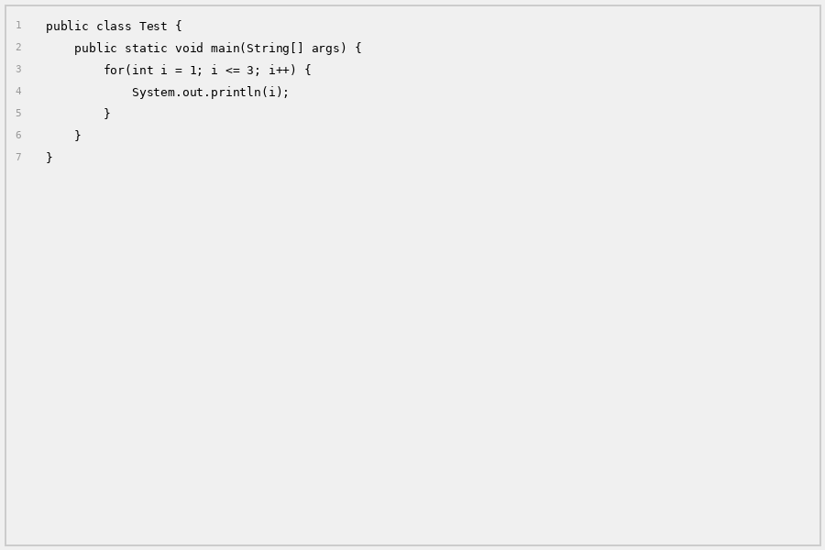
Question: What is the output?
A | 1 2 3
B | 1\n2\n3
C | 0 1 2
D | 1 2 3 4

Correct Answer: | B
Explanation: | The loop runs 3 times (i=1, i=2, i=3) and println prints each on a new line.

Q17 [CODING]: For Loop - Starting Point
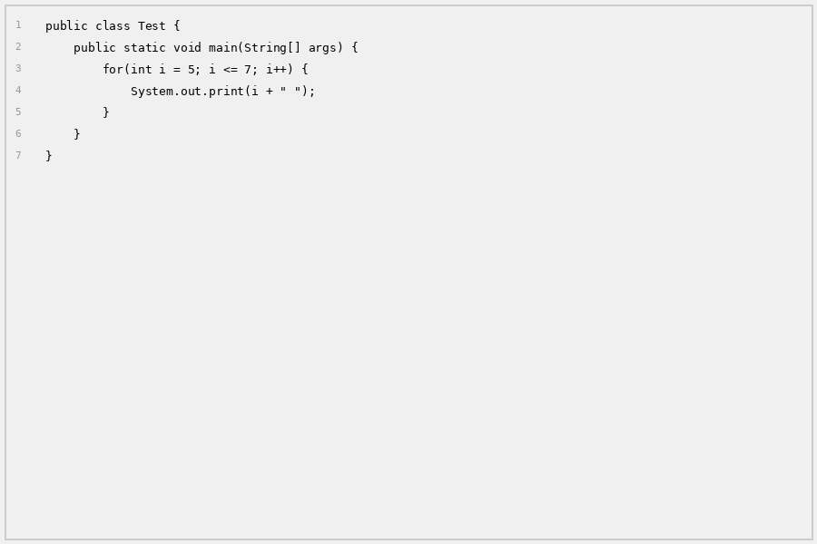
Question: What is the output?
A | 5 6 7
B | 6 7
C | 5 6 7 8
D | 7 8 9

Correct Answer: | A
Explanation: | Loop starts at i=5 and runs while i<=7, so it prints: 5 6 7

Q18 [CODING]: While Loop - Basic
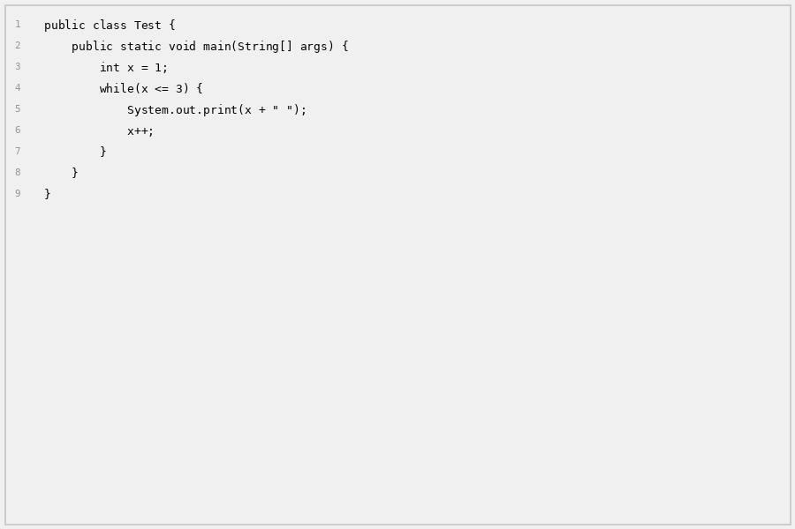
Question: What is the output?
A | 1 2 3
B | 1 2 3 4
C | 0 1 2 3
D | 1 2

Correct Answer: | A
Explanation: | x starts at 1, prints and increments: 1, 2, 3. When x=4, condition x<=3 is false, loop stops.

Q19 [CODING]: Do-While - Executes Once
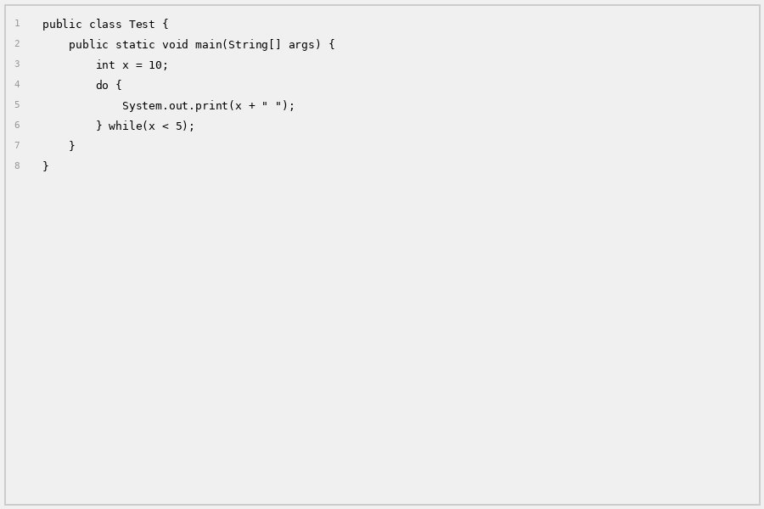
Question: What is the output?
A | Nothing
B | 10
C | Infinite loop
D | Error

Correct Answer: | B
Explanation: | do-while always executes body once (prints 10), then checks condition x<5 which is false, so stops.

Q20 [CODING]: For Loop - Condition False From Start
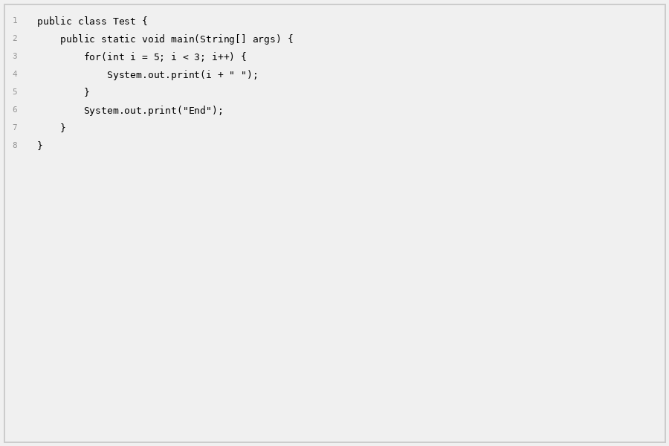
Question: What is the output?
A | 5 4 3 End
B | End
C | Nothing
D | 5 End

Correct Answer: | B
Explanation: | i=5, condition i<3 is false from the start, so loop doesn't run. Only 'End' is printed.

Q21 [CODING]: For Loop with Break
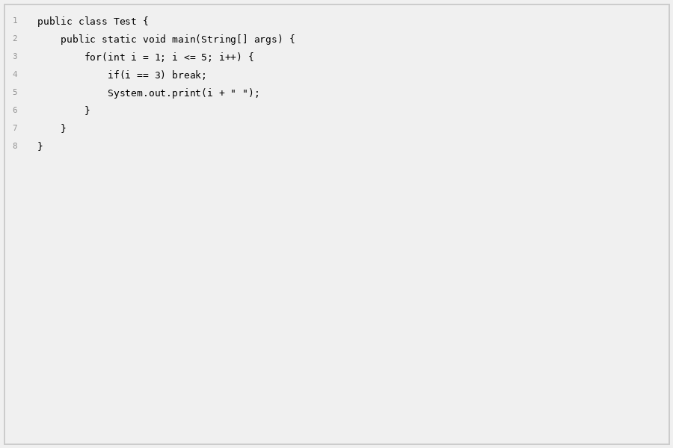
Question: What is the output?
A | 1 2 3 4 5
B | 1 2
C | 1 2 3
D | 3 4 5

Correct Answer: | B
Explanation: | Loop prints 1 and 2. When i=3, break stops the loop immediately.

Q22 [CODING]: For Loop with Continue
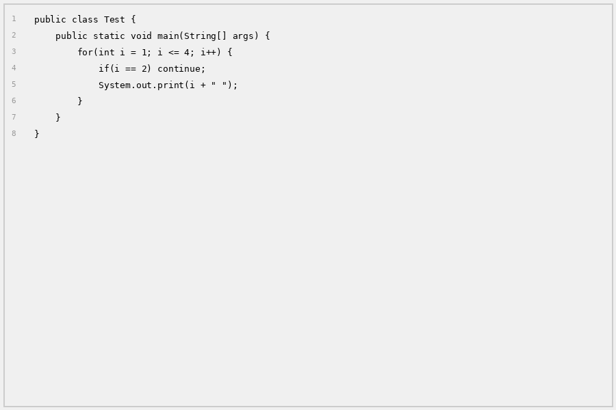
Question: What is the output?
A | 1 2 3 4
B | 1 3 4
C | 2 3 4
D | 1 4

Correct Answer: | B
Explanation: | Prints 1, skips 2 (continue), then prints 3 and 4.

Q23 [CODING]: For Loop - Decrement
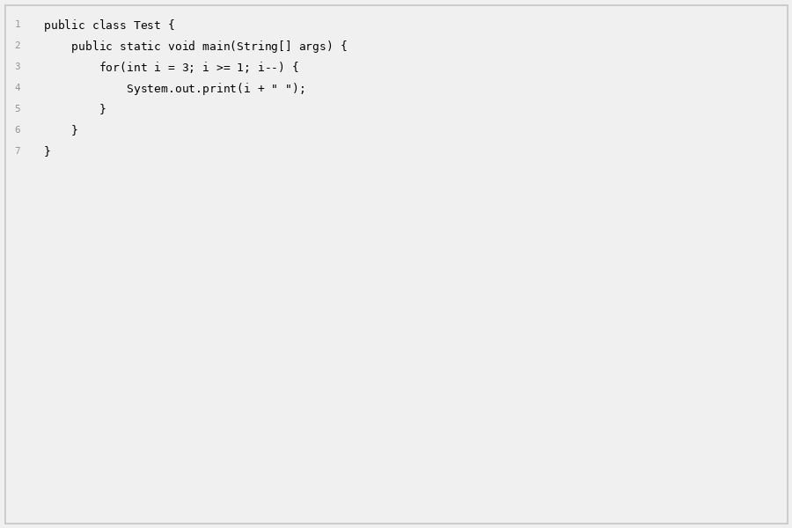
Question: What is the output?
A | 1 2 3
B | 3 2 1
C | 3 2 1 0
D | 3 4 5

Correct Answer: | B
Explanation: | Loop starts at 3 and decrements: 3, 2, 1. When i=0, condition i>=1 is false.

Q24 [CODING]: While Loop - Decrement
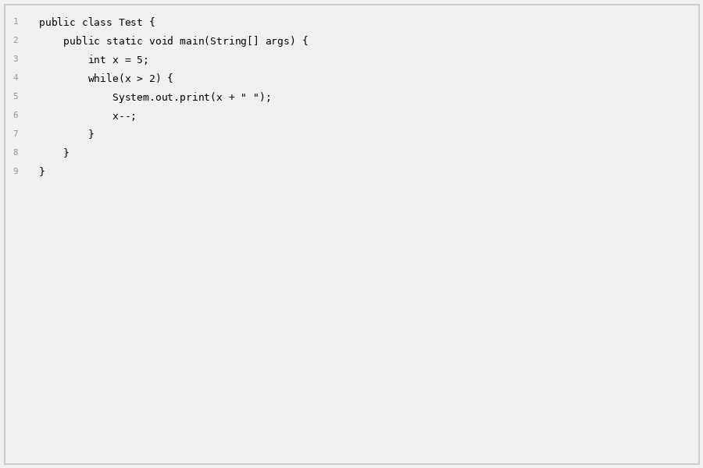
Question: What is the output?
A | 5 4 3
B | 5 4 3 2
C | 5 4 3 2 1
D | 4 3

Correct Answer: | A
Explanation: | x=5 (print), x=4 (print), x=3 (print), x=2, condition x>2 is false, stops.

Q25 [CODING]: For Loop - Add Two
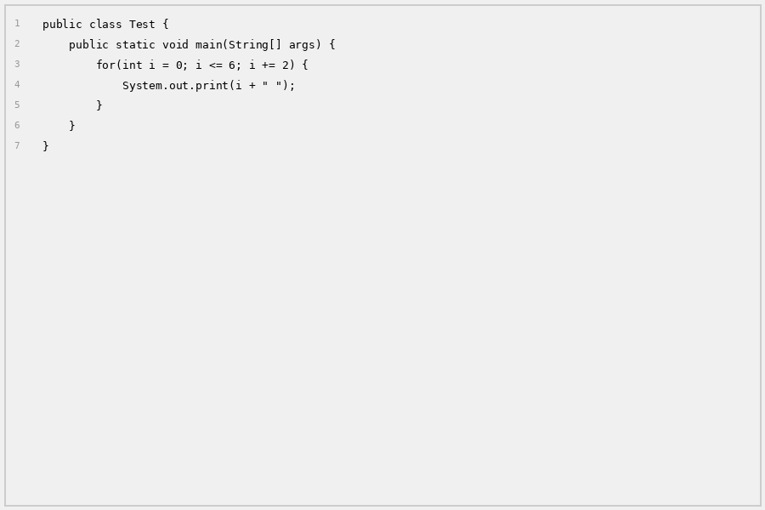
Question: What is the output?
A | 0 2 4 6 8
B | 0 2 4 6
C | 2 4 6
D | 1 3 5

Correct Answer: | B
Explanation: | Starts at 0, adds 2 each time: 0, 2, 4, 6. When i=8, condition i<=6 is false.

Q26 [CODING]: For Loop with Variable
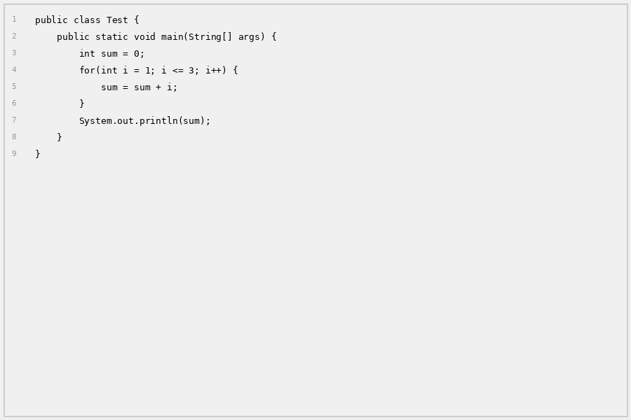
Question: What is the output?
A | 1
B | 3
C | 6
D | 9

Correct Answer: | C
Explanation: | Loop adds: 0+1=1, 1+2=3, 3+3=6. Output: 6

Q27 [CODING]: While Loop - Multiple Conditions
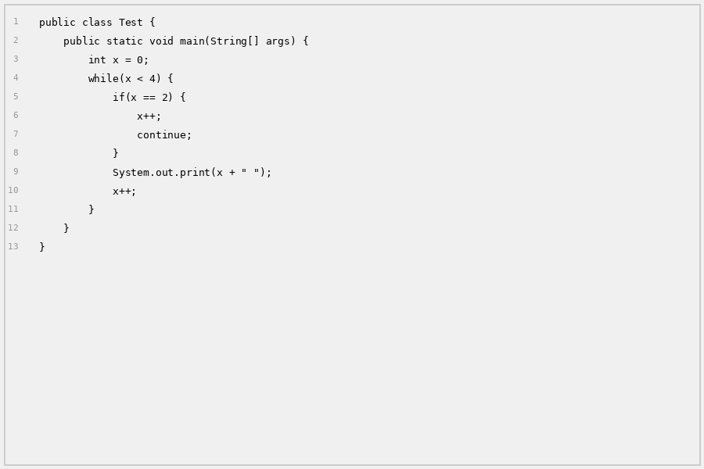
Question: What is the output?
A | 0 1 2 3
B | 0 1 3
C | 1 2 3
D | 0 1

Correct Answer: | B
Explanation: | Prints 0, 1, skips 2 (continue), then prints 3.

Q28 [CODING]: Nested For Loop - Double
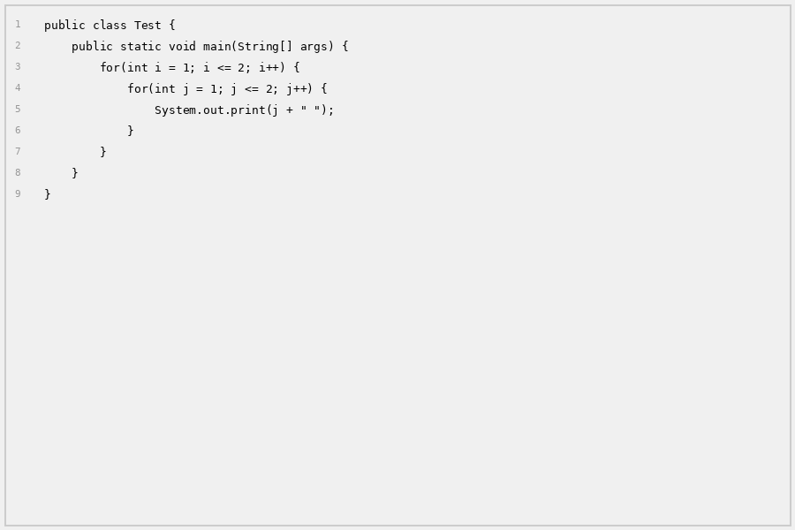
Question: What is the output?
A | 1 2
B | 1 2 1 2
C | 1 2 3 4
D | 2 2

Correct Answer: | B
Explanation: | Outer loop runs 2 times, inner loop runs 2 times each. Total: 1 2 1 2

Q29 [CODING]: Do-While - With Break
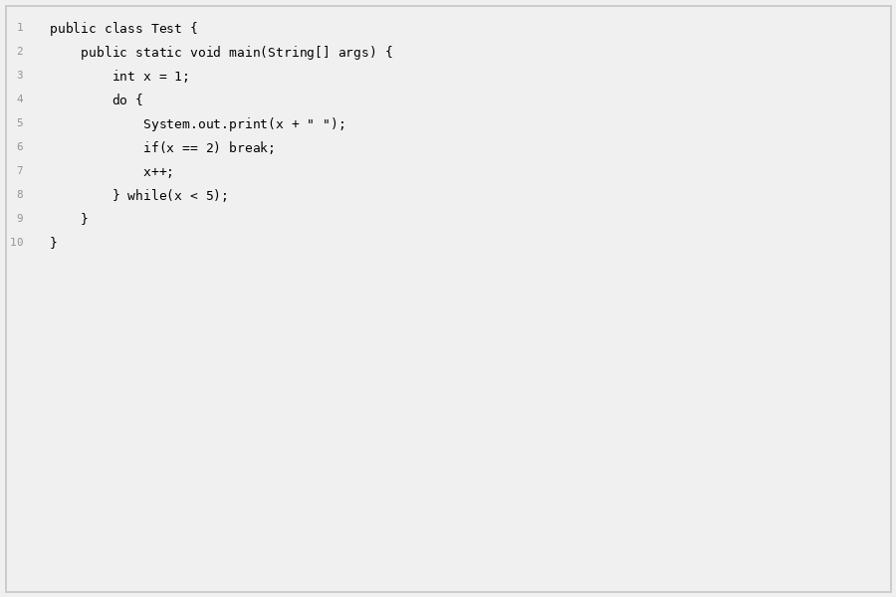
Question: What is the output?
A | 1 2
B | 1 2 3 4
C | 1 2 3
D | 1

Correct Answer: | A
Explanation: | Prints 1, x++, prints 2, break stops the loop.

Q30 [CODING]: For-Each Loop - Array
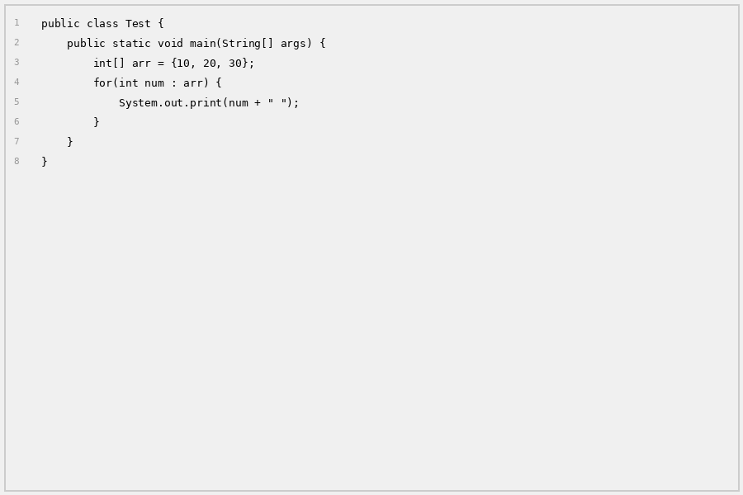
Question: What is the output?
A | 0 1 2
B | 10 20 30
C | 1 2 3
D | arr[0] arr[1] arr[2]

Correct Answer: | B
Explanation: | For-each goes through each element: 10, 20, 30.

Q31 [CODING]: For Loop - Count Down From 5
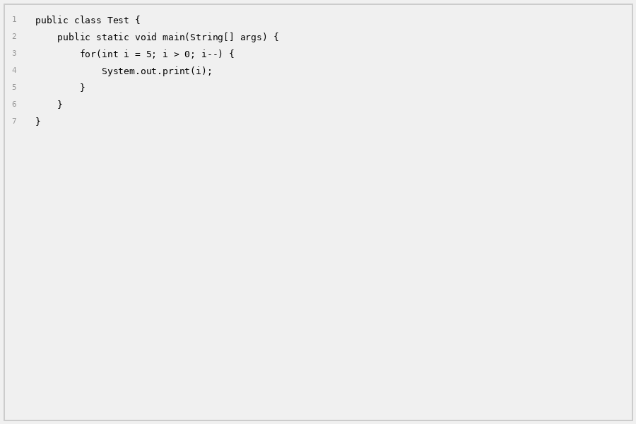
Question: What is the output?
A | 5432
B | 54321
C | 12345
D | 54320

Correct Answer: | B
Explanation: | Decrements from 5 to 1 and prints: 54321

Q32 [CODING]: While Loop - Sum
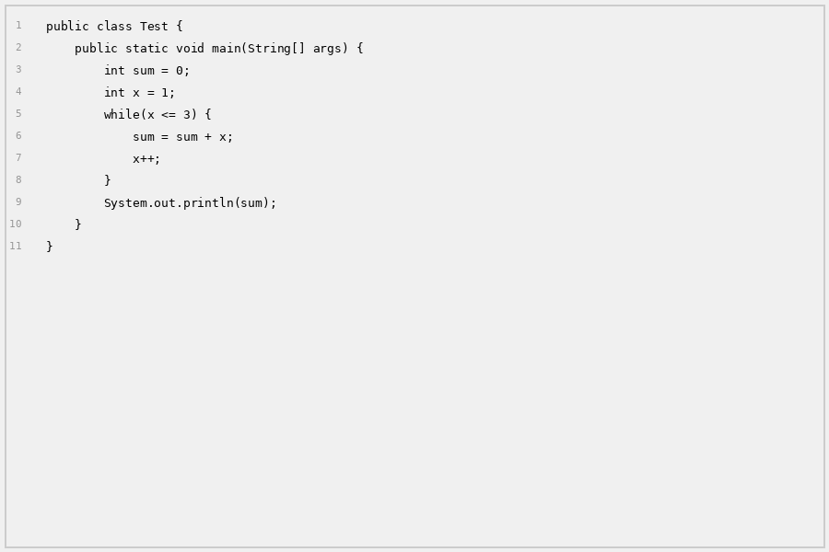
Question: What is the output?
A | 3
B | 6
C | 9
D | 12

Correct Answer: | B
Explanation: | 0+1=1, 1+2=3, 3+3=6. Output: 6

Q33 [CODING]: For Loop - Multiply
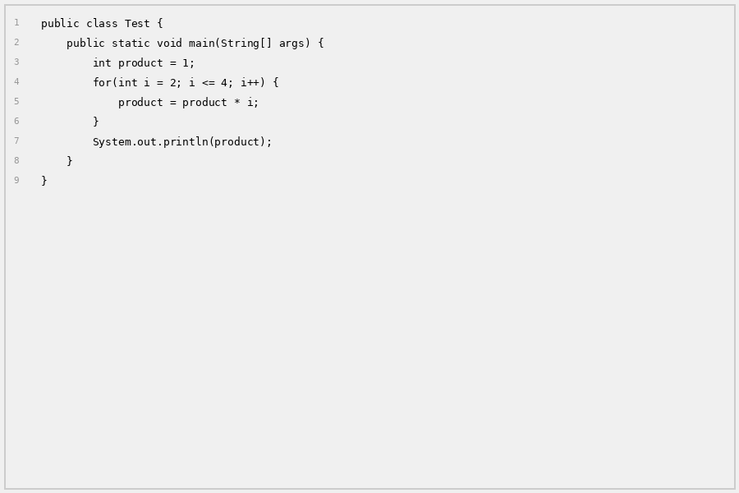
Question: What is the output?
A | 4
B | 6
C | 8
D | 24

Correct Answer: | D
Explanation: | 1*2=2, 2*3=6, 6*4=24. Output: 24

Q34 [CODING]: For Loop - Odd Numbers
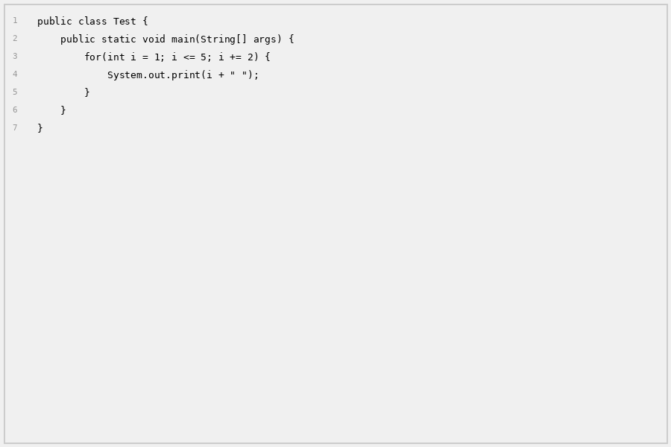
Question: What is the output?
A | 2 4
B | 1 3 5
C | 1 2 3 4 5
D | 1 3 5 7

Correct Answer: | B
Explanation: | Starts at 1, adds 2: 1, 3, 5. Condition i<=5 stops at 5.

Q35 [CODING]: While Loop - With Counter
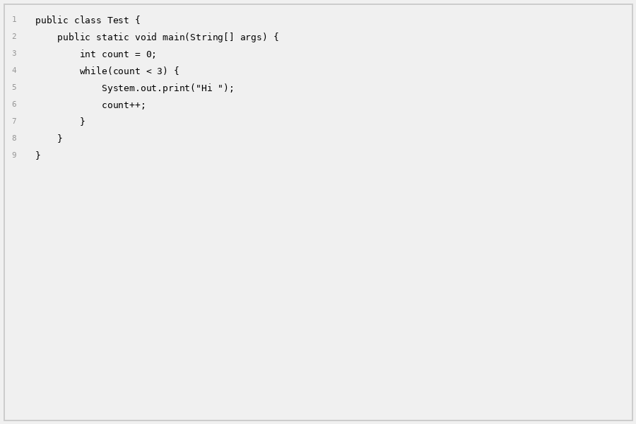
Question: What is the output?
A | Hi
B | Hi Hi
C | Hi Hi Hi
D | Hi Hi Hi Hi

Correct Answer: | C
Explanation: | Loop runs 3 times (count 0, 1, 2). Each prints 'Hi '.

Q36 [CODING]: For Loop - With Break and Continue
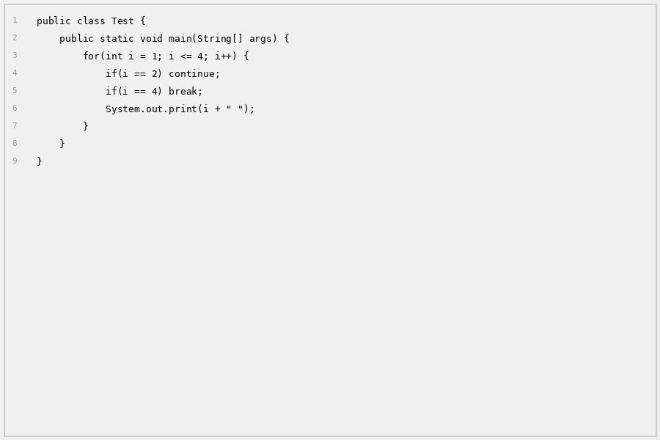
Question: What is the output?
A | 1 3
B | 1 2 3
C | 1 3 4
D | 1

Correct Answer: | A
Explanation: | Prints 1, skips 2, prints 3, breaks at 4. Output: 1 3

Q37 [CODING]: Do-While - Loop Always Executes
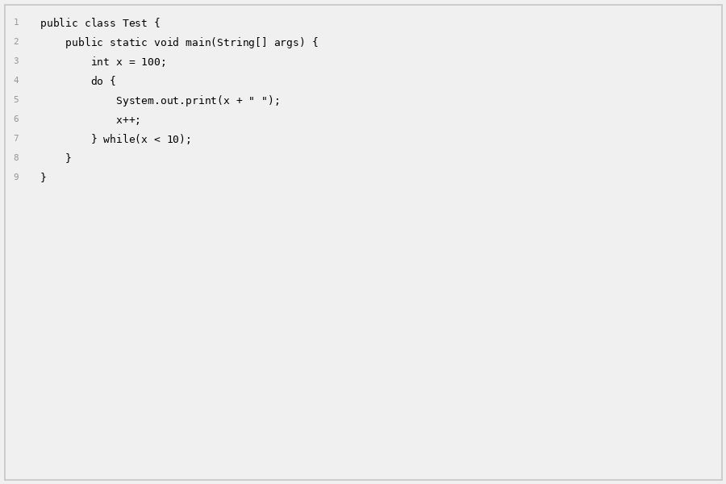
Question: What is the output?
A | Nothing
B | 100
C | 100 101 102...
D | Compilation Error

Correct Answer: | B
Explanation: | do-while always executes body once (prints 100), then checks x<10 which is false.

Q38 [CODING]: Nested For Loop - Break
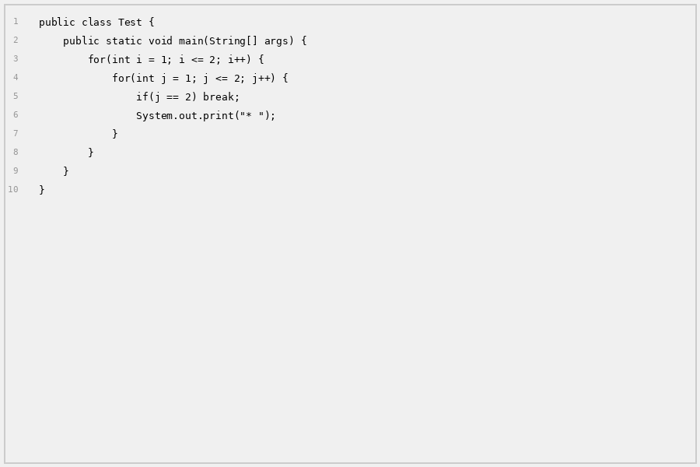
Question: How many asterisks are printed?
A | 1
B | 2
C | 3
D | 4

Correct Answer: | B
Explanation: | Inner loop breaks when j=2, so prints 1 star per outer iteration. 2 outer * 1 = 2 stars.

Q39 [CODING]: For Loop - Variable Change
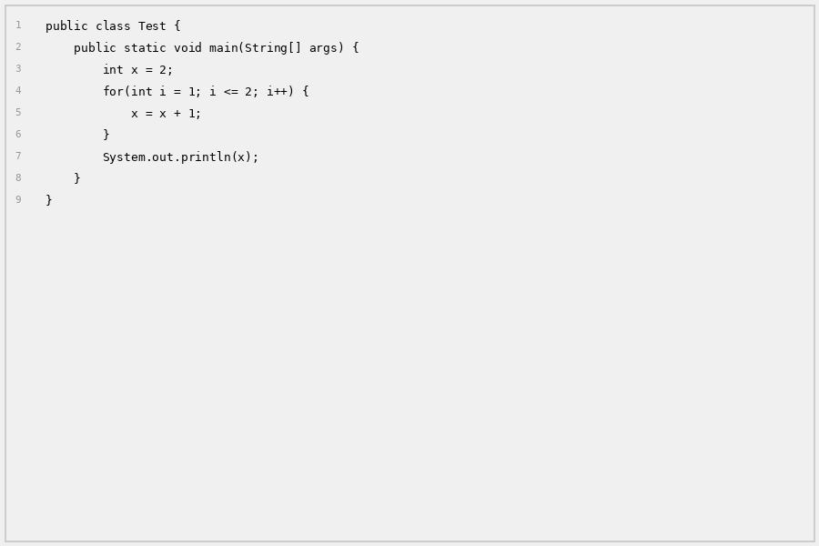
Question: What is the output?
A | 2
B | 3
C | 4
D | 5

Correct Answer: | C
Explanation: | x starts at 2. Loop runs 2 times: x=3, then x=4. Output: 4

Q40 [CODING]: For Loop - Array Length
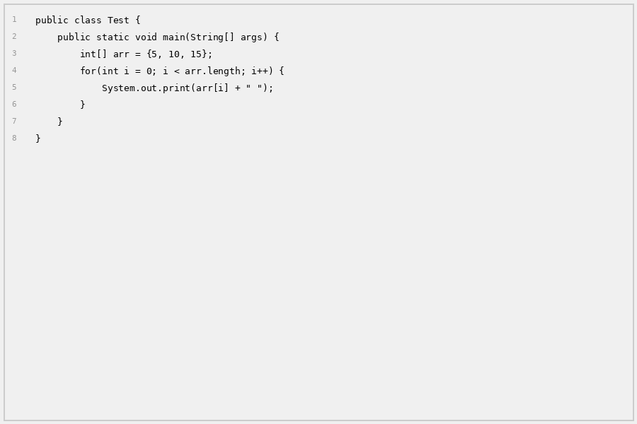
Question: What is the output?
A | 0 1 2
B | 5 10 15
C | 3
D | arr[0] arr[1] arr[2]

Correct Answer: | B
Explanation: | arr.length is 3, so i goes 0,1,2. Prints arr[0]=5, arr[1]=10, arr[2]=15.

Q41 [CODING]: While Loop - Assignment
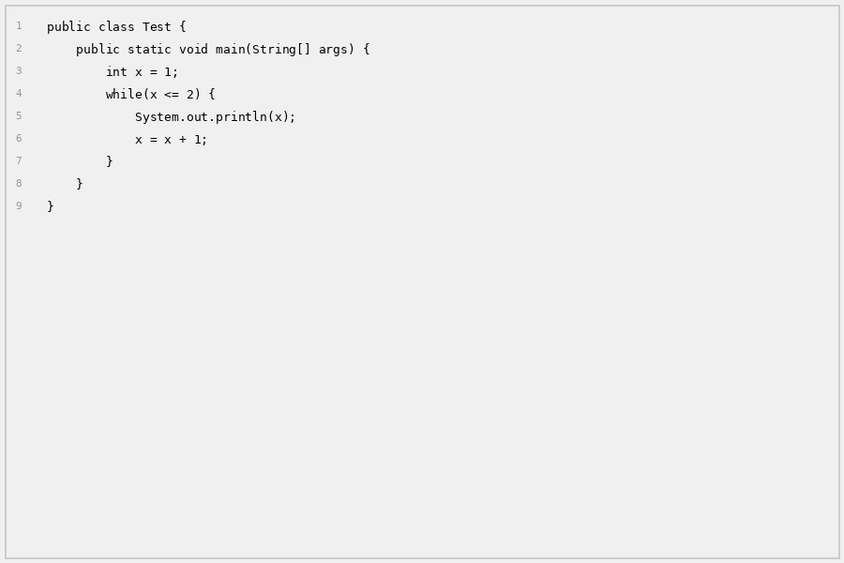
Question: What is the output?
A | 1 2
B | 1\n2
C | 1
D | 2

Correct Answer: | B
Explanation: | Prints 1 (newline), prints 2 (newline). Output on separate lines.

Q42 [CODING]: For Loop - Continue Skip
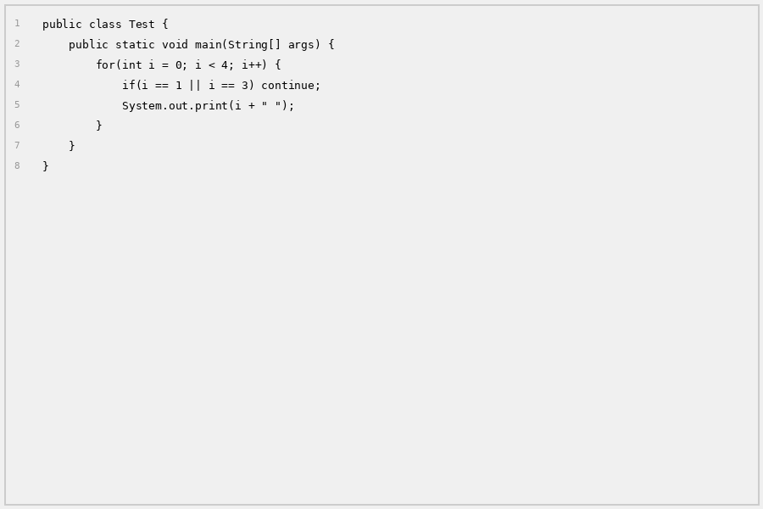
Question: What is the output?
A | 0 1 2 3
B | 0 2
C | 1 3
D | 0 1 2

Correct Answer: | B
Explanation: | Prints 0, skips 1, prints 2, skips 3. Output: 0 2

Q43 [CODING]: Do-While - Increment Then Check
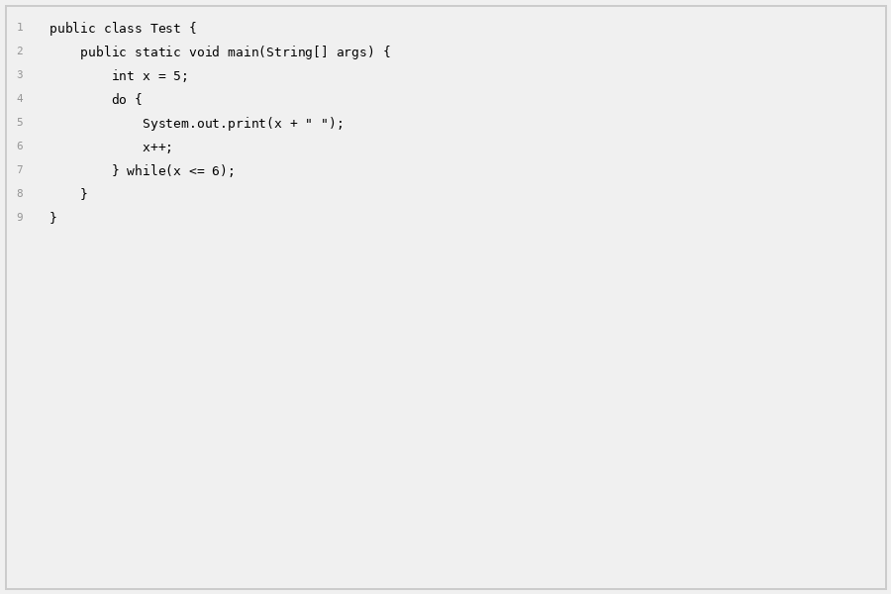
Question: What is the output?
A | 5
B | 5 6
C | 5 6 7
D | 6

Correct Answer: | B
Explanation: | Prints 5, x=6, condition 6<=6 true, prints 6, x=7, condition 7<=6 false.

Q44 [CODING]: For Loop - Three Steps
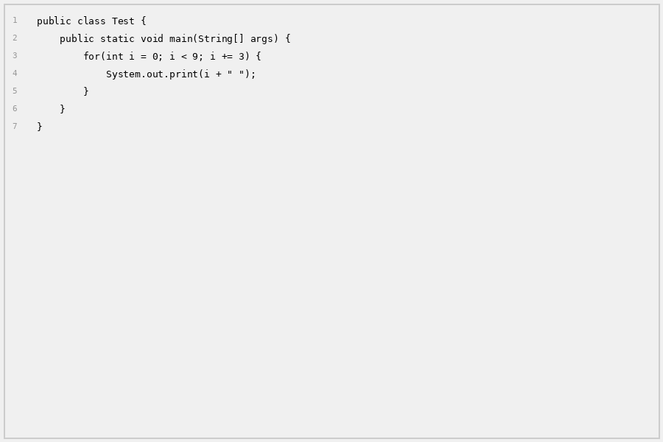
Question: What is the output?
A | 0 3 6 9
B | 0 3 6
C | 3 6 9
D | 0 3 6 9 12

Correct Answer: | B
Explanation: | i = 0, 3, 6. When i=9, condition i<9 is false. Output: 0 3 6

Q45 [CODING]: While Loop - Change Variable
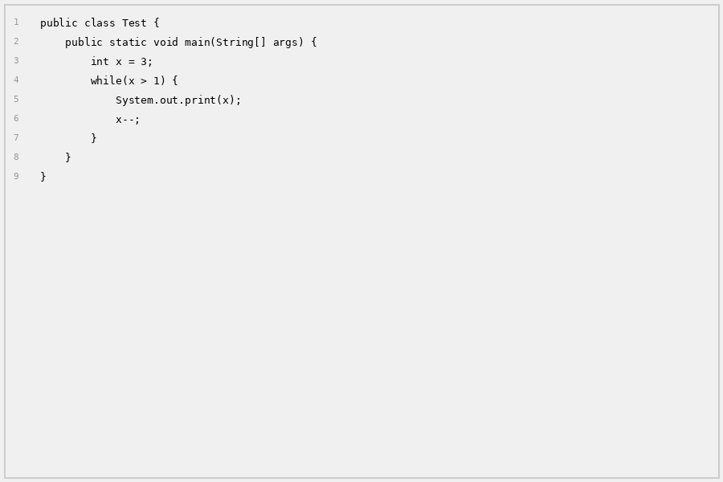
Question: What is the output?
A | 321
B | 32
C | 123
D | 12

Correct Answer: | B
Explanation: | Prints 3, x=2, prints 2, x=1, condition 1>1 false. Output: 32

Q46 [CODING]: For-Each - String Array
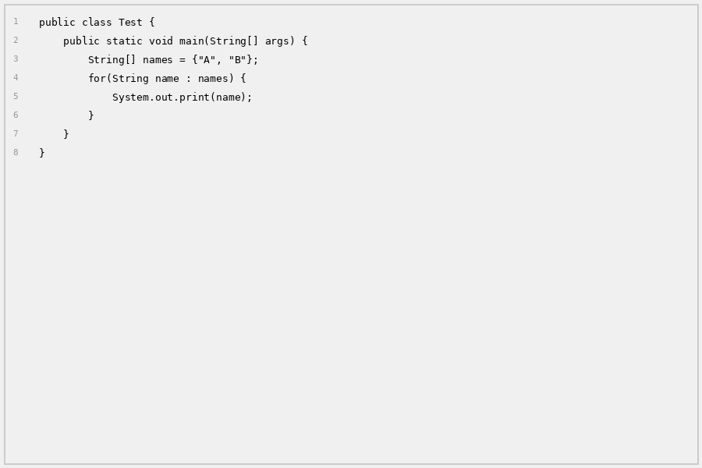
Question: What is the output?
A | A B
B | AB
C | A,B
D | names[0] names[1]

Correct Answer: | B
Explanation: | For-each goes through: A, B. No space between them. Output: AB

Q47 [CODING]: For Loop - Multiple By 2
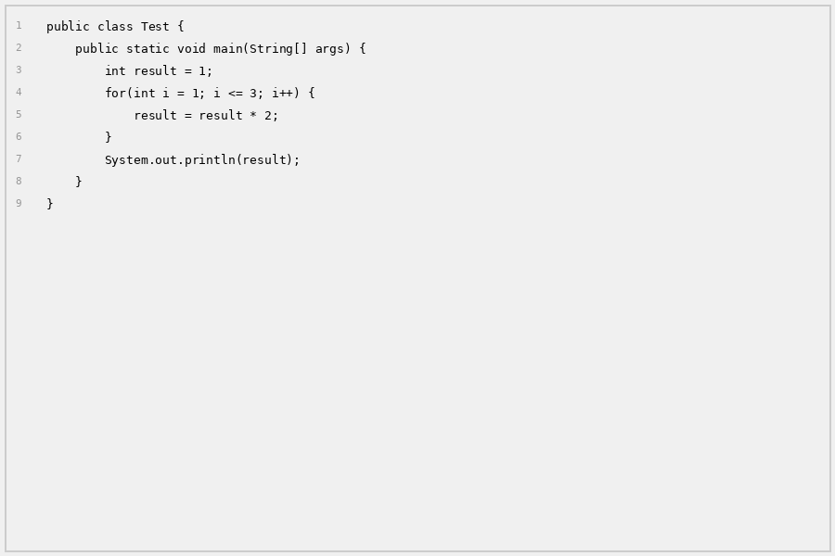
Question: What is the output?
A | 2
B | 4
C | 6
D | 8

Correct Answer: | D
Explanation: | 1*2=2, 2*2=4, 4*2=8. Output: 8

Q48 [CODING]: While Loop - Condition Check
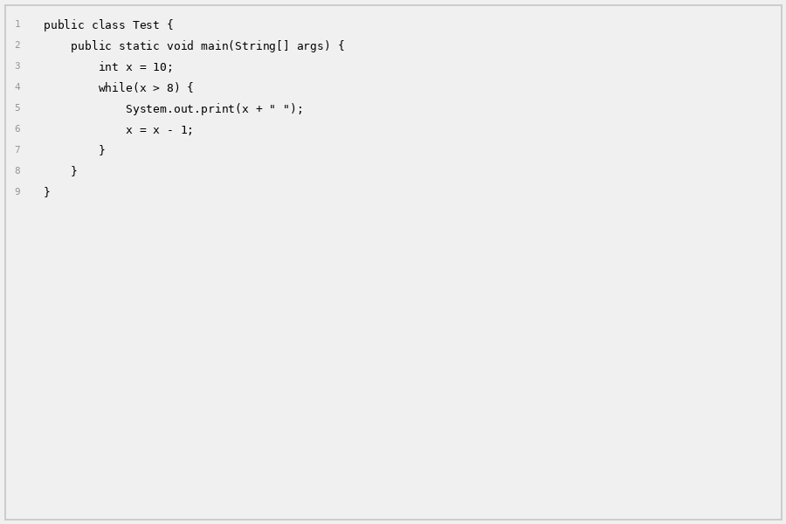
Question: What is the output?
A | 10
B | 10 9
C | 10 9 8
D | 9

Correct Answer: | B
Explanation: | Prints 10, x=9, prints 9, x=8, condition 8>8 false. Output: 10 9

Q49 [CODING]: For Loop - Break Early
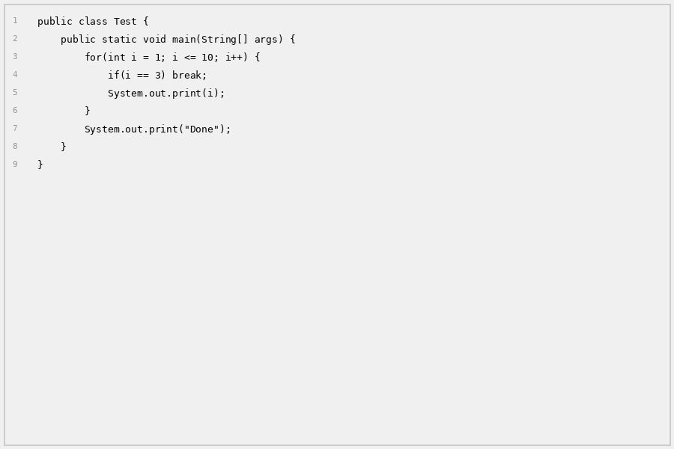
Question: What is the output?
A | 12Done
B | 123Done
C | 3Done
D | Done

Correct Answer: | A
Explanation: | Prints 1, 2, then breaks when i=3. Then prints Done. Output: 12Done

Q50 [CODING]: Do-While - Condition Check
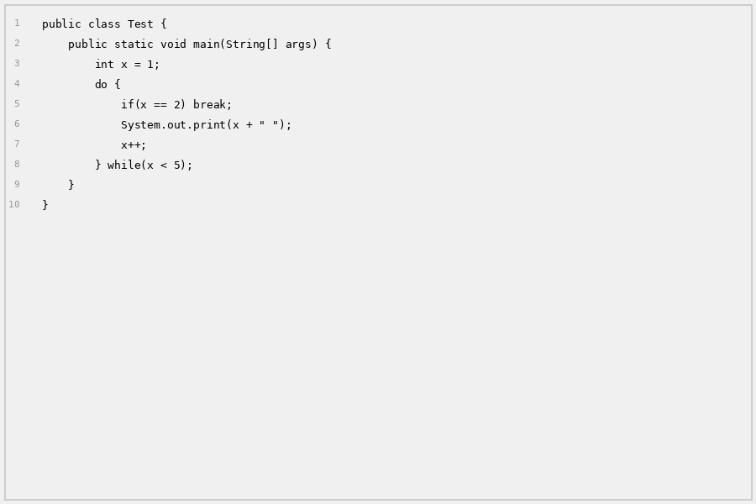
Question: What is the output?
A | 1
B | 1 2
C | 1 2 3 4
D | 2 3 4

Correct Answer: | A
Explanation: | Prints 1, x=2, next iteration checks if x==2 which is true, breaks. Output: 1

