Software Requirements Specification (SRS)

Municipal Helpdesk System
Field | Value
Project Name | Municipal Helpdesk System
Document Type | Software Requirements Specification
Version | 1.0
Date | 2026-02-23
Status | Draft
Classification | Full-Stack Web Application (Web Portal) — Functional Prototype

Table of Contents
- Introduction
- Overall Description
- System Architecture & Tech Stack
- Specific Requirements
- Data Requirements
- External Interface Requirements
- Non-Functional Requirements
- Appendices

1. Introduction

1.1 Purpose
This document provides a complete Software Requirements Specification for the Municipal Helpdesk System, an AI-assisted civic issue reporting and resolution platform. It describes all functional and non-functional requirements, system architecture, data models, workflows, user roles, and interface specifications needed to build a functional prototype.
This document is intended for: - Developers implementing the frontend and backend. - Architects designing the system and infrastructure. - QA Engineers deriving test cases. - Project Stakeholders reviewing scope and functionality.

1.2 Scope
The Municipal Helpdesk System enables citizens to report civic issues (e.g., potholes, damaged streetlights, sanitation problems) via a web portal. An AI module classifies the uploaded image and recommends a relevant municipal department. An administrator reviews, approves, or overrides the AI’s recommendation and assigns the ticket to a specific department worker. The worker then resolves the issue and uploads proof, or flags false reports for admin review.
Key capabilities include: - Citizen self-service ticket creation with image upload and GPS geolocation capture. - AI-powered image classification for automatic department routing. - Admin dashboard for ticket review, assignment, and escalation management. - Worker interface for task execution, resolution proof upload, and false-report flagging. - Officer analytics dashboard with KPIs, charts, and SLA tracking. - Role-Based Access Control (RBAC) across all four user roles. - Email notifications on ticket status changes. - AES-256 encryption for sensitive data fields.

1.3 Definitions, Acronyms, and Abbreviations
Term | Definition
SRS | Software Requirements Specification
RBAC | Role-Based Access Control
JWT | JSON Web Token — used for stateless session management
ORM | Object-Relational Mapping
SLA | Service Level Agreement
KPI | Key Performance Indicator
OTP | One-Time Password
AES | Advanced Encryption Standard
CRUD | Create, Read, Update, Delete
API | Application Programming Interface
GPS | Global Positioning System
Ticket | A digital representation of a civic issue reported by a Citizen

2. Overall Description

2.1 Product Perspective
The Municipal Helpdesk System is a self-contained, full-stack web application. It is not a component of a larger existing system but is designed as an independent platform that integrates with external services (AI image classification and email delivery) via APIs.
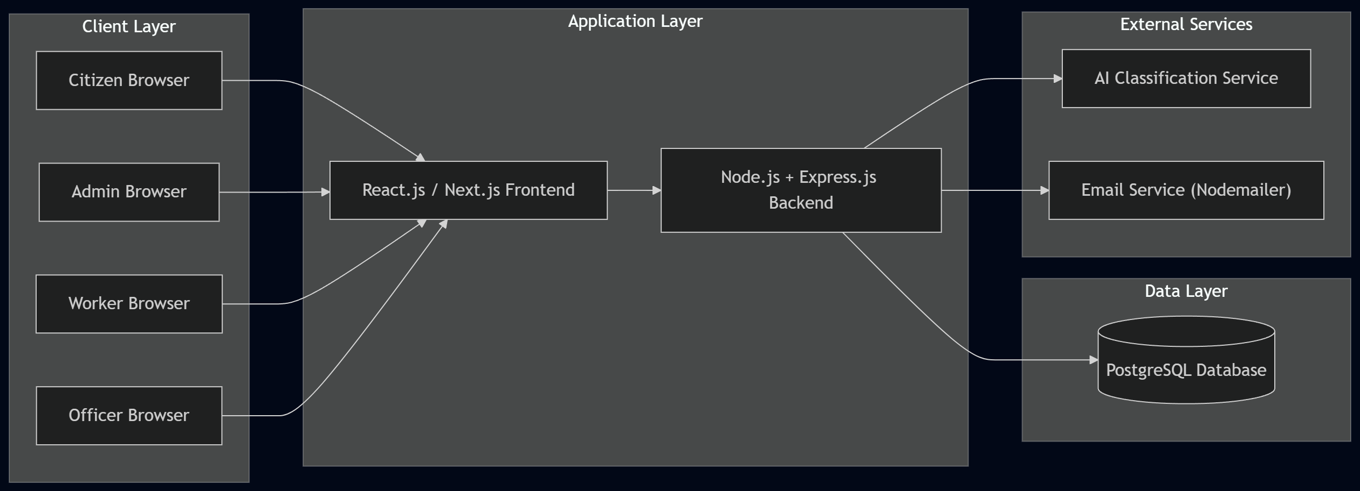

2.2 Product Functions (High-Level)
# | Function | Description
1 | User Authentication | Email/Password registration & login with JWT sessions and optional Email OTP.
2 | Citizen Ticket Submission | Image upload, GPS capture, auto-population of contact info.
3 | AI Image Classification | Automatic categorization of issue images into municipal departments.
4 | Admin Ticket Management | Review AI recommendations, approve/override, assign to department workers.
5 | Worker Task Execution | View assigned tickets, resolve with proof, or flag false reports.
6 | Escalation Management | Admin handles worker-flagged tickets (reject or re-assign).
7 | Master Data Management | Admin CRUD for Departments and Employee (Worker) accounts.
8 | Officer Analytics Dashboard | Aggregated KPIs, charts, SLA tracking — read-only executive view.
9 | Notification Service | Email notifications on all ticket status transitions.
10 | Data Encryption | AES-256 encryption of highly sensitive user data fields.

2.3 User Roles & Permissions (RBAC)
The system enforces four strictly separated roles. Every API route and frontend page is protected by requireRole() middleware.
Role | Permissions
Citizen | Register/Login. Create tickets. View & track own tickets only. Cannot access any admin/worker/officer views.
Admin | Manage Departments & Users (CRUD). View all tickets. Review AI recommendations. Approve/Override/Assign tickets. Handle escalations.
Dept Worker | View tickets assigned to self / own department only. Mark tickets as Resolved (with proof photo). Flag false reports.
Officer | Read-only access to analytics dashboard. View aggregated KPIs, charts, SLA metrics. Cannot edit any tickets.

2.4 Operating Environment
Component | Specification
Client | Modern web browser (Chrome, Firefox, Edge, Safari)
Server OS | Linux / Windows / macOS (Node.js runtime)
Runtime | Node.js v18+
Database | PostgreSQL 14+
AI Service | Google Cloud Vision API or TensorFlow.js model
Email Service | SMTP-compatible server via Nodemailer

2.5 Design & Implementation Constraints
- The system is a functional prototype; production hardening (load balancing, CDN, etc.) is out of scope.
- Email sending may be mocked for the prototype, but the full logic path must exist.
- AI image classification must support at least the categories: Water, Electricity, Sanitation, Roads.
- All sensitive fields must use AES-256 encryption via Node.js crypto module.
- The backend must follow a modular, well-commented codebase structure.

2.6 Assumptions & Dependencies
- Users have internet access and a GPS-capable device/browser.
- The AI classification model or API key is provisioned prior to deployment.
- A PostgreSQL database server is available and accessible.
- An SMTP server or mail service credentials are available for Nodemailer.

3. System Architecture & Tech Stack

3.1 Technology Stack
Layer | Technology
Frontend | React.js (or Next.js) + Tailwind CSS
Backend | Node.js + Express.js
Database | PostgreSQL (Relational)
ORM | Prisma or Sequelize
Auth | JWT for session management, bcrypt for password hashing
Encryption | Node.js crypto module — AES-256 for sensitive fields
AI | Google Cloud Vision API or pre-trained TensorFlow.js model
Email | Nodemailer (SMTP)

3.2 High-Level Architecture
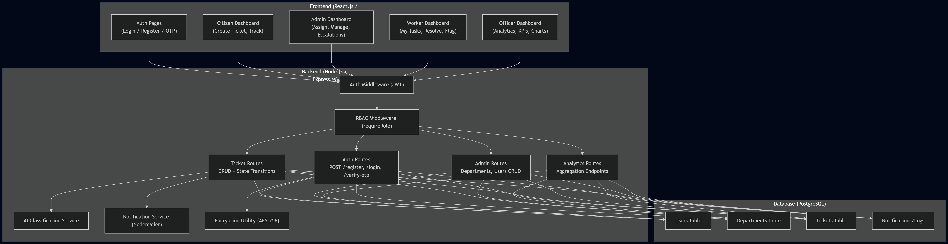

3.3 Backend Module Structure (Recommended)
server/
├── config/
│ ├── db.js # Database connection & ORM config
│ └── env.js # Environment variables
├── middleware/
│ ├── auth.js # JWT verification middleware
│ └── rbac.js # Role-based access control middleware
├── models/
│ ├── User.js
│ ├── Department.js
│ ├── Ticket.js
│ └── Notification.js
├── routes/
│ ├── auth.routes.js
│ ├── ticket.routes.js
│ ├── admin.routes.js
│ └── analytics.routes.js
├── services/
│ ├── ai.service.js # AI image classification
│ ├── email.service.js # Nodemailer notification service
│ └── crypto.service.js # AES-256 encryption utility
├── utils/
│ └── helpers.js
├── app.js # Express app setup
└── server.js # Entry point

4. Specific Requirements

4.1 Functional Requirements

FR-01: User Registration
Field | Detail
ID | FR-01
Priority | High
Actor | Citizen (self-registration), Admin (creates Worker/Officer accounts)
Endpoint | POST /api/auth/register
Description | New Citizens can self-register with email and password. Admin can create Worker and Officer accounts and map Workers to Departments.
Acceptance Criteria: 1. System accepts name, email, password, phone, address fields. 2. Password is hashed using bcrypt before storage. 3. Sensitive fields (e.g., phone, address) are encrypted using AES-256 before storage. 4. Duplicate email registration returns 409 Conflict. 5. Default role for self-registration is CITIZEN. 6. Admin-created accounts can have role DEPT_WORKER or OFFICER. 7. Worker accounts require a department_id mapping.

FR-02: User Login
Field | Detail
ID | FR-02
Priority | High
Actor | All Roles
Endpoint | POST /api/auth/login
Description | Authenticate users via email/password and return a JWT token.
Acceptance Criteria: 1. System validates email and bcrypt-compared password. 2. On success, returns a signed JWT containing userId, role, email. 3. JWT has a configurable expiration (e.g., 24 hours). 4. Invalid credentials return 401 Unauthorized.

FR-03: Email OTP Verification (Optional)
Field | Detail
ID | FR-03
Priority | Medium
Actor | Citizen
Endpoints | POST /api/auth/send-otp, POST /api/auth/verify-otp
Description | Optional email verification flow. Logic must fully exist; actual email send may be mocked.
Acceptance Criteria: 1. System generates a 6-digit OTP and associates it with the user’s email. 2. OTP is valid for a configurable duration (e.g., 10 minutes). 3. verify-otp endpoint validates the OTP and marks the user as email_verified = true. 4. Expired or invalid OTP returns 400 Bad Request.

FR-04: Citizen Ticket Creation (Workflow A)
Field | Detail
ID | FR-04
Priority | High
Actor | Citizen
Endpoint | POST /api/tickets
Description | Citizen creates a new ticket by uploading an image. System captures GPS, attaches contact info.
Acceptance Criteria: 1. Request accepts an image file (JPEG/PNG, max 10MB) via multipart form-data. 2. System captures GPS coordinates (latitude, longitude) from the client. 3. System auto-attaches the Citizen’s contact info (name, email, phone) from their profile. 4. Citizen may optionally provide a text description. 5. Ticket is created with initial status: PENDING_AI. 6. System immediately triggers the AI classification pipeline (see FR-05). 7. Response returns the created ticket with an assigned ticket_id. 8. Requires CITIZEN role.

FR-05: AI Image Classification & Department Recommendation (Workflow B — Part 1)
Field | Detail
ID | FR-05
Priority | High
Actor | System (Automated)
Trigger | Ticket created with status PENDING_AI
Description | AI service analyzes the uploaded image and sets a recommended_department_id on the ticket.
Acceptance Criteria: 1. AI service receives the uploaded image. 2. Classifies the image into one of the predefined municipal categories: Water, Electricity, Sanitation, Roads (extensible). 3. Maps the classification label to the corresponding department_id in the database. 4. Updates the ticket with recommended_department_id and ai_confidence_score. 5. Ticket status transitions to PENDING_ADMIN. 6. If AI classification fails, ticket still moves to PENDING_ADMIN with recommended_department_id = null and a flag indicating manual review is needed.

FR-06: Admin Ticket Review & Assignment (Workflow B — Part 2)
Field | Detail
ID | FR-06
Priority | High
Actor | Admin
Endpoint | PUT /api/tickets/:id/assign
Description | Admin reviews AI recommendation and assigns the ticket to a specific Worker in the chosen Department.
Acceptance Criteria: 1. Admin sees all tickets with status PENDING_ADMIN on their dashboard. 2. Each ticket displays the AI’s recommended_department_id and ai_confidence_score. 3. Admin can accept the AI recommendation or override by selecting a different department. 4. Admin selects a specific Worker from the chosen department’s roster. 5. System updates assigned_department_id, assigned_worker_id. 6. A boolean flag ai_recommendation_accepted records whether the admin accepted or overrode the AI. 7. Ticket status transitions to ASSIGNED. 8. Email notification sent to the Citizen informing them of the assignment. 9. Requires ADMIN role.

FR-07: Worker Task Resolution — Happy Path (Workflow C)
Field | Detail
ID | FR-07
Priority | High
Actor | Dept Worker
Endpoint | PUT /api/tickets/:id/resolve
Description | Worker completes the task, uploads an “After” photo as proof, and resolves the ticket.
Acceptance Criteria: 1. Worker sees only tickets assigned to themselves or their department. 2. Worker uploads a resolution image (“After” photo) as proof of completion. 3. Worker may add resolution notes. 4. Ticket status transitions to RESOLVED. 5. Email notification sent to the Citizen confirming resolution. 6. Requires DEPT_WORKER role. 7. Worker can only resolve tickets with status ASSIGNED.

FR-08: Worker False Report Flagging (Workflow C — Edge Case)
Field | Detail
ID | FR-08
Priority | High
Actor | Dept Worker
Endpoint | PUT /api/tickets/:id/flag-false
Description | Worker flags a ticket as invalid/false report with written reasoning.
Acceptance Criteria: 1. Worker selects “Flag as False” on an assigned ticket. 2. Worker provides mandatory written reasoning/proof for the false-report claim. 3. Ticket status transitions to ESCALATED_TO_ADMIN. 4. Requires DEPT_WORKER role. 5. Only tickets with status ASSIGNED can be flagged.

FR-09: Admin Escalation Resolution
Field | Detail
ID | FR-09
Priority | High
Actor | Admin
Endpoint | PUT /api/tickets/:id/resolve-escalation
Description | Admin reviews escalated tickets and either rejects them or re-assigns them.
Acceptance Criteria: 1. Admin sees all tickets with status ESCALATED_TO_ADMIN. 2. Admin reviews the worker’s reasoning for the false-report flag. 3. Option A — Reject: Admin marks the ticket as REJECTED (closed). Citizen notified. 4. Option B — Re-assign: Admin re-assigns the ticket to a different worker/department. Status returns to ASSIGNED. Worker notified. 5. Admin provides resolution notes documenting the decision. 6. Requires ADMIN role.

FR-10: Department Management (Master Data)
Field | Detail
ID | FR-10
Priority | High
Actor | Admin
Endpoints | GET/POST/PUT/DELETE /api/admin/departments
Description | Admin manages the master list of municipal departments.
Acceptance Criteria: 1. Admin can Create a new department (name, description). 2. Admin can Read a list of all departments and a single department by ID. 3. Admin can Update department details. 4. Admin can Delete a department (with guards if active tickets reference it). 5. Requires ADMIN role.

FR-11: User / Employee Management (Master Data)
Field | Detail
ID | FR-11
Priority | High
Actor | Admin
Endpoints | GET/POST/PUT/DELETE /api/admin/users
Description | Admin manages user accounts — primarily creating Worker and Officer accounts and mapping Workers to Departments.
Acceptance Criteria: 1. Admin can Create worker accounts with role = DEPT_WORKER and a department_id. 2. Admin can Create officer accounts with role = OFFICER. 3. Admin can List all users, filter by role or department. 4. Admin can Update user details (name, department mapping, active status). 5. Admin can Deactivate user accounts (soft delete). 6. Requires ADMIN role.

FR-12: Email Notifications
Field | Detail
ID | FR-12
Priority | Medium
Actor | System (Automated)
Description | System sends email notifications on every ticket status change.
Notification Triggers:
Status Transition | Recipient | Email Subject Template
PENDING_AI → PENDING_ADMIN | — | (No notification — internal transition)
PENDING_ADMIN → ASSIGNED | Citizen | “Your ticket #{{id}} has been assigned”
ASSIGNED → RESOLVED | Citizen | “Your ticket #{{id}} has been resolved”
ASSIGNED → ESCALATED | Admin | “Ticket #{{id}} escalated — review required”
ESCALATED → REJECTED | Citizen | “Your ticket #{{id}} has been closed”
ESCALATED → ASSIGNED | Worker | “Ticket #{{id}} has been re-assigned to you”
Acceptance Criteria: 1. Emails are sent via Nodemailer over SMTP. 2. Email sending can be mocked (logged to console) for the prototype. 3. The full notification logic pipeline must exist regardless of mocking.

FR-13: Officer Analytics Dashboard
Field | Detail
ID | FR-13
Priority | Medium
Actor | Officer
Endpoints | Multiple GET /api/analytics/* endpoints
Description | Read-only aggregated data endpoints powering the Officer’s executive dashboard.
Required API Endpoints:
Endpoint | Description
GET /api/analytics/tickets-by-department | Count of tickets grouped by department.
GET /api/analytics/tickets-by-status | Count of tickets grouped by current status.
GET /api/analytics/average-resolution-time | Average time from ASSIGNED to RESOLVED per dept.
GET /api/analytics/ai-accuracy-rate | Percentage of times Admin accepted AI recommendation.
GET /api/analytics/sla-compliance | Percentage of tickets resolved within SLA thresholds.
GET /api/analytics/monthly-trend | Ticket count trend over the past 12 months.
Acceptance Criteria: 1. All endpoints return JSON-formatted aggregated data. 2. Frontend renders data as charts (bar, pie, line) and KPI cards. 3. Data is read-only — Officer cannot modify any records. 4. Requires OFFICER role (also accessible by ADMIN).

4.2 Ticket State Machine
The following state machine governs the complete lifecycle of a ticket:
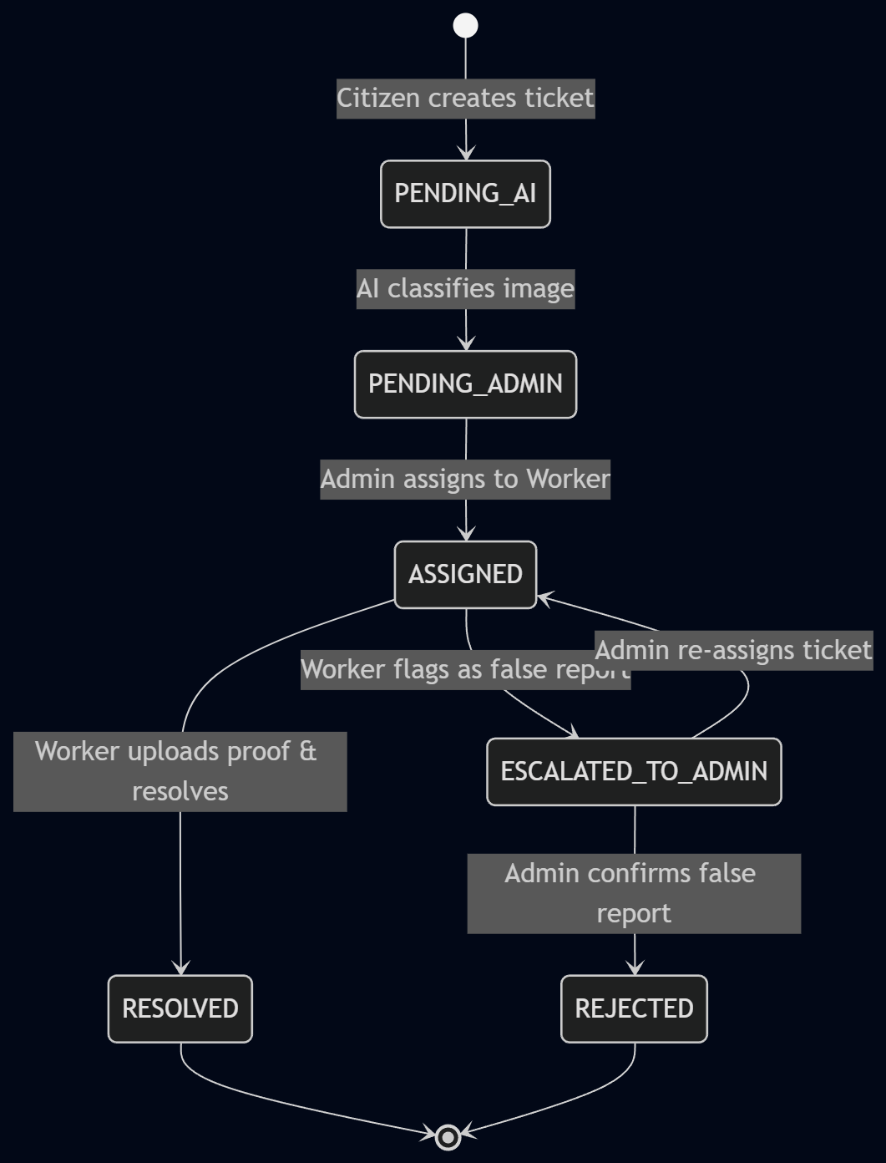
Valid State Transitions:
From | To | Triggered By | Condition
PENDING_AI | PENDING_ADMIN | System | AI classification completes
PENDING_ADMIN | ASSIGNED | Admin | Admin assigns to worker
ASSIGNED | RESOLVED | Worker | Proof uploaded + resolve action
ASSIGNED | ESCALATED_TO_ADMIN | Worker | False report flagged with reasoning
ESCALATED_TO_ADMIN | REJECTED | Admin | Confirms false / invalid report
ESCALATED_TO_ADMIN | ASSIGNED | Admin | Re-assigns to new worker/dept

5. Data Requirements

5.1 Entity-Relationship Diagram

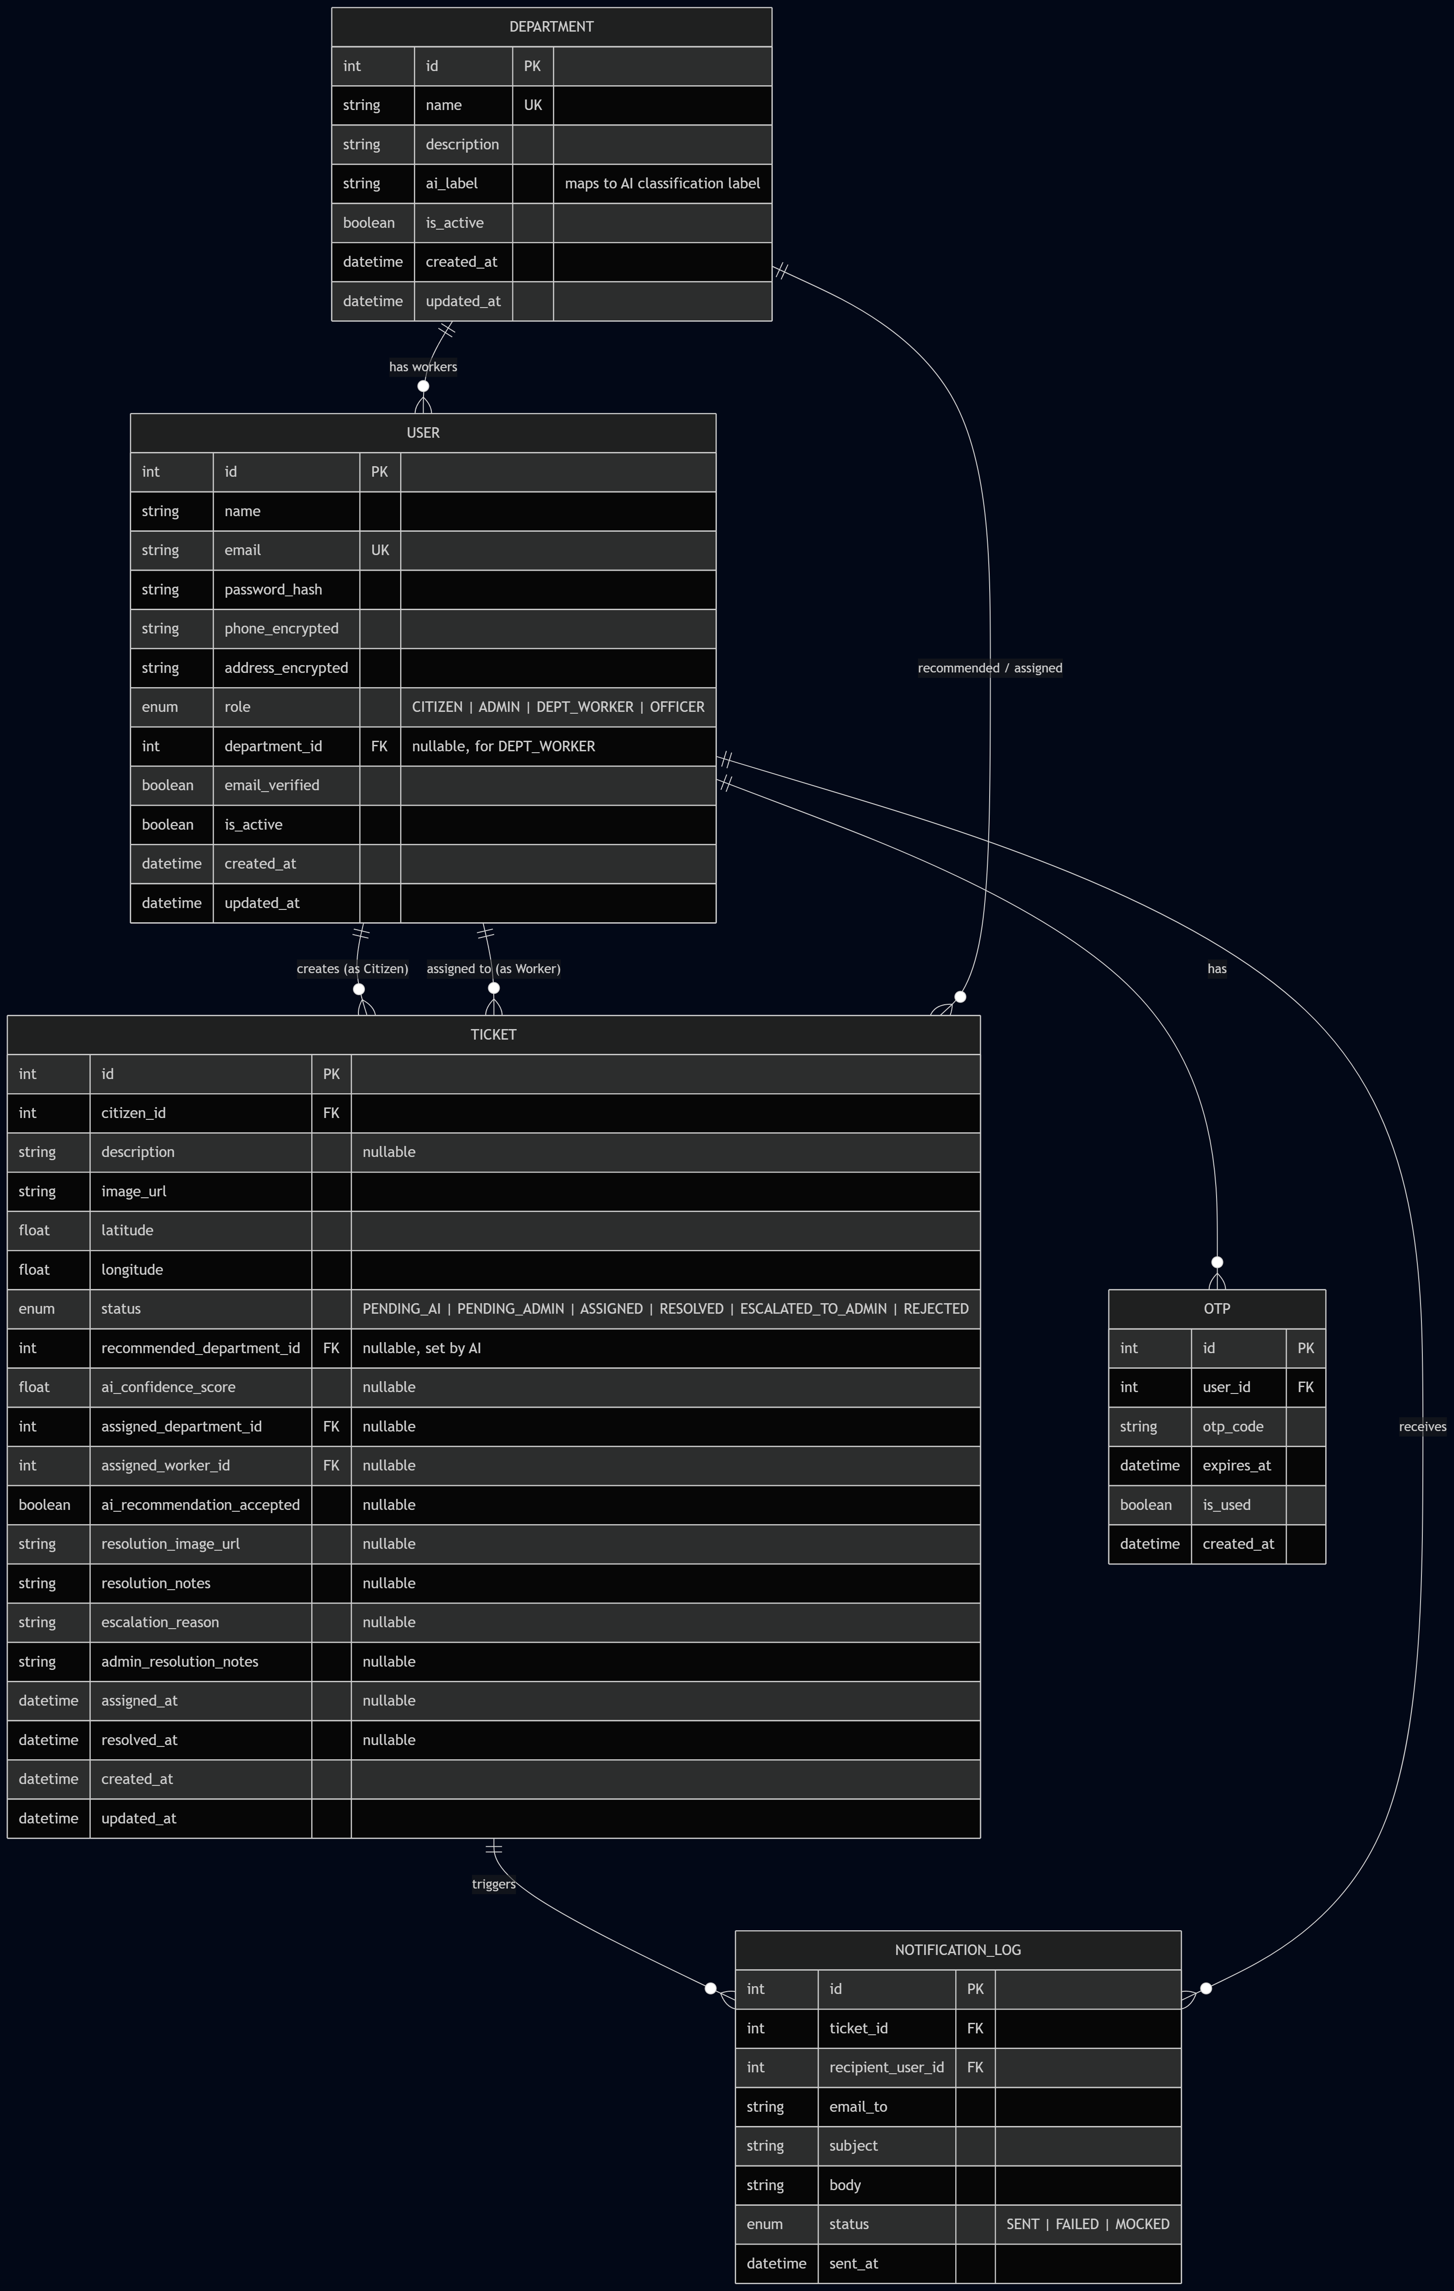

5.2 Data Dictionary

Users Table
Column | Type | Constraints | Notes
id | INTEGER | PK, Auto-Increment
name | VARCHAR(255) | NOT NULL
email | VARCHAR(255) | NOT NULL, UNIQUE
password_hash | VARCHAR(255) | NOT NULL | bcrypt hashed
phone_encrypted | TEXT | NULL | AES-256 encrypted
address_encrypted | TEXT | NULL | AES-256 encrypted
role | ENUM | NOT NULL | CITIZEN, ADMIN, DEPT_WORKER, OFFICER
department_id | INTEGER | FK → Departments, NULL | Required for DEPT_WORKER only
email_verified | BOOLEAN | DEFAULT false
is_active | BOOLEAN | DEFAULT true | Soft-delete flag
created_at | TIMESTAMP | DEFAULT NOW()
updated_at | TIMESTAMP | DEFAULT NOW()

Departments Table
Column | Type | Constraints | Notes
id | INTEGER | PK, Auto-Increment
name | VARCHAR(255) | NOT NULL, UNIQUE | e.g., “Water Supply”, “Roads”
description | TEXT | NULL
ai_label | VARCHAR(100) | UNIQUE | Maps to AI classification output label
is_active | BOOLEAN | DEFAULT true
created_at | TIMESTAMP | DEFAULT NOW()
updated_at | TIMESTAMP | DEFAULT NOW()

Tickets Table
Column | Type | Constraints | Notes
id | INTEGER | PK, Auto-Increment
citizen_id | INTEGER | FK → Users, NOT NULL | Creator of the ticket
description | TEXT | NULL | Optional citizen description
image_url | VARCHAR(500) | NOT NULL | Path/URL to uploaded image
latitude | DECIMAL(10,7) | NOT NULL | GPS latitude
longitude | DECIMAL(10,7) | NOT NULL | GPS longitude
status | ENUM | NOT NULL | See state machine
recommended_department_id | INTEGER | FK → Departments, NULL | Set by AI
ai_confidence_score | DECIMAL(5,4) | NULL | 0.0000 to 1.0000
assigned_department_id | INTEGER | FK → Departments, NULL | Set by Admin
assigned_worker_id | INTEGER | FK → Users, NULL | Set by Admin
ai_recommendation_accepted | BOOLEAN | NULL | true if Admin accepted AI suggestion
resolution_image_url | VARCHAR(500) | NULL | Worker’s “After” photo
resolution_notes | TEXT | NULL | Worker’s notes
escalation_reason | TEXT | NULL | Worker’s false-report reasoning
admin_resolution_notes | TEXT | NULL | Admin’s escalation decision notes
assigned_at | TIMESTAMP | NULL | When ticket was assigned
resolved_at | TIMESTAMP | NULL | When ticket was resolved/rejected
created_at | TIMESTAMP | DEFAULT NOW()
updated_at | TIMESTAMP | DEFAULT NOW()

Notification Log Table
Column | Type | Constraints | Notes
id | INTEGER | PK, Auto-Increment
ticket_id | INTEGER | FK → Tickets
recipient_user_id | INTEGER | FK → Users
email_to | VARCHAR(255) | NOT NULL
subject | VARCHAR(500) | NOT NULL
body | TEXT | NOT NULL
status | ENUM | NOT NULL | SENT, FAILED, MOCKED
sent_at | TIMESTAMP | DEFAULT NOW()

OTP Table
Column | Type | Constraints | Notes
id | INTEGER | PK, Auto-Increment
user_id | INTEGER | FK → Users
otp_code | VARCHAR(6) | NOT NULL
expires_at | TIMESTAMP | NOT NULL
is_used | BOOLEAN | DEFAULT false
created_at | TIMESTAMP | DEFAULT NOW()

6. External Interface Requirements

6.1 User Interface Requirements

UI-01: Authentication Pages
- Login form: email + password fields, “Login” button, link to registration.
- Registration form: name, email, password, phone, address fields, “Register” button.
- OTP verification form: 6-digit code input, “Verify” button, “Resend OTP” link.

UI-02: Citizen Dashboard
- Create Ticket: Image upload drag-and-drop area, GPS auto-capture indicator, optional description textarea, “Submit” button.
- My Tickets: Table/card view listing citizen’s own tickets with columns: ID, Status (color-coded badge), Department, Created Date, Last Updated.
- Ticket Detail: Full ticket info, image preview, map pin for GPS location, status timeline.

UI-03: Admin Dashboard
- Pending Review Queue: List of PENDING_ADMIN tickets with AI recommendation, confidence score, image preview.
- Assignment Modal: Department dropdown (pre-filled with AI recommendation), Worker dropdown (filtered by department), “Assign” button.
- Escalation Queue: List of ESCALATED_TO_ADMIN tickets with worker’s reasoning, “Reject” and “Re-assign” actions.
- Master Data Management: Departments CRUD table, Users CRUD table with role and department filters.

UI-04: Worker Dashboard
- My Tasks: List of tickets assigned to the worker, filtered by ASSIGNED status.
- Resolve Modal: Image upload for “After” photo, resolution notes textarea, “Mark Resolved” button.
- Flag Modal: Reasoning textarea (required), “Flag as False Report” button.

UI-05: Officer Analytics Dashboard
- KPI Cards: Total tickets, resolved tickets, average resolution time, AI accuracy rate.
- Charts: Tickets by department (bar chart), tickets by status (pie chart), monthly trend (line chart), SLA compliance (gauge or bar).
- Filters: Date range selector, department filter.

6.2 API Interface Requirements
All APIs follow RESTful conventions: - Base URL: /api - Content-Type: application/json (except file uploads: multipart/form-data) - Authentication: Authorization: Bearer <JWT> header on all protected routes. - Standard error response format:
{
"success": false,
"error": {
"code": "VALIDATION_ERROR",
"message": "Human-readable error message",
"details": []
}
}
Complete API Endpoint Summary:
Method | Endpoint | Role(s) | Description
POST | /api/auth/register | Public / Admin | Register new user
POST | /api/auth/login | Public | Login and receive JWT
POST | /api/auth/send-otp | Authenticated | Request email OTP
POST | /api/auth/verify-otp | Authenticated | Verify email OTP
POST | /api/tickets | Citizen | Create new ticket
GET | /api/tickets | All (filtered) | List tickets (role-based filtering)
GET | /api/tickets/:id | All (authorized) | Get ticket detail
PUT | /api/tickets/:id/assign | Admin | Assign ticket to worker
PUT | /api/tickets/:id/resolve | Dept Worker | Resolve ticket with proof
PUT | /api/tickets/:id/flag-false | Dept Worker | Flag ticket as false report
PUT | /api/tickets/:id/resolve-escalation | Admin | Handle escalated ticket
GET | /api/admin/departments | Admin | List departments
POST | /api/admin/departments | Admin | Create department
PUT | /api/admin/departments/:id | Admin | Update department
DELETE | /api/admin/departments/:id | Admin | Delete department
GET | /api/admin/users | Admin | List users
POST | /api/admin/users | Admin | Create user account
PUT | /api/admin/users/:id | Admin | Update user
DELETE | /api/admin/users/:id | Admin | Deactivate user
GET | /api/analytics/tickets-by-department | Officer, Admin | Tickets grouped by department
GET | /api/analytics/tickets-by-status | Officer, Admin | Tickets grouped by status
GET | /api/analytics/average-resolution-time | Officer, Admin | Avg resolution time per department
GET | /api/analytics/ai-accuracy-rate | Officer, Admin | AI recommendation acceptance rate
GET | /api/analytics/sla-compliance | Officer, Admin | SLA compliance metrics
GET | /api/analytics/monthly-trend | Officer, Admin | Monthly ticket volume trend

6.3 Hardware Interface Requirements
- GPS: Browser Geolocation API (navigator.geolocation) for capturing citizen’s location during ticket creation.
- Camera/File System: Browser File API for image upload (camera capture on mobile, file picker on desktop).

6.4 Software Interface Requirements
External Service | Interface Type | Purpose
Google Cloud Vision API | REST API | Image classification (primary option)
TensorFlow.js pre-trained model | JS Library | Image classification (alternative option)
SMTP Server (via Nodemailer) | SMTP Protocol | Sending email notifications
PostgreSQL Database | TCP/ORM | Persistent data storage

7. Non-Functional Requirements

7.1 Performance Requirements
ID | Requirement
NFR-01 | API response time ≤ 500ms for standard CRUD operations (p95).
NFR-02 | AI image classification should complete within ≤ 5 seconds.
NFR-03 | The system should support at least 100 concurrent users for the prototype.
NFR-04 | Image upload size capped at 10MB per file.

7.2 Security Requirements
ID | Requirement
NFR-05 | Passwords must be hashed with bcrypt (cost factor ≥ 10).
NFR-06 | Sensitive PII fields (phone, address) must be encrypted at rest using AES-256.
NFR-07 | All API routes (except /auth/register and /auth/login) require a valid JWT.
NFR-08 | RBAC middleware must enforce role-based access on every protected endpoint.
NFR-09 | JWT tokens must have a configurable expiration and include role information.
NFR-10 | Input validation and sanitization on all user-provided data to prevent SQL injection and XSS.
NFR-11 | File uploads must validate MIME type (JPEG/PNG only) and file size.
NFR-12 | CORS must be configured to allow only the frontend origin.

7.3 Reliability & Availability
ID | Requirement
NFR-13 | The system should handle graceful failures — if AI service is down, tickets still proceed to PENDING_ADMIN with manual review flag.
NFR-14 | Database transactions must be used for multi-step operations (e.g., ticket assignment + notification).
NFR-15 | All API errors must return structured error responses (no stack traces in production).

7.4 Usability
ID | Requirement
NFR-16 | Frontend must be responsive (desktop + tablet + mobile).
NFR-17 | Ticket statuses should be color-coded for quick visual identification.
NFR-18 | Form validation with inline error messages on all user input forms.

7.5 Scalability
ID | Requirement
NFR-19 | Database schema must be designed for easy extension (new departments, new statuses).
NFR-20 | AI service integration must be abstracted behind a service layer for easy swapping.

7.6 Maintainability
ID | Requirement
NFR-21 | Codebase must follow a modular architecture (routes, controllers, services, models).
NFR-22 | Code must be well-commented and ready for production-like review.
NFR-23 | Environment variables managed via .env file (never hardcoded secrets).

