Katakam Santhosh Kumar 2403A51L21
Batch-51

ASSIGNMENT 14.5
Web Design Application – AI-Assisted HTML/CSS/JS Generation

Task Description #1 (Image Gallery Website):
PROMPT: Generate a responsive image gallery using HTML, CSS Grid, and JavaScript with hover zoom effects and mobile-friendly layout.
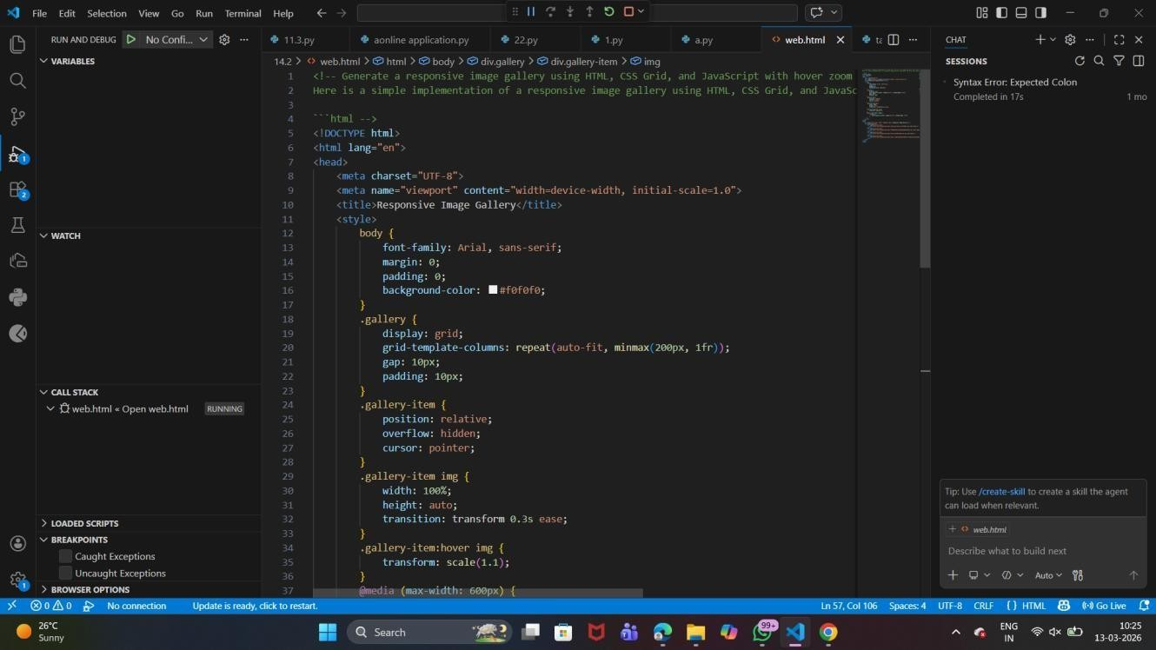
CODE:

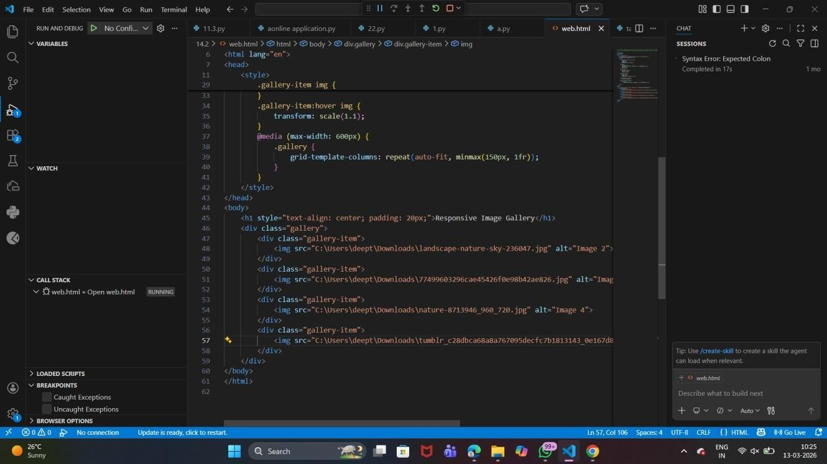

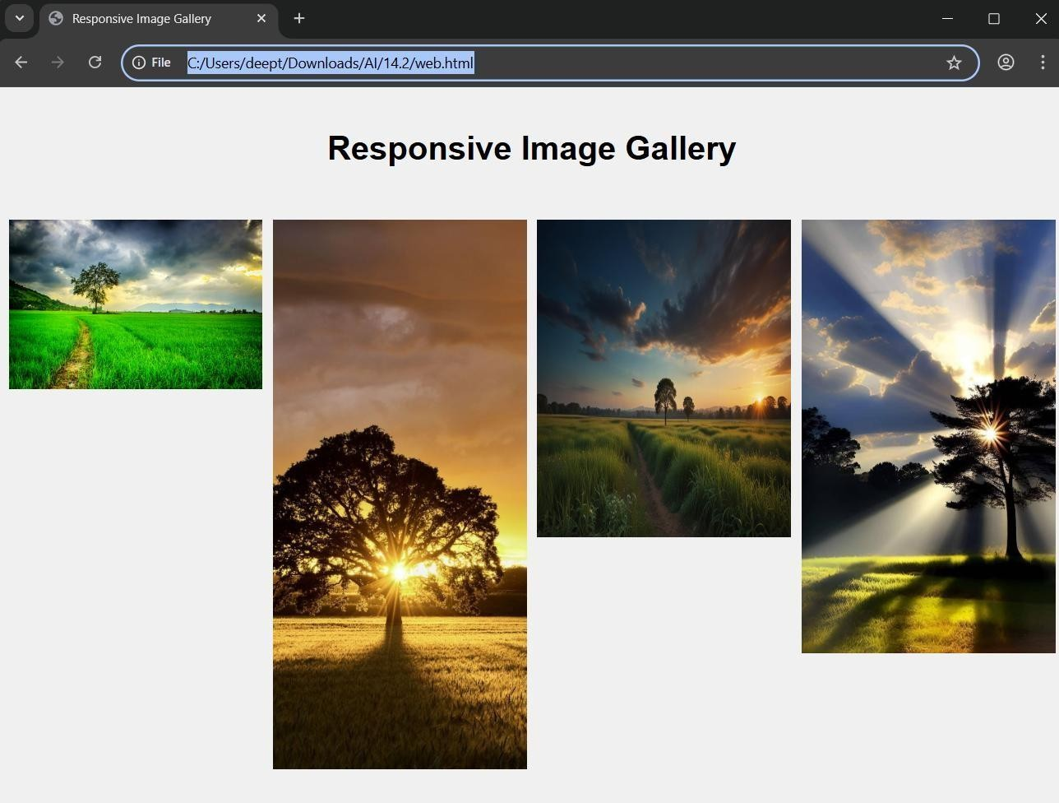
OUTPUT:

Explanation

- CSS Grid arranges images in a structured grid.
- Hover zoom effect improves visual interaction.
- Responsive design adjusts layout for different devices.

Task Description #2 (Profile Card Generator):

PROMPT: Create a modern profile card using HTML, CSS Flexbox, and JavaScript showing user image, name, role, and social media links with hover animation.

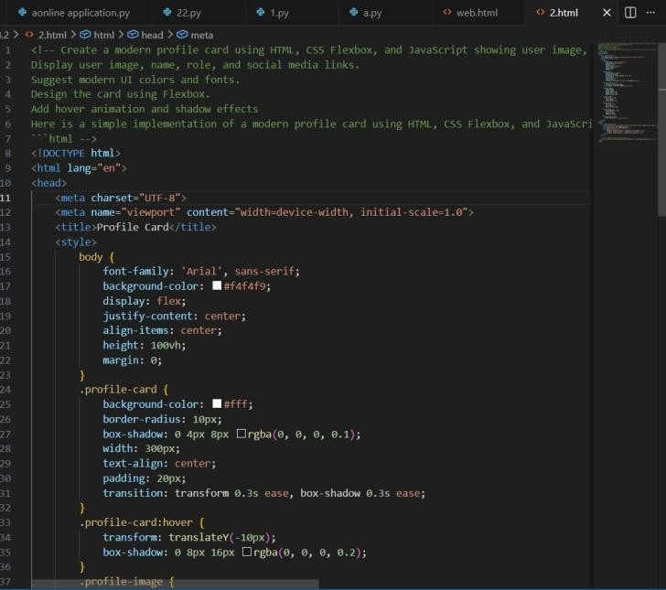
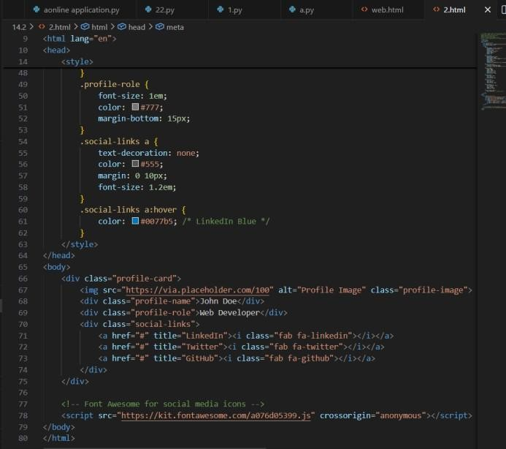
CODE:
OUTPUT:

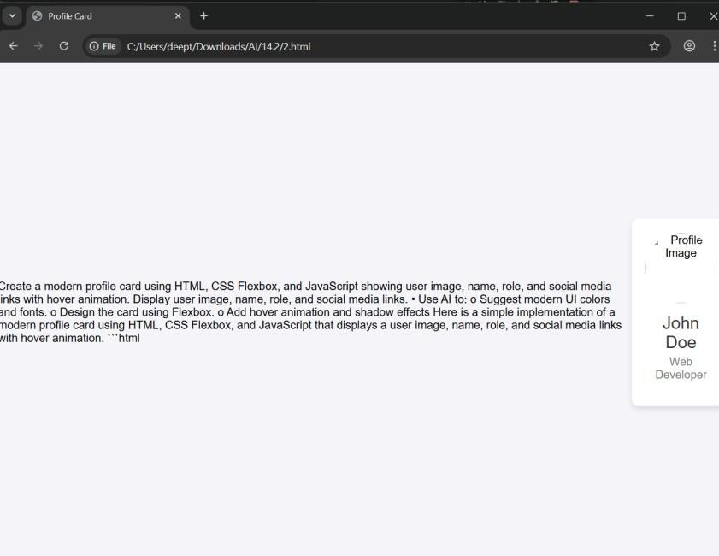

Explanation
- Flexbox aligns card elements properly.
- Modern colors and fonts improve UI design.
- Hover animation adds interactive effects.

Task Description #3 (Develop a dynamic shopping cart system):

Prompt : Develop a dynamic shopping cart using HTML, CSS, and JavaScript that allows adding, removing, and updating items with real-time total price and localStorage support.

Code :

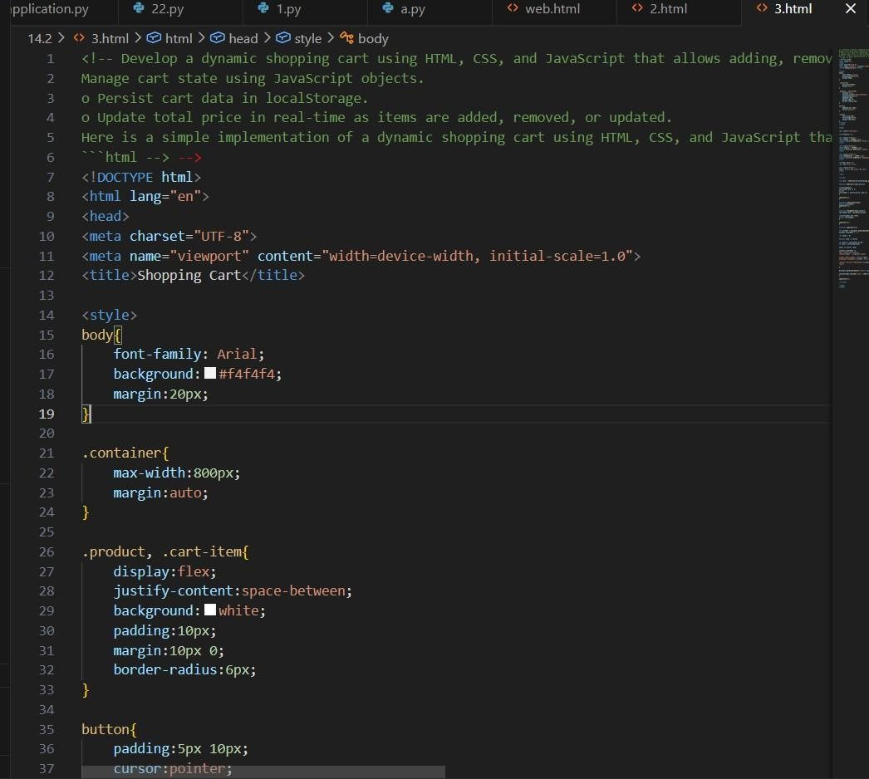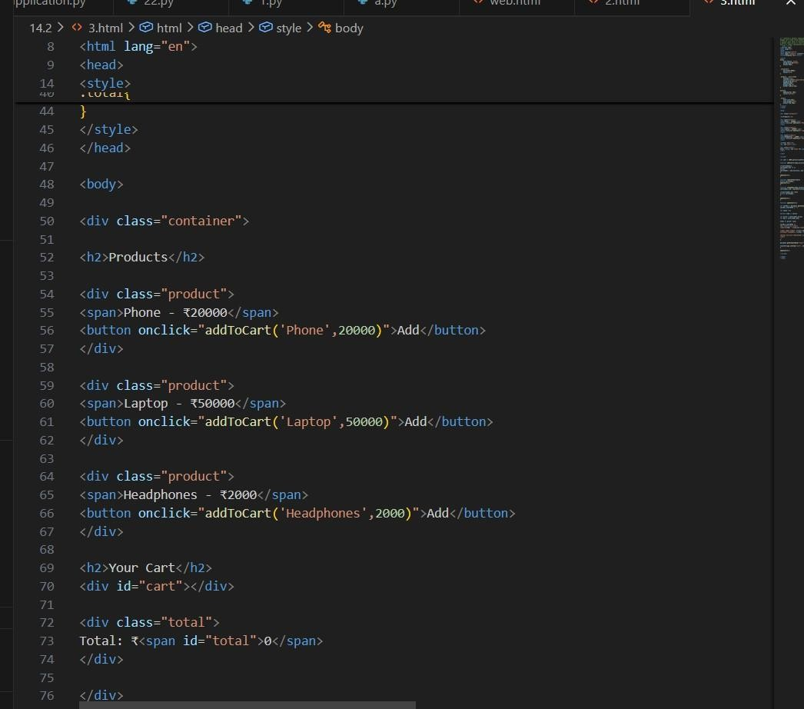

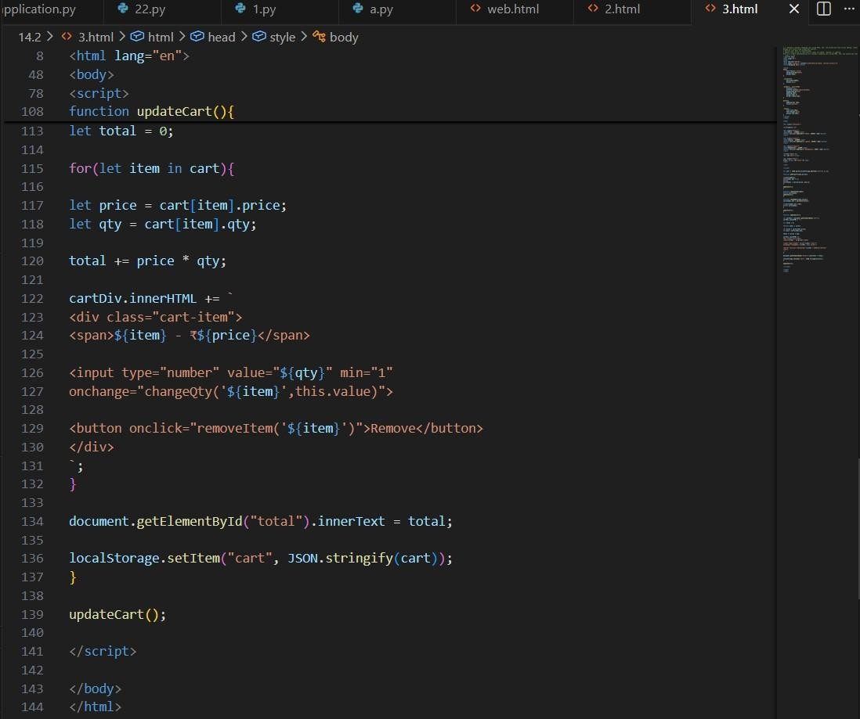

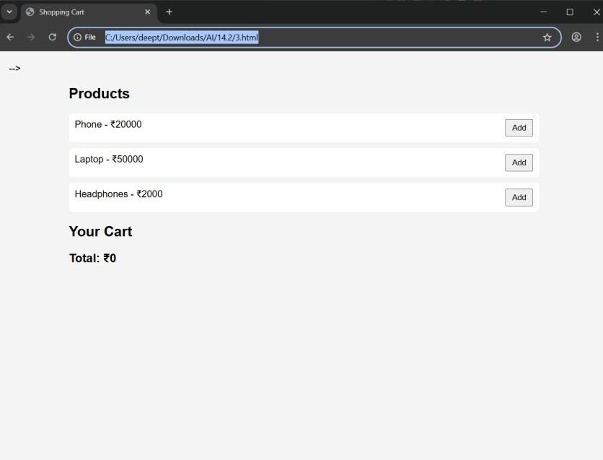
Output :

Explanation
- JavaScript objects manage cart items.
- Total price updates automatically.
- localStorage saves cart data after refresh.

Task description #4 (Role-Based Access Control Application):
Prompt : Create a role-based web application using HTML, CSS, and JavaScript with Admin, Editor, and User roles and conditional UI rendering and Design access control logic,Maintain secure state transitions,Create scalable UI components.

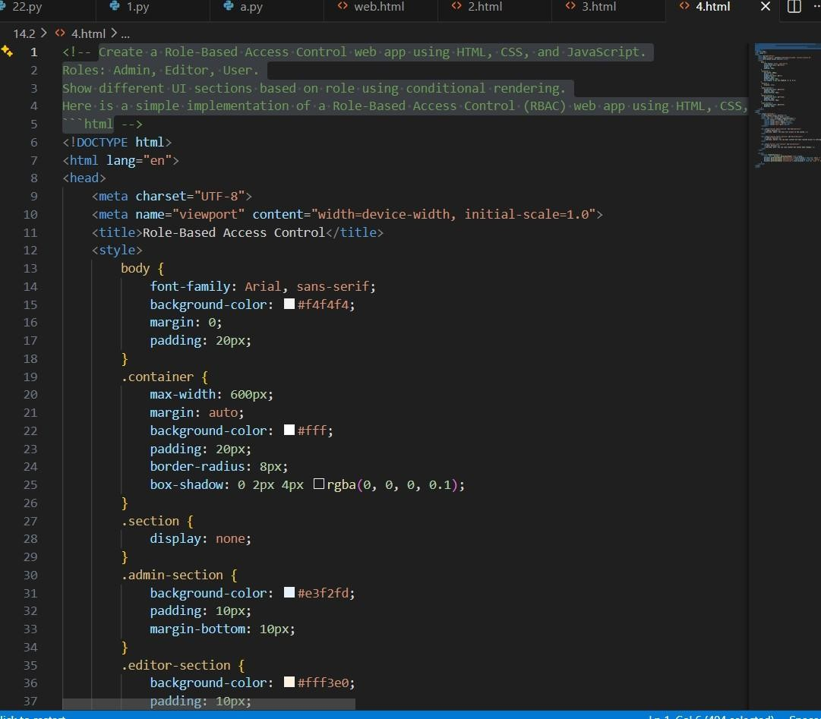
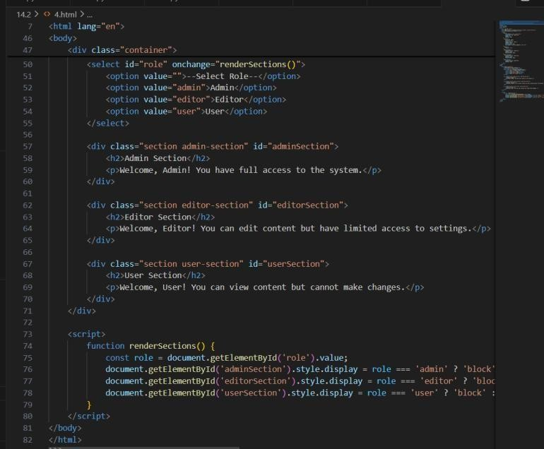
Code :

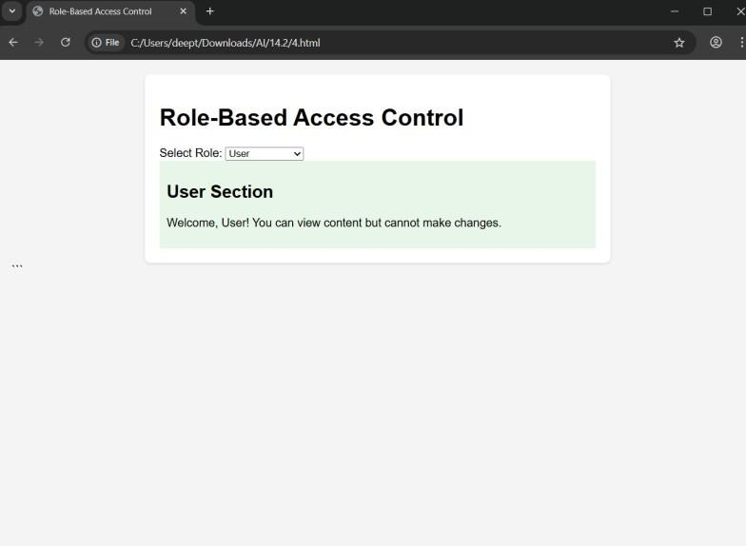
Output :

Explanation
- Different roles have different permissions.
- UI changes based on user role.
- Improves security and access control.

Task Description #5 (Multi-Language Website-Design a multilingual website):
Prompt : Design a multilingual website using HTML, CSS, and JavaScript with dynamic language switching and language preference stored in localStorage and Structure translation files,Handle RTL/LTR layouts,Improve accessibility.

Code :

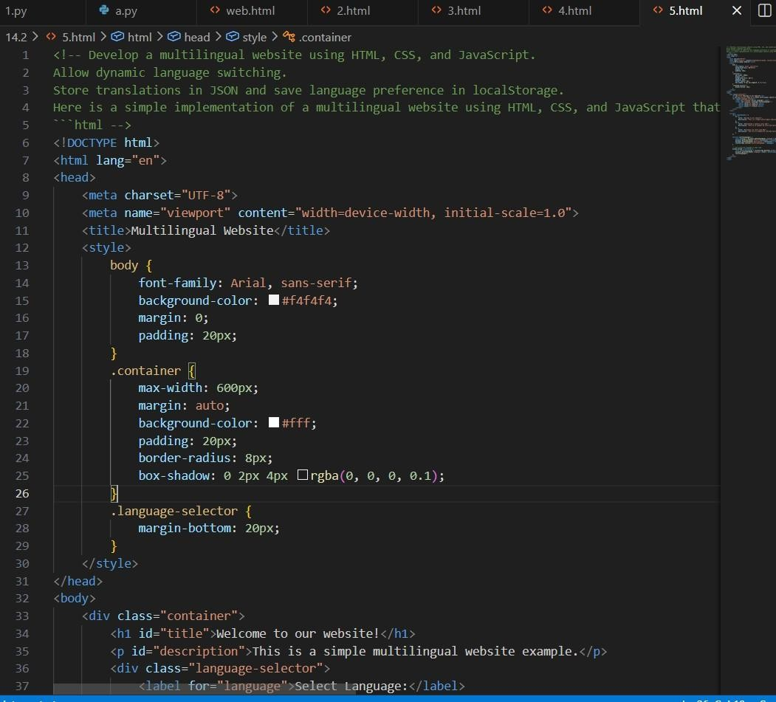
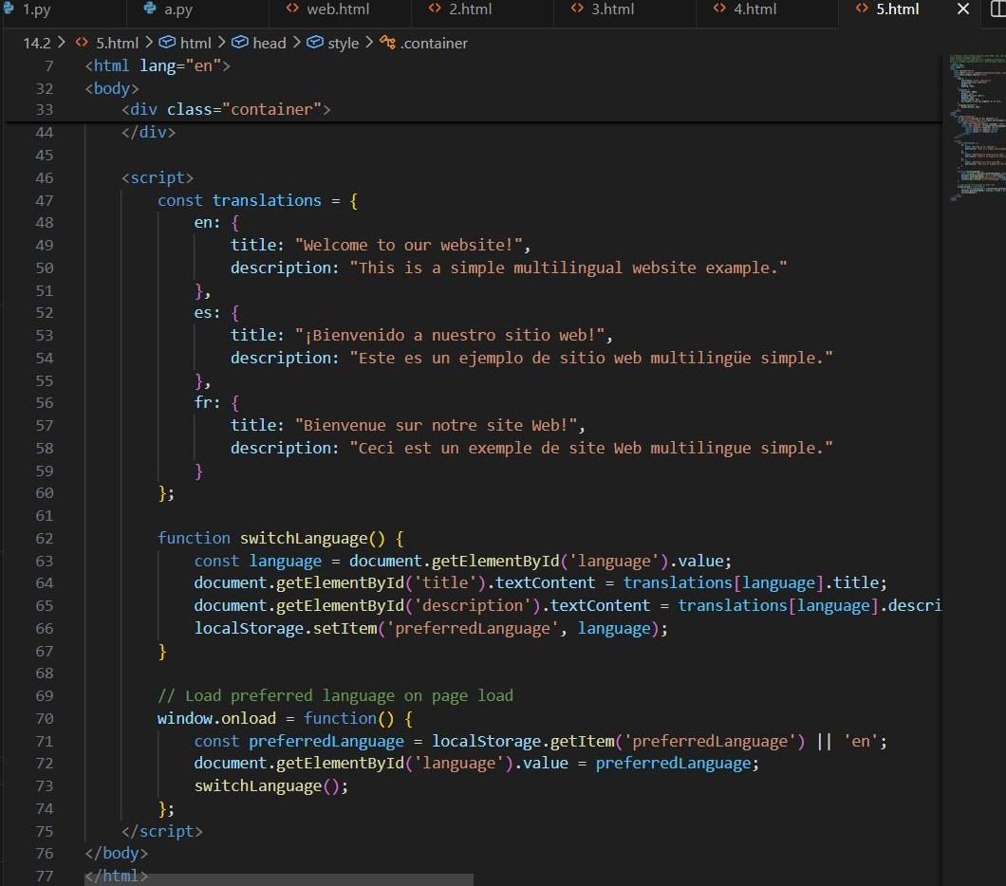
Output :

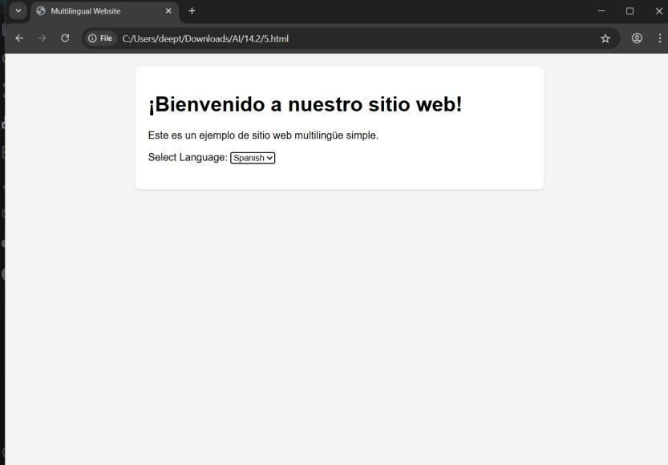

Explanation:
- JSON files store translation data.
- Users can switch languages dynamically.
- Language preference is saved for future visits.

Task Description #6 (Online Examination System-Create an online exam interface.):
Prompt : Create an online examination interface using HTML, CSS, and JavaScript with MCQ questions, countdown timer, and single submission system and Manage exam state,Improve exam UX,Ensure accessibility.
Code :

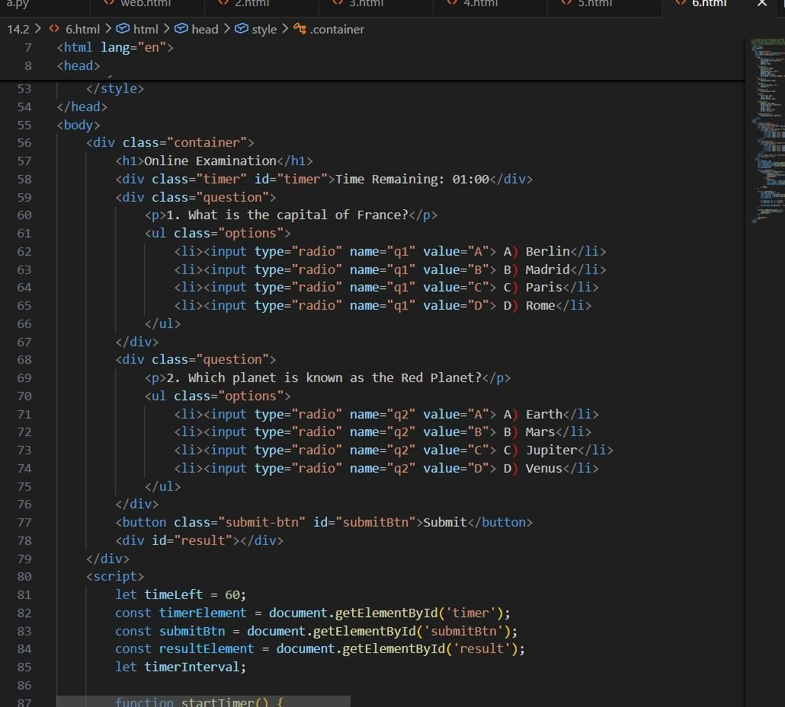
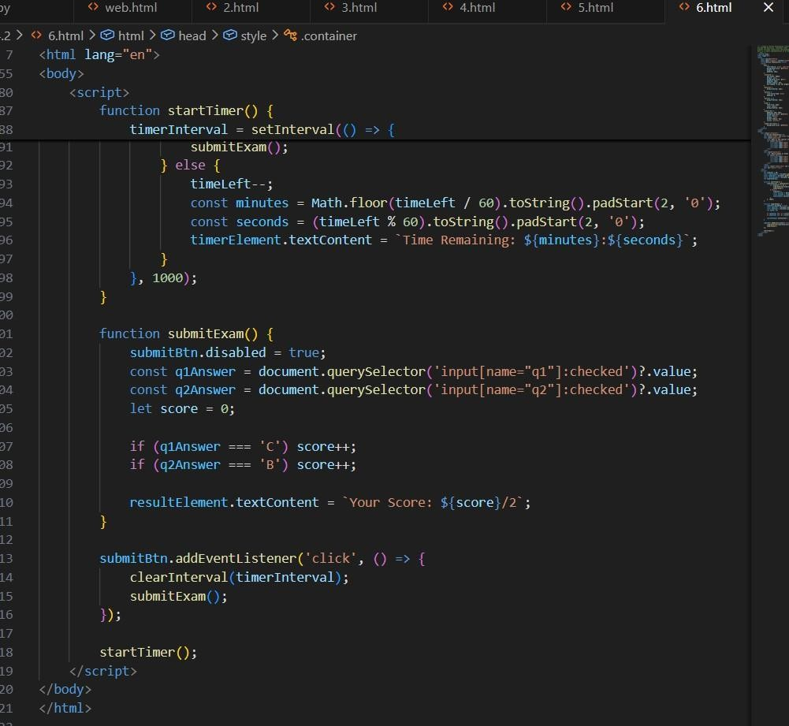

Output :
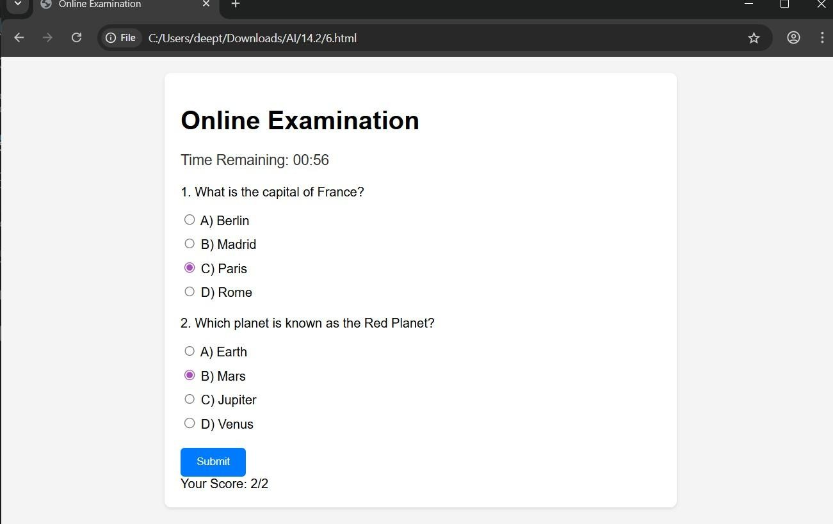
Explanation :
- Timer controls exam duration.
- JavaScript manages exam state.
- Prevents multiple submissions.

