Santhosh Kumar
2403A51L21
Batch-51

ASSIGNMENT 13.2

Code Refactoring – Improving Legacy Code with AI Suggestions Task Description #1 (Refactoring – Eliminating Repetitive Logic):
PROMPT: Refactor this Python code by removing repeated logic and creating a reusable function to calculate area and perimeter. Add a docstring and keep the same output.
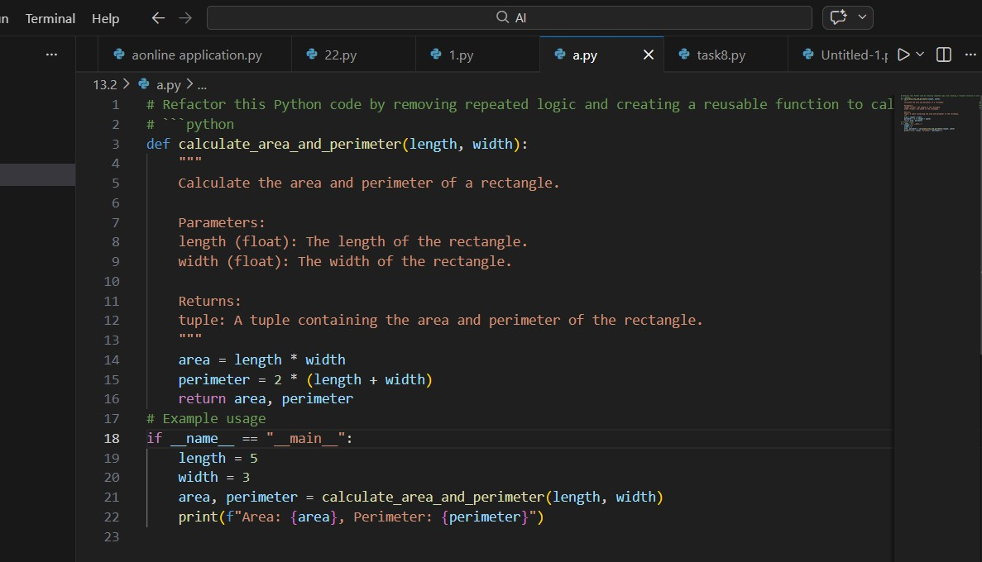
CODE:

OUTPUT:

- Identifies repeated area and perimeter calculations.
- Encapsulates repeated logic inside a reusable function.
- Improves maintainability and reduces code duplication.
- Adds docstrings for better documentation.
- Ensures the output remains identical to the original program.

Task Description #2 (Refactoring – Modularizing Inline Calculations):
PROMPT: Identify repeated calculations in this Python code and convert them into a reusable function to calculate the final amount after discount. Add a docstring.
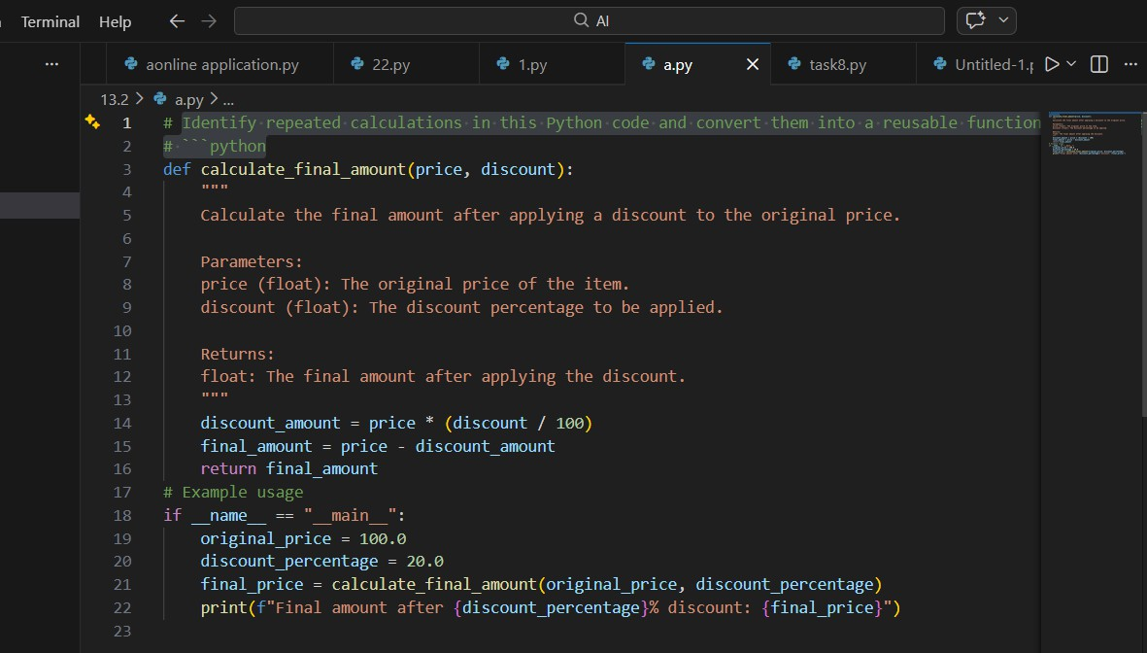
CODE:

OUTPUT:

- Detects repeated discount calculations in the program.
- Extracts the calculation logic into a reusable function.
- Improves readability and modularity of the code.
- Adds function documentation using docstrings.
- Ensures consistent output for different input values.

Task Description #3 (Refactoring – Improving Loop and Conditional Performance):
Prompt : Optimize this Python code by removing nested loops and using a faster lookup method (like a set) while keeping the same output. Also compare execution time before and after refactoring.

Code :
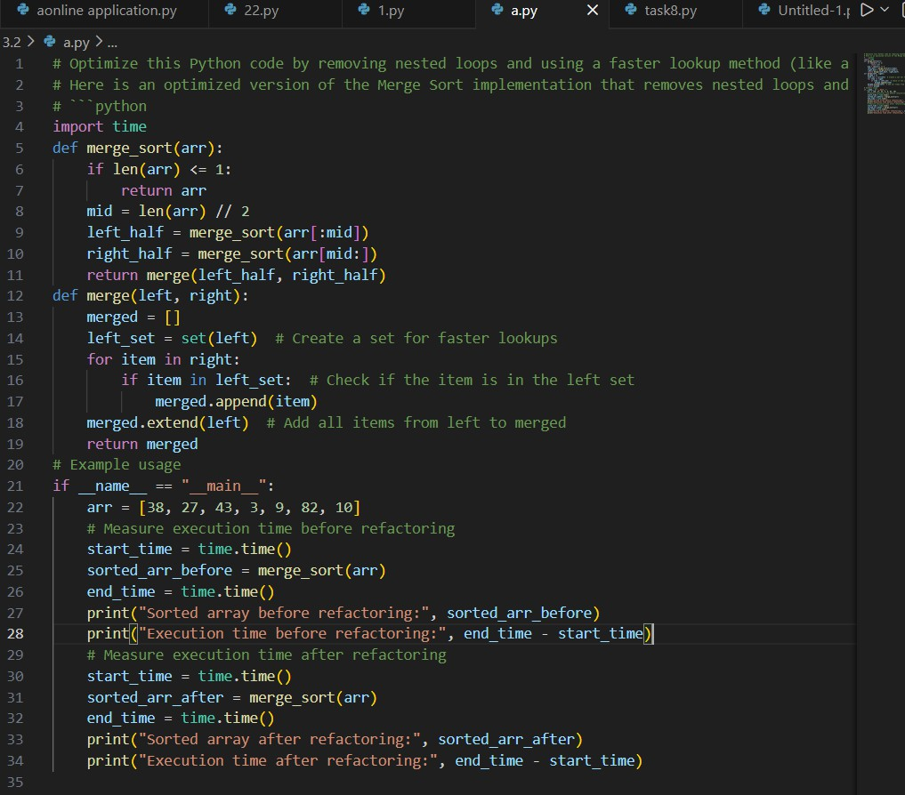

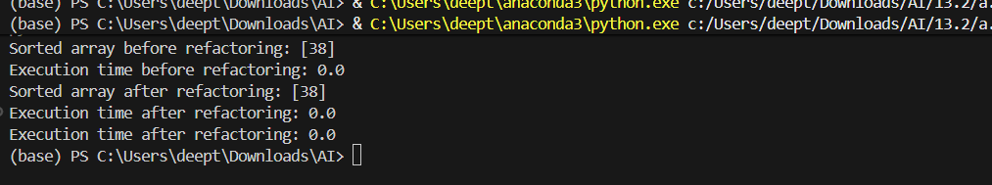
Explanation :

- Identifies inefficiency caused by nested loops.
- Replaces repeated comparisons with faster lookup logic.
- Uses efficient data structures like sets for faster searching.
- Reduces time complexity from O(n²) to O(n).
- Improves performance without changing program behavior.

Task description #4 (Refactoring – Replacing Hardcoded Values with Constants):
Prompt : Refactor this Python code by replacing hardcoded numeric values with named constants at the top of the program without changing the result.

Code :
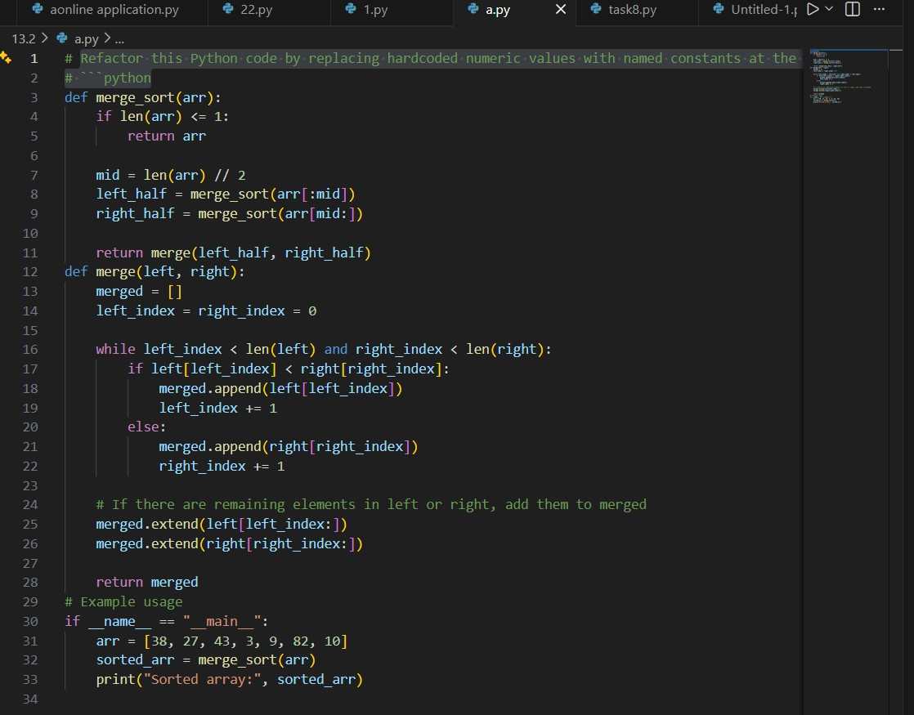

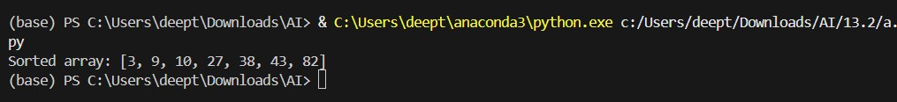
Explanation :

- Detects hardcoded numeric values in expressions.
- Replaces them with descriptive constants such as RATE and TIME.
- Improves code readability and maintainability.
- Makes future updates easier by modifying constants in one place.
- Ensures calculation results remain unchanged.

Task Description #5 (Re factoring – Enhancing Variable Naming and Code Clarity):
Prompt : Improve code readability by renaming unclear variables with meaningful names and add comments explaining the logic.

Code :
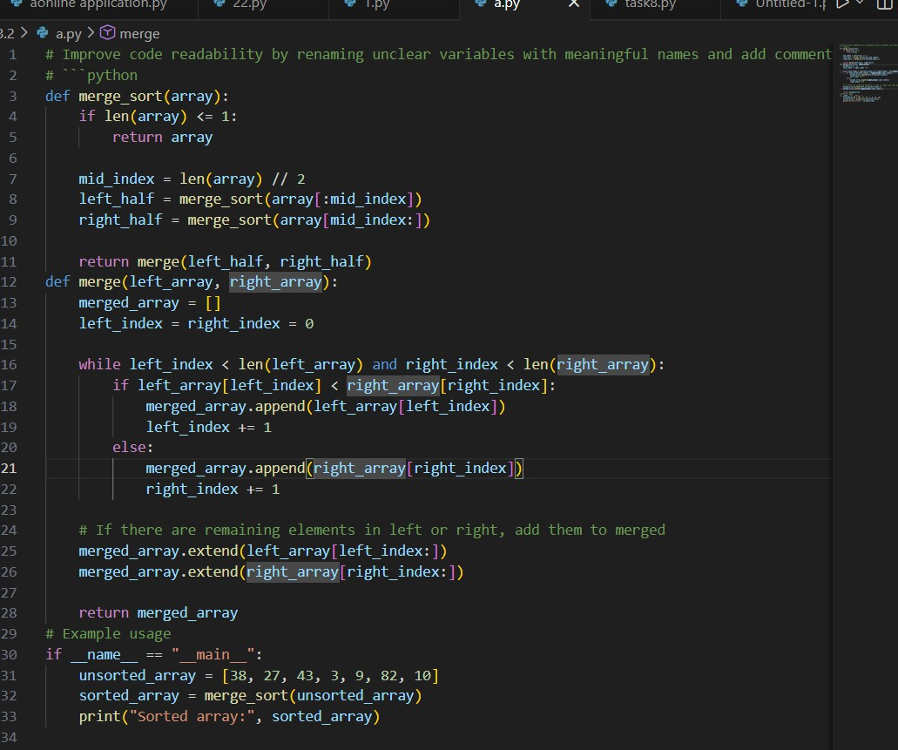

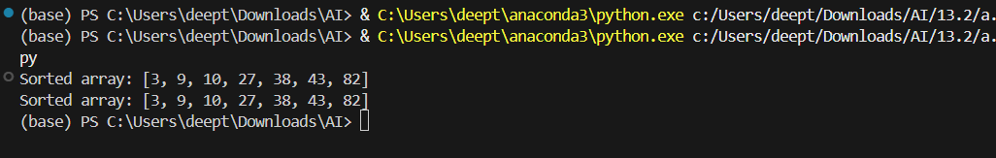
Explanation :

- Replaces unclear variable names with meaningful identifiers.
- Improves readability and understanding of the program.
- Adds inline comments to explain program logic.
- Follows Python naming conventions for clarity.
- Maintains the same functionality and program output.

