Command Line output for hello.py webapp

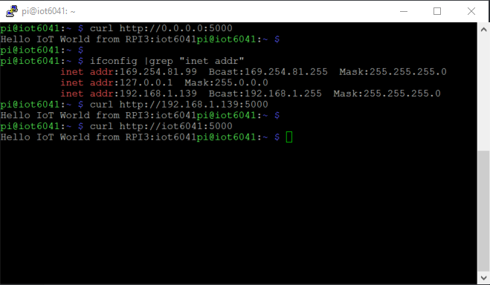

Remote Web Browser output of Webapp hello.py

