## VISVESVARAYA TECHNOLOGICAL UNIVERSITY

**“Jnana Sangama”, Belgaum -590014, Karnataka.**



## PROJECT WORK-2 REPORT

**On “RideX”**

***Submitted by***

## SANCHIT MEHTA(1BM23CS299) SANTHOSH N(1BM23CS302) SHAMARAO(1BM23CS308) SUHAS BP(1BM23CS345)

***Under the Guidance of***

**Srushti C S**

**Assistant Professor**

***in partial fulﬁllment for the award of the degree of***

## BACHELOR OF ENGINEERING

***in***

## COMPUTER SCIENCE AND ENGINEERING



**B.M.S. COLLEGE OF ENGINEERING**

**(Autonomous Institution under VTU) BENGALURU-560019**

**2024-2025**

**B. M. S. College of Engineering,**

**Bull Temple Road, Bangalore 560019**

(Aﬃliated To Visvesvaraya Technological University, Belgaum)

**Department of Computer Science and Engineering**



**CERTIFICATE**

This is to certify that the project work entitled **“RideX”** carried out by **SANCHIT MEHTA(1BM23CS299), SANTHOSH N(1BM23CS302), SHAMARAO(1BM23CS308), SUHAS BP(1BM23CS345)** who are bonaﬁde

students of **B. M. S. College of Engineering.** It is in partial fulﬁllment for the award of **Bachelor of Engineering in Computer Science and Engineering** of the Visveswaraiah Technological University, Belgaum during the year 2024. The project report has been approved as it satisﬁes the academic requirements in respect of **Full Stack Web Development(23CS3AEFWD)** work prescribed for the said degree.

Signature of the Guide Signature of the HOD

Srushti C S Assistant Professor BMSCE, Bengaluru

Dr. Kavitha Sooda

Prof & Head of Dept of CSE BMSCE, Bengaluru

External Viva

Name of the Examiner Signature with date

## B.M.S. COLLEGE OF ENGINEERING DEPARTMENT OF COMPUTER SCIENCE AND ENGINEERING



**DECALARATION**

We, **SANCHIT MEHTA(1BM23CS299), SANTOSH N(1BM23CS302), SHAMARAO(1BM23CS308), SUHAS BP(1BM23CS345)**

students of 3rd Semester, B.E, Department of Computer Science and Engineering, BMS College of Engineering, Bangalore, hereby declare that, this Full Stack Web Development entitled **"RideX"** has been carried out by us under the guidance of Srushti C S, Assistant Professor, Department of CSE, BMS College of Engineering, Bangalore during the academic semester Sept 2024 – Jan 2025.

We also declare that to the best of our knowledge and belief, the development reported here is not from part of any other report by any other students.

Signature

**SANCHIT MEHTA(1BM23CS299) SANTOSH N(1BM23CS302) SHAMARAO(1BM23CS308) SUHAS BP(1BM23CS345)**

# TABLE OF CONTENTS

|  |  |  |
| --- | --- | --- |
| **Serial**  **No.** | **TITLE** | **PAGE**  **NO.** |
| 1 | **Introduction** | 1 |
| 1.1 | Overview | 1 |
| 1.2 | Motivation | 1 |
| 2 | **Project Requirements** | 2 |
| 2.1 | Hardware Requirements | 2 |
| 2.2 | Software Requirements | 2 |
| 3 | **ER diagram of the project** | 3 |
| 4 | **Schema of theproject** | 4 |
| 5 | **User Interface Design** | 5 |
| 6 | **Reference** | 10 |

**INTRODUCTION**

* 1. **Overview**

RideX project is a web-based platform designed to provide seamless ride-hailing, driving, and package delivery services. It mimics the functionality of well-known ride-sharing services, integrating features for users to request rides, explore delivery options, and join as drivers to earn income at reasonable price for both customers and drivers reducing ride cancellations and faster ride acceptance by drivers. Thus, improving time eﬃciency. The platform includes visually appealing sections,

user-friendly navigation, and a focus on safety and accessibility for a global audience.

* 1. **Motivation**

The motivation behind the RideX project is to address the challenges commonly faced in the ride-sharing industry, such as high ride cancellations, slow ride acceptance, and ineﬃciencies in time management. By providing a platform that balances aﬀordability for customers and fair income for drivers, RideX aims to create a mutually beneﬁcial ecosystem that fosters trust and reliability. The focus on intuitive design, global accessibility, and robust safety features underscores the project’s commitment to enhancing user experience and ensuring security.

Ultimately, RideX seeks to redeﬁne convenience in transportation and delivery services, oﬀering a more eﬃcient, transparent, and dependable solution for both riders and drivers worldwide.

# PROJECT REQUIREMENTS

* 1. **Hardware Requirements:**
     + A PC with the following or greater speciﬁcations:
       - Intel Core i3 or higher
       - 8 GB RAM
       - 500 GB Hard Drive
     + A stable internet connection (2Mbps or higher)
  2. **Software Requirements:**
* Operating system : Windows, Linux
* Front end technologies are : HTML, CSS, JavaScript
* IDE : VS Code,Sublime text
* Back end requirement : PHP/Node.js
* Server : XAMPP server/Node.js

USER_ID DRIVERID

PH_NO

**USER**

WEIGHT

L_NO

**DRIVER**

**PACKAGE**

## 2. ER DIAGRAM OF THE PROJECT

NAME

EMAIL

DRIVES

DRIVES

1

1 RIDE_ID

SOURCE

BOOKS N

**RIDE**

USER_ID

BOOKS

DRIVER_ID

DESTINATION

FARE

PACKAGE_ID

ORDERS

ORDERS

SOURCE

VEHICLE_ID

**VEHICLE**

N

DESTINATION

LISENCE_PLATE

**4. SCHEMA OF THE PROJECT**

**USER**

**VEHICLE**

**PACKAGE**

**LISENCE_PLATE**

**VEHICLE_ID**

**L_NO**

**DRIVER**

**_ID**

**USER**

**_ID**

**FA RE**

**DESTINAT ION**

**SOUR CE**

**RIDE**

**_ID**

**DRIVER_ID**

**RIDE**

**DRIVER**

|  |  |  |  |
| --- | --- | --- | --- |
| **PH_NO** | **USER_ID** | **NAME** | **EMAIL** |

|  |  |  |  |  |
| --- | --- | --- | --- | --- |
| **PACKAGE_ID** | **WEIGHT** | **SOURCE** | **DESTINATION** | **USER_ID** |

**USER INTERFACE DESIGN**

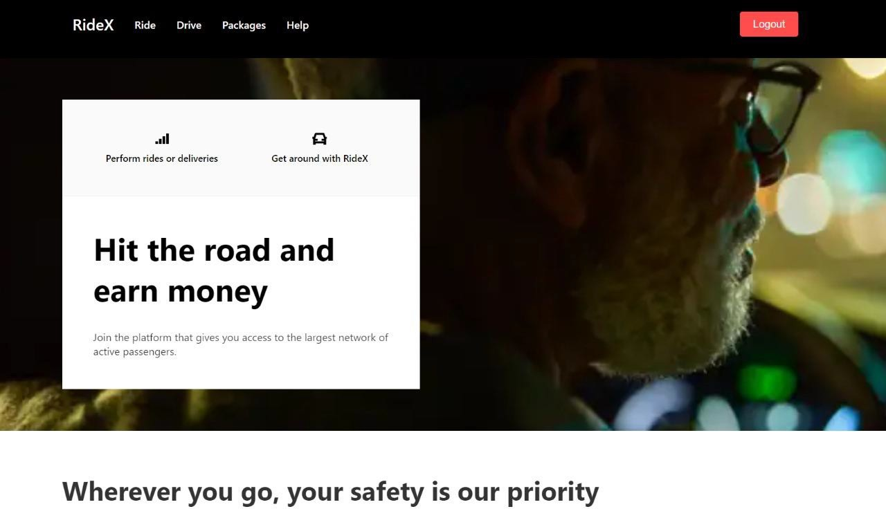

**Fig:1 Homepage**

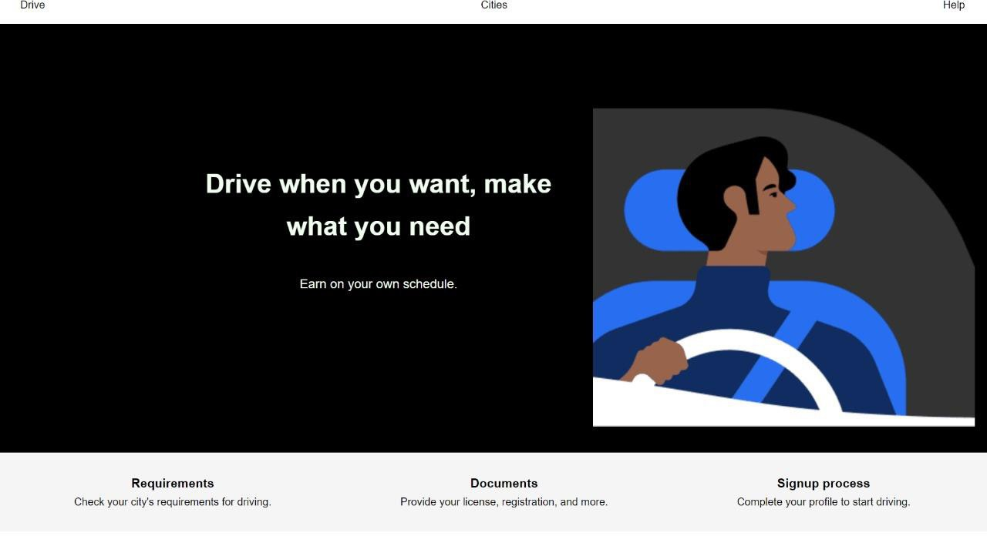

**Fig: 2 Driver Page**

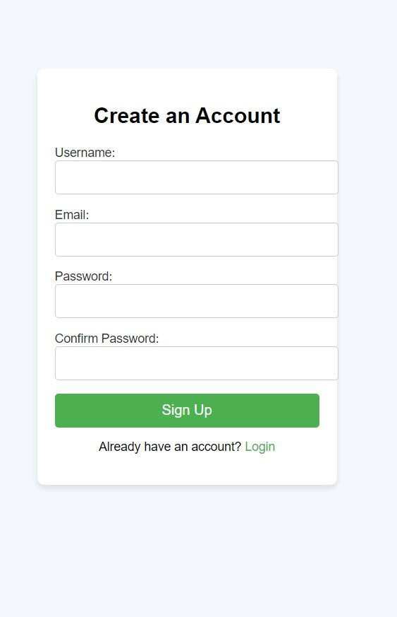

**Fig 3: Sign Up Page**

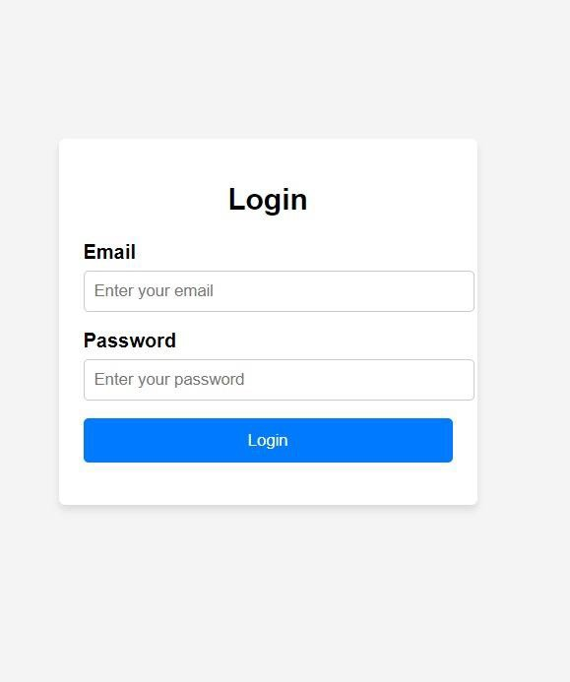

**Fig 4 : Login Page** *7*

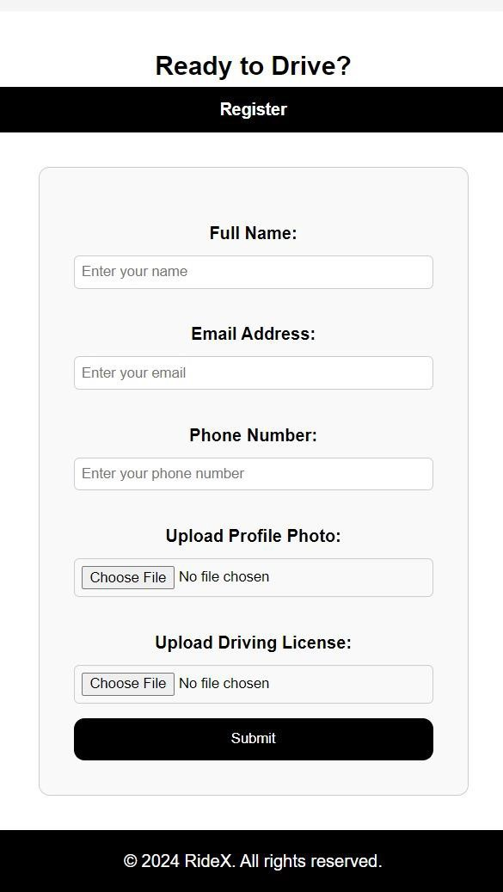

**Fig 5: Driver Register Page**

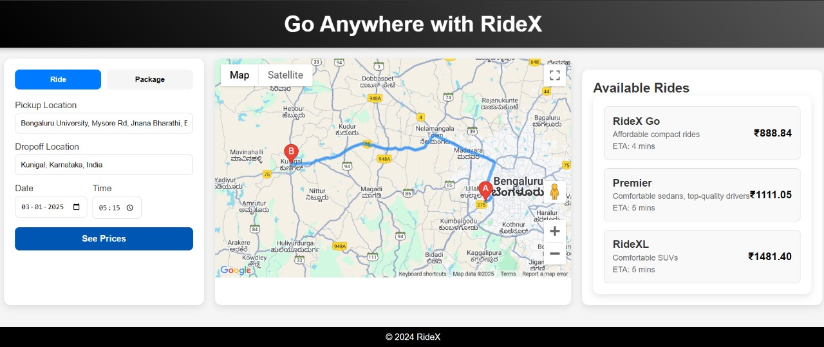

**Fig 6: Ride Search Page**

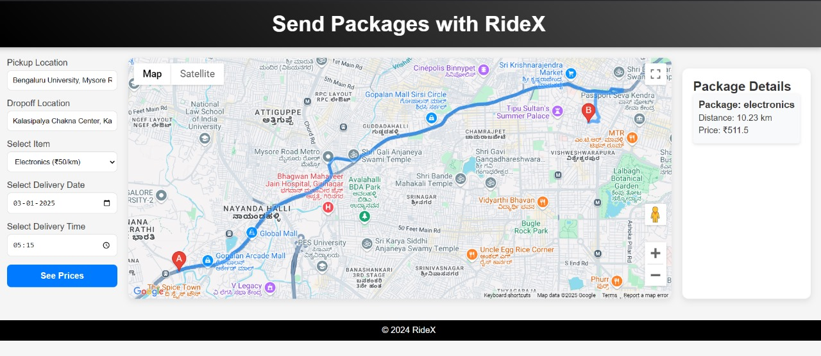

**Fig 7: Package sending Page**

**Help Center - RideX**

### Getting Started

**What is RideX?** Your App Name is a ride-hailing app that connects riders with drivers.

**How do** I **sign up?** Visit the Sign-Up Page or download the app and follow the instructions.

**How do** I **book a ride?** Open the app, enter your locations, choose a ride, and tap "Confirm Ride."

### For Riders

**How can** I **track my ride?** Use the real-time map in the app after booking. **How do** I **cancel a ride?** Tap "Cancel Ride" in the ride summary screen. **How do** I **contact my driver?** Use the in-app messaging or call option.

### For Drivers

**How do** I **register as a driver?** Sign up on the Driver Sign-Up Page.

**How do** I **accept rides?** Tap "Accept" when a.ride request appears.

**How do** I **contact support?** Use the "Help" section in the app.

### Payments

**What payment methods are supported?** CrediUdebit cards, e-wallets, and cash (in some areas).

**How do** I **update my payment method?** Go to "Payment Settings" in the app.

**How do** I **view receipts?** Check "Ride History" in your account.

### Contact Us

Email: [support@RideX.com](mailto:support@RideX.com) Phone: +1-800-123-4567

## REFERENCES

* [**https://www.uber.com/in/en/**](https://www.uber.com/in/en/)
* [**https://www.lyft.com/**](https://www.lyft.com/)
* [**https://bolt.eu/**](https://bolt.eu/)