**Detection and Identification of Potato Plant Leaf Diseases using Convolution Neural Networks**

MRS JAISAKTHI.P

*Assistant Professor*

*Easwari Engineering College*

*Department of Information Technology*

Chennai, India.

MADHUSHALINI.V

*Department of Information Technology*

*Easwari Engineering College*

Chennai, India.

GANESH MOORTHI.S

*Department of Information Technology*

*Easwari Engineering College*

Chennai, India.

HARISH.P

*Department of Information Technology*

*Easwari Engineering College*

Chennai, India.

***Abstract — Crops suffering from various diseases can be a big turndown for crop yield. This can affect effective crop production, if left unnoticed. Hence, it is of great importance to diagnose the plant diseases at early stages so that appropriate and timely action can be taken by the farmers to avoid further losses. This project focuses on the approach which is based on image processing for detection of diseases of plants. In this paper, we propose a system which uses convolutional neural networks that helps farmers to identify any possible plant disease by uploading a leaf image to the system. The system consists of a set of algorithms which can identify the type of disease. Input image given by the user undergoes several processing steps to detect the disease and results are returned back to the user on a user interface, for Example: Computer screen.***

***Keywords — Image processing, Leaf image, convolution neural network, Image resizing.***

**I. INTRODUCTION**

One of the major causes for the decrease in the quality and amount of agricultural productivity is plant diseases. Farmers face great difficulties in detecting and controlling plant diseases. Thus, detecting the plant diseases at early stages is important so that appropriate action can be taken by the farmers to avoid further losses. Detection of plant diseases once they attack the plants is extremely important. In this paper, we concentrate on not only detecting and identifying the type of disease that the plant is affected with, but also to suggest remedies and prevent any such attacks in future. The concept that we are using here is Neural Networks. Neural Networks is a series of algorithms that recognizes relationships in data by mimicking the working of a human brain. Some of the types of neural networks are: Deep Multilayer perceptron(MLP), Convolutional Neural Network(CNN), Recursive Neural Network(RNN) and many more. In this paper, we have used Convolutional Neural Network as it provides high accuracy than other neural network algorithms and is highly suitable for image processing. L. Sherly Puspha Annabel et al. [20] explains various kinds of leaf diseases that a plant leaf can be prone to. These diseases can be bacterial, fungal or viral. Some of them are leaf rust, powdery mildew, bacterial blight and so on.Ch. Usha Kumari describes the detection and classification of potato plant leaf diseases with four stages. Mr. Ketan D. Bodhe**,** Mr. Himanshu et al. [4] proposed the rule-based system for detecting leaf diseases in cotton leaves. They used an android application for which the images required were captured from various cotton farms in their local regions. By use of internet connecting smart phones farmers identified the diseases on the cotton crop. Hence, it is important and crucial to diagnose the leaf diseases in potato plants at early stages in order to produce high crop yield.

**II. LITERATURE SURVEY**

Mr. Ketan D. Bodhe, Mr. Himanshu V. Taiwade, Mr. Virendra P. Yadav, Mr. Nikesh V. Aote *“Implementation of Prototype for Detection & Diagnosis of Cotton Leaf Diseases using Rule Based System for Farmers”* **[4]**The proposed system makes use of internet connecting smart phones so that farmers can easily identify the diseases on the cotton crop.

Uday Pratap Singh, Siddharth Singh Chouhan, Sukirty Jain, Sanjeev Jain “*Multilayer Convolution Neural Network for the Classification of Mango Leaves Infected by Anthracnose Disease*” **[7]** Therefore, for this work a Multilayer Convolutional Neural Network (MCNN) explains the classification of the Mango leaves infected by the Anthracnose fungal disease. Dataset contains both healthy and infected leaf images.

Pranjali B. Padol, Prof. Anjali A. Yadav “*SVM Classifier Based Grape Leaf Disease Detection* ” *2016 Conference on Advances in Signal Processing (CASP) Cummins College of Engineering for Women, Pune”* **[2]** This system is intended to detect and classify leaf diseases of grape using SVM classification technique. Initially, the diseased region is found using segmentation by K-means clustering, then both color and texture features are extracted and then a classification technique is applied to detect the type of leaf disease.

**III. PROPOSED SYSTEM**

The stages in the system may be defined as follows:

**Image Acquisition:** The images of the plant leaf are captured by a camera. The image obtained is in RGB format and this image is further processed in the preprocessing stage for refinement. An image in RGB format means nothing but it has the three primary colors namely: Red,Green and Blue, each color in their definite proportions.

**Image Pre-processing:** In order to remove noise in the image different pre-processing techniques can be considered. RGB to Gray Converter-Weighted method or luminosity Method-You is one of the techniques used here. The weighted method has a solution to that problem. Red color has more wavelength of all the three colors, and green is the color that has not only less wavelength than red color but also it is the color that gives a more soothing effect to the eyes. It means that we need to decrease the contribution of red color, and increase the contribution of the green color, and add blue color contribution in between these two. Hence, the new equation that form is: New grayscale image = ((0.3 * R) + (0.59 * G) + (0.11 * B)). From this equation, we can see that Red has 30% of it’s part, Green has 59%, which is greater in all three colors and Blue has 11%. Next comes an important phase called Image Resizing. Sometimes, the resolution of document images can be very high, typically higher than 2000 *2000, which is too large to be fed to a CNN with the current availability of computing resources. Large input dimensions are not only expensive, but can also lead to over-fitting conditions. To avoid such issues, we go for image resizing.

Once the process of converting RGB image into Gray is done, it resizes into a standard format that is either 256 × 256 for better resolution.

**CLAHE** – Adaptive Histogram Equalization(AHE) is an algorithm which is used to enhance the contrast of the image. There are two types of AHE- Ordinary AHE and CLAHE. Ordinary AHE may also be employed to enhance the contrast of the image. But this can bring many outliers. Hence, Contrast-Limited Adaptive Histogram Equalization(CLAHE) is employed to enhance the contrast and the same time, can reduce the number of outliers occurring.

**Gaussian blur** – Gaussian blur is an algorithm which is used to blur the image after resizing. This blur algorithm takes a single pixel as an average of all the pixel points around. The center point calculates the average of all the surrounding pixel points. If the average is 1, then it is data smoothing. As the blur radius increases, the blur increases. This also helps in removing unwanted noise.

**Convolutional Neural Networks** – After removing noise from the image, what we need to do is feature extraction. We use CNN for document image classification.

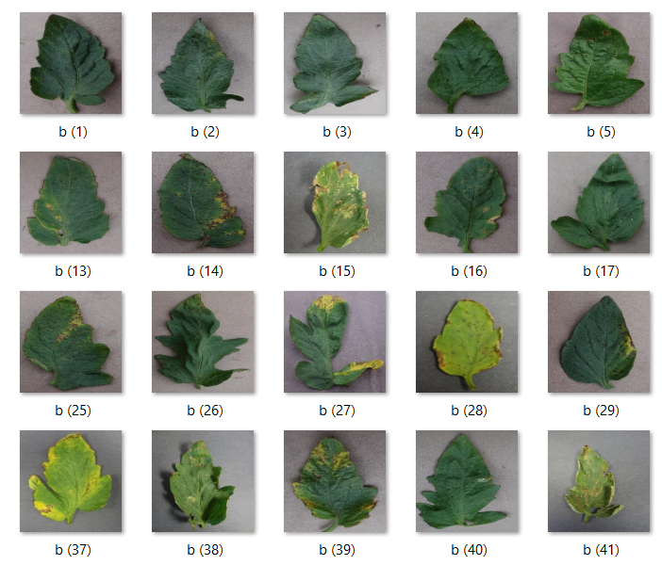

The general idea behind this is to learn a hierarchy of feature detectors and train a nonlinear classifier to identify complex document layouts. For a given input image, down-sampling and pixel value normalization is performed, and then the normalized image is fed to the CNN to predict the class label.

**Flow chart -**

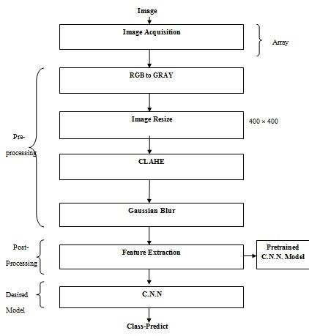**Preprocessing -** The working may be explained as follows:The image of a leaf is captured using a camera and is stored in a particular directory. This image undergoes preprocessing, starting with conversion of RGB image into Grayscale image. The image is captured in RGB format, but the machine can understand only binary language (0’s and 1’s). Therefore, the image is converted from RGB image to Grayscale. This image is stored in a destination path in the same directory. Next, comes the resizing of the image, which is done to feed the input data into the neural network to a specific pixel range. The pixel range defined here is 256*256. Next, we calculate the mean, standard deviation and variance values.

Fig 2.a. Potato leaves in RGB format

Fig 2.b. Potato leaves in Grayscale

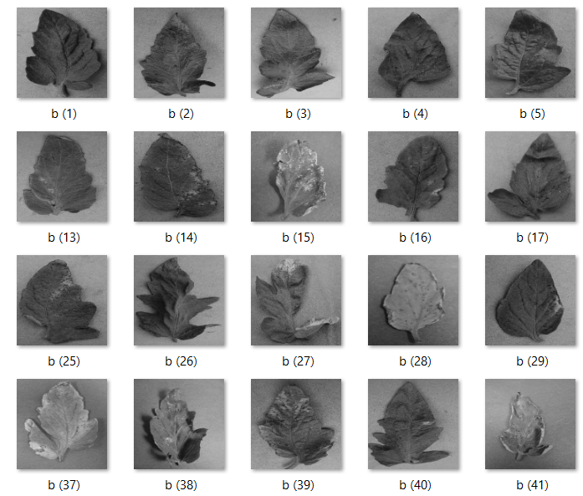

**Feature Extraction –** This may be defined as a kind of dimension reduction method that efficiently represents the enhanced parts of an image as a feature vector. The image is initially blurred to an extent, such that it can be smoothened easily. This smoothened image is next fed into the convolutional neural network which processes to produce the further output.

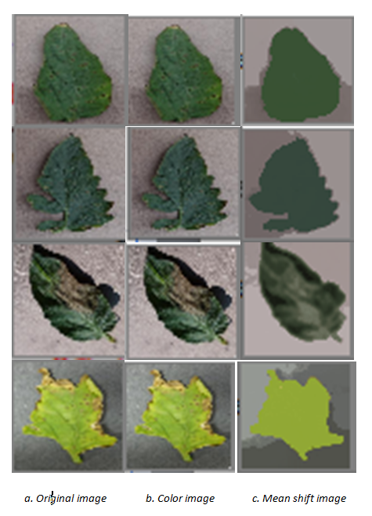

**Convolutional Neural Algorithm –** The image is taken from the directory for training. This image is used for training the neural network. The image is read and resized for better accuracy. Further, this image is appended into the training directory.

**Experimental Results -** The results are displayed in a User Interface. The interface prompts for an input image. User provides the image that he wishes to predict. The algorithm takes this input and processes it to tell if the leaf is healthy or unhealthy. If the leaf is predicted unhealthy, then it suggests remedies.

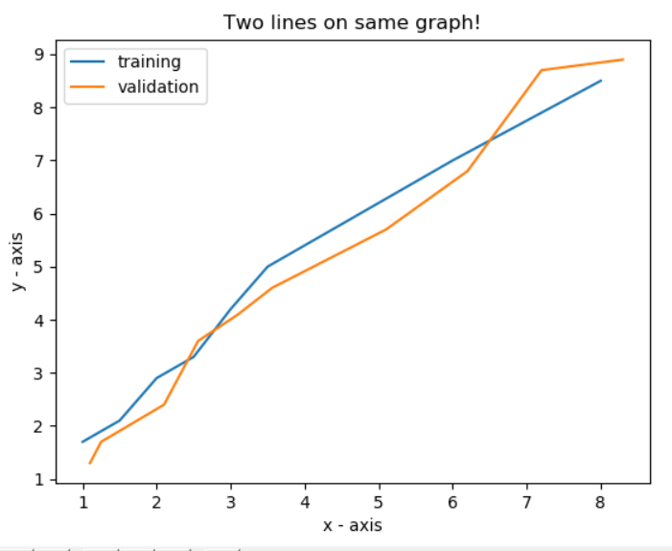

Fig 3. Training versus Validation Graph

**IV. CONCLUSION**

This paper describes about the plant diseases that a leaf of a potato plant can be exposed to. Further, not only does it detect and identify the type of disease it is prone to, but also it suggests remedies for the farmers so that they are aware of it and can take preventive measures towards effective crop yield.

**VII. REFERENCES**

**[1]** Muhammad Attique Khan, M Ikramullah Lali, Muhammad Sharif, Kashif Javed, Khursheed Aurangzeb, Syed Irtaza Haider, Abdulaziz Saud, Altamrah, And Talha Akram “*An Optimized Method for Segmentationand Classification of Apple Diseasesbased on Strong Correlation and GeneticAlgorithm based Feature Selection*”2169-3536 (c) 2018 IEEE.

**[2]** Pranjali B. Padol, Prof. Anjali A. Yadav “*SVM Classifier Based Grape Leaf Disease Detection* ”*2016 Conference on Advances in Signal Processing (CASP) Cummins College of Engineering for Women, Pune. Jun 9-11, 2016.*

**[3]** MelikeSardogan, AdemTuncer, YunusOzen “*Plant Leaf Disease Detection and Classification based on CNN with LVQ Algorithm*” 3rd International Conference on Computer Science and Engineering.

**[4]** Mr. Ketan D. Bodhe**,** Mr. Himanshu V. Taiwade, Mr. Virendra P. Yadav, Mr. Nikesh V. Aote**“***Implementation of Prototype for Detection & Diagnosis of Cotton Leaf Diseases using Rule Based System for Farmers****”*** Proceedings of the International Conference on Communication and Electronics Systems (ICCES 2018) IEEE Xplore Part Number:CFP18AWO-ART; ISBN:978-1-5386-4765-3.

**[5]** Ch. Usha Kumari, S. Jeevan Prasad, G. Mounika **“***Leaf Disease Detection: Feature Extraction with K-means clustering and Classification with ANN*” Proceedings of the Third International Conference on Computing Methodologies and Communication (ICCMC 2019)IEEE Xplore Part Number: CFP19K25-ART; ISBN: 978-1-5386-7808-4.

**[6]** R Meena Prakash, G.P. Saraswathy, G Rajalakshmi “*Detection of Leaf Diseases and Classification using Digital Image Processing*”2017 International Conference on Innovations in Information, Embedded and Communication Systems (ICIIECS).

**[7]** Gao, W. and Lin, W., 2012. Frontal Parietal Control Network Regulates the Anti-Correlated Default and Dorsal Attention Networks. Human Brain Mapping, 33(1), 192–202.

**[8]** Wu, S.G., Bao, F.S., Xu, E.Y., Wang, Y.X., Chang, Y.F. and Xiang, Q.L., 2007. “*A Leaf Recognition Algorithm for Plant Classification using Probabilistic Neural Network*”. 7th IEEE International Symposium on Signal Processing and Information Technology, Giza, Egypt,11-16.

**[9]** Zhang X., Liu Y., Lin H., Liu Y. (2016) “*Research on SVM Plant Leaf Identification Method Based on CSA*”. In: Che W. et al. (eds) Social Computing. ICYCSEE 2016. Communications in Computer and Information Science, Vol 624, Springer, Singapore.

**[10]** Hossain, J. and Amin, M.A., 2010. “*Leaf Shape Identification Based Plant Biometrics*”. 13th International Conference on Computer and Information Technology, Dhaka, Bangladesh, 458-463.

**[11]** Du, J.X., Wang, X.F. and Zhang, G.J., 2007. “*Leaf shape-based plant species recognition*”. Applied Mathematics and Computation, 185, 883-893.

**[12]** Monzurul Islam, Anh Dinh, Khan Wahid, Pankaj Bhowmik “Detection of Potato Diseases Using Image Segmentation and Multiclass Support Vector Machine” 2017 IEEE 30th Canadian Conference on Electrical and Computer Engineering (CCECE).

**[13]** Sammy V. Militante, Bobby D. Gerardoĳ , Nanette V. Dionisio “*Plant Leaf Detection and Disease Recognition using Deep Learning*” 2019 IEEE Eurasia Conference on IOT, Communication and Engineering.

**[14]** Sandika Biswas, Bhushan Jagyasi et al. “*Severity Identification of Potato Late Blight Disease from Crop Images Captured under Uncontrolled Environment*” 2014 IEEE Canada International Humanitarian Technology Conference - (IHTC) 978-1-4799-3996-1/14/$31.00 ©2014 IEEE.

**[15]** Shanwen Zhang , Xiaowei Wu et al. “*Leaf image based cucumber disease recognition using sparse representation classification*” 0168-1699/ 2017 Elsevier B.V. All rights reserved.

**[16]** Yang Lua, Shujuan Yi et al. “*Identification of rice diseases using deep convolutional neural networks*” 0925-2312/© 2017 Elsevier B.V. All rights reserved.

**[17]** Tallha Akram, Syed Rameez Naqvi et al. “*Towards real-time crops surveillance for disease classification: exploiting parallelism in computer vision*” 0045-7906/© 2017 Elsevier Ltd. All rights reserved.

## [18] Santanu Phadikar, Jaya Sil , Asit Kumar Das “*Rice diseases classification using feature selection and rule generation techniques*” 0168-1699/$ - see front matter 2012 Elsevier B.V. All rights reserved.

## [19] Marion Neumann, Lisa Hallau et al. “*Erosion Band Features for Cell Phone Image Based Plant Disease Classification*” 1051-4651/14 $31.00 © 2014 IEEE.

## [20] L. Sherly Puspha Annabel, *Member, IEEE,* T. Annapoorani and P. Deepalakshmi *“Machine Learning for Plant Leaf Disease Detection and Classification – A Review”* International Conference on Communication and Signal Processing, April 4-6, 2019, India.