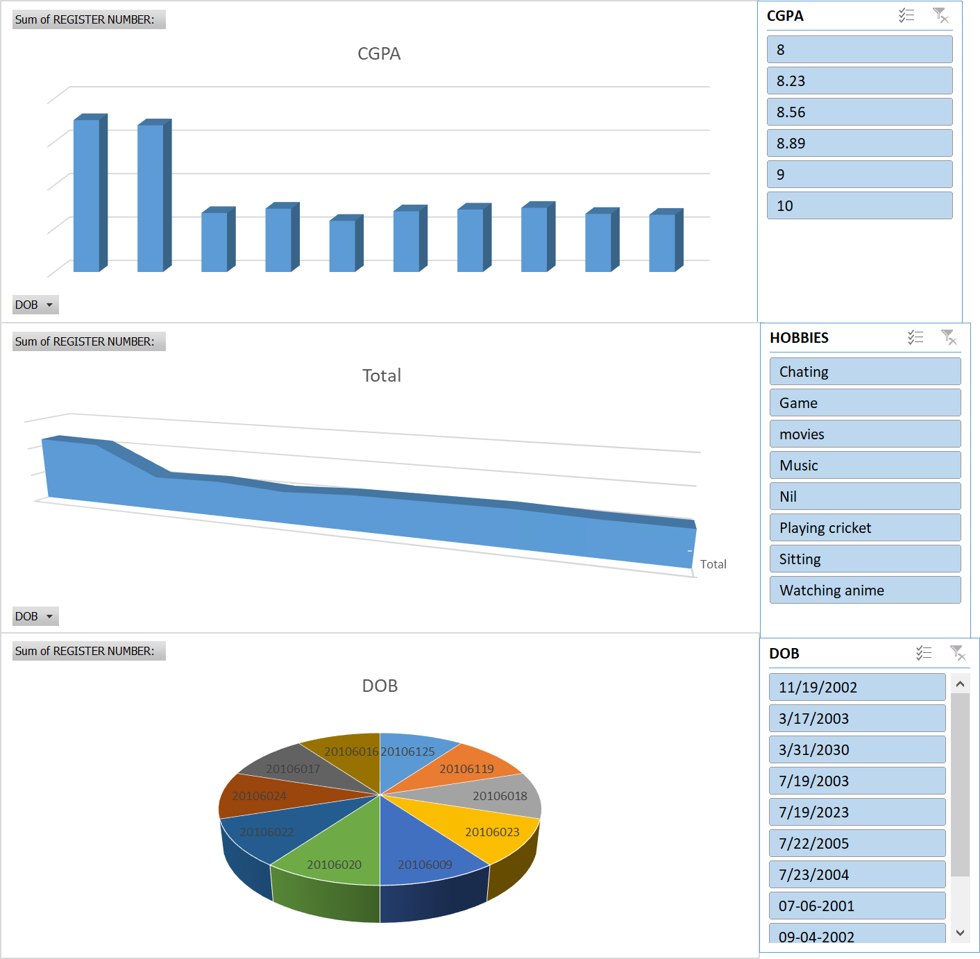

|  |  |
| --- | --- |
| **Row Labels** | **Sum of CGPA** |
| 20106009 | 9 |
| 20106016 | 9 |
| 20106017 | 8.23 |
| 20106018 | 10 |
| 20106020 | 8 |
| 20106022 | 10 |
| 20106023 | 9 |
| 20106024 | 10 |
| 20106119 | 8.56 |
| 20106125 | 8.89 |
| **Grand Total** | **90.68** |
|  |  |
| SUM | 90.68 |
| AVERAGE | 9.068 |
| COUNT | 10 |