EXPT NO: 9 | TEXT CLASSIFICATION AND TEXT GENERATION USING TRANSFORMERS
DATE: 02.10.2026 | TEXT CLASSIFICATION AND TEXT GENERATION USING TRANSFORMERS

PRE-LAB QUESTIONS (PROVIDE BRIEF ANSWERS TO THE FOLLOWING QUESTIONS)

- What is a Transformer model in Natural Language Processing (NLP)?
A Transformer is a deep learning model used in NLP to understand and process text using an attention mechanism. It helps identify relationships between words in a sentence.
- What is BERT, and how is it used for text classification?
BERT stands for Bidirectional Encoder Representations from Transformers. It understands the context of words in both directions and is used to classify text into categories such as positive and negative.
- What is fine-tuning in the context of pretrained language models?
Fine-tuning is the process of training a pretrained model with a specific dataset to improve its performance on a particular task.
- What is the difference between text classification and text generation?
Text Classification: Assigns a category or label to the given text.
Text Generation: Produces new text based on the given input.
Example:
- Classification: Identifying a movie review as positive or negative.
- Generation: Generating a movie summary.

- What is a sequence-to-sequence model, and how is it used in text generation?
A sequence-to-sequence model converts an input sequence into an output sequence using an encoder and decoder. It is used for text generation, translation, and summarization.

AIM
To implement text classification by fine-tuning a pretrained BERT model and develop a simple sequence-to-sequence text generation application using Transformer models.

SOFTWARE REQUIREMENTS
- Python
- Google Colab
- Hugging Face Transformers
- Hugging Face Datasets
- PyTorch
- NumPy
- Pandas
- Matplotlib

OBJECTIVES
Students will be able to:
- Understand the architecture and working of Transformer models in NLP.
- Understand the concepts of text classification and text generation.
- Load and preprocess text datasets for NLP applications.
- Fine-tune a pretrained BERT model for text classification.
- Evaluate the classification model using appropriate performance metrics.
- Implement a sequence-to-sequence application using a pretrained Transformer model.
- Generate text using the model's text generation capabilities.
- Analyze and compare the outputs produced by the Transformer models.

PROCEDURE
PART A: DATASET PREPARATION AND TEXT PREPROCESSING
Perform the following tasks:
- Load a text dataset such as the IMDb movie review dataset.
- Explore the dataset and examine sample text entries and their labels.
- Check the number of samples and the distribution of class labels.
- Separate the dataset into training and testing sets or use the predefined splits.
- Load a pretrained tokenizer corresponding to the BERT model.
- Tokenize the text using the tokenizer.
- Apply padding and truncation to maintain consistent input lengths.
- Convert the tokenized data into the required format for model training.
- Prepare the dataset for batch-wise processing.
(CODE: CONATAINS STUDENT ROLL NOS
SCREENSHOT OF CODE
SCREENSHOT OF OUTPUT)
PART B: FINE-TUNING BERT FOR TEXT CLASSIFICATION
Perform the following tasks:
- Load a pretrained BERT model for sequence classification.
- Configure the model for the required number of classes.
- Prepare the tokenized training and testing datasets.
- Define the training parameters, including learning rate, batch size, and number of epochs.
- Fine-tune the BERT model using the training dataset.
- Evaluate the trained model using the testing dataset.
- Calculate appropriate performance metrics, such as accuracy, precision, recall, and F1-score.
- Test the model using new text inputs.
- Display the predicted class labels and corresponding evaluation results.
- Save the fine-tuned model and tokenizer.
(CODE: CONATAINS STUDENT ROLL NOS
SCREENSHOT OF CODE
SCREENSHOT OF OUTPUT)

PART C: IMPLEMENTING A SEQUENCE-TO-SEQUENCE APPLICATION USING TRANSFORMERS
Perform the following tasks:
- Load a pretrained sequence-to-sequence Transformer model, such as T5-small.
- Load the corresponding tokenizer.
- Prepare a sample text input for the selected text generation task.
- Preprocess the input according to the model's requirements.
- Generate output text using the pretrained model.
- Apply appropriate generation parameters, such as maximum output length and beam search, where applicable.
- Display the input text and the generated output.
- Experiment with different input texts and generation settings.
- Observe how changes in the input and generation parameters affect the output.
- Save the generated outputs for further analysis.
(CODE: CONATAINS STUDENT ROLL NOS
SCREENSHOT OF CODE
SCREENSHOT OF OUTPUT)

PART D: MODEL TESTING AND OUTPUT ANALYSIS
Perform the following tasks:
- Test the fine-tuned BERT model using sample positive and negative text inputs.
- Record the predicted class labels for the test inputs.
- Analyze the classification results using the selected evaluation metrics.
- Test the sequence-to-sequence model using different input texts.
- Compare the generated outputs for different inputs and generation settings.
- Examine the relevance, readability, and coherence of the generated text.
- Identify possible errors or limitations in the classification and generation outputs.
- Compare the applications of BERT-based classification and sequence-to-sequence text generation.
- Summarize the observations obtained from both models.
(CODE: CONATAINS STUDENT ROLL NOS
SCREENSHOT OF CODE
SCREENSHOT OF OUTPUT)
CODE:
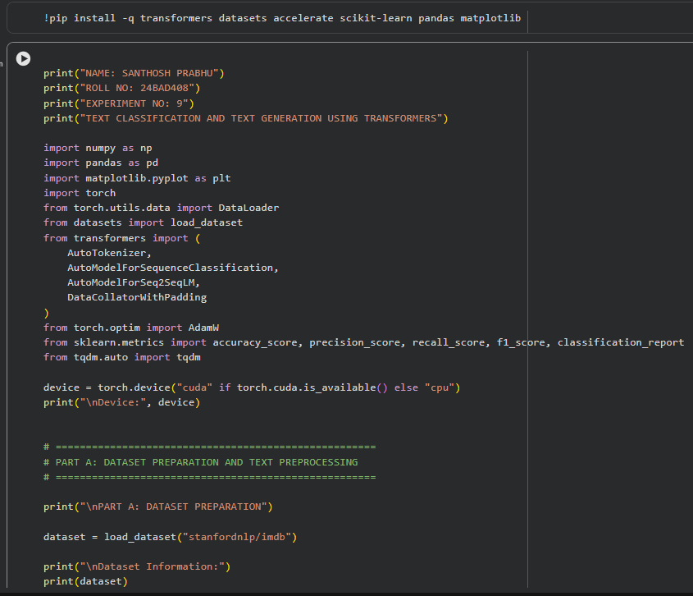
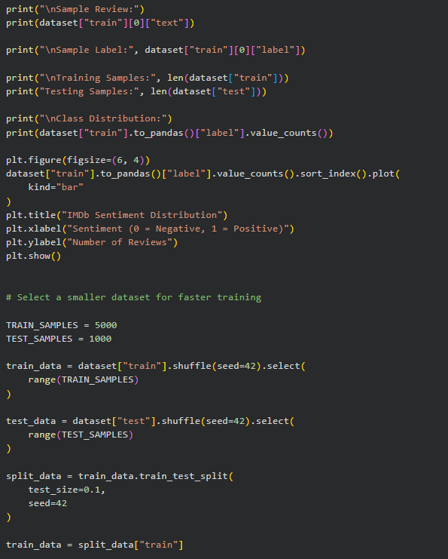
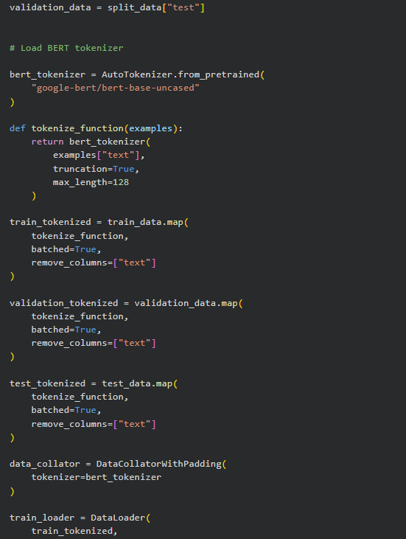

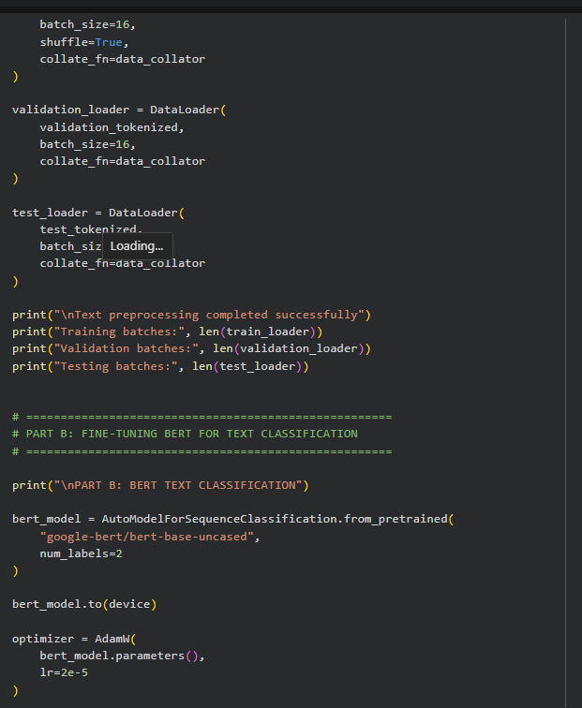
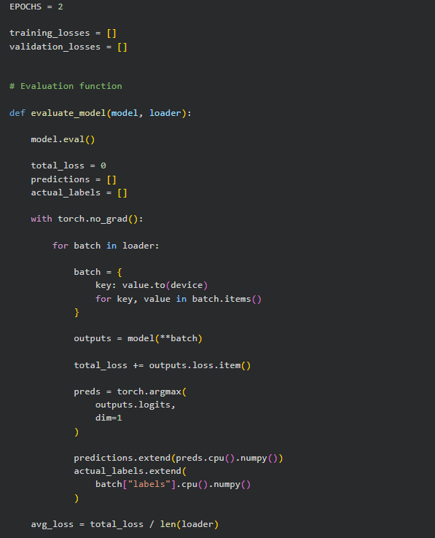

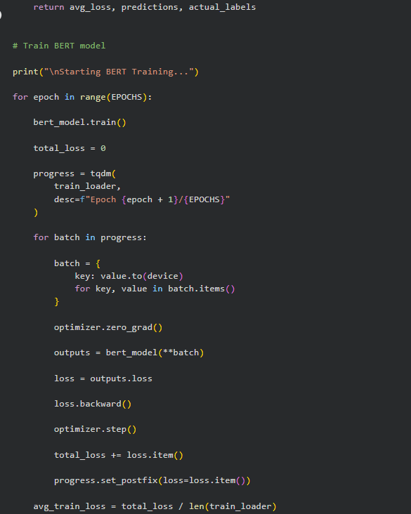
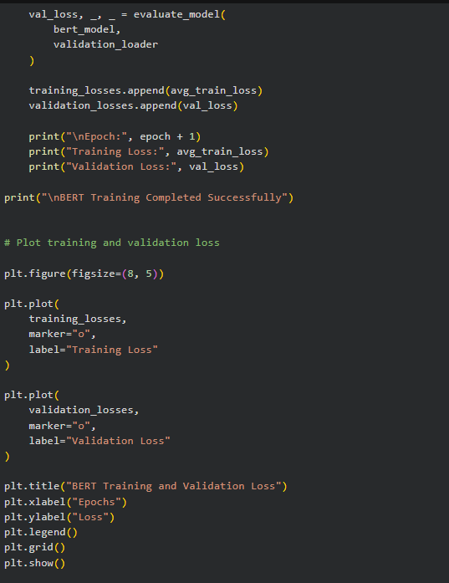
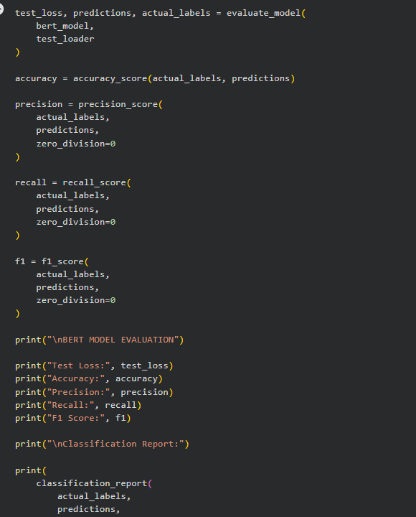
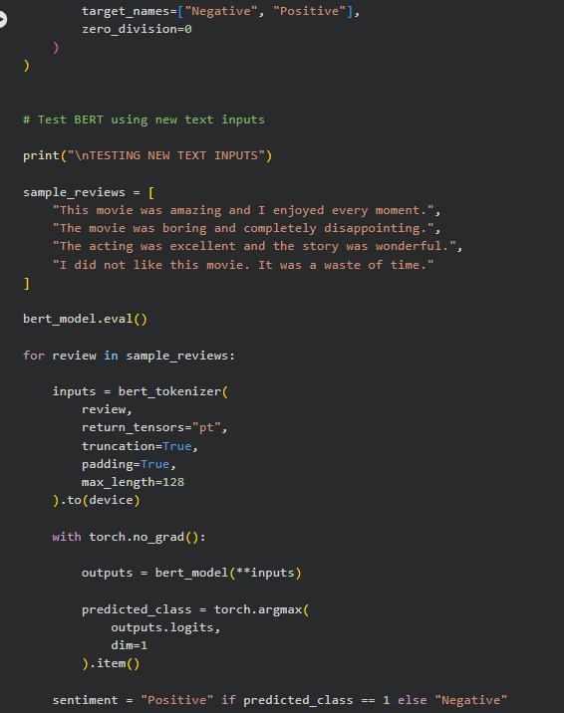

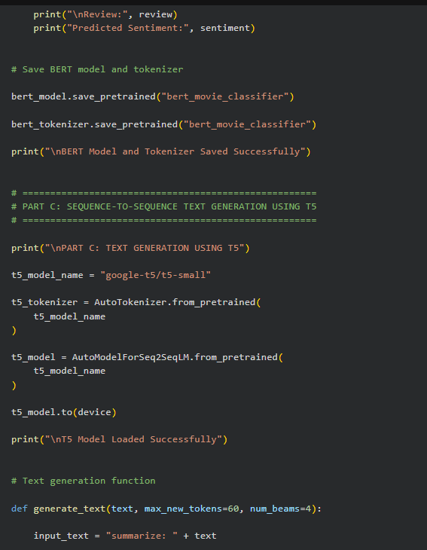
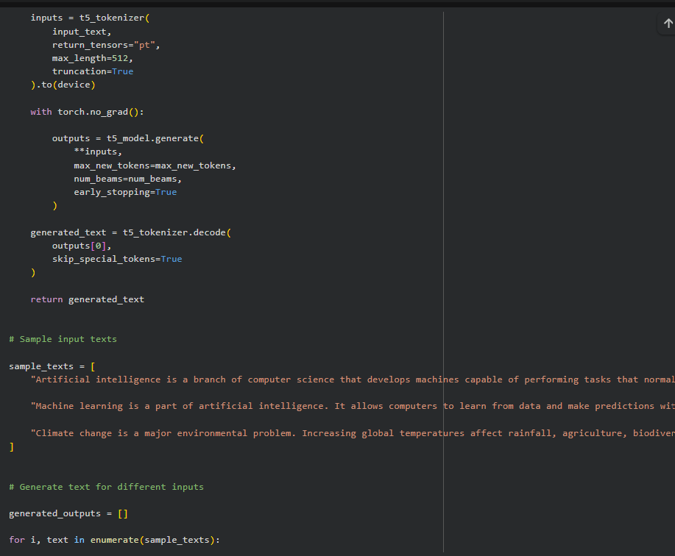

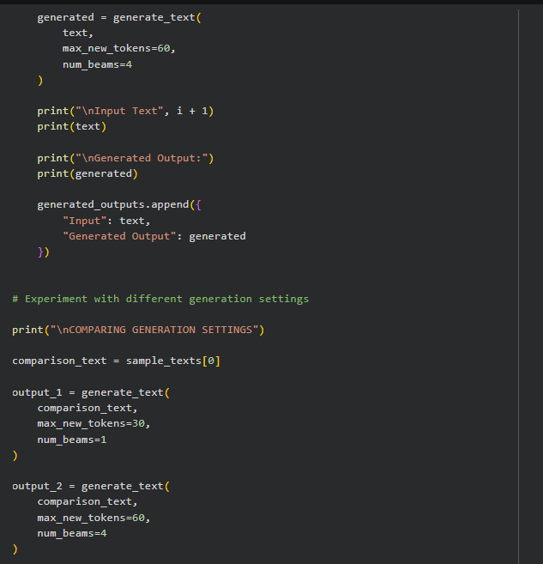
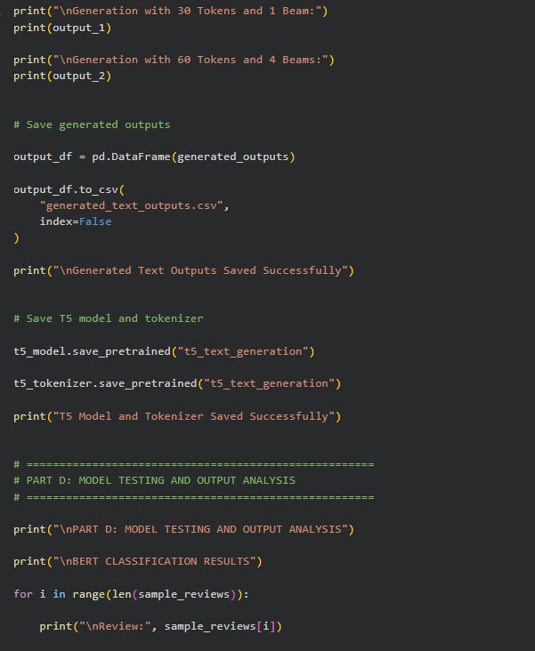
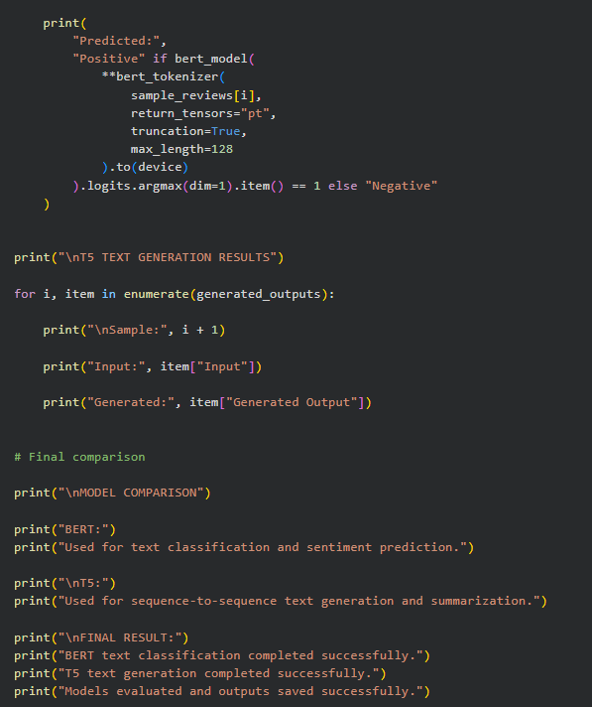
OUTPUT:
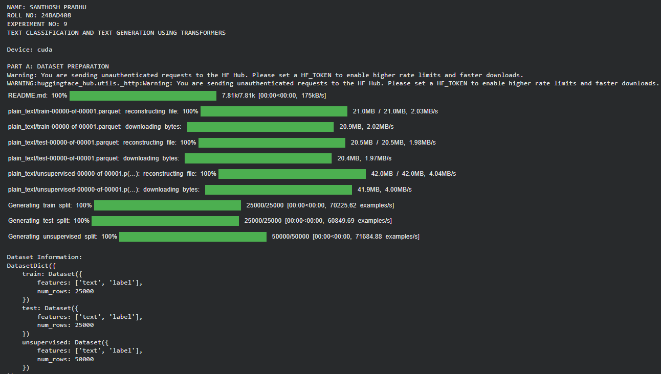

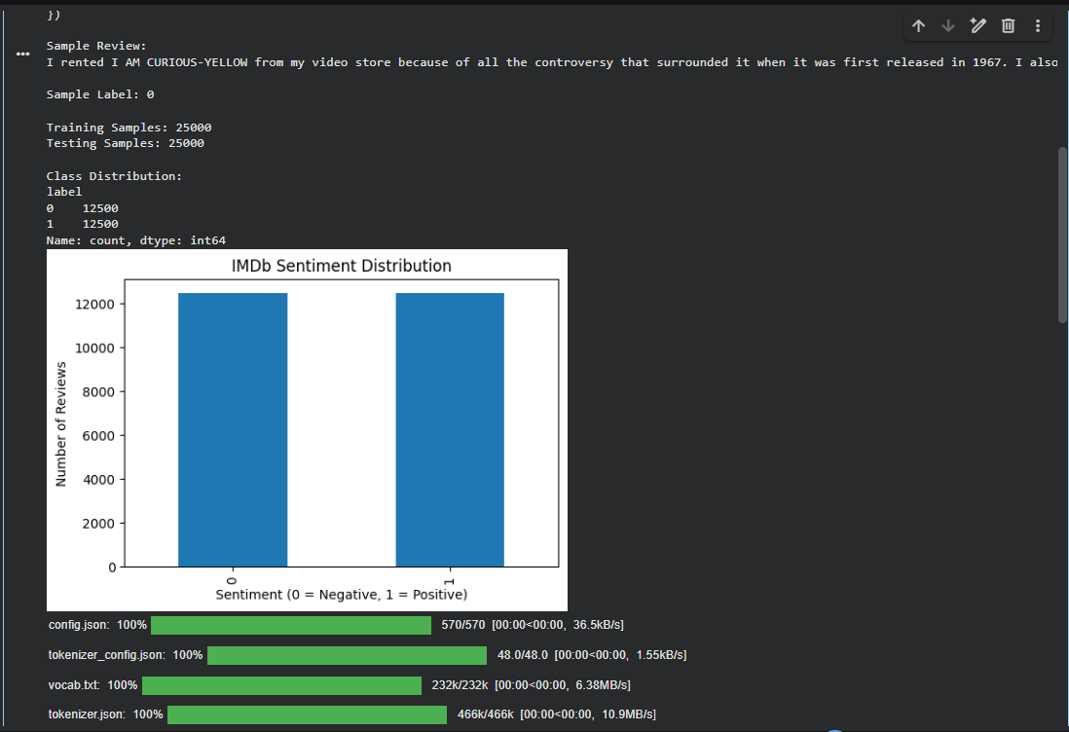
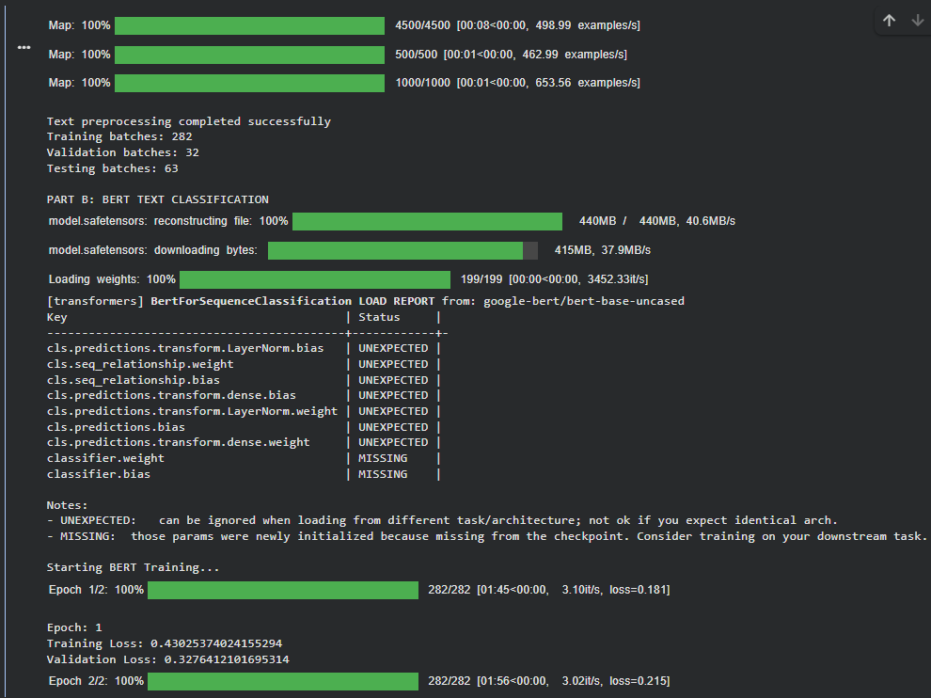
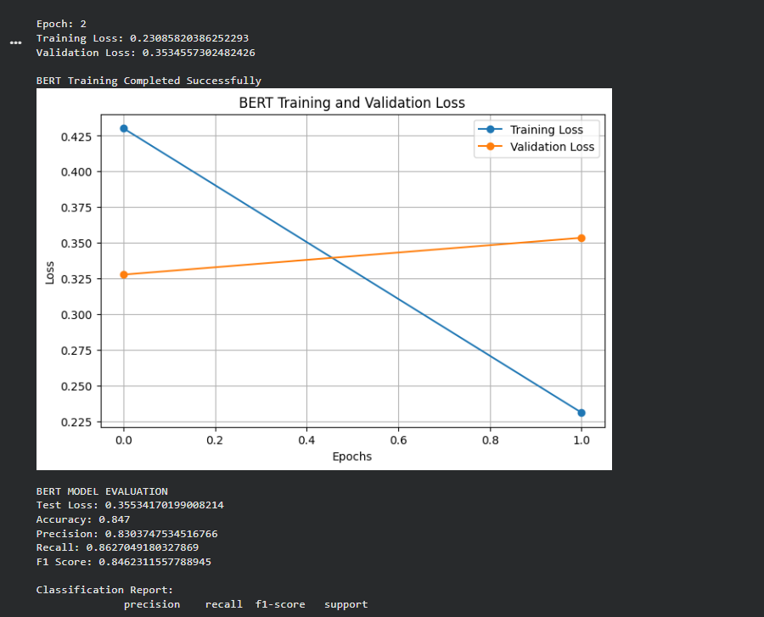
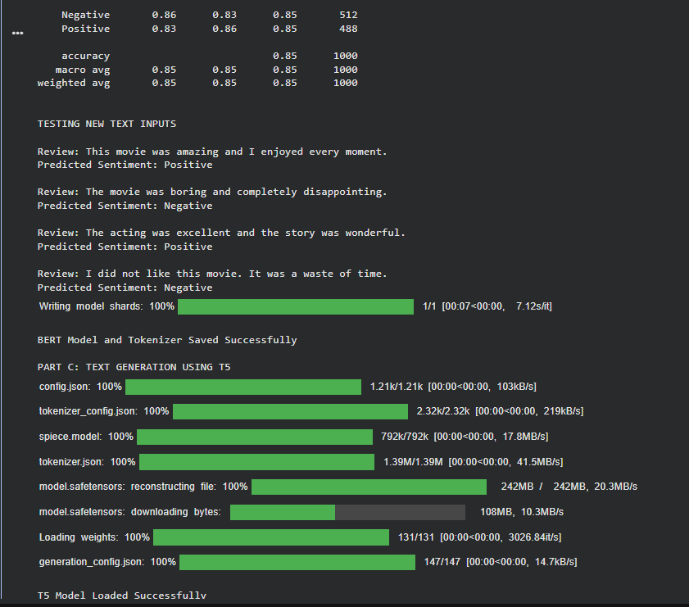

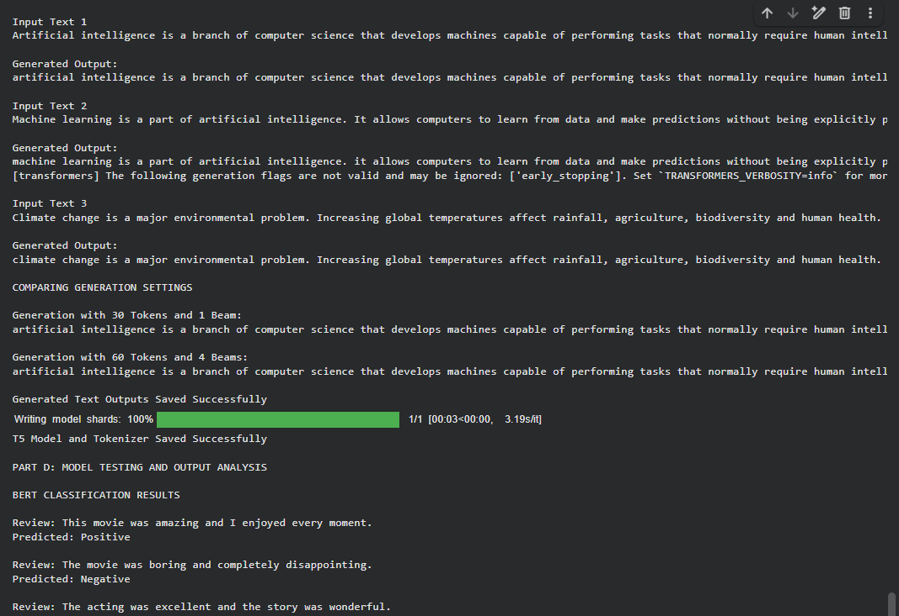
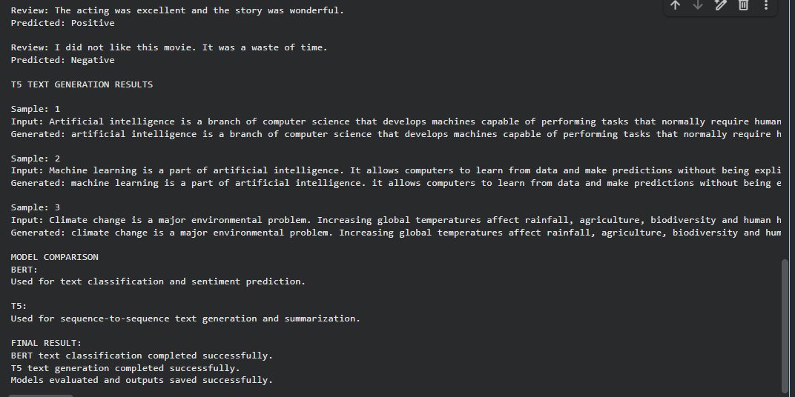
EXPECTED OUTCOME
Students will understand the architecture and applications of Transformer models in Natural Language Processing. They will learn to fine-tune a pretrained BERT model for text classification, preprocess textual data, and evaluate classification performance using appropriate metrics. Students will also develop a simple sequence-to-sequence text generation application using a pretrained Transformer model and analyze the quality and relevance of the generated outputs.

POST-LAB QUESTIONS (PROVIDE BRIEF ANSWERS TO THE FOLLOWING QUESTIONS)
- What is the role of BERT in text classification?
BERT understands the context and meaning of words in a sentence and classifies the text into categories such as positive or negative.
- Why is tokenization required before providing text to a Transformer model?
Tokenization converts text into smaller units called tokens and then into numerical IDs that the Transformer model can understand.
- What is the purpose of fine-tuning a pretrained BERT model?
Fine-tuning helps a pretrained BERT model learn a specific task using a particular dataset and improves its prediction accuracy.
- Mention any two-evaluation metrics used for text classification.
• Accuracy: Measures the percentage of correct predictions.
• Precision: Measures how many predicted positive results are actually positive.

- What is the role of the encoder and decoder in a sequence-to-sequence Transformer?
• Encoder: Understands and processes the input sequence.
• Decoder: Generates the output sequence based on the encoder's information.
- What is the difference between text classification and text generation?
Text Classification: Assigns labels to input text.
Text Generation: Creates new text based on the given input.
- How does the maximum output length affect text generation?
Maximum output length controls the number of tokens generated by the model. A higher value allows longer text, while a lower value produces shorter text.
- Mention one real-world application of Transformer-based text classification and one application of text generation.
Text Classification: Detecting spam emails and analyzing customer reviews.
Text Generation: Automatic report generation and text summarization.
SUGGESTIONS FOR DATASETS & MODELS
Datasets:
- IMDb Movie Reviews – https://huggingface.co/datasets/stanfordnlp/imdb
- GLUE Benchmark – https://huggingface.co/datasets/nyu-mll/glue
- SST-2 Sentiment Classification – https://huggingface.co/datasets/nyu-mll/glue

Pretrained Models:
- BERT Base Uncased – https://huggingface.co/google-bert/bert-base-uncased
- T5-small – https://huggingface.co/google-t5/t5-small

ASSESSMENT
Description | Max Marks | Marks Awarded
Pre Lab Exercise | 5
In Lab Exercise | 10
Post Lab Exercise | 5
Viva | 10
Total | 30
Faculty Signature

