Create an instance for windows:

Root volume with 30GB

Instance created with Volume: [vol-092365ea220ced010](https://eu-north-1.console.aws.amazon.com/ec2/home?region=eu-north-1#Volumes:volumeId=vol-092365ea220ced010;sort=desc:createTime)—30GB

Root volume=8GB

[vol-0fe18197f8ae15ce0](https://eu-north-1.console.aws.amazon.com/ec2/home?region=eu-north-1#Volumes:volumeId=vol-0fe18197f8ae15ce0;sort=desc:createTime)🡪 root volume with 8gb is created.A screenshot of a computer

create an EBS volume of 5 GB, attach it to an EC2 machine (Linux and Windows),

EBS->Volumes:5GB created.

Volume🡪[vol-0cf3ae923b3ba4dbe](https://eu-north-1.console.aws.amazon.com/ec2/home?region=eu-north-1#VolumeDetails:volumeId=vol-0cf3ae923b3ba4dbe)

Attaching EBS volume to Instances: windows server

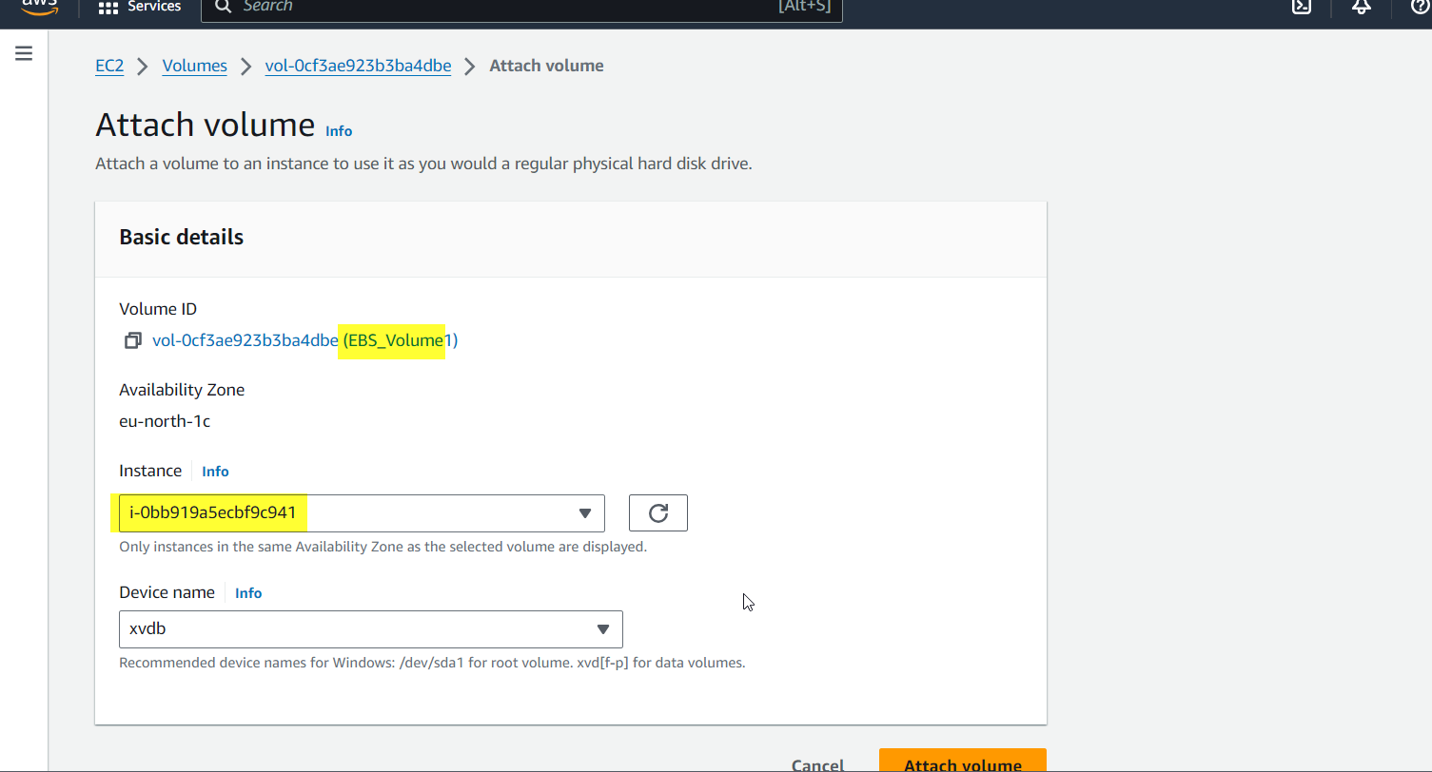

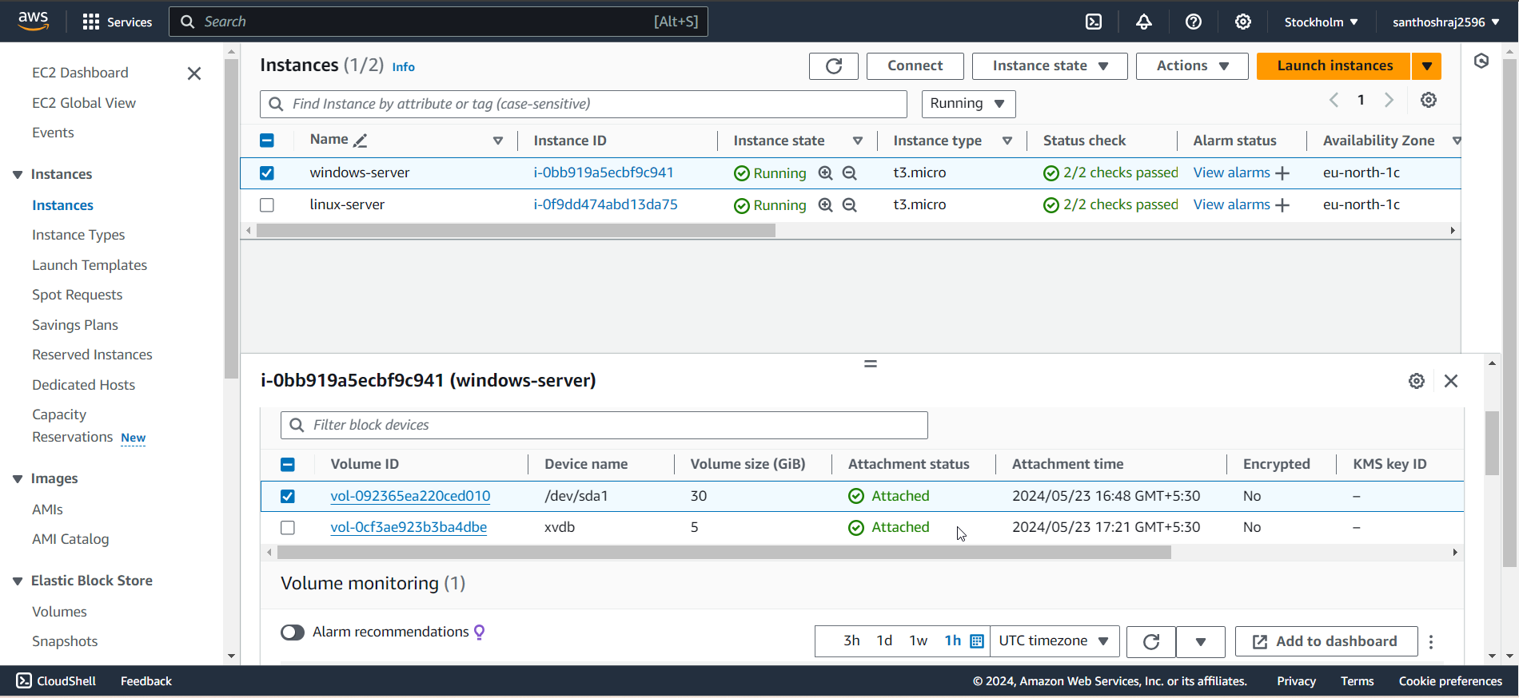

**EBS-Volume2 created** : [vol-067a8984671de4861](https://eu-north-1.console.aws.amazon.com/ec2/home?region=eu-north-1#VolumeDetails:volumeId=vol-067a8984671de4861)🡪 for linux, since we cannot attach EBS volume already attached to other instances.

Attaching volume to instance:linux

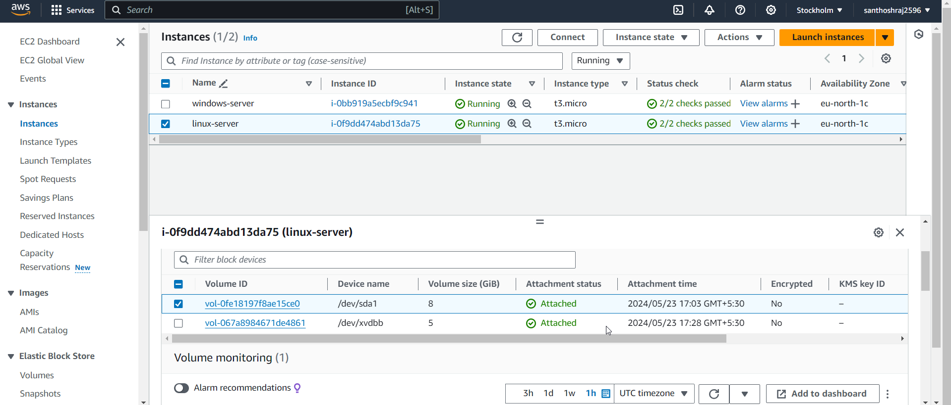

Login to linux: two blk is available.

take a snapshot:

Creating snapshot for EBS_volume1 and EBS_Volume2:

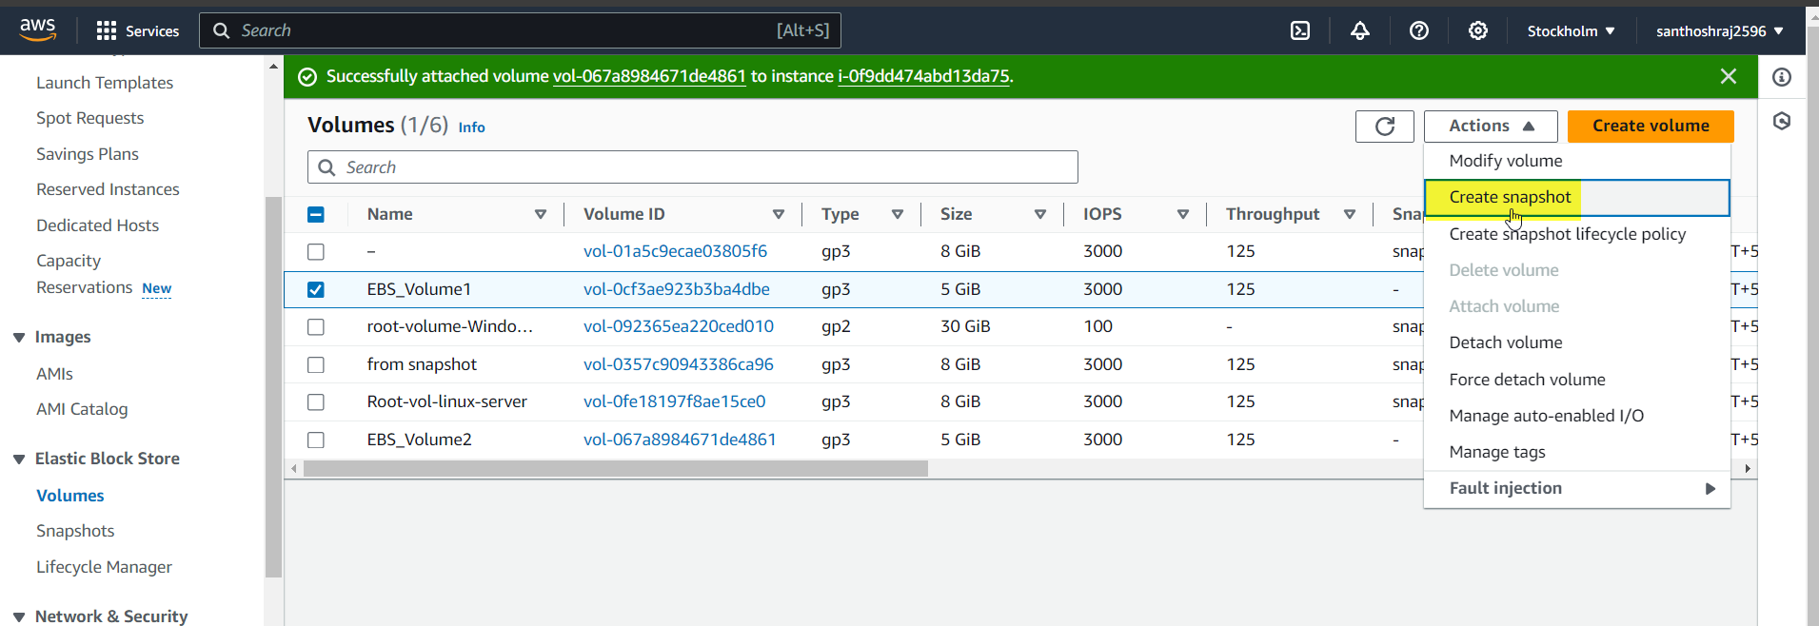

Snapshot created for both volumes:

create an EBS volume using the taken snapshot.

Creating a volume from snapshot:

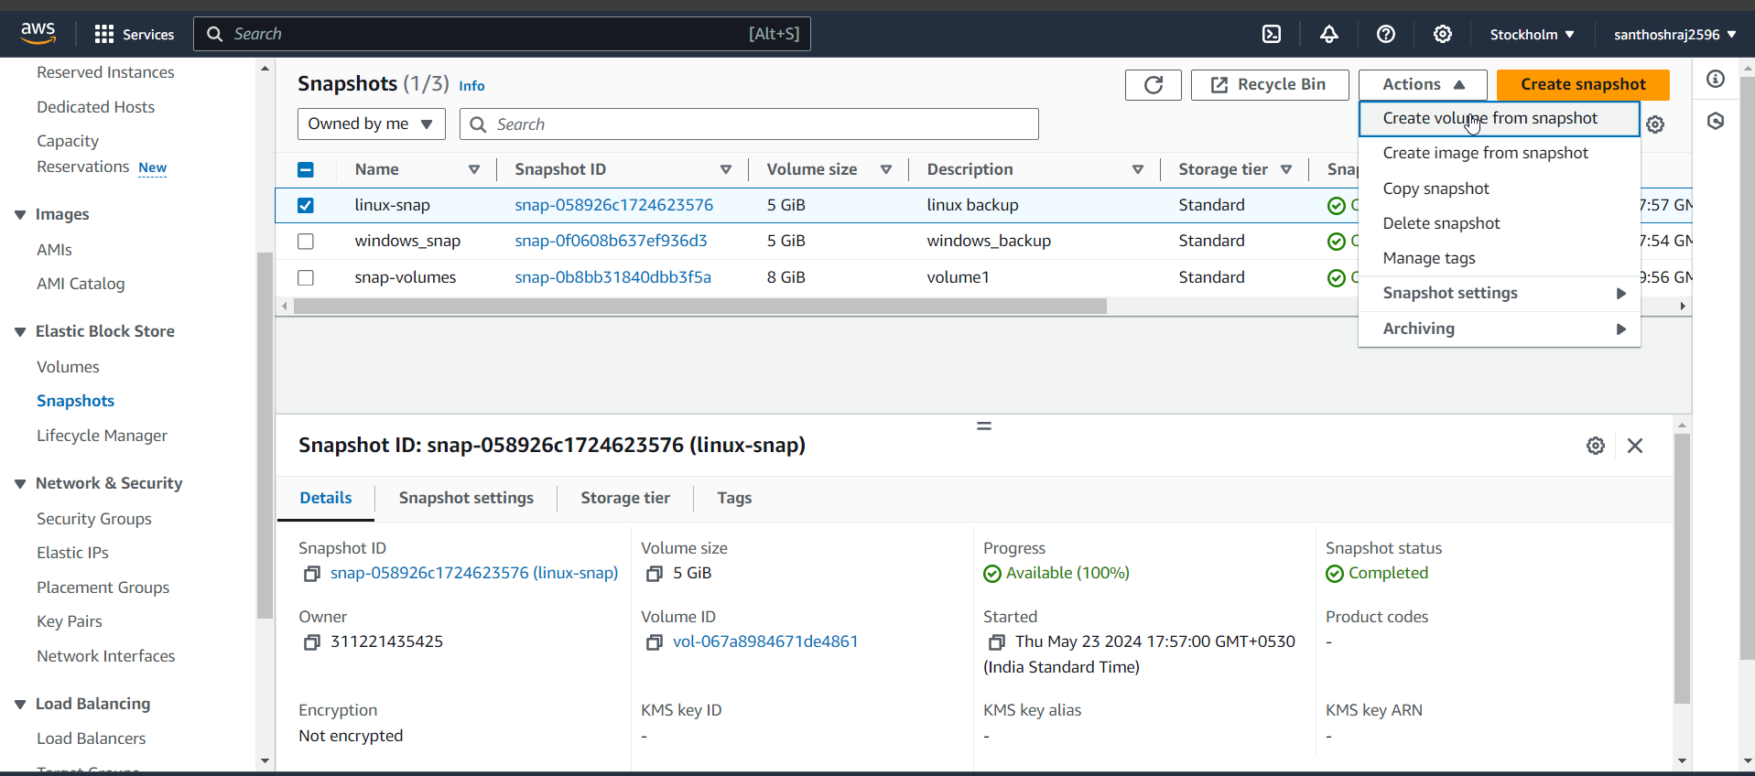

For linux:

For windows:

