**Index1.html**

**Dockerfile_cp**



**Build:**

**Images:**

**docker-compose_v1.yml**

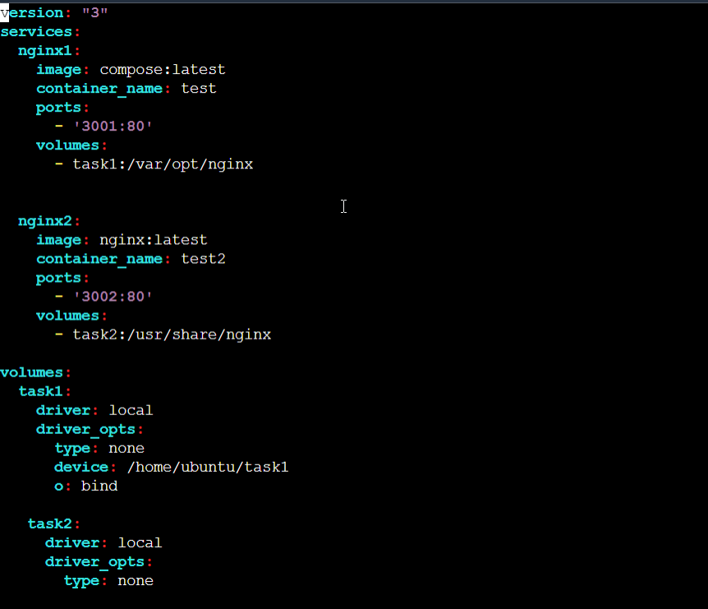

**Starting the Docker-compose file:**



Available volumes:

Running container

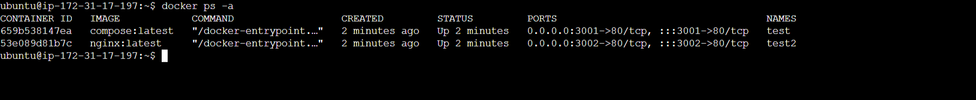

Nothing available in/var/opt/nginx

So nothing copied in local /home/ubuntu/task1

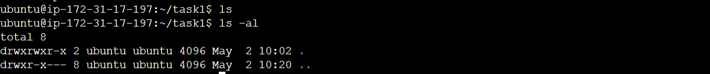

For nginx2 service/container:test2

Based on volume mount at container**:/usr/share/nginx** to local path: **/home/ubuntu/task2,**

**Html ->**folder is available**.**

Stopping the docker compose, container test, test2 is removed

But volumes and local path: /home/ubuntu/task2 is still available.

**

**Volume:ubuntu_task2**

**Docker push to docker hub:**

Already login done🡪fyr using docker login

Git hub push:

