Creating VPC with internet gateway:

CIDR: 10.0.0.0/16🡪 class B. 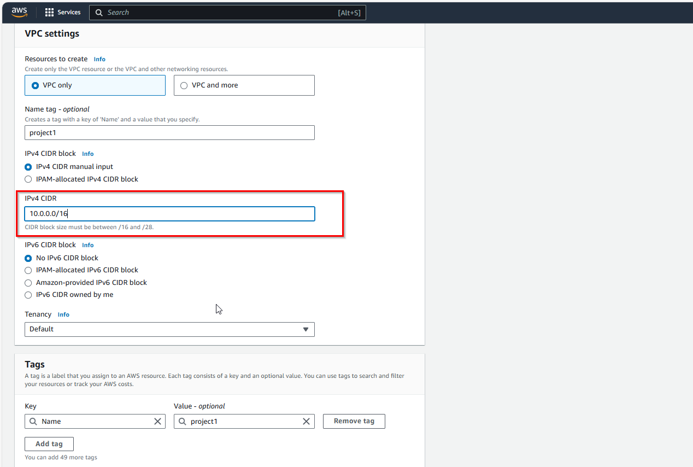

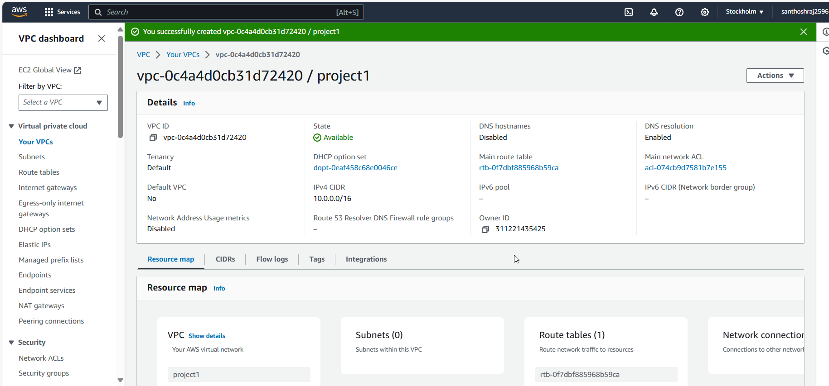

Creating Internet gateway:

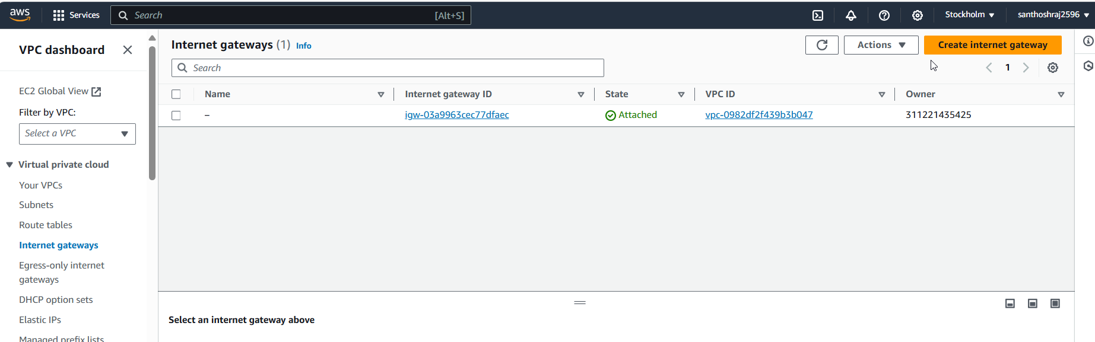

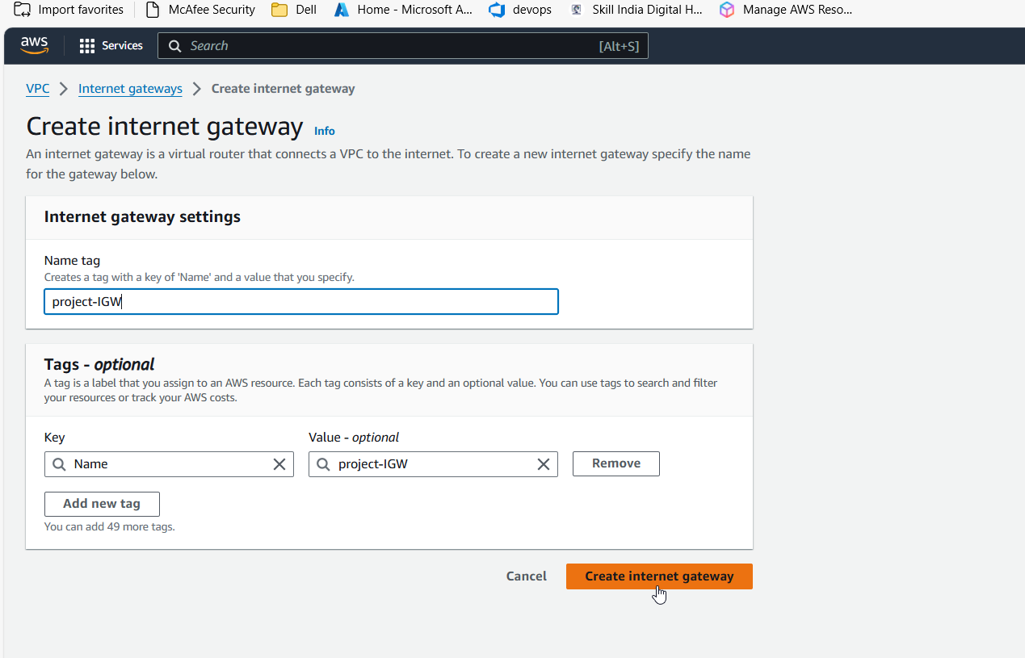

Attaching to VPC:

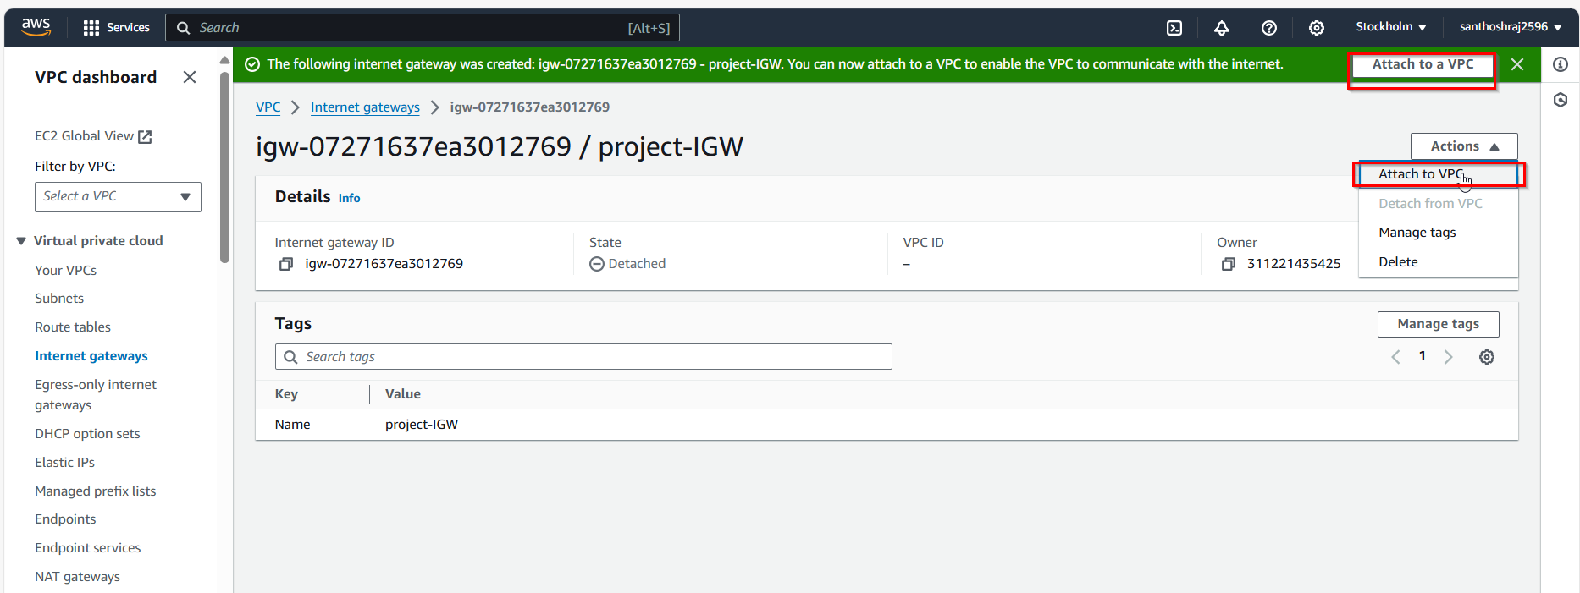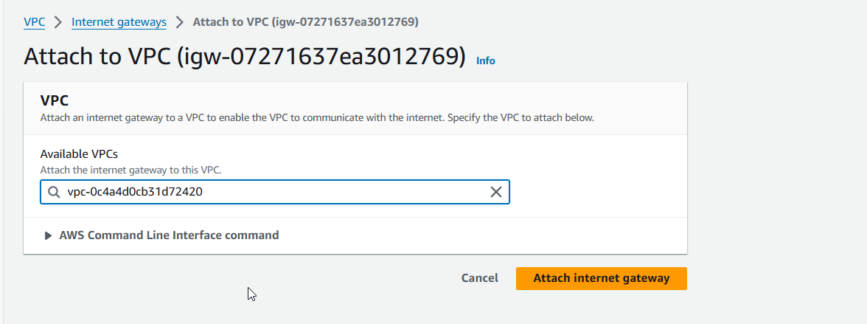

Creating Subnets based on VPC:project1

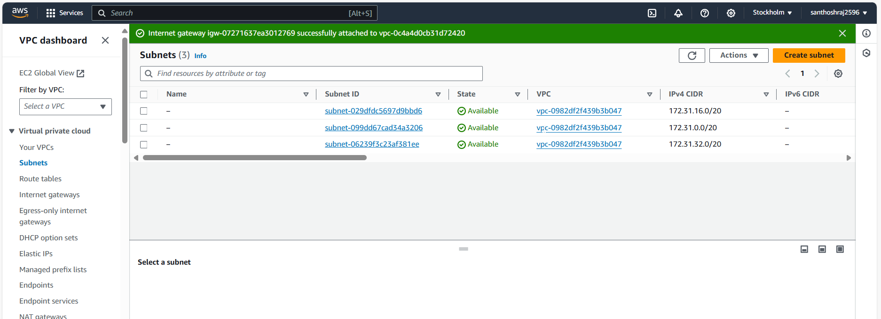

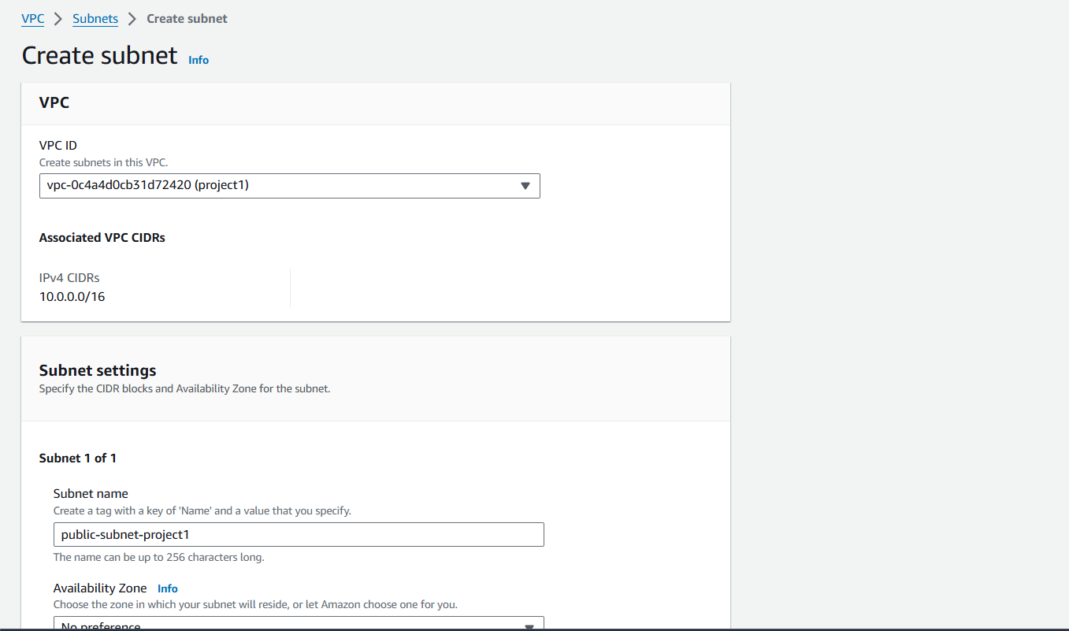

Since we do not require much of host Address, splitting the class B CIDR:10.0.0.0/16 into sub network with CIDR :10.0.1.0/24 , so 2^8=256 IP’s for host address.

Public subnets:

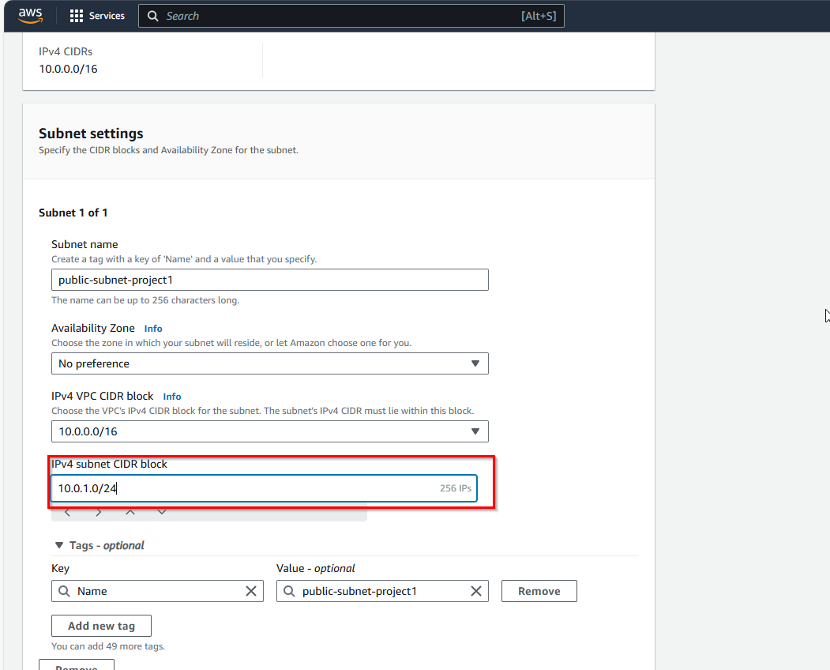

Private subnet: with CIDR: 10.0.2.0/24=256 IP’s

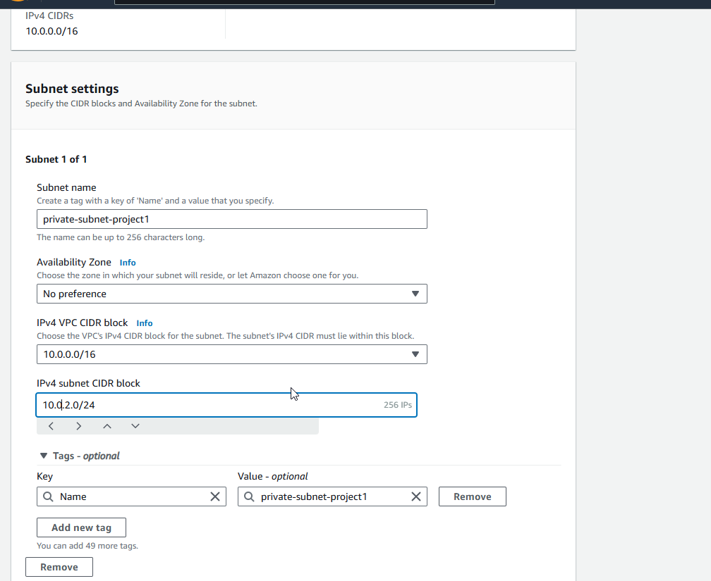

Subnets created:

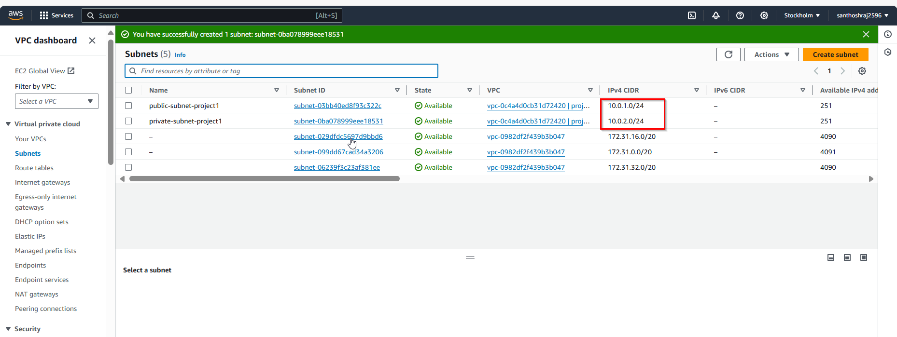

**Creating Router table:**

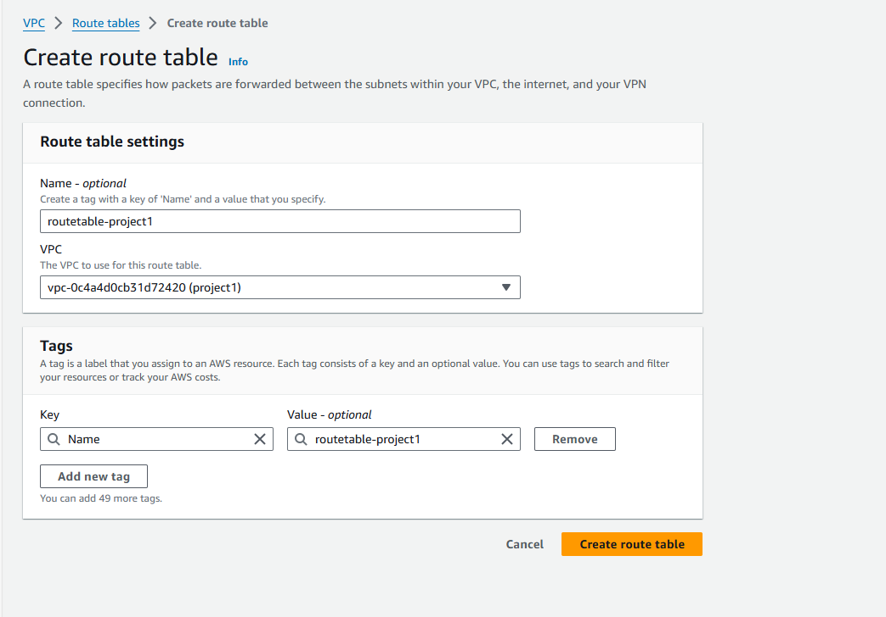

Editing Route table allowing all traffic for destination

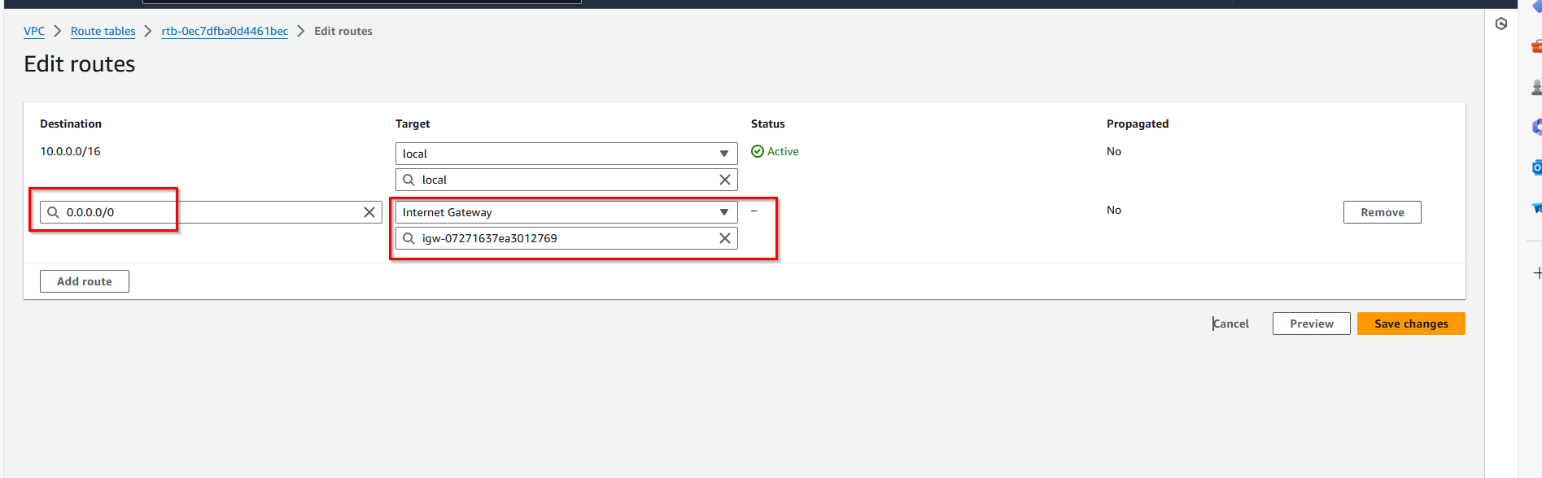

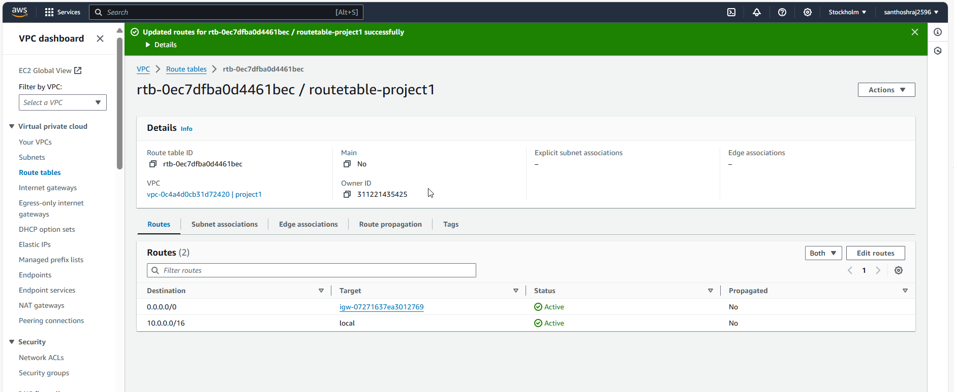

Adding router table to subnets:

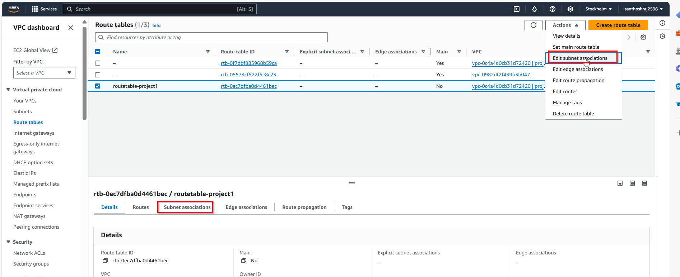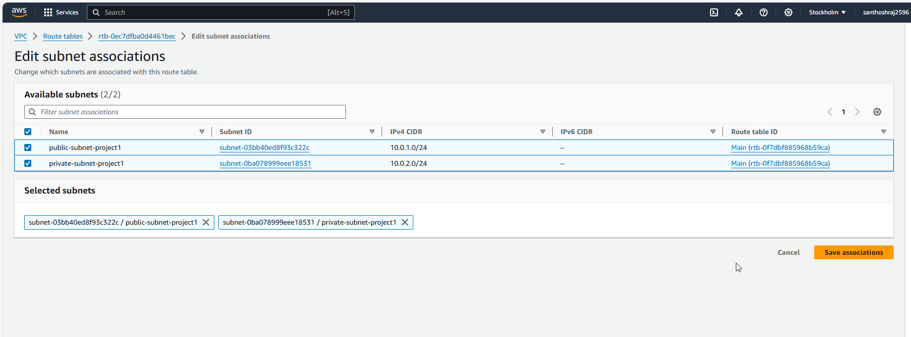

2 public and private Ip’s are associated to route table:

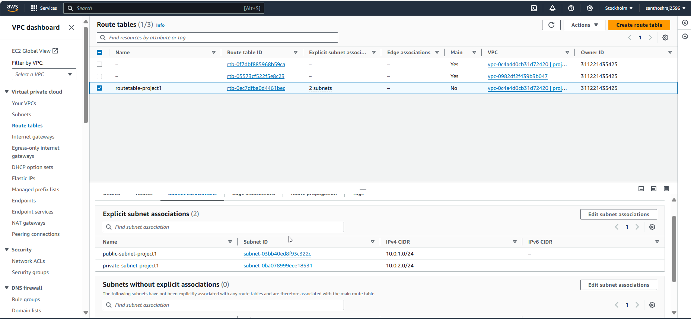

Resource map:

VPC with two subnets are connected to router which is connected to internet gateway:

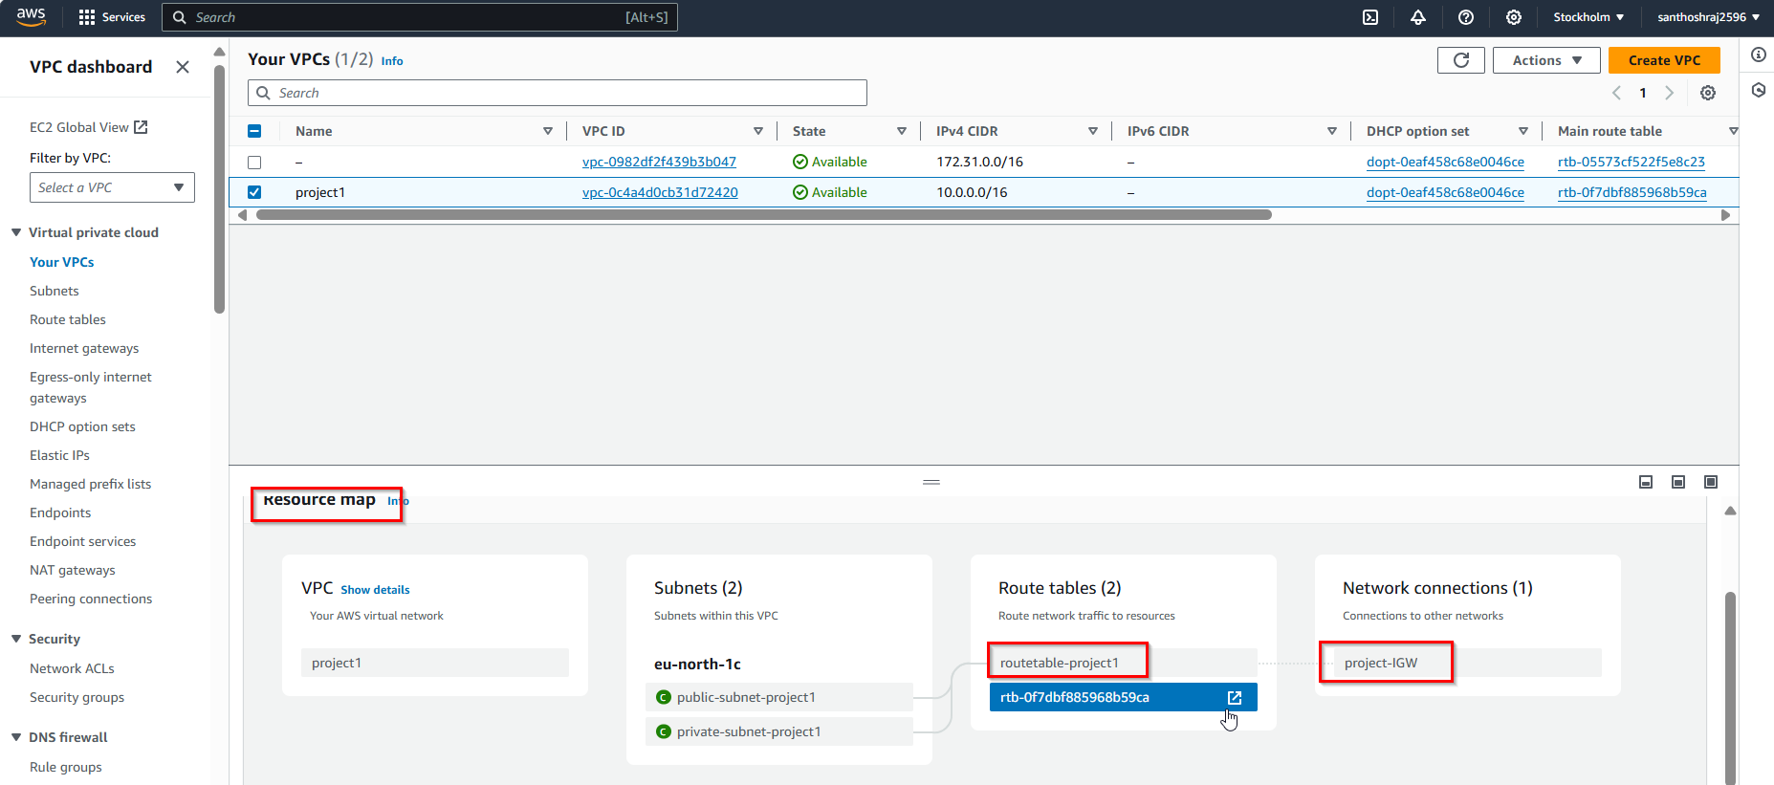

Lauching instance with Public subnet under the VPC:project

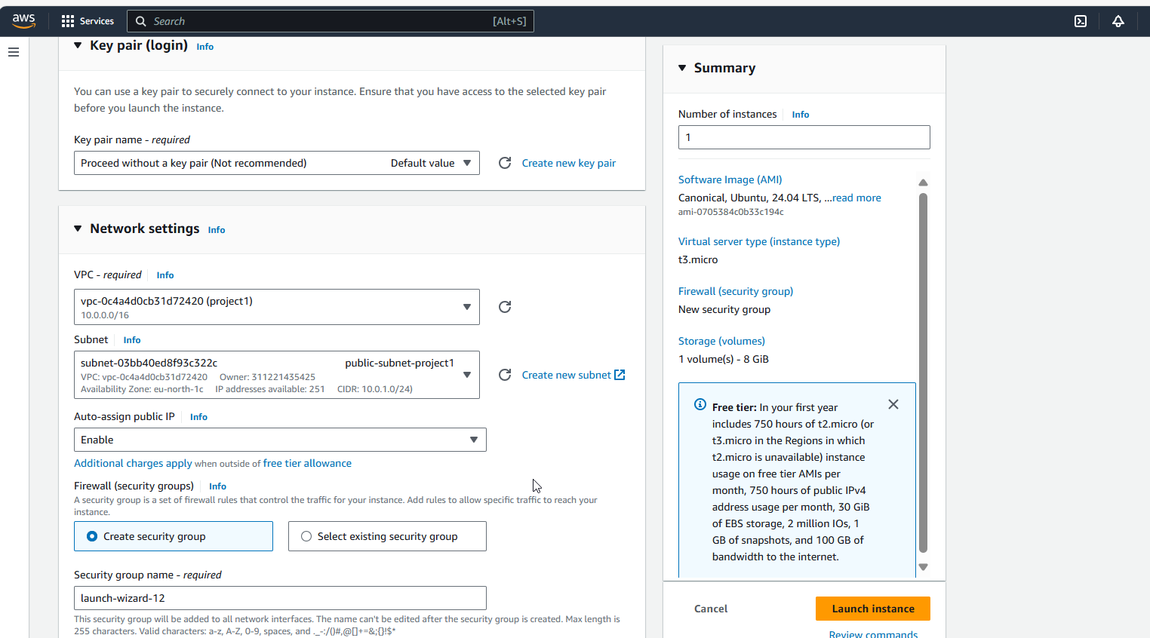

Private IP is generated based on the public subnet CIDR range allocated:

