**Creating Instance:**

Nginx -server:-> instance name:

Code commit -> creating repo:

Repo is created with main branch,

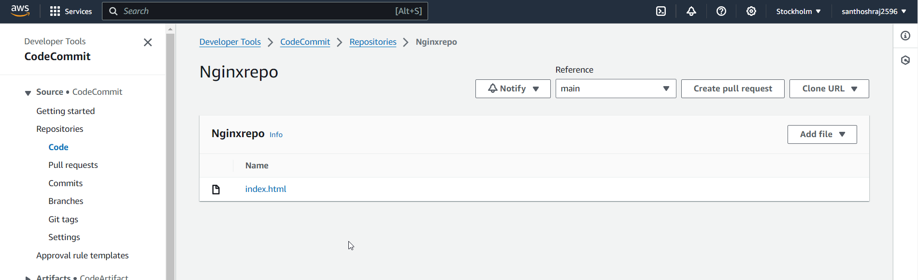

**

For this we need to create IAM Role:

Adding permission: both S3 and EC2 instance

Roles with Permission added.

In Create deployment group added:

Creating without load balancer:

Creating deployment:

**For the above creating S3 bucket.**

**Deployment status in progress:**

**Stop deployment:**

**Adding App spec file:**

**Code pipeline:**

**Skipping build:**

**Deploy:**

**When we deploy the code, in deployment , facing this below error**

**Added roles properly in IAM Roles:**

**Same is added to deployment group:**

* Index.html file cannot be deployed in EC2 instance .
* If so, cant proceed with dockerfile to launch the nginx.