Installing docker in EC2 instances

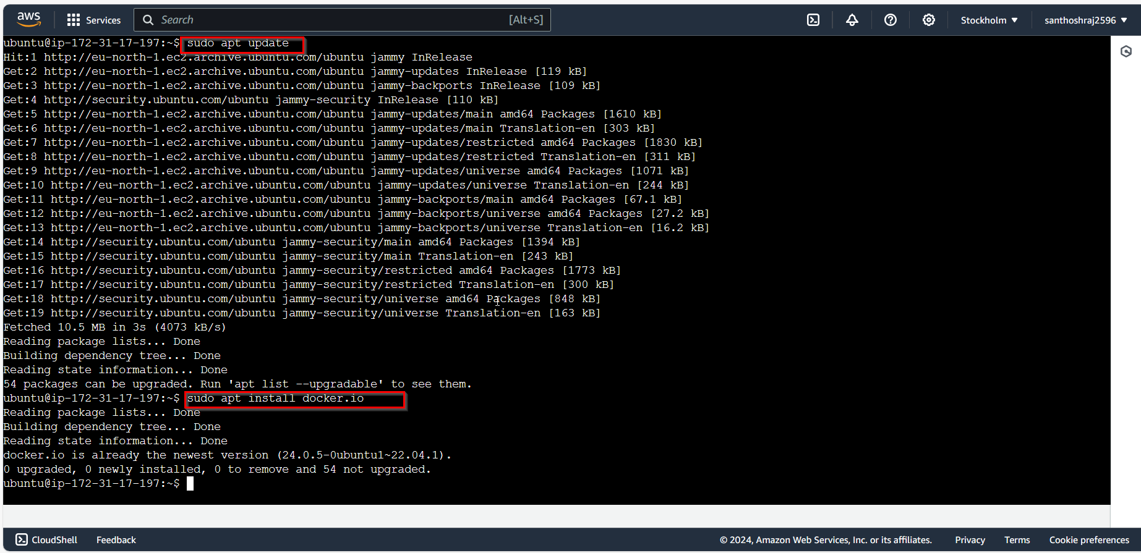

Pulling Docker built images from Docker hub.-🡪nginx

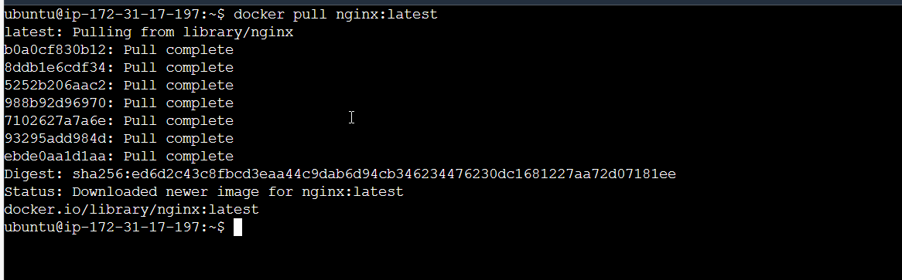

Running the container using docker image and listing the running containers.

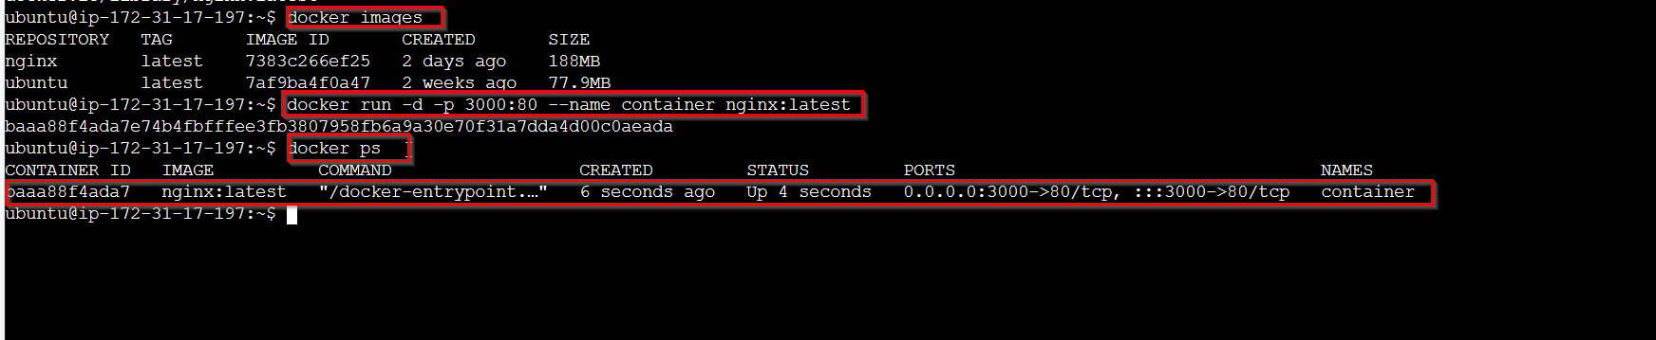

Stopping the container and port is deallocated

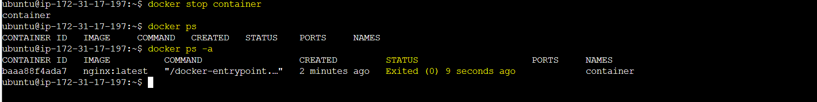

Running the container with same already exist, facing error.



So removing the container. 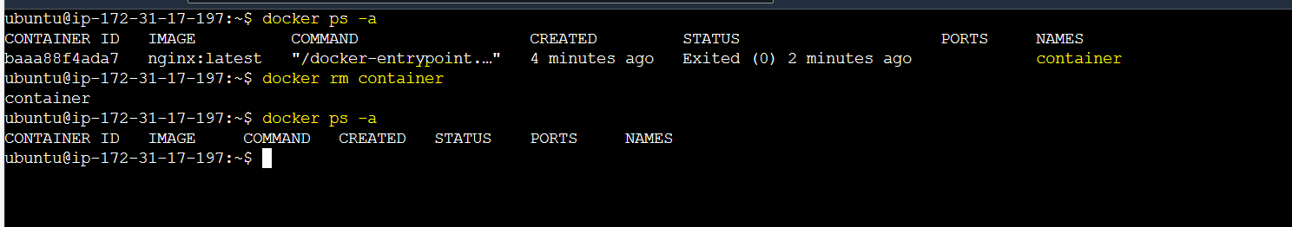

Starting the stopped container

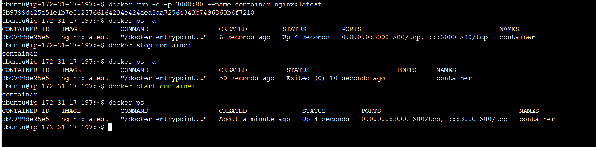

To check what inside the running containers

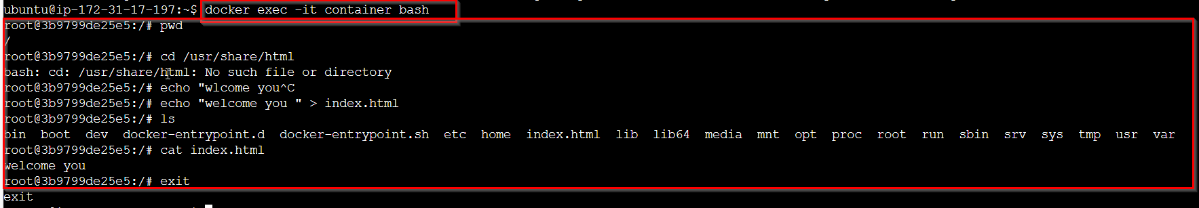

Trying to remove the running containers

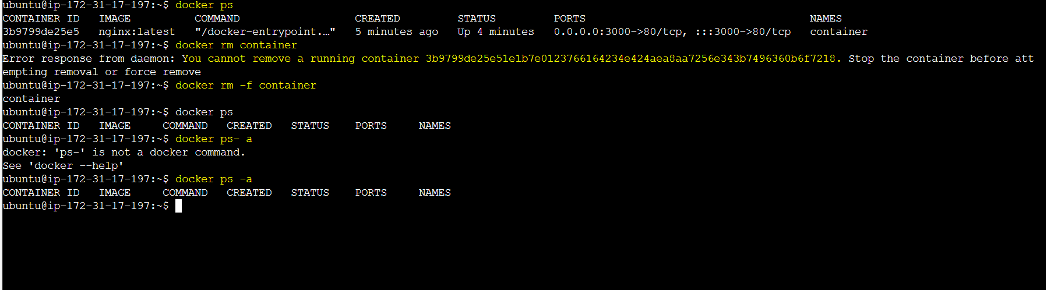

We cannot remove image referencing the container

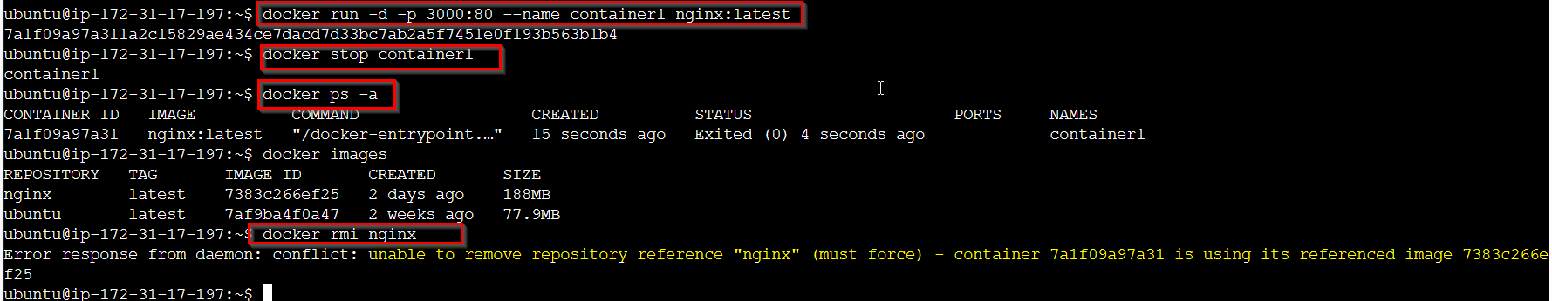

Forcing the image to get deleted

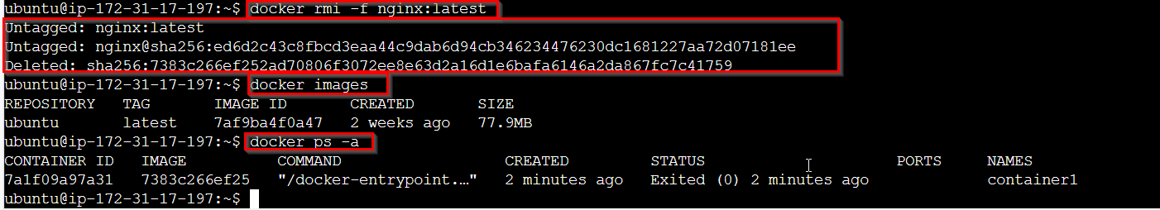

Trying to run the container with deleted imageid, will encounter error

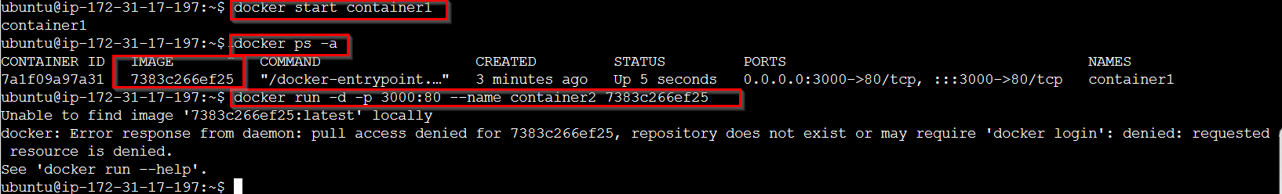

When trying to remove the image of running container forcefully, we can only remove the image name and tag

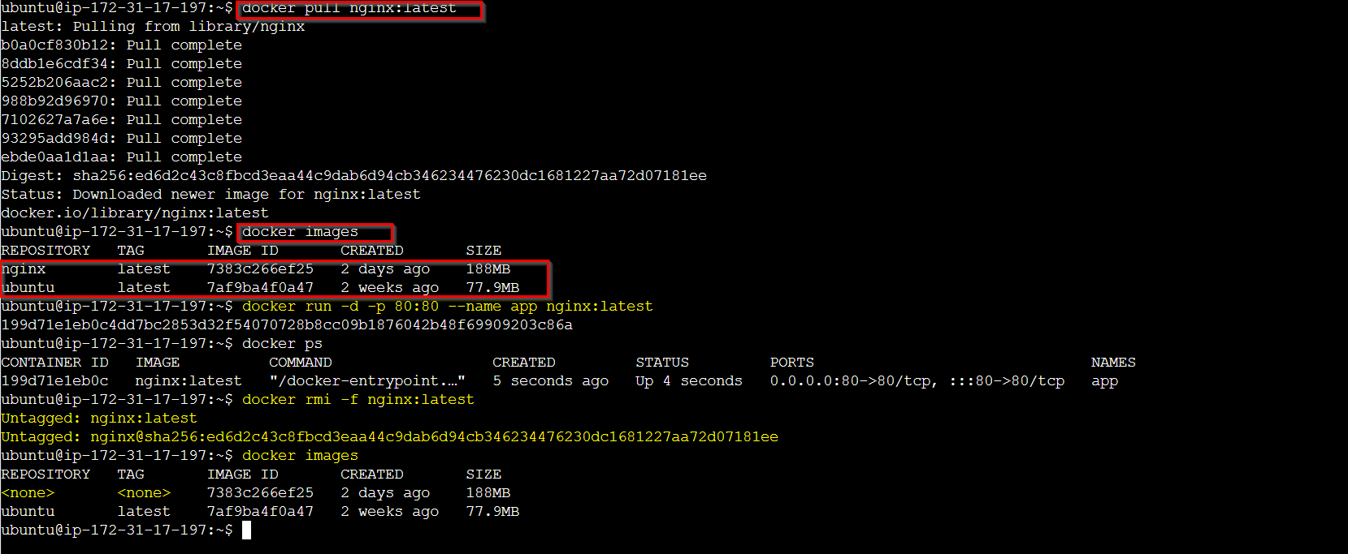

We cannot remove images forcefully for running containers, we need to stop the container and remove.



