**Launching Jenkins using Docker:**

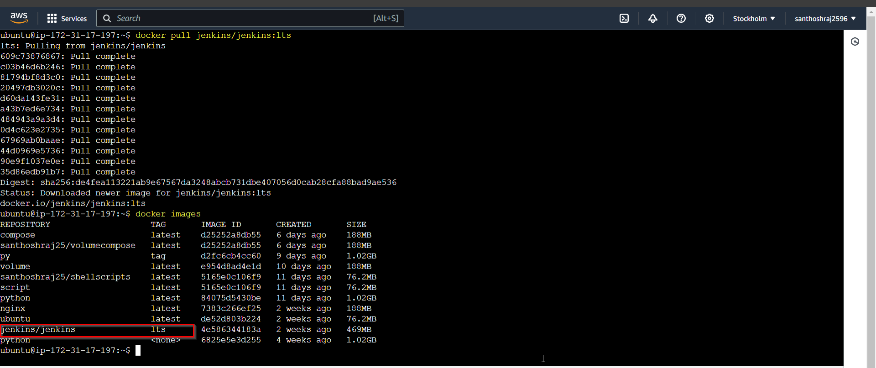

**Docker-compose file:**

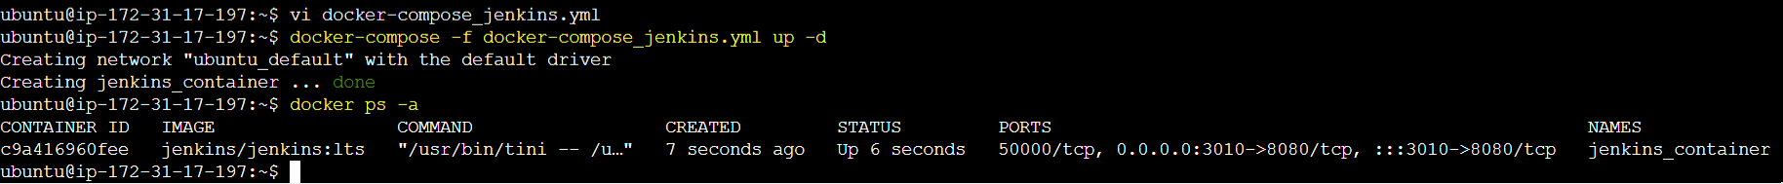

**Password:**

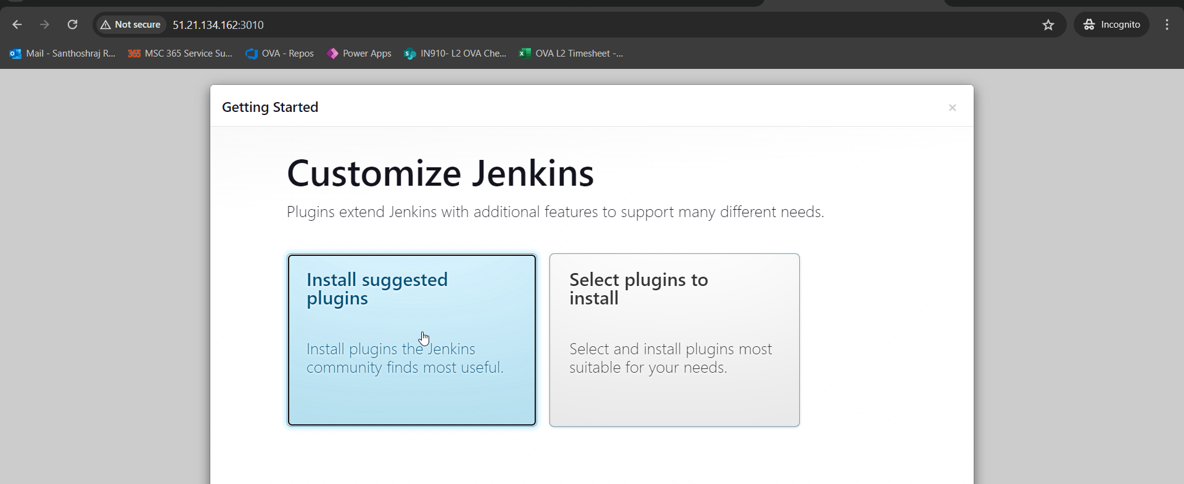

**Using Git Hub repo:**

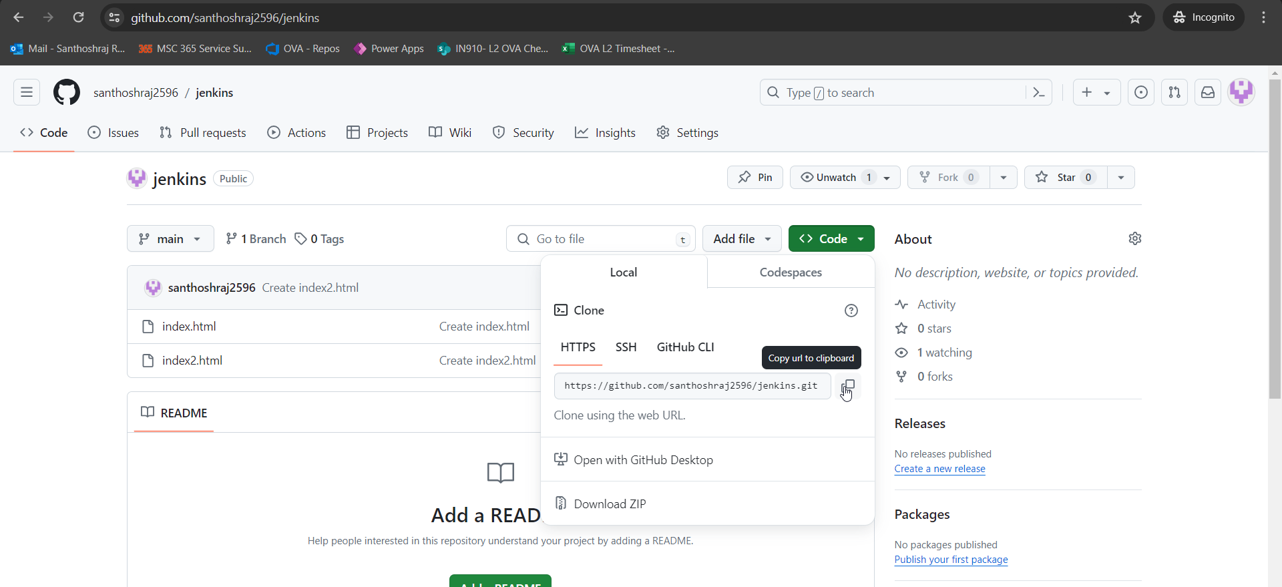

**Project1:**

**Scheduling POL SCM:**  every 1minute any changes in GIT hub will be auto pulled.

Build now:🡪 console output

Available in Workspace too:

**Users:**

Manage Jenkins🡪 under security-> users:

We can create user:

User created: Guvi

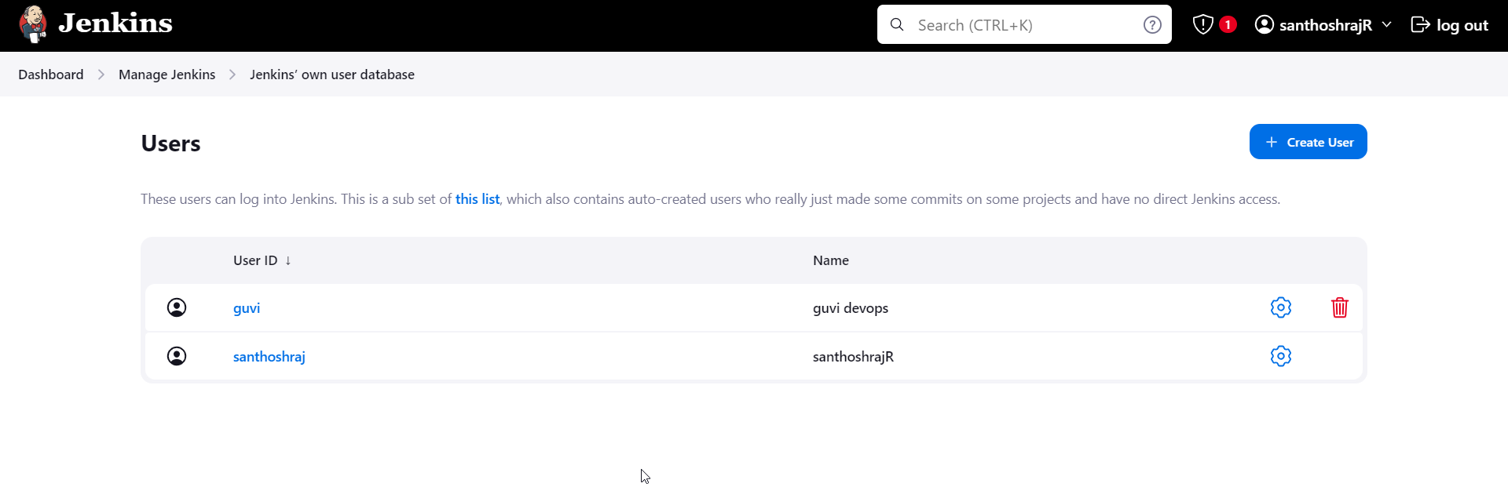

Under Manage Jenkins🡪security-> security: we can change permissions for the user and their respective projects.

1.Matrix based strategy🡪 user read, view can be controlled using this authorization.

Providing only read access for the Guvi user->**project-based matrix**

Here there is no Manage Jenkins, since it is restricted:

Allowing user :to sign up, so that they can register. 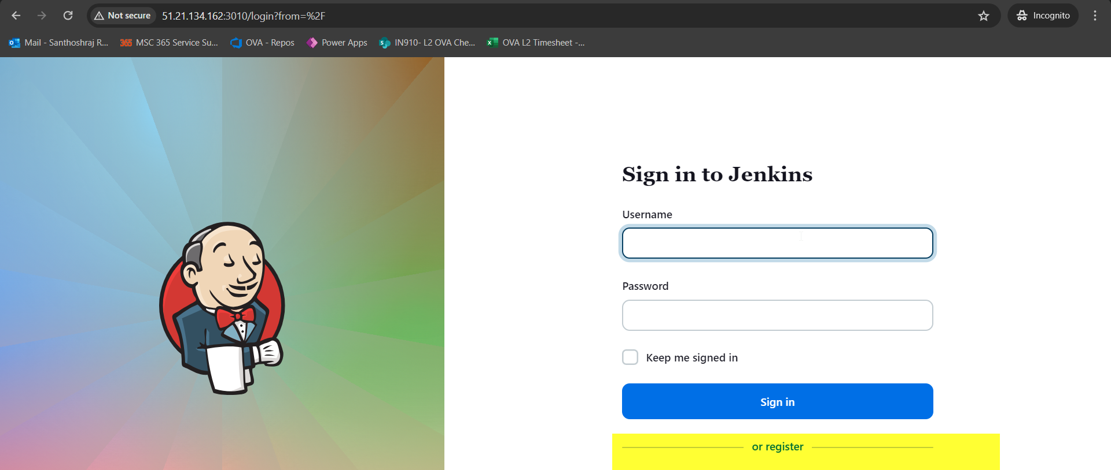

Users cannot configure Build under project, since it is restricted.

Currently User: Santhoshraj is only admin:

