Deployment.yaml file:

Deployment is created:

POD is created based on Deployment:

Service.yaml file is created:

Service is created

Type: LoadBalancer service is created since it is cloud service, so communication should happen outside cluster.

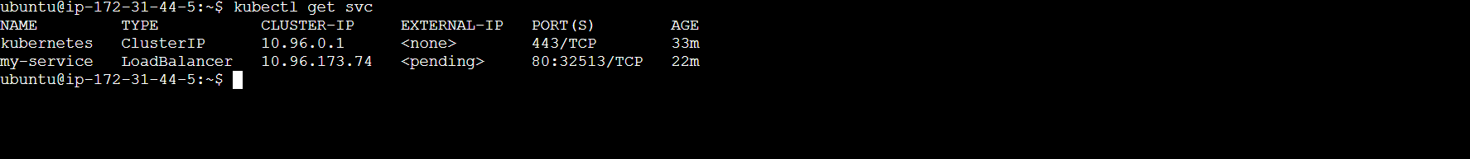

Port is exposed to 32513

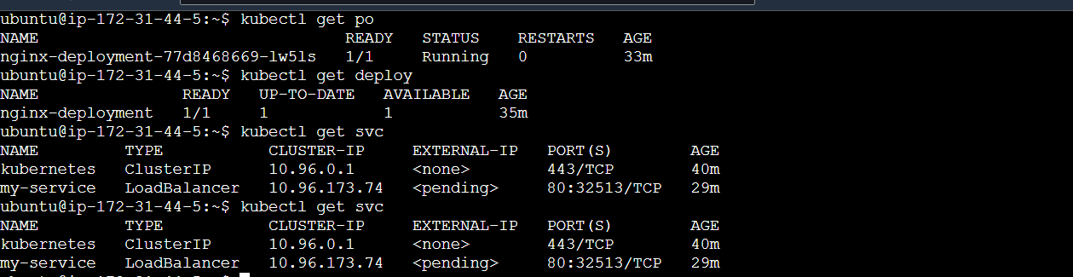

Curl is also working fine and fetching nginx application :

