**EC2 instance:**

Since my system not supporting 2core CPU, iam proceeding with EC2-ubuntu.

T3.medium.

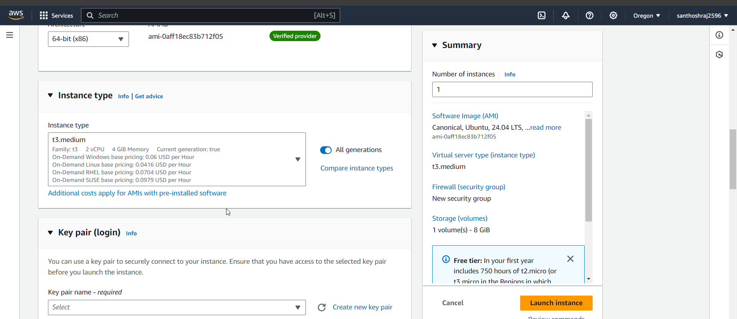

Installing minikube based on documentation:

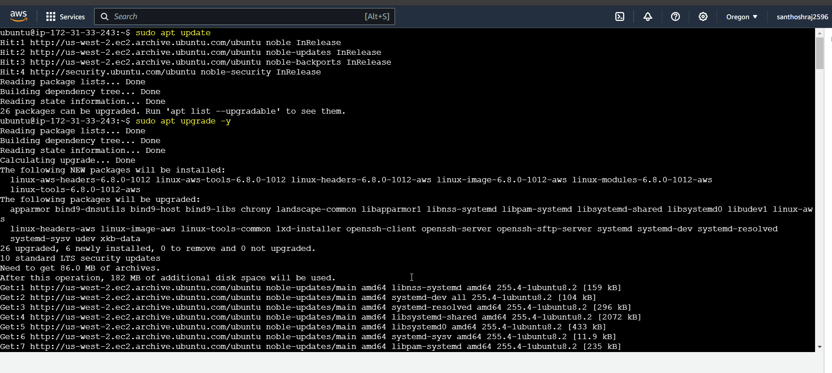

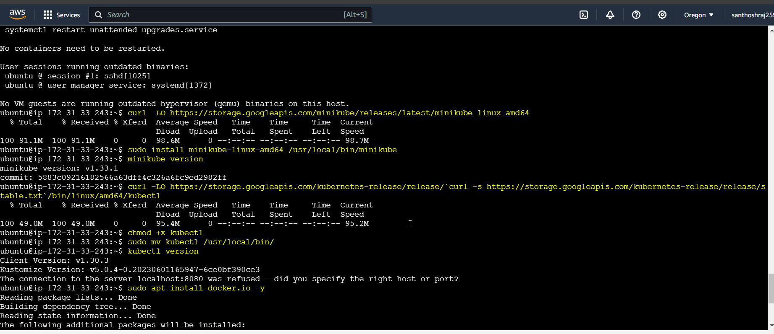

Starting the minikube:

Master node/control-plane is installed available:

Since no deployment, Pod is available and default service ->Cluster IP is available.

**Available default namespace:**

**Namespace created:**

