Installed Prometheus, Grafana and node Exporter, it is running fine:

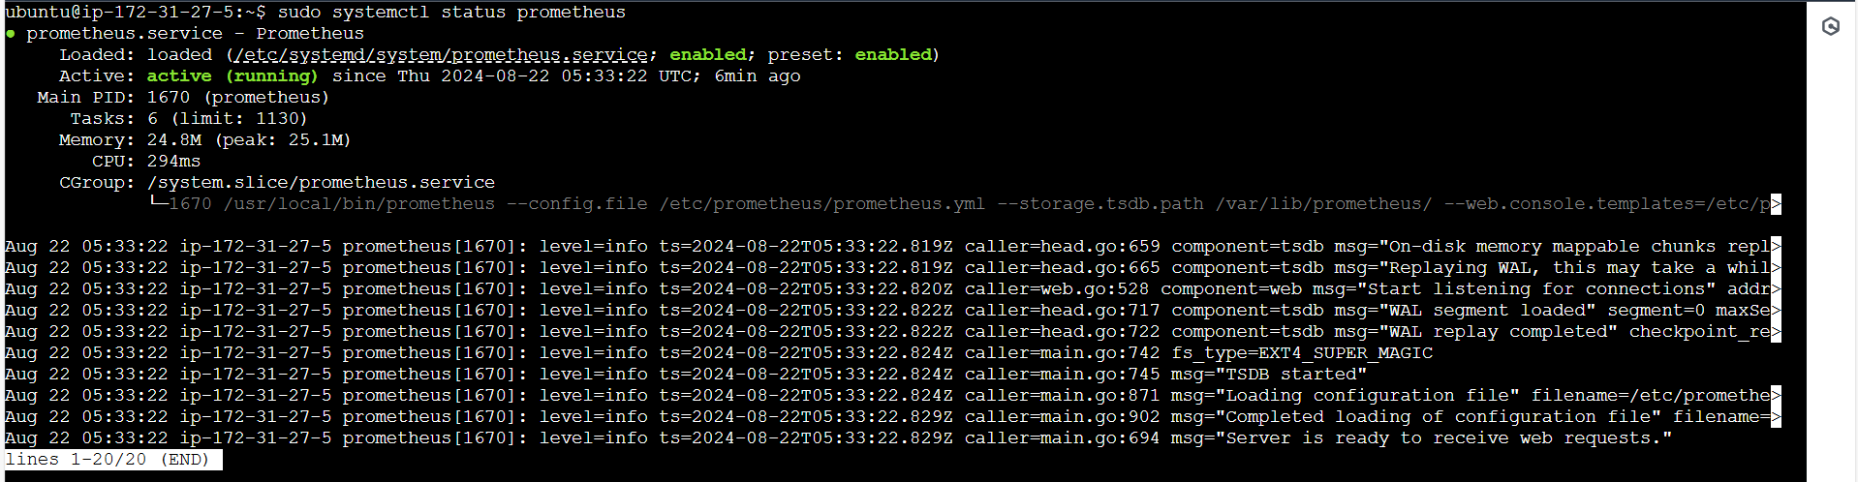 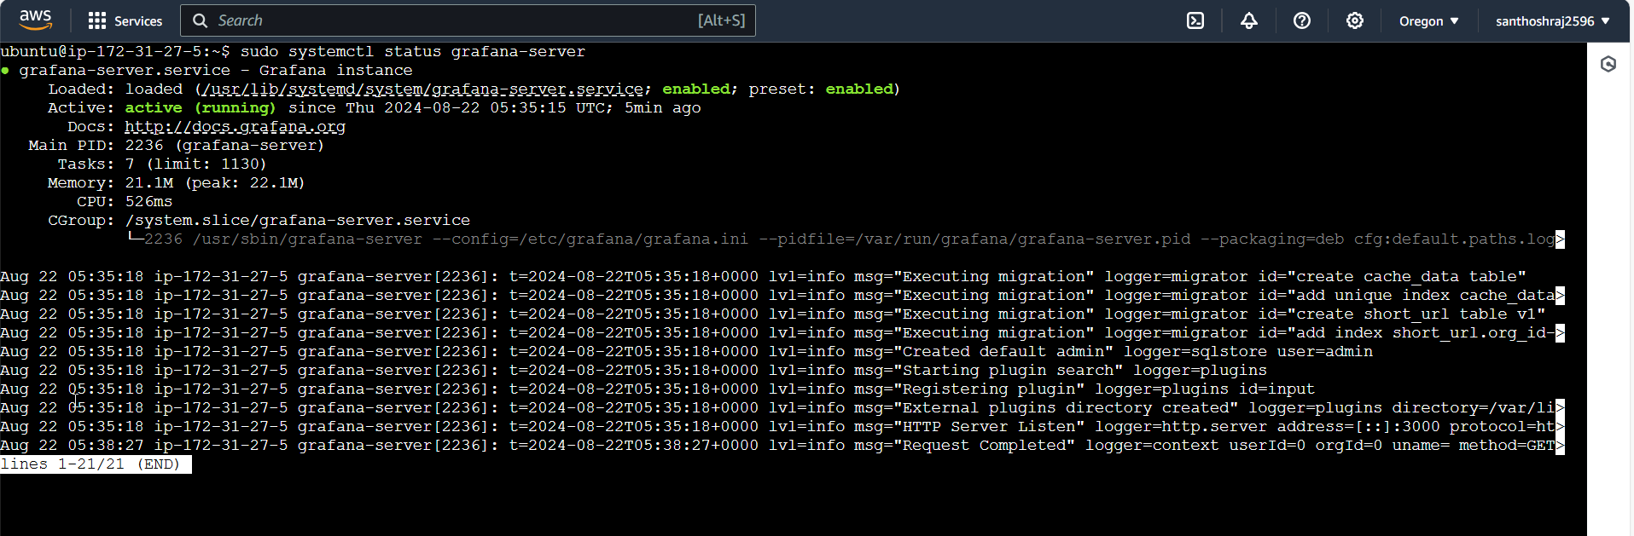 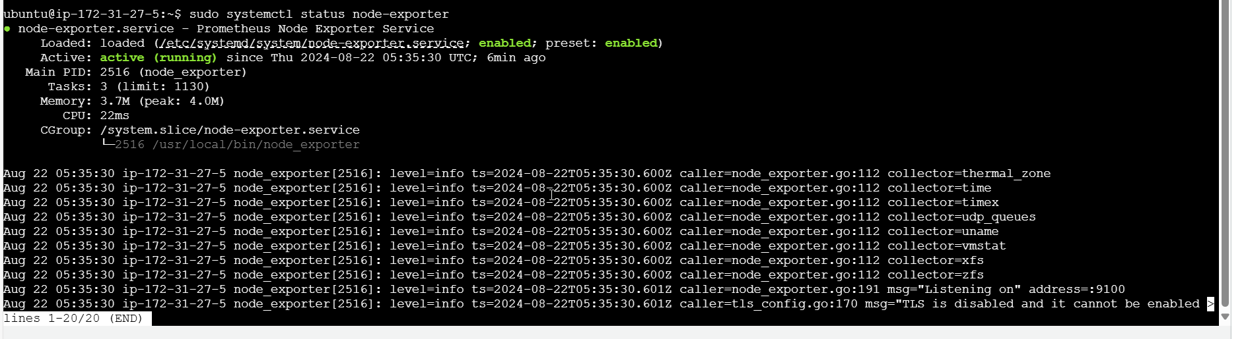

After allowing all traffic in SG inbound rules:

Grafana, prometheus and node-exporter is running:

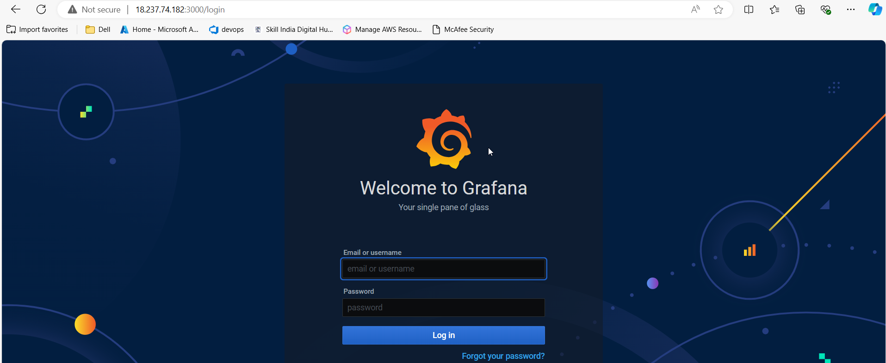 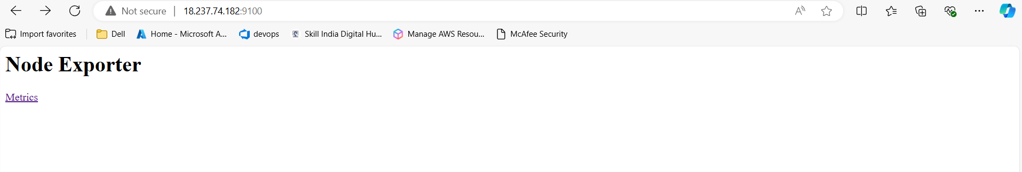

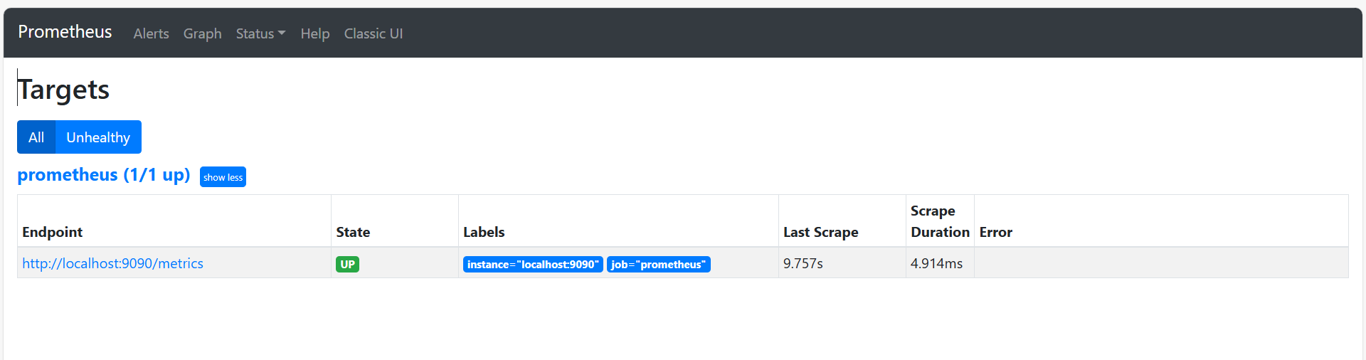

Install docker and docker-compose, run docker compose using nginx image:

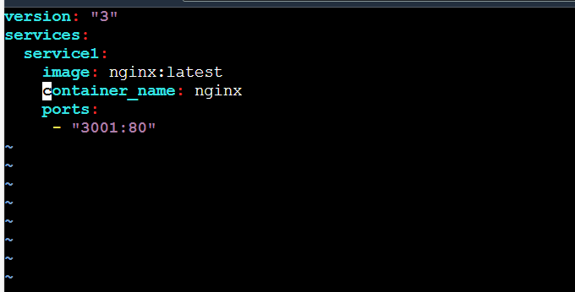

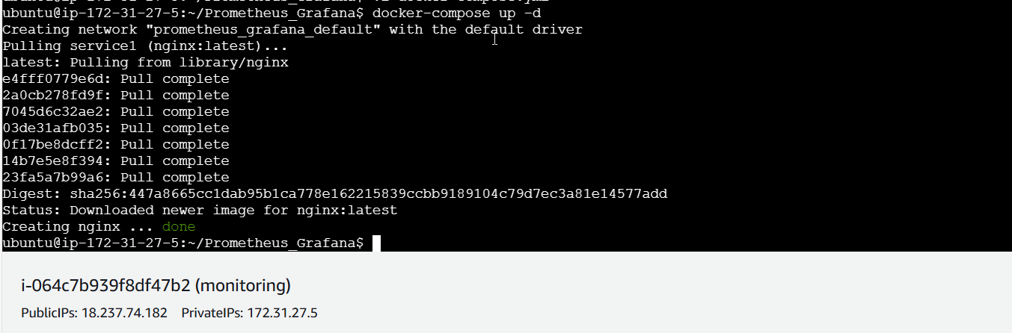 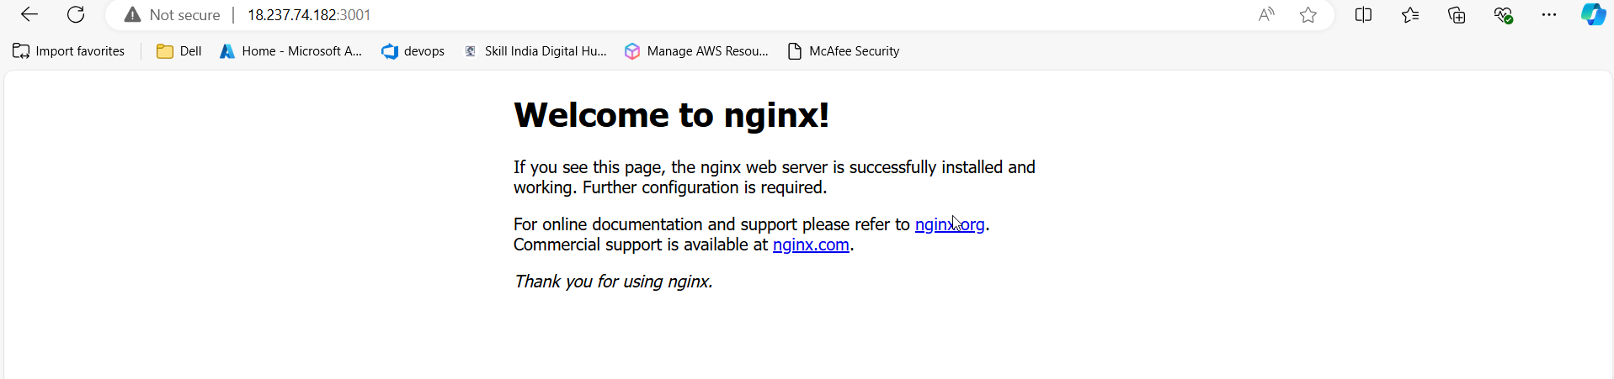

To enable docker metric, creating json file:

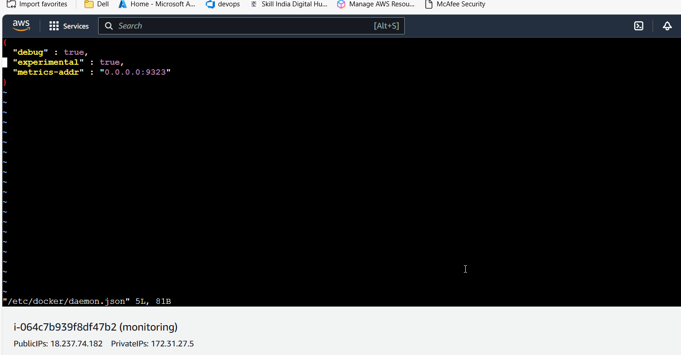

Prometheus.yml: config file modified

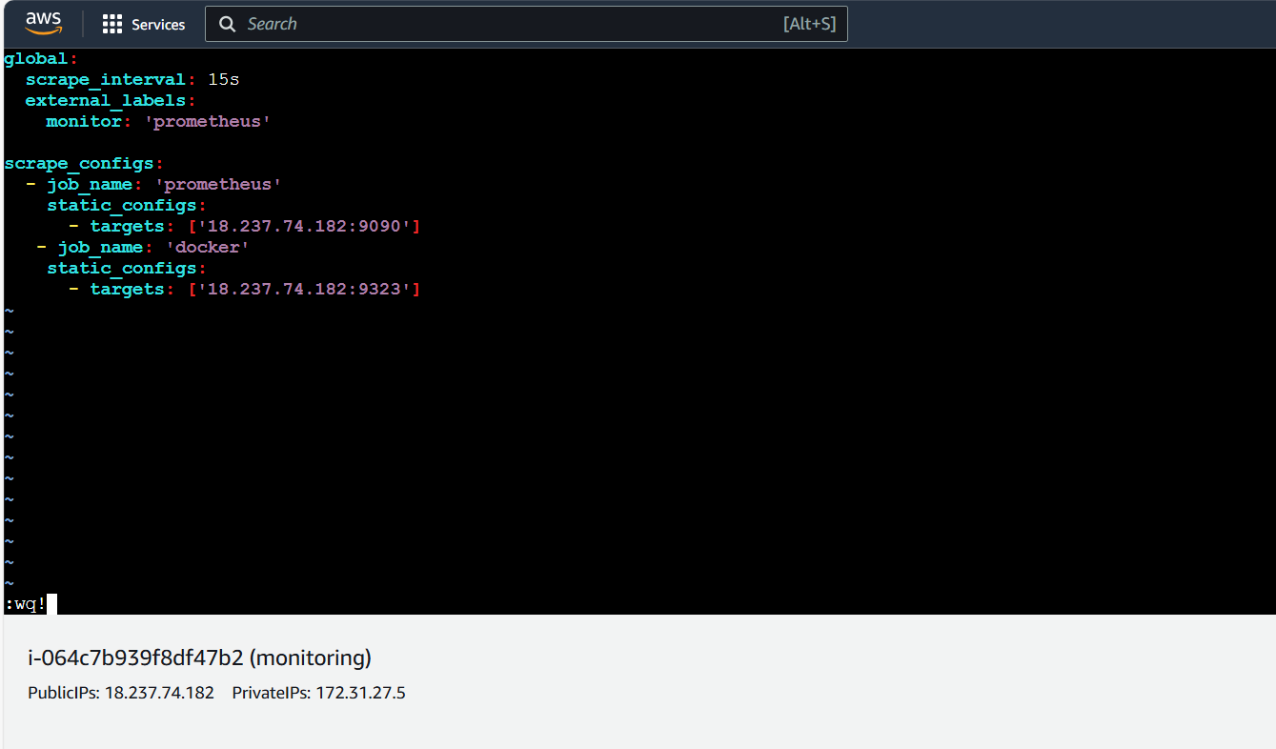

Targets were added:

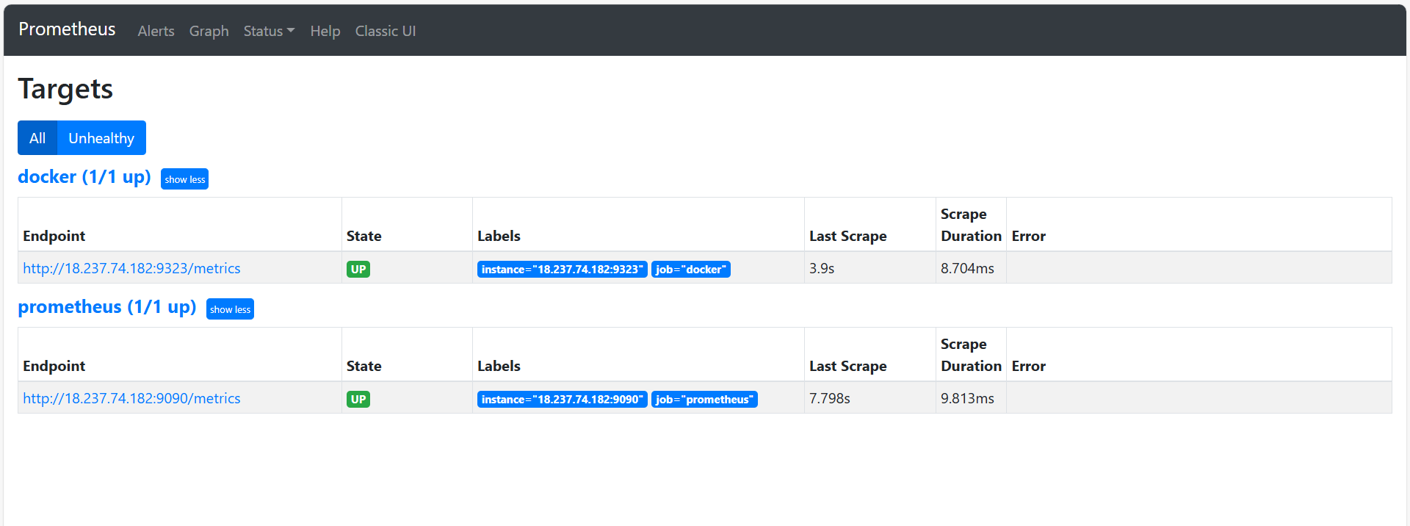

Adding datasource in prometheus:

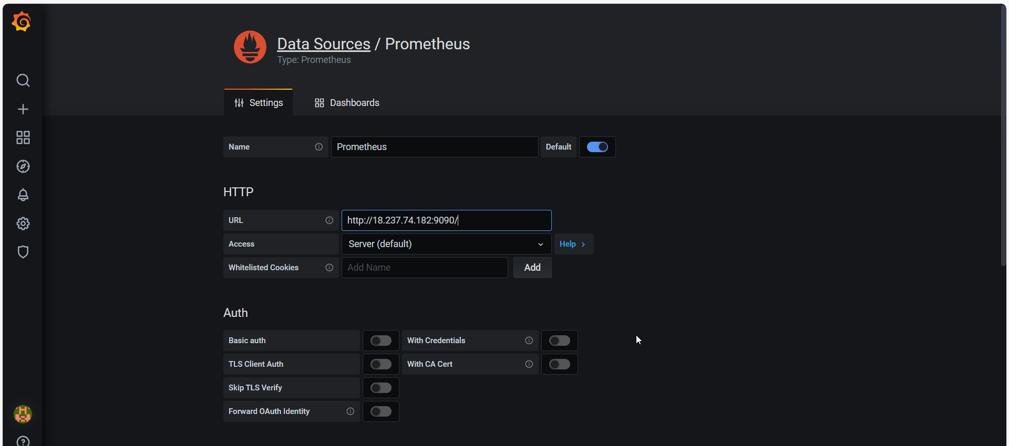

Creating panel to view running container:

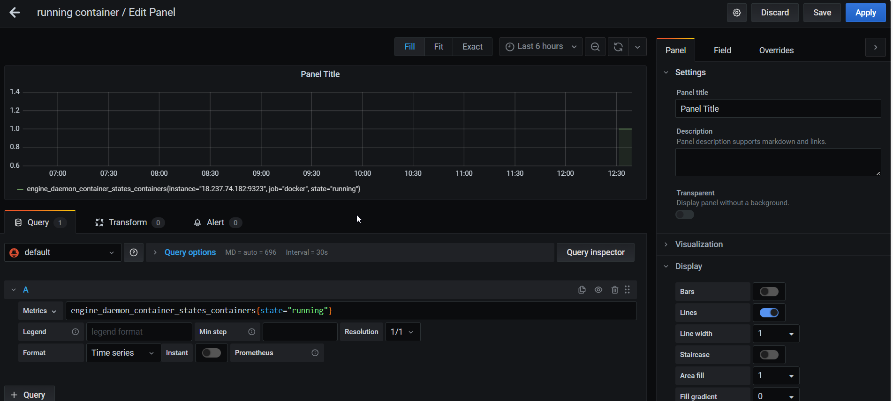

Dashboard:

