Task: **Given a file, replace all occurrence of the word ""give"" with ""learning"" from the 5th line till the end in only those lines that contain the word "welcome"**

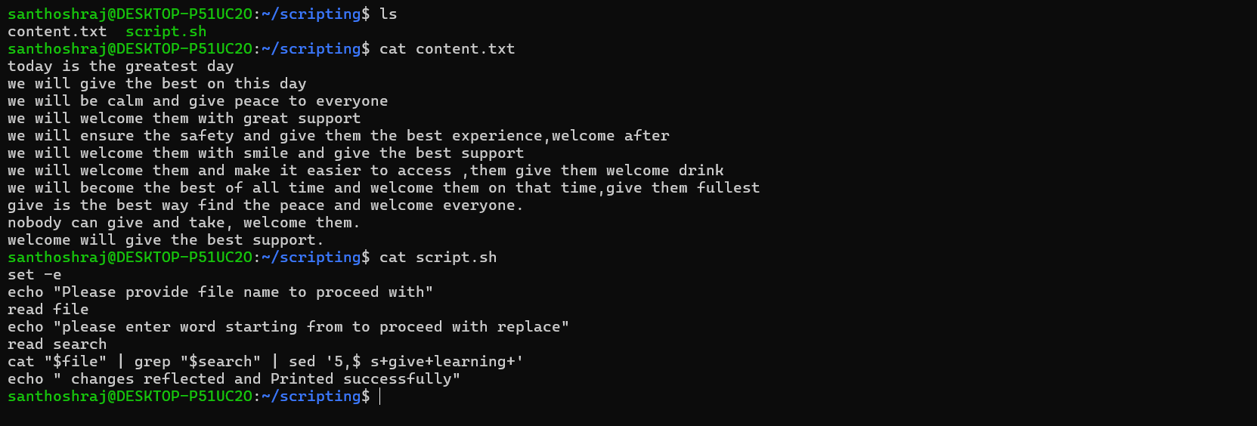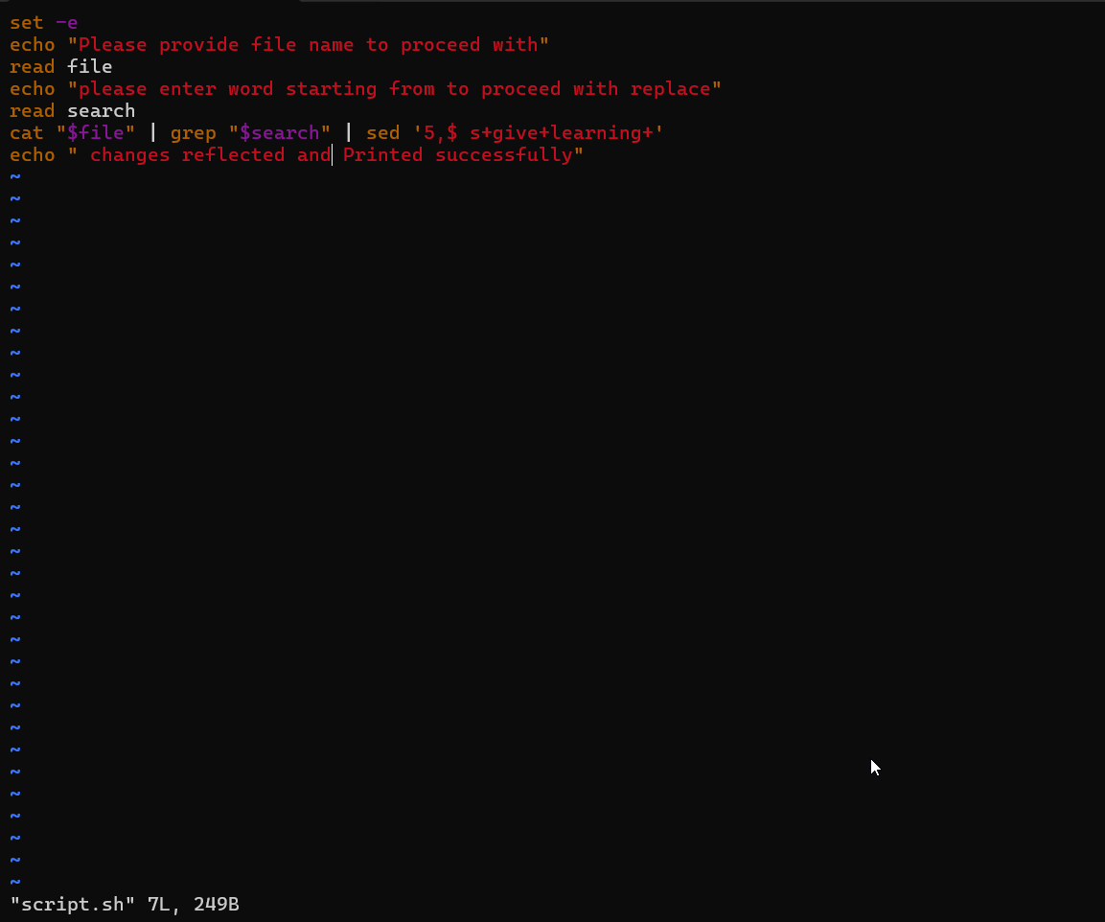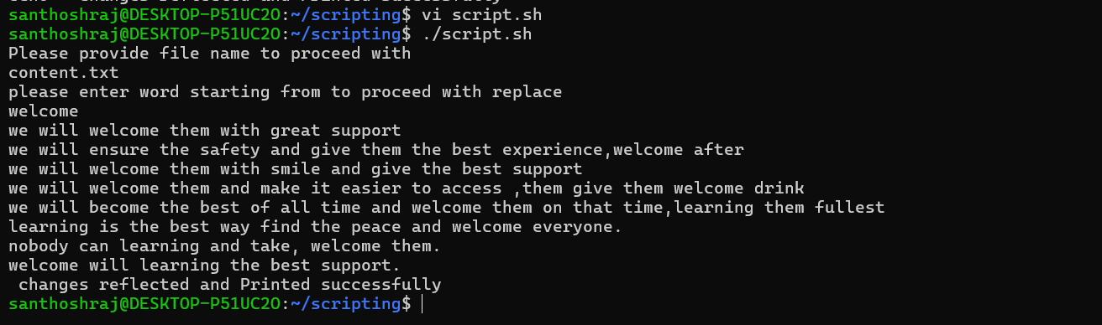

Git push:

