Database Systems Laboratory
PROJECT REPORT
MyGovt – AI-Powered Tamil Nadu Citizen Services Platform
A PostgreSQL / PostGIS / pgvector database system for schemes, services and complaint management

Item | Details
Project name | MyGovt – AI-Powered Tamil Nadu Citizen Services Platform
Student name(s) | [STUDENT NAME 1 – to be filled] [STUDENT NAME 2 – to be filled]
Register number(s) | [REGISTER NO. 1 – to be filled] [REGISTER NO. 2 – to be filled]
Course code and name | BCSE302L – Database Systems (Lab: BCSE302P)
Faculty name | [FACULTY NAME – to be filled]
Database management system | PostgreSQL 16.15 with PostGIS 3.6.2, pgvector 0.8.6, pg_trgm, pgcrypto, btree_gist
Source code repository | github.com/santhoshraja-15/My-Govt (branch audit/tn-data-verification)

Text in [square brackets] is a placeholder that the student must replace before submission.

Contents
1. Project Title
2. Introduction
3. Objectives
4. Software Requirements
5. Database Design
6. Database Creation and Sample Data
7. Database Operations and Outputs
8. Advanced Database Features
9. Project Output Screenshots
10. Conclusion
11. References

1. Project Title
MyGovt – AI-Powered Tamil Nadu Citizen Services Platform. A PostgreSQL / PostGIS / pgvector database system for schemes, services and complaint management.
Item | Details
Student name(s) | [STUDENT NAME 1 – to be filled] [STUDENT NAME 2 – to be filled]
Register number(s) | [REGISTER NO. 1 – to be filled] [REGISTER NO. 2 – to be filled]
Course | BCSE302L – Database Systems (Lab: BCSE302P)
Faculty | [FACULTY NAME – to be filled]

2. Introduction
Citizens of Tamil Nadu must discover government schemes, check whether they are eligible, find the documents a service needs, and, when something goes wrong, file a complaint and follow it to resolution. This information is spread over many department websites. MyGovt gathers it in one relational database and puts a web application, a rule-based eligibility checker, a grounded question-answering assistant and an officer console on top of it.

2.1 Problem statement
Government information is fragmented, hard to verify and hard to act on. A citizen cannot easily tell which scheme applies to them, and a complaint filed with the wrong office is lost. The database must therefore (a) store schemes, services, departments and jurisdictions with a clear provenance, (b) route each complaint to the responsible authority, (c) keep a tamper-evident history of what happened to every complaint, and (d) never present unverified records as official fact.

2.2 Why a relational database
- Integrity: primary keys, foreign keys, UNIQUE, NOT NULL and CHECK constraints reject invalid complaints, schemes and statuses at the database, not only in application code.
- Relationships: departments → authorities → officers → complaints; schemes ↔ eligibility rules ↔ documents are naturally relational.
- Automatic behaviour: triggers write complaint history and protect the audit log; views expose SLA breaches and department performance.
- Spatial and semantic search: PostGIS resolves a complaint location to a ward and local body; pgvector and full-text indexes support search – inside the same transactional database.

2.3 Scale of the implemented database
Table 1: Size of the MyGovt database (counted from the catalog)
Measure | Value
Schemas / tables | 10 schemas / 50 tables
Columns | 513
Foreign keys | 77
Triggers | 13
Project functions | 7 (PL/pgSQL)
Views | 2 project views (+ 2 supplied by extensions)
Index types in use | B-tree, GIN, GiST (spatial), HNSW (vector)

All government records in the prototype are marked 'provisional'; none has been confirmed against an official source document, and the database enforces this by a CHECK constraint (a record cannot be set to 'official_verified' without a source document reference). Complaint rows in the demonstration database include clearly labelled synthetic data.

3. Objectives
- Design a normalised relational schema for departments, jurisdictions, schemes, services, documents, citizens and complaints.
- Enforce data integrity with PRIMARY KEY, FOREIGN KEY, UNIQUE, NOT NULL and CHECK constraints.
- Automate complaint tracking with triggers, and protect the audit trail from modification.
- Provide views for SLA monitoring and department performance reporting.
- Demonstrate SELECT, INSERT, UPDATE, DELETE, joins, aggregates, subqueries, functions, procedures, views and transaction control (COMMIT, ROLLBACK, SAVEPOINT).
- Deliver a working web application (FastAPI + Next.js) that uses the database as its single system of record.

3.1 Scope
In scope: the PostgreSQL database, its migrations, the REST API and the web interface for citizens, officers and administrators. Out of scope for this submission: confirming each record against official government sources (data is provisional), production hosting, and any integration with live government systems. Neo4j, Redis and MinIO are optional components and are not required by the database design.

4. Software Requirements
Table 2: Software requirements
Component | Technology / version
DBMS | PostgreSQL 16.15
Extensions | PostGIS 3.6.2, pgvector 0.8.6, pg_trgm 1.6, pgcrypto 1.3, btree_gist 1.7
Database tools | psql, pgAdmin (optional); asyncpg driver
Backend | Python 3.12, FastAPI, SQLAlchemy (raw SQL via asyncpg), PyJWT, Argon2
Frontend | Next.js 15, React 18, Tailwind CSS, React Flow (ER diagram)
Testing | pytest, Playwright, axe-core
Delivery | Docker Compose, GitHub Actions (10 CI jobs)
Operating system | Windows 11 (development); Linux containers (CI)
Optional | Neo4j (graph), Redis (cache/rate limit), MinIO (object storage)

5. Database Design

5.1 Entity–relationship diagram
The ER diagram below is generated live from the PostgreSQL catalog by the application's Database Architecture Explorer, so it always matches the real database. Boxes are tables (coloured by schema), the key symbol marks a primary key, the link symbol a foreign key.
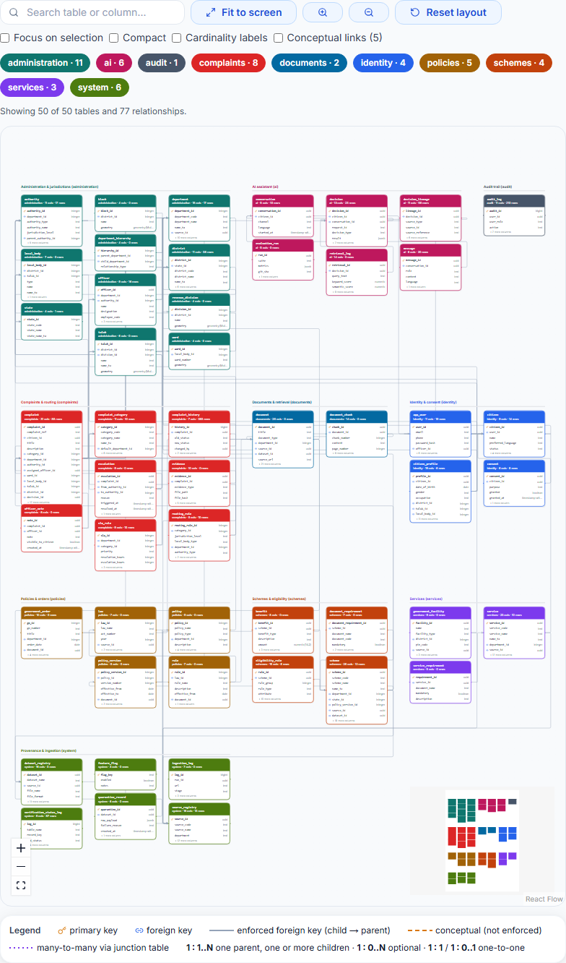
Figure 1: Entity–relationship diagram of all 50 tables (Database Architecture Explorer)
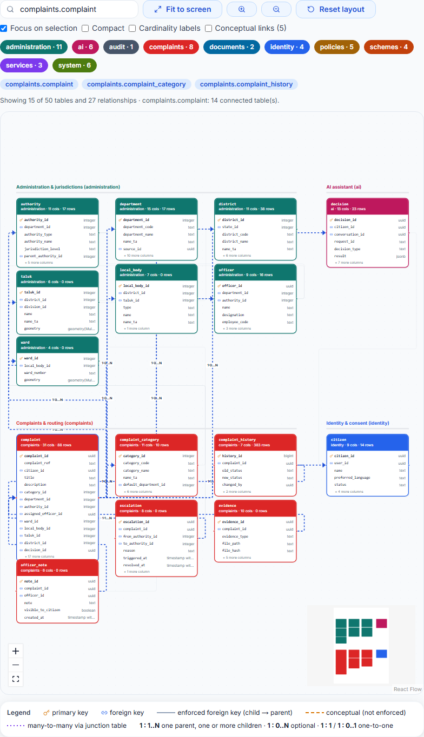
Figure 2: Focus view: the complaint table and its connected entities

5.2 Core entities and relationships
Table 3: Foreign-key relationships among the core tables (each is 1 : N)
Parent (one) | Child (many) | Foreign-key column(s)
administration.authority | administration.authority | parent_authority_id
administration.department | administration.authority | department_id
administration.authority | administration.officer | authority_id
administration.department | administration.officer | department_id
administration.authority | complaints.complaint | authority_id
administration.department | complaints.complaint | department_id
administration.officer | complaints.complaint | assigned_officer_id
complaints.complaint_category | complaints.complaint | category_id
identity.citizen | complaints.complaint | citizen_id
administration.department | complaints.complaint_category | default_department_id
complaints.complaint | complaints.complaint_history | complaint_id
administration.officer | identity.app_user | officer_id
identity.app_user | identity.citizen | user_id
schemes.scheme | schemes.eligibility_rule | scheme_id
administration.department | schemes.scheme | department_id
administration.department | services.service | department_id

Cardinality: one department has many authorities, officers, schemes, services and complaints; one citizen files many complaints; one complaint has many history rows (written by a trigger); one scheme has many eligibility rules. Many-to-many relationships (for example schemes ↔ documents) are resolved by junction tables whose primary key is made of two foreign keys.

5.3 Tables, attributes, primary keys and foreign keys
PK = primary key, FK = foreign key (target shown), UQ = unique, NN = NOT NULL. The twelve core tables used throughout this report are listed; the full 50-table catalog is in the repository.
Table 4: administration.department (15 columns)
Attribute | Data type | Null? | Key
department_id | integer | NN | PK
department_code | text | NN | UQ
department_name | text | NN
name_ta | text
description | text
website_url | text
contact_email | text
contact_phone | text
status | text | NN
source_id | uuid |  | FK → system.source_registry
short_name | text
verified_at | timestamp with time zone
verified_by | text
source_document_ref | text
verification_status | text

Table 5: administration.authority (11 columns)
Attribute | Data type | Null? | Key
authority_id | integer | NN | PK
department_id | integer | NN | FK → administration.department
authority_type | text | NN
authority_name | text | NN
jurisdiction_level | text | NN
jurisdiction_id | integer
parent_authority_id | integer |  | FK → administration.authority
contact_information | jsonb | NN
verification_status | text | NN
is_routing_placeholder | boolean | NN
notes | text

Table 6: administration.officer (9 columns)
Attribute | Data type | Null? | Key
officer_id | uuid | NN | PK
department_id | integer | NN | FK → administration.department
authority_id | integer | NN | FK → administration.authority
name | text | NN
designation | text | NN
employee_code | text |  | UQ
email | text
phone | text
status | text | NN

Table 7: identity.app_user (11 columns)
Attribute | Data type | Null? | Key
user_id | uuid | NN | PK
email | text |  | UQ
phone | text |  | UQ
password_hash | text | NN
role | text | NN
officer_id | uuid |  | FK → administration.officer
status | text | NN
failed_logins | integer | NN
created_at | timestamp with time zone | NN
updated_at | timestamp with time zone | NN
is_synthetic | boolean | NN

Table 8: identity.citizen (9 columns)
Attribute | Data type | Null? | Key
citizen_id | uuid | NN | PK
user_id | uuid |  | FK → identity.app_user, UQ
name | text | NN
preferred_language | text | NN
status | text | NN
created_at | timestamp with time zone | NN
updated_at | timestamp with time zone | NN
is_synthetic | boolean | NN
synthetic_batch | text

Table 9: schemes.scheme (28 columns)
Attribute | Data type | Null? | Key
scheme_id | uuid | NN | PK
scheme_code | text | NN | UQ
scheme_name | text | NN
name_ta | text
short_description | text
full_description | text
scheme_level | text | NN
department_id | integer |  | FK → administration.department
state_id | integer |  | FK → administration.state
category | text
benefits_summary | text
application_url | text
official_url | text
status | text | NN
effective_from | date
effective_to | date
… 12 more columns

Table 10: schemes.eligibility_rule (15 columns)
Attribute | Data type | Null? | Key
rule_id | uuid | NN | PK
scheme_id | uuid | NN | FK → schemes.scheme
rule_group | integer | NN
rule_type | text | NN
attribute | text | NN
operator | text | NN
value | jsonb | NN
unit | text
mandatory | boolean | NN
priority | integer | NN
human_readable | text
human_readable_ta | text
source_reference | text
effective_from | date
effective_to | date

Table 11: services.service (23 columns)
Attribute | Data type | Null? | Key
service_id | uuid | NN | PK
service_code | text
service_name | text | NN
name_ta | text
department_id | integer |  | FK → administration.department
category | text
description | text
service_type | text
application_url | text
official_url | text
government_fee | numeric(10,2)
service_charge | numeric(10,2)
processing_time | text
status | text | NN
source_id | uuid |  | FK → system.source_registry
verified_at | timestamp with time zone
… 7 more columns

Table 12: complaints.complaint_category (11 columns)
Attribute | Data type | Null? | Key
category_id | integer | NN | PK
category_code | text | NN | UQ
category_name | text | NN
name_ta | text
description | text
default_department_id | integer |  | FK → administration.department
default_priority | text | NN
default_sla_hours | integer | NN
is_active | boolean | NN
verification_status | text
source_document_ref | text

Table 13: complaints.complaint (31 columns)
Attribute | Data type | Null? | Key
complaint_id | uuid | NN | PK
complaint_ref | text | NN | UQ
citizen_id | uuid | NN | FK → identity.citizen
title | text | NN
description | text | NN
language | text
category_id | integer |  | FK → complaints.complaint_category
category_confidence | numeric(4,3)
department_id | integer |  | FK → administration.department
authority_id | integer |  | FK → administration.authority
assigned_officer_id | uuid |  | FK → administration.officer
priority | text | NN
status | text | NN
is_corruption_report | boolean | NN
is_anonymous | boolean | NN
latitude | double precision
… 15 more columns

Table 14: complaints.complaint_history (7 columns)
Attribute | Data type | Null? | Key
history_id | bigint | NN | PK
complaint_id | uuid | NN | FK → complaints.complaint
old_status | text
new_status | text | NN
changed_by | uuid
remarks | text
changed_at | timestamp with time zone | NN

Table 15: audit.audit_log (11 columns)
Attribute | Data type | Null? | Key
audit_id | bigint | NN | PK
user_id | uuid
user_role | text
action | text | NN
entity_type | text | NN
entity_id | text
old_value | jsonb
new_value | jsonb
ip_address | inet
request_id | text
occurred_at | timestamp with time zone | NN

5.4 Relational schema
Notation: TABLE(PK: key, FK: foreign key, other attributes).
DEPARTMENT(PK:department_id, department_code, department_name, name_ta, description, website_url, contact_email, contact_phone, status, … +6 more)
AUTHORITY(PK:authority_id, FK:department_id, authority_type, authority_name, jurisdiction_level, jurisdiction_id, FK:parent_authority_id, contact_information, verification_status, … +2 more)
OFFICER(PK:officer_id, FK:department_id, FK:authority_id, name, designation, employee_code, email, phone, status)
CITIZEN(PK:citizen_id, FK:user_id, name, preferred_language, status, created_at, updated_at, is_synthetic, synthetic_batch)
SCHEME(PK:scheme_id, scheme_code, scheme_name, name_ta, short_description, full_description, scheme_level, FK:department_id, FK:state_id, … +19 more)
ELIGIBILITY_RULE(PK:rule_id, FK:scheme_id, rule_group, rule_type, attribute, operator, value, unit, mandatory, … +6 more)
SERVICE(PK:service_id, service_code, service_name, name_ta, FK:department_id, category, description, service_type, application_url, … +14 more)
COMPLAINT_CATEGORY(PK:category_id, category_code, category_name, name_ta, description, FK:default_department_id, default_priority, default_sla_hours, is_active, … +2 more)
COMPLAINT(PK:complaint_id, complaint_ref, FK:citizen_id, title, description, language, FK:category_id, category_confidence, FK:department_id, … +22 more)
COMPLAINT_HISTORY(PK:history_id, FK:complaint_id, old_status, new_status, changed_by, remarks, changed_at)

5.5 Normalization
The schema was designed so that every table describes one kind of thing and every non-key attribute depends on that thing's key.
- First normal form (1NF): every table has a primary key and atomic columns. The few jsonb / array columns (for example eligibility rule values and document lists) hold a single structured value that the application treats as a unit; they are not repeating groups of facts that are queried independently.
- Second normal form (2NF): all core tables use a single-column surrogate key (serial or UUID), so a non-key attribute cannot depend on part of a key. Junction tables use a composite key made only of foreign keys and carry no descriptive attributes.
- Third normal form (3NF): descriptive facts live once, in their own table – department names in administration.department, complaint category names and default SLA in complaints.complaint_category, jurisdiction names in the administration tables – and other tables reference them by foreign key instead of copying the text.
Honest limitation: functional dependencies are not recorded in the PostgreSQL catalog, so the Database Architecture Explorer reports structural facts (keys, atomic columns, possible duplicate columns) and does not claim that the whole schema is in 3NF. The statement above is the designer's analysis of the core tables, not a tool-verified proof.

Deliberate denormalization
complaints.complaint stores both department_id and authority_id even though the authority already determines its department. The values are the result of routing at the moment the complaint was filed; if the authority table is later reorganised, the complaint must keep the routing decision that was actually applied. This is a conscious trade-off of a small amount of redundancy for historical accuracy.

6. Database Creation and Sample Data
Database server: PostgreSQL 16.15. The schema is created by database/schema/001_schema.sql followed by migrations 002–008. The statements below are copied from that file – they are the statements that built the database, not simplified examples.

6.1 CREATE TABLE statements
Each table shows PRIMARY KEY, FOREIGN KEY (REFERENCES), UNIQUE, NOT NULL, DEFAULT and CHECK constraints.

administration.department
CREATE TABLE administration.department (
department_id serial PRIMARY KEY,
department_code text UNIQUE NOT NULL,
department_name text NOT NULL,
name_ta text,
description text,
website_url text,
contact_email text,
contact_phone text,
status text NOT NULL DEFAULT 'active',
source_id uuid REFERENCES system.source_registry(source_id)
);

administration.authority
CREATE TABLE administration.authority (
authority_id serial PRIMARY KEY,
department_id int NOT NULL REFERENCES administration.department(department_id),
authority_type text NOT NULL CHECK (authority_type IN ('state','district','taluk','municipal','panchayat','department_office')),
authority_name text NOT NULL,
jurisdiction_level text NOT NULL CHECK (jurisdiction_level IN ('state','district','taluk','local_body','ward')),
jurisdiction_id int, -- id in the table implied by jurisdiction_level
parent_authority_id int REFERENCES administration.authority(authority_id), -- escalation chain
contact_information jsonb NOT NULL DEFAULT '{}'
);

administration.officer
CREATE TABLE administration.officer ( -- SYNTHETIC DATA ONLY in prototype
officer_id uuid PRIMARY KEY DEFAULT gen_random_uuid(),
department_id int NOT NULL REFERENCES administration.department(department_id),
authority_id int NOT NULL REFERENCES administration.authority(authority_id),
name text NOT NULL,
designation text NOT NULL,
employee_code text UNIQUE,
email text,
phone text,
status text NOT NULL DEFAULT 'active'
);

schemes.scheme
CREATE TABLE schemes.scheme (
scheme_id uuid PRIMARY KEY DEFAULT gen_random_uuid(),
scheme_code text UNIQUE NOT NULL,
scheme_name text NOT NULL,
name_ta text,
short_description text,
full_description text,
scheme_level text NOT NULL CHECK (scheme_level IN ('central','state','district')),
department_id int REFERENCES administration.department(department_id),
state_id int REFERENCES administration.state(state_id),
category text,
benefits_summary text,
application_url text,
official_url text,
status text NOT NULL DEFAULT 'active' CHECK (status IN ('active','closed','suspended','draft')),
effective_from date,
effective_to date,
policy_version_id int REFERENCES policies.policy_version(policy_version_id),
source_id uuid REFERENCES system.source_registry(source_id),
dataset_id uuid REFERENCES system.dataset_registry(dataset_id),
verified_at timestamptz, -- last verified against an official source
embedding vector(1024),
tsv tsvector,
created_at timestamptz NOT NULL DEFAULT now(),
updated_at timestamptz NOT NULL DEFAULT now()
);

schemes.eligibility_rule
CREATE TABLE schemes.eligibility_rule (
rule_id uuid PRIMARY KEY DEFAULT gen_random_uuid(),
scheme_id uuid NOT NULL REFERENCES schemes.scheme(scheme_id) ON DELETE CASCADE,
rule_group int NOT NULL DEFAULT 1, -- rules in same group = AND; groups = OR
rule_type text NOT NULL DEFAULT 'demographic',
attribute text NOT NULL, -- must exist in the profile attribute registry
operator text NOT NULL CHECK (operator IN ('=','!=','>','>=','<','<=','IN','NOT_IN','BETWEEN','IS_TRUE','IS_FALSE')),
value jsonb NOT NULL, -- scalar | array | [lo,hi]
unit text,
mandatory boolean NOT NULL DEFAULT true,
priority int NOT NULL DEFAULT 100,
human_readable text, -- shown to the citizen (en)
human_readable_ta text,
source_reference text, -- clause/para in the official doc
effective_from date,
effective_to date
);

complaints.complaint_category
CREATE TABLE complaints.complaint_category (
category_id serial PRIMARY KEY,
category_code text UNIQUE NOT NULL,
category_name text NOT NULL,
name_ta text,
description text,
default_department_id int REFERENCES administration.department(department_id),
default_priority text NOT NULL DEFAULT 'medium' CHECK (default_priority IN ('low','medium','high','critical')),
default_sla_hours int NOT NULL DEFAULT 72
);

complaints.complaint
CREATE TABLE complaints.complaint (
complaint_id uuid PRIMARY KEY DEFAULT gen_random_uuid(),
complaint_ref text UNIQUE NOT NULL DEFAULT
('MYG-' || to_char(now(),'YYYY') || '-' || lpad(nextval('complaints.complaint_seq')::text, 6, '0')),
citizen_id uuid NOT NULL REFERENCES identity.citizen(citizen_id),
title text NOT NULL,
description text NOT NULL,
language text,
category_id int REFERENCES complaints.complaint_category(category_id),
category_confidence numeric(4,3),
department_id int REFERENCES administration.department(department_id),
authority_id int REFERENCES administration.authority(authority_id),
assigned_officer_id uuid REFERENCES administration.officer(officer_id),
priority text NOT NULL DEFAULT 'medium' CHECK (priority IN ('low','medium','high','critical')),
status text NOT NULL DEFAULT 'submitted' CHECK (status IN
('submitted','needs_triage','classified','assigned','in_progress','resolved','closed','rejected','escalated','reopened')),
is_corruption_report boolean NOT NULL DEFAULT false,
is_anonymous boolean NOT NULL DEFAULT false,
latitude double precision,
longitude double precision,
location geometry(Point,4326),
ward_id int REFERENCES administration.ward(ward_id),
local_body_id int REFERENCES administration.local_body(local_body_id),
taluk_id int REFERENCES administration.taluk(taluk_id),
district_id int REFERENCES administration.district(district_id),
decision_id uuid, -- FK added after ai.decision exists
created_at timestamptz NOT NULL DEFAULT now(),
updated_at timestamptz NOT NULL DEFAULT now(),
due_date timestamptz,
escalation_due_at timestamptz,
resolved_at timestamptz
);

complaints.complaint_history
CREATE TABLE complaints.complaint_history (
history_id bigserial PRIMARY KEY,
complaint_id uuid NOT NULL REFERENCES complaints.complaint(complaint_id) ON DELETE CASCADE,
old_status text,
new_status text NOT NULL,
changed_by uuid, -- app_user.user_id, NULL = system
remarks text,
changed_at timestamptz NOT NULL DEFAULT now()
);

identity.citizen
CREATE TABLE identity.citizen ( -- SYNTHETIC DATA ONLY in prototype
citizen_id uuid PRIMARY KEY DEFAULT gen_random_uuid(),
user_id uuid UNIQUE REFERENCES identity.app_user(user_id),
name text NOT NULL,
preferred_language text NOT NULL DEFAULT 'en' CHECK (preferred_language IN ('en','ta','tanglish')),
status text NOT NULL DEFAULT 'active',
created_at timestamptz NOT NULL DEFAULT now(),
updated_at timestamptz NOT NULL DEFAULT now()
);

6.2 Sample records (INSERT statements)
The INSERT statements below were generated from rows that exist in the database (the verified seed in database/seed/002_verified_seed_data.sql and the demonstration data). Government records are provisional – the verification_status column says so for every row.
INSERT INTO administration.department (department_code, department_name, status)
VALUES ('REVT', 'Revenue Department', 'active');
INSERT INTO administration.department (department_code, department_name, status)
VALUES ('HLTH', 'Health and Family Welfare Department', 'active');
INSERT INTO administration.department (department_code, department_name, status)
VALUES ('EDUC', 'School Education Department', 'active');
INSERT INTO complaints.complaint_category (category_code, category_name, default_sla_hours)
VALUES ('CAT-POW', 'Power Outage / Electricity Fault', 24);
INSERT INTO complaints.complaint_category (category_code, category_name, default_sla_hours)
VALUES ('CAT-WAT', 'Water Supply Disruption', 24);
INSERT INTO complaints.complaint_category (category_code, category_name, default_sla_hours)
VALUES ('CAT-ROA', 'Road Damage / Potholes', 72);
INSERT INTO schemes.scheme (scheme_code, scheme_name, scheme_level, status)
VALUES ('TN-AMMA-BABY-CARE', 'Amma Baby Care Kit', 'state', 'active');
INSERT INTO schemes.scheme (scheme_code, scheme_name, scheme_level, status)
VALUES ('TN-AMMA-UNAVAGAM', 'Amma Unavagam (Subsidized Canteens)', 'state', 'active');
INSERT INTO services.service (service_code, service_name, category)
VALUES ('SVC-PATTA-TRANSFER', 'Application for Patta Transfer (Mutation of Land)', 'land_record');
INSERT INTO services.service (service_code, service_name, category)
VALUES ('SVC-BIRTH-CERT', 'Birth Certificate Issuance', 'vital_statistics');

6.3 Sample records as stored
SELECT department_id, department_code, department_name, verification_status FROM administration.department ORDER BY department_id LIMIT 6;
department_id | department_code | department_name | verification_status
---------------+-----------------+---------------------------------------------+---------------------
1 | REVT | Revenue Department | provisional
2 | HLTH | Health and Family Welfare Department | provisional
3 | EDUC | School Education Department | provisional
4 | AGRI | Department of Agriculture & Farmers Welfare | provisional
5 | SWWF | Social Welfare and Women Empowerment | provisional
6 | HRCE | Hindu Religious and Charitable Endowments | provisional
(6 rows)
SELECT scheme_code, scheme_name, scheme_level, category, verification_status FROM schemes.scheme ORDER BY scheme_name LIMIT 6;
scheme_code | scheme_name | scheme_level | category
-----------------------+--------------------------------------------------------+--------------+----------------------
TN-AMMA-BABY-CARE | Amma Baby Care Kit | state | maternal_child_health
TN-AMMA-UNAVAGAM | Amma Unavagam (Subsidized Canteens) | state | food_security
TN-PATTA-CHITTA | Anytime Anywhere Land Records (e-Services) | state | land_records
TN-CM-BREAKFAST | Chief Minister Breakfast Scheme | state | education_nutrition
TN-CM-HEALTH-INS | Chief Minister Comprehensive Health Insurance (CMCHIS) | state | health_insurance
TN-DISABILITY-PENSION | Disability Pension Scheme (Differently Abled Welfare) | state | social_security
(6 rows)
SELECT category_id, category_code, category_name, default_priority, default_sla_hours FROM complaints.complaint_category ORDER BY category_id LIMIT 6;
category_id | category_code | category_name | default_priority | default_sla_hours
-------------+---------------+-------------------------------------+------------------+-------------------
1 | CAT-POW | Power Outage / Electricity Fault | high | 24
2 | CAT-WAT | Water Supply Disruption | high | 24
3 | CAT-ROA | Road Damage / Potholes | medium | 72
4 | CAT-GAR | Garbage / Solid Waste Collection | medium | 48
5 | CAT-HOS | Hospital / Medical Services | high | 24
6 | CAT-SCH | School Infrastructure & Midday Meal | medium | 72
(6 rows)
Row counts of the core tables in the database used for this report:
Table 16: Row counts (demonstration database including labelled synthetic complaints)
Table | Rows
administration.department | 17
administration.authority | 17
administration.officer | 16
identity.app_user | 18
identity.citizen | 13
schemes.scheme | 12
schemes.eligibility_rule | 8
services.service | 10
complaints.complaint_category | 10
complaints.complaint | 86
complaints.complaint_history | 396
audit.audit_log | 1

7. Database Operations and Outputs
All statements in this section were executed against a disposable copy of the demonstration database (mygovt_dev_report) by docs/submission/run_sql_evidence.py; the output shown is exactly what PostgreSQL returned. The same statements are in docs/submission/lab_queries.sql.

7.1 SELECT, JOIN, aggregates and subqueries

SELECT with ILIKE pattern and ORDER BY
SELECT service_name, category, processing_time FROM services.service WHERE service_name ILIKE '%certificate%' ORDER BY service_name;
service_name | category | processing_time
---------------------------------------+------------------+-------------------
Birth Certificate Issuance | vital_statistics | Instant to 3 days
Community Certificate | certificate | 15 days
Death Certificate Issuance | vital_statistics | Instant to 3 days
Encumbrance Certificate (EC) | land_record | 3 days
First Generation Graduate Certificate | certificate | 15 days
Income Certificate | certificate | 7 days
Legal Heir Certificate | certificate | 15 days
Nativity Certificate | certificate | 7 days
(8 rows)

INNER JOIN
SELECT s.scheme_name, d.department_name, s.verification_status FROM schemes.scheme s JOIN administration.department d ON d.department_id = s.department_id ORDER BY s.scheme_name LIMIT 8;
scheme_name | department_name | verification
------------------------------------------------------------+-------------------------------------------+-------------
Amma Baby Care Kit | Health and Family Welfare Department | provisional
Amma Unavagam (Subsidized Canteens) | Municipal Administration and Water Supply | provisional
Anytime Anywhere Land Records (e-Services) | Revenue Department | provisional
Chief Minister Breakfast Scheme | School Education Department | provisional
Chief Minister Comprehensive Health Insurance (CMCHIS) | Health and Family Welfare Department | provisional
Disability Pension Scheme (Differently Abled Welfare) | Social Welfare and Women Empowerment | provisional
Indira Gandhi National Old Age Pension Scheme (IGNOAPS ... | Social Welfare and Women Empowerment | provisional
Kalaignar Magalir Urimai Thogai | Social Welfare and Women Empowerment | provisional
(8 rows)

LEFT JOIN with COUNT
SELECT s.scheme_name, count(r.rule_id) AS rules FROM schemes.scheme s LEFT JOIN schemes.eligibility_rule r ON r.scheme_id = s.scheme_id GROUP BY s.scheme_name ORDER BY rules DESC, s.scheme_name LIMIT 6;
scheme_name | rules
------------------------------------------------------------+-------
Indira Gandhi National Old Age Pension Scheme (IGNOAPS ... | 2
Kalaignar Magalir Urimai Thogai | 2
Pudhumai Penn (Moovalur Ramamirtham Higher Education) | 2
Disability Pension Scheme (Differently Abled Welfare) | 1
Pradhan Mantri Kisan Samman Nidhi (PM-Kisan) | 1
Amma Baby Care Kit | 0
(6 rows)

Self-join
SELECT a.authority_name, p.authority_name AS escalates_to FROM administration.authority a LEFT JOIN administration.authority p ON p.authority_id = a.parent_authority_id ORDER BY a.authority_id LIMIT 5;
authority_name | escalates_to
------------------------------------------------------------+--------------
Revenue Department (department-level routing) | NULL
Health and Family Welfare Department (department-level ... | NULL
School Education Department (department-level routing) | NULL
Department of Agriculture & Farmers Welfare (department... | NULL
Social Welfare and Women Empowerment (department-level ... | NULL
(5 rows)

Aggregate functions with GROUP BY
SELECT d.department_name, count(*) AS total, count(*) FILTER (WHERE c.status IN ('resolved','closed')) AS resolved, round(100.0 * count(*) FILTER (WHERE c.status IN ('resolved','closed')) / count(*), 1) AS resolved_pct FROM complaints.complaint c JOIN administration.department d ON d.department_id = c.department_id GROUP BY d.department_name ORDER BY total DESC;
department_name | total | resolved | resolved_pct
---------------------------------------------+-------+----------+--------------
Municipal Administration and Water Supply | 30 | 11 | 36.7
Health and Family Welfare Department | 14 | 6 | 42.9
Revenue Department | 11 | 6 | 54.5
Energy Department (TANGEDCO) | 9 | 4 | 44.4
Rural Development and Panchayat Raj | 7 | 2 | 28.6
Department of Agriculture & Farmers Welfare | 7 | 4 | 57.1
School Education Department | 5 | 2 | 40.0
Social Welfare and Women Empowerment | 3 | 3 | 100.0
(8 rows)

Subquery (nested aggregate)
SELECT department_name FROM administration.department WHERE department_id IN (SELECT department_id FROM complaints.complaint GROUP BY department_id HAVING count(*) > (SELECT avg(n) FROM (SELECT count(*) AS n FROM complaints.complaint GROUP BY department_id) t)) ORDER BY department_name;
department_name
-------------------------------------------
Health and Family Welfare Department
Municipal Administration and Water Supply
Revenue Department
(3 rows)

7.2 INSERT, UPDATE and DELETE

INSERT
INSERT INTO administration.department (department_code, department_name, status) VALUES ('RPT-DEMO', 'Report Demonstration Department', 'active') RETURNING department_id, department_code, department_name;
department_id | department_code | department_name
---------------+-----------------+---------------------------------
21 | RPT-DEMO | Report Demonstration Department
(1 row)

UPDATE
UPDATE administration.department SET department_name = 'Report Demo Department (renamed)', website_url = 'https://example.org' WHERE department_code = 'RPT-DEMO' RETURNING department_code, department_name, website_url;
department_code | department_name | website_url
-----------------+----------------------------------+---------------------
RPT-DEMO | Report Demo Department (renamed) | https://example.org
(1 row)

Verify the change
SELECT department_code, department_name, website_url FROM administration.department WHERE department_code = 'RPT-DEMO';
department_code | department_name | website_url
-----------------+----------------------------------+---------------------
RPT-DEMO | Report Demo Department (renamed) | https://example.org
(1 row)

DELETE
DELETE FROM administration.department WHERE department_code = 'RPT-DEMO';
DELETE 1

Verify the deletion
SELECT count(*) AS rows_left FROM administration.department WHERE department_code = 'RPT-DEMO';
rows_left
-----------
0
(1 row)

7.3 Constraint enforcement (statements that the database rejects)
Each of the following statements is deliberately invalid. The error text is PostgreSQL's own.

UNIQUE violation (duplicate department code)
INSERT INTO administration.department (department_code, department_name) SELECT department_code, 'duplicate' FROM administration.department LIMIT 1;
ERROR: UniqueViolationError: duplicate key value violates unique constraint "department_department_code_key"
DETAIL: Key (department_code)=(REVT) already exists.

CHECK violation (invalid scheme level)
INSERT INTO schemes.scheme (scheme_code, scheme_name, scheme_level) VALUES ('X-1', 'Bad level', 'galactic');
ERROR: CheckViolationError: new row for relation "scheme" violates check constraint "scheme_scheme_level_check"
DETAIL: Failing row contains (f13100a0-567b-40a1-a8f6-d34ffdc46289, X-1, Bad level, null, null, null, galactic, null,

FOREIGN KEY violation (unknown department)
INSERT INTO schemes.scheme (scheme_code, scheme_name, scheme_level, department_id) VALUES ('X-2', 'Orphan scheme', 'state', 99999);
ERROR: ForeignKeyViolationError: insert or update on table "scheme" violates foreign key constraint "scheme_department
DETAIL: Key (department_id)=(99999) is not present in table "department".

NOT NULL violation (missing name)
INSERT INTO administration.department (department_code) VALUES ('X-3');
ERROR: NotNullViolationError: null value in column "department_name" of relation "department" violates not-null constr
DETAIL: Failing row contains (23, X-3, null, null, null, null, null, null, active, null, null, null, null, null, prov

Governance CHECK: official_verified needs a source document
UPDATE administration.department SET verification_status = 'official_verified' WHERE department_id = 1;
ERROR: CheckViolationError: new row for relation "department" violates check constraint "chk_department_verified_has_s
DETAIL: Failing row contains (1, REVT, Revenue Department, வருவாய் துறை, Land administration, certifications, disaste

7.4 Transaction control: COMMIT, ROLLBACK, SAVEPOINT

BEGIN a transaction
BEGIN;
BEGIN

UPDATE inside the transaction
UPDATE complaints.complaint SET priority = 'critical' WHERE complaint_ref = 'DEMO-0003' RETURNING complaint_ref, priority;
complaint_ref | priority
---------------+----------
DEMO-0003 | critical
(1 row)

ROLLBACK
ROLLBACK;
ROLLBACK

After ROLLBACK the priority is unchanged
SELECT complaint_ref, priority FROM complaints.complaint WHERE complaint_ref = 'DEMO-0003';
complaint_ref | priority
---------------+----------
DEMO-0003 | medium
(1 row)

BEGIN, UPDATE, SAVEPOINT, second UPDATE
BEGIN; UPDATE complaints.complaint SET priority = 'high' WHERE complaint_ref = 'DEMO-0003'; SAVEPOINT sp1; UPDATE complaints.complaint SET priority = 'low' WHERE complaint_ref = 'DEMO-0003';
UPDATE 1

ROLLBACK TO SAVEPOINT then COMMIT
ROLLBACK TO SAVEPOINT sp1; COMMIT;
COMMIT

After COMMIT only the first update persisted
SELECT complaint_ref, priority FROM complaints.complaint WHERE complaint_ref = 'DEMO-0003';
complaint_ref | priority
---------------+----------
DEMO-0003 | high
(1 row)
Result: after ROLLBACK the priority was unchanged; after ROLLBACK TO SAVEPOINT and COMMIT only the first update ('high') persisted, the second ('low') was undone.

8. Advanced Database Features

8.1 Functions
The project defines seven PL/pgSQL functions. Five are trigger functions; resolve_jurisdiction is a callable table function.
SELECT n.nspname AS schema, p.proname AS function, pg_get_function_result(p.oid) AS returns FROM pg_proc p JOIN pg_namespace n ON n.oid = p.pronamespace WHERE n.nspname IN ('administration','complaints','schemes','system','audit') AND p.prokind = 'f' ORDER BY 1, 2;
schema | function | returns
----------------+-------------------------+------------------------------------------------------------
administration | resolve_jurisdiction | TABLE(ward_id integer, local_body_id integer, taluk_id ...
audit | block_mutation | trigger
complaints | fill_location | trigger
complaints | log_status_change | trigger
schemes | refresh_tsv | trigger
system | log_verification_change | trigger
system | touch_updated_at | trigger
(7 rows)

administration.resolve_jurisdiction
CREATE OR REPLACE FUNCTION administration.resolve_jurisdiction(p_lon double precision, p_lat double precision)
RETURNS TABLE (ward_id int, local_body_id int, taluk_id int, district_id int) AS $$
WITH pt AS (
SELECT ST_SetSRID(ST_MakePoint(p_lon, p_lat), 4326) AS g
WHERE p_lon BETWEEN -180 AND 180 AND p_lat BETWEEN -90 AND 90
)
SELECT w.ward_id,
COALESCE(w.local_body_id, lb.local_body_id),
COALESCE(lb.taluk_id, t.taluk_id),
COALESCE(t.district_id, lb.district_id, d.district_id)
FROM pt
LEFT JOIN LATERAL (
SELECT x.ward_id, x.local_body_id FROM administration.ward x
WHERE ST_Covers(x.geometry, pt.g) ORDER BY ST_Area(x.geometry), x.ward_id LIMIT 1) w ON true
LEFT JOIN LATERAL (
SELECT x.local_body_id, x.taluk_id, x.district_id FROM administration.local_body x
WHERE ST_Covers(x.geometry, pt.g) ORDER BY ST_Area(x.geometry), x.local_body_id LIMIT 1) lb ON true
LEFT JOIN LATERAL (
SELECT x.taluk_id, x.district_id FROM administration.taluk x
WHERE ST_Covers(x.geometry, pt.g) ORDER BY ST_Area(x.geometry), x.taluk_id LIMIT 1) t ON true
LEFT JOIN LATERAL (
SELECT x.district_id FROM administration.district x
WHERE ST_Covers(x.geometry, pt.g) ORDER BY ST_Area(x.geometry), x.district_id LIMIT 1) d ON true;
$$ LANGUAGE sql STABLE;

complaints.log_status_change
CREATE OR REPLACE FUNCTION complaints.log_status_change() RETURNS trigger AS $$
BEGIN
IF TG_OP = 'INSERT' THEN
INSERT INTO complaints.complaint_history(complaint_id, old_status, new_status, remarks)
VALUES (NEW.complaint_id, NULL, NEW.status, 'created');
ELSIF NEW.status IS DISTINCT FROM OLD.status THEN
INSERT INTO complaints.complaint_history(complaint_id, old_status, new_status)
VALUES (NEW.complaint_id, OLD.status, NEW.status);
END IF;
RETURN NEW;
END $$ LANGUAGE plpgsql;

Calling a function
SELECT * FROM administration.resolve_jurisdiction(80.2707, 13.0827);
ward_id | local_body_id | taluk_id | district_id
---------+---------------+----------+-------------
NULL | NULL | NULL | NULL
(1 row)
The function returns NULLs here because jurisdiction boundary polygons (ward, taluk, district geometries) are not loaded in the demonstration database; with boundary data it returns the ward, local body, taluk and district that contain the point.

8.2 Stored procedure
PostgreSQL supports stored procedures (CREATE PROCEDURE … CALL) that, unlike functions, can control transactions. The MyGovt application itself uses functions and triggers and has no stored procedure. To satisfy the lab requirement, the procedure below was written for this report and created ONLY on the scratch database; it is illustrative and is not part of the application.

Create a stored procedure (illustrative; not used by the application)
CREATE OR REPLACE PROCEDURE complaints.close_stale_resolved(p_days integer)
LANGUAGE plpgsql AS $$
DECLARE n integer;
BEGIN
UPDATE complaints.complaint SET status = 'closed'
WHERE status = 'resolved' AND resolved_at < now() - make_interval(days => p_days);
GET DIAGNOSTICS n = ROW_COUNT;
RAISE NOTICE '% resolved complaint(s) older than % days were closed', n, p_days;
COMMIT;
END $$;
CREATE PROCEDURE

Complaints by status before the procedure
SELECT status, count(*) FROM complaints.complaint WHERE status IN ('resolved','closed') GROUP BY status ORDER BY status;
status | count
----------+-------
closed | 35
resolved | 3
(2 rows)

CALL the procedure
CALL complaints.close_stale_resolved(7);
CALL
NOTICE: 0 resolved complaint(s) older than 7 days were closed

Complaints by status after the procedure
SELECT status, count(*) FROM complaints.complaint WHERE status IN ('resolved','closed') GROUP BY status ORDER BY status;
status | count
----------+-------
closed | 35
resolved | 3
(2 rows)

8.3 Triggers
Thirteen triggers exist. The three below are the most important: complaint history, append-only audit log, and the verification-status log.
CREATE OR REPLACE FUNCTION complaints.log_status_change() RETURNS trigger AS $$
BEGIN
IF TG_OP = 'INSERT' THEN
INSERT INTO complaints.complaint_history(complaint_id, old_status, new_status, remarks)
VALUES (NEW.complaint_id, NULL, NEW.status, 'created');
ELSIF NEW.status IS DISTINCT FROM OLD.status THEN
INSERT INTO complaints.complaint_history(complaint_id, old_status, new_status)
VALUES (NEW.complaint_id, OLD.status, NEW.status);
END IF;
RETURN NEW;
END $$ LANGUAGE plpgsql;
CREATE TRIGGER trg_complaint_history AFTER INSERT OR UPDATE OF status ON complaints.complaint
FOR EACH ROW EXECUTE FUNCTION complaints.log_status_change();

History of SYN-7-000019 before the update
SELECT h.old_status, h.new_status, h.remarks FROM complaints.complaint_history h JOIN complaints.complaint c USING (complaint_id) WHERE c.complaint_ref = 'SYN-7-000019' ORDER BY h.history_id;
old_status | new_status | remarks
------------+------------+---------
NULL | submitted | created
submitted | classified | NULL
(2 rows)

UPDATE the status (the trigger trg_complaint_history fires)
UPDATE complaints.complaint SET status = 'assigned' WHERE complaint_ref = 'SYN-7-000019' RETURNING complaint_ref, status;
complaint_ref | status
---------------+----------
SYN-7-000019 | assigned
(1 row)

History after the update: a new row was written by the trigger
SELECT h.old_status, h.new_status, h.remarks FROM complaints.complaint_history h JOIN complaints.complaint c USING (complaint_id) WHERE c.complaint_ref = 'SYN-7-000019' ORDER BY h.history_id;
old_status | new_status | remarks
------------+------------+---------
NULL | submitted | created
submitted | classified | NULL
classified | assigned | NULL
(3 rows)

Write one audit row (INSERT is allowed)
INSERT INTO audit.audit_log (action, entity_type, entity_id) VALUES ('report.demo', 'complaint', 'DEMO-0001') RETURNING audit_id, action, entity_type;
audit_id | action | entity_type
----------+-------------+-------------
1 | report.demo | complaint
(1 row)

Append-only audit trail: the trigger blocks UPDATE
UPDATE audit.audit_log SET action = 'tampered' WHERE action = 'report.demo';
ERROR: RaiseError: audit_log is append-only

...and DELETE
DELETE FROM audit.audit_log WHERE action = 'report.demo';
ERROR: RaiseError: audit_log is append-only

8.4 Views

View complaints.v_department_performance
SELECT department_id, total, resolved, sla_breached FROM complaints.v_department_performance ORDER BY total DESC LIMIT 5;
department_id | total | resolved | sla_breached
---------------+-------+----------+--------------
7 | 30 | 11 | 13
2 | 14 | 6 | 7
1 | 11 | 6 | 4
13 | 9 | 4 | 3
4 | 7 | 4 | 1
(5 rows)

View complaints.v_sla_breached (top 5 by lateness)
SELECT complaint_ref, status, priority, date_trunc('hour', overdue_by) AS overdue_by FROM complaints.v_sla_breached ORDER BY overdue_by DESC LIMIT 5;
complaint_ref | status | priority | overdue_by
---------------+-------------+----------+-------------------
SYN-7-000032 | in_progress | medium | 26 days, 8:00:00
SYN-7-000071 | in_progress | medium | 24 days, 1:00:00
SYN-7-000021 | in_progress | high | 22 days, 5:00:00
SYN-7-000049 | in_progress | medium | 20 days, 12:00:00
SYN-7-000026 | in_progress | high | 16 days, 10:00:00
(5 rows)

Definition of the view
SELECT pg_get_viewdef('complaints.v_sla_breached'::regclass, true) AS definition;
definition
------------------------------------------------------------
SELECT complaint_id, complaint_ref, citizen_id...
(1 row)

8.5 Indexes and extensions

Index methods beyond B-tree (GiST, GIN, HNSW)
SELECT am.amname AS method, count(*) AS indexes FROM pg_index i JOIN pg_class c ON c.oid = i.indexrelid JOIN pg_am am ON am.oid = c.relam JOIN pg_namespace n ON n.oid = c.relnamespace WHERE n.nspname NOT IN ('pg_catalog','public') GROUP BY am.amname ORDER BY am.amname;
method | indexes
--------+---------
btree | 187
gin | 4
gist | 9
hnsw | 3
(4 rows)

Extensions installed
SELECT extname, extversion FROM pg_extension ORDER BY extname;
extname | extversion
------------+------------
btree_gist | 1.7
pg_trgm | 1.6
pgcrypto | 1.3
plpgsql | 1.0
postgis | 3.6.2
vector | 0.8.6
(6 rows)

Query plan for a join (EXPLAIN)
EXPLAIN SELECT s.scheme_name, d.department_name FROM schemes.scheme s JOIN administration.department d ON d.department_id = s.department_id;
QUERY PLAN
------------------------------------------------------------
Hash Join (cost=14.05..25.58 rows=120 width=64)
Hash Cond: (s.department_id = d.department_id)
-> Seq Scan on scheme s (cost=0.00..11.20 rows=120 ...
-> Hash (cost=11.80..11.80 rows=180 width=36)
-> Seq Scan on department d (cost=0.00..11.80...
(5 rows)

9. Project Output Screenshots
Screenshots were captured from the running application (Next.js front end, FastAPI back end, PostgreSQL database) by an automated script, docs/submission/../../frontend/audit/submission_shots.js; they show real data from the demonstration database.

9.1 Database structure and sample records
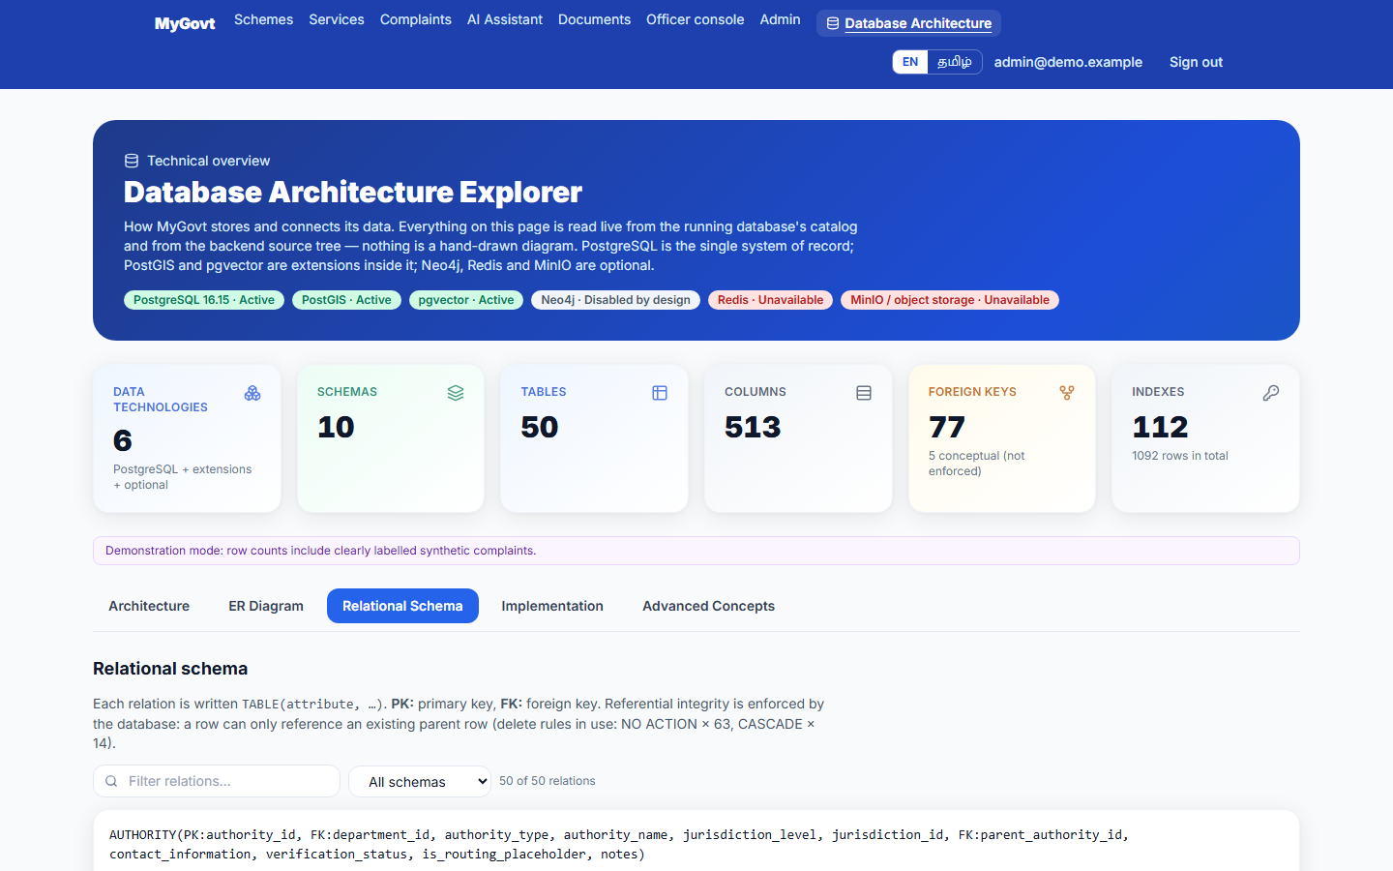
Figure 3: Relational schema browser (tables, keys, notation, example joins)
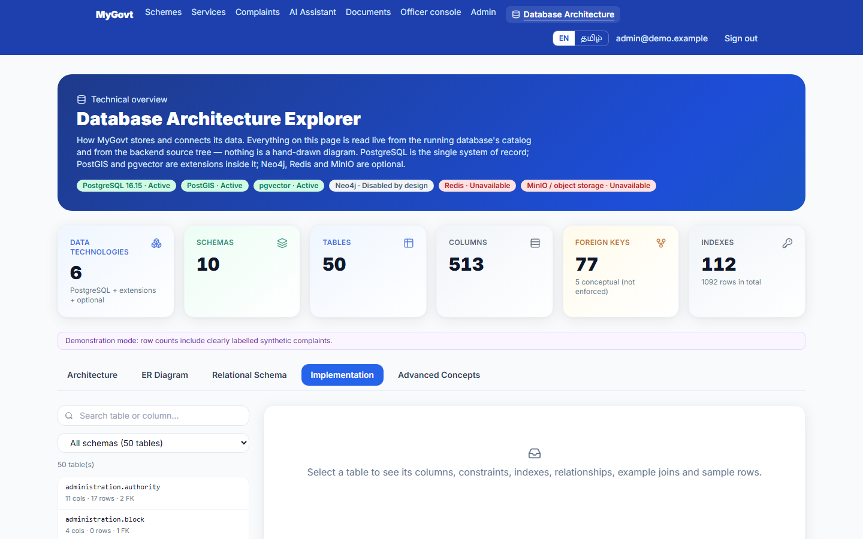
Figure 4: Implementation browser (actual CREATE TABLE text, constraints, indexes, row counts)
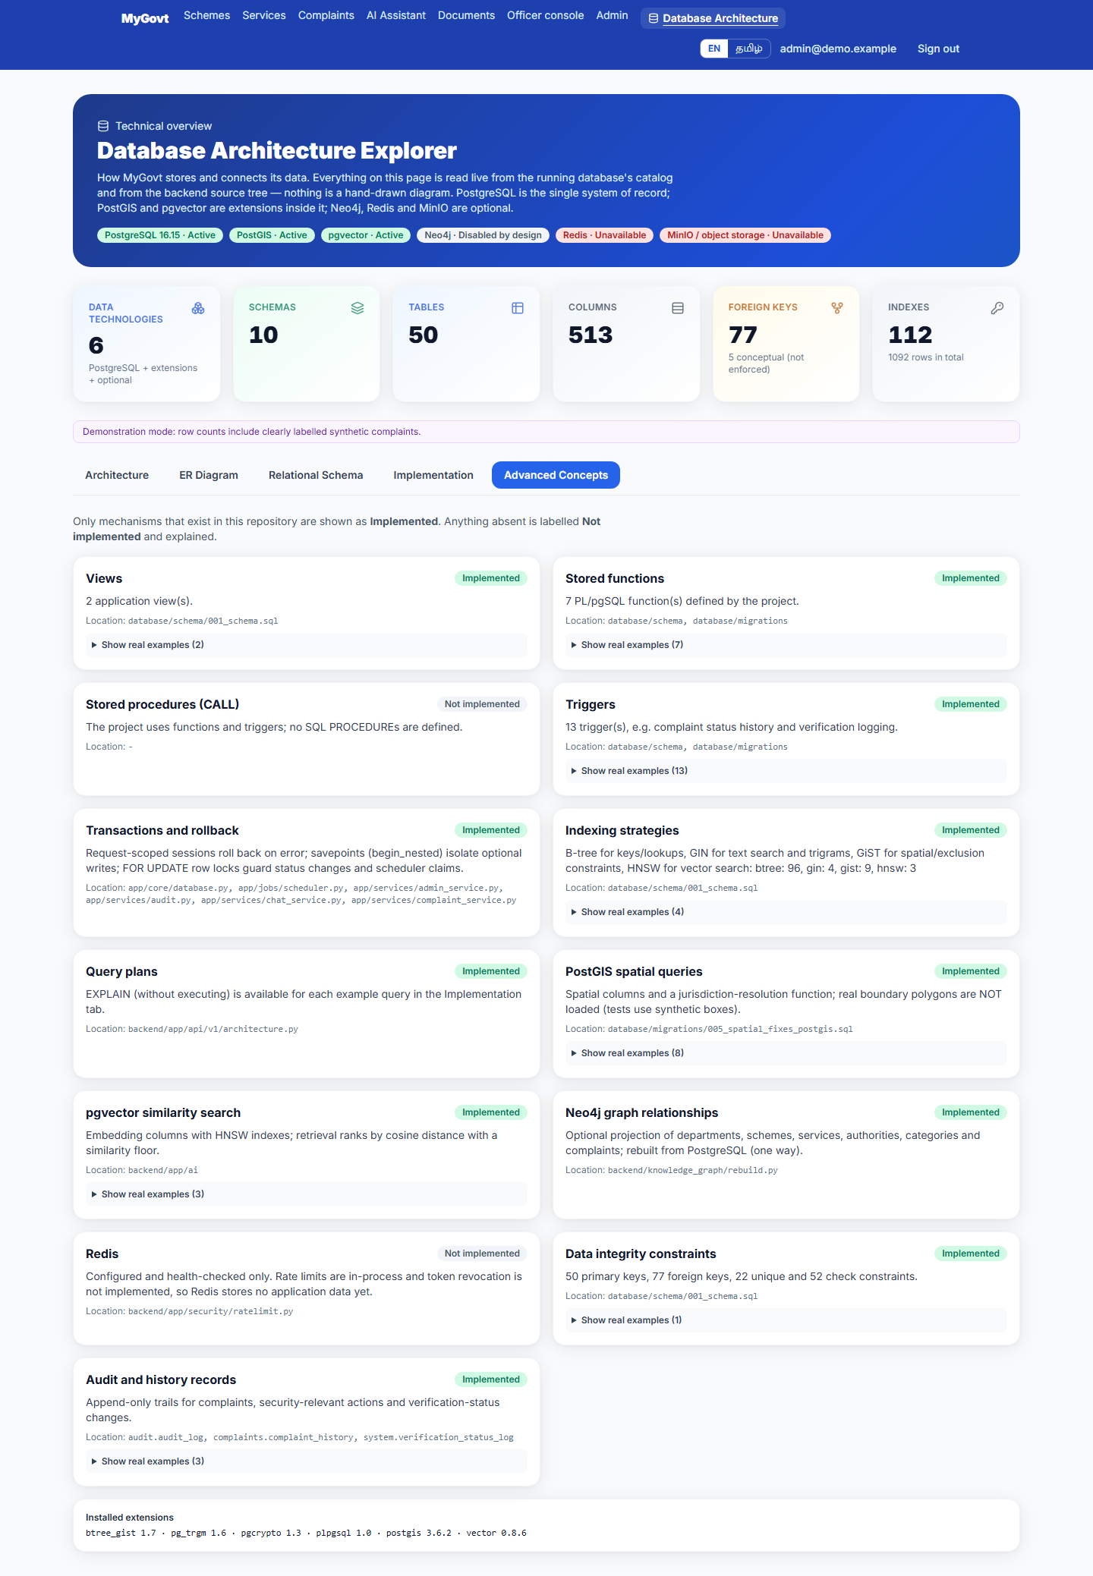
Figure 5: Advanced concepts: triggers, functions, views and transactions found in the database
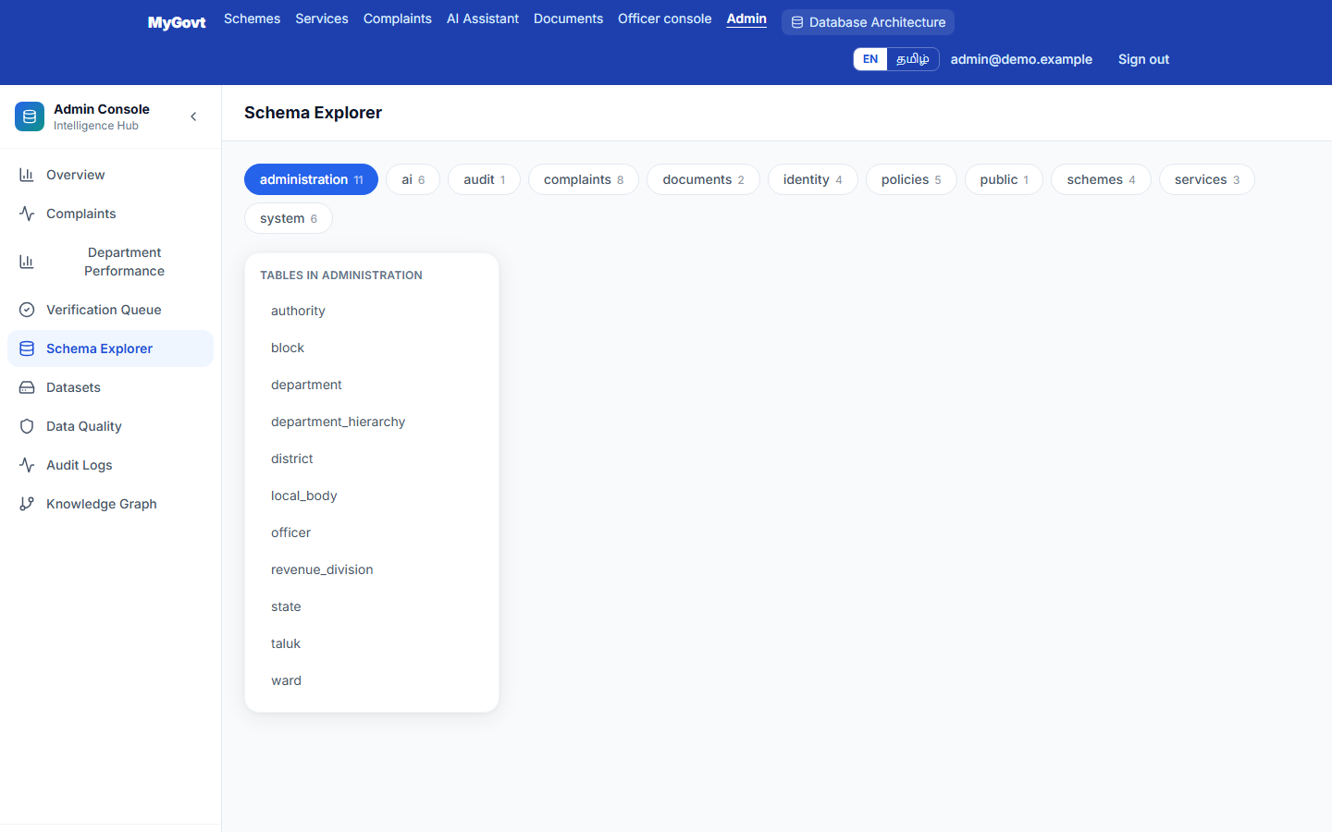
Figure 6: Administrator schema explorer

9.2 Query execution
Query execution is shown as text with outputs in Sections 7 and 8; the administrator SQL workspace in the application runs read-only queries as follows.
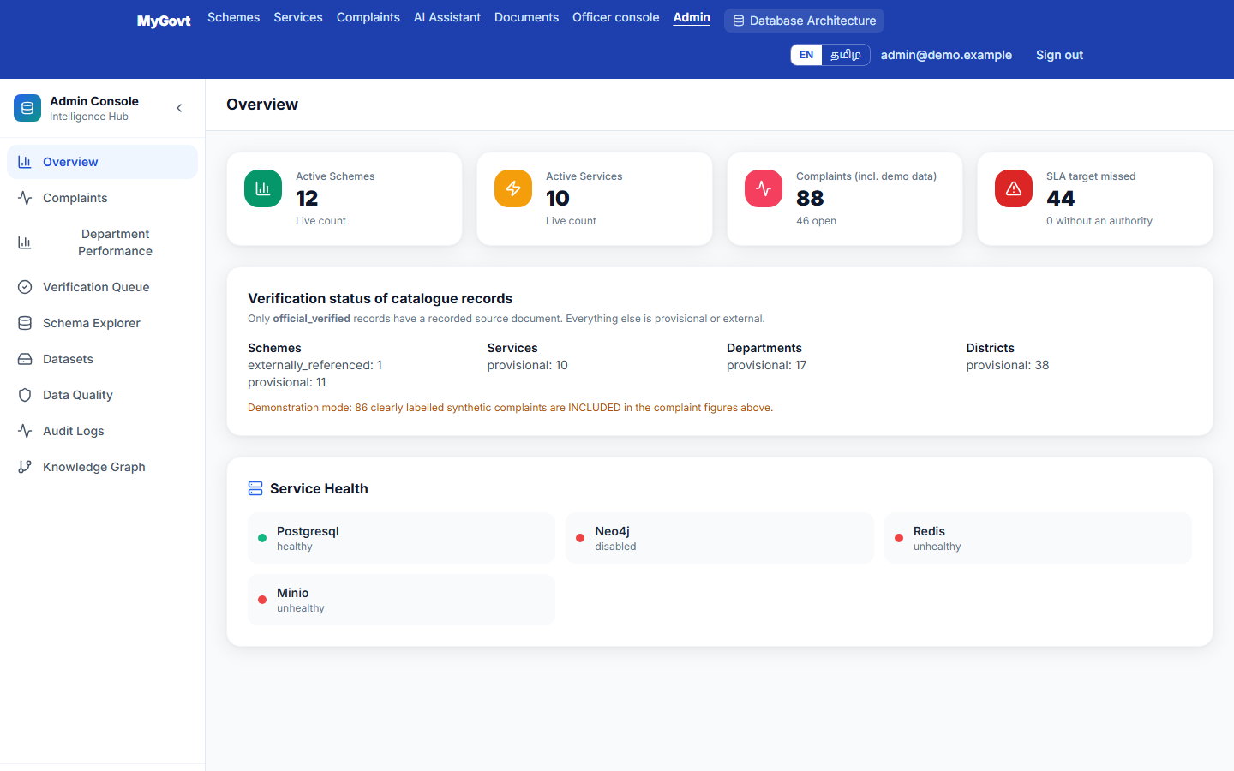
Figure 7: Administrator overview
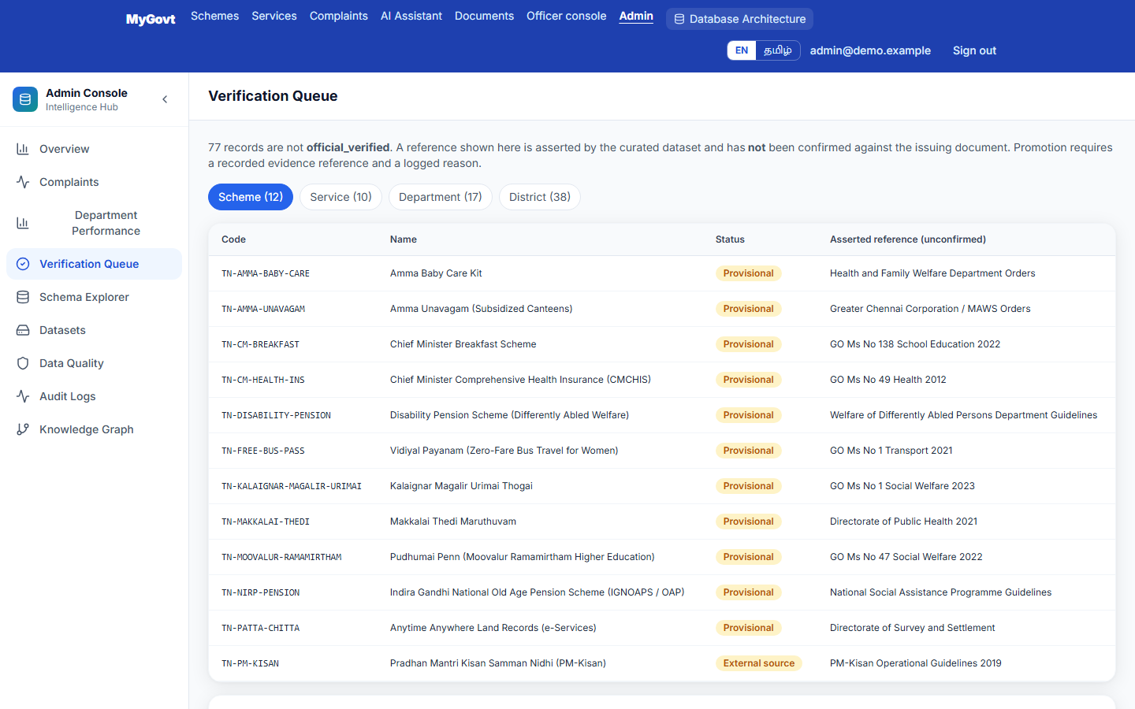
Figure 8: Verification queue: records awaiting verification against an official source

9.3 Application screens
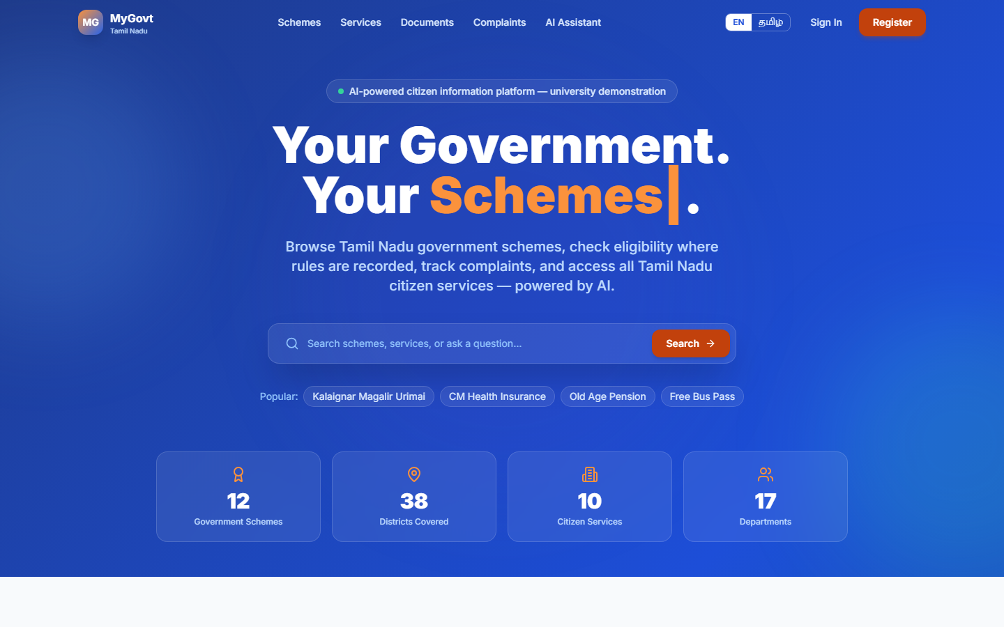
Figure 9: Landing page
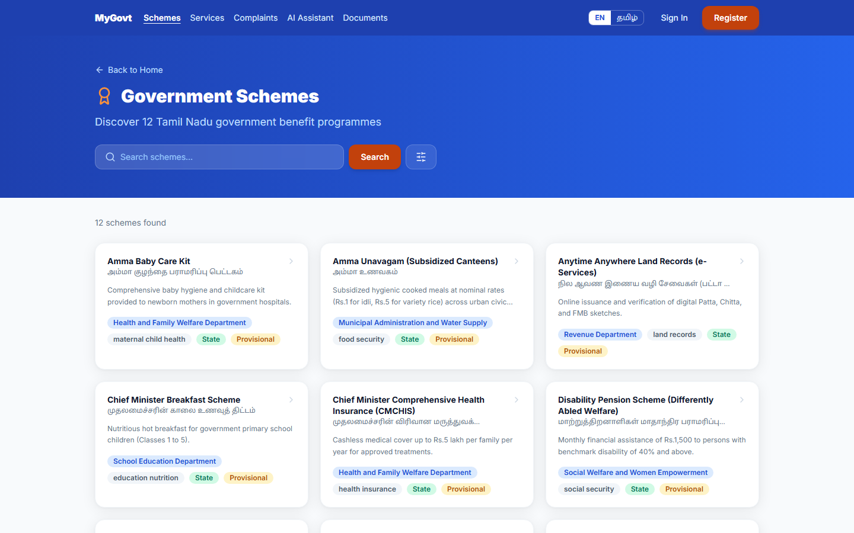
Figure 10: Scheme search and filters
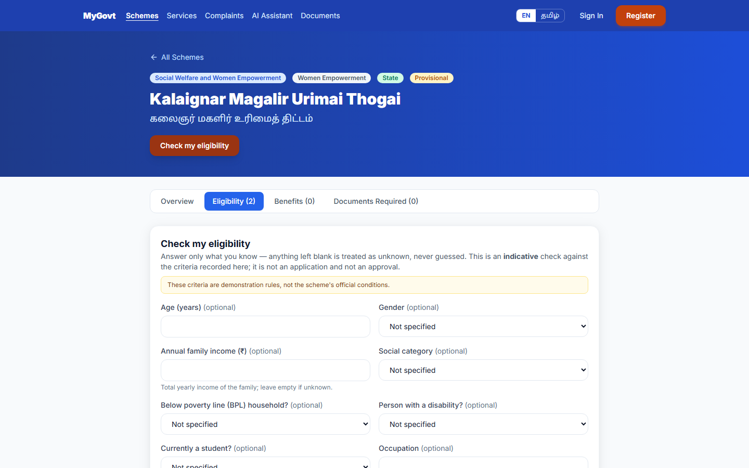
Figure 11: Eligibility checker (rule-based)
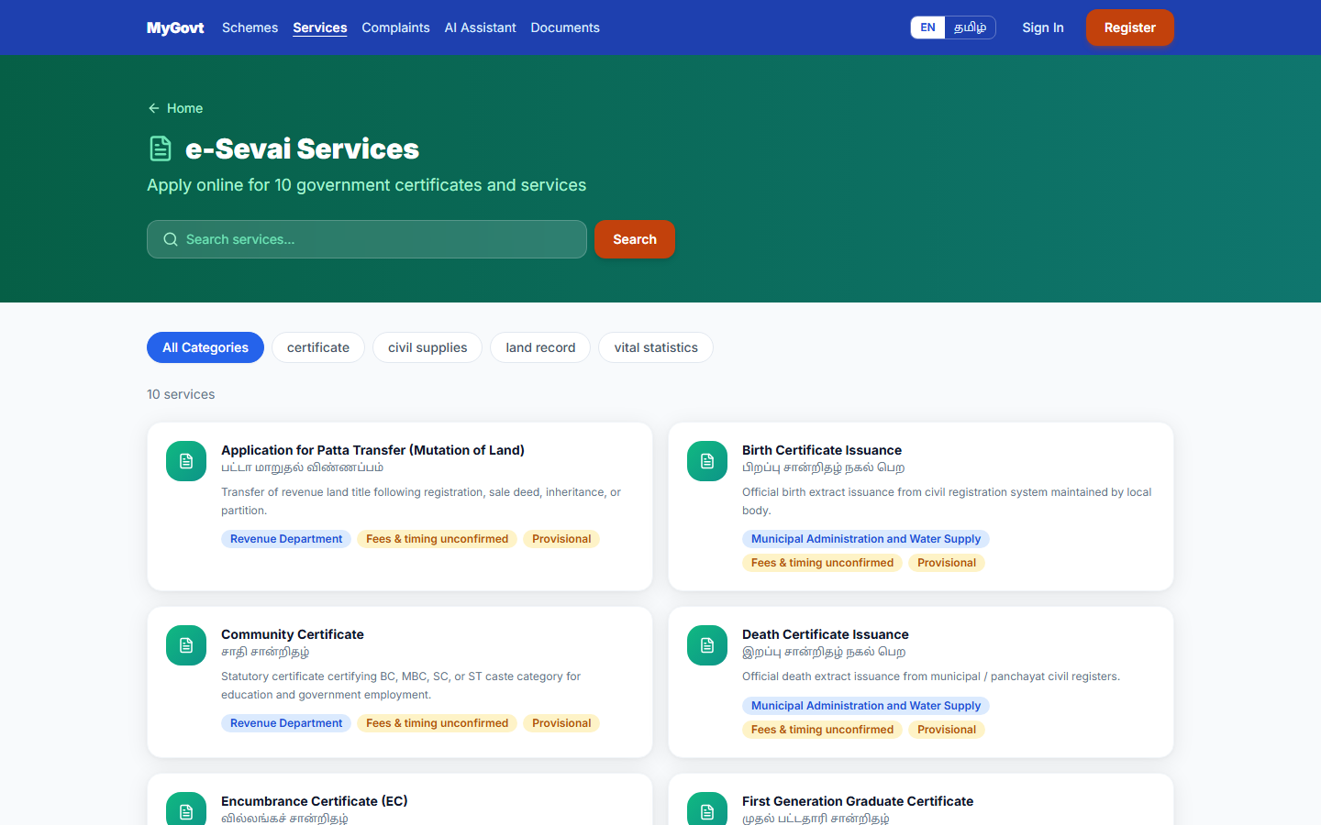
Figure 12: Service search
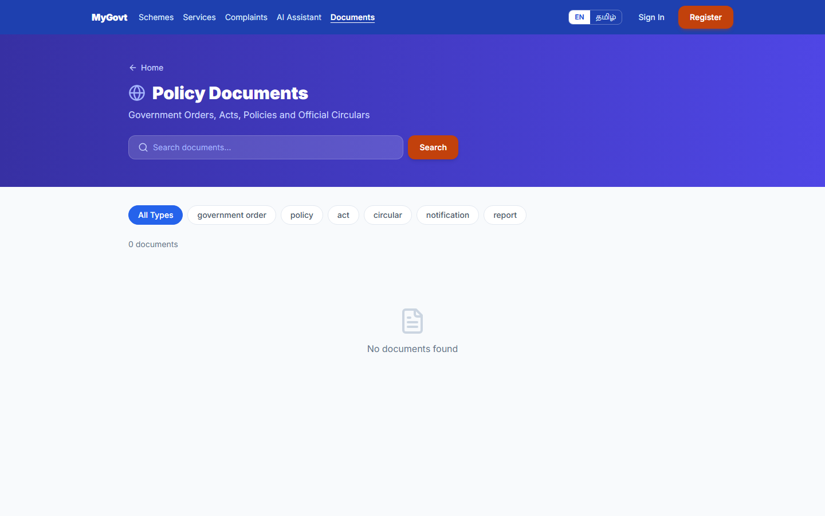
Figure 13: Document requirements
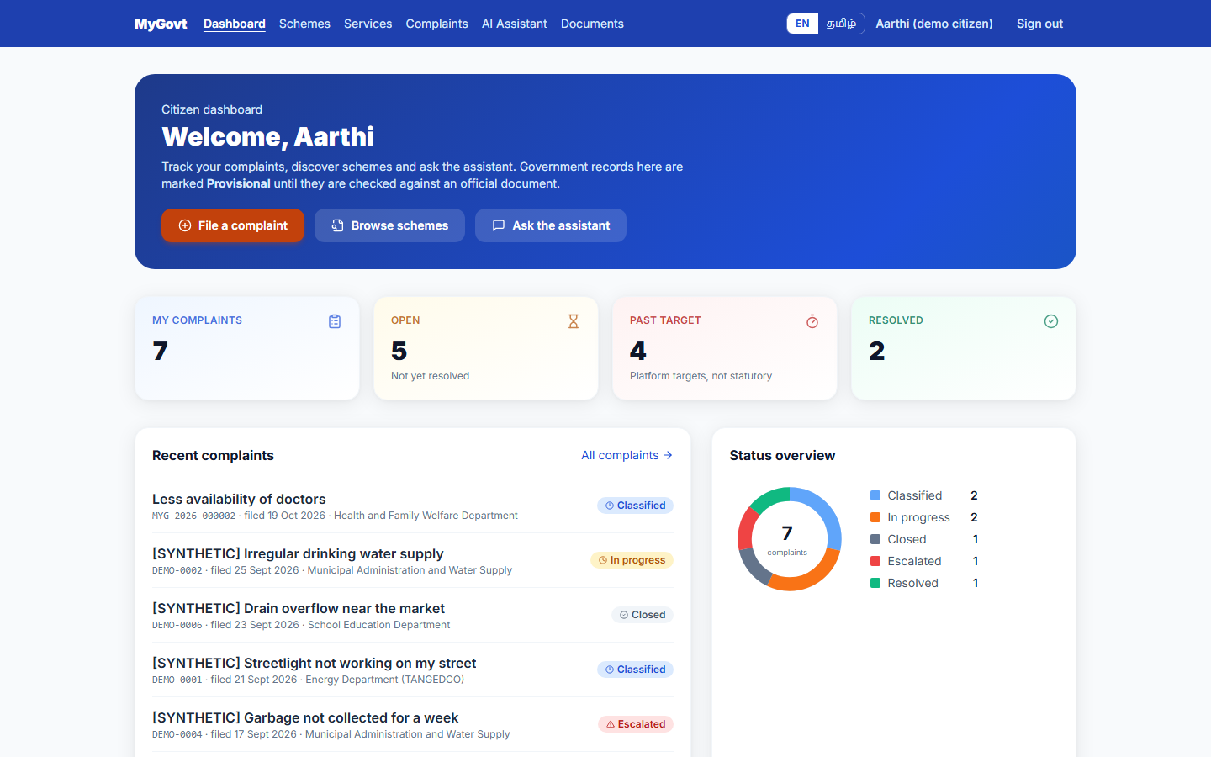
Figure 14: Citizen dashboard
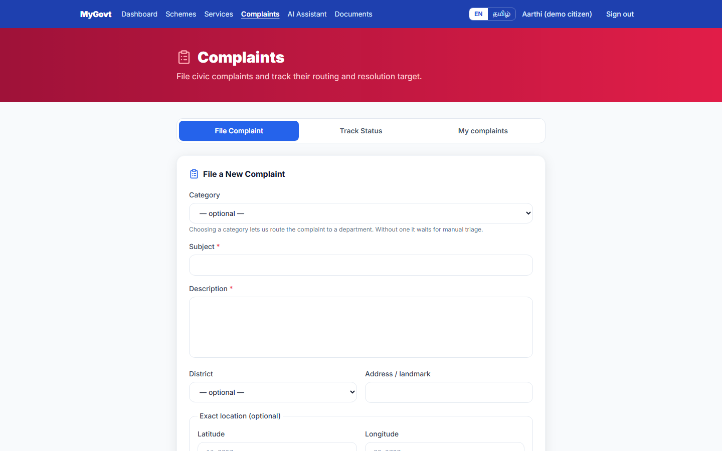
Figure 15: Complaint filing form
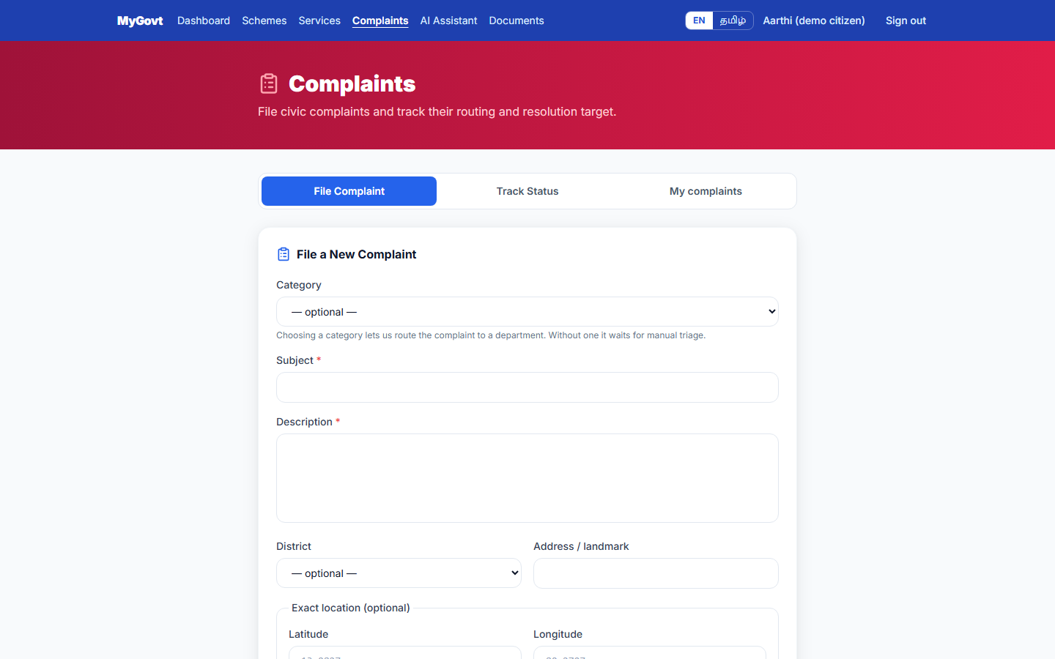
Figure 16: Complaint list and tracking
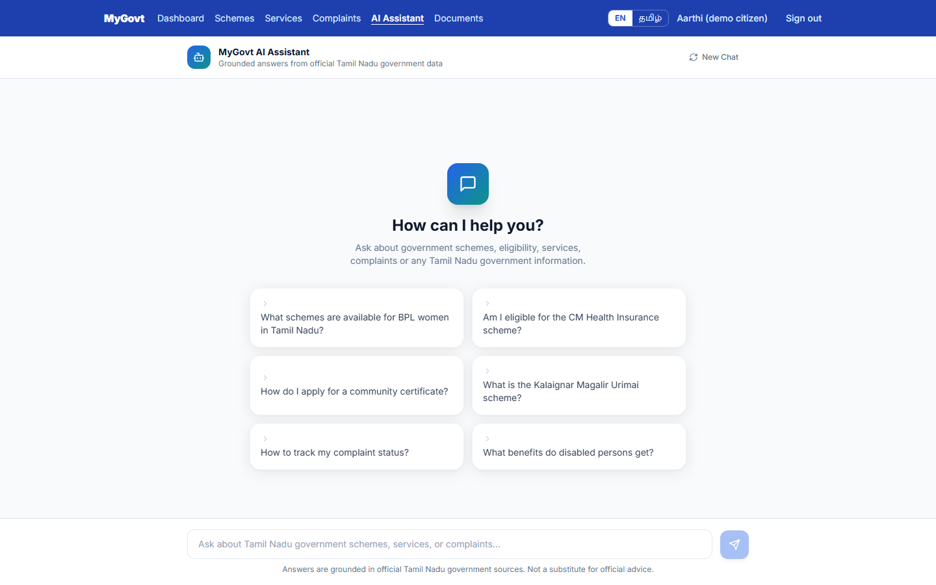
Figure 17: AI assistant (grounded in the database)
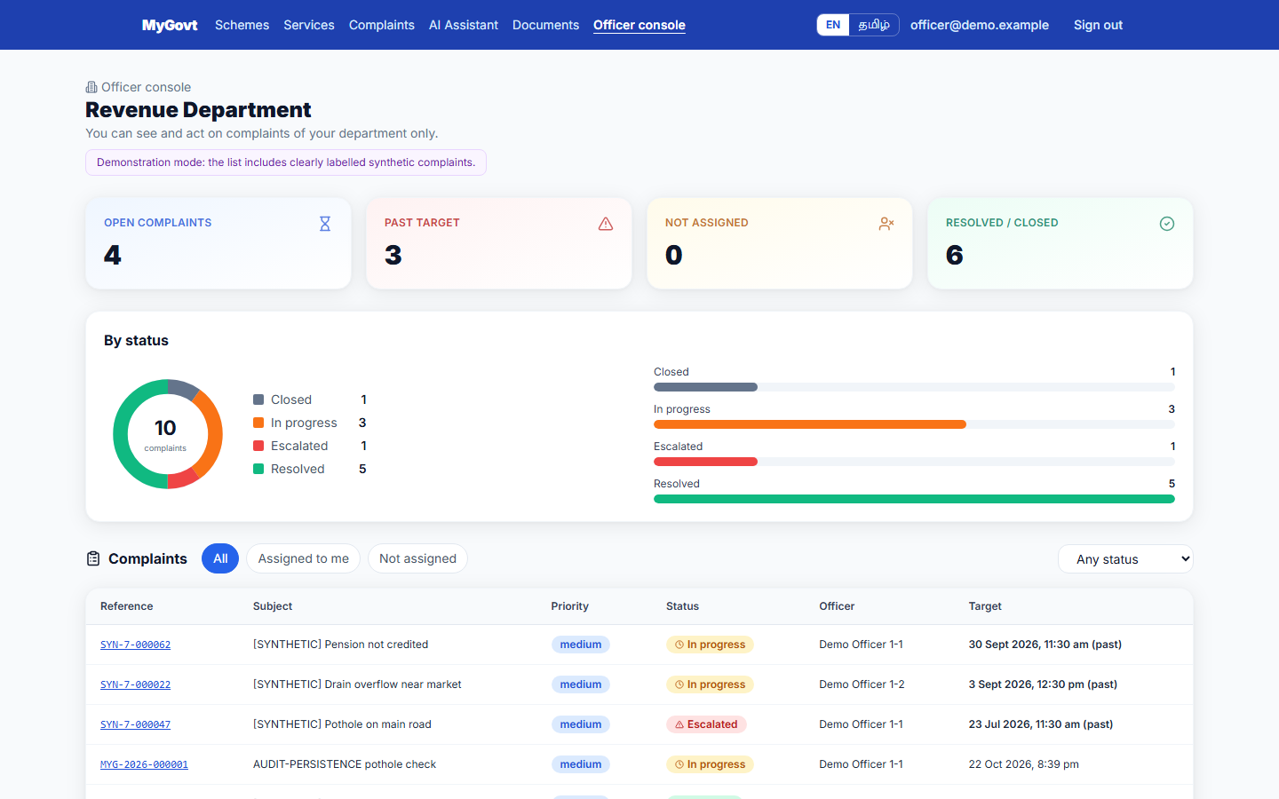
Figure 18: Officer console (department-scoped queue)
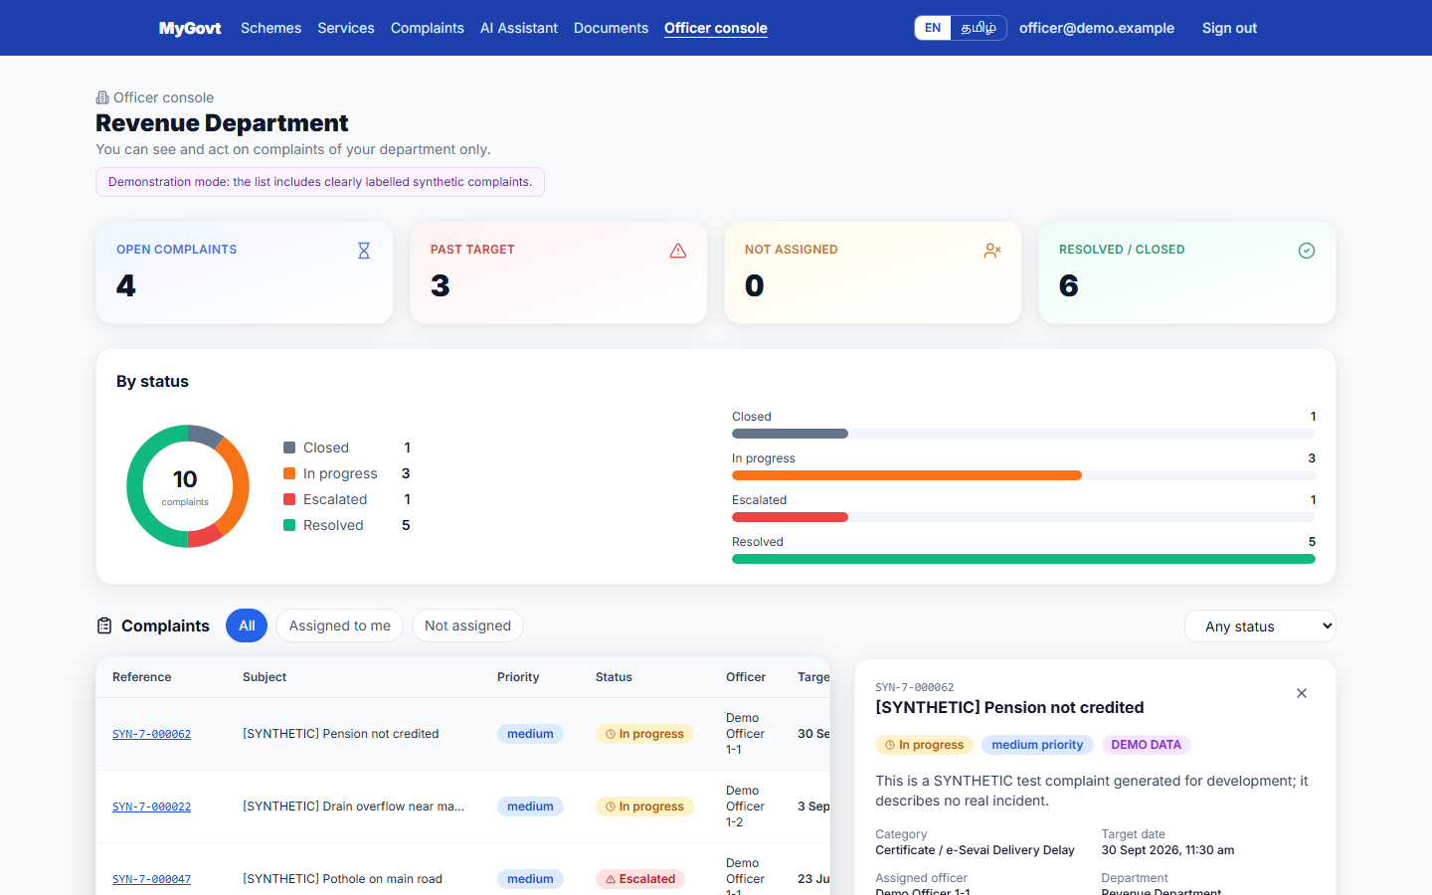
Figure 19: Officer complaint detail with history and status actions
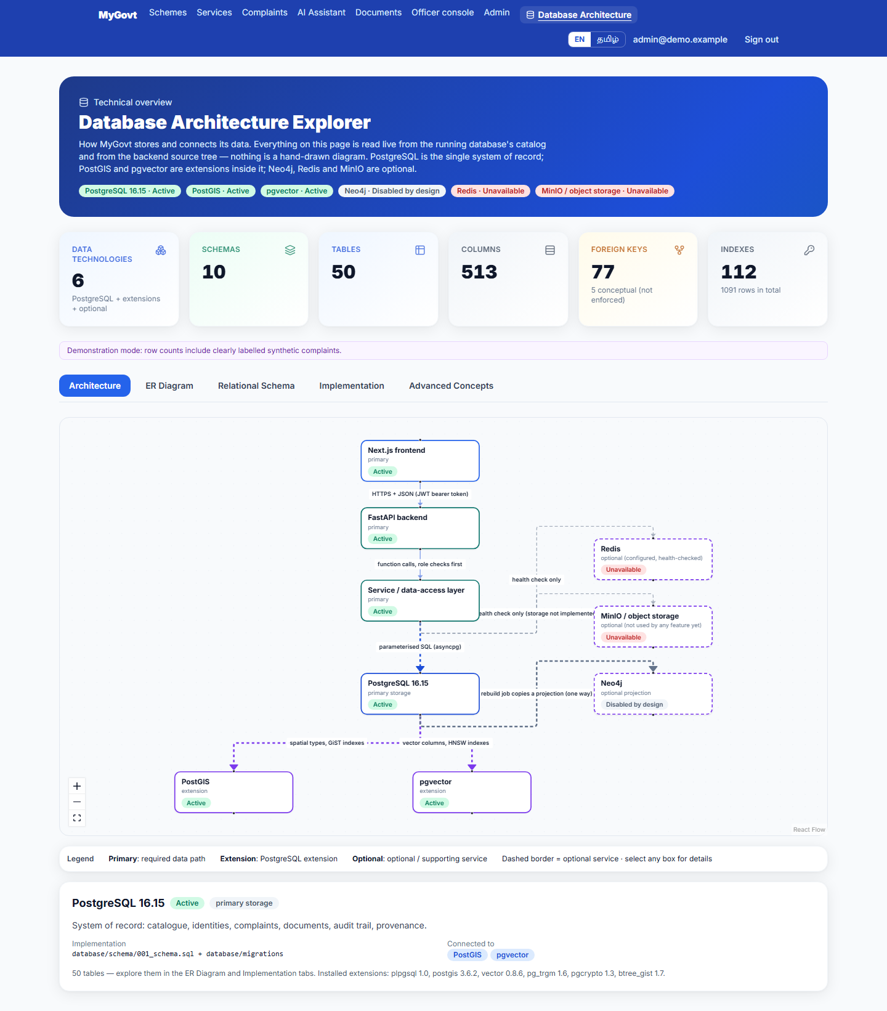
Figure 20: Architecture overview

10. Conclusion
MyGovt demonstrates a complete database-backed application: a normalised PostgreSQL schema of 50 tables with enforced keys and constraints; triggers that record the history of every complaint and make the audit log append-only; views that report SLA breaches and department performance; spatial and vector indexes for location and search; and a web application whose every figure is read from the database.

10.1 Testing and results
Table 17: Testing summary (details: docs/complete_system_audit.md)
Check | Result
Automated tests (pytest + Playwright) | 525 backend tests collected (133 unit tests); 103 end-to-end browser tests
Hosted continuous integration | GitHub Actions run 39298767536 on commit 586d690: 10 of 10 jobs passed (backend, frontend, e2e, security, SQL and data checks, 4 image builds, Compose stack)
System audit | 15/15 routes, 530 controls clicked, 67 API operations probed (0 access-control anomalies), 56 data-consistency checks (0 mismatches)
Defects found and fixed | 30 recorded in docs/audit/defect_register.csv: 22 fixed (each with a regression test or probe), 8 left open as documented limitations
SQL evidence | 47 statements executed for this report; the only errors are the deliberate constraint-violation demonstrations

10.2 Limitations
- No government record is officially verified: all schemes, services and departments are 'provisional' pending confirmation against official documents.
- Third normal form is argued from the design but is not verified by a tool (functional dependencies are not stored in the catalog).
- The application has no SQL stored procedure; the procedure in Section 8.2 is illustrative.
- Jurisdiction boundary polygons are not loaded, so spatial routing by coordinates is demonstrated structurally only.
- The system is ready for a university demonstration, not for public release (see docs/complete_system_audit.md §14).

10.3 Future enhancements
- Verify records against official documents and move them to 'official_verified' through the governed workflow.
- Load ward / taluk / district boundaries to enable automatic location-based routing.
- Table partitioning for the audit log and complaint history as volume grows.
- Notification (SMS / e-mail) on status changes; mobile application; full Tamil content review.

11. References
- PostgreSQL 16 Documentation – https://www.postgresql.org/docs/16/
- PostGIS 3 Documentation – https://postgis.net/documentation/
- pgvector – https://github.com/pgvector/pgvector
- Silberschatz, A., Korth, H. F., Sudarshan, S. Database System Concepts, McGraw-Hill.
- Elmasri, R., Navathe, S. B. Fundamentals of Database Systems, Pearson.
- FastAPI – https://fastapi.tiangolo.com/ ; Next.js – https://nextjs.org/docs
- Government of Tamil Nadu – official department websites (source of the provisional scheme and service records).
- Project repository – https://github.com/santhoshraja-15/My-Govt (docs/complete_system_audit.md, docs/database-architecture.md).

