Ex.No: 5. | IMPLEMENT RSA ALGORITHM USING HTML AND JAVASCRIPT.
Date : 2.3.2026

Program:
<!DOCTYPE html>
<html>
<head>
<title>RSA Algorithm Demo</title>

<style> body {
font-family: Arial, sans-serif; margin: 20px;
background-color: #f9f9f9;
}

h2 {
color: #333;
}

label {
font-weight: bold;
}

input { padding: 5px;
margin-right: 10px;
}

button {
padding: 6px 12px; background-color: #4CAF50; color: white;
border: none; cursor: pointer;

}

button:hover {
background-color: #45a049;
}

#output {
margin-top: 20px; padding: 15px;
border: 1px solid #ccc; background-color: #fff; border-radius: 5px;
font-family: Consolas, monospace; white-space: pre-wrap;
}
</style>
</head>

<body>

<h2>RSA Cryptography Demo</h2>

<label>Message:</label>
<input type="text" id="message" value="HELLO RSA">
<button onclick="runRSA()">Run RSA</button>

<h3>Results:</h3>
<div id="output"></div>

<script>
function gcd(a, b) {
return (b === 0) ? a : gcd(b, a % b);
}

function modPow(base, exp, mod) { let result = 1n;
base = BigInt(base) % BigInt(mod);

exp = BigInt(exp); mod = BigInt(mod);

while (exp > 0n) {
if (exp % 2n === 1n) {
result = (result * base) % mod;
}

exp = exp / 2n;
base = (base * base) % mod;
}

return result;
}

function modInverse(e, phi) {
let [old_r, r] = [BigInt(e), BigInt(phi)]; let [old_s, s] = [1n, 0n];
let [old_t, t] = [0n, 1n];

while (r !== 0n) { let q = old_r / r;

[old_r, r] = [r, old_r - q * r];
[old_s, s] = [s, old_s - q * s];
[old_t, t] = [t, old_t - q * t];
}

return (old_s + phi) % phi;
}

function runRSA() { let p = 61n;
let q = 53n;

let n = p * q;
let phi = (p - 1n) * (q - 1n);

let e = 17n;
let d = modInverse(e, phi);

let msg = document.getElementById("message").value;

let msgCodes = Array.from(msg).map(function (ch) { return BigInt(ch.charCodeAt(0));
});

let encrypted = msgCodes.map(function (m) { return modPow(m, e, n);
});

let decrypted = encrypted.map(function (c) { return modPow(c, d, n);
});

let decryptedMsg = decrypted
.map(function (num) {
return String.fromCharCode(Number(num));
})
.join("");

document.getElementById("output").textContent = "Public Key (e, n): (" + e + ", " + n + ")\n" +
"Private Key (d, n): (" + d + ", " + n + ")\n\n" + "Original Message: " + msg + "\n" +
"Encrypted (numeric): " + encrypted.join(", ") + "\n" + "Decrypted Message: " + decryptedMsg;
}
</script>

</body>
</html>

OUTPUT:

TEST CASE 1:
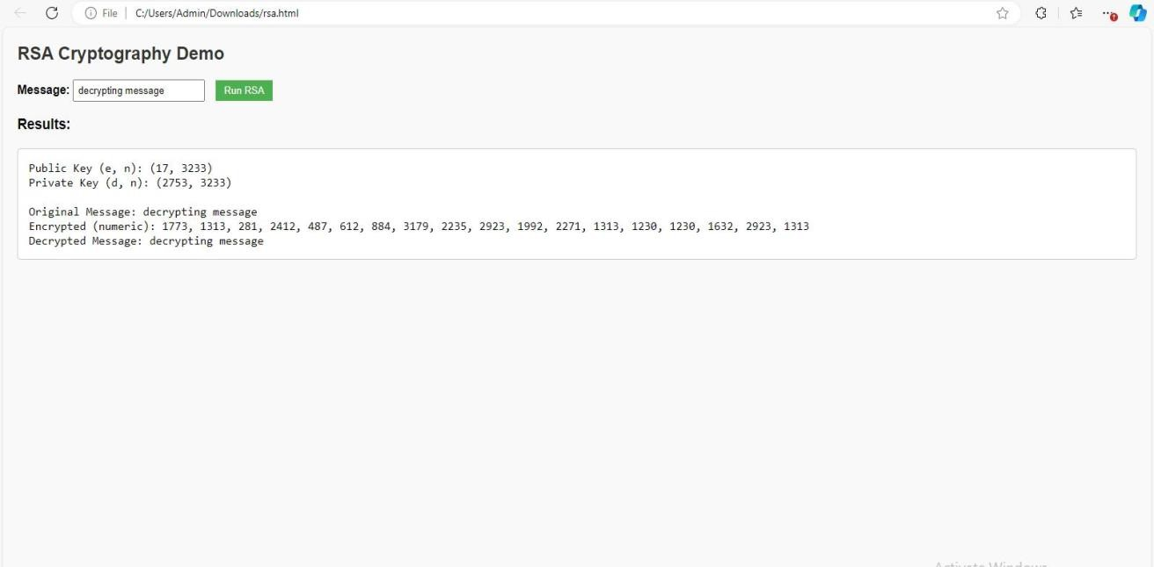

TEST CASE 2:

