**Steps to configure MQ Source connector for Event streams topic**

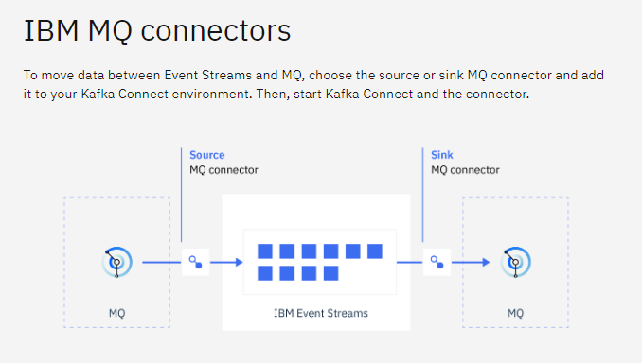

MQ Source connector is an inbuild connector in Event Streams for moving data from MQ to Event streams. This guide assumes both MQ and Event Streams are deployed in same CP4I Openshift Cluster.

Steps to configure MQSource connector for Event Streams

**Step 1:**

Install Event Streams operators in Openshift Cluster

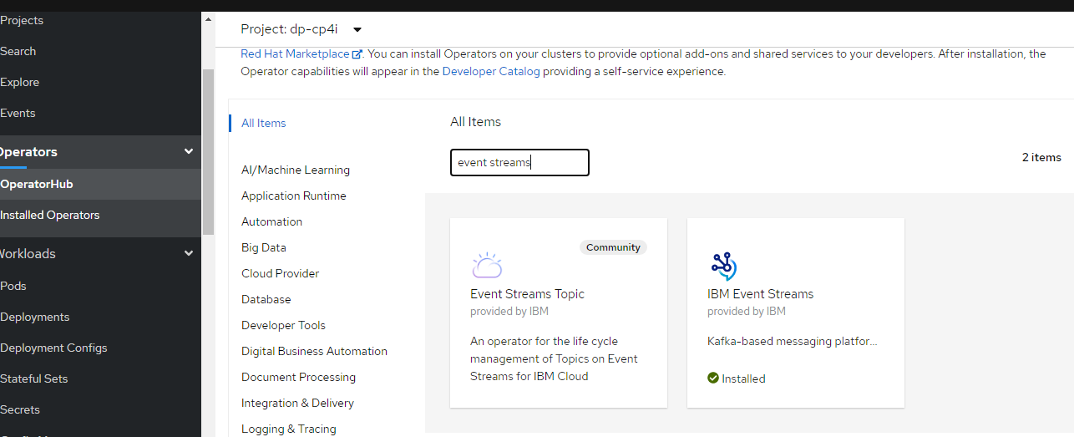

**Step2:**

Installation can be verified in Installed Operators tab

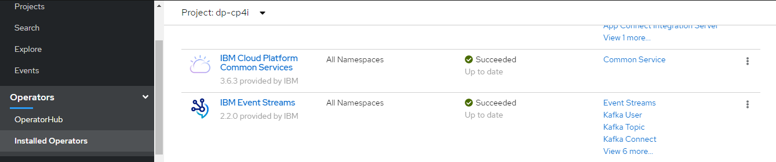

**Step 3:**

Go to platform Navigator -> Select Runtimes -> Create Instance

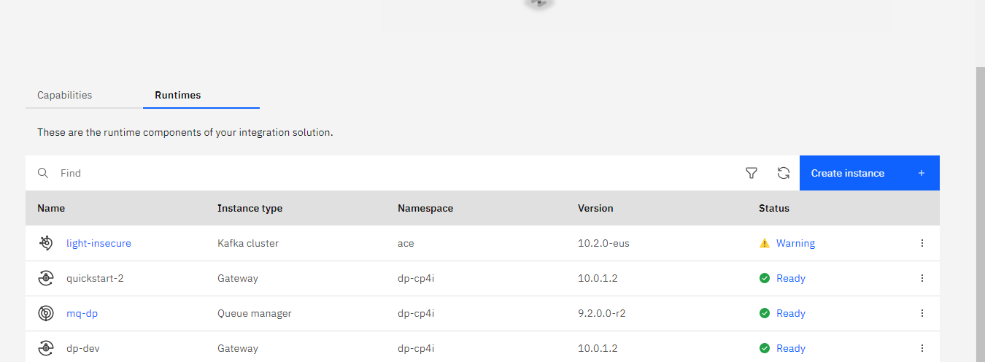

**Step 4:**

Select Kafka Cluster and select the type of cluster you want to setup (In this example I have selected Lightweight without Security option)

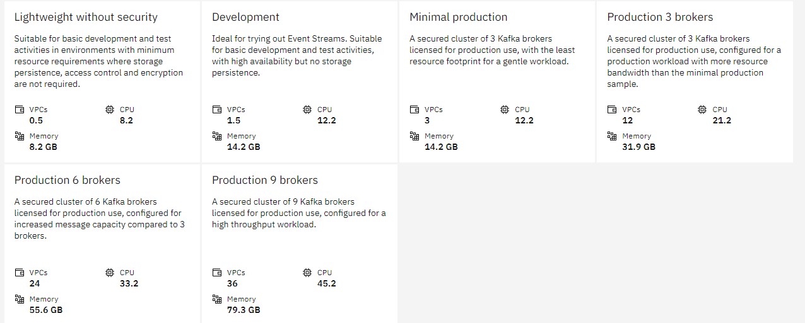

**Step 5:**

Enter details on front end or create yaml file as below



This will create a default Event Streams instance

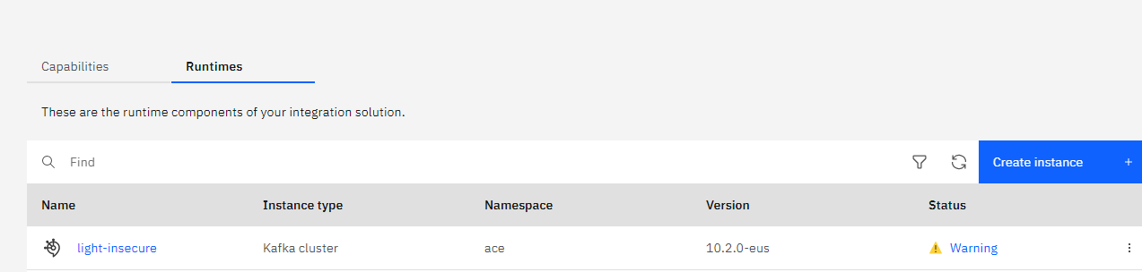

**Step 6:**

Select the newly created Event Streams instance and create a topic using Create Topic button (Ex: mqmessage). This is the topic which receives message from MQ

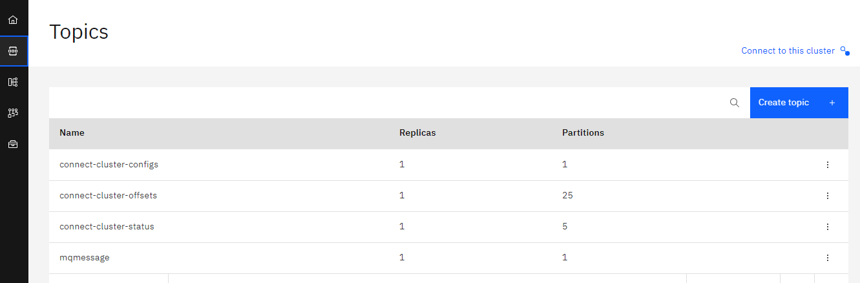

From Step 1 to Step 6 completes the setup and creation of topic in Event Streams.

**Step 7:**

Assuming an MQ instance has already been created in the same cluster as Event Streams and a Queue has been created from which data will be transferred to Event streams



This use case consider no auth between MQ and Event streams which can be used in non prod region, but in production region authentication should be implemented

**Step 8:**

Select the queue manager and create a local queue (Ex: ESQ)

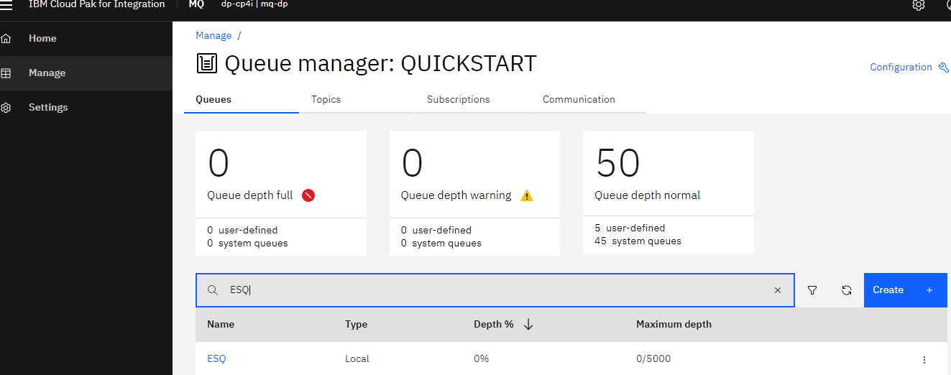

**Step 9:**

Open Event Streams instance and select Toolbox option from the right side icons

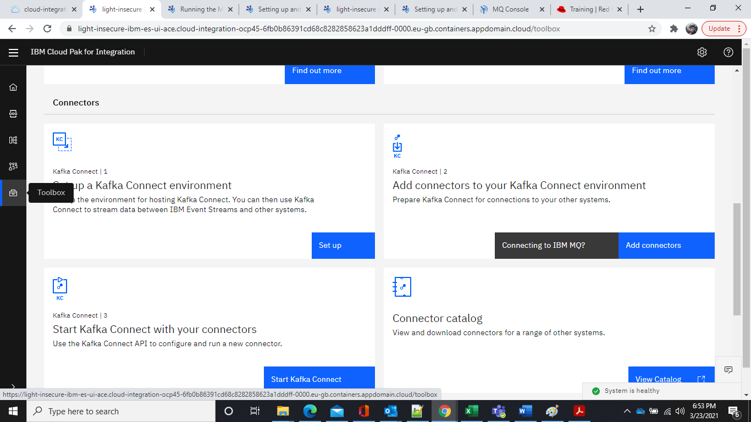

**Step 10:**

Select Setup a kafka connect environment option to initiate a kafka connect environment for your Event streams instance

Follow the instruction present in the Set up link

**Step 11:**

Select Add Connectors to your Kafka Connect environment

Follow the instruction present in the Connecting to IBM MQ? Option

**Step 12:**

**Select Start Kafka Connect with your connectors**

Follow the instruction present in the Start Kafka Connect option

Alternate to Step 10 to Step 12, you can setup and start MQ connectors from the below link

<https://ibm.github.io/event-streams/connecting/setting-up-connectors/>

Make sure the download MQ Source connect jar file

