FINAL REVIEW - APPENDICES
FarmDirect: Farmer-to-Consumer Agricultural Marketplace
This technical appendix suite provides complete supporting evidence, core production source code listings, operational sub-functionality screen flows, the master QA test case execution matrix, and relational database DDL specifications that support the main technical review reports without cluttering the primary text.
Appendix A: Key Source Code Modules
Appendix A provides representative implementations of the core technical innovations highlighted in the implementation review:
A.1 Concurrency Control & Row-Level Inventory Locking (app.py)
Implements pessimistic locking using 'SELECT ... FOR UPDATE' inside an atomic database transaction to prevent inventory overselling:
-- Listing A.1: Python / Flask - Atomic Row Locking in place_order()
@app.route('/customer/place-order', methods=['POST'])
@role_required('customer')
def place_order():
conn = get_db_connection(); cursor = conn.cursor(dictionary=True)
try:
prod_ids = tuple(int(k) for k in cart_data.keys())
format_strings = '(%s)' if len(prod_ids) == 1 else str(tuple(prod_ids))
cursor.execute(f"SELECT product_id, available_quantity FROM products WHERE product_id IN {format_strings} FOR UPDATE;", prod_ids)
for p in cursor.fetchall():
if p['available_quantity'] < cart_data[str(p['product_id'])]:
conn.rollback(); flash('Insufficient stock', 'danger'); return redirect(url_for('cart'))
cursor.execute("UPDATE products SET available_quantity = available_quantity - %s WHERE product_id = %s;",
(cart_data[str(p['product_id'])], p['product_id']))
conn.commit()
finally: cursor.close(); conn.close()

A.2 Client-Side Laptop Webcam Hardware Integration (static/js/script.js)
Utilizes HTML5 MediaDevices API to access laptop camera hardware, streaming video into a viewfinder, and binding blobs via DataTransfer:
-- Listing A.2: JavaScript - HTML5 MediaDevices & Canvas DataTransfer Binding
const FarmDirectWebcam = {
start: async function() {
const stream = await navigator.mediaDevices.getUserMedia({ video: { idealWidth: 1280, idealHeight: 720 }, audio: false });
document.getElementById('webcamVideo').srcObject = stream;
},
capture: function() {
const video = document.getElementById('webcamVideo'), canvas = document.getElementById('webcamCanvas');
canvas.width = video.videoWidth || 640; canvas.height = video.videoHeight || 480;
canvas.getContext('2d').drawImage(video, 0, 0, canvas.width, canvas.height);
canvas.toBlob((blob) => {
const file = new File([blob], 'webcam_produce.jpg', { type: 'image/jpeg' });
const dt = new DataTransfer(); dt.items.add(file);
document.getElementById('productImageInput').files = dt.files;
}, 'image/jpeg', 0.92);
}
};

A.3 MySQL Connection Pooling & Safe Resource Leasing (utils/db.py)
Implements connection pool leasing with deterministic try-finally cursor cleanup to eliminate database connection leaks:
-- Listing A.3: Python - Centralized MySQL Connection Pooling and Execution
_connection_pool = mysql.connector.pooling.MySQLConnectionPool(pool_name="farmdirect_pool", pool_size=10, ...)
def query_db(query, args=(), one=False, commit=False):
conn = get_db_connection(); cursor = conn.cursor(dictionary=True)
try:
cursor.execute(query, args)
if commit: conn.commit(); return cursor.lastrowid or cursor.rowcount
rv = cursor.fetchall(); return (rv[0] if rv else None) if one else rv
finally: cursor.close(); conn.close() # Safely returns connection back to pool

Appendix B: Screenshots of Core Sub-Functionalities & Screen Flow
Appendix B documents vital supporting sub-functionalities of FarmDirect that were not featured in the primary testing report, illustrating public crop discovery, cart item quantity management, farmer inventory tracking, and consumer order tracking:
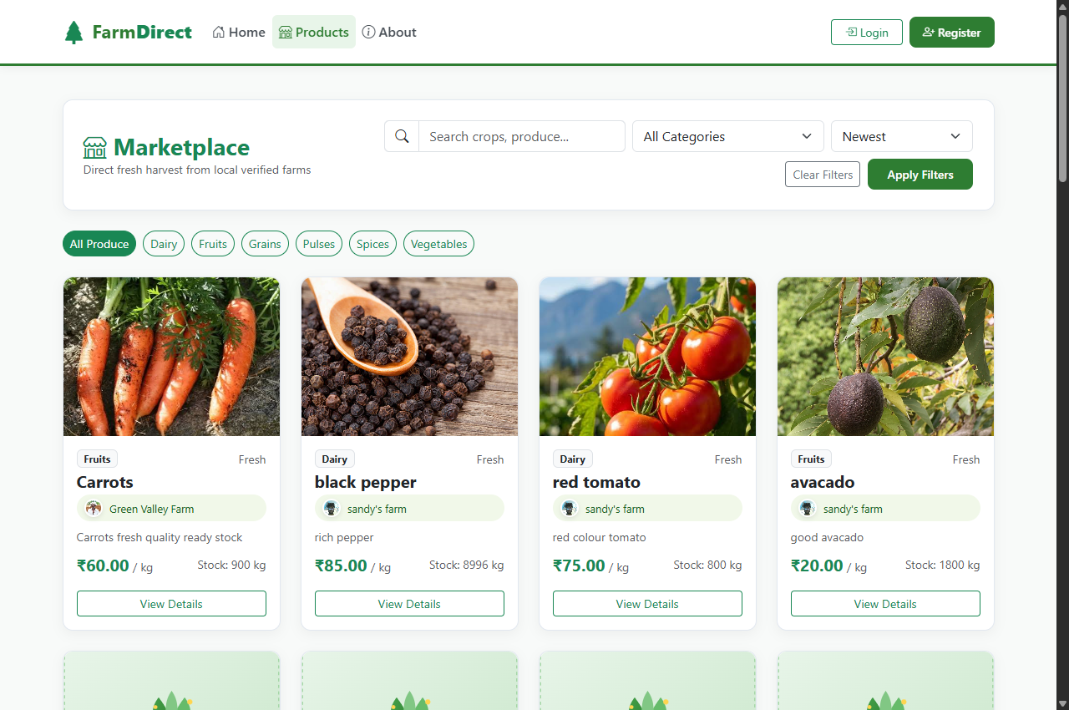  Figure B.1: Marketplace Produce Discovery & Filtering  Demonstrates public crop catalog (/products) with live search by crop name, category filter pills, price sorting, farmer origin tags, and 'Add to Cart' actions. | 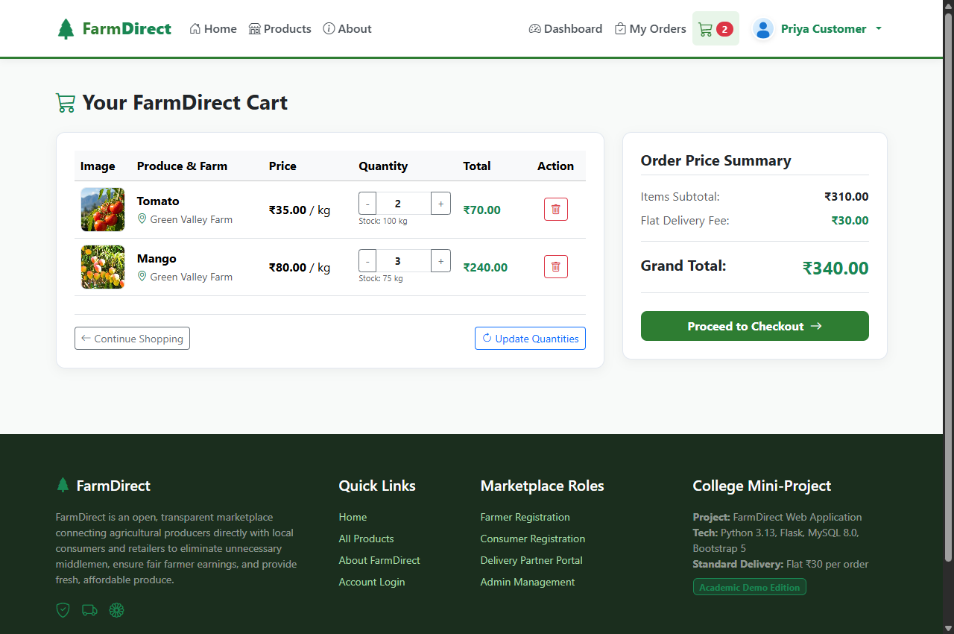  Figure B.2: Customer Cart & Dynamic Price Calculations  Demonstrates multi-item shopping cart (/customer/cart) with quantity increment/decrement controls, real-time subtotal computation, delivery fee aggregation, and checkout redirection.
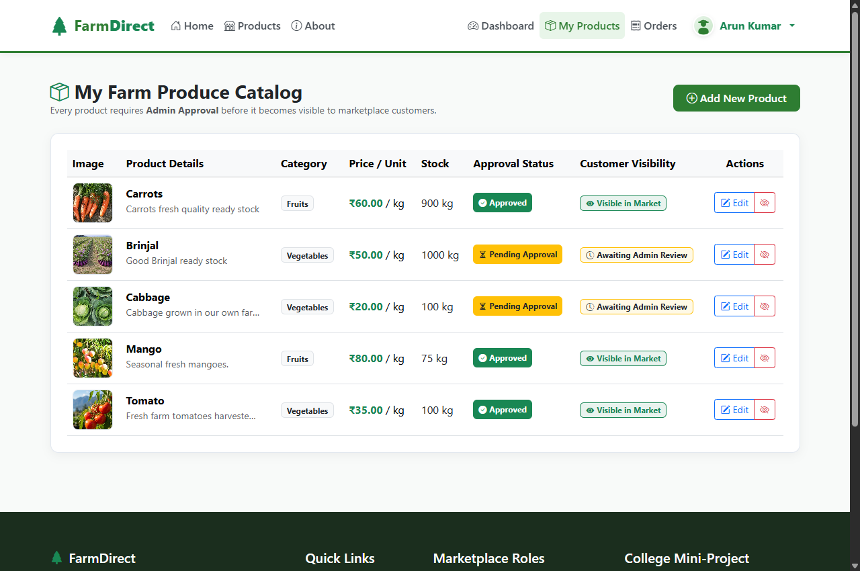  Figure B.3: Farmer Agricultural Inventory & Status  Demonstrates farmer's inventory management dashboard (/farmer/products) displaying crop images, category classifications, available stock units, and dual approval badges. | 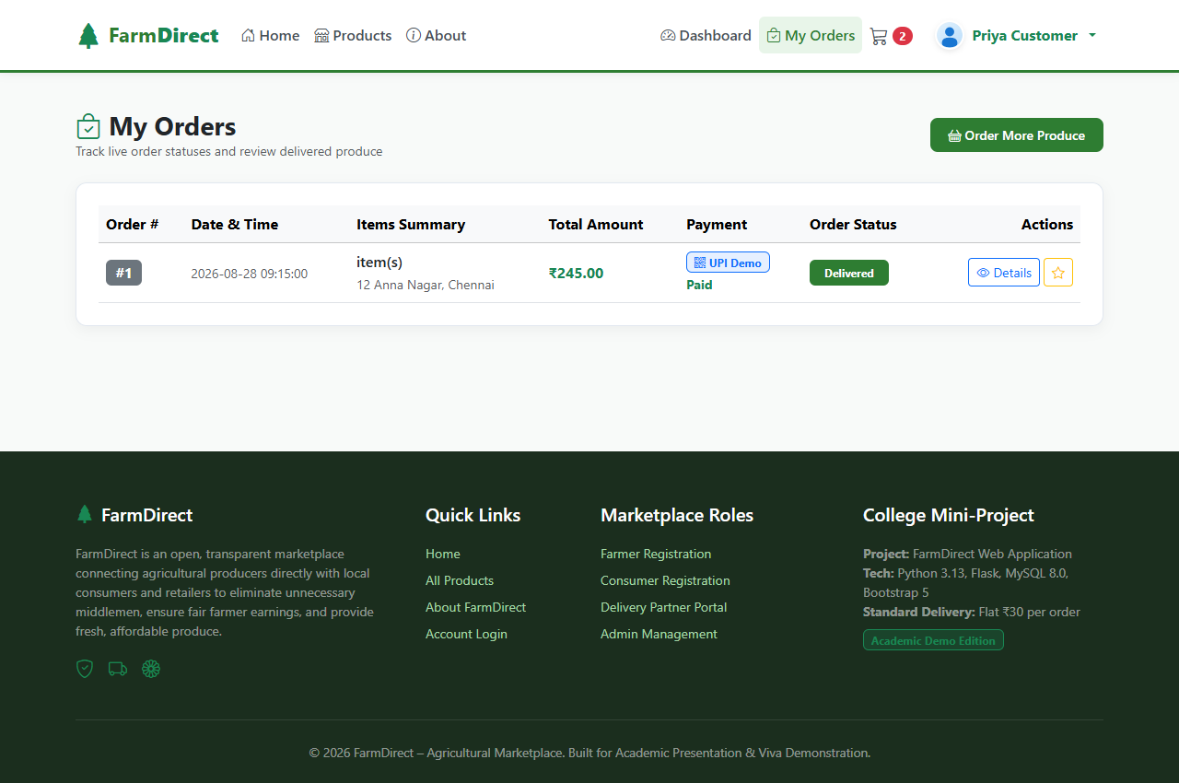  Figure B.4: Customer Order History & Delivery State Machine  Demonstrates customer's order history dashboard (/customer/orders) showing purchase invoices, payment method badges, and real-time delivery status progression (Placed -> Delivered).
Appendix C: Master Test Case Specification Table
Appendix C provides the exhaustive formal Quality Assurance verification matrix (TC-001 through TC-010). Each test case records preconditions, test steps, expected architectural behaviors, actual observed responses, and final verification verdicts:
Test ID | Actor / Module | Test Scenario & Input Steps | Expected Result | Actual Result | Verdict
TC-001 | Auth / Security | Register user with weak/empty password | Reject registration and display validation alert | Rejected with flash error message | PASS
TC-002 | Auth / Security | Login with valid user credentials | Hash verified via Scrypt; session cookie issued with user role | Session created; redirected to role dashboard | PASS
TC-003 | RBAC Route Guard | Customer attempts unauthorized /admin/dashboard access | Intercept request, deny access, redirect to login | HTTP 302 redirect with 'Access Denied' alert | PASS
TC-004 | Admin / KYC | Admin approves pending farmer KYC submission | Farmer status transitions to 'verified' in MySQL database | Status updated instantly; crop listing unlocked | PASS
TC-005 | Farmer / Webcam | Farmer clicks 'Take Photo' to activate laptop camera | Browser prompts getUserMedia(); streams live video feed | Live stream rendered in modal viewfinder | PASS
TC-006 | Farmer / Upload | Submit produce listing with webcam captured image | Image saved to static/uploads/; product saved with status 'pending' | Product registered with correct image path | PASS
TC-007 | Customer / Cart | Add products to shopping cart and modify quantities | Cart updates subtotal and grand total with delivery fee | Calculated accurately via Decimal precision | PASS
TC-008 | Customer / Pay | Select 'UPI / QR Payment' at checkout | Dynamic SVG QR generated embedding order total & merchant UPI URI | Sharp SVG QR displayed instantly on client | PASS
TC-009 | Concurrency Lock | Two simultaneous checkouts for product with stock = 1 | Pessimistic 'SELECT ... FOR UPDATE' allows 1 order, rejects 2nd | First order succeeds; second receives out-of-stock | PASS
TC-010 | Delivery Module | Delivery partner claims dispatch order and updates status | Status transitions: Assigned -> In Transit -> Delivered in DB | Customer tracking updates in real-time | PASS

Appendix D: Database Schema DDL & Visual Studio Code Execution Guide
Appendix D documents the relational database DDL statements for MySQL 8.0, followed by the step-by-step Visual Studio Code (VS Code) project execution and review demonstration procedure:
-- SQL - MySQL 8.0 Relational Table Definitions (InnoDB Engine)
-- MySQL 8.0 InnoDB Relational Table DDL
CREATE TABLE users (user_id INT AUTO_INCREMENT PRIMARY KEY, full_name VARCHAR(100), email VARCHAR(100) UNIQUE,
password_hash VARCHAR(255), role ENUM('admin','farmer','customer','delivery'), phone VARCHAR(20), city VARCHAR(50));
CREATE TABLE farmers (farmer_id INT PRIMARY KEY, farm_name VARCHAR(100), farm_location TEXT,
verification_status ENUM('pending','verified','rejected') DEFAULT 'pending', FOREIGN KEY (farmer_id) REFERENCES users(user_id));
CREATE TABLE products (product_id INT AUTO_INCREMENT PRIMARY KEY, farmer_id INT, category_id INT, product_name VARCHAR(100),
unit VARCHAR(20), price DECIMAL(10,2), available_quantity DECIMAL(10,2), product_status ENUM('available','out_of_stock'),
approval_status ENUM('pending','approved','rejected') DEFAULT 'pending', image_filename VARCHAR(255), FOREIGN KEY (farmer_id) REFERENCES farmers(farmer_id));
CREATE TABLE orders (order_id INT AUTO_INCREMENT PRIMARY KEY, customer_id INT, total_amount DECIMAL(10,2),
order_status ENUM('placed','confirmed','dispatched','delivered'), payment_method ENUM('cod','upi','card'), payment_status ENUM('pending','paid'));
CREATE TABLE delivery_tracking (tracking_id INT AUTO_INCREMENT PRIMARY KEY, order_id INT, delivery_partner_id INT,
current_status ENUM('assigned','picked_up','in_transit','delivered') DEFAULT 'assigned', updated_at TIMESTAMP ON UPDATE CURRENT_TIMESTAMP);
D.2 Visual Studio Code (VS Code) Execution & Demonstration Procedure
The project is configured for execution within Microsoft Visual Studio Code on Windows:
-- PowerShell / VS Code - Step-by-Step Environment Setup & Execution Procedure
# 1. Launch Visual Studio Code in Project Workspace
code "d:\Santhosh Rathinam\farm"
# 2. Select Python Interpreter in VS Code (Ctrl + Shift + P -> 'Python: Select Interpreter')
# Ensure Python 3.12 (or virtual environment .venv\Scripts\python.exe) is selected
# 3. Open VS Code Integrated Terminal (Ctrl + ~) & Install Dependencies
pip install -r requirements.txt
# 4. Verify / Initialize MySQL 8.0 Database Schema via VS Code Terminal
python -c "from utils.db import ensure_schema; ensure_schema()"
# 5. Execute Web Application in VS Code
# Option A: Press 'F5' or 'Ctrl + F5' to Run with Debugging
# Option B: In VS Code Integrated Terminal, run:
python app.py # Launches WSGI development server at http://127.0.0.1:5000
# 6. Open Browser (Chrome/Edge) at http://127.0.0.1:5000
# Demonstration Demo Credentials:
# - Admin: admin@farmdirect.com / admin123
# - Farmer: arun@farm.com / farmer123
# - Customer: priya@gmail.com / customer123
# - Delivery: delivery@farmdirect.com / delivery123

