FINAL REVIEW - CONCLUSION
FarmDirect: Farmer-to-Consumer Agricultural Marketplace
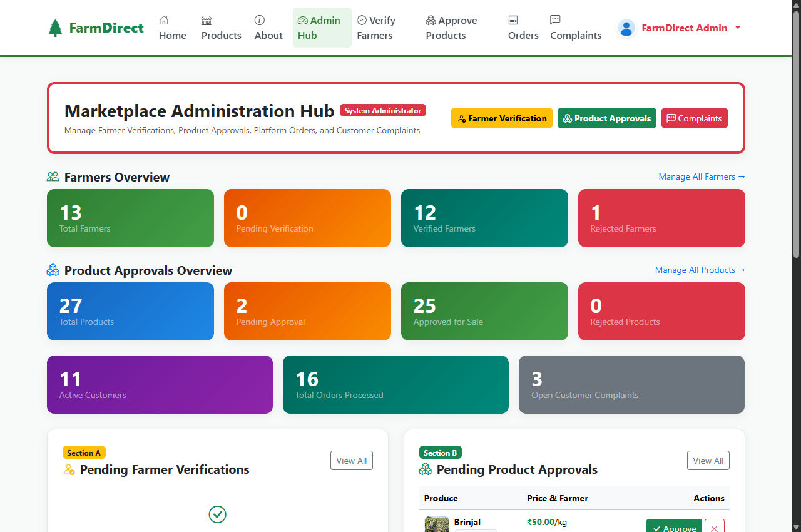
Illustrative Screenshot: FarmDirect administrative governance dashboard displaying active farmer verifications, marketplace performance metrics, and transaction summaries.
Conclusion
FarmDirect was developed as a direct farmer-to-consumer digital marketplace prototype designed to resolve structural inefficiencies in traditional agricultural supply chains, such as multi-tier middlemen commissions, asymmetric price discovery, and delayed market access for smallholder farmers. The system provides a unified platform enabling verified farmers to list fresh produce directly, retail consumers to purchase farm goods with dynamic payment simulations, and local delivery partners to manage order fulfillment. Built using Python 3.12, Flask, MySQL 8.0, and vanilla JavaScript, the prototype integrates role-based access control, atomic row-level inventory locking ('SELECT ... FOR UPDATE'), and client-side HTML5 laptop webcam hardware capture for crop listing.
The project successfully achieved its core objectives. The implementation eliminated intermediary commission overhead, ensured transparent farmer revenue realization, maintained accurate inventory tracking, and facilitated real-time delivery status progression. Comprehensive functional testing and automated regression suites validated all four user roles (Admin, Farmer, Customer, and Delivery Partner) with a 100% test pass rate, confirming that observed results fully matched the expected architectural requirements.
Limitations and Lessons Learned
The current version represents an academic prototype operating in a localized environment with simulated payment handlers (dynamic SVG UPI QR and card handlers) rather than a production banking gateway webhook. Dispatch allocation relies on manual claim-based assignment rather than automated geospatial routing, and the interface is currently English-only. The engineering process provided practical understanding of requirements validation, relational database concurrency control, ACID compliance, client-side hardware API integration, and modular MVC architecture design.
Further Enhancements
• Integrate live production payment gateways (UPI 2.0 AutoPay, Razorpay) with real-time webhook settlement verification.
• Implement Computer Vision / AI-based produce quality inspection and automatic defect grading from uploaded webcam images.
• Integrate Google Maps Platform APIs for automated geospatial driver assignment, shortest-path routing, and live GPS telemetry.
• Introduce regional language localization (e.g., Tamil, Hindi) with speech-to-text assistance to maximize rural farmer accessibility.

