FarmDirect: Design Documentation
1. System Design: Data Flow Diagrams (DFD Suite)
Data Flow Diagrams represent the logical flow of data through the FarmDirect marketplace. They identify external entities, data transformation processes, and underlying persistent data stores across three hierarchical levels of abstraction.
1.1 DFD Level 0 — Context Diagram
The Level 0 Context Diagram establishes the overall system boundary, depicting external interactions between the central FarmDirect platform and its four key user roles: Farmers, Customers, Delivery Partners, and System Administrators.
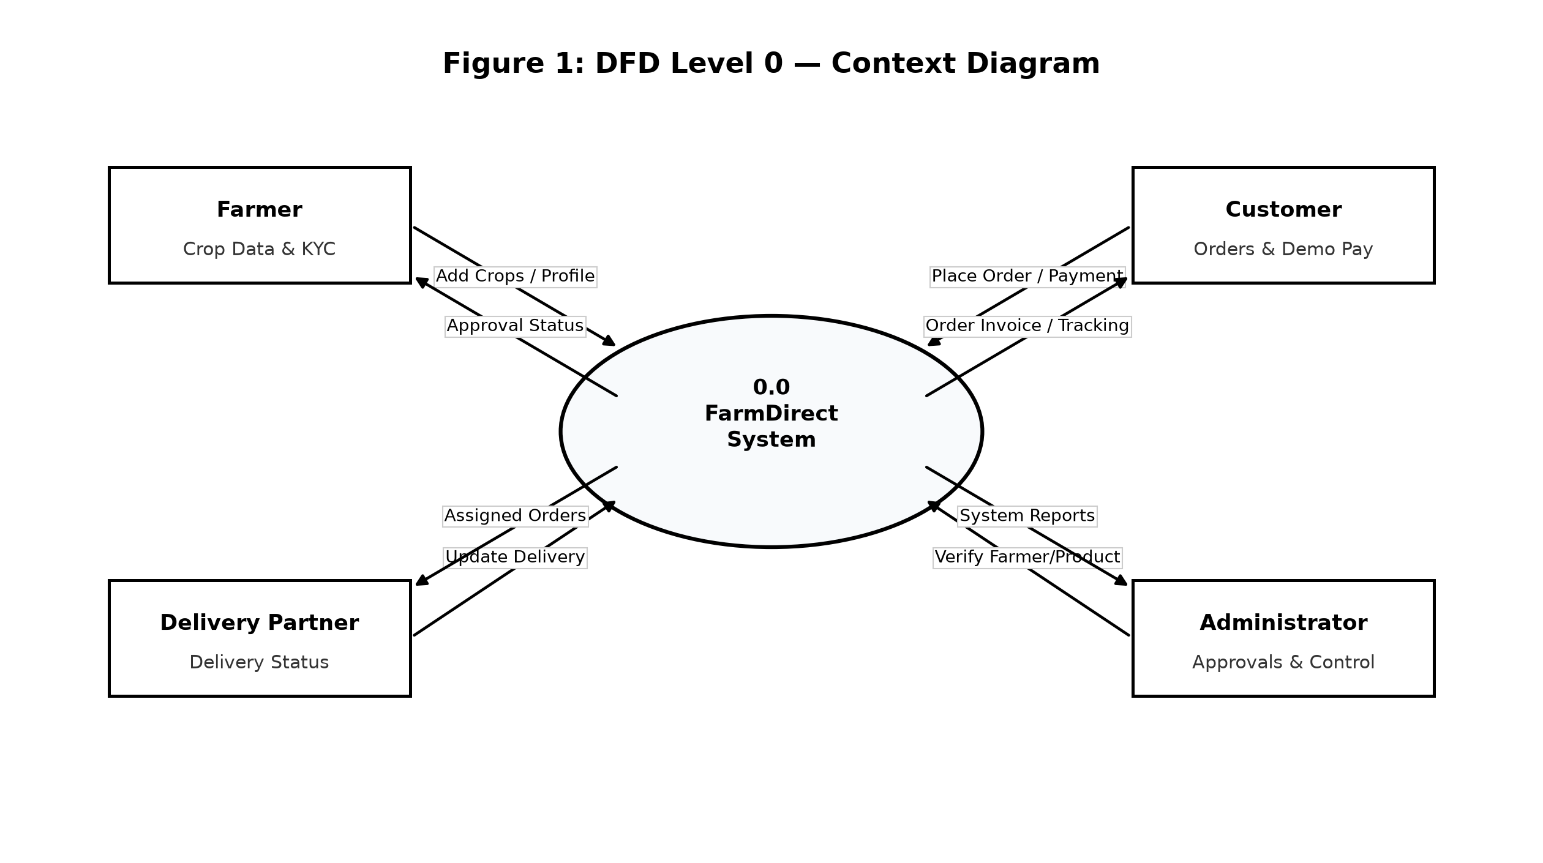
Figure 1: DFD Level 0 Context Diagram (System Boundary and External Actors)
1.2 DFD Level 1 — Major Functional Processes and Data Stores
The Level 1 DFD decomposes the system into five core functional processes and four primary data stores:
• Process 1.0 (User Login & Authentication): Validates credentials against D1 (Users Store).
• Process 2.0 (Farmer & Produce Approval): Manages quality verification and updates D2 (Products Store).
• Process 3.0 (Catalog Browse & Cart): Provides filtered produce listings and temporary cart handling.
• Process 4.0 (Order & Demo Payment): Validates stock, executes demo payment, and records transactions in D3 (Orders Store).
• Process 5.0 (Delivery Logistics & Reviews): Allocates dispatch drivers and updates D4 (Deliveries Store).
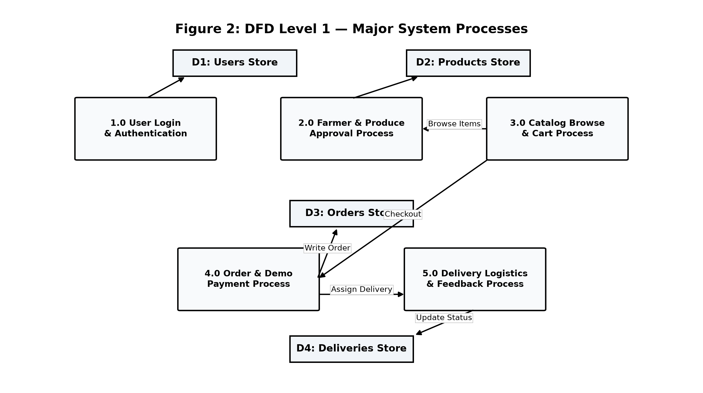
Figure 2: DFD Level 1 Diagram (Core System Processes and Data Stores)
1.3 DFD Level 2 — Order Placement and Demo Payment Sub-Process
The Level 2 DFD provides a granular breakdown of Process 4.0 (Order Placement & Demo Payment):
1. Sub-Process 4.1: Validates requested item quantities against real-time product stock.
2. Sub-Process 4.2: Computes order subtotal, flat delivery logistics fee, and final grand total.
3. Sub-Process 4.3: Processes demo payment simulation via Cash on Delivery, dynamic UPI QR code, or test Card credentials.
4. Sub-Process 4.4: Commits order records to the database, decrements stock quantities atomically, and initiates delivery partner assignment.
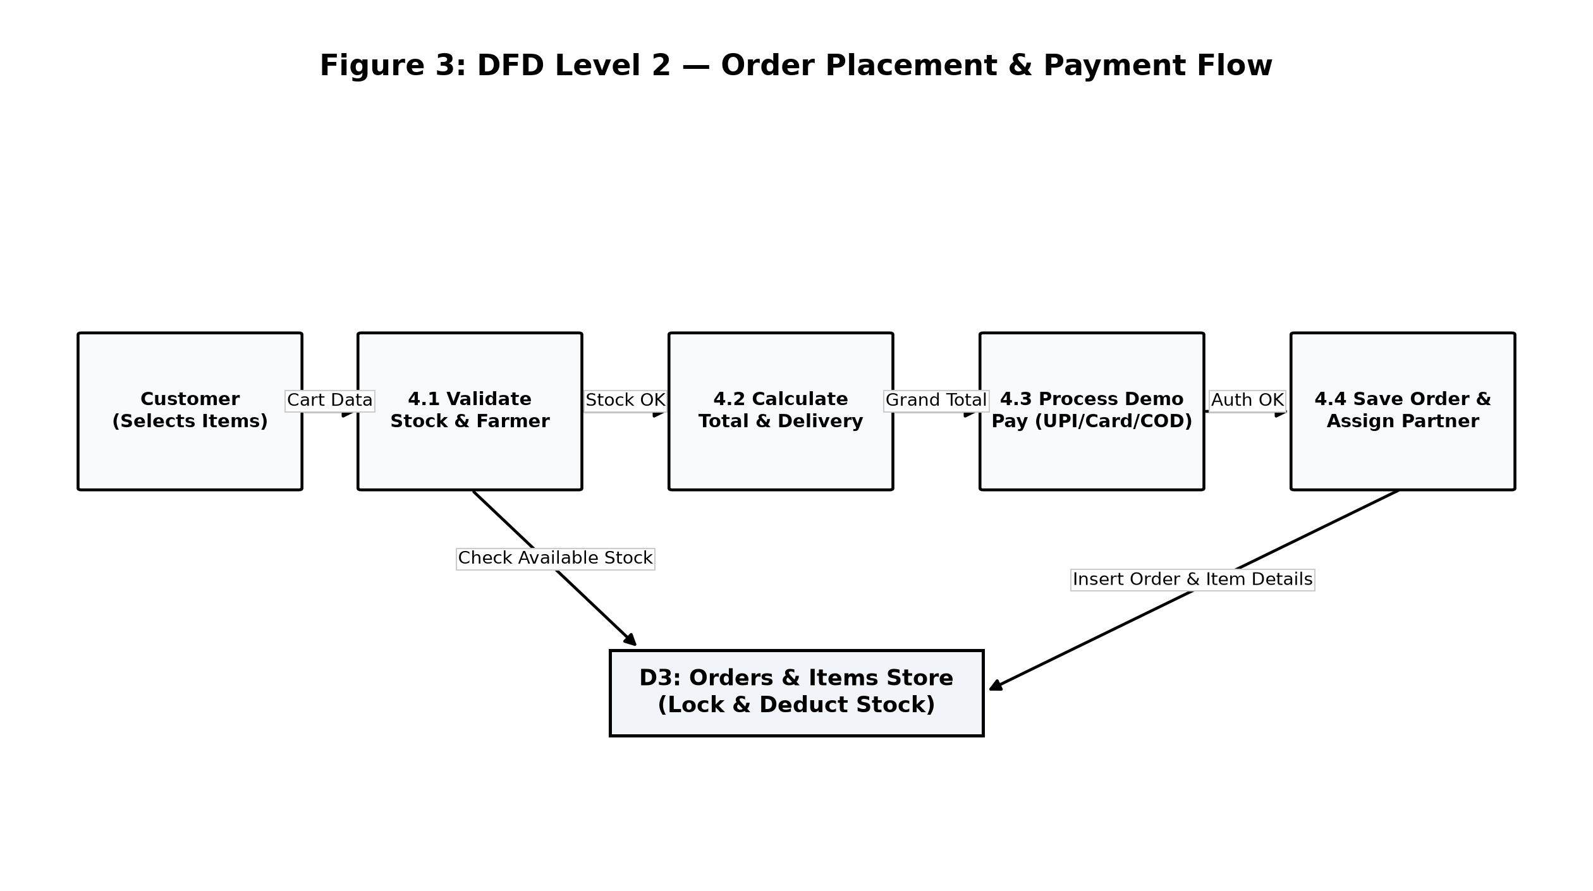
Figure 3: DFD Level 2 Diagram (Order Processing and Payment Sub-Processes)
2. Object-Oriented Design (UML Models)
2.1 UML Use Case Diagram
The Use Case Diagram defines the functional scope and boundary of the system from the perspective of each actor:
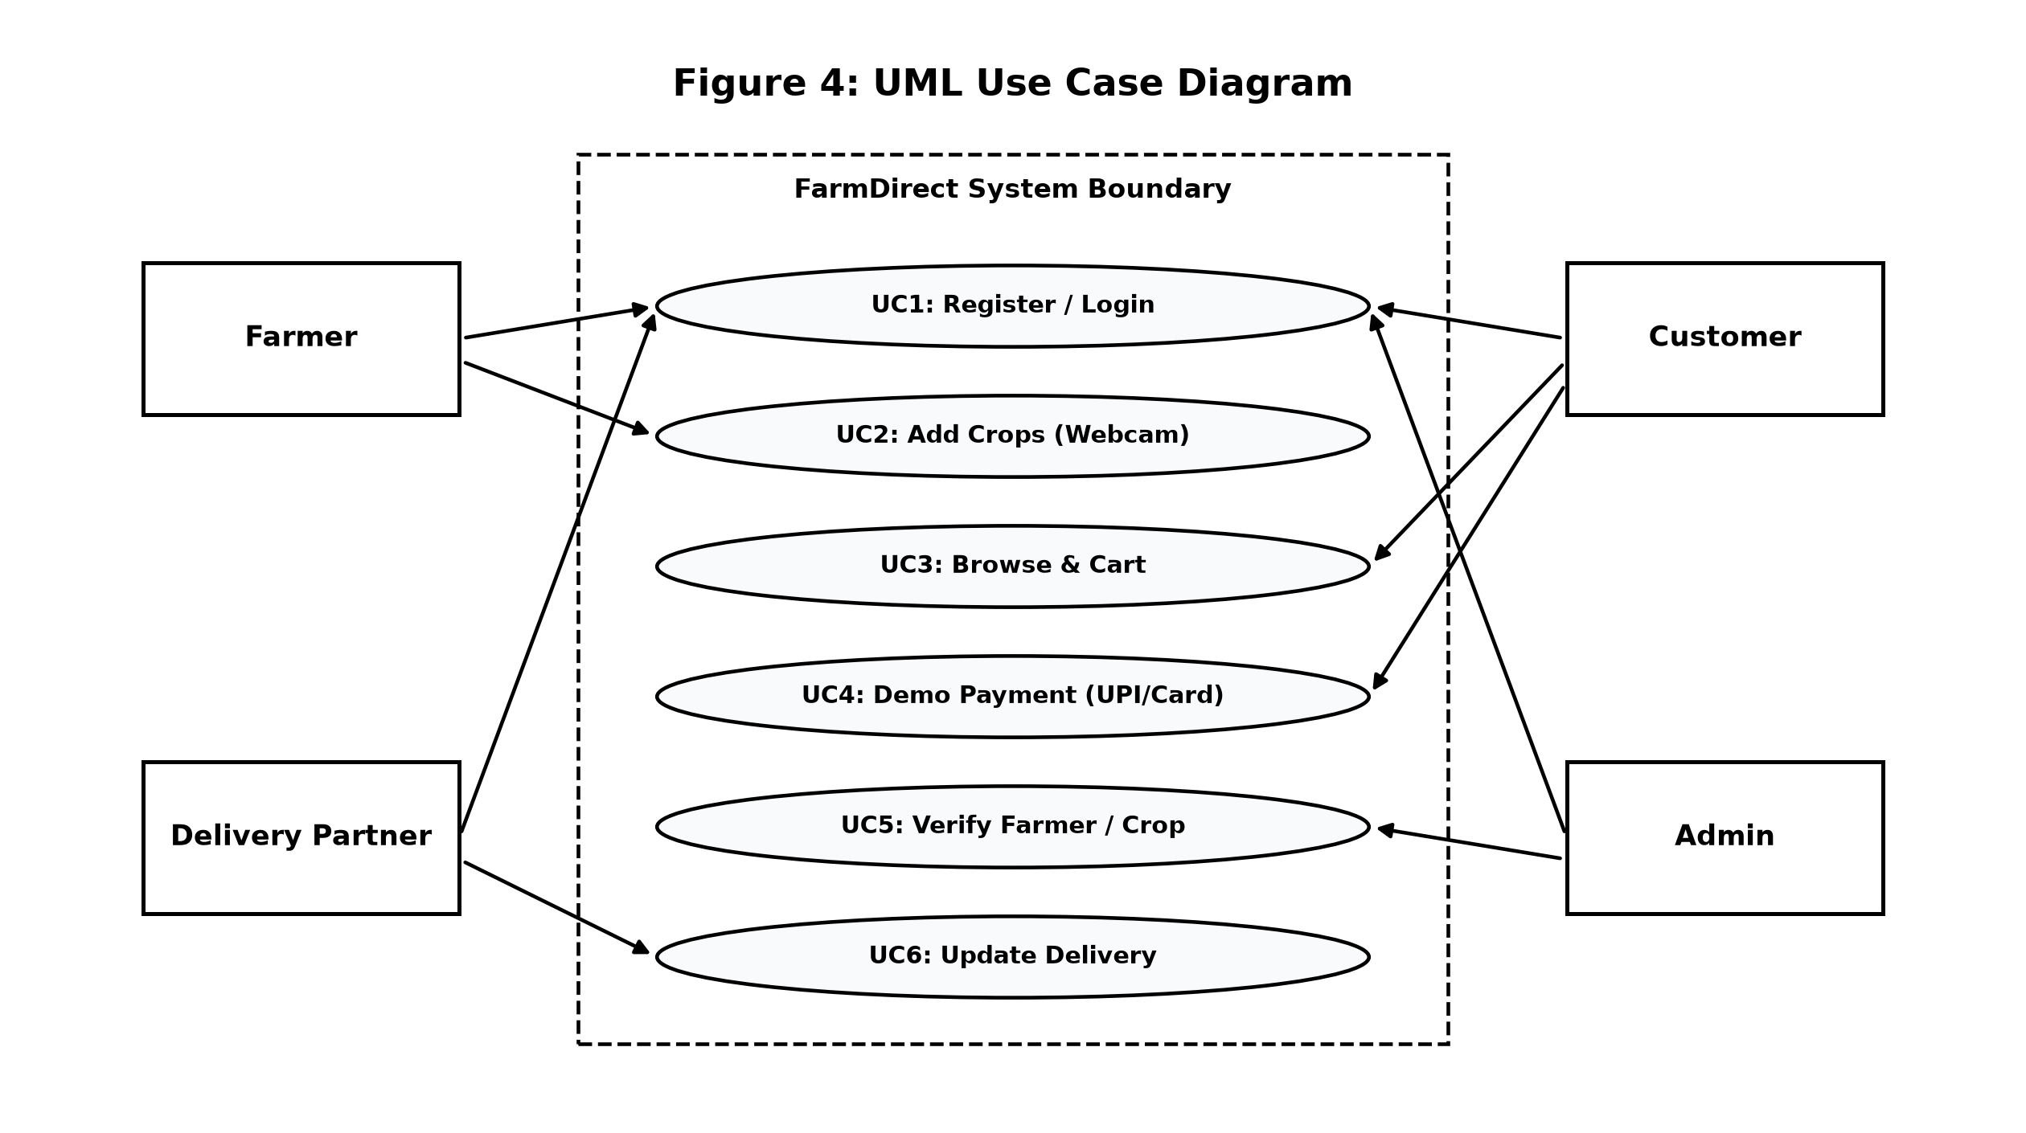
Figure 4: UML Use Case Diagram (Actor and System Scope)
Use Case | Actor | Description
UC-1: Register & Login | All Users | Authenticates user accounts with role-based dashboard redirection.
UC-2: Add Harvest (Webcam) | Farmer | Lists agricultural crops with price, quantity, and live laptop webcam capture.
UC-3: Browse & Cart | Customer | Searches verified agricultural catalog and manages cart items.
UC-4: Demo Payment | Customer | Simulates order checkout via COD, dynamic UPI QR, or test Card.
UC-5: Quality Verification | Administrator | Verifies farmer registrations and approves listed crop items.
UC-6: Update Delivery | Delivery Partner | Updates package fulfillment from Assigned to Delivered.

2.2 UML Class Diagram (Static Domain Model)
The Class Diagram models the static structural classes, domain attributes, public methods, and object associations within the FarmDirect platform:
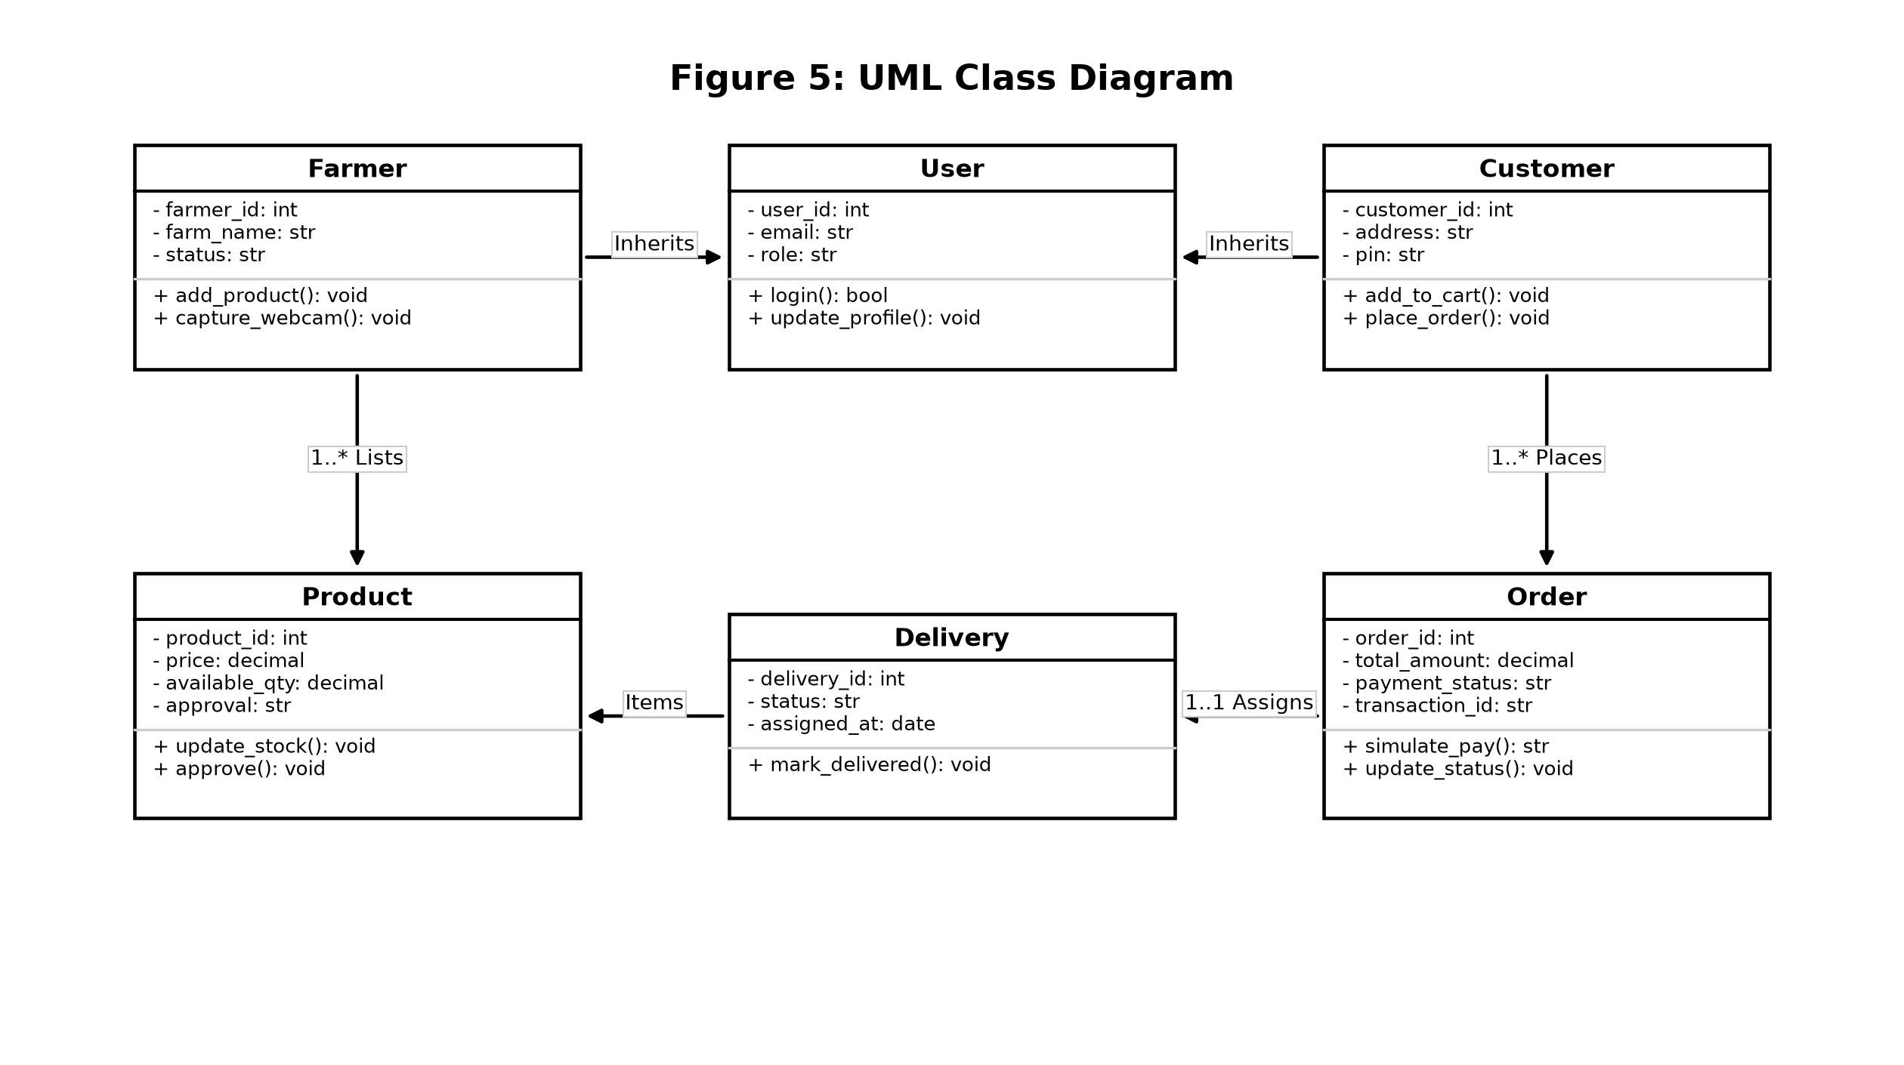
Figure 5: UML Class Diagram (Domain Model, Attributes, and Operations)
3. Database Design & MySQL Relational Schema
The FarmDirect database is implemented in MySQL 8.0 using the InnoDB storage engine to provide strict referential integrity, foreign key cascading, and ACID transactional guarantees.
3.1 Entity-Relationship (ER) Diagram
The ER Diagram illustrates the relational structure, primary keys [PK], foreign keys [FK], and cardinality constraints across all core entities:
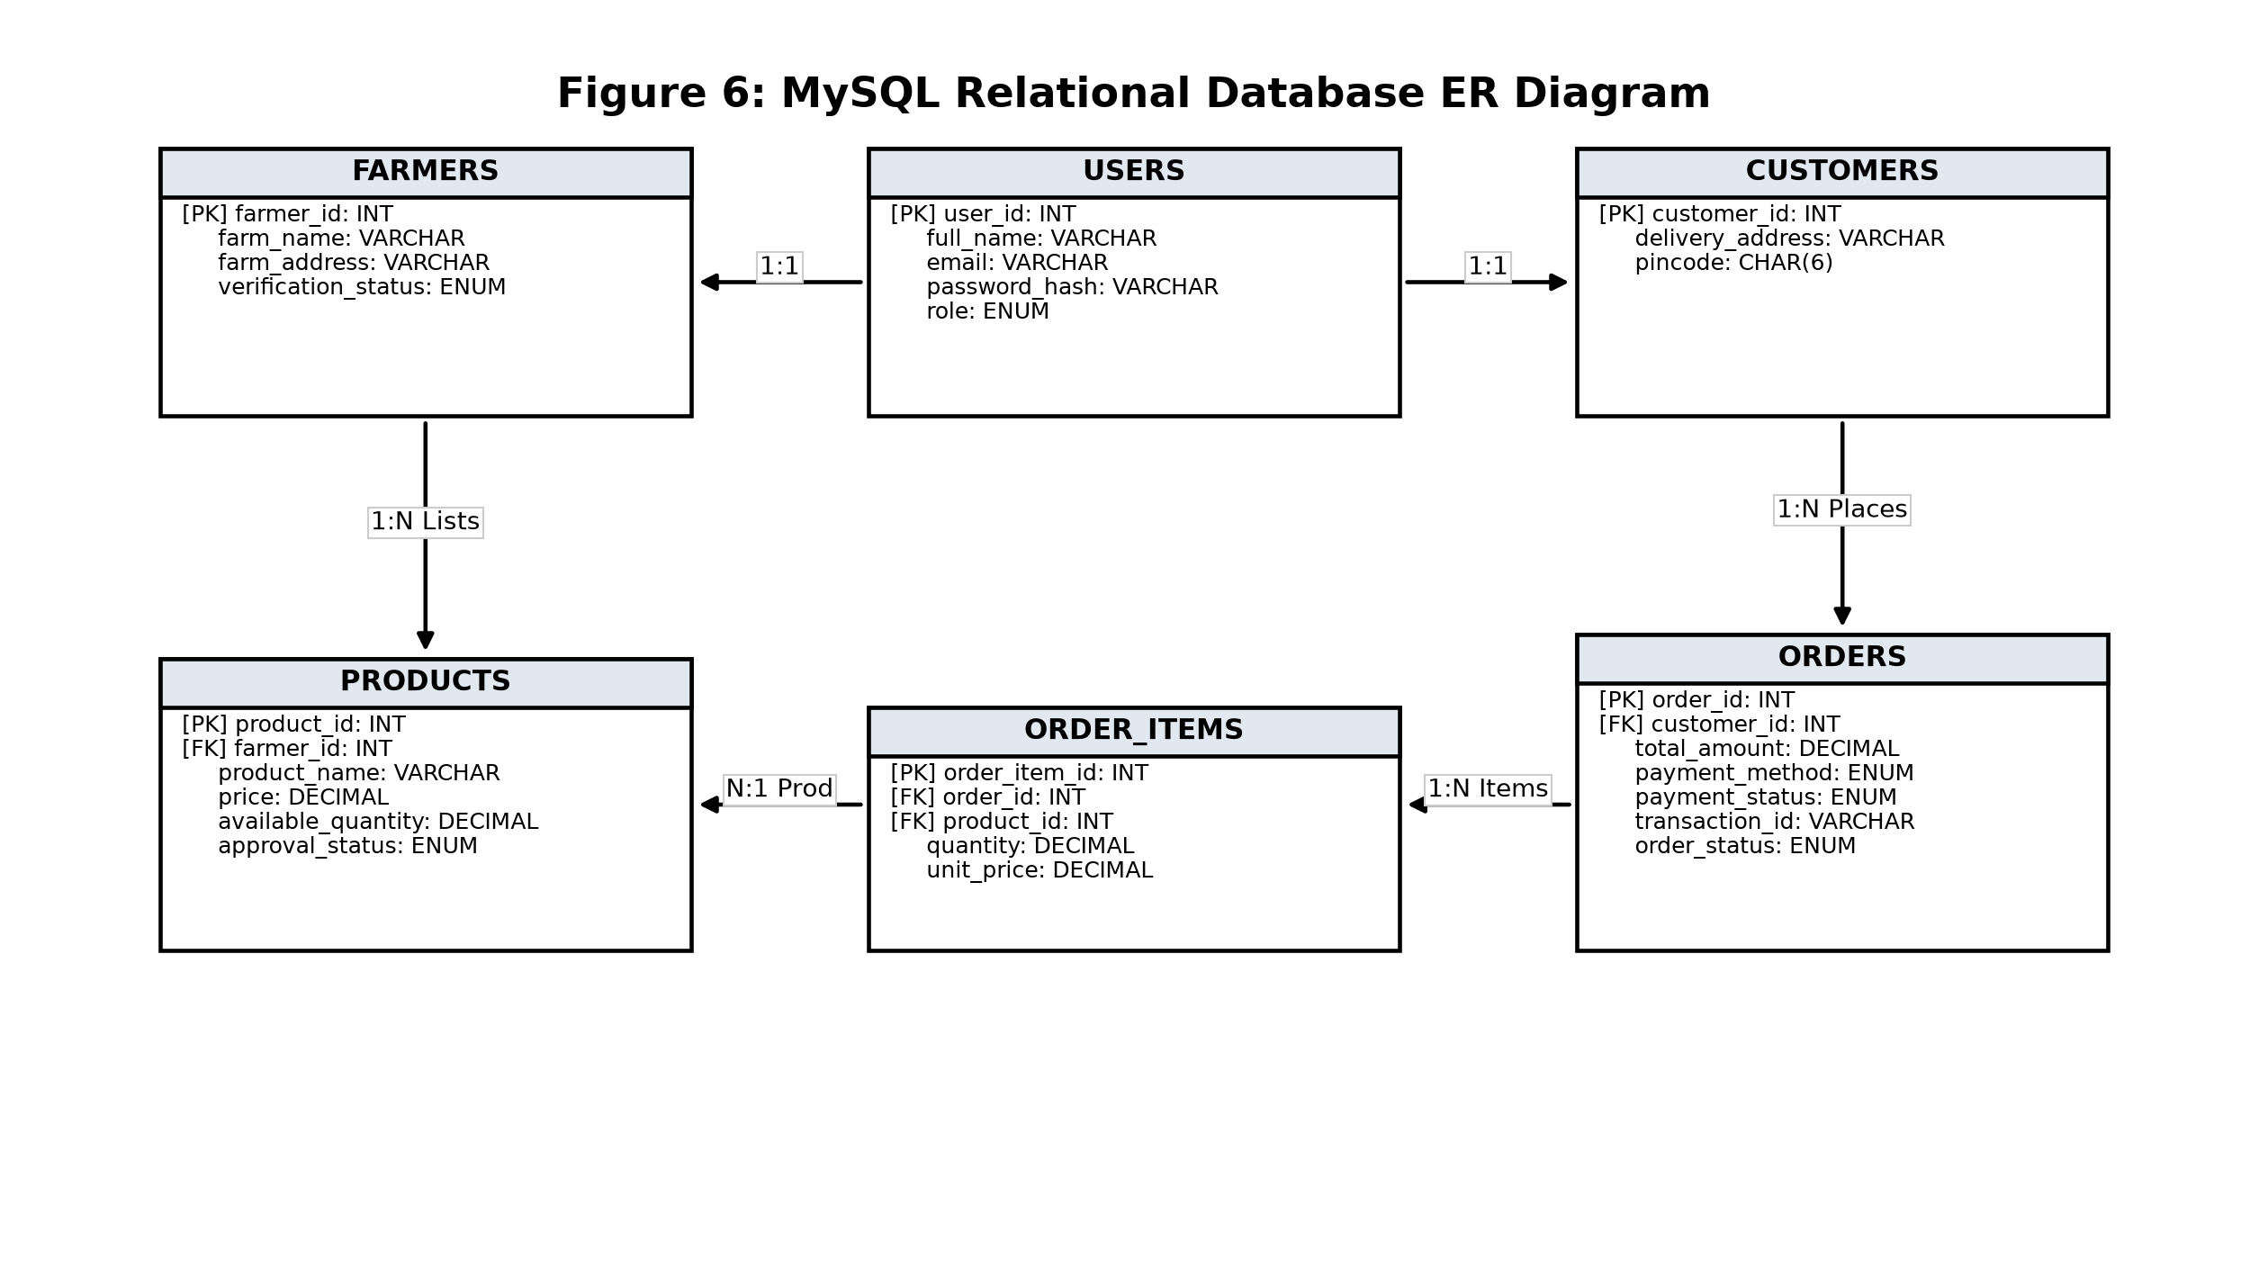
Figure 6: MySQL Relational Database Entity-Relationship (ER) Model
3.2 Relational Table Entries and Data Dictionary
Table Name | Primary / Foreign Keys | Attributes & Data Types | Constraints & Purpose
users | PK: user_id | full_name (VARCHAR), email (VARCHAR), password_hash (VARCHAR), role (ENUM) | email UNIQUE; role in ('farmer', 'customer', 'delivery_partner', 'admin')
farmers | PK/FK: farmer_id -> users | farm_name (VARCHAR), farm_address (VARCHAR), verification_status (ENUM) | verification_status in ('pending', 'verified', 'rejected')
customers | PK/FK: customer_id -> users | delivery_address (VARCHAR), pincode (CHAR(6)) | 6-digit postal PIN code; 1:1 relation with users table
products | PK: product_id  FK: farmer_id, category_id | product_name (VARCHAR), price (DECIMAL), available_quantity (DECIMAL), approval_status (ENUM) | price >= 0, qty >= 0; approval_status in ('pending', 'approved', 'rejected')
categories | PK: category_id | category_name (VARCHAR), description (VARCHAR) | Produce classification (Vegetables, Fruits, Grains)
orders | PK: order_id  FK: customer_id | total_amount (DECIMAL), payment_method (ENUM), payment_status (ENUM), transaction_id (VARCHAR), order_status (ENUM) | payment_status in ('pending', 'paid'); payment_method in ('cod', 'upi', 'card')
order_items | PK: order_item_id  FK: order_id, product_id | quantity (DECIMAL), unit_price (DECIMAL), item_total (DECIMAL) | ON DELETE CASCADE with orders; quantity > 0
deliveries | PK: delivery_id  FK: order_id, delivery_partner_id | pickup_status (ENUM), delivery_status (ENUM), assigned_at (DATETIME) | delivery_status in ('assigned', 'picked_up', 'out_for_delivery', 'delivered')
reviews | PK: review_id  FK: customer_id, product_id | rating (INT), review_text (VARCHAR), created_at (DATETIME) | CHECK (rating BETWEEN 1 AND 5); post-delivery review

• Referential Integrity & Normalization: All tables satisfy Third Normal Form (3NF) and Boyce-Codd Normal Form (BCNF) with zero partial or transitive dependencies.
• Atomic Stock Deductions: Stock deductions execute atomically within order transactions to prevent overselling.

