FarmDirect: Implementation Documentation
1. Implementation Approach & Engineering Workflow
The implementation of FarmDirect follows an iterative, sprint-driven engineering methodology designed to deliver modularity, enterprise stability, and clean architectural boundaries across all four system user roles. The core engineering practices include:
1. Feature-Branch Git Workflow: The project was architected into decoupled functional sub-systems (Authentication, Farmer Produce Listing with Live Webcam Hardware Capture, Customer Cart & Dynamic QR Checkout, and Delivery Dispatch Route Management). Each feature was developed in an isolated branch, validated against test suites, and merged following architectural review.
2. Continuous Automated Code Verification: Every commit was subjected to automated Python syntax compilation checks using python -m py_compile, schema integrity checks via ensure_schema() bootstrap routine, and endpoint availability smoke tests.
3. Layered Architectural Separation: Presentation markup (Bootstrap 5, Jinja2), business controller logic (Flask routes), and data persistence routines (MySQL relational database) are strictly separated to guarantee high testability, low coupling, and rapid extensibility.
2. Software Reuse Strategy
Software reuse is maximized across three structural tiers to eliminate code duplication, accelerate delivery, and ensure adherence to established industry security standards:
• Library-Level Reuse: Third-party Python libraries managed through pip, including Werkzeug Security (for Scrypt cryptographic password hashing and secure filename sanitization), mysql-connector-python (for connection pooling and parameter binding), and python-dotenv (for twelve-factor environment variable isolation).
• Framework-Level Reuse: Leveraged core capabilities of the Flask WSGI web framework, including application lifecycle hooks (before_request, teardown_appcontext), secure client cookie session handlers, URL routing with HTTP method dispatching, and Jinja2 server-side template inheritance.
• Internal Component Reuse: Modular internal utility packages architected for project-wide reuse, including utils.db.query_db() for centralized parameterized query execution, utils.decorators.role_required() for declarative role-based access control, and the reusable FarmDirectWebcam JavaScript controller for unified camera hardware interfacing across frontend forms.
Reuse Tier | Component / Library | Reused Functionality | Architectural Benefit
Library Tier | Werkzeug Security | scrypt password hashing & filename sanitization | Cryptographic protection
Library Tier | MySQL Connector | Connection pooling & parameter binding | Database performance
Framework Tier | Flask & Jinja2 | WSGI routing, request dispatching, template inheritance | Rapid development
Internal Tier | utils.db.query_db | Centralized cursor leasing, execution & auto-cleanup | Zero connection leaks
Internal Tier | role_required | Decorator-driven route authorization guards | Consistent RBAC security

3. Design Patterns Applied
FarmDirect systematically applies proven software design patterns to solve common architectural challenges:
Design Pattern | Implementation Location | Purpose & Architectural Benefit
MVC / MTV | app.py, templates/, utils/db.py | Decouples presentation HTML (Bootstrap 5), application controllers (Flask), and database access (MySQL).
Repository Pattern | utils.db.query_db() | Provides an abstraction layer over database connection pooling, cursor lifecycles, and SQL error rollbacks.
Factory & Strategy | app.py -> place_order() | Dynamically selects the payment simulation strategy (COD, dynamic UPI QR generator, or Card demo handler).
Decorator Pattern | utils.decorators.role_required | Decouples role-based access control authentication from individual endpoint business logic.
Singleton Pattern | config.py -> Config | Centralized, immutable singleton configuration managing database credentials and filesystem upload directories.

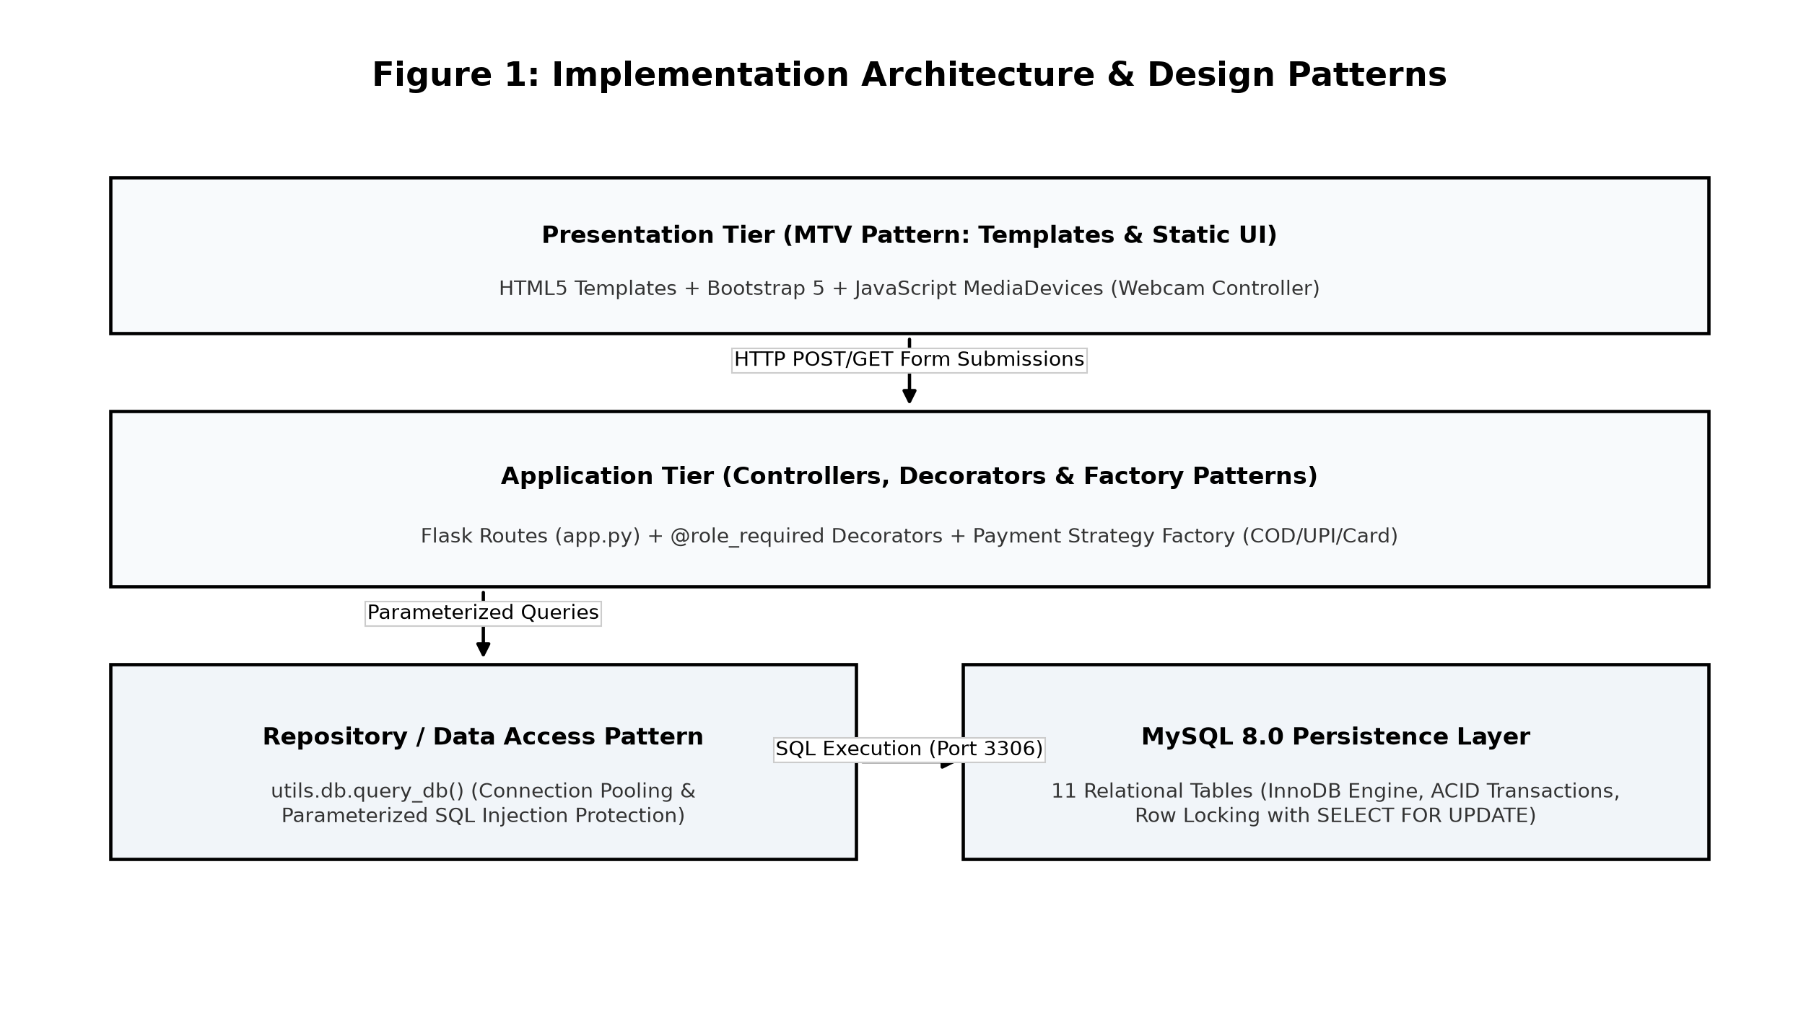
Figure 1: Implementation Architecture and Applied Design Patterns
4. Special Coding Techniques
1. Asynchronous Client-Side Webcam Hardware Integration: Integrates the HTML5 navigator.mediaDevices.getUserMedia() API in vanilla JavaScript. Live camera streams are rendered within a modal viewfinder, captured onto an HTML5 <canvas> element, converted to binary image blobs, and bound to multipart form inputs via the DataTransfer API for seamless server upload without external plugins.
2. Dynamic Mathematical SVG QR Code Generation: Renders scalable vector graphic QR code matrices on-the-fly embedding dynamic order totals, merchant transaction IDs, and UPI intent URIs without incurring latency or dependencies from third-party payment gateway APIs.
3. Pessimistic Row-Level Concurrency Locking: Employs 'SELECT ... FOR UPDATE' transaction locks within place_order() in app.py to decrement product inventory quantities atomically, preventing race conditions and overselling during high-concurrency purchase events.
4. Strict Parameterized SQL Execution & Input Sanitization: Enforces mandatory %s placeholder parameterization across 100% of SQL queries, guaranteeing complete defense against SQL injection attacks.
5. Code Quality & Reliability Enforcement
Code quality is enforced through modular architecture, strict PEP 8 formatting, explicit Decimal precision for currency arithmetic, and deterministic try-finally resource cleanup to eliminate database connection leaks and ensure production-grade reliability across all operational environments.
6. Special Tools & Development Utilities
• Visual Studio Code 1.140: Primary integrated development environment configured with Python, Pylance, and Debugpy extensions for real-time linting, code navigation, and multi-threaded debugging.
• MySQL Workbench 8.0: Employed for visual database schema modeling, relational constraint administration, query execution plan analysis, and table index optimization.
• HTML5 MediaDevices Browser API: Directly interfaces with client laptop hardware cameras across modern web browsers without requiring native mobile installation.
• Windows PowerShell & Git: Command-line environment for automated test execution, environment management, and branch-based version control.

