FINAL REVIEW - REFERENCES
FarmDirect: Farmer-to-Consumer Agricultural Marketplace
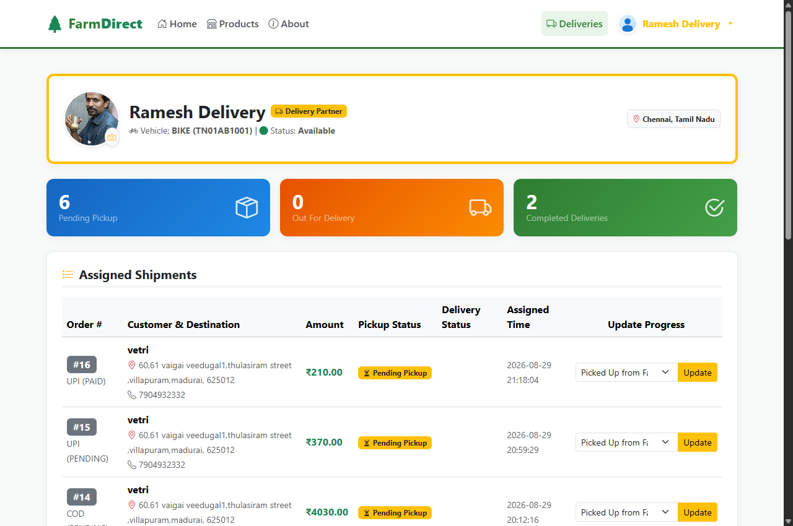
Illustrative Demo Screenshot: FarmDirect delivery partner dispatch and real-time order fulfillment tracking interface.
References
[1] Pallets Projects, "Flask Web Development Framework Reference Documentation," flask.palletsprojects.com, https://flask.palletsprojects.com/en/3.0.x/, accessed Oct. 2026.
[2] Oracle Corporation, "MySQL 8.0 Reference Manual: InnoDB Storage Engine and Row Locking," dev.mysql.com, https://dev.mysql.com/doc/refman/8.0/en/, accessed Oct. 2026.
[3] Python Software Foundation, "Python 3.12 Language and Standard Library Documentation," python.org, https://docs.python.org/3.12/, accessed Oct. 2026.
[4] Pallets Projects, "Werkzeug WSGI Utility and Cryptographic Password Hashing (Scrypt)," werkzeug.palletsprojects.com, https://werkzeug.palletsprojects.com/en/3.0.x/, accessed Oct. 2026.
[5] World Wide Web Consortium (W3C), "Media Capture and Streams (HTML5 getUserMedia API) Specification," w3.org, https://www.w3.org/TR/mediacapture-streams/, accessed Oct. 2026.
[6] Mark Otto and Jacob Thornton, "Bootstrap 5.3 Responsive Front-End Framework Documentation," getbootstrap.com, https://getbootstrap.com/docs/5.3/, accessed Oct. 2026.
[7] National Payments Corporation of India (NPCI), "Unified Payments Interface (UPI) System Specifications and QR Guidelines," npci.org.in, https://www.npci.org.in/what-we-do/upi/, accessed Oct. 2026.
[8] Mozilla Developer Network (MDN) Contributors, "HTML5 Canvas API and DataTransfer File Binding Interfaces," developer.mozilla.org, https://developer.mozilla.org/en-US/docs/Web/API/Canvas_API, accessed Oct. 2026.
[9] Oracle Corporation, "MySQL Connector/Python Developer Guide for Connection Pooling," dev.mysql.com, https://dev.mysql.com/doc/connector-python/en/, accessed Oct. 2026.

