FarmDirect: Tools and Technologies Documentation
1. Full-Stack Technology Architecture Overview
The FarmDirect marketplace is constructed using an enterprise-grade, open-source technology stack optimized for reliability, maintainability, low operational complexity, and academic transparency. The architecture integrates modern web standards, server-side Python computing, relational database management, and browser hardware APIs.
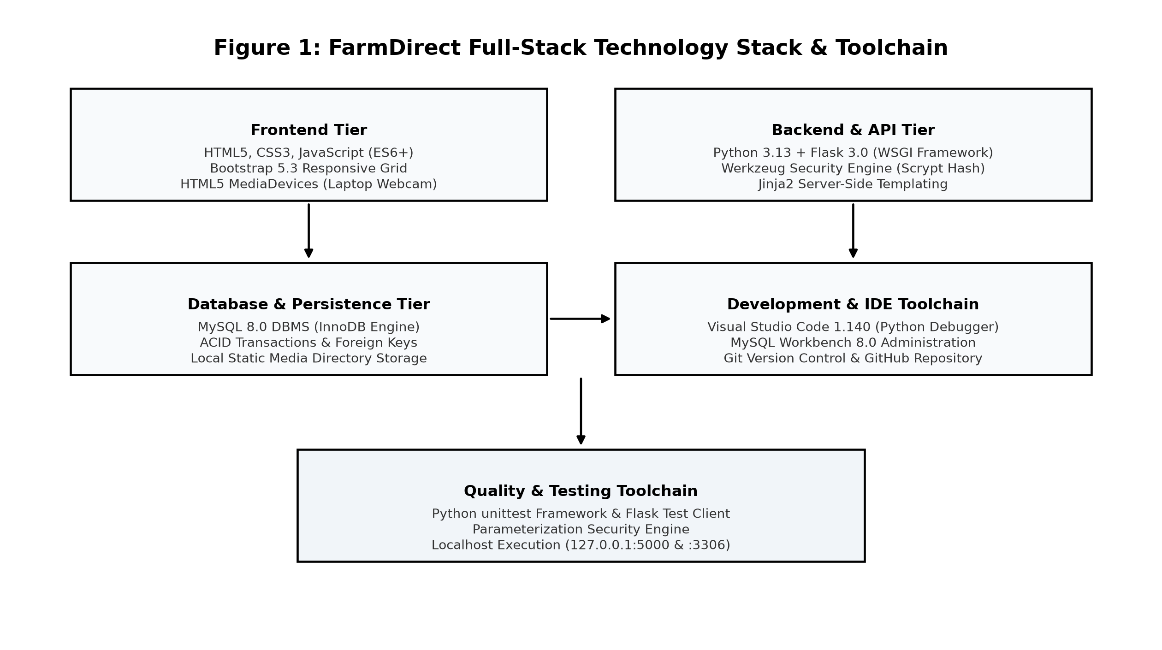
Figure 1: FarmDirect Full-Stack Technology Stack and Toolchain Ecosystem
2. Frontend Framework and Client-Side Technologies
The client tier is built upon modern web standards without heavy single-page application (SPA) framework overhead, ensuring rapid initial page loads, high accessibility, and seamless execution across mobile and desktop devices:
• HTML5 & CSS3: Provides structured semantic layout elements (<nav>, <main>, <section>, <article>, <footer>) and custom responsive CSS styling adhering to modern web design principles.
• Bootstrap 5.3 Framework: Utilized for its responsive 12-column flexbox grid system, styled UI cards, modals, form controls, and responsive navigation components.
• Vanilla JavaScript (ES6+): Powers dynamic interactive client modules, including real-time cart quantity adjustments, dynamic payment method toggling, test card auto-filling, and modal lifecycle control.
• HTML5 MediaDevices API (navigator.mediaDevices.getUserMedia): Directly interfaces with local laptop webcam hardware to stream video frames onto an HTML5 <canvas>, allowing real-time harvest photography directly within the browser with automatic track disposal.
• Jinja2 Templating Engine: Integrates server-side variable interpolation, template inheritance (base.html), conditional blocks, and loop iterators seamlessly with client HTML.
3. Backend & API Application Layer
The server tier is powered by the Python 3.13 runtime environment and the Flask 3.0 web microframework, providing an efficient and flexible computing backbone:
• Python 3.13: Chosen for its clean readability, robust standard library, strong type safety, and comprehensive ecosystem for web development and automated testing.
• Flask 3.0 WSGI Microframework: Serves as the central application controller. Flask provides lightweight HTTP request routing (@app.route), session state persistence, request parameter parsing, flash messaging, and error handling.
• Werkzeug Security Engine: Encapsulates cryptographic password hashing using the industry-standard Scrypt key derivation algorithm (generate_password_hash, check_password_hash) and file upload path sanitization (secure_filename) to prevent directory traversal attacks.
• Role-Based Access Control (RBAC): Implemented via custom Python decorators (@role_required) that inspect session tokens on every request to enforce strict endpoint security for Farmers, Customers, Delivery Partners, and Administrators.
4. Database & Persistent Storage Architecture
• MySQL 8.0 DBMS (Primary Relational Store): Serves as the persistent database engine. Configured with the InnoDB storage engine, which provides full ACID (Atomicity, Consistency, Isolation, Durability) transactional compliance, row-level locking (SELECT ... FOR UPDATE), foreign key cascading, and crash recovery.
• mysql-connector-python: The official Oracle-supported driver managing TCP/IP socket connections between Flask and MySQL on port 3306 with automatic parameter substitution.
• Local Filesystem Storage with UUID Hash Partitioning: User profile images and agricultural produce photos are stored on the local filesystem under static/uploads/products/ and static/uploads/profiles/. File paths are hashed with unique timestamps and UUIDs, with only lightweight relative string paths stored in MySQL to prevent database bloat.
5. Development, Collaboration, and Quality Toolchain
The following table details the engineering tools utilized during development, testing, and administration:
Category | Tool / Technology | Specification & Architectural Justification
Version Control | Git & GitHub | Distributed version control managing branch protection, commit history, and release tags.
IDE & Editor | Visual Studio Code 1.140 | Integrated development environment with Microsoft Python, Pylance, and Debugpy extensions.
Database Admin | MySQL Workbench 8.0 | Visual database modeling, SQL script execution, index analysis, and table data inspection.
Automated Testing | Python unittest Framework | Test suite execution verifying route responses, image validation, and demo payment flows.
Hardware Interface | HTML5 MediaDevices API | Zero-install browser camera integration streaming live laptop webcam frames to canvas.
Runtime Environment | Localhost (127.0.0.1) | Local dual-port runtime execution (Port 5000 Flask Web Server, Port 3306 MySQL DBMS).

6. Technology Selection Criteria & Justification Matrix
Every tool and technology in FarmDirect was evaluated against five rigorous engineering criteria:
1. Maturity & Community Support: Python, Flask, and MySQL possess vast global developer ecosystems, extensive documentation, and long-term stability.
2. Performance & Low Latency: The monolithic 3-tier architecture running on localhost executes queries and renders templates with sub-150ms latency.
3. Security Posture: Enforces Scrypt password encryption, parameterized SQL queries, secure session cookies, and zero storage of sensitive financial credentials.
4. Licensing & Zero Cost: 100% constructed using Free and Open-Source Software (FOSS) with permissive licenses (MIT, BSD, GPL), requiring zero commercial fees.
5. Academic & Viva Transparency: Clear, decoupled code structure allowing straightforward demonstration of routes, models, and queries during academic project evaluation.
7. Locked Dependency Manifest (requirements.txt)
The exact package versions locking all runtime dependencies for reproducible execution across environments:
Package Name | Locked Version | Role and Functional Purpose in Application
Flask | 3.0.3 | Core WSGI web application framework, routing, and session management.
mysql-connector-python | 8.4.0 | Official MySQL driver for database queries and connection pooling.
Werkzeug | 3.0.3 | WSGI utility library providing Scrypt password hashing and file security.
python-dotenv | 1.0.1 | Loads environment variables from .env file for database configuration.
Pillow | 12.3.0 | Python Imaging Library for image processing, dimension checks, and thumbnails.

