# Linux Commands

# VIM shortcuts

# Simulations

## Cadence Virtuso

# Linux Commands

1. rm -rf

2. cd ../mydir : Go up to my parent, then into directory mydir

3. bjobs | wc -l

word count the number of jobs running

4.cp copy, mv move, rm remove, to copy directerios use "cp -rf", to copy to present directory use:

Cp -rf filepath .

5. bjobs list of jobs running

7. cd .. go up one level

8. cd - go back to previous directory

9. mail rvelithx -a creport.txt ; mail rvelithx -a <filepath1> -a <filepath2> mailing multiple files ;-a for attachments

after typing in subject : ctrl+D for the e-mail to be sent

10. ctrl z suspends the foreground process and ctrl c :terminate the current foreground command right now

11. arc submit flow/finesim/4cpu mem=8000 -- finesim -np 4 *.sp

run in parallel all files ending with .sp

12. source results/run_eos_with_probes.sh

13. Ctrl+A or Home – moves the cursor to the start of a line.

14. Ctrl+E or End – moves the cursor to the end of the line

ctrl+U erase entire line

15. find -name "*.sp" : find files with extension .sp * wildcards

17. copy a text to multiple folders : tee command, ex:

18. paste

19. source is a shell built-in command which is used to read and execute the content of a file(generally set of commands),

passed as an argument in the current shell script

20. arc submit -i synopsys_waveview-lic - wv : to open waveview

arc submit wv; arc submit makes use of the load sharing facility instead of running on the desktop

21. grep -c "padvrefmux" ./eos/acff_125/vio_report_sorted.log : count the number of times the word in double quotes occurs in that file

22. grep "padvrefmux" ./eos/acff_125/vio_report_sorted.log | grep namp | wc -l

23. grep ERROR `find -name "*log"` : look for errors in the log f

24. cp `find -name "*ac0"` ac0/ : copy all files that end with ac0 to ac0/ directory : NOT WORKING Backquotes (“backticks”) cause their contents to be evaluated as a shell command

25. find -name "*sp" | grep template : find all files that end with *sp extension, in the template folder

26. gvim `find -name "*sp" | grep template` : open all these files

27. cat axsf_gs/tttt/tttt_125/vccmax_vcnmin/sim_offset.op | grep -A 15 "element.*imatched.*ppath.*amp2.*amp2_p.*qn3.*0.*xq0.*mqn0"

print the part of the file that grep uses to search in double quotes following 15 lines

29. For every new terminal :

source /p/psg/ctools/arc/current/arc.cshrc

alias source1 arc shell project/falcon/fp8/0.8/phys/

alias source2 arc shell icf_models/P1275_21/p1275_21x3r1,synopsys_finesim/R-2020.12-SP1-1,synopsys_hspice/R-2020.12-3

alias source3 arc shell project/falcon/fp8/0.8/phys,synopsys_waveview/R-2020.12-SP1

#alias virtu 'arc submit -i mem=32000 -- virtuoso &'

alias waveview 'arc submit -i synopsys_waveview-lic - wv'

alias bjobs 'bjobs_nb -u `whoami`'

30. *******************VERY USEFUL ******************* runs same command for different files in one single go

find -name "*creport*" ; find all files that end with creport in the directory

find -name "*creport*" > file ; write this list to a file

cp file file1 ; copy to another file file1

gvim file1 ; open using vim text editor

paste file file1 > file2 ; contents of file as coloumn 1 and file1 as coloumn 2 and write this content to file2

gvim file2 ; open using vim text editor

source file2 ; run commands in file 2 add cp or mv so it runs same command for different files in one single go

31. diff : diffference between two files

sdiff: compares two files and prints the difference side by side

32. For pipelining programs the output of left command goes to the command on the right as input

who | wc -l ; count the number of users logged in to the computer

33. awk : AWK is a pattern-matching language. It matches data by regu‐

lar expression and then performs actions based on the data

awk '{print $2, $4}' myfile : Print the second and fourth word on each line

34. cut : The cut command extracts columns of text from files

cut -c19 myfile : The cut command extracts columns of text from files. A “col‐

umn” is defined by character offsets (e.g., the nineteenth char‐

acter of each line)

35. ls *.jpg | cut -d. -f1 > /tmp/jpegs : list all files with jpg extension, remove the extension(first word?? occurs after .) and write to a temporary file

36. diff <(ls *.jpg|cut -d. -f1) <(ls *.txt|cut -d. -f1) : Each <() operator stands in for a filename on the command

line, as if that “file” contained the output of ls and cut

37. Filename completion: Press the Tab key while you are in the middle of typing a file‐

name, and the shell will automatically complete (finish typing)

the filename for you

we sort the output of who again, extract the first

column of information (using awk), and display the results one

page at a time (using less)who | sort | awk '{print $1}' | less : we sort the output of who again, extract the first

column of information (using awk), and display the results one

page at a time (using less)

38. ctrl+z suspend a job

ctrl +c kill a job

40. if shell prompt does not appear:

1. Press ^J to get a shell prompt. This keystroke produces the

same character as the Enter key (a newline) but will work

even if Enter does not.

2. Type the shell command reset (even if the letters don’t

appear while you type) and press ^J again to run this com‐

mand. This should bring your shell back to normal.

41. To terminate a shell either run the exit command or type ctrl+d

43. cat creport.txt| awk '{print $7,$1,$2,$3}'| sort -n | head : sort according to coloumn 7, numerical -n, in ascending order and print first ten lines

44**.** cat important | xargs ls -l : For instance, the following command runsthe **ls -l** command on all the listed files in important. Useful for running same command for a list of files.

45. find -name "*log" | xargs grep ERROR : search all files listed by find command for error

46. du -sh * : print the total size, only directories and not folders within and in readable format, depending on the size it will use different format for size mb, gb, kb

47. grep vfrzreg `find -name "eos_modetran*sp"` : print the line containing the word vfrzreg in each of the files found by the find command

48. If in a file first line is set of x co-ordinates and second line is a set of y co-ordinates then to print the corresponding x and y co-ordinates in a single line

cat ./eosrun/acff_125/eos_with_probes.mt0 | awk '{for(i=1;i<=NF;i++)a[i][NR]=$i}END{for(i in a)for(j in a[i])printf"%s"(j==NR?"\n":FS),a[i][j]}' > violog

cat ./eosrun/acss_-40/eos_with_probes.mt0 | awk '{for(i=1;i<=NF;i++)a[i][NR]=$i}END{for(i in a)for(j in a[i])printf"%s"(j==NR?"\n":FS),a[i][j]}' >violog

49. Intro to awk: [www.youtube.com/watch?v=9YOZmI-zWok](http://www.youtube.com/watch?v=9YOZmI-zWok)

50. Intro to sed: [www.youtube.com/watch?v=EACe7aiGczw&list=RDCMUCVls1GmFKf6WlTraIb_IaJg&index=3](http://www.youtube.com/watch?v=EACe7aiGczw&list=RDCMUCVls1GmFKf6WlTraIb_IaJg&index=3)

51. Shell scripts to find (x,y) >3uA and print it to another file

52. shell scripts to generate columns of data from mt0 files

53. shell script to change name and copy to another directory

54. find -name "vio_report_sorted.log" | grep "discharge" | grep -v "archive" : to not include the keyword archive in grep search

55. find -maxdepth 1 -name "*log" > outfiles : search only in current directory and not in subdirecteries

56. sed -i 's/acff/acss/g' outfiles : replace all occurrences of acff with acss, -i option replaces the old text in the file, otherwise sed simply prints the new text to screen, file will remain unchanged

57. grep 'TITLE' PDS_B_acff_-40.log : search for sentences with TITLE

58. find ./eosrun_1_12/ -name "*fsdb" : search fsdb file in the folder name given and not all folders

59. **grep -c ’ˆ$’ ch04** : You might use this pattern to count the number of blank lines in a file using the count option, *-c*, to gr ep

60. search and replace for one line only

61. arc cancel <the number after #> : if you want to cancel arc jobs

62. arc submit -i "node/[memory>=8000]" group=jesd204 priority=60 – console : to open a knsole with more processing power

63. history | grep arc : history of commands used

64. to kill a job : nbjob remove --target png_vp "fullid=='png_vp.job id' "

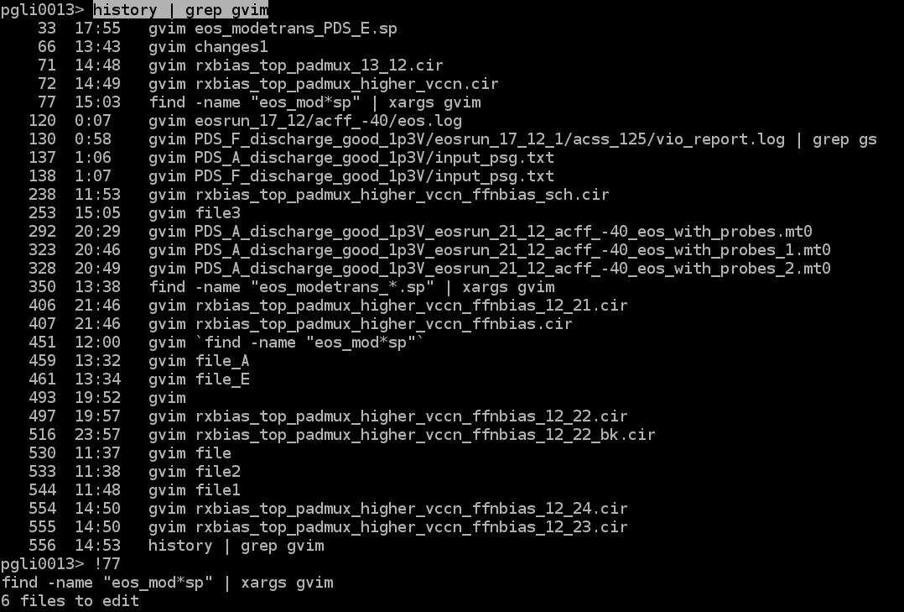

65. How to copy all files except folders:

66. gnumeric eosrun_1_5/acff_-40/eos_with_probes1.mt0 : linux form of excel

67. grep OR : grep 'pattern1\|pattern2' filename

For AND OR : [www.thegeekstuff.com/2011/10/grep-or-and-not-operators/](http://www.thegeekstuff.com/2011/10/grep-or-and-not-operators/)

68. grep Fail_ODC pua_review*csv : search for Fail_ODC in all files that match the pattern

69. sort -u similar to unique with additional sorting feature alphabetically

70. chmod 777 voltage_save_state : rwr permissons for all 3 types of users, if you are owner of file

# VIM Shortcuts:

16. go to a line number in vim: type line number and then shift+g

39. Vim to compare files : file>split diff with : more useful method

a. Open the first file in vim

b. Type :vsplit to get two panes side by side (tip: maximise the window on your widescreen monitor before you run this command)

c. Jump to the second pane (Ctrl+w followed by arrow key) and then open the other file :e filename

28. How to remove a character from all lines in Vim:

Place cursor on first or last ;

Press Ctrl+v to enter Visual Block mode

Use arrow keys or j, k to select the ; characters you want to delete (or the other "first few characters")

Press x to delete them all at once

29. If you want to search and replace the pattern in the entire file, use the percentage character % as a range.

This character indicates a range from the first to the last line of the file:

For example, to search for the first occurrence of the string ‘foo’ in the current line and replace it with ‘bar’, you would use:

% as a range that covers entire file, can use different delimiting character if '/' is already present use # for eg.

:%s/foo/bar/ or :%s#foo#bar#gg

:%s/foo/bar/g ; Find each occurrence of 'foo' (in all lines), and replace it with 'bar’, g stands for global

:%s/$/,/ ; add , to the end of every line

:%s/^/,/ ; add , to the beginning of every line

42. vim text editor commands to replace text:

1. ctrl + v to go into visual mode

2. select the text using hjkl or arrow keys

3. type r and then type the text that needs to replaced

43. :r file name_to_be_copied_from : write contents of the file to the vim file, useful for writing same text to many file, pastes from the line where the cursor is

44. How to open a file in vim whose path is given: place cursor on file path and type ‘gf’ in command mode

45. To go to end of line use $

46. select entire line ‘ctrl v’

47. bufdo! :

48. search and replace for one line only

49. ctrl + v, select text, shft +i, change made to one column will be made to all selected columns

50. 

Rahul appended to text within ()

51. changes to only a few lines, select those line and run :%s#

\s : all spaces

\d digits

\a alphabets

# Simulations:

.sp file : PWL stands for piece wise linear. First coloumn is the voltage source, second and third are net1 and net2 and fourth coloumn is the voltage across these two nets.

In PWL first coloumn represents time and second the voltage across it at that time

.mto contains all the measures given in the .sp file

.subckt is like a symbol contains all the pins

EOS Simulations:

copy txt sp and cir files

change path in txt, corners and no for postl corners and sp add extra eos line

.mosra reltotaltime='3600*24*365*10' SimMode=0

Commands:

source1

source2

source3

arc shell eos_flow/2.4

$EOS_DIR/run_eos.pl -input_config input_psg.txt -work_area eosrun

After running the above command:

source run_eos_with_probes.sh

/nfs/png/disks/fp8_io_1/users/skaniyax/msrivasx/RX/schavalx/schavalx.i10soc2.io75xddrfmxrx_lib.1/io75xddrfmxrx_lib/circuitsim/eos_padmux/rxtop_cir

fsdb files ds violations ppath from xls

fsdb files in pbias

how to generate vio reports:

send the violations file to windows via mail

vio_report_sorted

the copy paste it to excel

gd violations should not be present

bulk violations

# AC Simulations:

template and sim_pvt_vcn1px.sh file in folder

used similar commands for twakeup folder simulations:

generate testbench:

a. sh sim_pvt_vcn1px.sh gen

run simulations: (number of CPU cores given last)

b. sh sim_pvt_vcn1px.sh run 4

c. sh sim_pvt_vcn1px.sh ext

d. sh sim_pvt_vcn1px.sh srt

c and commands to generate report look for report in report/creport.txt path

[18:00] Velitheri, RahulX Krishna

the functional modes

look at there waveforms there are some togglings

you should also have the same

or simi;ar

also add the images that you added in the excel sheet for pwr_mux functionlay 3 supply + 2 currents

for PDS

functional modes

waveforms similar to ppt-set1

waveforms similar to padmux-set2

to kill jobs : arc cancel jobid(number)

Aging simulations:

change file in .txt file

three lines difference between stress and fresh and supply voltages -supply voltages scaled in stress and three lines included:

.option mraapi=1

.mosra reltotaltime='3600*24*365*10' SimMode=2

+ AgingStart=1.25n

refer dcd folder

start 1.25n

sh run

check for errors in log files

then only sh run_pb

used same config file as levelshift

didnot change voltages in stress

# nova simulations:

command to run:

/nfs/site/disks/psg_data_1/sneogi/enova/Nova/run_nova_single.pl -spice $PWD/sim_offset.sp -dir $PWD/test -type MPP -skew acff -netbatchyes,pool=png_express,class=SLES11SP4,qslot=/psg/fm/phe/big/gen -simulator finesim

simulations:

tgttl nova simulation

offset nova simulations

alpha delay simulations

dcd again

pds with vref, pwr_good and rxtop biastop

# kick back:

70mv and 350mv

1. change vicm and the other list of voltages according to bit pattern
2. The vrefintctrl stepsize is vccn/512;
3. For your ppathana’s
4. Vicm=0.35V = vrefintctrl=162(decimal)=1010 0010
5. Vicm=0.07V = vrefintctrl=32(decimal)=0010 00000
6. You can check the o_vrefint_a and see if it’s 0.07/0.35v after you set these settings.
7. This should be one of the vref kick back simulation too.

New eos:

Replace old netlist

/nfs/png/disks/fp8_io_1/users/skaniyax/msrivasx/RX/schavalx/schavalx.i10soc2.io75xddrfmxrx_lib.1/io75xddrfmxrx_lib/circuitsim/eos_padmux/eos_padmux_with_pwrgood_vref/

Prepare report look at gate violations and plot isub

CTLE

Spice file explanation 26:00, 40:00, find transfer function-2

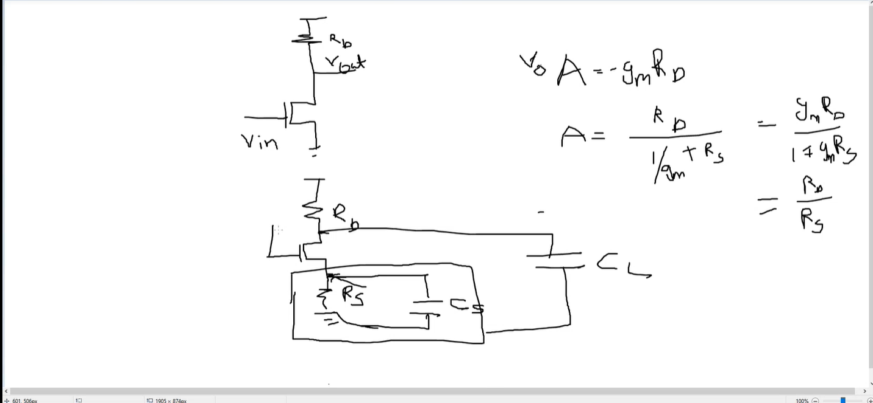

Read Constant gm bias-razavi bandgap chapter

Calculate values for differential amplifier

## Cadence Virtuso

1 .Pole and zero analysis in Virtuso:

<https://www.youtube.com/watch?v=cr-eW4iFKps>

2. differential amplifier simulation:

<https://www.youtube.com/watch?v=uZ2rWwFFa70>

3. Highlight net when mouse is placed on it: options>display>dynamic highlighting

4. place mouse on net and right click> add probe

5. Click on symbol and press E to descend read

6. to return to top level from a symbol press ctrl E

7. Opamp parameters simulation : (refer txt file)

<https://www.youtube.com/c/VirbhadraRathod/videos>

1. Print operating points after simulation and click on symbol to descend read. View operating points on the transistor level
2. To open virtuso, run command in the specific folder to access all schematics
3. in finesim function defined at the last will be used if same function is used multiple times

EXCEL Tricks

1. Change formatting of numbers accuracy
2. Ctrl+shift+dn arrow to select all elements in a coloumn below
3. To find a number greater/lesser than use conditional formatting
4. While importing need to change delimiter to space
5. Sort function select entire row and custom sort
6. To copy same text to multiple cells : select cells type text and ctrl+enter
7. To import multiple files at once : [www.youtube.com/watch?v=nC7Bzb35e68](http://www.youtube.com/watch?v=nC7Bzb35e68)
8. To create formulae in excel: <https://www.hec.ca/en/cams/help/topics/Solving_equations_with_Excel.pdf>

<https://www.youtube.com/watch?v=qpZUbXCVxSQ>

Tasks:

For single ended find slope optimal solution

For Bulk EOS violations : and instead of saying timming mismatch say capcitive coupling

/nfs/png/disks/fp8_io_7/users/rvelithx/schavalx/eos_padmux/eos_padmux_with_pwrgood_vref/PDS_A_discharge_good : in this folder i have updated two config files

pua:file

change rail and signal name correspondingly

unrealistic current spike, calculates realistics current, area under curve=charge

comment acff,-40 and 125

add corner tttt,-40 and run eos into a new file

please high vds violations higher than 1.2V

new pin, three pins delay of 20u, new pin should follow vccn_io but should go to 1.2v

new pin, gnd senseamp

add voltsource new pin, 10ns delay

bias_en

Synopsis Waveview

Filter options : include sublevel searches, can search for even sublevel signals from top

Grouping files if they are same and plotting same signal from all files