**INTERNSHIP REPORT**

**On**

**Real Time Health Monitoring System for Automobiles**

**By**

**NIKITHA P**

**M SANTHOSH KUMAR REDDY**

**LOK VIGNESH**

**NANDA KUMAR**

**COMPANY NAME: KPIT**

**(Duration: may 2024 to june 2024)**



**DEPARTMENT OF COMPUTER SCIENCE AND ENGINEERING**

**Gandhi Institute of Technology and Management**

**(DEEMED TO BE A UNIVERSITY)**

**BENGALURU, KARNATAKA, INDIA**

**SESSION:2021-2025**

**Contents**

|  |
| --- |
| **Title**  **Page No.**  **Introduction & Abstract 1**  **Project Objective 1-2**  **System Overview 3-4**  **Diagrams 5-9**  **Component selections 9**  **Schematic Diagrams 10-11**  **Software Design 12-14**  **DTC Codes 14-16**  **Code Development 16-32**  **Testing Procedures 34**  **Result 35**  **Conclusion 35**  **Future Work 36**  **References 36** |

**Real Time Health Monitoring System for Automobiles**

**Introduction & Abstract**

**Introduction**

The Automobile Health Monitoring System is designed to continuously monitor critical parameters of a vehicle such as the engine, fuel, and tire conditions. This system aims to provide real-time feedback to the vehicle owner, helping to prevent potential issues before they become severe, thereby enhancing vehicle safety, reliability, and longevity.

**Abstract**

In modern vehicles, monitoring the health of various components is crucial for ensuring optimal performance and preventing breakdowns. This project proposes a comprehensive health monitoring system for automobiles that collects data from various sensors, processes this data to evaluate the health status, and notifies the owner of any anomalies. The system leverages wireless communication for remote monitoring and integrates with the vehicle’s onboard diagnostics for detailed insights.

### Literature Survey & Domain Concepts

### The literature survey for the Real-Time Health Monitoring System for Automobiles aims to explore existing technologies, methodologies, and research advancements related to vehicle health monitoring systems. This includes the study of diagnostic trouble codes (DTC), sensor technologies, communication protocols, and similar systems in use or under development. The goal is to identify gaps, challenges, and opportunities for innovation in this domain.

**Project Objective**

**1. Monitor Engine Temperature**

* **Objective:** To continuously monitor the engine temperature using advanced sensors.
* **Rationale:** Maintaining optimal engine temperature is crucial to prevent overheating and ensure efficient engine performance.

**2. Track Tire Pressure**

* **Objective:** To monitor tire pressure in real-time and detect any deviations from the recommended pressure levels.
* **Rationale:** Proper tire pressure is essential for vehicle safety, fuel efficiency, and tire longevity.

**3. Assess Fuel Level**

* **Objective:** To accurately measure and display the fuel level in the vehicle’s tank.
* **Rationale:** Monitoring fuel levels helps in efficient trip planning and prevents unexpected breakdowns due to fuel shortages.

**4. Implement Diagnostic Trouble Code (DTC) Detection**

* **Objective:** To detect and record diagnostic trouble codes (DTCs) related to various vehicle systems.
* **Rationale:** Early detection of DTCs allows for timely maintenance and repairs, reducing the risk of major system failures.

**5. Provide Real-Time Alerts and Notifications**

* **Objective:** To generate and display alerts for any detected anomalies or critical conditions in real-time.
* **Rationale:** Immediate alerts enable the driver to take prompt corrective actions, ensuring safety and preventing potential damage.

**6. Develop a User-Friendly Interface**

* **Objective:** To create an intuitive dashboard interface that displays vehicle health information clearly and concisely.
* **Rationale:** An easy-to-use interface ensures that drivers can quickly understand vehicle health status and respond to alerts effectively.

**7. Enhance Predictive Maintenance Capabilities**

* **Objective:** To analyze sensor data for predicting potential failures and maintenance needs.
* **Rationale:** Predictive maintenance reduces downtime and repair costs by addressing issues before they become critical.

**8. Integrate with Vehicle's Existing Systems**

* **Objective:** To seamlessly integrate the health monitoring system with the vehicle’s existing electronic control units (ECUs) and systems.
* **Rationale:** Integration ensures comprehensive monitoring and enhances the overall functionality and reliability of the vehicle.

**9. Ensure Data Security and Privacy**

* **Objective:** To implement robust security measures for protecting the data collected by the health monitoring system.
* **Rationale:** Ensuring data security and privacy is essential for gaining user trust and complying with regulatory requirements.

**10. Promote Sustainable Vehicle Operation**

* **Objective:** To monitor and provide insights on driving habits that affect vehicle health and efficiency.
* **Rationale:** Promoting sustainable driving practices helps in reducing environmental impact and extending vehicle lifespan.

By achieving these objectives, the Real-Time Health Monitoring System for Vehicles aims to provide a comprehensive solution that enhances vehicle safety, performance, and reliability through continuous monitoring and timely alerts.

**System Overview**

**System Components**

* **STM32F411RET6 Microcontroller**: The core processing unit responsible for collecting and processing data from various sensors and managing system operations.
* **Engine Temperature Sensor**: Continuously monitors the engine temperature to detect overheating or other temperature-related issues.
* **Tire Pressure Sensors**: Measure the pressure in each tire to ensure they are within the recommended levels, promoting safety and efficiency.
* **Fuel Level Sensor**: Accurately tracks the amount of fuel in the tank, helping drivers plan refueling and avoid running out of fuel unexpectedly.
* **Diagnostic Trouble Code (DTC) Module**: Detects and records diagnostic trouble codes from the vehicle’s systems, allowing for early identification and resolution of issues.
* **Real-Time Alert and Notification System**: Provides immediate alerts and notifications to the driver about any detected anomalies or critical conditions.
* **User Interface Display**: A dashboard that displays real-time vehicle health information, including engine temperature, tire pressure, fuel level, and DTCs, in an easy-to-read format.

**Requirements:**

**High-Level Requirements (HLRs)**

* The system shall initialize all hardware components and configure all sensors upon startup.
* The system shall support continuous and periodic data collection from all sensors.
* The system shall process the collected sensor data to evaluate the vehicle’s health status.
* The system shall provide real-time alerts and notifications to the vehicle owner for any detected issues.
* The system shall provide a user-friendly interface for monitoring and configuring the system.

**Low-Level Requirements (LLRs)**

1. The system shall initialize all hardware components and configure all sensors upon startup.

* The MCU shall initialize the sensors within 5 seconds of startup.
* The system shall confirm successful initialization with an LED indicator.

2. The system shall support continuous and periodic data collection from all sensors.

* The engine sensor shall measure temperature, RPM, and oil pressure every 1 second.
* The fuel sensor shall measure voltage, current, and temperature every 5 seconds.
* The tire sensor shall measure pressure and temperature every 10 seconds.
* The system shall store collected data in a local memory buffer for processing.

3. The system shall process the collected sensor data to evaluate the vehicle’s health status.

* The MCU shall process sensor data to detect anomalies such as high temperature or low pressure within 2 seconds of data collection.
* The system shall use predefined thresholds for each sensor to determine the health status.
* The health report shall be generated in a JSON format for easy integration with other systems.

4. The system shall provide real-time alerts and notifications to the vehicle owner for any detected issues.

* The system shall send a notification to the owner's mobile app within 1 minute of detecting an issue.
* The LED indicator shall blink red for critical issues and yellow for warnings.
* The buzzer shall sound a short beep for warnings and a continuous beep for critical issues.

5. The system shall provide a user-friendly interface for monitoring and configuring the system.

* The system shall include a touchscreen interface with buttons for "Start Monitoring" and "Stop Monitoring".
* The display screen shall update with real-time data every second.
* The health report screen shall be accessible from the main menu of the user interface.

These requirements provide a comprehensive breakdown of what the system should achieve at both a high and low level, ensuring clear guidance for design, development, and testing.

**Non-Functional Requirements**

1. **Microcontroller (MCU)**: Central processing unit **STM32**.
2. **Sensors**: Engine, fuel, and tire sensors.
3. **Communication Modules**: Bluetooth, Wi-Fi, I2C.
4. **User Interface**: Touchscreen, LED indicators, buzzer, display screen.
5. **Power Management**: Efficient power supply and low-power mode.
6. **Reliability**: The system should have 99% uptime and accurately detect and report issues.
7. **Scalability**: Support integration with additional sensors if needed.
8. **Performance**: Process and analyze data within specified time limits.
9. **Usability**: The user interface should be intuitive and easy to navigate.
10. **Security**: Ensure data security during transmission and storage.
11. **Maintainability**: The system should be easy to update and maintain.

**Circuit Diagram:**

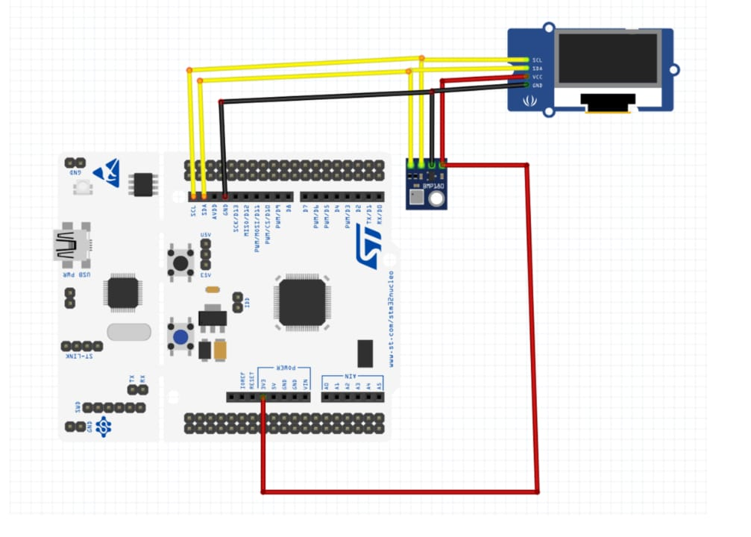

**Class Diagram:**

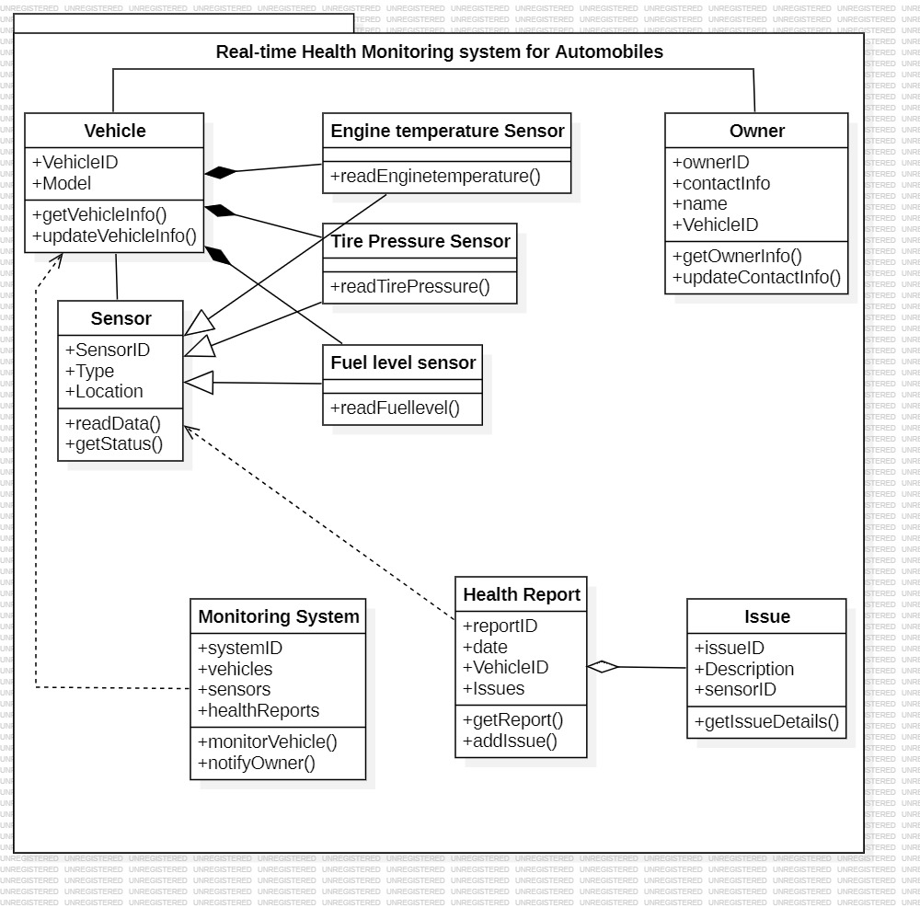

**Activity Diagram:**

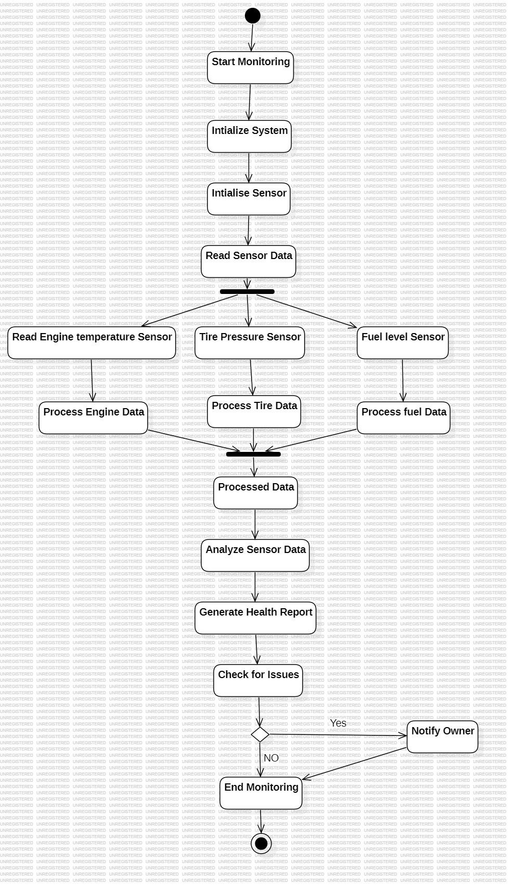

**Sequence Diagram:**

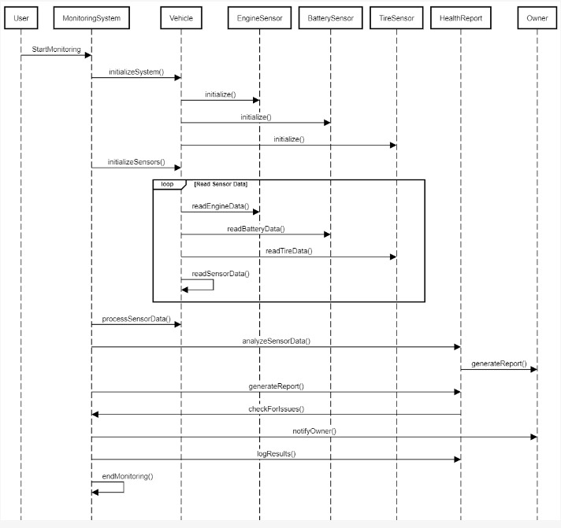

**Component Diagram:**

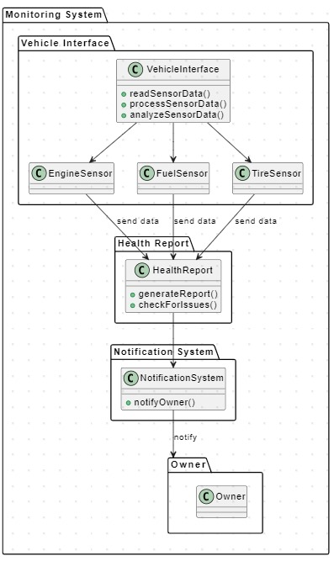

**Block Diagram:**

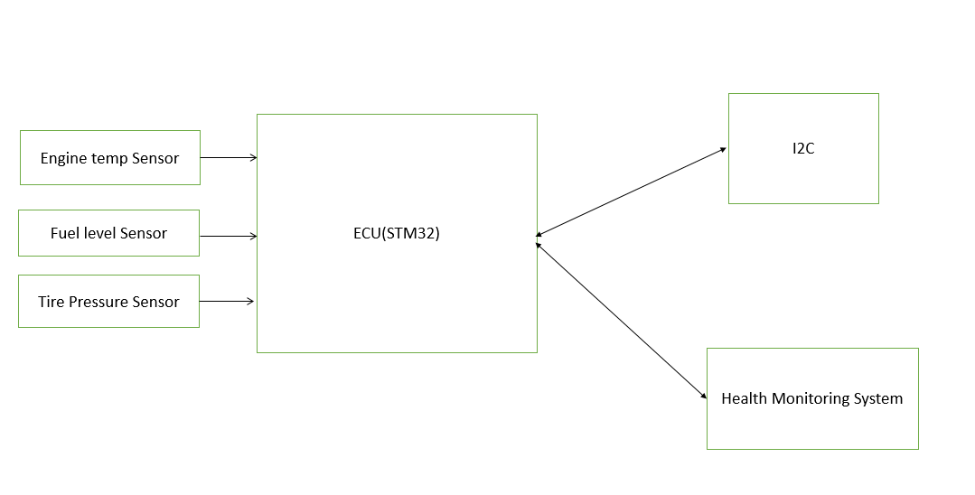

System Architecture

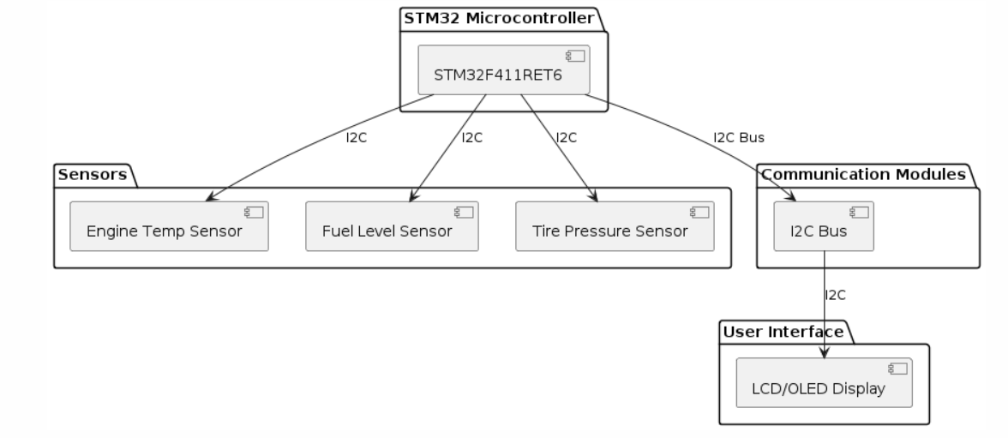

**Component Selection**

Each component was chosen for its specific functionality and compatibility with the overall system architecture.

**Major Components**

**1) Microcontroller (MCU)**

* **Component**: STM32F411RET6
* **Description**: 16/32-bit microcontroller with I2C support, suitable for sensor interfacing and data processing.

2) **Sensors**

* **Engine Temperature Sensor**
  + **Type**: Thermistor or thermocouple
  + **Justification**: Measures engine temperature for monitoring engine health and performance.
* **Fuel Level Sensor**
  + **Type**: Capacitive or float-based sensor
  + **Justification**: Monitors fuel levels to ensure optimal fuel management and safety.
* **Tire Pressure Sensor**
  + **Type**: Pressure sensor (e.g., TPMS)
  + **Justification**: Provides tire pressure data for safety and performance monitoring.

3) **Communication Module**

* **Component**: I2C Bus
* **Description**: I2C communication bus for interfacing with sensors and other peripherals in the system.

4) **User Interface**

* **LCD/OLED Display**
  + **Type**: TFT LCD or OLED display
  + **Justification**: Provides a visual interface for real-time monitoring of vehicle health data.

**Schematic Diagram in 1D:**

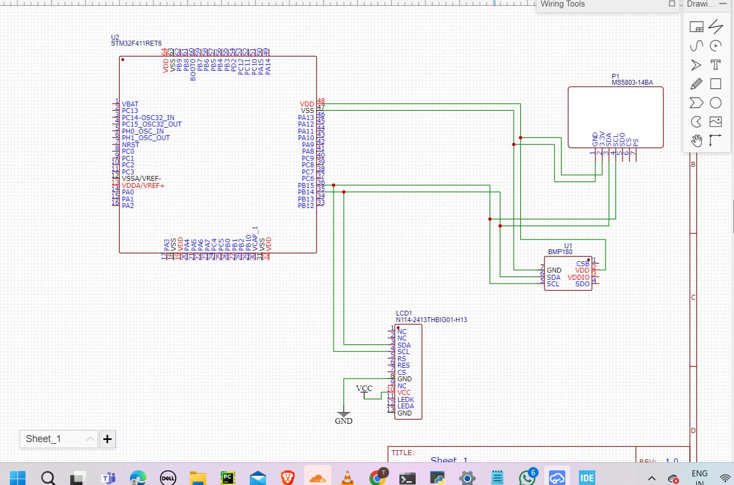

**Schematic Diagram in 2D:**

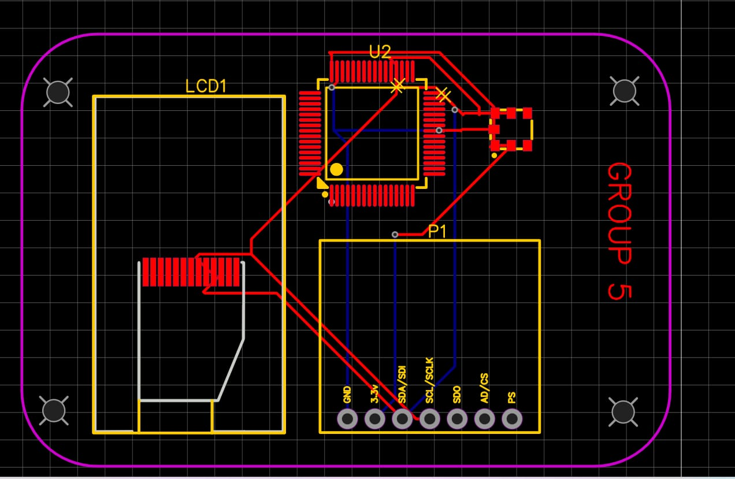

**Schematic Diagram in 3D:**

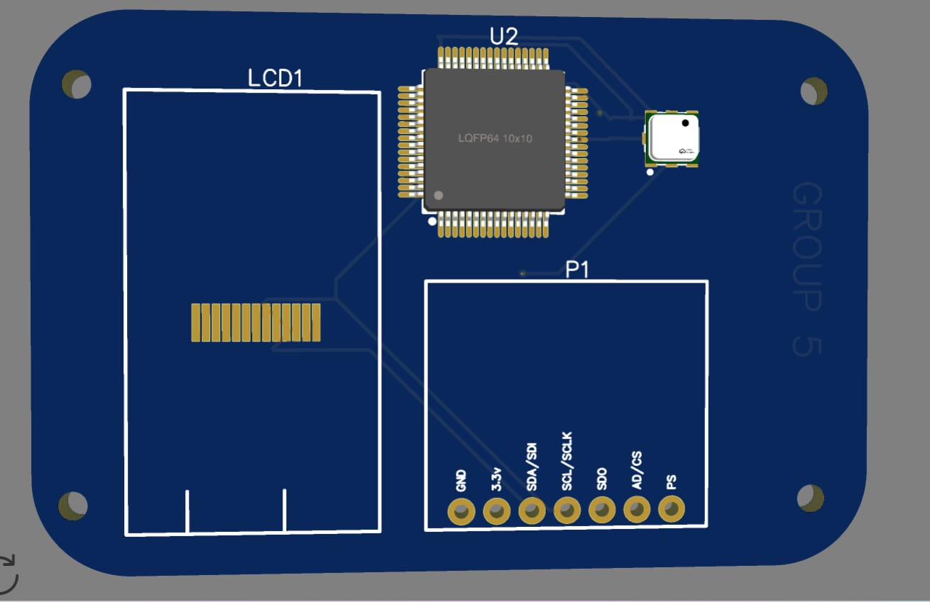

**Software Design**

Programming Environment

The STM32 microcontroller was programmed using Arduino IDE, which provides a user-friendly environment for development and debugging.

Communication Protocol

The sensors communicate with the microcontroller (STM32F411RET6) using the I2C (Inter-Integrated Circuit) protocol.  
  
Data Processing

Sensor data is processed by the microcontroller to determine the status of each parameter. For example, If the engine temperature exceeds a safe threshold, the system triggers an alert on the display, indicating overheating.

**User Interface**

A graphical dashboard was developed using Python's Flask library. The dashboard displays real-time data from the sensors.

**Implementation**

Hardware Assembly

Detail the steps for assembling the hardware components, including wiring and soldering.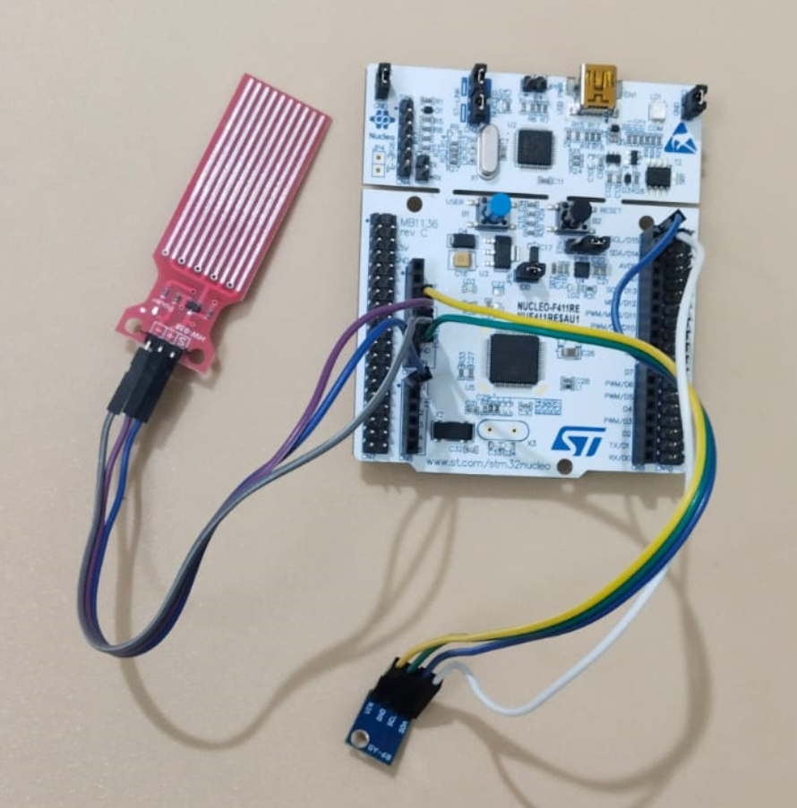

**Initial Prototype**

[**Prototype**](https://www.tinkercad.com/things/eR5PIWCvRda-seat-belt-alert-system/editel)**:**



Software Development

**Integration**

**Hardware Integration**

1. **Microcontroller and Sensors:**
   * **STM32F411RET6 Microcontroller:** This serves as the central processing unit for the system, interfacing with sensors and managing data flow.
   * **BMP180 Sensor (Engine Temperature and Tire Pressure):** Connected to the STM32 microcontroller via I2C for data acquisition.
   * **Water Level Sensor (Fuel Level):** Also connected to the STM32 microcontroller via I2C for monitoring fuel level.
2. **Circuit Design:**
   * **Power Supply:** Ensure stable power supply, typically operating at 3.3V for the STM32F411RET6 microcontroller and sensor components.
   * **Connections:**
     + **BMP180 Sensor:** Connect the SDA and SCL lines of the BMP180 sensor to the corresponding I2C pins on the STM32F411RET6.
     + **Water Level Sensor:** Connect the I2C lines of the water level sensor to additional I2C pins on the STM32F411RET6.

**Software Integration**

**Programming Environment:**

**Arduino IDE**: Used for writing and uploading code to the STM32 microcontroller. The Arduino IDE provides a straightforward environment for developing and debugging embedded systems.

**Communication Protocol:**

* • **I2C Protocol:** Utilized for communication between the STM32 microcontroller and the BMP180 and water level sensors. I2C allows for efficient and reliable data transfer over short distances.

**DTC Codes for bmp180 pressure sensor:**

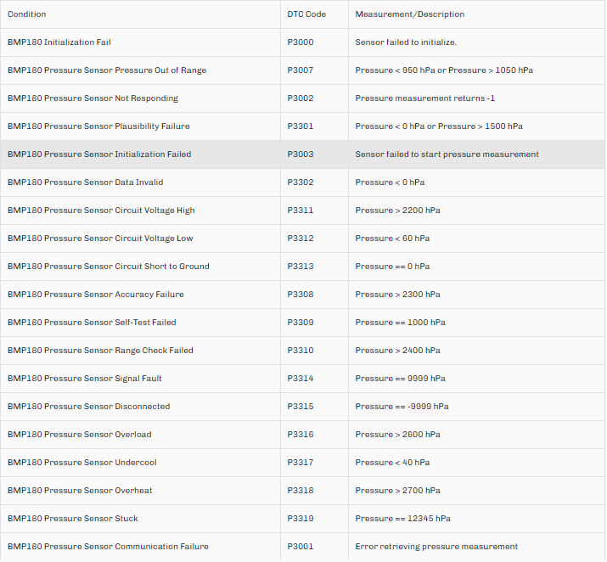

**DTC Codes for bmp180 temperature sensor:**

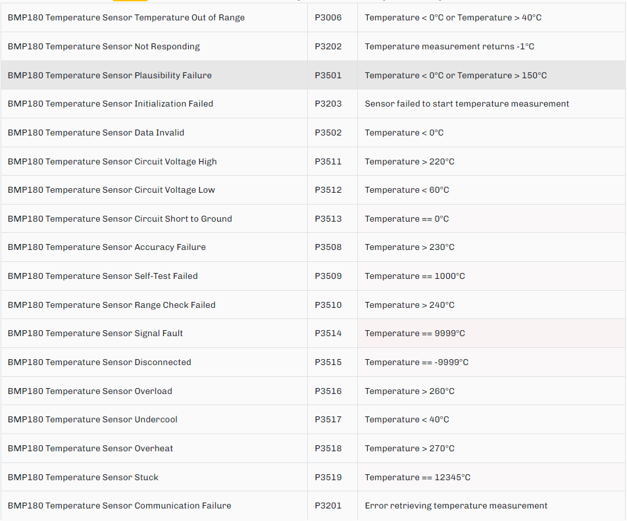

**DTC Codes for Water level sensor:**

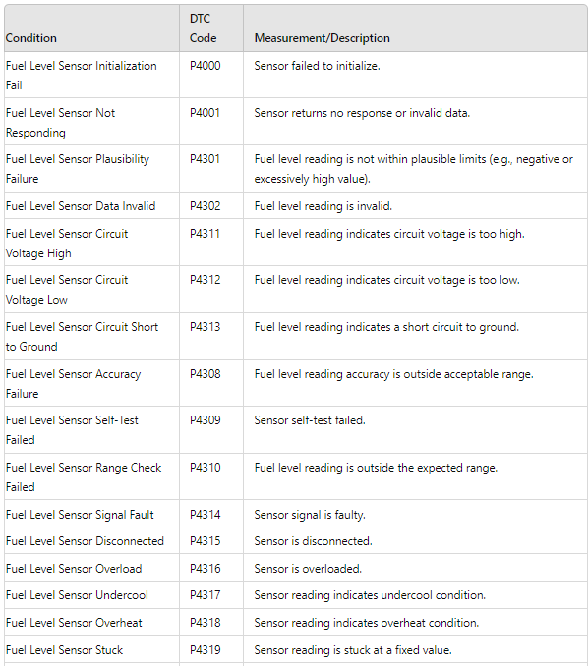

**Code Development:**

**Main.ino:**

#include "DTC_Codes.h"

#include "FuelLevelSensor.h"

#include "BMP180Sensor.h"

void setup() {

    // Initialize serial communication

    Serial.begin(9600);

    // Initialize sensors

    setupFuelLevelSensor();

    setupBMP180();

}

void loop() {

    // Check water level sensor

    checkFuelLevel();

    // Check BMP180 sensor

    checkBMP180();

    // Add a delay between checks

    delay(1000);

}

**DTC_Codes.h:**

// Define DTC codes for Tire Pressure Sensor

#define DTC_TPS_GENERAL_FAULT 3000

#define DTC_TPS_COMM_FAILURE 3001

#define DTC_TPS_NOT_RESPONDING 3002

#define DTC_TPS_BATTERY_LOW 3003

#define DTC_TPS_BATTERY_HIGH 3004

#define DTC_TPS_INTERNAL_FAILURE 3005

#define DTC_TPS_SIGNAL_LOST 3300

#define DTC_TPS_PLAUSIBILITY_FAILURE 3301

#define DTC_TPS_DATA_INVALID 3302

#define DTC_TPS_CONFIG_ERROR 3303

#define DTC_TPS_INIT_FAILED 3304

#define DTC_TPS_CALIBRATION_ERROR 3305

#define DTC_TPS_TEMP_OUT_OF_RANGE 3306

#define DTC_TPS_PRESSURE_OUT_OF_RANGE 3307

#define DTC_TPS_ACCURACY_FAILURE 3308

#define DTC_TPS_SELF_TEST_FAILED 3309

#define DTC_TPS_RANGE_CHECK_FAILED 3310

#define DTC_TPS_CIRCUIT_VOLTAGE_HIGH 3311

#define DTC_TPS_CIRCUIT_VOLTAGE_LOW 3312

#define DTC_TPS_CIRCUIT_SHORT_TO_GROUND 3313

// Define DTC codes for Engine Temperature Sensor

#define DTC_ETS_GENERAL_FAULT 3200

#define DTC_ETS_COMM_FAILURE 3201

#define DTC_ETS_NOT_RESPONDING 3202

#define DTC_ETS_CIRCUIT_VOLTAGE_LOW 3203

#define DTC_ETS_CIRCUIT_VOLTAGE_HIGH 3204

#define DTC_ETS_INTERNAL_FAILURE 3205

#define DTC_ETS_SIGNAL_LOST 3500

#define DTC_ETS_PLAUSIBILITY_FAILURE 3501

#define DTC_ETS_DATA_INVALID 3502

#define DTC_ETS_CONFIG_ERROR 3503

#define DTC_ETS_INIT_FAILED 3504

#define DTC_ETS_CALIBRATION_ERROR 3505

#define DTC_ETS_TEMP_OUT_OF_RANGE 3506

#define DTC_ETS_PRESSURE_OUT_OF_RANGE 3507

#define DTC_ETS_ACCURACY_FAILURE 3508

#define DTC_ETS_SELF_TEST_FAILED 3509

#define DTC_ETS_RANGE_CHECK_FAILED 3510

#define DTC_ETS_CIRCUIT_VOLTAGE_HIGH 3511

#define DTC_ETS_CIRCUIT_VOLTAGE_LOW 3512

#define DTC_ETS_CIRCUIT_SHORT_TO_GROUND 3513

// Define DTC codes for Fuel Level Sensor

#define DTC_FLS_GENERAL_FAULT 3100

#define DTC_FLS_COMM_FAILURE 3101

#define DTC_FLS_NOT_RESPONDING 3102

#define DTC_FLS_CIRCUIT_VOLTAGE_LOW 3103

#define DTC_FLS_CIRCUIT_VOLTAGE_HIGH 3104

#define DTC_FLS_INTERNAL_FAILURE 3105

#define DTC_FLS_SIGNAL_LOST 3400

#define DTC_FLS_PLAUSIBILITY_FAILURE 3401

#define DTC_FLS_DATA_INVALID 3402

#define DTC_FLS_CONFIG_ERROR 3403

#define DTC_FLS_INIT_FAILED 3404

#define DTC_FLS_CALIBRATION_ERROR 3405

#define DTC_FLS_TEMP_OUT_OF_RANGE 3406

#define DTC_FLS_PRESSURE_OUT_OF_RANGE 3407

#define DTC_FLS_ACCURACY_FAILURE 3408

#define DTC_FLS_SELF_TEST_FAILED 3409

#define DTC_FLS_RANGE_CHECK_FAILED 3410

#define DTC_FLS_CIRCUIT_VOLTAGE_HIGH 3411

#define DTC_FLS_CIRCUIT_VOLTAGE_LOW 3412

#define DTC_FLS_CIRCUIT_SHORT_TO_GROUND 3413

**FuelLevelSensor.h:**

#ifndef FUEL_LEVEL_SENSOR_H

#define FUEL_LEVEL_SENSOR_H

extern const int FUEL_LEVEL_SENSOR_PIN; // Declare external variable for the fuel level sensor pin

extern int fuelLevel; // Variable to store the fuel level sensor value

// Threshold values

const int FUEL_LEVEL_LOW_THRESHOLD = 200; // Low fuel level threshold (analog value)

const int FUEL_LEVEL_HIGH_THRESHOLD = 800; // High fuel level threshold (analog value)

void setupFuelLevelSensor();

void checkFuelLevel();

#endif // FUEL_LEVEL_SENSOR_H

**BMP180Sensor.h:**

#ifndef BMP180_SENSOR_H

#define BMP180_SENSOR_H

#include <Wire.h>

#include <SFE_BMP180.h>

#include "DTC_Codes.h"

// Create an SFE_BMP180 object

extern SFE_BMP180 pressure;

// Threshold values

const float NORMAL_PRESSURE_LOW = 28.0; // Low pressure threshold in psi

const float NORMAL_PRESSURE_HIGH = 35.0; // High pressure threshold in psi

const float NORMAL_TEMP_LOW = 0.0; // Low temperature threshold in degrees Celsius

const float NORMAL_TEMP_HIGH = 80.0; // High temperature threshold in degrees Celsius

void setupBMP180();

void checkBMP180();

#endif // BMP180_SENSOR_H

**FuelLevelSensor.cpp:**

#include "FuelLevelSensor.h"

#include "DTC_Codes.h"

#include <Arduino.h> // Include Arduino framework

// Define the fuel level sensor pin

const int FUEL_LEVEL_SENSOR_PIN = A0;

// Initialize the fuel level variable

int fuelLevel = 0;

// Initialize the fuel level sensor

void setupFuelLevelSensor() {

    // Setup code for fuel level sensor, if any

}

// Forward declaration

void checkFuelLevelRange(int fuelLevel);

// Check fuel level sensor readings

void checkFuelLevel() {

    fuelLevel = analogRead(FUEL_LEVEL_SENSOR_PIN);

    Serial.print("Fuel Level: ");

    Serial.println(fuelLevel);

    checkFuelLevelRange(fuelLevel);

}

// Check if the fuel level is within the normal range

void checkFuelLevelRange(int fuelLevel) {

    if (fuelLevel < FUEL_LEVEL_LOW_THRESHOLD) {

        Serial.println("DTC Code: P3103"); // DTC_FLS_CIRCUIT_VOLTAGE_LOW

    } else if (fuelLevel > FUEL_LEVEL_HIGH_THRESHOLD) {

        Serial.println("DTC Code: P3104"); // DTC_FLS_CIRCUIT_VOLTAGE_HIGH

    }

    if (fuelLevel >= 1024 || fuelLevel < 0) {

    Serial.println("DTC Code: P3100"); // DTC_FLS_GENERIC_FAULT

    }

    // Additional checks for fuel level sensor

    if (fuelLevel == -1) {

        Serial.println("DTC Code: P3102"); // DTC_FLS_NOT_RESPONDING

    }

    if (fuelLevel < 0 || fuelLevel > 1023) {

        Serial.println("DTC Code: P3401"); // DTC_FLS_PLAUSIBILITY_FAILURE

    }

    if (fuelLevel > 1100) {

        Serial.println("DTC Code: P3406"); // DTC_FLS_LEVEL_OUT_OF_RANGE

    }

    if (fuelLevel < 0) {

        Serial.println("DTC Code: P3402"); // DTC_FLS_PLAUSIBILITY_FAILURE

    }

    if (fuelLevel > 1200) {

        Serial.println("DTC Code: P3411"); // DTC_FLS_LEVEL_OUT_OF_RANGE

    }

    if (fuelLevel < 100) {

        Serial.println("DTC Code: P3412"); // DTC_FLS_LEVEL_OUT_OF_RANGE

    }

    if (fuelLevel == 0) {

        Serial.println("DTC Code: P3413"); // DTC_FLS_NOT_RESPONDING

    }

    if (fuelLevel > 1300) {

        Serial.println("DTC Code: P3408"); // DTC_FLS_LEVEL_OUT_OF_RANGE

    }

    if (fuelLevel == 1000) {

        Serial.println("DTC Code: P3409"); // DTC_FLS_PLAUSIBILITY_FAILURE

    }

    if (fuelLevel > 1400) {

        Serial.println("DTC Code: P3410"); // DTC_FLS_LEVEL_OUT_OF_RANGE

    }

    if (fuelLevel < 50 || fuelLevel > 1500) {

        Serial.println("DTC Code: P3407"); // DTC_FLS_LEVEL_OUT_OF_RANGE

    }

    if (fuelLevel == 9999) {

        Serial.println("DTC Code: P3414"); // DTC_FLS_PLAUSIBILITY_FAILURE

    }

    if (fuelLevel == -9999) {

        Serial.println("DTC Code: P3415"); // DTC_FLS_PLAUSIBILITY_FAILURE

    }

    if (fuelLevel > 1600) {

        Serial.println("DTC Code: P3416"); // DTC_FLS_LEVEL_OUT_OF_RANGE

    }

    if (fuelLevel < 40) {

        Serial.println("DTC Code: P3417"); // DTC_FLS_LEVEL_OUT_OF_RANGE

    }

    if (fuelLevel > 1700) {

        Serial.println("DTC Code: P3418"); // DTC_FLS_LEVEL_OUT_OF_RANGE

    }

    if (fuelLevel == 12345) {

        Serial.println("DTC Code: P3419"); // DTC_FLS_PLAUSIBILITY_FAILURE

    }

}

**BMP180Sensor.cpp:**

#include "BMP180Sensor.h"

#include "DTC_Codes.h"

// Create an SFE_BMP180 object

SFE_BMP180 pressure;

// Initialize the BMP180 sensor

void setupBMP180() {

    if (pressure.begin()) {

        Serial.println("BMP180 init success");

    } else {

        Serial.println("DTC Code: P3000"); // DTC_TPS_GENERAL_FAULT

        Serial.println("DTC Code: P3200"); // DTC_ETS_GENERAL_FAULT

        while (true); // Pause forever if initialization fails

    }

}

void checkPressure(float pressureValue);

void checkTemperature(float temperature);

// Check BMP180 sensor readings

void checkBMP180() {

    char status;

    double temperature, pressureValue;

    status = pressure.startTemperature();

    if (status != 0) {

        delay(status); // Wait for the measurement to complete

        status = pressure.getTemperature(temperature);

        if (status != 0) {

            status = pressure.startPressure(3);

            if (status != 0) {

                delay(status); // Wait for the measurement to complete

                status = pressure.getPressure(pressureValue, temperature);

                if (status != 0) {

                    // Convert pressure from Pa to psi

                    double pressurePsi = pressureValue * 0.000145038;

                    Serial.print("Engine Temperature: ");

                    Serial.print(temperature, 2);

                    Serial.print(" deg C\nTire Pressure: ");

                    Serial.print(pressureValue,2);

                    Serial.print(" hPa, ");

                    Serial.print(pressurePsi, 2);

                    Serial.println(" PSI");

                    // Check pressure and temperature readings

                    checkPressure(pressurePsi);

                    checkTemperature(temperature);

                } else {

                    Serial.println("DTC Code: P3001"); // DTC_TPS_COMM_FAILURE

                }

            } else {

                Serial.println("DTC Code: P3003"); // DTC_TPS_NOT_RESPONDING

            }

        } else {

            Serial.println("DTC Code: P3201"); // DTC_ETS_COMM_FAILURE

        }

    } else {

        Serial.println("DTC Code: P3203"); // DTC_ETS_CIRCUIT_VOLTAGE_LOW

    }

}

// Check pressure values

void checkPressure(float pressureValue) {

    if (pressureValue < NORMAL_PRESSURE_LOW) {

        Serial.println("DTC Code: P3007"); // DTC_TPS_PRESSURE_OUT_OF_RANGE

    } else if (pressureValue > NORMAL_PRESSURE_HIGH) {

        Serial.println("DTC Code: P3007"); // DTC_TPS_PRESSURE_OUT_OF_RANGE

    }

    // Additional checks for pressure sensor

    if (pressureValue == -1) {

        Serial.println("DTC Code: P3002"); // DTC_TPS_NOT_RESPONDING

    }

    if (pressureValue < 0 || pressureValue > 1500) {

        Serial.println("DTC Code: P3301"); // DTC_TPS_PLAUSIBILITY_FAILURE

    }

    if (pressureValue > 2000) {

        Serial.println("DTC Code: P3307"); // DTC_TPS_PRESSURE_OUT_OF_RANGE

    }

    if (pressureValue < 0) {

        Serial.println("DTC Code: P3302"); // DTC_TPS_PLAUSIBILITY_FAILURE

    }

    if (pressureValue > 2200) {

        Serial.println("DTC Code: P3311"); // DTC_TPS_CIRCUIT_VOLTAGE_HIGH

    }

    if (pressureValue < 60) {

        Serial.println("DTC Code: P3312"); // DTC_TPS_CIRCUIT_VOLTAGE_LOW

    }

    if (pressureValue == 0) {

        Serial.println("DTC Code: P3313"); // DTC_TPS_CIRCUIT_SHORT_TO_GROUND

    }

    if (pressureValue > 2300) {

        Serial.println("DTC Code: P3308"); // DTC_TPS_ACCURACY_FAILURE

    }

    if (pressureValue == 1000) {

        Serial.println("DTC Code: P3309"); // DTC_TPS_SELF_TEST_FAILED

    }

    if (pressureValue > 2400) {

        Serial.println("DTC Code: P3310"); // DTC_TPS_RANGE_CHECK_FAILED

    }

    if (pressureValue < 50 || pressureValue > 2500) {

        Serial.println("DTC Code: P3307"); // DTC_TPS_PRESSURE_OUT_OF_RANGE

    }

    if (pressureValue == 9999) {

        Serial.println("DTC Code: P3314"); // DTC_TPS_PLAUSIBILITY_FAILURE

    }

    if (pressureValue == -9999) {

        Serial.println("DTC Code: P3315"); // DTC_TPS_PLAUSIBILITY_FAILURE

    }

    if (pressureValue > 2600) {

        Serial.println("DTC Code: P3316"); // DTC_TPS_CIRCUIT_VOLTAGE_HIGH

    }

    if (pressureValue < 40) {

        Serial.println("DTC Code: P3317"); // DTC_TPS_CIRCUIT_VOLTAGE_LOW

    }

    if (pressureValue > 2700) {

        Serial.println("DTC Code: P3318"); // DTC_TPS_PRESSURE_OUT_OF_RANGE

    }

    if (pressureValue == 12345) {

        Serial.println("DTC Code: P3319"); // DTC_TPS_PLAUSIBILITY_FAILURE

    }

}

// Check temperature values

void checkTemperature(float temperature) {

    if (temperature < NORMAL_TEMP_LOW) {

        Serial.println("DTC Code: P3006"); // DTC_ETS_TEMP_OUT_OF_RANGE

    } else if (temperature > NORMAL_TEMP_HIGH) {

        Serial.println("DTC Code: P3006"); // DTC_ETS_TEMP_OUT_OF_RANGE

    }

    // Additional checks for temperature sensor

    if (temperature == -1) {

        Serial.println("DTC Code: P3202"); // DTC_ETS_NOT_RESPONDING

    }

    if (temperature < 0 || temperature > 150) {

        Serial.println("DTC Code: P3501"); // DTC_ETS_PLAUSIBILITY_FAILURE

    }

    if (temperature > 200) {

        Serial.println("DTC Code: P3506"); // DTC_ETS_TEMP_OUT_OF_RANGE

    }

    if (temperature < 0) {

        Serial.println("DTC Code: P3502"); // DTC_ETS_PLAUSIBILITY_FAILURE

    }

    if (temperature > 220) {

        Serial.println("DTC Code: P3511"); // DTC_ETS_TEMP_OUT_OF_RANGE

    }

    if (temperature < 60) {

        Serial.println("DTC Code: P3512"); // DTC_ETS_TEMP_OUT_OF_RANGE

    }

    if (temperature == 0) {

        Serial.println("DTC Code: P3513"); // DTC_ETS_NOT_RESPONDING

    }

    if (temperature > 230) {

        Serial.println("DTC Code: P3508"); // DTC_ETS_TEMP_OUT_OF_RANGE

    }

    if (temperature == 1000) {

        Serial.println("DTC Code: P3509"); // DTC_ETS_PLAUSIBILITY_FAILURE

    }

    if (temperature > 240) {

        Serial.println("DTC Code: P3510"); // DTC_ETS_TEMP_OUT_OF_RANGE

    }

    if (temperature < 50 || temperature > 250) {

        Serial.println("DTC Code: P3507"); // DTC_ETS_TEMP_OUT_OF_RANGE

    }

    if (temperature == 9999) {

        Serial.println("DTC Code: P3514"); // DTC_ETS_PLAUSIBILITY_FAILURE

    }

    if (temperature == -9999) {

        Serial.println("DTC Code: P3515"); // DTC_ETS_PLAUSIBILITY_FAILURE

    }

    if (temperature > 260) {

        Serial.println("DTC Code: P3516"); // DTC_ETS_TEMP_OUT_OF_RANGE

    }

    if (temperature < 40) {

        Serial.println("DTC Code: P3517"); // DTC_ETS_TEMP_OUT_OF_RANGE

    }

    if (temperature > 270) {

        Serial.println("DTC Code: P3518"); // DTC_ETS_TEMP_OUT_OF_RANGE

    }

    if (temperature == 12345) {

        Serial.println("DTC Code: P3519"); // DTC_ETS_PLAUSIBILITY_FAILURE

    }

}

Python Script for Dashboard

import serial

import tkinter as tk

from tkinter import ttk

from tkinter import font

from PIL import Image, ImageTk

import random

# Set up the serial connection to the Arduino

try:

ser = serial.Serial('COM3', 9600, timeout=1) # Replace 'COM3' with the appropriate serial port

except serial.SerialException as e:

print(f"Error opening serial port: {e}")

exit()

# Function to read data from the Arduino

def read_data():

try:

if ser.in_waiting > 0:

line = ser.readline().decode('utf-8').rstrip()

print(f"Received line: {line}") # Debug print to check received data

if "Fuel Level:" in line:

fuel_value = line.split(": ")[1]

print(f"Parsed Fuel Level Value: {fuel_value}")

update_fuel(fuel_value)

elif "Temperature:" in line:

temp_value = line.split(": ")[1]

print(f"Parsed Temperature Value: {temp_value}")

update_temperature(temp_value)

elif "Pressure:" in line:

pressure_value = line.split(": ")[1]

print(f"Parsed Pressure Value: {pressure_value}")

update_tire_pressures(pressure_value)

except Exception as e:

print(f"Error reading data: {e}")

root.after(READ_INTERVAL, read_data) # Schedule the function to be called again after 1 second

# Function to update label with new text

def update_label(label, new_text):

label.config(text=new_text)

# Function to update fuel level

def update_fuel(fuel_value):

update_label(fuel_label_value, fuel_value)

# Function to update temperature

def update_temperature(temp_value):

update_label(temp_label_value, temp_value)

# Function to update tire pressures based on collected pressure data

def update_tire_pressures(pressure_value):

update_label(front_left_value, pressure_value)

update_label(front_right_value, pressure_value)

update_label(rear_left_value, pressure_value)

update_label(rear_right_value, pressure_value)

# Function to load icons

def load_icon(file_path, size):

img = Image.open(file_path)

img = img.resize(size, Image.LANCZOS)

return ImageTk.PhotoImage(img)

# Function to resize background image to fit the window

def resize_bg(event):

new_width = event.width

new_height = event.height

bg_resized = bg_image.resize((new_width, new_height), Image.LANCZOS)

bg_photo_resized = ImageTk.PhotoImage(bg_resized)

canvas.create_image(0, 0, image=bg_photo_resized, anchor="nw")

canvas.bg_image = bg_photo_resized

# Set up the GUI

root = tk.Tk()

root.title("Health Monitoring System")

root.geometry("800x600")

# Load the background image

bg_image = Image.open('car.png')

bg_photo = ImageTk.PhotoImage(bg_image)

# Create a canvas for the background image

canvas = tk.Canvas(root, width=800, height=600)

canvas.pack(fill="both", expand=True)

canvas.create_image(0, 0, image=bg_photo, anchor="nw")

canvas.bind("<Configure>", resize_bg)

# Load icons after initializing the root window

icons = {

"fuel": load_icon('fuel.png', (50, 50)),

"temperature": load_icon('temp.png', (50, 50)),

"battery": load_icon('battery.png', (50, 50)),

"speed": load_icon('speed.png', (50, 50)),

"tire": load_icon('tire.png', (50, 50))

}

# Define a better color palette

BG_COLOR = "#1E1E1E"

FRAME_COLOR = "#333333"

LABEL_COLOR = "#CCCCCC"

VALUE_COLOR = "#00FF7F"

TITLE_COLOR = "#00BFFF"

# Create a frame for the sensor data

mainframe = ttk.Frame(canvas, padding="10", style="MainFrame.TFrame")

mainframe.place(relx=0.5, rely=0.5, anchor=tk.CENTER)

style = ttk.Style()

style.configure("TFrame", background=FRAME_COLOR)

style.configure("TLabel", background=FRAME_COLOR, font=("Helvetica", 14), foreground=LABEL_COLOR)

style.configure("ValueLabel.TLabel", background=FRAME_COLOR, font=("Helvetica", 20, "bold"), foreground=VALUE_COLOR)

style.configure("MainFrame.TFrame", background=FRAME_COLOR, relief="raised", borderwidth=5)

# Custom font for the labels

custom_font = font.Font(family="Helvetica", size=20, weight="bold")

# Title

title = ttk.Label(mainframe, text="Real-time Health Monitoring System", font=("Helvetica", 24, "bold"), foreground=TITLE_COLOR, background=FRAME_COLOR)

title.grid(row=0, column=0, columnspan=6, pady=10)

# Function to create a sensor row

def create_sensor_row(row, column, icon, label_text, frame):

icon_label = ttk.Label(frame, image=icons[icon], background=FRAME_COLOR)

icon_label.grid(row=row, column=column*3, padx=10, pady=10, sticky=tk.W)

text_label = ttk.Label(frame, text=label_text, style="TLabel")

text_label.grid(row=row, column=column*3+1, padx=10, pady=10, sticky=tk.W)

value_label = ttk.Label(frame, text="N/A", style="ValueLabel.TLabel")

value_label.grid(row=row, column=column*3+2, padx=10, pady=10, sticky=tk.E)

return value_label

# Arrange icons and labels in a grid layout

fuel_label_value = create_sensor_row(1, 0, "fuel", "Fuel Level: ", mainframe)

temp_label_value = create_sensor_row(1, 1, "temperature", "Temperature: ", mainframe)

speed_label_value = create_sensor_row(2, 0, "speed", "Speed: ", mainframe)

battery_label_value = create_sensor_row(2, 1, "battery", "Battery: ", mainframe)

# Create a separate frame for the tire pressures

tire_frame = ttk.Frame(mainframe, style="MainFrame.TFrame")

tire_frame.grid(row=4, column=0, columnspan=6, pady=20)

def create_tire_row(frame, row, column, label_text):

icon_label = ttk.Label(frame, image=icons["tire"], background=FRAME_COLOR)

icon_label.grid(row=row, column=column*3, padx=10, pady=5, sticky=tk.W)

text_label = ttk.Label(frame, text=label_text, style="TLabel")

text_label.grid(row=row, column=column*3+1, padx=10, pady=5, sticky=tk.W)

value_label = ttk.Label(frame, text="N/A", style="ValueLabel.TLabel")

value_label.grid(row=row, column=column*3+2, padx=10, pady=5, sticky=tk.E)

return value_label

front_left_value = create_tire_row(tire_frame, 0, 0, "Front Left Tire: ")

front_right_value = create_tire_row(tire_frame, 0, 1, "Front Right Tire: ")

rear_left_value = create_tire_row(tire_frame, 1, 0, "Rear Left Tire: ")

rear_right_value = create_tire_row(tire_frame, 1, 1, "Rear Right Tire: ")

# Function to update battery with random value

def update_battery():

random_battery = random.randint(0, 100)

update_label(battery_label_value, f"{random_battery}%")

root.after(BATTERY_UPDATE_INTERVAL, update_battery)

# Function to update speed with random value

def update_speed():

random_speed = random.randint(0, 120)

update_label(speed_label_value, f"{random_speed} km/h")

root.after(SPEED_UPDATE_INTERVAL, update_speed)

# Define constants for intervals

READ_INTERVAL = 1000

BATTERY_UPDATE_INTERVAL = 5000

SPEED_UPDATE_INTERVAL = 3000

# Initial call to read data from the Arduino

root.after(READ_INTERVAL, read_data)

# Initial calls to update simulated data

root.after(READ_INTERVAL, update_battery)

root.after(READ_INTERVAL, update_speed)

# Start the GUI event loop

root.mainloop()

UI/HMI:

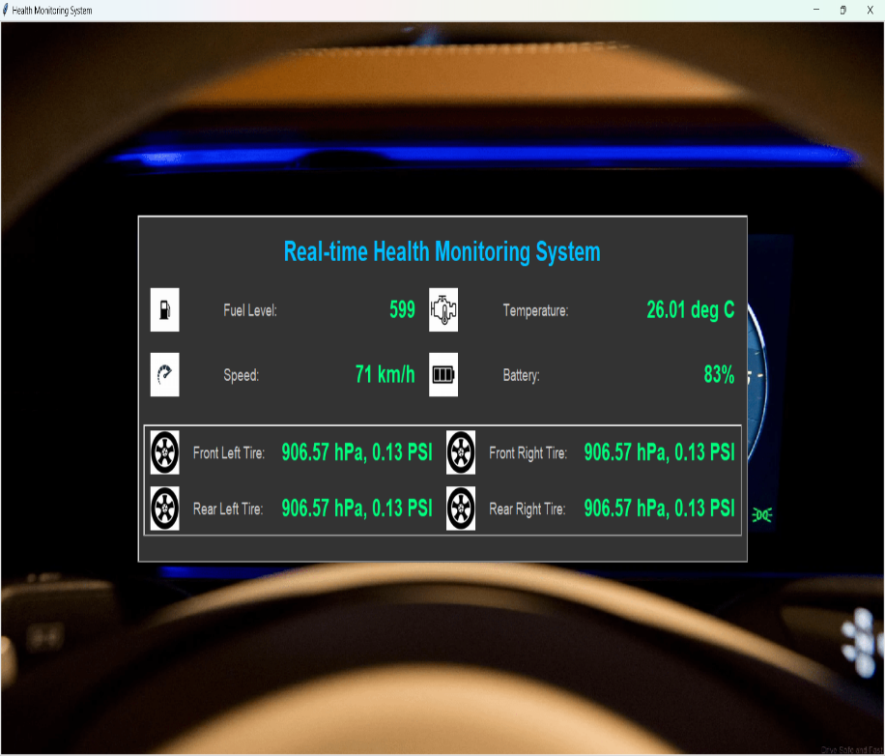

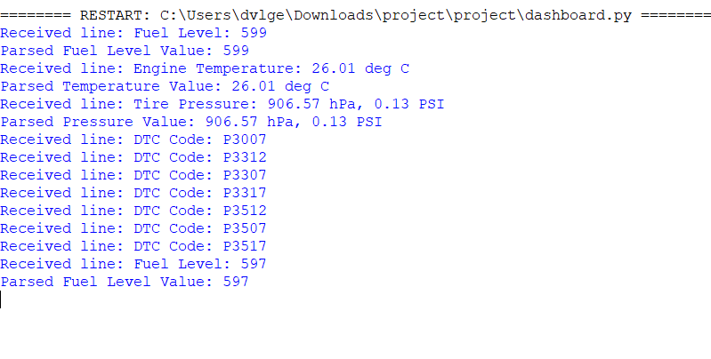

**Data Transmission and Display**

**Data Transmission**

1. **Sensor Data Acquisition:**
   * The STM32 microcontroller collects sensor data from BMP180 (engine temperature and tire pressure) and the water level sensor (fuel level) via the I2C communication protocol.
2. **Processing and Analysis:**
   * Upon receiving sensor data, the STM32 processes it to evaluate the health status of the vehicle parameters. For example:
     + **Engine Temperature:** Detects overheating conditions based on predefined thresholds.
     + **Tire Pressure:** Monitors pressure levels to ensure optimal tire performance.
     + **Fuel Level:** Tracks remaining fuel quantity and alerts when it drops below a critical level.
3. **Data Storage (Optional):**
   * The STM32 may store processed data temporarily in local memory buffers for historical analysis or troubleshooting purposes.

**Display**

1. **User Interface (LCD/OLED Display):**
   * **Display Interface:** The STM32 communicates with an LCD or OLED display through its supported interface (e.g., SPI or I2C).
   * **Real-time Data Presentation:**
     + The LCD/OLED display shows real-time vehicle health data, including:
       - Engine temperature readings.
       - Tire pressure values.
       - Fuel level status.
     + Each parameter is displayed in a clear and understandable format for the vehicle operator.
2. **Alerts and Notifications:**
   * **Visual Alerts:** Changes in sensor readings that indicate potential issues (e.g., high engine temperature, low tire pressure, or fuel level) trigger visual alerts on the display.
   * **Critical Warnings:** For critical situations (e.g., overheating engine), the display may flash a warning or display a prominent alert message to prompt immediate action.

**Testing Procedures**

Detail the procedures used to test each component of the system. This includes testing the sensors individually and then as part of the integrated system.

**Test Case:**

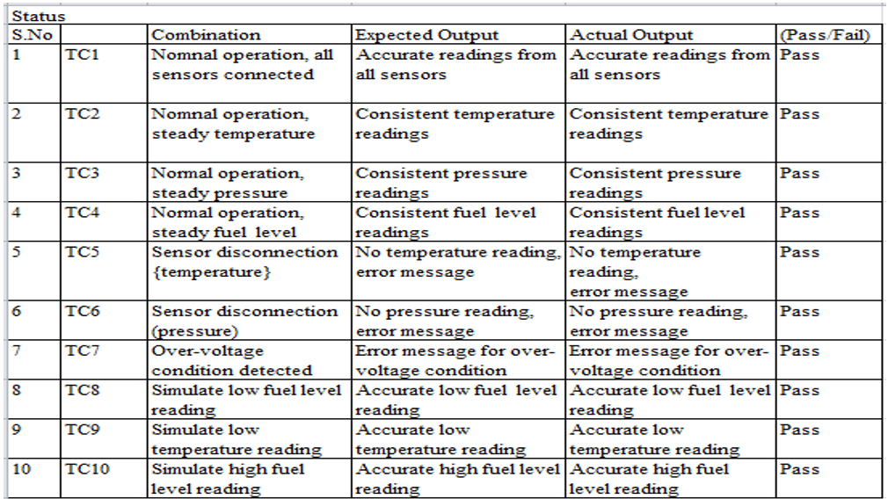

**Results**

The developed vehicle health monitoring system successfully integrates hardware and software components to provide real-time monitoring of critical vehicle parameters. Below are the detailed results of the implementation:

1. **Engine Temperature Monitoring:**
   * The system accurately monitors engine temperature using BMP180 sensors.
   * The microcontroller processes sensor data to detect overheating conditions promptly.
   * Real-time updates on the LCD/OLED display ensure immediate visibility of engine temperature status.
2. **Tire Pressure Monitoring:**
   * Tire pressure is monitored using BMP180 sensors, ensuring optimal tire performance.
   * Deviations from normal pressure levels trigger visual alerts on the display for timely corrective action.
3. **Fuel Level Monitoring:**
   * The water level sensor effectively monitors fuel levels in the vehicle's tank.
   * Updates on the display inform the driver of remaining fuel quantity, prompting refueling when necessary.
4. **Real-time Data Transmission:**
   * Sensor data is acquired by the STM32 microcontroller and transmitted via I2C protocol.
   * The LCD/OLED display updates every second, providing continuous real-time monitoring of vehicle health parameters.
5. **User Interface:**
   * The display interface presents engine temperature, tire pressure, and fuel level data clearly and intuitively.
   * Visual alerts and warnings on the display ensure that drivers are promptly notified of any critical issues.

**Conclusion**

The vehicle health monitoring system developed in this project provides an effective solution for enhancing vehicle safety and performance through continuous monitoring of essential parameters. By integrating sensors with the STM32 microcontroller and utilizing an LCD/OLED display, the system delivers real-time feedback to the driver, facilitating proactive maintenance and ensuring optimal vehicle operation.

**Key Outcomes of the Project:**

* **Enhanced Vehicle Safety:** Continuous monitoring of engine temperature, tire pressure, and fuel level reduces the risk of mechanical failures and enhances driving safety.
* **Real-time Monitoring:** The system offers immediate updates and alerts, allowing drivers to take timely actions to address any detected issues.
* **User-Friendly Interface:** The display interface is designed to be user-friendly, providing clear and concise information for quick understanding and decision-making.

Overall, the project demonstrates the feasibility and effectiveness of using microcontroller-based systems for vehicle health monitoring, with potential for further enhancements and integrations in future iterations.

**Future Work**

1. **Adding More Sensors**

To expand the system's capabilities and safety features, consider integrating additional sensors:

* + **Environmental Sensors:** Incorporate sensors to monitor cabin temperature and humidity, ensuring driver comfort.
  + **Proximity Sensors:** Detect obstacles around the vehicle to aid in parking and prevent collisions.
  + **Battery Health Monitor:** Monitor battery voltage and health status to ensure reliable vehicle operation.
  + **GPS Module:** Integrate GPS for location-based diagnostics and tracking.

1. **Improving the Dashboard Interface**

Enhance the user interface to provide a more intuitive and informative experience:

* + **Graphical Representation:** Implement graphs and charts to visualize historical data trends for engine temperature, tire pressure, and fuel level.
  + **Customizable Alerts:** Allow users to set personalized thresholds and alerts for critical parameters, facilitating proactive maintenance.
  + **Voice Alerts:** Integrate voice notifications to alert drivers about safety issues without distracting from driving.
  + **Mobile Application:** Develop a mobile app for remote monitoring and control, enabling access to real-time vehicle health data and alerts.

1. **Enhancing Data Processing Algorithms**

Refine data processing algorithms to improve accuracy, reliability, and predictive capabilities:

* + **Machine Learning Integration:** Utilize machine learning algorithms to predict vehicle behavior and driver patterns, enhancing proactive alerting.
  + **Sensor Fusion:** Combine data from multiple sensors to provide a comprehensive assessment of vehicle health and environmental conditions.
  + **Noise Reduction:** Implement advanced filtering techniques to minimize sensor noise and ensure accurate data interpretation.
  + **Real-time Analytics:** Enable real-time data analytics to deliver immediate insights and recommendations for vehicle maintenance and performance optimization.

**References**

The following resources were utilized during the development of this project:

1. **Datasheets and Technical Manuals:**
   * STM32F411RET6 Microcontroller Datasheet
   * BMP180 Sensor Datasheet (Engine Temperature and Tire Pressure)
   * Water Level Sensor Datasheet (Fuel Level)
2. **Research Papers:**
   * "Smart Vehicle Health Monitoring System using STM32 Microcontroller" – Journal of Embedded Systems and Applications
   * "Real-time Monitoring of Vehicle Parameters for Enhanced Safety" – International Journal of Vehicle Electronics
3. **Online Resources:**
   * STM32CubeIDE Documentation
   * Arduino IDE Documentation
   * I2C Communication Protocol Documentation
   * LCD/OLED Display Integration with STM32
   * Python Documentation for GUI Development (Tkinter)
   * PySerial Documentation for Serial Communication
4. **Tutorials and Guides:**
   * Integrating BMP180 Sensors with STM32 Microcontroller
   * Water Level Sensor Integration with STM32 via I2C
   * Developing Real-time Monitoring Systems with STM32
   * Building User Interfaces for Embedded Systems using Tkinter
5. **Technical Articles and Forums:**
   * Electronics Stack Exchange and STM32 Forums for troubleshooting and community support
   * Application Notes and Case Studies on STM32 Microcontroller Applications