Initial output

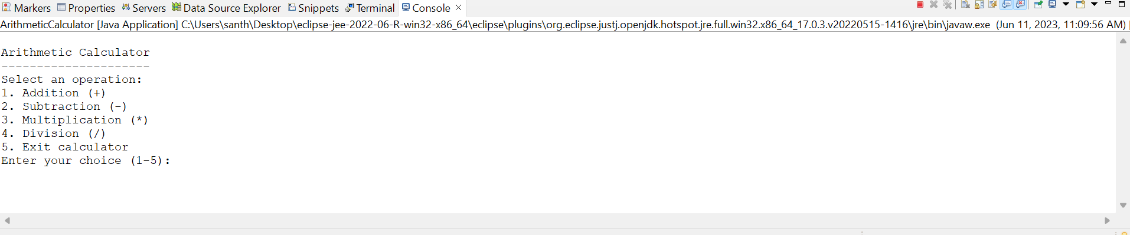

User chooses addition and enters 2 numbers

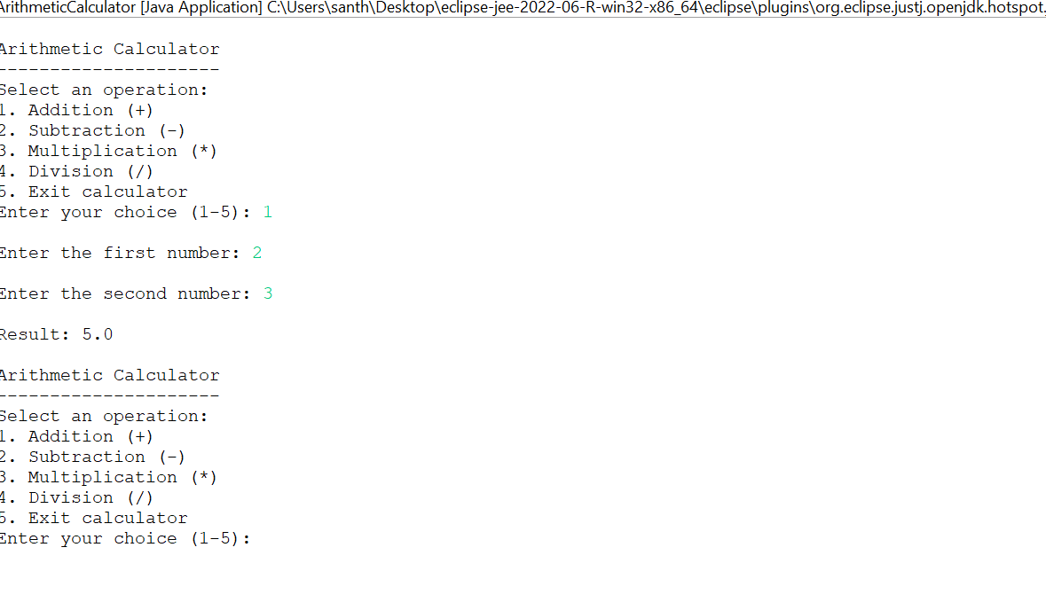

User chooses subtraction and enters 2 numbers

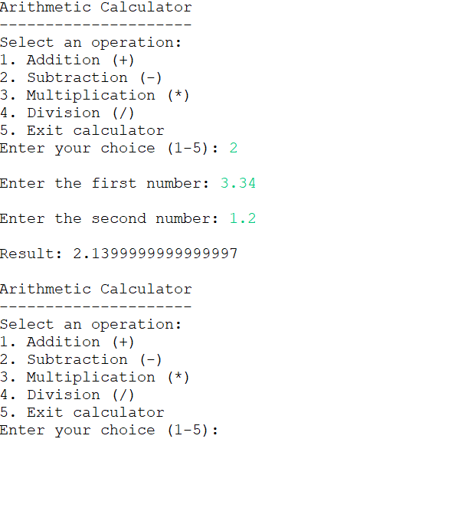

User chooses multiplication and enters 2 numbers

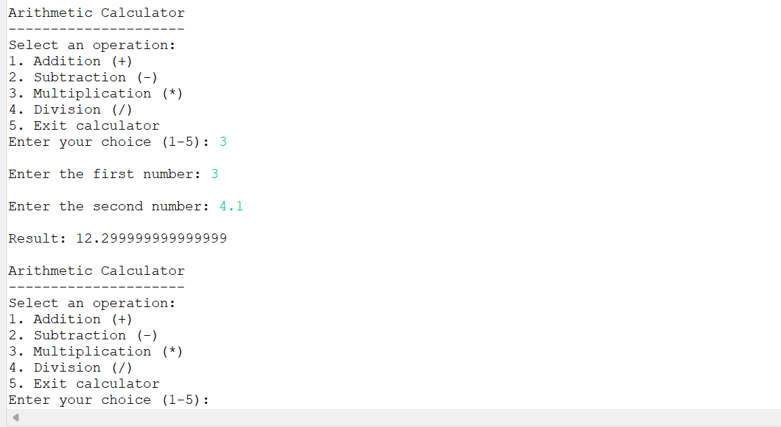

User chooses division and enters 2 numbers

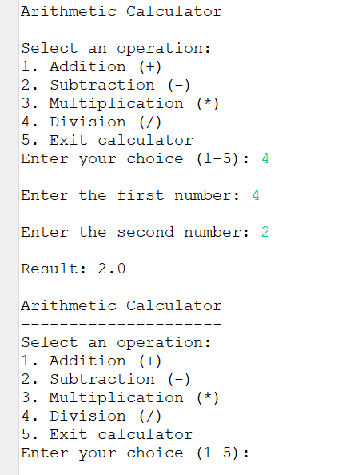

User chooses division and enters 2 numbers and second number is 0

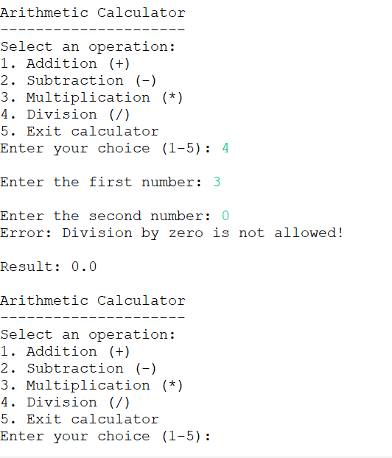

User chooses invalid operation

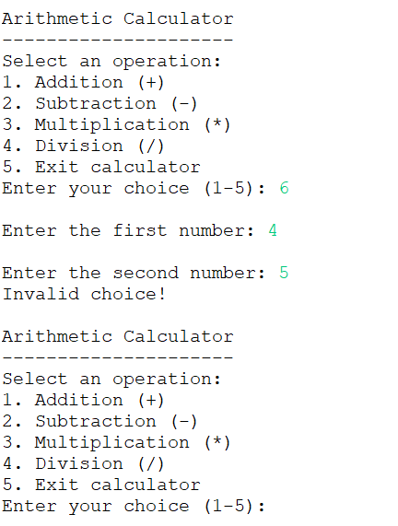

User choose to exit

