In this project I have used MVC architecture.

I am using Tomcat V10.1 as server

And I have used the concept of connection pooling for optimized database connections.

**Steps to follow for connection pooling:**

1. Press ctrl+shift+r in eclipse IDE and search for context.xml file for tomcat v10.1

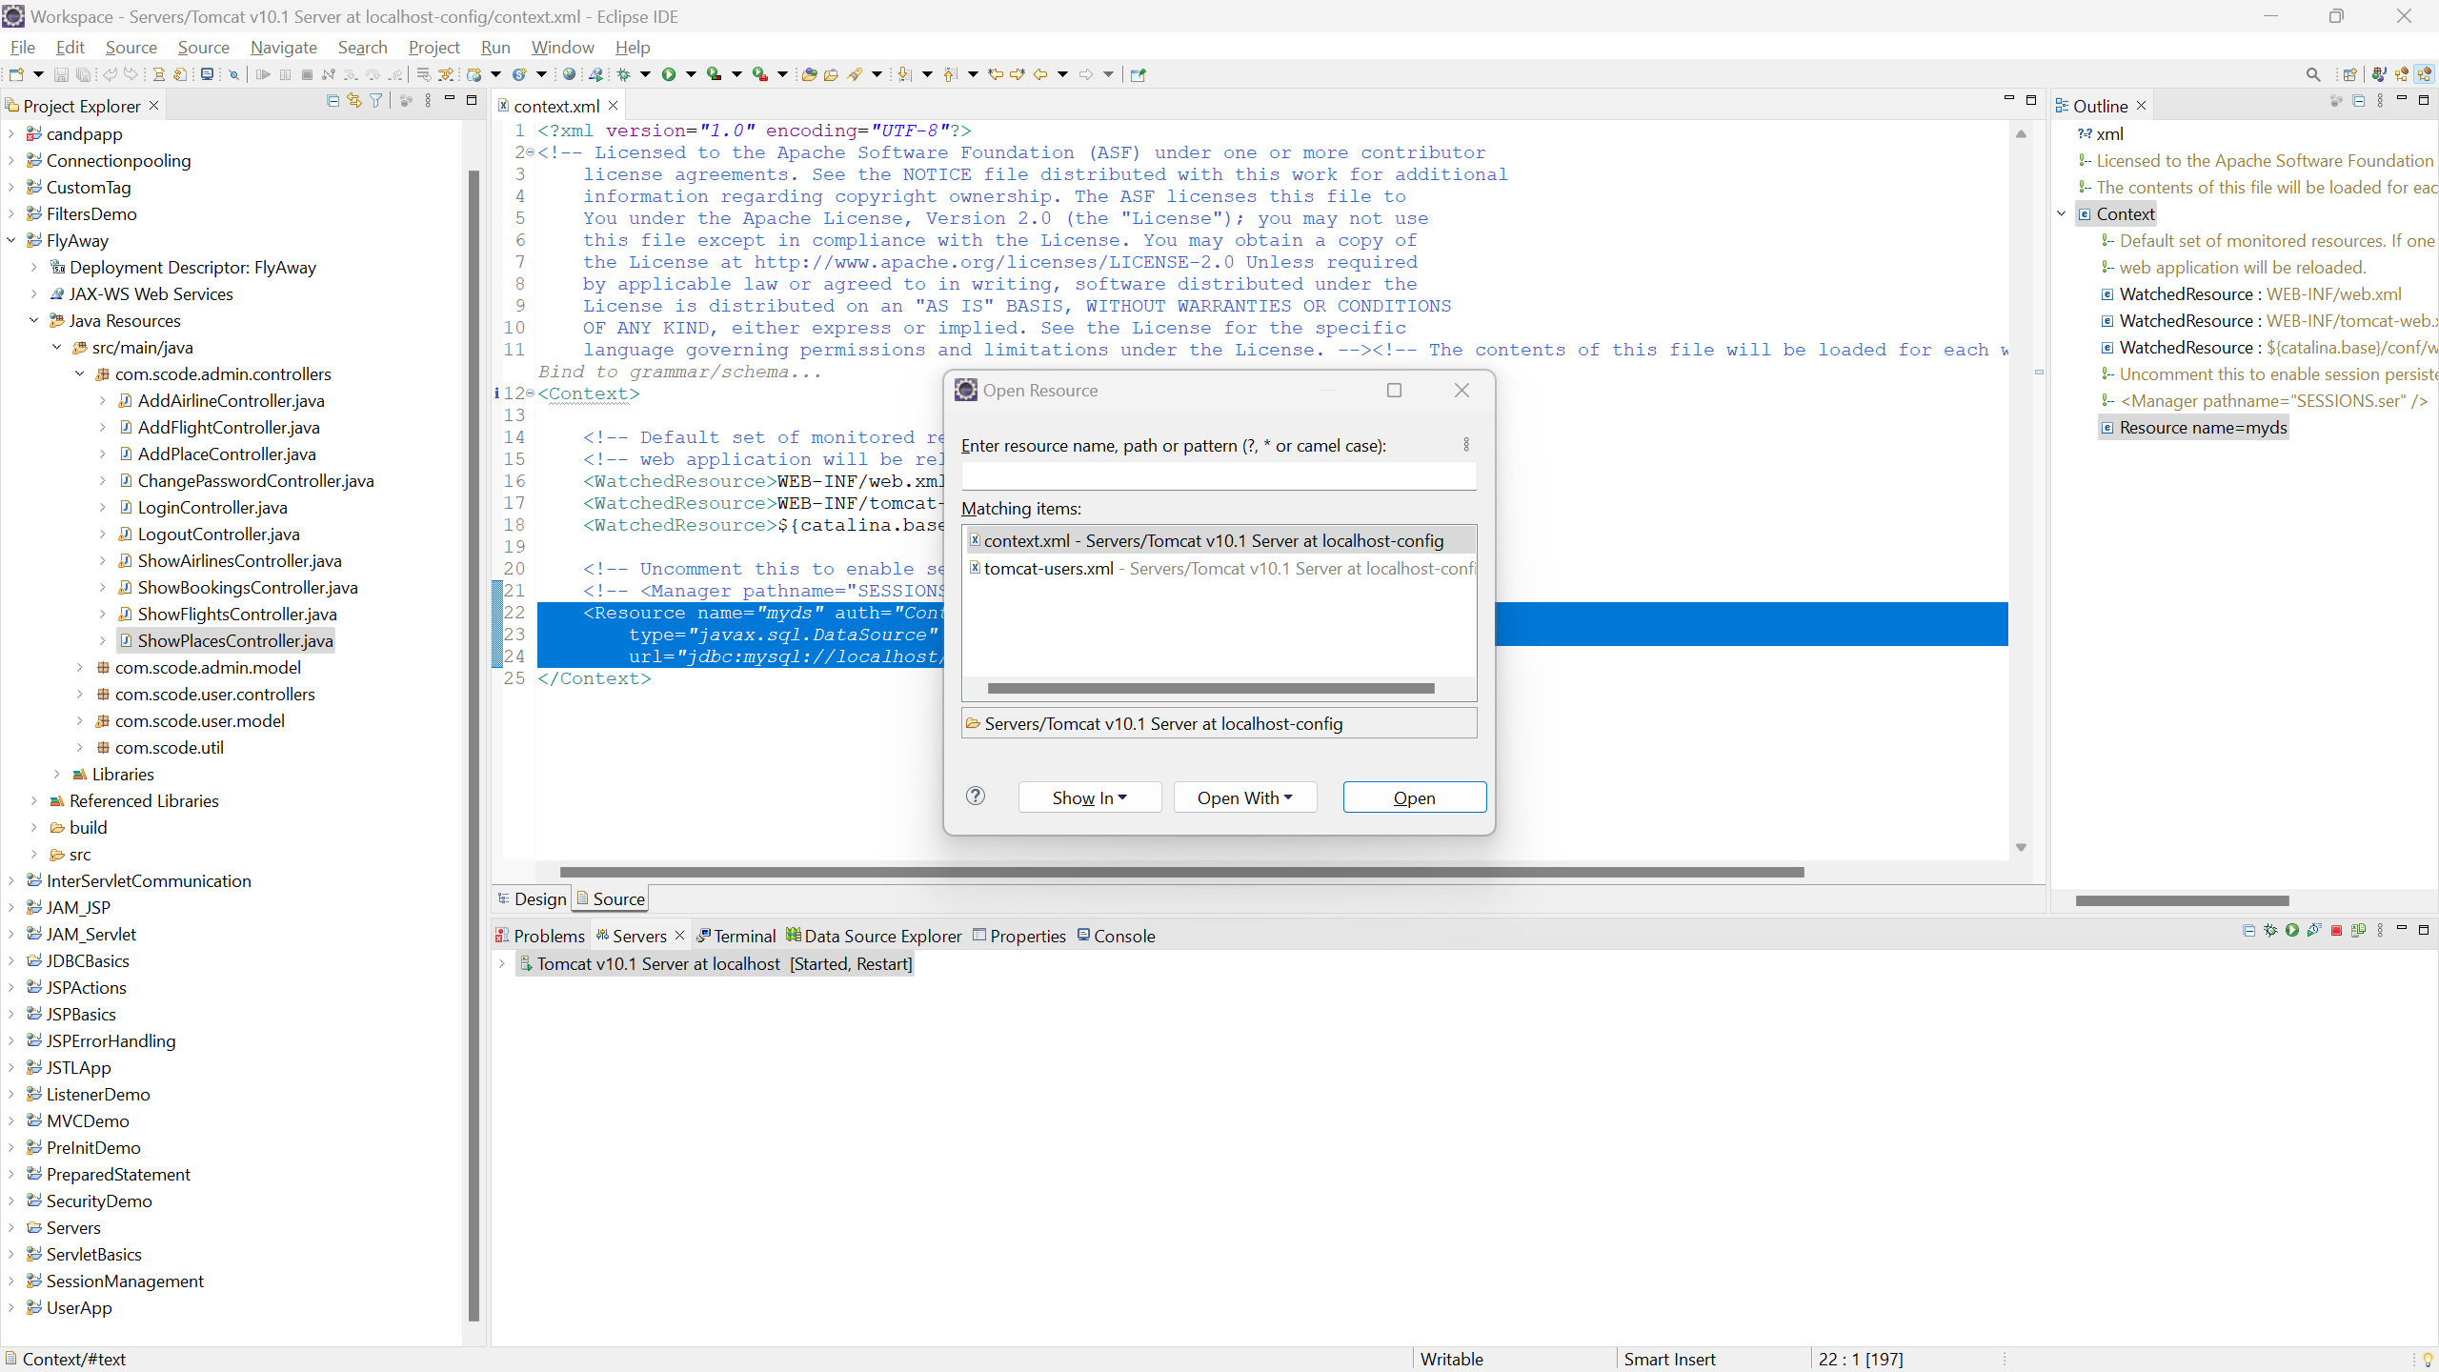

1. Open context.xml and paste below line between context tags

<Resource name=*"myds"* auth=*"Container"* maxIdle=*"20"* type=*"javax.sql.DataSource"* driverClassName=*"com.mysql.cj.jdbc.Driver"*

url=*"jdbc:mysql://localhost/flyaway"* username=*"root"* password=*""*/>

1. In the above line change username with your database username and password with your database password.
2. Also before running project run the attached sql file to create database and tables

